Recommendation systems

Broadly, recommendation systems can be categorized into three types:

1. Content-Based Filtering: Recommendations are based on the features of items and a profile of the user’s preferences. For example, if a user likes a particular genre of movies, the system will recommend movies of that genre.

2. Collaborative Filtering: Recommendations are based on the behavior of similar users. This method assumes that users who agreed in the past will agree in the future.
3. Hybrid Systems: It combines both content-based and collaborative filtering methods to leverage the strengths of both.

Metrics:
Evaluating the effectiveness of a recommendation system involves several metrics:
1. Precision: The ratio of relevant items recommended to the total recommended items.
2. Recall: The ratio of relevant items recommended to the total relevant items.
3. F1-Score: The harmonic mean of precision and recall.
4. Mean Absolute Error (MAE) / Root Mean Squared Error (RMSE): They measure the accuracy of predicted ratings versus user-provided ratings.
5. Hit Rate: The percentage of users for whom the system makes at least one successful recommendation.
6. Coverage: The proportion of items that the system can recommend.
7. Diversity: Measures how varied the recommendations are.
8. Relevance - how relevant the list of recommended items are

+ stat by user – which content is more interesting for him (video, text?) - % of read posts
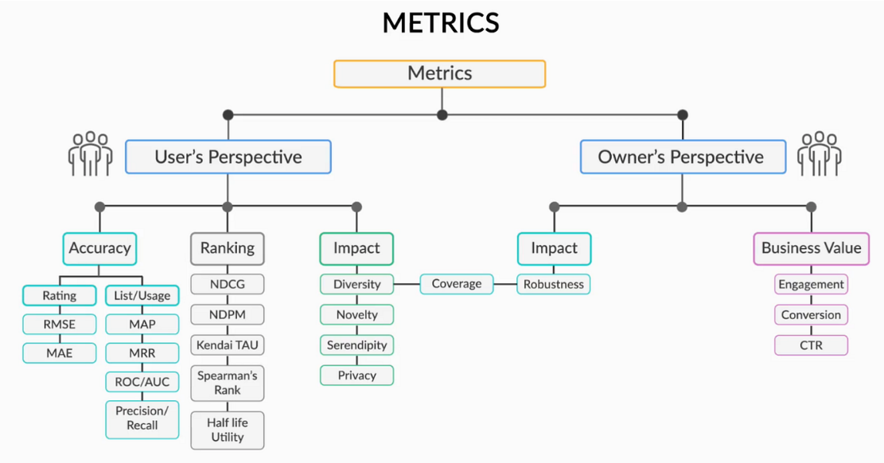

A typical recommendation system has the following structure:

1. Data Collection:
- Gather data on user behavior, preferences, and ratings.
- Collect metadata on items (products, movies, etc.), such as genre, type, and descriptions.

2. Data Preprocessing:
- Clean and normalize data.
- Handle missing data.

3. Feature Engineering:
- Construct user and item profiles.
- Extract features from metadata (for content-based filtering).

4. Model Training:
- Develop models using historical data to predict user preferences.

5. Prediction and Recommendation:
- Generate recommendations based on the model’s predictions.

6. Evaluation and Optimization:
- Measure performance using key metrics and refine algorithms
- Validate on a hold-out set or via A/B testing.

2. Content-Based Filtering:
- TF-IDF, Word2Vec: For text-based content features.
- Cosine Similarity: Measure similarity between item profiles.

Use cases
  - Who is going to use it?
  - How are they going to use it?

Constraints
  - Mainly identify traffic and data handling constraints at scale.
  - Scale of the system such as requests per second, requests types, data written per second, data read per second)
  - Special system requirements such as multi-threading, read or write oriented.

A recommender system can be viewed as a search ranking system, where the input query is a set of user and contextual information, and the output is a ranked list of items. Given a query, the recommendation task is to find the relevant items in a database and then rank the items based on certain objectives, such as clicks or purchases
A query, which can include various user and contextual features, is generated when a user visits the app store. The recommender system returns a list of apps (also referred to as impressions) on which users can perform certain actions such as clicks or purchases. These user actions, along with the queries and impressions, are recorded in the logs as the training data for the learner. Since there are over a million apps in the database, it is intractable to exhaustively score every app for every query within the serving latency requirements (often O(10) milliseconds).
Therefore, the first step upon receiving a query is retrieval. The retrieval system returns a short list of items that best match the query using various signals, usually a combination of machine-learned models and human-defined rules.
After reducing the candidate pool, the ranking system ranks all items by their scores. The scores are usually P(y|x), the probability of a user action (label y) given the features (x), including user features (e.g., country, language, demographics), contextual features (e.g., device, hour of the day, day of the week), and impression features (e.g., app age, historical statistics of an app).
For categorical features, the original inputs are feature strings (e.g., “language=en”). Each of these sparse, high-dimensional categorical features are first converted into a low-dimensional and dense real-valued vector, often referred to as an embedding vector.
The embedding vectors are initialized randomly and then the values are trained to minimize the final loss function during model training. These low-dimensional dense embedding vectors are then fed into the hidden layers of a neural network in the forward pass.
For the deep part of the model, A 32- dimensional embedding vector is learned for each categorical feature. We concatenate all the embeddings together with the dense features, resulting in a dense vector of approximately 1200 dimensions. The concatenated vector is then fed into 3 ReLU layers, and finally the logistic output unit.
Every time a new set of training data arrives, the model needs to be re-trained. However, retraining from scratch every time is computationally expensive
The key metrics problem:
For most search engines, it’s hard to come up with an objective metric to optimize for. This is the metric that tells you that your results for a particular search query are good and the search was successful. This metric changes based on what product you are building and what constitutes as “success” for your search. You might be tempted to start off optimizing for user clicks, but if you use clicks blindly, you may train a model that favors bad, “click-baity” results more. Big search engines spend a lot of money on building human relevance systems [6], where trained human raters use well-defined guidelines to generate an objective “success rating” for each search result.
Basic architecture:
Usually a scalable system includes webserver (load balancer), service (service partition), database (master/slave database cluster) and caching systems.
Component Design
- Component + specific APIs required for each of them.

Challenges:
- Perhaps your system needs a load balancer and many machines behind it to handle the user requests. * Or maybe the data is so huge that you need to distribute your database on multiple machines. What are some of the downsides that occur from doing that?
- Is the database too slow and does it need some in-memory caching?
Scaling your abstract design
Vertical scaling
You scale by adding more power (CPU, RAM) to your existing machine.
Horizontal scaling
You scale by adding more machines into your pool of resources.
Caching
Load balancing helps you scale horizontally across an ever-increasing number of servers
Database replication
Database replication is the frequent electronic copying data from a database in one computer or server to a database in another so that all users share the same level of information. The result is a distributed database in which users can access data relevant to their tasks without interfering with the work of others.
Map-reduce:
For sufficiently small systems you can often get away with adhoc queries on a SQL database, but that approach may not scale up trivially once the quantity of data stored. Adding a map-reduce layer makes it possible to perform data and/or processing intensive operations in a reasonable amount of time. You might use it for calculating suggested users in a social graph, or for generating analytics reports. eg. Hadoop, and maybe Hive or HBase.
Web App System Design Considerations:
- Full Text Search
Using Sphinx/Lucene/Solr - which achieve fast search responses because, instead of searching the text directly, it searches an index instead.
- Server Side rendering
- Asynchronous loading of assets (Lazy load items)

Embeddings:
- Let’s start by talking about one of the most fundamental aspects of any model, it’s embedding.
- Embedding is just a lower dimensionality representation of the data.
- In practice, this is just a vector living in a “latent” or “semantic” space.
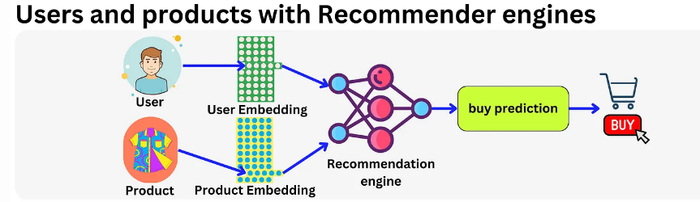
- The idea is to have a vector representation for each user and product and use that as base features. In fact, any sparse feature could be encoded within an embedding vector and modern recommender engines typically use hundreds of embedding matrices for different categorical variables.
- Conceptually, a recommender system is simple: you take a set of features for a user UU and a set of features for an item II along with features CC capturing the context at the time of the recommendation (time of the day, weekend / week day, …), and you match those features to an affinity event (e.g. did the user click on the ad or not): click or not = F(U,I,C)F(U,I,C).
- In the early days they started with Gradient Boosting models. Those models are good with dense features (e.g. age, gender, number of clicks in the last month, …) but very bad with sparse features (page Id, user Id, Ad Id, …).
Conceptually, choosing the right ad for the right user is pretty simple. We pull ads from a database, rank them according to how likely the user is to click on them, run an auction process to pick the best one, and we finally present it to the user.
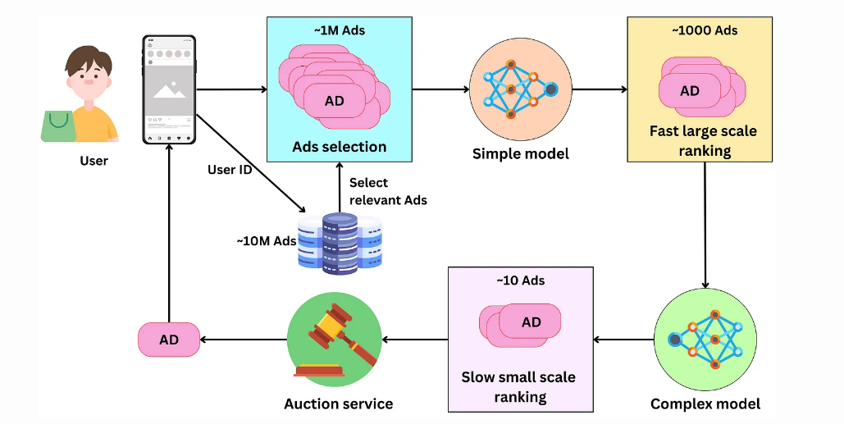
Selecting ads: The ads are indexed in a database and a subset of them is retrieved for a specific user. At all times, there are between 10M and 100M ads and we need to filter away ads that are not relevant to the user. Meta has access to age, gender, location, or user’s interest data that can be used as keywords filters for fast ads retrieval. Additional context information can be used to further filter the selected ads. For example, if it is winter and the user lives in Canada, we could exclude ads for swim suits! We can expect this process to pull between 100K and 1M ads
Fast large scale ranking: With that many ads, we need to rank them in stages. Typically there are two stages: a first fast (per ad) large scale ranking stage and a slow (per ad) small scale ranking one. The first stage needs to be able to handle a large amount of ads

- The model has usually a low capacity and uses a subset of the features making it fast. The ads are scored with a probability of being clicked by the user and only the top ads are retained for the next step. Typically this process generates between 100 and 1000 ads.
- Slow small scale ranking: This step needs to handle a smaller amount of ads, so we can use a more complex model that is slower per ad. This model, being more complex, has better predictive performance than the one in the previous step, leading to a more optimal ranking of the resulting ads. We keep only the best ranking ads for the next step. At this point, we may have of the order of ~10 remaining ads.
- The auction: An advertiser only pays Facebook when the user clicks on the ad. During the campaign creation, the advertiser sets a daily budget for a certain period. From this, we can estimate the cost he is willing to pay per click (bid) and the remaining ads are ranked according to their bid and probability of click. The winning ad is presented to the user.

Architecture
- The models used in multi-stage ranking are recommender engines. They take as inputs a set of features about the user, the ads and the context, and they output the probability that the user will click on the ads.
- The base architecture used at Facebook is the SparseNN architecture. The main components are as follows:
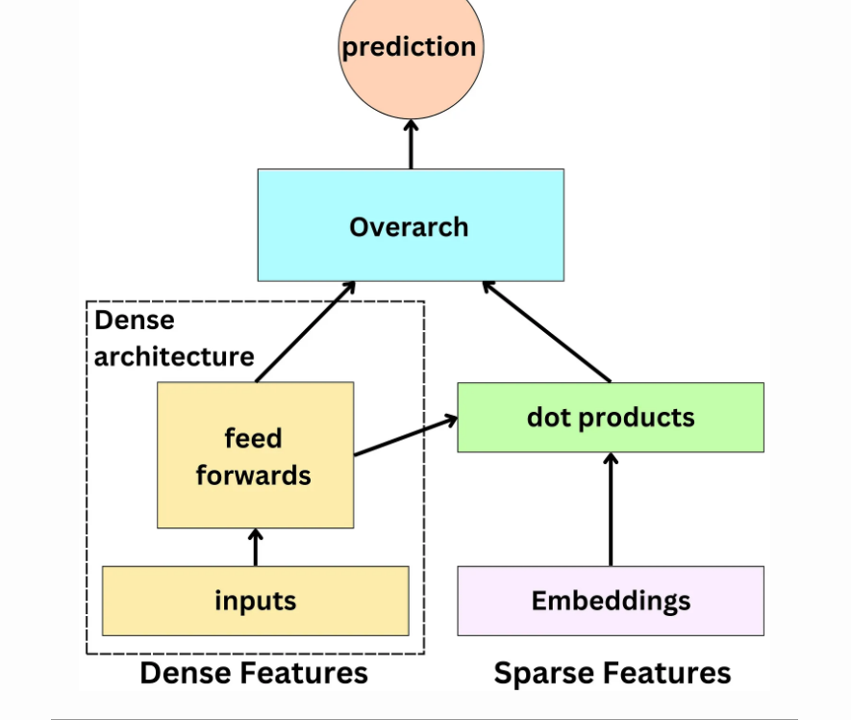
- The dense features: those are typically the continuous variables and low dimensionality categorical variables: age, gender, number of likes in the past week, …
- The sparse features: those are the high dimensionality categorical variables and they are represented by an embedding: user id, page id, ad id, …
- The dense architecture: dense features are fed to the dense architecture. Latent representations of dense features are derived from non-linear functions in dense architecture. The latent representations have the same size as sparse features’ embeddings.
- The dot product layer: reminiscent of the latent matrix factorization model, multiple dot products of pairs of dense and sparse embeddings are computed.
- The overarch: the resulting outputs are fed to a set of non-linear functions before producing a probability prediction.

Types of systems:

Multi-task Learning Architecture (“An Overview of Multi-Task Learning in Deep Neural Networks”)
- In the context of a recommender system, Multi-task learning (MTL) architecture can be used to improve the performance of the system by simultaneously learning to recommend multiple types of items to users.
- For example, consider a movie streaming platform that wants to recommend both movies and TV shows to its users. Traditionally, the platform would train separate recommender systems for movies and TV shows, but with MTL architecture, the platform can train a single neural network to recommend both movies and TV shows at the same time.
- The task-specific layers for movies would learn the specific features and characteristics of movies that are important for making accurate recommendations, such as user ratings and movie length Similarly, the task-specific layers for TV shows would learn the specific features and characteristics of TV shows that are important for making accurate recommendations, such as episode duration and the number of seasons.
- The neural network would be trained using loss functions specific to each task, such as mean squared error for predicting user ratings for movies, and cross-entropy loss for predicting the probability of a user watching a specific TV show.
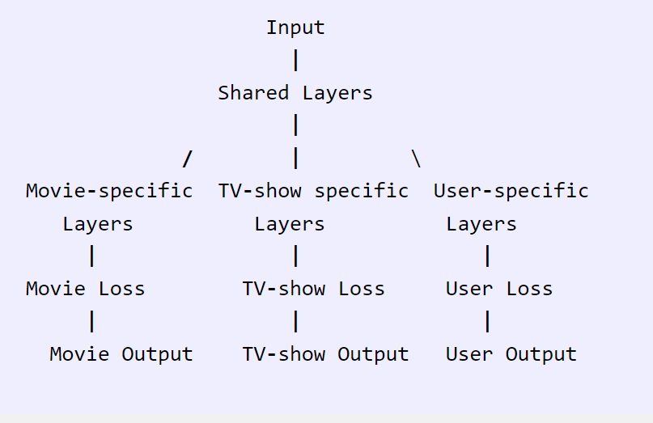
- The user-specific layers learn features that are specific to each user, such as user preferences or viewing history. These layers take into account the user-specific data to personalize the recommendations for each user.
Each task has its own loss function that measures the error between the predicted output and the actual output of the neural network for that task.

Mixture of Experts (“Recommending What Video to Watch Next: a Multitask Ranking System”)
- Mixture of experts (MoE) is a type of neural network architecture that can be used for recommender systems to combine the predictions of multiple models or “experts” to make more accurate recommendations.
MoE can be used to combine the predictions of multiple recommendation models that specialize in different types of recommendations. For example, one model might specialize in recommending popular items, while another model might specialize in recommending niche items. The MoE architecture consists of multiple “experts” and a “gate” network that learns to select which expert to use for a given input. Each expert is responsible for making recommendations for a subset of items or users.
- In this architecture, the input is user and item data, such as user ratings and item features. The MoE consists of three experts, each of which is responsible for making recommendations for a subset of items or users.
- Each expert has its own output, which is a prediction of the user’s preference for the items in its subset. The gate network takes the input data and predicts which expert is best suited to make recommendations for that input. The gate network output is a weighted combination of the outputs of the three experts, where the weights are determined by the gate network.
- The MoE architecture allows the recommender system to leverage the strengths of multiple models to make more accurate recommendations.

Multi-tower Models (“Cross-Batch Negative Sampling for Training Two-Tower Recommenders”)
- Multi-tower models are a type of neural network architecture used in recommender systems to model the interactions between users and items.
- In a two-tower architecture, there are two towers or columns: one tower represents the user and the other tower represents the item. Each tower consists of multiple layers of neurons, which can be fully connected or sparse.
- The user tower takes as input the user’s features, such as demographic information, browsing history, or social network connections, and processes them through the layers to produce a user embedding, which is a low-dimensional vector representation of the user.
- The item tower takes as input the item’s features, such as its genre, cast, or director, and processes them through the layers to produce an item embedding, which is a low-dimensional vector representation of the item.
- The user and item embeddings are then combined using a similarity function, such as dot product or cosine similarity, to produce a score that represents the predicted rating or likelihood of interaction between the user and the item.
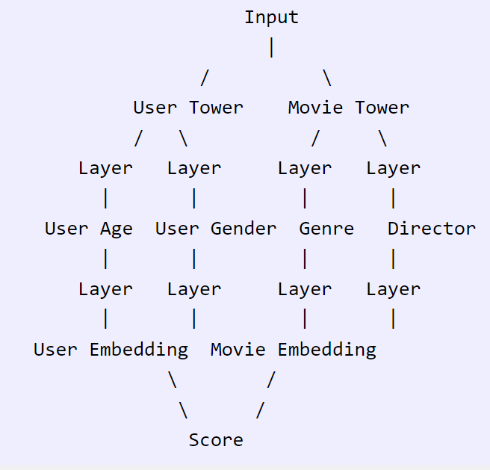
- In this architecture, the user tower and the movie tower are each represented by two layers of neurons. The user tower takes as input the user’s age and gender, which are processed through the layers to produce a user embedding. The movie tower takes as input the movie’s genre and director, which are processed through the layers to produce a movie embedding.
- The user and movie embeddings are then combined using a similarity function, such as dot product or cosine similarity, to produce a score that represents the predicted rating or likelihood of the user watching the movie.
- For example, if a user is a 30-year-old female, and the movie is a drama directed by Christopher Nolan, the user tower will produce a user embedding that represents the user’s age and gender, and the movie tower will produce a movie embedding that represents the movie’s genre and director. The user and movie embeddings are then combined using a similarity function to produce a score that represents the predicted rating or likelihood of the user watching the movie.
Training Data
Features
- When it comes to features, we need to think about the different actors of process: users, the ads and the context. Meta has ~10,000 features capturing those actors’ behavior. Let’s look at a few examples:

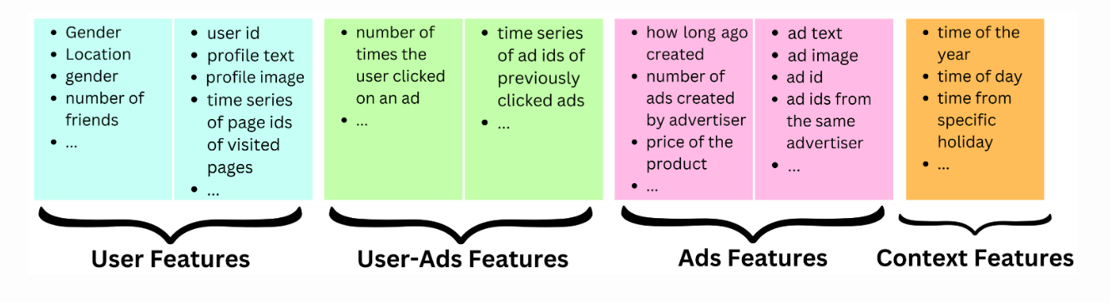
- User features: Dense features: age, gender, number of friends, number of friends with a specific interest, number of likes for pages related to a specific interest, etc.
  - Embedding features: latent representation of the profile text, latent representation of the profile picture, etc.
  - Sparse features: user id, time series of page ids of visited pages, user ids of closest friends, etc.
- Ads features
  - Dense features: how long ago created, number of ads created by advertiser, price of the product, etc.
  - Embedding features: latent representation of the ad text, latent representation of the ad image, etc.
  - Sparse features: Ad id, ad ids from the same advertiser, etc.
- Context features
  - Dense features: time of the year, time of day, time from specific holiday, election time of not, etc
- User-ads interaction features
  - Dense features: number of times the user clicked on an ad, number of times the user clicked on ads related to a specific subject, etc.
  - Sparse features: time series of ad ids of previously clicked ads, time series of ad ids of previously seen ads, etc.

Training Samples
- The problem is a binary classification problem: will the user click or not? On Facebook, there are between 1B and 2B daily active users and each user sees on average 50 ads per day. That is ~3T ads shown per month. The typical click-through rate for ads is between 0.5% and 1%.
In a recommender system, one common approach for training a model to make predictions is to use a binary classification framework, where the goal is to predict whether a user will interact with an item or not (e.g., click on an ad or purchase a product).

Metrics
Offline Metrics
- Because the model is a binary classifier, it is usually trained with the cross-entropy loss function, and it is easy to use that metric to assess models.

Online Metrics
Once an engineer validates that the challenger model is better than the current one in production when it comes to the offline metrics, we can start the A/B testing process to validate the model on production data. The Ads Score metric used in production is a combination of the total revenue generated by the model and a quality metric measured by how often the users hide or report an ad.
- Online metrics refer to evaluation metrics that are computed in real-time using actual user interactions with the recommender system.
- The goal of using both offline and online metrics is to ensure that the models that perform well on offline metrics also perform well in production, where they interact with real users. However, in practice, there is often a low correlation between the performance of models on offline and online metrics.
- For example, a model that performs well on an offline metric, such as normalized entropy, may not perform well on an online metric, such as Ads Score, which measures how well the model performs in terms of user engagement and conversion. This could be due to various reasons, such as the difference between the data distribution in the offline and online environments, the presence of feedback loops in the online environment, and the lack of personalization in the offline experiments.
- To address this issue, active research is ongoing to create offline metrics that have a higher correlation with the online metrics. One approach is to incorporate user feedback and engagement data into the offline experiments to better simulate the online environment.

The Auction
The Winning Ad
The auction process is used to reorder the top predicted ads taking into account the bid put on those ads by the advertisers and the quality of those ads. The bid is the maximum amount an advertiser is willing to pay for a single click of their ad.
p(user will click) is the calibrated probability coming out of the recommender engine.
Ad quality is an estimate of the quality of an ad coming out of another machine learning model. This model is trained on the events when users reported or hid an ad instead of click events.
Pre-computing
The ranking process does not need to be realtime. Being able to pre-compute the ads is cheaper since we don’t need to use as many machines to reduce the latency and we can use bigger models (so slower) which will improve the ranking quality.
Finding the right triggers:
If we want to pre-compute ads rankings a few minutes or hours in advance, we need to find the right triggers to do so. We could recompute the ads ranking in a scheduled manner, for example each hour we run the ranking for the 3B Facebook users. That seems like a waste of resources if the user doesn’t log in for a week let’s say!
We could start the process at the moment the user logs in. This way the ads are ready by the time the user scrolls to the first ad position. This works if the ranking process is fast enough.
We could recompute the ranking every time there is a significant change in the user’s state. For example the user liked a page related to a specific interest or registered for a new group.
Twitter’s Recommendation Algorithm
The foundation of Twitter’s recommendations is a set of core models and features that extract latent information from Tweet, user, and engagement data. These models aim to answer important questions about the Twitter network, such as, “What is the probability you will interact with another user in the future?” or, “What are the communities on Twitter and what are trending Tweets within them?” Answering these questions accurately enables Twitter to deliver more relevant recommendations.
The recommendation pipeline is made up of three main stages that consume these features:
Fetch the best Tweets from different recommendation sources in a process called candidate sourcing.
Rank each Tweet using a machine learning model.
Apply heuristics and filters, such as filtering out Tweets from users you’ve blocked, NSFW content, and Tweets you’ve already seen.
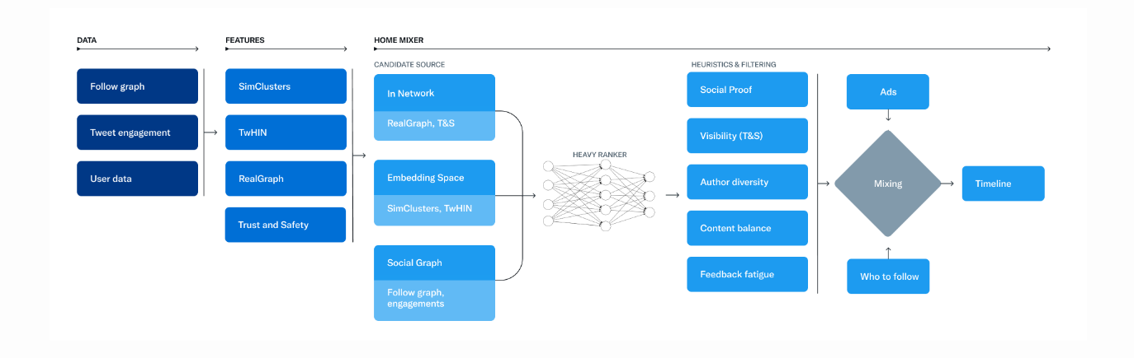
Candidate Sources
Twitter has several Candidate Sources that we use to retrieve recent and relevant Tweets for a user. For each request, we attempt to extract the best 1500 Tweets from a pool of hundreds of millions through these sources. We find candidates from people you follow (In-Network) and from people you don’t follow (Out-of-Network).
Today, the For You timeline consists of 50% In-Network Tweets and 50% Out-of-Network Tweets on average, though this may vary from user to user.
In-Network Source
The In-Network source is the largest candidate source and aims to deliver the most relevant, recent Tweets from users you follow. It efficiently ranks Tweets of those you follow based on their relevance using a logistic regression model. The top Tweets are then sent to the next stage.
The most important component in ranking In-Network Tweets is Real Graph. Real Graph is a model which predicts the likelihood of engagement between two users. The higher the Real Graph score between you and the author of the Tweet, the more of their tweets we’ll include.
Out-of-Network Sources
Finding relevant Tweets outside of a user’s network is a trickier problem: How can we tell if a certain Tweet will be relevant to you if you don’t follow the author? Twitter takes two approaches to addressing this.
Social Graph
Our first approach is to estimate what you would find relevant by analyzing the engagements of people you follow or those with similar interests. We traverse the graph of engagements and follows to answer the following questions:
What Tweets did the people I follow recently engage with?
Who likes similar Tweets to me, and what else have they recently liked?
We generate candidate Tweets based on the answers to these questions and rank the resulting Tweets using a logistic regression model.
Embedding Spaces
Embedding space approaches aim to answer a more general question about content similarity: What Tweets and Users are similar to my interests?
Embeddings work by generating numerical representations of users’ interests and Tweets’ content. We can then calculate the similarity between any two users, Tweets or user-Tweet pairs in this embedding space. Provided we generate accurate embeddings, we can use this similarity as a stand-in for relevance.
One of Twitter’s most useful embedding spaces is SimClusters. SimClusters discover communities anchored by a cluster of influential users using a custom matrix factorization algorithm. There are 145k communities, which are updated every three weeks. Users and Tweets are represented in the space of communities, and can belong to multiple communities. Communities range in size from a few thousand users for individual friend groups, to hundreds of millions of users for news or pop culture.
Ranking
The goal of the For You timeline is to serve you relevant Tweets. At this point in the pipeline, we have ~1500 candidates that may be relevant. Scoring directly predicts the relevance of each candidate Tweet and is the primary signal for ranking Tweets on your timeline. At this stage, all candidates are treated equally, without regard for what candidate source it originated from.
Ranking is achieved with a ~48M parameter neural network that is continuously trained on Tweet interactions to optimize for positive engagement (e.g. Likes, Retweets, and Replies). This ranking mechanism takes into account thousands of features and outputs ten labels to give each Tweet a score, where each label represents the probability of an engagement. We rank the Tweets from these scores.
Heuristics, Filters, and Product Features
After the Ranking stage, we apply heuristics and filters to implement various product features. These features work together to create a balanced and diverse feed. Some examples include:
Visibility Filtering: Filter out Tweets based on their content and your preferences. For instance, remove Tweets from accounts you block or mute.
Author Diversity: Avoid too many consecutive Tweets from a single author.
Content Balance: Ensure we are delivering a fair balance of In-Network and Out-of-Network Tweets.
Feedback-based Fatigue: Lower the score of certain Tweets if the viewer has provided negative feedback around it.
Social Proof: Exclude Out-of-Network Tweets without a second degree connection to the Tweet as a quality safeguard. In other words, ensure someone you follow engaged with the Tweet or follows the Tweet’s author.
Conversations: Provide more context to a Reply by threading it together with the original Tweet.
Edited Tweets: Determine if the Tweets currently on a device are stale, and send instructions to replace them with the edited versions.
Mixing and Serving
At this point, Home Mixer has a set of Tweets ready to send to your device. As the last step in the process, the system blends together Tweets with other non-Tweet content like Ads, Follow Recommendations, and Onboarding prompts, which are returned to your device to display.
Twitter Deep Retrieval
it takes the “best” tweets, ranks them with an ML model, filters the unwanted tweets and presents it to a user. Let’s delve deeper into Twitter’s ML algorithm that go through multistage tweet selection processes for ranking. Twitter first selects about 1500 relevant tweets with 50% coming from your network and 50% from outside. For the 50% in your network, they then use Real Graph to rank people within your network which internally is a logistic regression algorithm running on Hadoop.
The features used here are previous retweets, tweet interactions and user features and with these, they compute the probability that the user will interact with these users again.
For the 50% out of network, they use GraphJet. “Different users and tweet interactions are captured over a certain time window and a SALSA algorithm (random walk on a bipartite graph) is run to understand the tweets that are likely to interest some users and how similar users are to each other.
SimClusters algorithm: “clusters users into communities. The idea is to assign similarity metrics between users based on what influencers they follow. With those clusters, we can assign users’ tweets to communities and measure similarity metrics between users and tweets.”
TwHIN algorithm: is a more modern graph algorithm to compute latent representations (embeddings) of the different Twitter entities (users, tweets, ads, advertisers) and the relationships between those entities (clicks, follows, retweets, authors, etc.). The idea is to use contrastive learning to minimize the dot products of entities that interact in the graph and maximize the dot-product of entities that do not.
Once the recommendations are selected, they are ranked via a 48M parameters MaxNet model that includes thousands of features and 10 engagement labels to compute a final score to rank tweets.
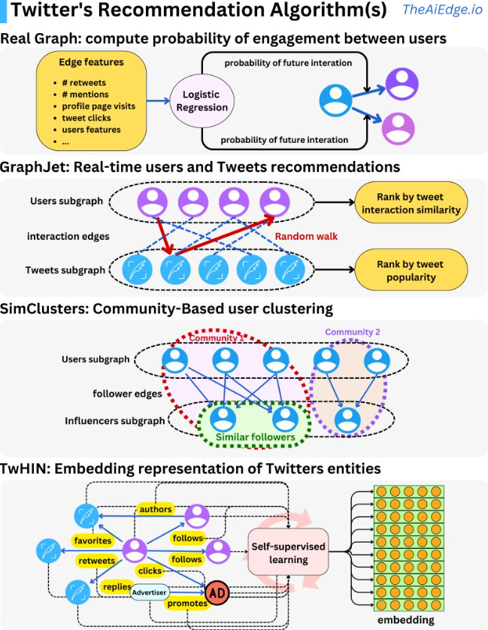
The first step in the process is to select ~1500 relevant tweets, 50% coming from people in your network and 50% outside of it. Real Graph (“RealGraph: User Interaction Prediction at Twitter“) is used to rank people in your network. It is a logistic regression algorithm running on Hadoop.
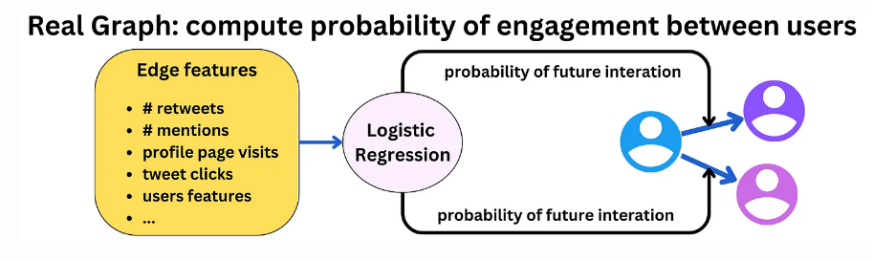
The SimClusters algorithm (“SimClusters: Community-Based Representations for Heterogeneous Recommendations at Twitter“) clusters users into communities.
The idea is to assign similarity metrics between users based on what influencers they follow. With those clusters, we can assign users’ tweets to communities and measure similarity metrics between users and tweets.
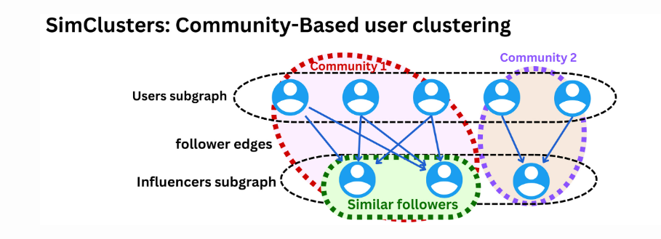
The TwHIN algorithm (“TwHIN: Embedding the Twitter Heterogeneous Information Network for Personalized Recommendation“) is a more modern graph algorithm to compute latent representations (embeddings) of the different Twitter entities (users, tweets, ads, advertisers) and the relationships between those entities (clicks, follows, retweets, authors, …). The idea is to use contrastive learning to minimize the dot products of entities that interact in the graph and maximize the dot-product of entities that do not.
TikTok Recommender System
Challenges: The unique problem TikTok has is that the training data is non-stationary as a user’s interest can change in a matter of minutes and the number of users, ads, videos are also constantly changing. “The predictive performance of a recommender system on a social media platform deteriorates in a matter of hours, so it needs to be updated as often as possible
The high level overview of how TikTok works is:
A user opens the app and sends a request to the TikTok service to populate videos in their feed.
TikTok’s service requests feed ranking from the recommender engine.
During retrieval, the first stage will select a set of relevant video candidates for that user and select the top 100 or so videos.
The second stage is a fine ranking of the candidates selected with the first video being the one with the highest score.
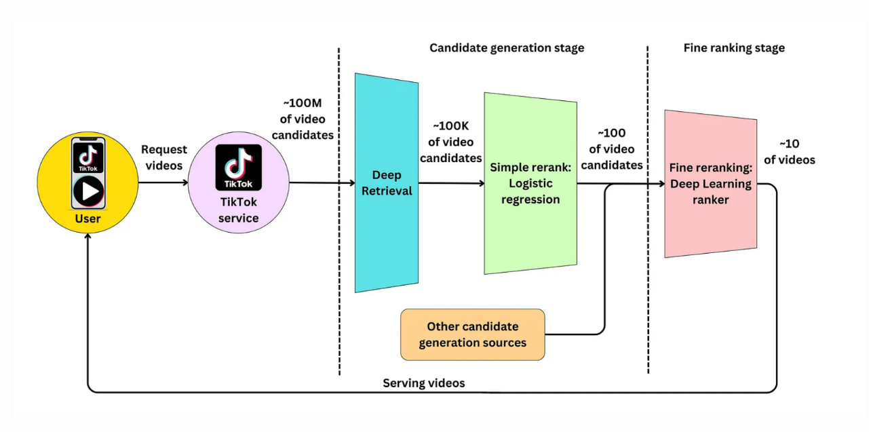
TikTok is continuously learning online in order to keep the recommendations fresh and the model server generates features for the model to recommend. It does this via a feedback loop that processes where the user interacts with the recommended items generated by the model server, and their behavior is used to update the model parameters.
Specifically, the user feedback in the form of interactions with the recommended videos (e.g., likes, shares, comments) is collected and sent to the training server, where it is used to generate new training samples. These new samples are then used to update the model parameters in the parameter server, which are then synchronized with the production model every minute. This continuous feedback loop enables the recommender system to adapt to the rapidly changing user behavior on the platform, improving the accuracy of the recommendations over time.
In a typical recommender system, sparse variables such as users, videos, and ads are assigned to fixed embedding tables using a hash function.
Recommender systems need to predict highly on sparse categorical variables. TikTok has ~1B active users and ~100M videos available on the platform, both represented by categorical variables. Once you build new features from those, the number of sparse variables increases. Building models using those variables can be challenging because we typically use embedding tables to encode them. This adds a lot of memory load on the serving servers.
Dynamic vectors:
Furthermore, to free up memory and keep the embeddings up-to-date, TikTok sets a predetermined period of inactivity after which a vector representation expires. This ensures that the embedding tables only store representations for active and relevant users, items, or features. Overall, dynamic size embeddings allow TikTok to efficiently manage resources and provide accurate recommendations to users.
Instantaneous Updates During Runtime
TikTok is very large, with a size of several terabytes. This means that it can be very slow to synchronize the entire model across the network, which can impact the efficiency and effectiveness of the model. To overcome this challenge, the model is only partially updated.
Sparse Variables:
Sparse variables are variables that have a large number of possible values, but only a small subset of these values are present in the data at any given time. In the context of recommender systems, examples of sparse variables include users, items, and features of items.
Users: There are millions of users on the platform, but any given user has only rated or interacted with a small subset of movies.
Movies: There are thousands of movies in the database, but any given user has only rated or interacted with a small subset of them.
Genres: There are many movie genres, but any given movie may only belong to a small subset of them.
Collisions
Users: If the system uses a fixed embedding table and a hash function to assign users to vectors, some users may end up sharing the same vector. This means that the system can’t differentiate between the preferences and behaviors of different users who share the same vector.
Candidate Generation Stage
The candidate generation stage has to generally be fast considering the number of videos that exist, it’s usually the ranking that is slow but it deals with fewer candidates.
Deep Retrieval Model (DR)
A typical approach to candidate generation is to find features for users that relate to features of the items. This is done by analyzing user behavior data and item metadata to identify relevant features and then finding relationships between them. For example, if we have a movie recommendation system, we can identify features of movies such as genre, actors, director, release year, and rating. We can also analyze user behavior data such as movies they have watched and rated, time of day, and day of the week they typically watch movies.
We can then find relationships between these features by using techniques such as collaborative filtering, content-based filtering, or a combination of both. Collaborative filtering involves finding similarities between users based on their past behavior and recommending items that similar users have liked. Content-based filtering, on the other hand, involves recommending items that have similar features to items that the user has liked in the past.
By finding features for users that relate to features of the items, we can generate a set of candidate items that are likely to be relevant to the user. “We could look at a latent representation of the user and find item latent representations that are close using approximate nearest neighbor search algorithms. These approaches require us to iterate over all the possible items which can be computationally expensive.
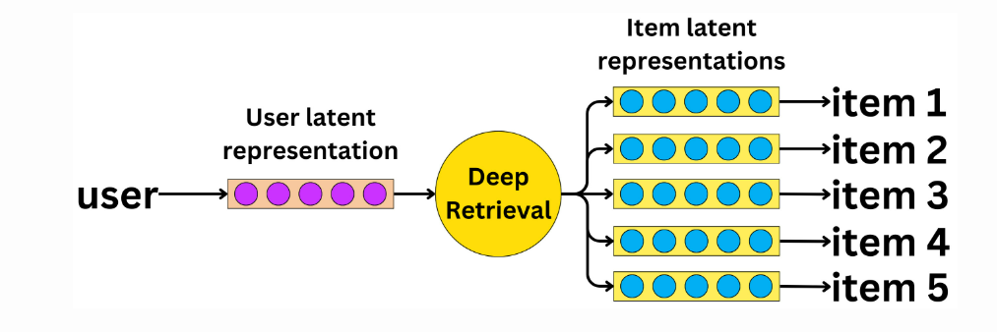
In TikTok’s Deep retrieval system, a probability distribution is learned over the possible paths in the DR structure, based on the user inputs. This means that given a user’s query or request, the system will learn which paths are most likely to be relevant to that query.
Fine Ranking Stage
The candidate selection component must be optimized for latency and recall. We need to make sure all relevant videos are part of the candidate pool even if that means including irrelevant videos.
TikTok’s machine learning infrastructure is quite complex and it leverages machine learning to improve user engagement. Given the large size of TikTok’s user base, the company relies on an army of machine learning engineers to test and develop multiple machine learning models simultaneously. The ultimate goal of these models is to identify videos that will be popular with users and increase their engagement with the platform.
TikTok uses a variety of signals to measure user engagement with videos, such as likes, comments, watch time, and subscriptions. These signals can be used as input features to machine learning models. The models score videos based on these signals simultaneously, meaning that they take into account all the positive signals to determine the video’s overall popularity. By using multiple models in parallel and considering multiple positive signals, TikTok can better predict which videos are likely to be popular with users and tailor its recommendations accordingly.

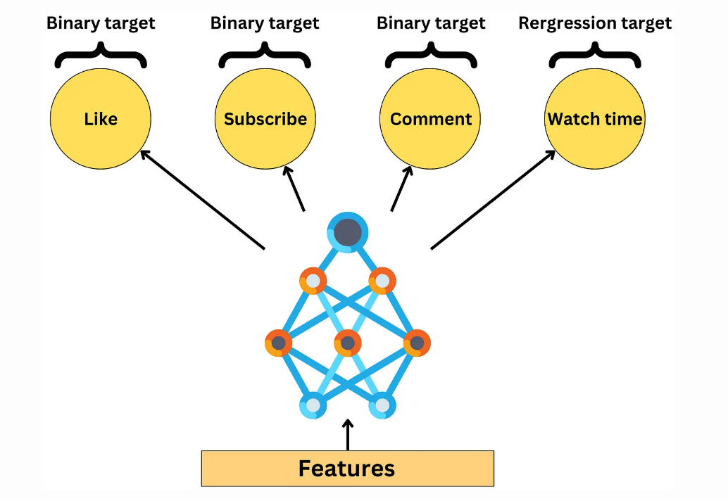
Challenges:
Selection bias in recommender systems refers to a situation where the recommendation algorithm is biased towards certain items or users, leading to a skewed distribution of recommendations. This bias can occur when the system is trained on a dataset that is not representative of the actual user population, or when the system relies on incomplete or biased user feedback data. For example, if a recommender system only recommends popular items or items that are frequently interacted with, then it may not be providing diverse recommendations that reflect the true preferences of the user population. Similarly, if the system relies only on explicit user feedback such as ratings or reviews, it may not be capturing the full range of user preferences and could be biased towards certain types of users.
Selection bias is a major problem in ranking problems since users will interact with the first video and ignore the later ones thus, the videos further down the recommended list artificially receive less signal.
This will bias the training data for future model development iterations. TikTok can be used on a mobile device as well as on an iPad or desktop computer. Each device behaves differently regarding selection bias.

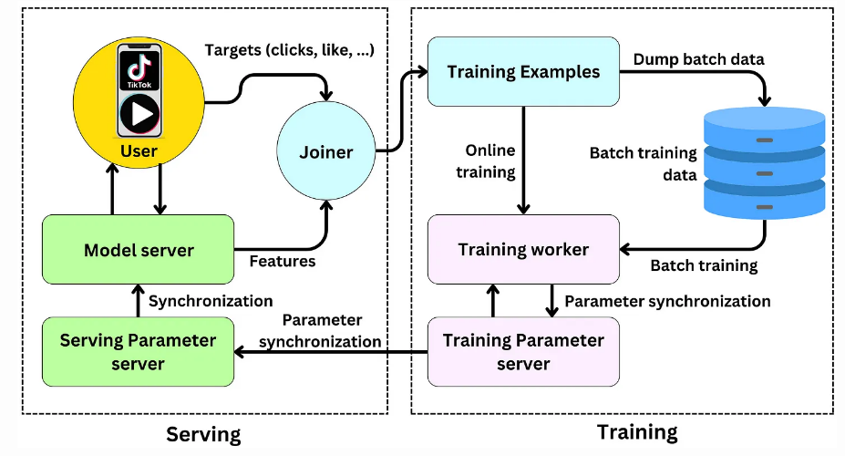
The production model generates recommendations using the current features. The user interacts (clicks, likes, comments, watch the whole video, …) with the production model recommendations which leads to immediate targets that can be used in subsequent training data. The Joiner links the features used for generating recommendations and user engagement. The resulting data is sent to a database as future training data and to the training worker to be used as current online training data. Once the model in the training server is updated, the updated parameters are sent to the serving parameters server and the production model is synchronized with the model in the training server.
Pinterest
Pinterest uses Transformers to personalize recommendations by encoding short and long term user behaviors. “Pins are a combination of an image, text description and an external link to the actual product. Each of the pins is represented by an embedding which is an aggregation of visual, text annotations, and engagement information on that pin
because the amount of data processed by a platform like Pinterest is so large, it is often the case that the training data for a machine learning model doesn’t span longer than 30 days. This means that the user behavior captured by the model only reflects the last 30 days of user activity.
In typical model development, the problem is framed as a classification problem where we try to predict whether a user will interact with an item or not. However, this approach ignores the intrinsic time-series structure of the problem, which means that the model may not be able to capture the dynamic changes in user behavior over time. In other words, the model may not be able to adapt quickly to changes in user behavior or preferences, which can lead to decreased performance over time.
“Pinterest goes about that problem differently! They learn long and short term interests separately. They first train the PinnerFormer Transformer (https://lnkd.in/djT-_kt4) by looking at user-pins engagement time series as far back as 1 year from now. The Transformer is able to learn the relationship between different engagements at different points in time in order to predict the future. Instead of predicting only the next engagement, they built a loss function that takes into account all future engagements in the next 14 days.
“Another Transformer is trained using the long term user embedding as input and short term past actions (hours or minutes ago) to predict next pin or ad interaction, depending on the ranking problem. It learns the relationship between the different short term actions and long term interest to recommend the items.”
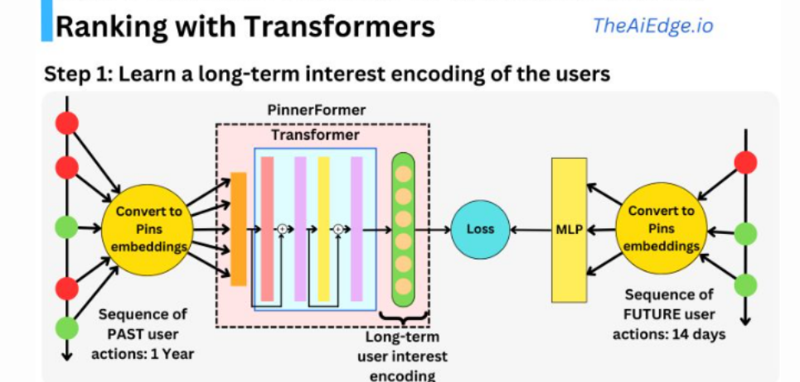
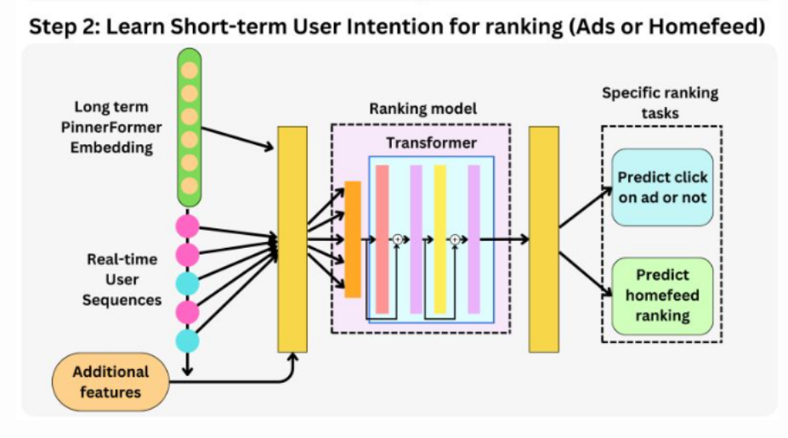
Now let’s delve deeper into how Pinterest uses Transformers for multimodal Image retrieval.
Pinterest has been working on a new feature that allows users to search for products or pins using an image as a query and a text prompt to modify the query. In essence, you can share the image and write that you want it in a different color, and it will retrieve it for you!
First, the images are passing through a visual transformer, something like Swin, which has been trained on ImageNet dataset, which is a large collection of images with annotated labels. During training, the network learns to identify and extract important features from the images that are useful for predicting the correct label.
The image and text latent representations are concatenated and used as inputs to a Fastformer transformer to then learn a latent joint image-text representation that is similar to the image we are trying to find.
Training data: set of image-text prompt pairs as inputs and images as targets.
E.g.: input: image of a blue top + text prompt I need it in black.
Target: picture with same top in black.
“The target image is passed through the same visual transformer described above and the Fastformer is trained trying to maximize the dot product similarity between the image representation and the learned joint image-text representation.
The learned joint image-text representations serve as a query in an image database. To retrieve images from the database that are most similar to the query image-text representation, a nearest-neighbor search
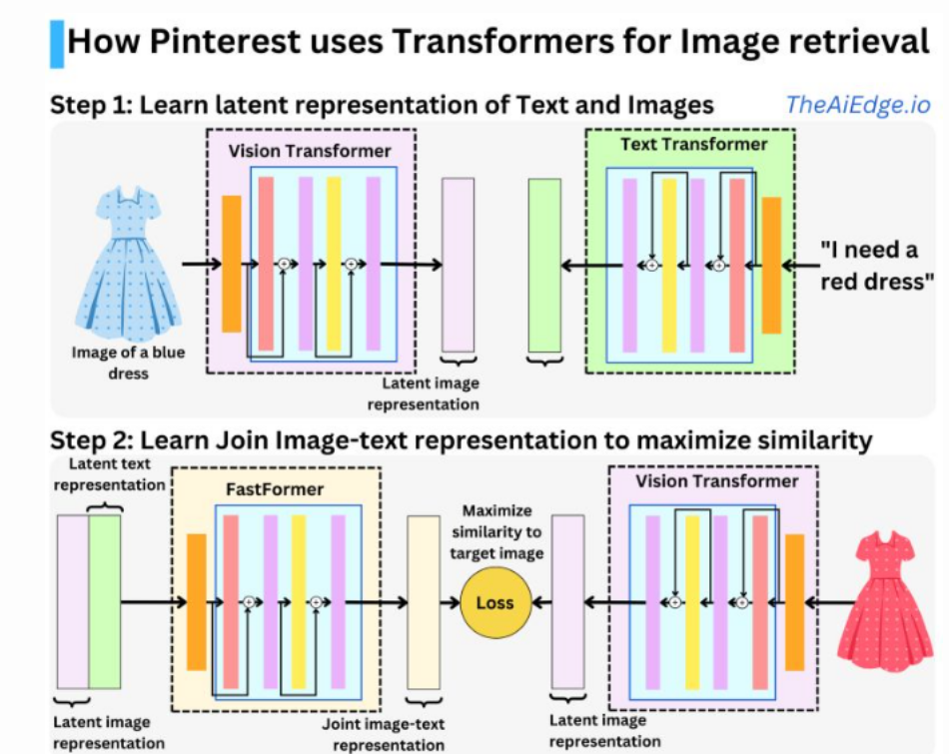
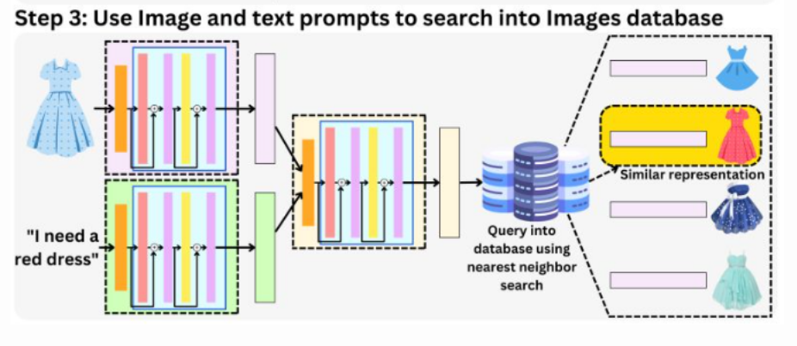

Google Search
The system needs to be fast, scalable and needs to adapt to the latest news!
When a query is created, it goes through a spell check and it is expanded with additional terms such as synonyms to cover as well as possible the user’s query.
The query is then matched against a database, very likely by keyword matching for very fast retrieval. A large set of documents are then selected. The small subset of those documents is selected using simple (fast) heuristic such as PageRank and other contextual information.
The ranking process happens in stages. The results go through a set of Recommender engines. There is most likely a simple Recommender Engine first ranking a large amount of documents (maybe 100,000 or 10,000 documents) and a complex one refining the ranking of the top ranked documents (maybe 100 or 1000). At this point, there might be tens of thousands of features created from the different entities at play: the user, the pages, the query, and the context. Google captures the user history, the pages interaction with other users, the pages natural language semantic, the query semantic, … The context relates to the time of the day, day of the week, … but also the current news of the day.
A typical server can handle 10,000 HTTP requests per second, but the limiting latency factor is mostly coming from the machine learning models. For example, if ranking 10,000 documents takes ~200 ms, that means we need ~8000 ML servers up at all times to handle the 40K/s requests.
Offline Environment:
Training Data Generation: In the offline environment, LinkedIn combines impression and label data to create training data. The labels indicate instances where recruiters sent messages to potential candidates, and the candidates responded positively.
XGBoost for Feature Generation: The training data is then fed into a pre-trained XGBoost model, which generates model scores and tree interaction features. These features are used to augment the training data, providing additional information for the subsequent ranking model.
Ranking Model Training: The augmented training data is used to train the ranking model, which in this case is a generalized linear mixed model (GLMix). The ranking model learns to predict the relevance or suitability of candidates for a given search query.
Online Environment:
Candidate Retrieval: In the online environment, when a search request is received, the search engine (such as Elastic or Solr) retrieves a set of candidates based on the query. These candidates are potential matches for the search query.
First-level XGBoost Scoring: The retrieved candidates are scored using a first-level XGBoost model. This model helps identify the most promising candidates among the retrieved set.
Feature Augmentation: The top 1,000 candidates from the previous step are augmented with additional features, which could include information about the candidate, the search query, or other relevant factors
Ranking: The augmented candidates are ranked based on their scores, taking into account the XGBoost model outputs and the features generated. The top 125 candidates are then selected for display as search results to the user.
Batch Vs Real- Time
Most use cases don’t require real-time recommendations: In many situations, batch recommendations are sufficient and offer computational advantages. Computation and serving decoupling: Batch recommendations can be pre-computed and cached in a key-value store, allowing separation between computation and serving.
More computation for real-time recommendations: Real-time recommendations involve aggregating streamed events and generating recommendations on-demand based on user interactions. This requires additional computation compared to batch recommendations, which compute a single set daily. However, recommendations can be saved for customers who don’t visit the app, reducing unnecessary computations.
Therefore, real-time recommendations are necessary to adapt quickly to the evolving context of the customer and cater to their immediate needs.
The first issue that we run into at scale is the number of items being recommended. Item catalogues can grow to millions, hundreds of millions, even billions in extreme cases. Scoring every item for every user just isn’t feasible in those (or really most) cases. Scoring is computationally expensive.
Enter 2-stage recommender systems. Before we score the items we need to select a reasonably relevant set that contains the items that the user will eventually engage with. This stage is commonly referred to as the candidate Retrieval stage
4-Stage Recommender Systems
These four stages of Retrieval, Filtering, Scoring, and Ordering make up a design pattern which covers nearly every recommender system that we’ve encountered or built.

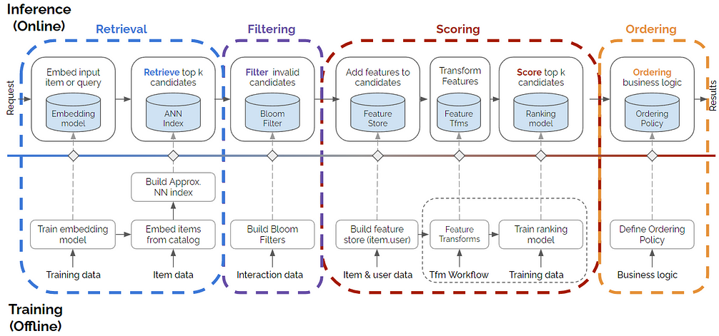
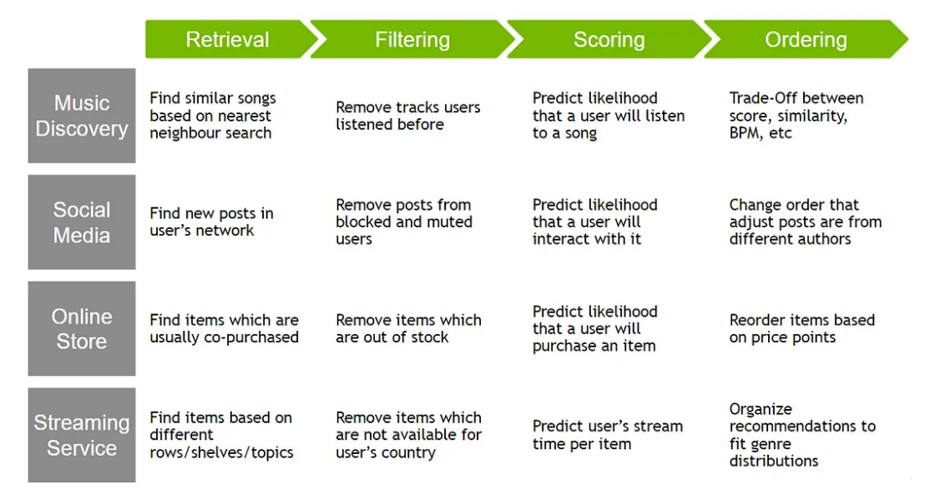
When we launched the first version of the Uber Eats restaurant ranking and recommender system, we were optimizing for a single objective: the eater’s probability to order from a restaurant (eater conversion rate).

Challenges
Building a recommender system for a three-sided marketplace introduces a unique set of challenges, as each side of the marketplace has intrinsic and different values that we need to take into consideration. Sometimes the relationship is straightforward. For example, more orders tends to benefit restaurants and delivery-partners since it enables them both to receive more income from orders.
But more often than not, balancing the marketplace entails a subtle trade-off requiring an intricate solution. Our previous example about new restaurants illustrates the issue. By optimizing purely for eater conversion (more eater orders), we might up-rank only restaurants we know our eaters like, leading to newer restaurants to the platform not receiving sufficient orders to keep them on the platform, thereby decreasing restaurant supply. With fewer restaurants, we might also lose potential eaters who do not find sufficient restaurant diversity on our platform.
Consider an eater who only ordered from ramen places so far. If our personalized relevance model does its job, it will determine that ramen restaurants have high relevance scores for this eater. As a result, the eater will likely see a list consisting primarily of ramen restaurants,
Many different considerations play a part in what the app displays. If we take a deeper look at how to best rank all the available restaurants for a particular eater, these factors include:
- How popular is the restaurant itself and what are the best features to determine popularity? Do we rely on the rating, the historic total orders, or the most recent month’s total orders? The order/impression ratio?
- What are the most representative attributes of the restaurant? Does the restaurant prepare and deliver food faster than others? What type of cuisines does it offer?
- What are the current contextual factors? Is it breakfast time or dinner time? What are the current traffic conditions along the delivery path? Is it a weekday or a weekend?
- What attributes best describe the eater? How many orders has the eater placed so far or in the last month? What kind of cuisines does the eater order most frequently? Is this person a new eater? Did this eater put any dishes into their shopping cart from the restaurant they just clicked into?
- What factors represents an eater’s preference for a particular restaurant? Do we look at how often this eater has clicked into/ordered from this restaurant? Did the eater give this restaurant a high rating?
- What would like-minded eaters order? How do we represent and find similar eaters? How about similar restaurants and dishes? How do we cold start new eaters in the context of collaborative filtering?
This problem motivated us to think about another ranking objective: diversity. More specifically, a good recommendation should be both relevant (so that eaters can easily find relevant restaurants) and diverse (so that eaters can explore different types of food as well). The developed a personalized diversification algorithm that takes the eater’s taste profile and restaurant cuisine profile as vector representations of the eater and the restaurant, and optimizes a combined objective of relevance and diversity.
Restaurant-partners
Maintaining the Uber Eats marketplace also means paying attention to the performance of our restaurant-partners. The popularity of restaurants is, of course, completely up to the eaters on our platform. However, we do want to give restaurants the opportunity to be seen on our platform.
The relevance ranking model for a plain list of restaurants outlined above relies heavily on historic data. Without special treatment, a new restaurant on our platform may have a low ranking since it has no impressions and no historic orders. To give new restaurants a fair opportunity to rank high and gather exposure, we used the multi-armed bandit (MAB) framework. In this case, we applied the upper confidence bound (UCB, one of the methodologies of MAB) approach to facilitate the exploration of new restaurants or restaurants with low impressions.
Earnings are typically the main incentive that motivates delivery-partners, and utilization, the number of deliveries they can make while they are online, plays a huge part in how much they can earn. Here, ranking and recommendations could potentially help improve utilization by leveraging predicted supply position or density as a signal and upranking restaurants with more delivery-partners nearby
Features importance have been provided by our Xgboost model and are reported here:
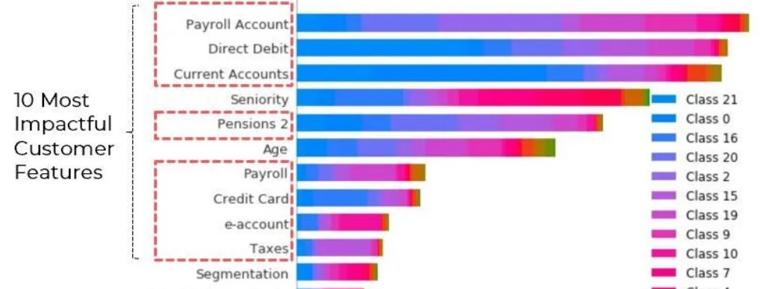
Features representation:
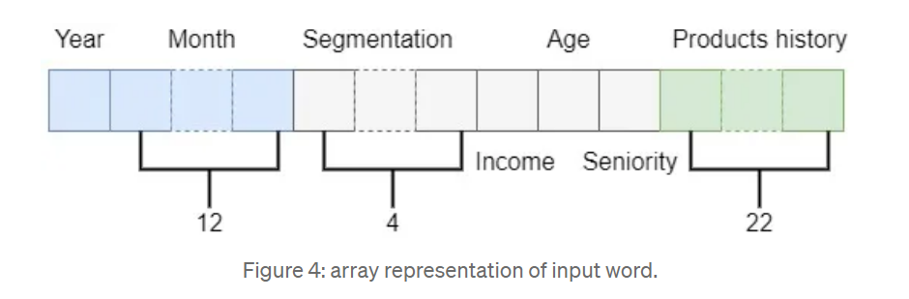
Borrowing the idea of BERT, we get rid of the decoder of the transformer and only keep the encoder. In fact, our goal is to make the encoder learn an embedding representation of the user data and then let a feed-fires networks build on top of the encoder to make predictions.
The first and the main one is Collaborative Filtering (CF) which is purely interaction-based (or behavioural). Being content-agnostic it treats items as ID-s and compares them using only their co-occurrence statistics. In its simplest form CF treats an item A as a one-hot encoded vector of similarity to other items: 1 — if A is similar to B as if they were viewed by the same user in a single session, and 0 if not.
First, each item is represented by a dense high-dimensional vector (an embedding) pretty much as a word in Word2Vec. When we want to compare 2 items we simply compare their respective vectors computing some similarity metric such as dot product or cosine similarity.
The model that embeds an item into a vector space is called an encoder. The goal of the encoder is to embed/encode items in a way that respects some sort of similarity between them.
Positive pairs are generated the way described above
Negative pairs are sampled randomly from the items pool
The items are embedded using an encoder
The similarity of the pairs is calculated as a dot product of the respective embeddings
These similarities are normalized and placed against the desired values — 1 for positive and 0 for negative pairs
Cross-entropy serves as a loss function to estimate the distance between the prediction (similarities) and the ground truth (ones and zeros). The loss function is finally minimized during the training by adjusting the encoder weights

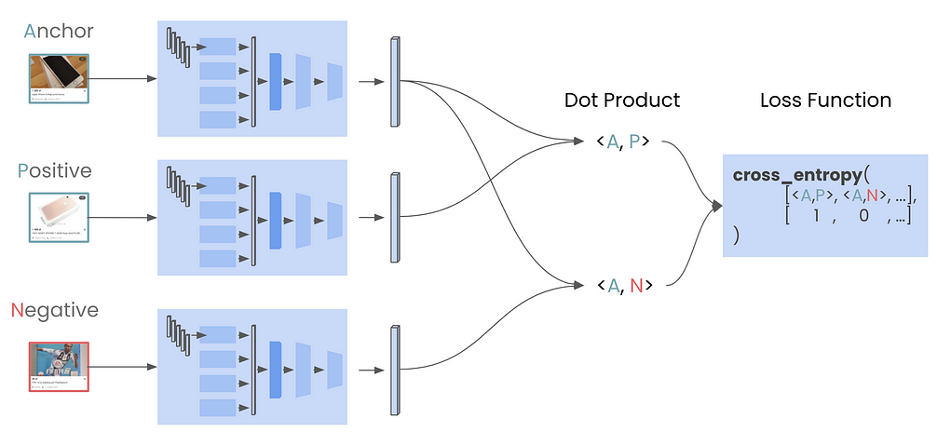
To achieve this, for each user we collect and maintain in real-time (using Kafka) two sets of short-term history events:
Hc : set of listing ids that user clicked in last 2 weeks.
Hs : set of listing ids that user skipped in last 2 weeks, where we define skipped listings as ones that were ranked high but skipped by user in favor of a click on a lower positioned listing
Next, each time the user conducts a search we calculate 2 similarity measures for each candidate listing lᵢ returned in search.
Finding similar users: If you define a vector to represent each user in your business by combining the user’s activities, past purchase history, and other user attributes, then you can find all users similar to a specified user. You can then see, for example, users who are purchasing similar products, users that are likely bots, or users who are potential premium customers and who should be targeted with digital marketing.
Instead of comparing vectors one by one, you could use the approximate nearest neighbor (ANN) approach to improve search times. Many ANN algorithms use vector quantization (VQ), in which you split the vector space into multiple groups, define "codewords" to represent each group, and search only for those codewords. This VQ technique dramatically enhances query speeds and is the essential part of many ANN algorithms, just like indexing is the essential part of relational databases and full-text search engines.
