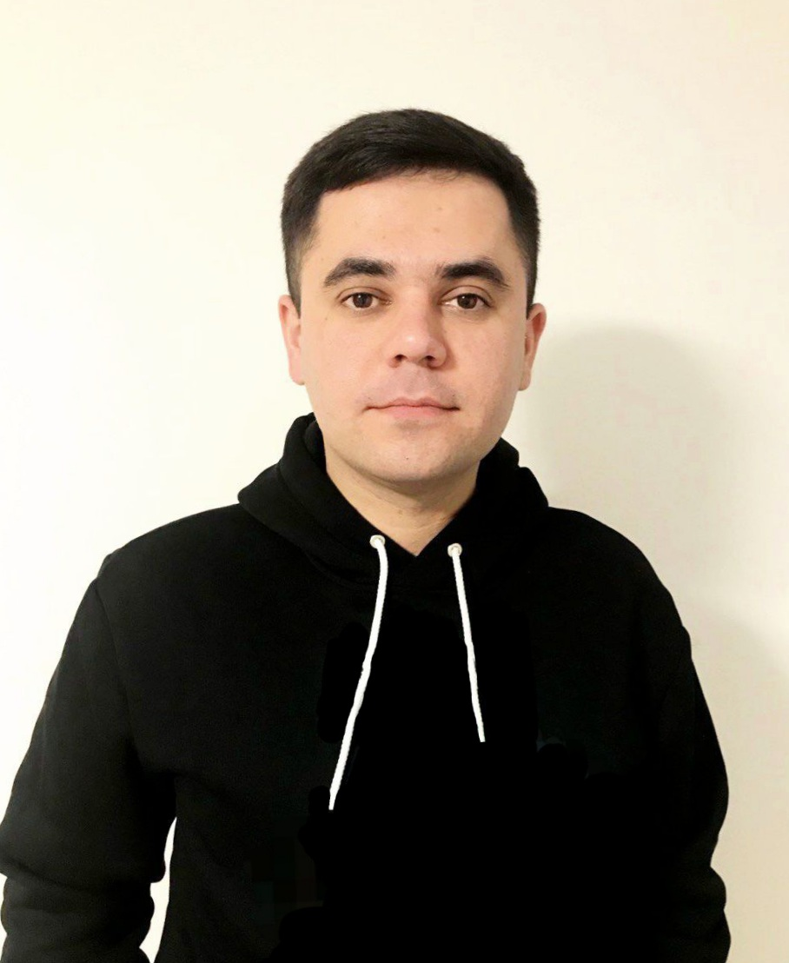


OLEH BILETSKYI
 | oleh.b.tech@gmail.com |  | github.com/olehbiletskyi
 | linkedin.com/in/olehbiletskyi |  | Ivano-Frankivsk(West UA)


Profile
I am an experienced front-end developer with a master's degree in computer science and mathematics.
I have been involved in projects of varying complexity with varying numbers of team members. In my work, I use JavaScript, TypeScript, React, ReactNative, and various libraries from their ecosystem. My mathematics background helps me to approach problems in a structured and analytical way. I like new technologies, communication, and sharing experiences.
In summary, I am a software engineer who strives to improve my skills every day. So I'm eager to take on new challenges in a new role.

Tech stack:
• JavaScript • TypeScript • React • React Native • Redux • Redux-Toolkit • RTK-Query • React Navigation • GraphQL • NativeBase • Chakra UI • Tailwind CSS • styled components • React Hook Form • HTML, CSS, SCSS


Work experience
• Mar 2023 – present — Volunteer Frontend Developer (''Start yourself'' charity organization)
Achievement: Joined something that will benefit society.
Projects: CRM for a charity organization for better and easier distribution of food and aid, accounting of people.

• Mar 2022 – Apr 2023 — React and React Native Developer (Malevich Company).
Achievement: Have got more experience with GraphQL, React Native (+ RN-ecosystem libraries), improved soft and hard skills, learned to write cleaner code, improved communication skills with colleagues and customers, took an active part in the code review, made attempts at mentoring, etc ...
Projects: 1. Website, admin panel and mobile application for creating, tracking and booking events, activities, locations of entertainment and educational type. 2. Mobile application to support the physical and mental health of caregivers. 3. Website and mobile application messenger and task manager for teamwork. 4. Website for forming a commercial offer to clients.

• Apr 2021 – Feb 2022 — React Developer (Devtrix).
Achievement: Gained more experience with React, Chakra UI, Tailwind CSS, developed repeatable and scalable components, pages, implemented business logic and functionality, client requirements, etc...
Projects: Gas production tracking website.
• Feb 2021 – Apr 2021 — Frontend Developer (WebHome Company).
Achievement: Gained first commercial experience in web development, got experience in cooperation with other developers (backend programmers, testers, designers, PM).
Projects: 1. Website for convenient trading on Instagram. 2. Marketplace for perfume trade.
• Mar 2019 – Feb 2021 — Technical Support Engineer (Ivano-Frankivsk Regional State Department).
• Sep 2017 – Sep 2018 — Teacher of computer science and mathematics (Public School).


Languages
English (limited working proficiency), Polish (limited), Ukrainian (native speaker), Russian (limited).


Soft skills
• analytical and structural thinking - I have a mathematical background, so I try to think about the problem first, and then start implementing it.
• teamwork - I like teamwork with distributed personal tasks.
• communication - I understand the importance of communication in avoiding problems and work to maintain clear communication with my team.
• responsibility - If I encounter any difficulties, I take responsibility for finding a solution, and if necessary, I seek guidance from my team.
• public speaking - I'm not afraid to speak.
• desire to learn - I actively seek out opportunities to learn and develop new skills.


Education
• Mathematics and Computer Science — Master's degree / Vasyl Stefanyk Precarpathian National University (Ivano-Frankivsk, Ukraine / Sep 2017 — Dec 2018.
• Mathematics — Master of Education / VSPNU / Sep 2017 — Dec 2018.

Self-learned
GL Pro BootCamp React Native, Advanced course "JavaScript+React", training course "Basics of Web UI development"

Hobby & interests: hiking, walking, documentary books, singing, sharing knowledge, new technologies.

