IMPORTANT: THIS GUIDE IS FOCUSED ON LINUX UBUNTU. YOU MIGHT USE OTHER OS AND CORRESPONDING COMMANDS. BUT UBUNTU IS RECOMMENDED.

# PREREQUISITES

First you need to install some tools to save time during practice session.

* Open terminal and update your OS. Execute following
  + sudo apt-get update.
* Get Java
  + detailed guide is [here](https://computingforgeeks.com/install-oracle-java-openjdk-14-on-ubuntu-debian-linux/).
* Get docker ce
  + detailed guide is [here](https://www.digitalocean.com/community/tutorials/how-to-install-and-use-docker-on-ubuntu-20-04).
* Get docker compose
  + detailed guide is [here](https://www.digitalocean.com/community/tutorials/how-to-install-docker-compose-on-ubuntu-20-04-quickstart).

# ENVIRONMENT SETUP

* Open terminal and create directory msdp-hive
  + *mkdir msdp-hive* (I am creating it in ~/dev directory)
* In terminal go to the new directory you created:
  + *cd ~/dev/msdp-hive/*
* In terminal create directory bde2020
  + *mkdir bde2020*
* open directory you’ve just created
  + *cd bde2020*
* Now we will need to clone repository. We are going to use [BDE](https://hub.docker.com/r/bde2020/hive/) (big data Europe distro).
* In terminal type:
  + *git clone* https://github.com/olehhrynyk/docker-hive
* Now type following in terminal
  + *ls*
* You need to see that you have new directory created

**

* Now go to that directory
  + *cd docker-hive*
* Now let’s download data we are going to use in our lab

Open browser and download file to /docker-hive/ directory

*https://drive.google.com/file/d/18YTS2FNaetDgz5NNwMqmJMScSeiOaqkd/view?usp=sharing*

*tar -xzf - -C ~/home/dev/msdp-hive/bde2020/docker-hive*

* Check if you have data directory
  + *ls*

**

* Check if you have all files there
  + *Ls -la data*

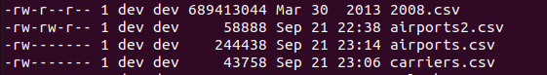

* Now please open docker-compose.yml in your favorite text editor
* Find hive-server section line 24 and add mapping for docker

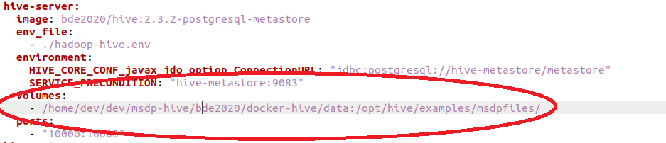

*volumes:*

*- /home/dev/dev/msdp-hive/bde2020/docker-hive/data:/opt/hive/examples/msdpfiles/*

* We are almost done with environment. We need presto installed. Please go to msdp-hive folder and create presto directory. I have it here *~/dev/msdp-hive/presto*
* Install presto into presto directory. Guide is [here](https://prestosql.io/docs/current/installation/cli.html).
* Okay we are done with environment setup. Now let’s start working with hive.

# First ropes with Hive

* Let’s start environment we created. Open docker-hive directory in terminal and run
  + docker-compose up -d

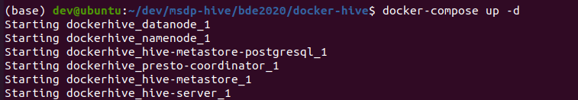

* Let’s verify docker images are actually running
  + docker ps

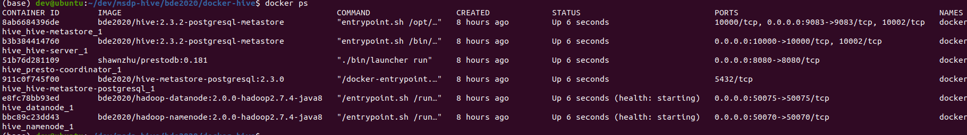

* Now let’s connect to hive server docker
  + *docker-compose exec hive-server bash*



* Let’s check you’ve connected files
  + *ls -la /opt/hive/examples/msdpfiles/*

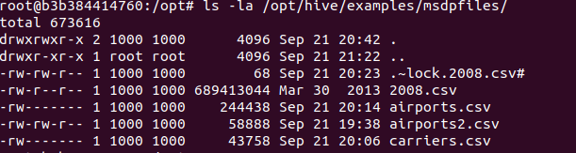

* Let’s run hive CLI
  + beeline -u jdbc:hive2://localhost:10000
* Type show databases;

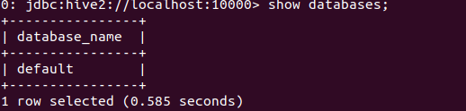

* Now let’s create msdphive database



* Let’s open it
  + Use msdphive;



* Now let’s create and load data;

## LOAD DATA

Flight data table

CREATE TABLE flight_data(

year INT,

month INT,

day INT,

day_of_week INT,

dep_time INT,

crs_dep_time INT,

arr_time INT,

crs_arr_time INT,

unique_carrier STRING,

flight_num INT,

tail_num STRING,

actual_elapsed_time INT,

crs_elapsed_time INT,

air_time INT,

arr_delay INT,

dep_delay INT,

origin STRING,

dest STRING,

distance INT,

taxi_in INT,

taxi_out INT,

cancelled INT,

cancellation_code STRING,

diverted INT,

carrier_delay STRING,

weather_delay STRING,

nas_delay STRING,

security_delay STRING,

late_aircraft_delay STRING

)

ROW FORMAT DELIMITED

FIELDS TERMINATED BY ',';

LOAD DATA LOCAL INPATH '/opt/hive/examples/msdpfiles/2008.csv' OVERWRITE INTO TABLE flight_data;

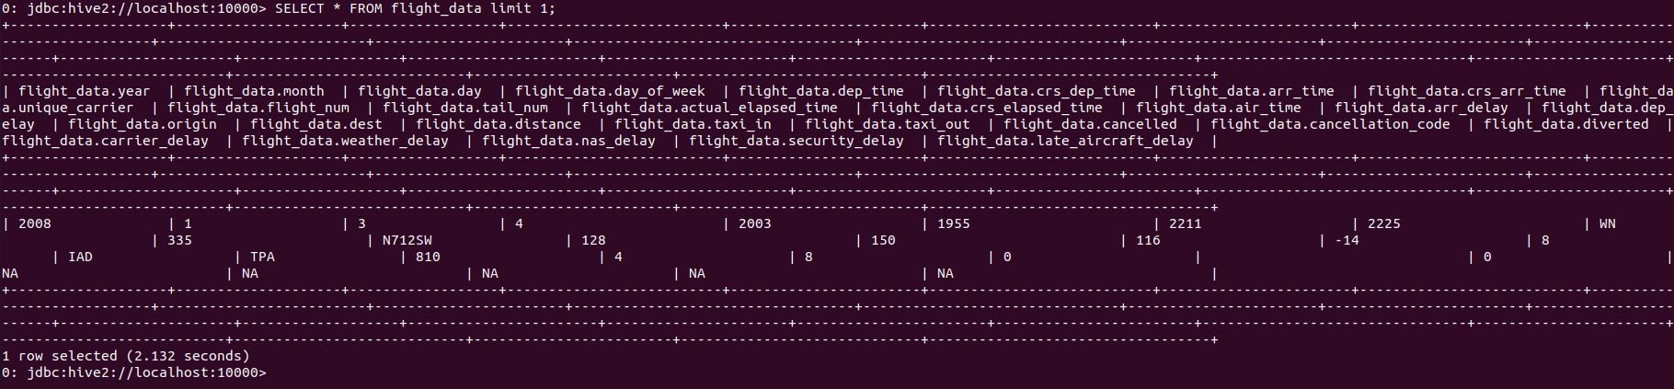

AIRPORTS TABLE

CREATE TABLE airports (

name STRING,

country STRING,

area_code INT,

code STRING)

ROW FORMAT DELIMITED

FIELDS TERMINATED BY ',';

LOAD DATA LOCAL INPATH '/opt/hive/examples/msdpfiles/airports2.csv' OVERWRITE INTO TABLE airports;

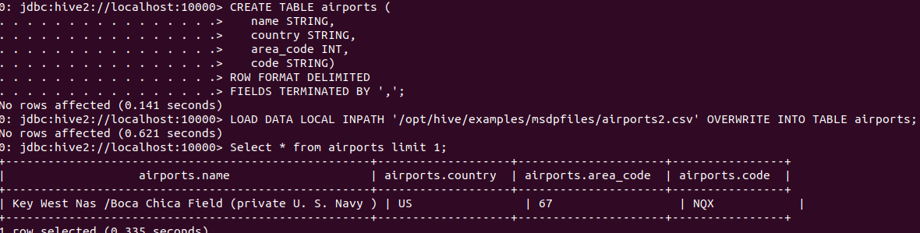

Carriers Table

CREATE TABLE carriers(

code STRING,

description STRING

)

ROW FORMAT DELIMITED

FIELDS TERMINATED BY ','

tblproperties ("skip.header.line.count"="1");

LOAD DATA LOCAL INPATH '/opt/hive/examples/msdpfiles/carriers.csv' OVERWRITE INTO TABLE carriers;

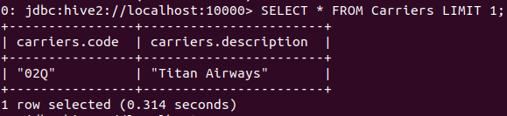

## BASIC ANALYSIS

* Find most popular carrier

SELECT unique_carrier, flight_count, cc.description FROM

(

SELECT unique_carrier, Count(*) flight_count FROM flight_data f GROUP BY unique_carrier

) fd

JOIN carriers cc on cc.code = fd.unique_carrier

ORDER BY flight_count DESC

LIMIT 3;

* Find 10 worst airports with highest average delay

SELECT

name,

avgDelay

FROM (

SELECT

name,

AVG(arr_delay) avgDelay

FROM

flight_data f

INNER JOIN airports a

ON (f.origin=a.code)

GROUP BY name

) a

ORDER BY avgDelay DESC

LIMIT 10;

* Most busy days

SELECT day_of_week, count(*) cc from flight_data f

WHERE month > 5 and month < 9

GROUP BY day_of_week

ORDER BY cc DESC

SELECT day_of_week, count(*) cc from flight_data f

GROUP BY day_of_week

ORDER BY cc DESC

* Flights inside US

WITH us_flights AS (

SELECT COUNT(*) cc1 FROM flight_data f JOIN airports a on f.dest = a.code WHERE a.area_code = 67

UNION

SELECT COUNT(*) cc1 FROM flight_data f JOIN airports a on f.origin = a.code WHERE a.area_code = 67

) SELECT SUM(cc1) from us_flights

* Cancelled us flights carriers

WITH us_flights AS (

SELECT unique_carrier, COUNT(*) cc1 FROM flight_data f WHERE f.cancelled = 1 GROUP BY unique_carrier

) SELECT u.cc1, cc.description from us_flights u JOIN carriers cc on cc.code = u.unique_carrier ORDER BY u.cc1 DESC LIMIT 10

analyze table flight_data compute statistics;

analyze table flight_data compute statistics for columns;

desc formatted table_name;

desc formatted table_name.id;

desc formatted table_name.id partition(time='2016-05-27');

sudo nmap -v -p 12345 127.0.0.1

echo -e '\x1dclose\x0d' | telnet 127.0.0.1 12345

## SAMPLING AND BUCKETING

SELECT * FROM flight_data TABLESAMPLE(BUCKET 1 OUT OF 4 ON unique_carrier) LIMIT 100;

## PARTITIONING

SET hive.exec.dynamic.partition.mode=nonstrict;

CREATE EXTERNAL TABLE flight_data_by_day_of_week(

year INT,

month INT,

day INT,

dep_time INT,

crs_dep_time INT,

arr_time INT,

crs_arr_time INT,

unique_carrier STRING,

flight_num INT,

tail_num STRING,

actual_elapsed_time INT,

crs_elapsed_time INT,

air_time INT,

arr_delay INT,

dep_delay INT,

origin STRING,

dest STRING,

distance INT,

taxi_in INT,

taxi_out INT,

cancelled INT,

cancellation_code STRING,

diverted INT,

carrier_delay STRING,

weather_delay STRING,

nas_delay STRING,

security_delay STRING,

late_aircraft_delay STRING

)

PARTITIONED BY (day_of_week int)

ROW FORMAT DELIMITED

FIELDS TERMINATED BY ','

LOCATION '/user/hive/warehouse/flight_data_partition_by_day_of_week';

INSERT OVERWRITE TABLE flight_data_by_day_of_week PARTITION(day_of_week)

SELECT

year,

month,

day,

dep_time,

crs_dep_time,

arr_time,

crs_arr_time,

unique_carrier,

flight_num,

tail_num,

actual_elapsed_time,

crs_elapsed_time,

air_time,

arr_delay,

dep_delay,

origin,

dest,

distance,

taxi_in,

taxi_out,

cancelled,

cancellation_code,

diverted,

carrier_delay,

weather_delay,

nas_delay,

security_delay,

late_aircraft_delay,

day_of_week

FROM

flight_data;

SELECT day_of_week, count(*) cc from flight_data_by_day_of_week f

GROUP BY day_of_week

ORDER BY cc DESC

## Bucketing

CREATE EXTERNAL TABLE flight_data_bucket_by_carrier(

year INT,

month INT,

day INT,

day_of_week INT,

dep_time INT,

crs_dep_time INT,

arr_time INT,

crs_arr_time INT,

unique_carrier STRING,

flight_num INT,

tail_num STRING,

actual_elapsed_time INT,

crs_elapsed_time INT,

air_time INT,

arr_delay INT,

dep_delay INT,

origin STRING,

dest STRING,

distance INT,

taxi_in INT,

taxi_out INT,

cancelled INT,

cancellation_code STRING,

diverted INT,

carrier_delay STRING,

weather_delay STRING,

nas_delay STRING,

security_delay STRING,

late_aircraft_delay STRING

)

CLUSTERED BY (unique_carrier) INTO 4 BUCKETS

ROW FORMAT DELIMITED

FIELDS TERMINATED BY ','

LOCATION '/user/hive/warehouse/flight_data_bucket_by_carrier';

SET hive.enforce.bucketing = true;

INSERT OVERWRITE TABLE flight_data_bucket_by_carrier

SELECT

*

FROM

flight_data;

SET hive.enforce.bucketing = false;

SELECT

*

FROM

flight_data_b TABLESAMPLE(BUCKET 1 OUT OF 4 ON unique_carrier) LIMIT 100;

## OPTIMIZATION

set hive.vectorized.execution = true

set hive.vectorized.execution.enabled = true

set hive.cbo.enable=true;

set hive.compute.query.using.stats=true;

set hive.stats.fetch.column.stats=true;

set hive.stats.fetch.partition.stats=true;

UDF

delete jar /opt/hive/examples/msdpfiles/msdp-hive-udf-1.0.jar;

add jar /opt/hive/examples/msdpfiles/msdp-hive-udf-1.0.jar;

create temporary function DayOfWeekUDF as 'com.epam.GetDayName';

DROP TEMPORARY FUNCTION IF EXISTS DayOfWeekUDF;

SELECT DayOfWeekUDF(day_of_week), count(*) cc from flight_data_by_day_of_week f

GROUP BY day_of_week

ORDER BY cc DESC

## PRESTO

./presto.jar --server localhost:8080 --catalog hive --schema msdphive