<ICT3K5-3R6240/4245 RS8Test.exe>

Outline:
This application executes commands written in the edit box line by line.
To input command line(s) in the box you have the following two options:
1. Inputting command line(s) typing keys from the keyboard
2. Loading a program pushing the "Load" button and then selecting a file
(This means you can prepare a set of command line(s) in a text format file.)
The format of the command line is the following:
C[Command code (1byte)][Parameter code (1byte)][Data (not fixed size)]
The first character must be 'C', which indicates that the line is for command execution. If the first character is ';' or a white space, the line is considered to be a comment and then ignored.
e.g.,
If you execute the command '0' accompanied by the parameter '1' and 5 bytes size of data "23456", the command line has to be "C0123456".
You can write a command code, a parameter code, and data in hex-decimal notation, i.e., two characters following '$' represent hex-decimal value. So instead of writing '0', you can write "$30". "C$30123456", "C0123456", "C0$31$323456", and so on are identical.
Example:
1. Start “RS8Test”, select COM port and baud rate (1) and click the “Connect” button (2).
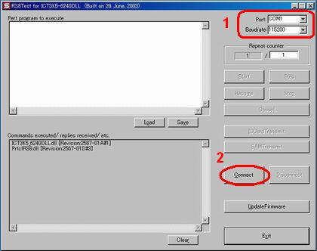
2. First of all, it is necessary to execute “Initialize command” (interface specification on page 24).
Please enter Initialize command (1).
For example: C$30$30$33$32$34$31$30$30$31$30$30$30
Please use “$” before the each Hex character.
It is also possible to enter “C003241001000”

To execute the command, please click the “Start” button (2).

You will find the communication log in the field on the bottom.
3 - - - executed command
4 - - - reply from the card reader
If everything is fine, you will receive “Positive reply”.
If error occurs, you receive “Negative reply”.
Please refer to the error code description on page 21 – 23.
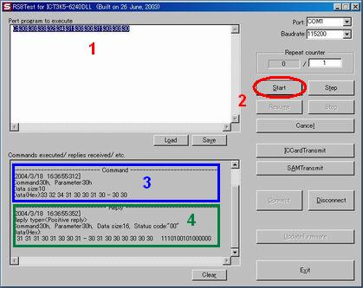
3. Enable command (interface specification on page 32)
To accept a card, there are two commands,
“Enable command (interface specification on page 32)” and “Entry command” (page 27).
Enable command is used in this example.
Please enter enable command (1).
For example: C$3A$30
Please use “$” before the each Hex character.
It is also possible to enter “C:0”

To execute the command, please click the “Start” button (2).

You will find the communication log in the field on the bottom.
3 - - - executed command
4 - - - reply from the card reader

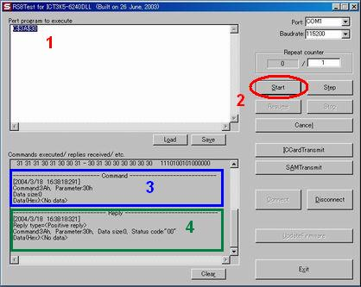
4. Read out data of magnet stripes.
Please insert a card.
Execute “Mag -Track read command” (page 30).
For example: “C$36$35” or “C65”
This command transmits the data on all 3 tracks.
Please enter the code in field 1 and execute it by the Start button 2.
You can find the data of 3 track s (1˜2˜3) in the field 4.

It is also possible to read out data of each track individually.
“C$36$31”, data on track 1
“C$36$32”, data on track 2
“C$36$33”, data on track 3
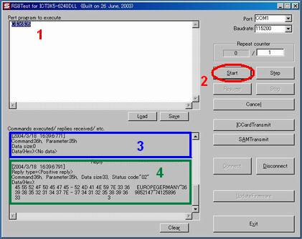
5. The procedure is always the same.
Input the command in the field (1) and execute then you find the reply in the field on the bottom (4).
We recommend you to prepare some command lines as .txt format.
It is possible to load .txt files from “RS8Test.exe”.

Please click the “Load” button.
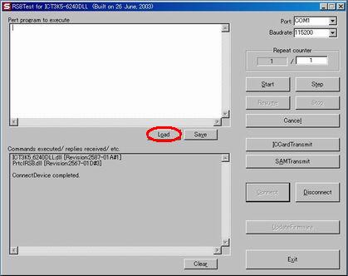

Then the extra window pops up and you can select text file.
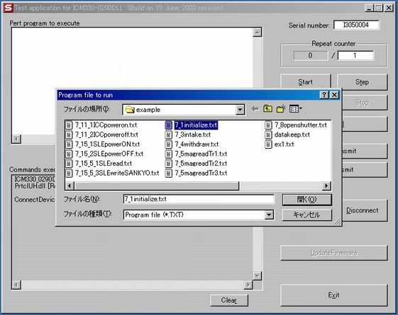
5. Exit the program.
Please disconnect (1) first and then exit (2) the program.
