How to Install Python3

<https://www.python.org/downloads/>

<https://www.python.org/downloads/release/python-364/>

[Windows x86-64 executable installer](https://www.python.org/ftp/python/3.6.4/python-3.6.4-amd64.exe) - <https://www.python.org/ftp/python/3.6.4/python-3.6.4-amd64.exe>

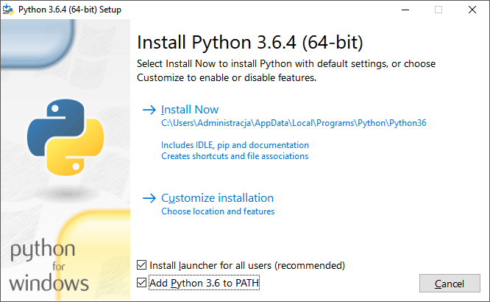

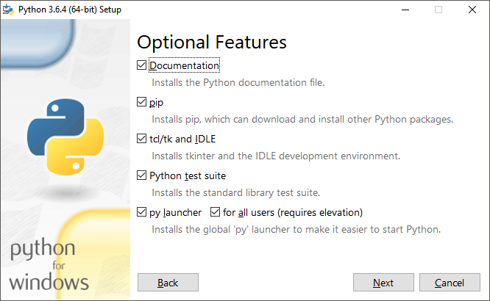

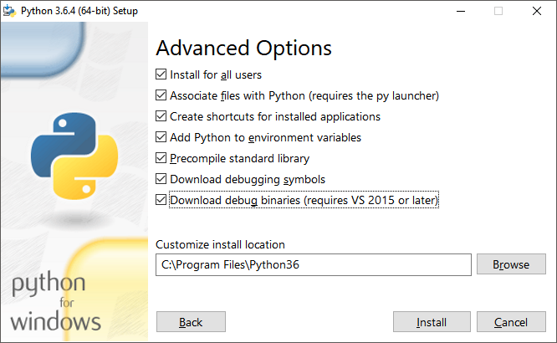

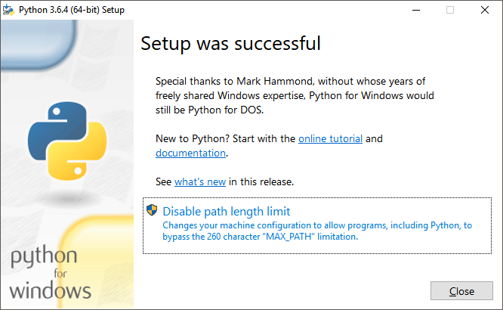

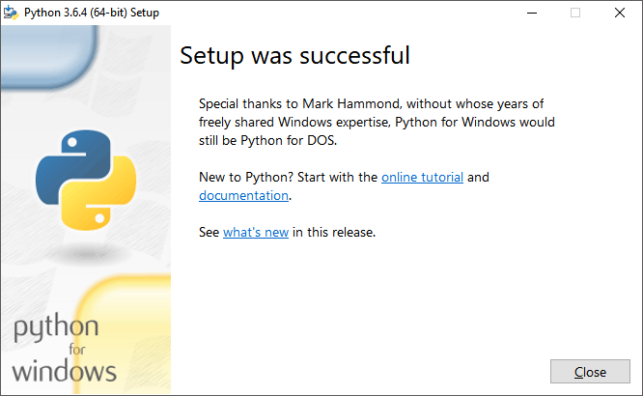

ESP8266/ESP32 Support

## Install ESPTOOL

Right-Click on the Console Window icon and “Run as Administrator”

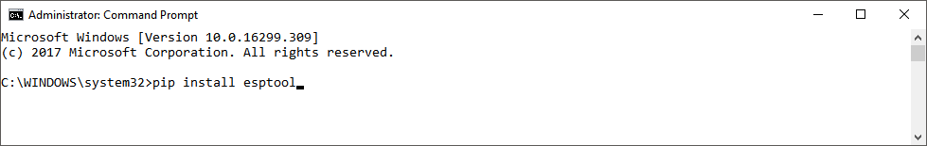

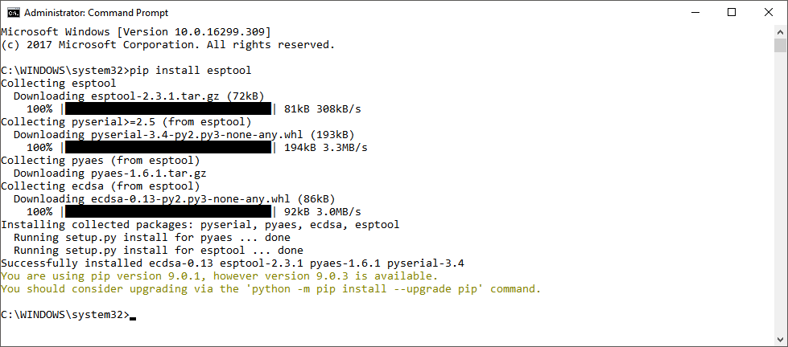

## Install MPFSHELL

Right-Click on the Console Window icon and “Run as Administrator”

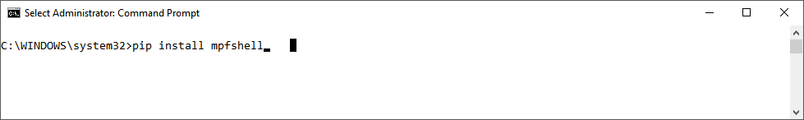

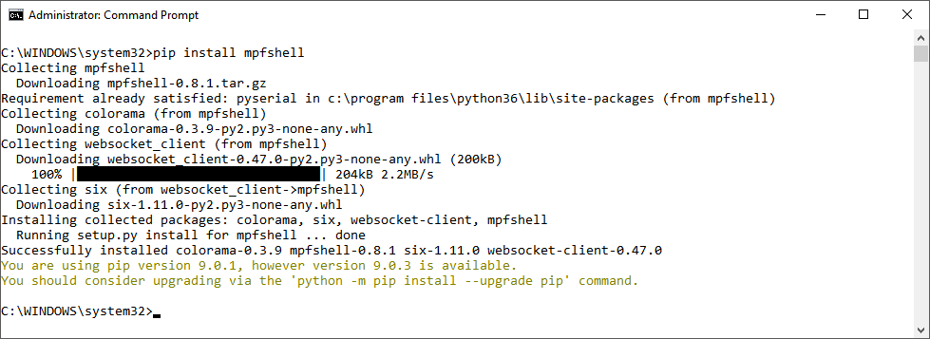

There is one more minor adjustment…

Find MPFSHELL and rename it to MPFSHELL.py

