**Redo**

1. **Existing alternatives (additional text) add it under the text of the problem:** 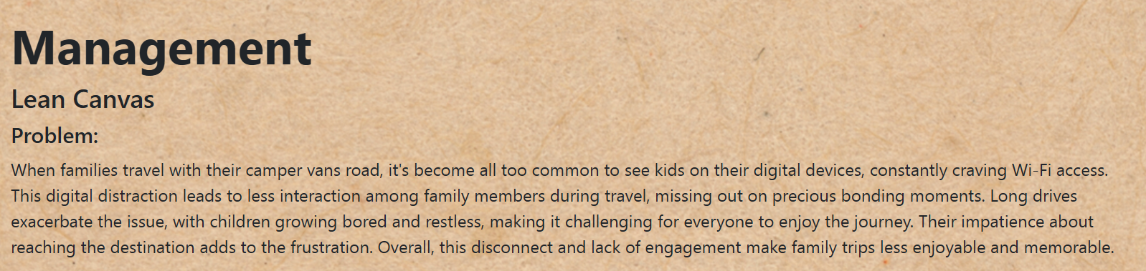

**Drive and Listen (**https://driveandlisten.herokuapp.com/**)** is a unique website that allows users to virtually take a drive around various cities around the world while listening to local radio stations. This interactive experience can help to reduce the boredom and reduce the monotony of long drives by providing virtual sightseeing combined with cultural audio. This tool captures the attention of children and makes the journey more interesting. They can explore new places and cultures virtually, which is both educational and entertaining. Families can discuss the virtual cities they are "visiting", which promotes interaction and conversation. This can lead to discussions about geography, cultures, and travel dreams, promoting family bonding.  
**Travel board games** are designed to be compact and easy to play in the car. Examples are magnetic chess, which prevents pieces from sliding around the car, and scavenger hunt games made for road trips, which encourage children to look out the window and spot various items and taking them from their phones. These games encourage family members to play together, stimulating interaction and teamwork. This can significantly reduce the feeling of isolation that children may experience when involved in individual activities on digital devices. Thanks to the travel board games, the problem with children being bored is already solved, because the games sometimes take long time and they are entertaining.

**Audio books** accessible through platforms like Storytel, provide a wide range of narrated books suitable for children of all ages. These can be educational, fictional, or even storytelling sessions. The website Storytel easily solves the problem of children becoming impatient in reaching the final destination since audio books may grab children's imaginations with engaging stories, making the journey feel shorter. Listening to a book can transport children into different worlds, reducing their impatience.

**2. Unique value proposition – add as a new part***Slogan:* Transform camper van travels into fun adventures: Keep kids entertained, get the family together!  
  
Transform camper van travels into fun-filled adventures that keep children entertained and happy, improving family bonding and the overall travel experience.

1. **Revenue streams – keep the text from the website and add the new one**

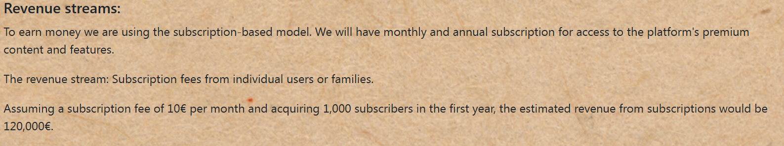

*Direct sales:*   
Another revenue stream is direct sales of games on our website. The team behind Faminvan will create unique games.  
Revenue model: one – time purchase of individual games created by our team.  
Revenue stream: Revenue generated from the sale of games.  
Assuming a price of a game 15€ and 200 purchases of the game in the first year, the estimated revenue from direct sales would be 3,000€.

*Advertisement partnerships:*Revenue model: collaboration with brands for in-game advertisements  
Revenue stream: advertising fees paid by brands for ad placement. Assuming partnerships with 3 brands, each contributing €5,000, estimated revenue is €15,000 for a year.

Estimated revenue for first full year: €138,000

1. **Customer segment – add as a new part**

Our target group are people between 40 – 60 years old. Dutch camper van lovers are predominantly Millennials, with a slight male majority based on Statista (*Comparison by Age of Motorhome Operators by Country France | Statista*, 2024). They often have high incomes and live in rural or small-town settings. Their lifestyle is heavily centered around outdoor activities and nature, with a strong interest in travel. Environmentally conscious and often early adopters of new products, they engage with a variety of media and remember advertisements well. (Statista, n.d.) They typically lead family-oriented lifestyles and this particular age group is in a phase where they seek travel experiences for themselves and their children/grandchildren. Campers prefer adventure over luxury and are characterized by their adventurous, active, open-minded, flexible, and independent nature. (*Go RVing RV Owner Demographic Profile*, n.d.)

1. **Add the picture of the new lean canva that I sent you and name it “Version 4 - redo”**

**References:**

*Go RVing RV Owner Demographic profile*. (n.d.). RVIA. https://www.rvia.org/go-rving-rv-owner-demographic-profile

Statista. (n.d.). *Target audience: Campers in the Netherlands | Statista*. https://www.statista.com/study/144833/target-audience-campers-in-the-netherlands/

*Comparison by age of motorhome operators by country France | Statista*. (2024, May 22). Statista. https://www.statista.com/statistics/1170325/camping-coaches-age-nationality-france-comparison/