**Depth47**

*by*

*Oleksandra Albear Rodrihes*



*Depth 47* is an indie horror game that tells the story of a father who lost his daughter. Waking up in the middle of the night, he discovers the true reason behind her suicide. The blame lies with a deadly game whose final task is to take one's own life. Now, he has only one goal: to play the game himself to find those who destroyed his family.

The plot revolves around the deadly game called *Depth 47*, which serves as the central theme of the story. This is not just a fictional tale but is inspired by real events that took place in many countries during the 2010s.

The essence of the game was that children and teenagers would write in a chat expressing their desire to play. A “curator” would then contact them and begin assigning tasks. At first, the tasks seemed simple and harmless, but as the game progressed, they became increasingly disturbing and terrifying.

By the time the tasks turned sinister, the players found themselves unable to quit. The curators would start threatening their families and loved ones, convincing the players they knew where they lived. This psychological manipulation left players with no choice but to follow the rules of the game, leading to the final, horrific task: suicide.

This is exactly what happened to the main character: his daughter played the game and reached the final task. Upon discovering this, he is consumed by grief and bitterness. He hadn’t known his child was playing this game, hadn’t realized someone was threatening her, and had failed to notice the changes in her mood or the fear she was hiding.

Overwhelmed by guilt, he quickly begins to blame himself. But almost immediately, this guilt is replaced by a burning desire for revenge. The question is: how can he find the curator?

The only way is to play the game and deliberately refuse one of the serious tasks, forcing the curator to come for him — to his home.

Similar games include *The Closing Shift, Shinkansen 0, Night Delivery*, and others. These are outstanding indie horror games where the story takes center stage. The atmosphere of fear is not artificially created through jump scares, unsettling music, or grotesque imagery, but rather through an authentic sense of dread, terrifying situations, and believable circumstances.

In these games, the plot unfolds gradually, allowing the player to immerse themselves in the character's life, understand them, and feel the atmosphere deeply. Furthermore, the endings are often quite unexpected and depend on the player's choices during the final arc of the game. This is an intriguing approach, where the player is not just an observer of events but can actively influence them through their actions.

This is precisely what *Depth 47* aims to achieve: a tense atmosphere, a natural sense of fear stemming from a realistic situation, gradual immersion into the protagonist's life, intrigue, and the opportunity to affect the ending.

Moreover, although these games cannot be called the best visually, there is something unique and appealing about them. The graphics make the games memorable and genuinely frightening. That would be great to adopt a similar visual style, as it perfectly conveys the game's mood, atmosphere, and sense of dread.

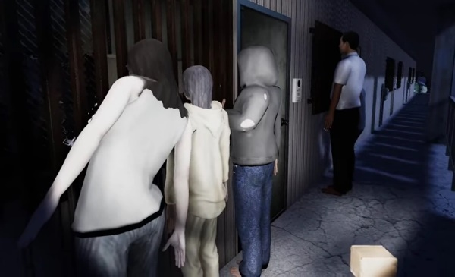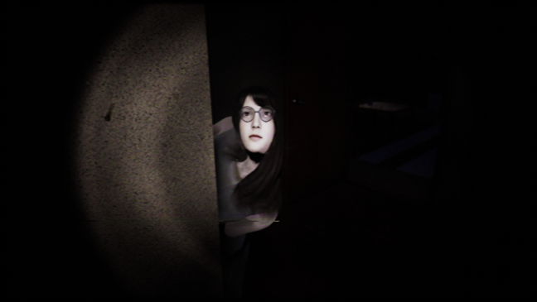

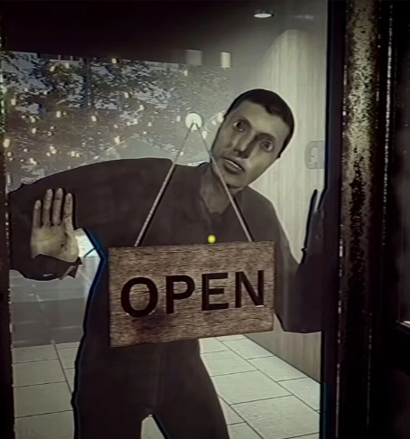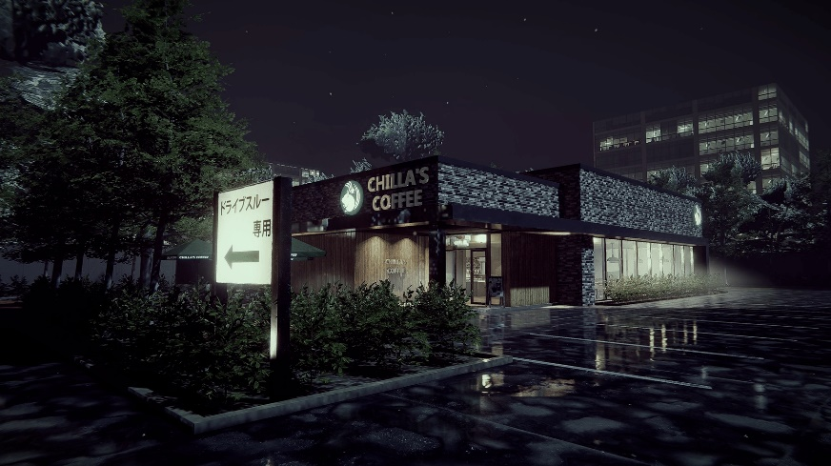

The target audience is people aged 18 and older who enjoy horror. The game has this age restriction for several reasons, including frightening scenes as well as depictions of suicide, self-harm, and similar content. The game will be released on Steam, with potential future expansion to the PlayStation Store. Players can use either a controller or a keyboard and mouse to play.

The atmosphere of *Depth47* may also slightly resemble the renowned film *The Babadook*. Much like the film, the game incorporates an air of mystery, pervasive silence, dark interiors, and a grim environment.

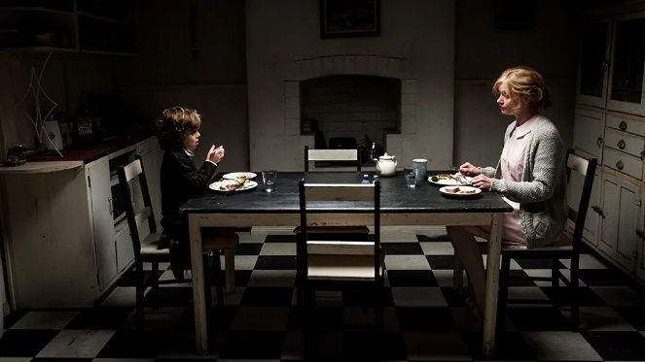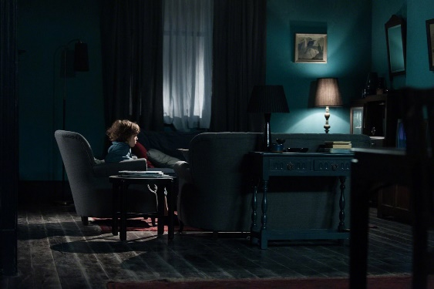

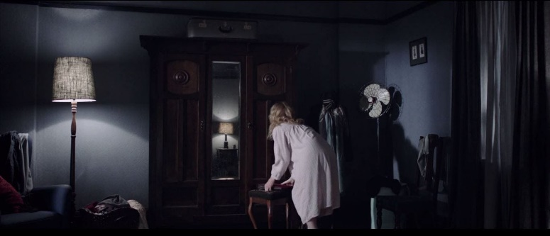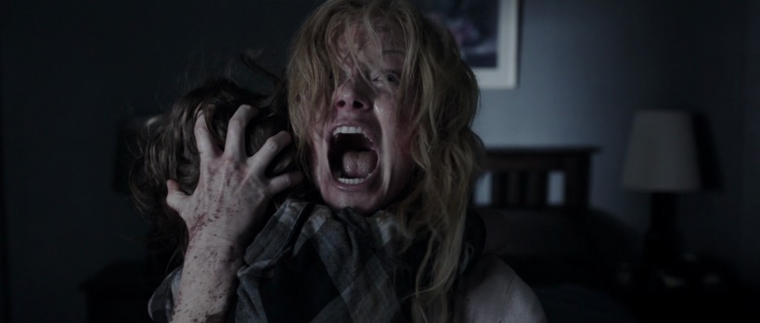

Narrative

At the beginning of the game, the player wakes up in an apartment. He gets up and goes to check his daughter's room. Along the way, the player familiarizes themselves with the layout of the home and its rooms. However, when he opens the door to the child's room, the bed is empty. The player continues searching until he reaches the farthest room. There, he sees the girl standing on the windowsill. As soon as the player enters the room, she jumps out. The player then wakes up back in his room.

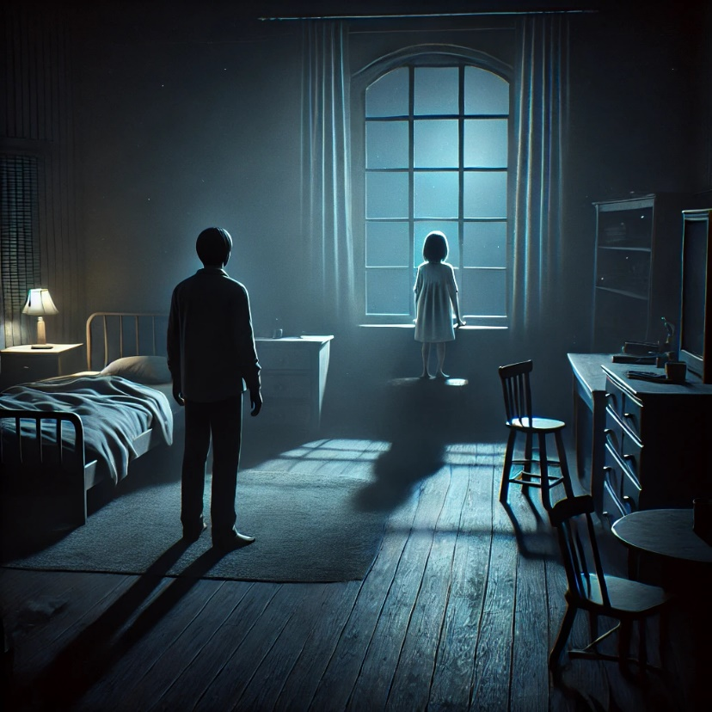

Right after this, the main events of the game begin. The player can interact with objects, and the apartment's condition makes it clear that the child has passed away. The child's room is empty. The player can examine items in the room and look around. Afterward, he goes to the kitchen to make coffee. But suddenly, sounds start coming from the child's room. When the player returns, he begins searching for the source of the noise and finds a phone. On it is a message: **"The game was completed."**

The father reads all the tasks his daughter completed and later finds evidence in her room that she was truly carrying them out. Exhausted by this discovery, he decides to take a nap. The protagonist once again has a dream.

In this dream, he gets out of bed because someone is banging on the apartment door. The player approaches the door, and the banging continues for a while but then abruptly stops. When the player returns, they notice a dark silhouette in the daughter's room. Immediately after this, the player wakes up.

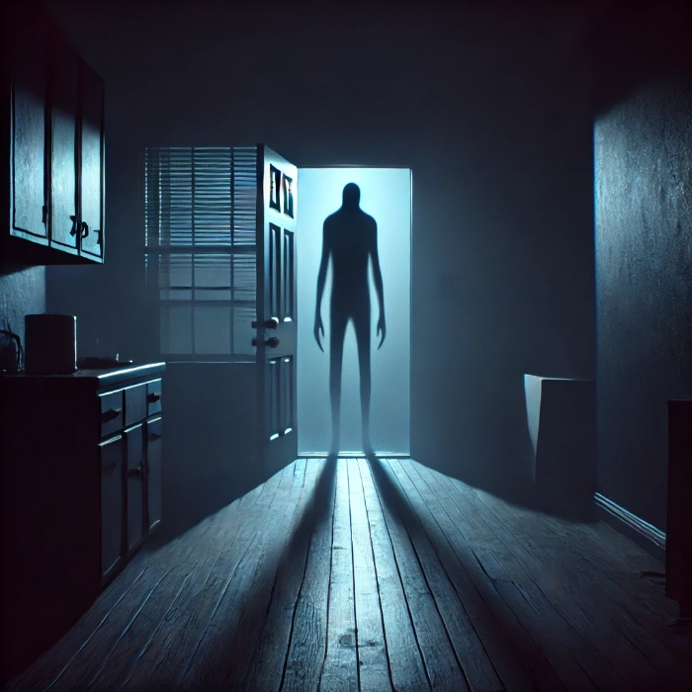

It is still night. The protagonist decides to play the game to lure out the curator and take revenge for his daughter's death. The player opens the phone and agrees to play. Now, he must endure three nights, completing all the tasks assigned by the curator.

During the first night, the tasks are simple. On the second night, they become more dangerous and challenging. The third night brings the final and most difficult tasks. It is during this third night that the protagonist writes that he will no longer do anything. He immediately receives a threat.

The next night, the threats become increasingly aggressive. At some point, the player notices that someone is watching him from the neighboring building—a dark figure. A little later, he sees the same figure standing outside on the street, staring up at his window. Moments later, the figure starts running toward the protagonist's apartment building.

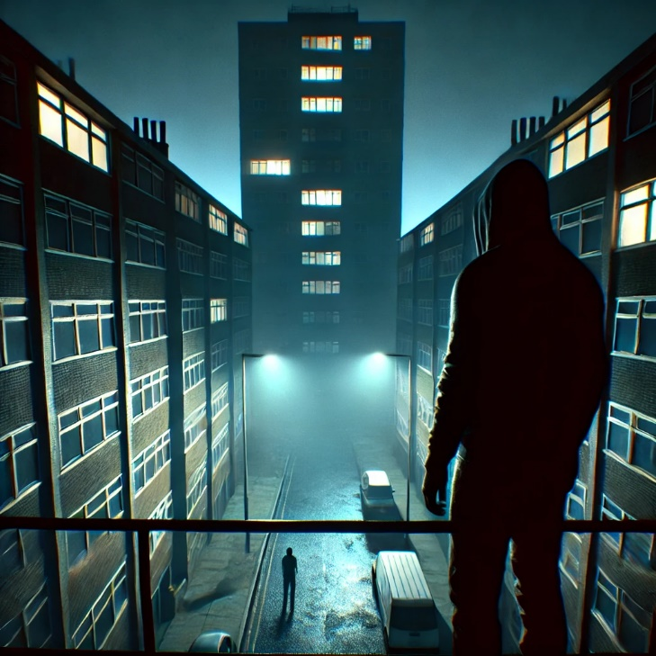

This marks the beginning of the final arc. Someone starts pounding on the door. The player has limited time to find a solution to the problem. The first option is to try escaping down the fire escape to the street. From there, the player can either board a bus or keep running. **If the player boards the bus**, the protagonist is killed, as the silhouette turns out to be on the bus as well. **If the player keeps running**, they will find a police station, leading to the curator’s arrest.

The second option is to hide in the apartment. No matter where the player hides, the figure will find them and kill them. However, if the player takes a weapon, such as a knife, they will be able to defend themselves. In this case, the protagonist kills the curator. The game ends with the protagonist being arrested for the murder.

The third option is suicide. The player can choose to jump out of the window or drown themselves in the bathtub. In this case, the game ends tragically, with the protagonist succumbing to the same fate as his daughter.

The fourth option is to hide, and when the curator enters the apartment, the player can emerge from their hiding spot and escape through the open door. From there, the player has several choices:

**Knocking on Neighbors' Doors** - the neighbors call the police, leading to the curator’s arrest.

**Running to the Courtyard**—If the player previously took the car keys, they could escape by car. However, the game ends with a message that the pursuit continues for the rest of their lives. The players are caught and killed if they don’t have the keys.

**Running to the Roof** - on the roof, the player faces a final confrontation: either the curator kills them, or the player manages to push the curator off the roof, ending the game ambiguously.

The main struggle of the player is to survive and cope with the psychological pressure of the game's tasks. The conflict lies in the protagonist's desire for revenge, intertwined with bitterness, sadness, and grief. Each new night, the apartment becomes increasingly cluttered with trash, empty alcohol bottles, scattered children's drawings, and other items that reflect the protagonist's deep struggle to come to terms with his daughter's death.

This gradual deterioration of the environment not only reinforces the emotional weight of the story but also immerses the player in the character's growing despair and mental state, making the atmosphere even more haunting and poignant.

The game will feature no NPCs during the main gameplay. Only in the final arc will the curator appear, and depending on the player’s choices, NPCs such as neighbors or police officers might also make brief appearances. However, there will be no significant interactions with the neighbors or police—just quick dialogues to advance the story.

On the other hand, the interaction with the curator will be intense, involving a chase, a fight, and a desperate struggle for survival. This focus on isolation throughout the game enhances the atmosphere of loneliness and vulnerability, making the curator's appearance in the final arc even more impactful and terrifying.

As it may already be clear, the game contains several unexpected twists and key moments. The first key moment is when the player discovers that the daughter is playing the deadly game. Essentially, this moment sets the entire plot in motion. Other key moments include when the protagonist decides to play the game himself and when he refuses to continue playing. The first event drives the story forward, while the second triggers the start of the final arc. Both events are crucial to the narrative and propel it. Also in the final arc, where any action the player takes can lead to a different ending, each one surprising and impactful.

Interface

The player's interface will be very simple. There are no health bars, stamina, money, or inventory. A significant part of the interactions in the game will revolve around the phone, through which the player will receive tasks. The phone will be activated by pressing a key on the keyboard.

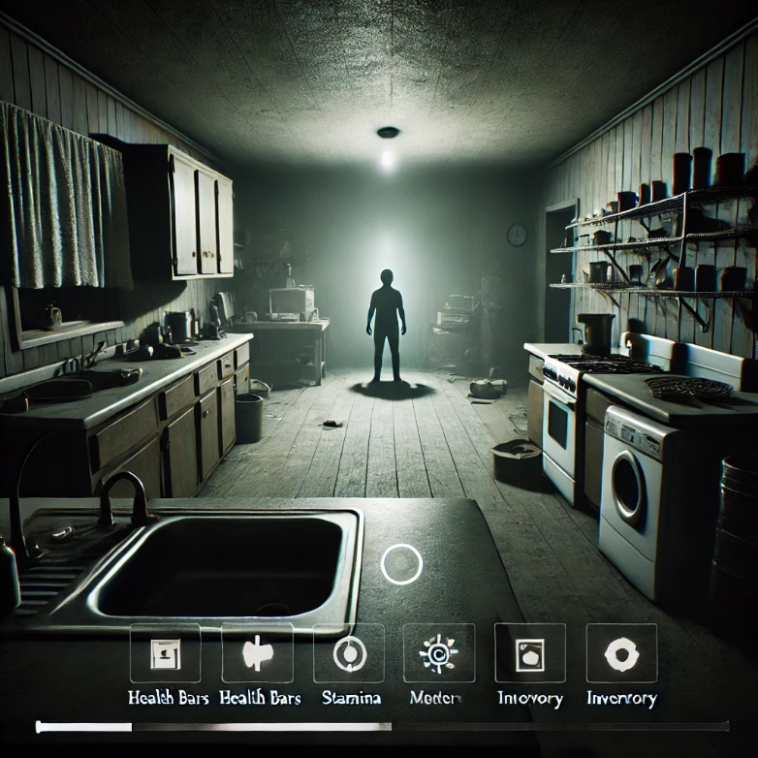

Approximate version of interface

The player can interact with various objects in the apartment, such as notes, photographs, the phone, the daughter's diary, windows, doors, the bed, the coffee machine, faucets, the staircase, the doorbell, and NPCs. Some of these interactions are dictated by the curator's tasks, some help the player understand what is happening in the game, and others advance the plot.

When interacting with objects, nothing can be taken or added to an inventory. The only items that can be picked up in the game are the car key and the knife. They do not go into an inventory but remain in the game's memory for future events.



Not all objects can be interacted with throughout the entire game. For example, the staircase or the front door can only be interacted with during the final arc. Similarly, interactions with certain objects are not always available. For instance, lying on the bed is not an option whenever the player wishes; this action is only accessible when dictated by the story.

Intuitive controls and progression will also play a role, especially in the final arc, where the player will rely purely on instinct to survive, following their gut feeling. This intuition can either fail them or lead to success. Before the final arc, the game's intuitive elements are limited to exploring the house and choosing to examine certain objects. However, everything else will be dictated by the curator's tasks and the game's directions.

From the very beginning of the game, the player only needs to know that the protagonist lived alone with his daughter until she took her own life. Upon the first exploration of the house, it becomes clear that the girl was playing a deadly game. Additionally, the player will notice from photographs that it was just the father and daughter, she attended school, and he worked. They lived an ordinary family life.

Later, when the player begins playing *Depth 47,* they will gradually uncover more details as tasks are completed. For example, by finding the daughter's diary in the apartment, it becomes evident that she started playing the game because she was struggling. Her mother had passed away, and her father decided to erase all memories of her, throwing away reminders and never mentioning her again. Moreover, he distanced himself emotionally from his daughter, which made her feel lonely. This loneliness drove her to start playing the game.

The diary will also reveal that the girl wanted to stop playing but was forced to continue because the curator threatened her father’s life. Knowing that the curator begins issuing threats when a player refuses to continue, the protagonist also chooses to stop playing at a certain point. This decision triggers the final arc, where the primary goal is to survive—and ideally, punish the curator for the girl’s death in one way or another.

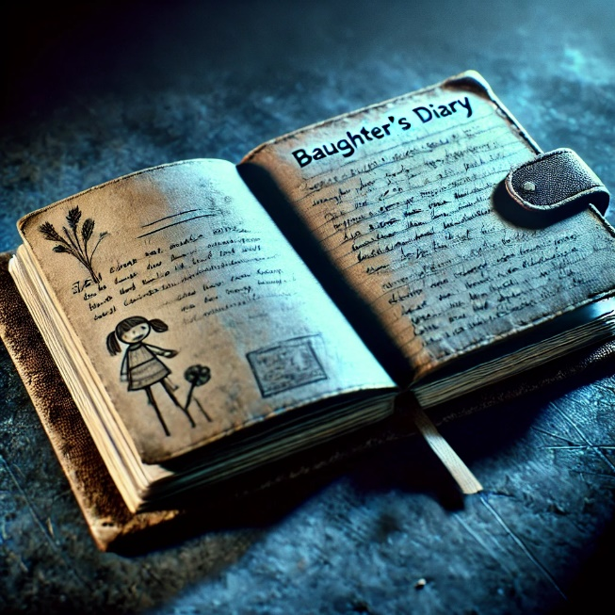

Audio

The game will feature minimal music to make the atmosphere, and events feel more realistic and terrifying. While music in games can amplify emotions, it also serves as a reminder that the player is within a game. By removing music, especially in horror games, the player may feel a heightened sense of tension, as it leaves them alone with the unfolding events. This lack of music enhances the immersive experience, making the player more vulnerable to the eerie silence and subtle environmental sounds, further deepening the sense of unease. Throughout the entire game, there will only be a deep, tense sound of emptiness.

Interestingly, this barely noticeable ambient sound will make all other sounds in the game feel much louder and more intense than they would otherwise. This subtle audio design will heighten the player's sensitivity, causing them to react more strongly to environmental sounds, such as creaking floors, distant thuds, or sudden noises. As a result, even small auditory cues will become sources of tension and fear, making the experience more immersive and unnerving for the player.

Of course, during very intense moments or jump scares, there will be sound. However, it won’t be full-fledged music but rather short, unsettling melodies, such as those played on a violin or piano, designed to amplify the sense of dread in the game. These sharp, eerie tones will enhance the horror and create a jarring contrast to the otherwise quiet and tense atmosphere, making these moments even more impactful.

In the main menu, which will consist of three buttons—Start/Continue Game, Options, and Exit—the music will be mysterious, slow, and slightly unsettling. This will set the tone for the experience ahead, giving players a sense of the tense and eerie atmosphere they will face in the game. The haunting melody will immediately immerse the player, preparing them for the psychological horror to come.

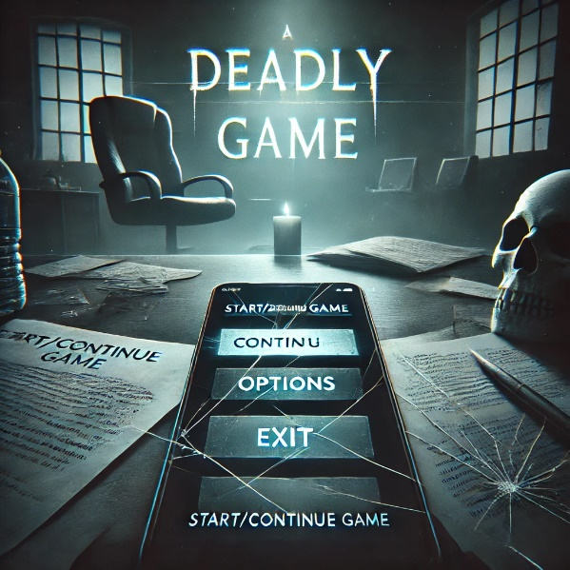

Approximate version of main menu

Sound is a crucial component of the game, significantly influencing both the mood and the perception of events. That is why it requires a very careful and thoughtful approach. With the right choices, the game world becomes far more terrifying and engaging. This is precisely why these sounds and melodies were chosen—they best highlight the unique characteristics of the world and the game itself.

[](https://www.youtube.com/embed/tKbZBhKmKRQ?feature=oembed)

Approximate version of how it may sound

Mechanics

The core gameplay revolves around exploration, interaction, task completion, decision-making, psychological tension, and survival. The player begins by investigating the protagonist's apartment, interacting with objects like notes, photographs, the daughter's diary, and other environmental elements. These interactions are performed by approaching objects and clicking the left mouse button, while the phone—a key tool for receiving tasks and progressing the story—is accessed and closed using the "T" key.

The core loop begins with exploration and investigation as the player uncovers details about the daughter's life and her involvement in the deadly game. Tasks are then received via the phone, acting as the primary driver of progression. The player must execute these tasks, which escalate from simple and safe actions to morally and physically challenging ones, increasing tension as the story unfolds. Through diary entries, notes, and environmental clues, the player learns about the daughter's struggles and the father's guilt and growing resolve.

During the first night, the tasks are simple and seemingly harmless. The first task instructs the player to draw something cute on a piece of paper and leave it on their bed before going to sleep. The second task requires them to turn off every light in the apartment and remain in complete darkness for five minutes. The final task of the night asks the player to stand in front of a mirror and take a picture of themselves with their phone.

On the second night, the tasks become more unsettling and dangerous. The first task directs the player to unlock the front door of their apartment before going to bed. The second task asks them to find a sharp object, such as a knife, and make a small cut on their hand, providing proof by showing the blood. For the third task, the player is instructed to walk outside at night to the nearest streetlight, stand there for two minutes, and take a picture.

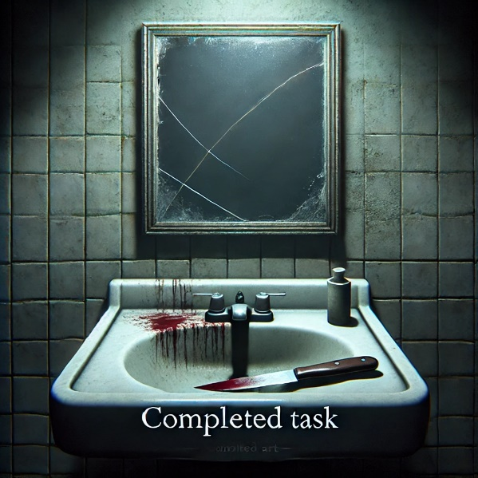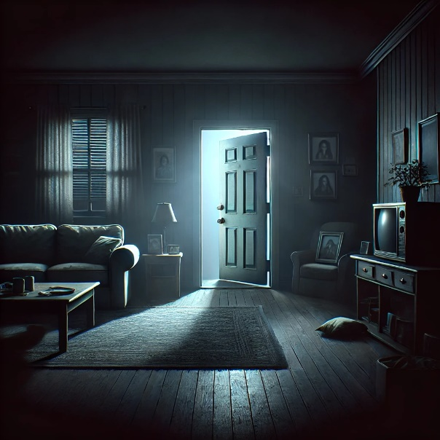

By the third night, the tasks reach a point of extreme danger and emotional distress. The first task commands the player to destroy a meaningful personal item, such as a photo, a gift, or a diary, by burning it. The second task escalates further, instructing the player to go to the balcony, stand on the edge, and lean forward as far as possible without falling, holding the position for thirty seconds.

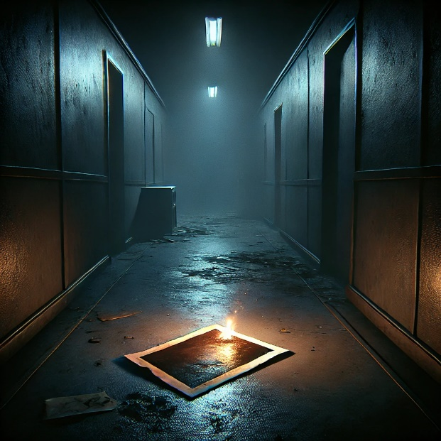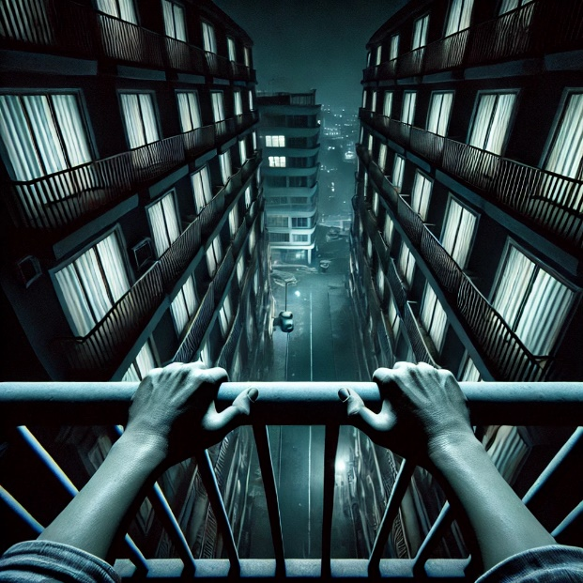

Key decisions are woven into the gameplay, with moments such as the protagonist refusing to continue the game. This triggers the final arc, where the player must navigate life-or-death situations, making critical choices like attempting to escape, confronting the curator, and so on. The survival challenge in the final arc adds a new layer of intensity, with each decision directly affecting the outcome.

The game finishes with one of several endings, shaped by the player's actions during the final arc. The combination of minimalistic design, realistic soundscapes, and tension-filled progression immerses the player in the protagonist's struggle, ensuring a deeply emotional and engaging experience. This core loop of exploration, task execution, and decision-making forms the backbone of the gameplay, driving the narrative and maintaining psychological tension throughout.

All the player’s actions are clearly driven by the emotions stemming from the death of the protagonist’s daughter. The desire to uncover the truth and seek revenge is at the core of their motivation. Additionally, the player must thoroughly explore the apartment and its objects to gain a deeper understanding of the situation, beyond a surface-level perspective, to piece together the full story.

The task system plays a significant role in shaping the player’s actions, effectively controlling their progression. Since failing to complete the curator’s tasks prevents the player from moving forward, compliance becomes essential, even as the tasks grow increasingly challenging and morally difficult.

In the final arc, however, the focus shifts entirely to survival and achieving "victory." At this stage, the player’s actions are aimed at staying alive and overcoming the immediate threats posed by the curator. The motivation reaches its peak here, as the player does everything in their power to avoid death and failure. This is the part of the game where the player’s actions hold the greatest weight, and they must rely heavily on their instincts and decisions.

The final arc encapsulates the emotional and narrative climax, making the player's ability to adapt, survive, and succeed both intensely personal and deeply impactful.

All obstacles in the player's path will appear only in the final arc. Before that, the player simply progresses through the story, with nothing standing in their way. In the end, however, the main obstacle to completing the game is the curator, who is trying to kill the player. Additionally, there is the pressure of limited time to find a way out of the situation and figure out a method to survive. Furthermore, the player does not know exactly what survival options are available, so the difficulty lies in figuring out a solution that will allow them to survive.

As previously mentioned, there are only two items the player can pick up—the car keys and the knife. Both items will contribute to successfully completing the game. However, the car keys will only be useful if the player escapes to the street through the building’s entrance; otherwise, they serve no purpose. If the player picks up the knife, it will only be helpful if they choose to hide in the house. In other situations, it will not be effective. These two items unlock two possible endings, but only under specific conditions.

Production

The vital art assets in the game establish the atmosphere, enhance immersion, and support the narrative. The apartment’s detailed environment—dim lighting, furniture, scattered personal items like family photos, children’s drawings, and alcohol bottles — reflects the protagonist’s grief and neglect. Lighting and shadows play a key role, creating tension and guiding the player’s focus. Interactive objects like the phone, diary, and keys are both functional and symbolic, driving the story and adding emotional depth. Textures and small details make the setting feel authentic and unsettling. The curator’s design, shadowy and menacing, contrasts sharply with the calm apartment, heightening fear during encounters. Together, these assets create an immersive, cohesive horror experience.

In the game, the lighting will be very dim. According to the story, it is always nighttime outside. While the player has good visibility, it is still clear that the apartment is barely lit. Small light sources like tiny lamps, flashes of lightning through the windows, and similar elements provide minimal illumination.

If the player goes outside, there are streetlights that brightly illuminate the roads. On the building's exterior, small perimeter lights cast a modest glow, lighting up the area. This design choice is intentional to make the indoor spaces appear even more frightening. Darkness often evokes fear in people, enhancing the unsettling atmosphere of the game. Point light will be the most used one, warm tones.

In general, light and shadow play a significant and crucial role in horror games, as this genre aims to scare players both visually and through its story. In *Depth47*, light will be scarce but sufficient for navigation. Darkness serves as one of the primary tools of fear in this game, amplifying the unsettling atmosphere and enhancing the horror experience.

There will be the usage of dynamic light on one of the nights with the lightning. That will help to create the atmosphere and the mood of the game.

Key reliability factors in *Depth47* are essential to ensuring a seamless and immersive player experience. Stable performance is crucial, with the game running smoothly without crashes, significant frame drops, or loading delays, regardless of hardware. Responsive controls are another vital aspect; interactions like movement, item pickups, and phone usage should respond instantly to player input, creating an intuitive gameplay experience.

Clear visual cues, such as the small dot indicating interactive objects, help players navigate the environment without frustration. Sound design must also be consistent, with environmental audio and effects reliably matching in-game events to maintain the eerie atmosphere. Logical gameplay flow ensures tasks and objectives are clear, allowing players to progress naturally without confusion or becoming stuck due to unclear instructions.

The color palette of the game is predominantly dark, with the only elements standing out being the sources of light. A bluish tint will dominate the visuals, as blue is a color often associated with sadness, perfectly aligning with the narrative's emotional undertones. This color choice also enhances the atmosphere of the game, amplifying its eerie and unsettling tone.

Dark colors evoke feelings of fear and darkness, playing into the psychological aspects of the horror experience. The bluish hues, combined with the dim lighting and shadows, create a cohesive aesthetic that not only underscores the story’s themes but also heightens the emotional impact on the player, making the environment feel oppressive, lonely, and hauntingly beautiful.

Project Scope

The development of *Depth47* will require approximately 6 months of focused work. During this time, the project will progress through pre-production, production, and polishing phases. Pre-production, lasting one month, will focus on finalizing the story, script, and branching choices. This phase will also involve creating a storyboard for key scenes and prototyping core gameplay mechanics, such as the interaction system, task mechanics, and lighting.

The production phase will take 3 to 4 months and will involve building the detailed apartment environment, including the father’s bedroom, daughter’s bedroom, living room, kitchen, and bathroom. These spaces will be designed to reflect the game’s narrative themes, with dim lighting, interactive objects, and environmental storytelling elements like scattered photos, drawings, and clutter. Gameplay systems will be fully implemented during this time, including the phone-based task system, object interaction mechanics, and AI behavior for the curator, particularly for the final arc. Dynamic lighting and sound design will also be integrated to enhance the game’s tense and eerie atmosphere.

The final month will be dedicated to polishing and testing. During this stage, performance optimization, bug fixes, and refinements to both audio and visuals will ensure a smooth and immersive experience. Playtesting will cover all story paths and multiple endings to confirm that all elements function as intended and provide the intended emotional and gameplay impact.

To support the development a team will be required including a game designer, environment artist, programmer, sound designer, and narrative designer. The game engine will be Unreal Engine, with collaboration tools like GitHub and Trello to manage tasks and version control. The estimated budget ranges from 100,000$ to 120,000$, accounting for software licenses, assets, sound design, salaries, and marketing.

The final deliverable will be a complete horror game with a detailed apartment environment, functioning gameplay systems, and a fully realized story. The game will include interactive objects, task progression, immersive sound, and lighting, an intense final arc with multiple endings. This structured approach ensures that *Depth47* achieves a balance of narrative depth, atmospheric horror, and engaging gameplay.