SELECT misto

FROM klient

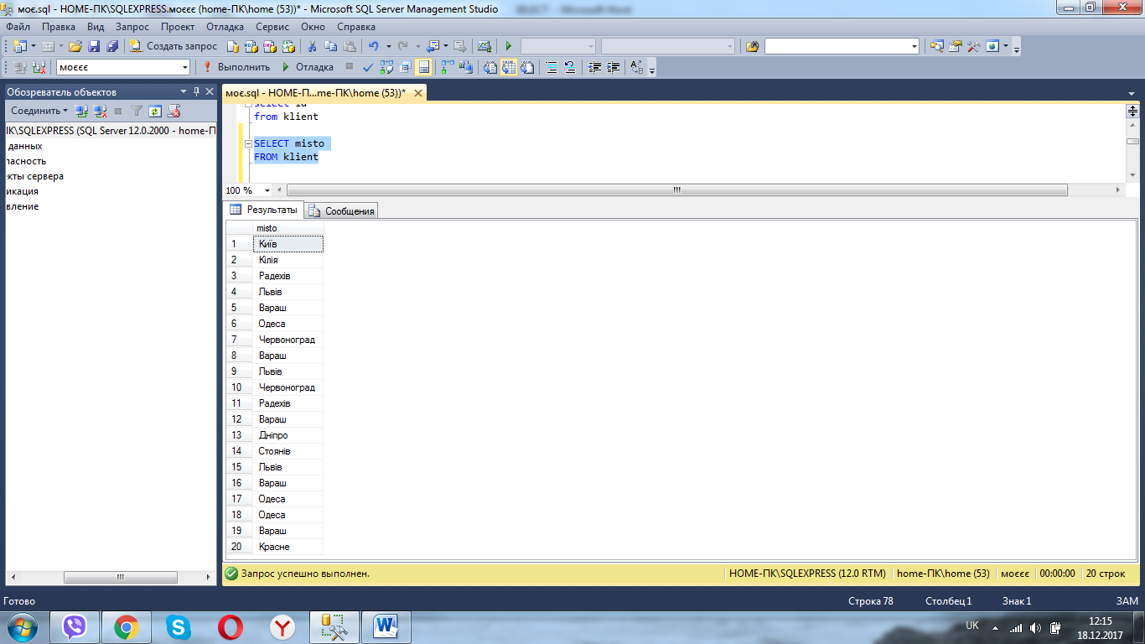

SELECT * FROM Eat

ORDER BY vartist DESC

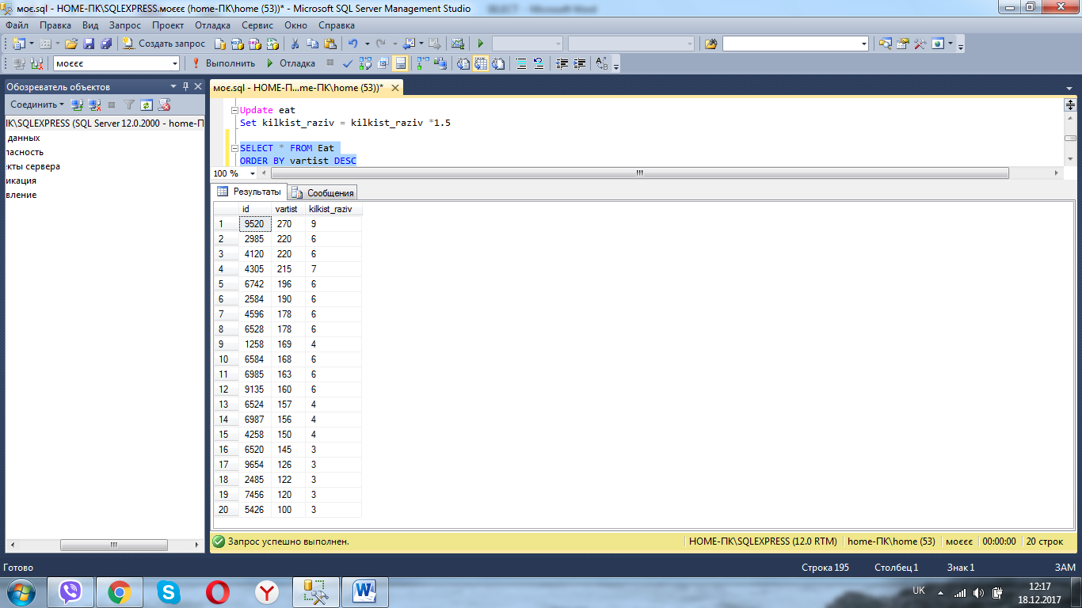

SELECT max(vartist) AS LargestVartist

FROM transport

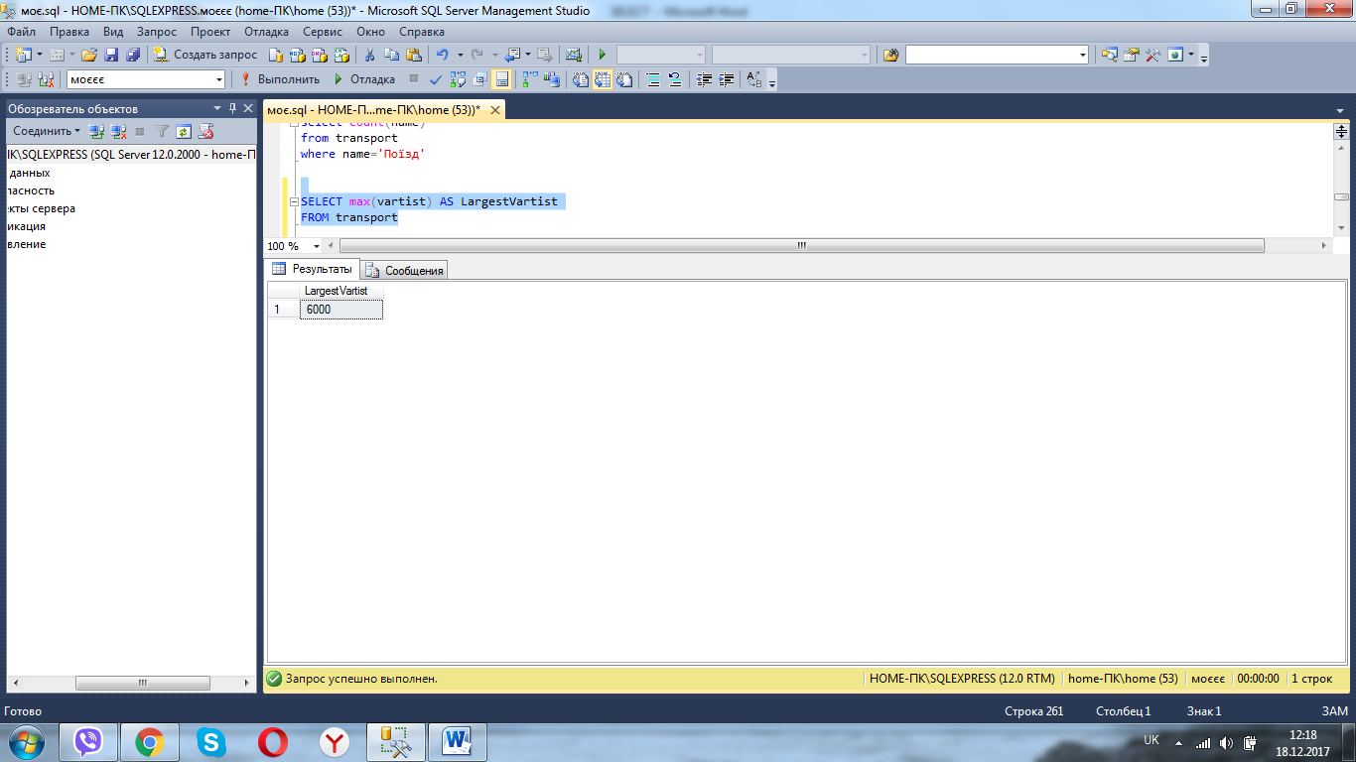

SELECT * FROM klient

WHERE misto='Львів'

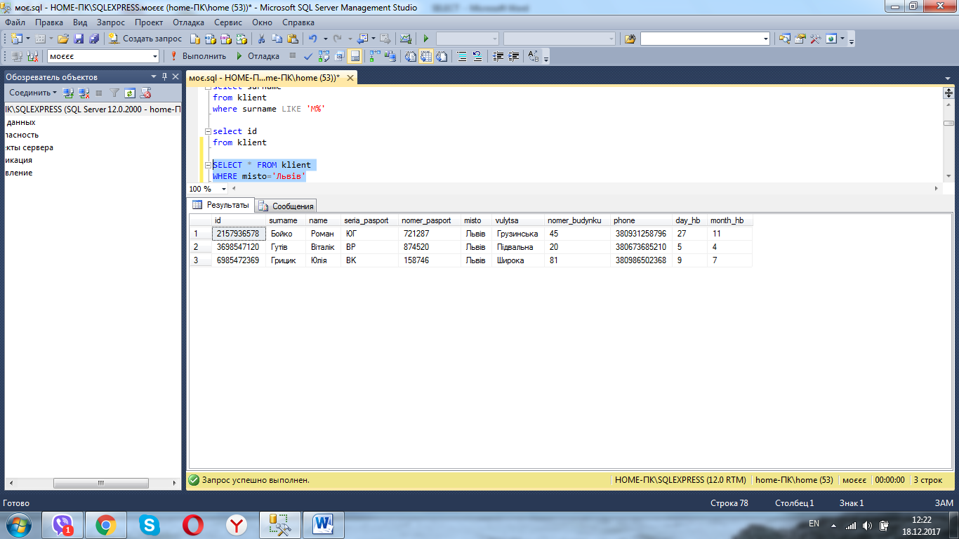

SELECT * FROM putivka

WHERE vartist > '1200'

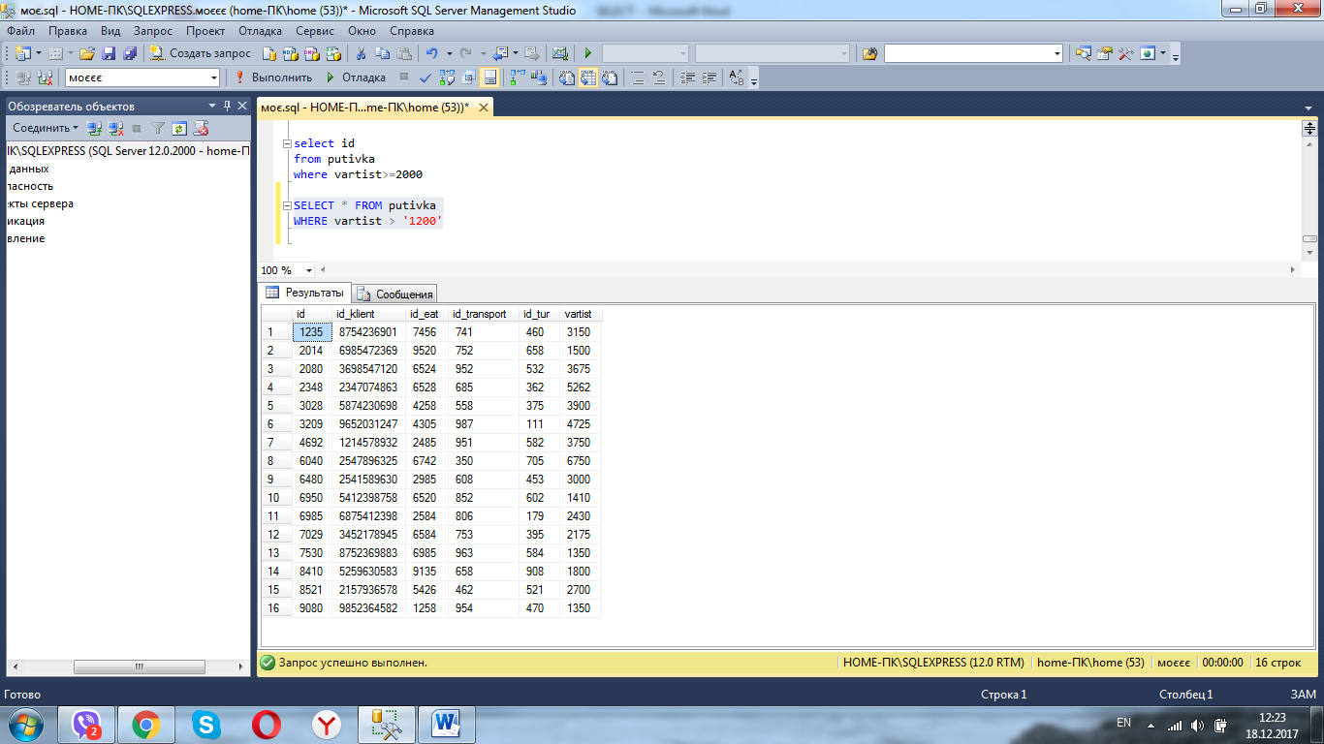

SELECT * FROM tur

WHERE kilkist_dniv BETWEEN 8 AND 12

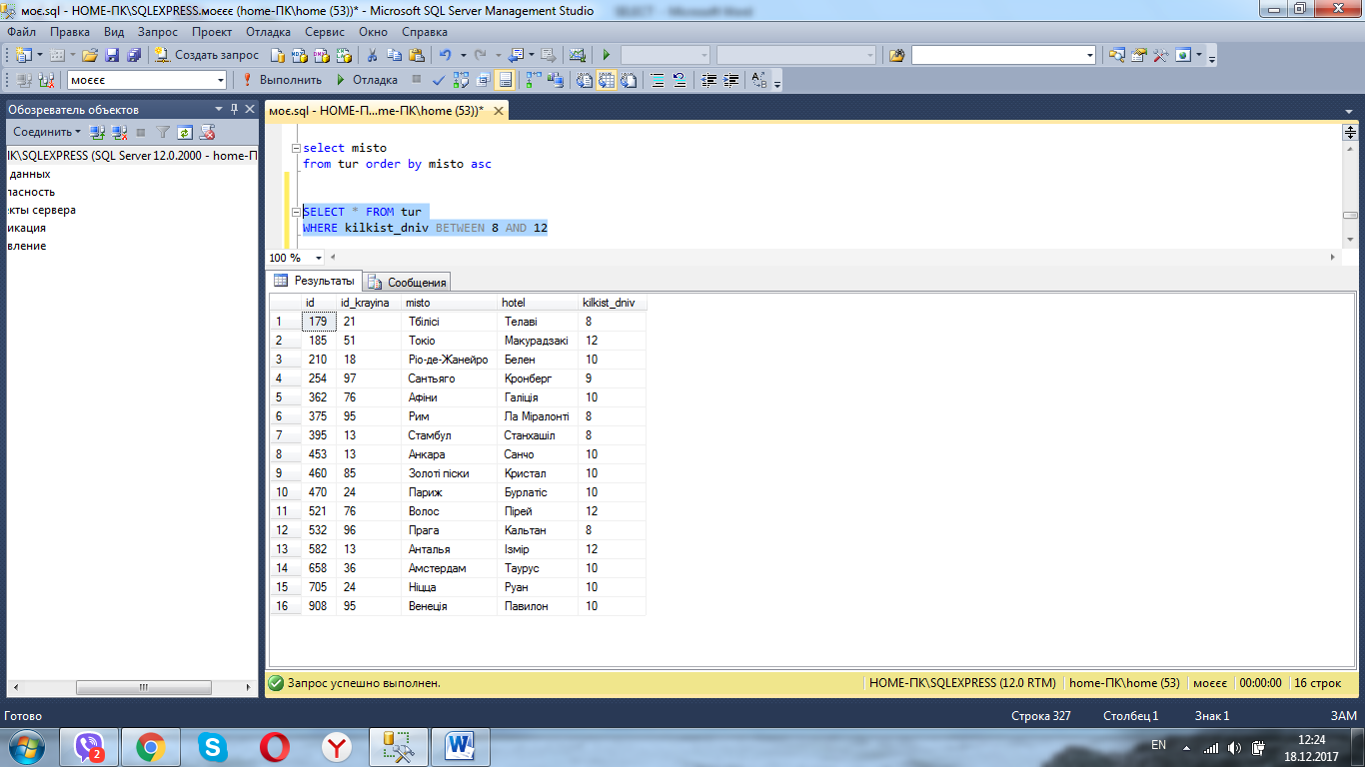

SELECT * FROM klient

WHERE phone LIKE '%18'

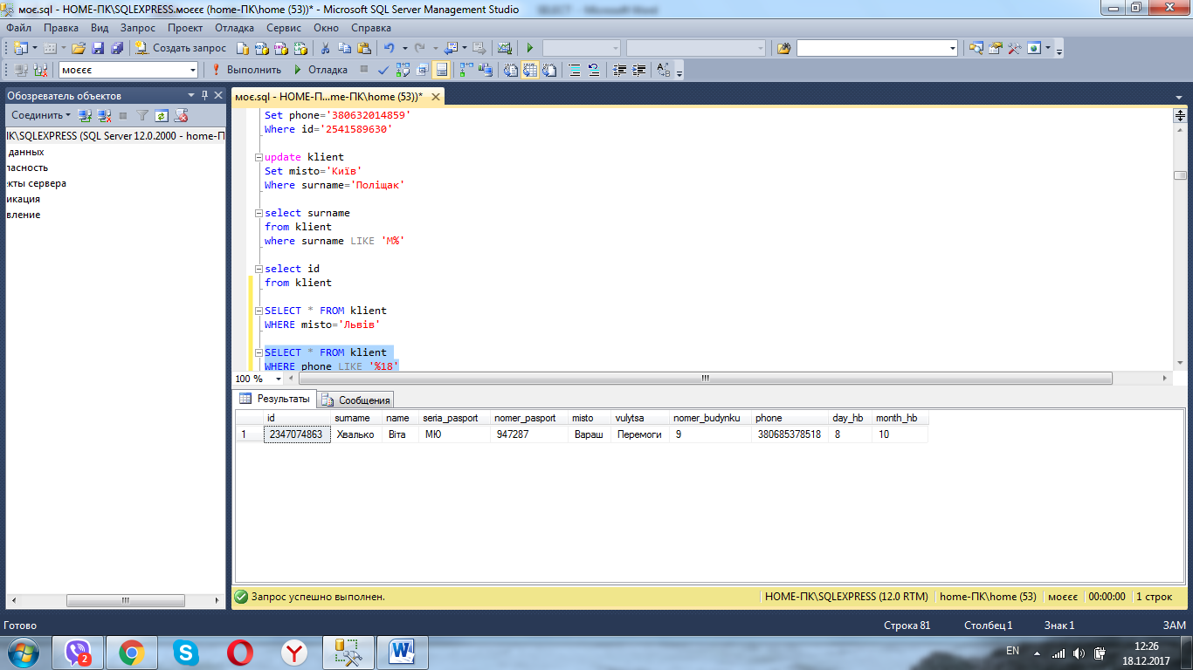

SELECT COUNT(id)

FROM klient

