select surname

from klient

where surname LIKE 'М%'

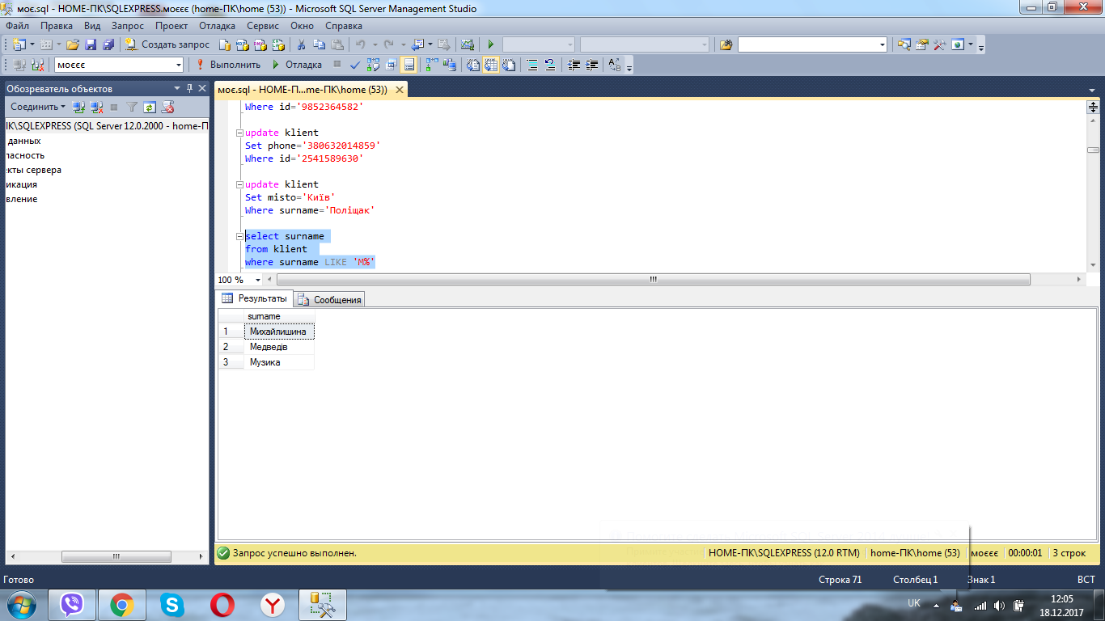

select id

from klient

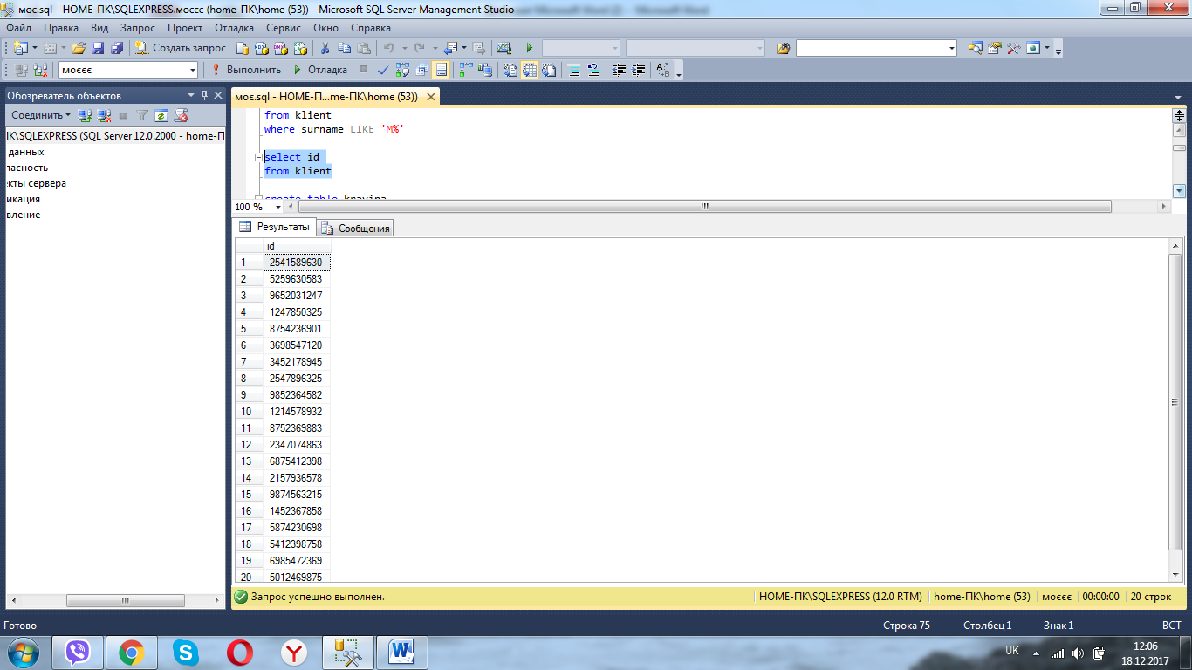

select name

from krayina

where neobhidnist_viza='Ні'

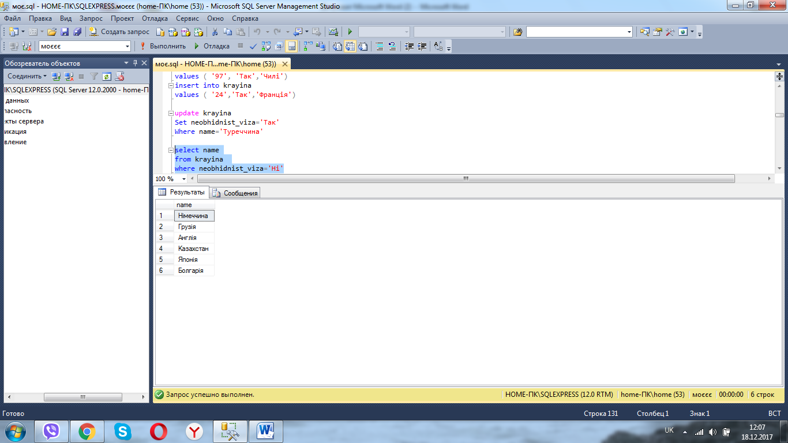

select name

from krayina

where id between 13 and 55 order by id desc

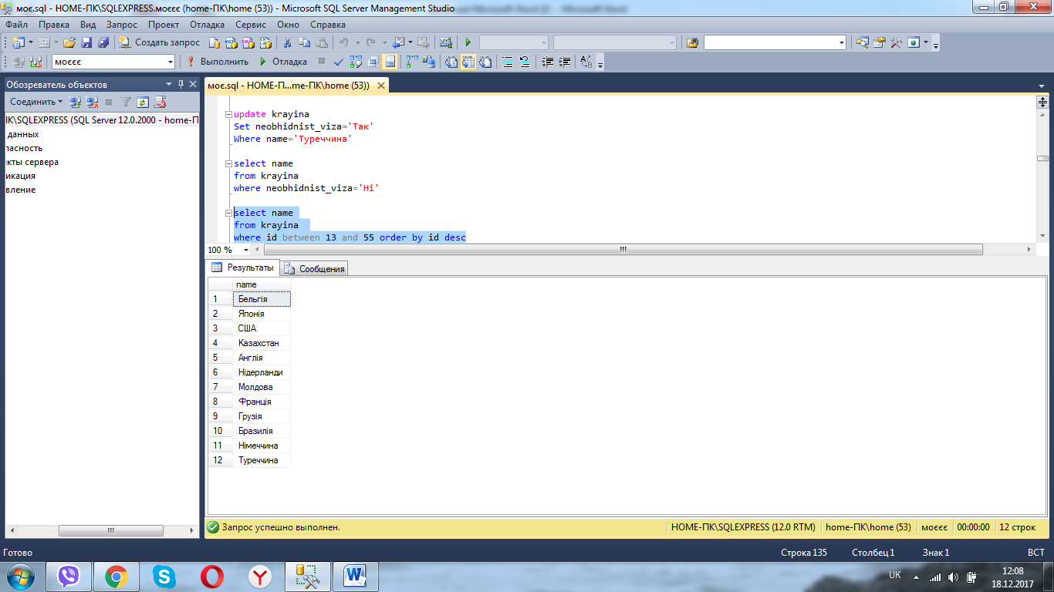

select count(name)

from transport

where name='Поїзд'



select misto

from tur order by misto asc

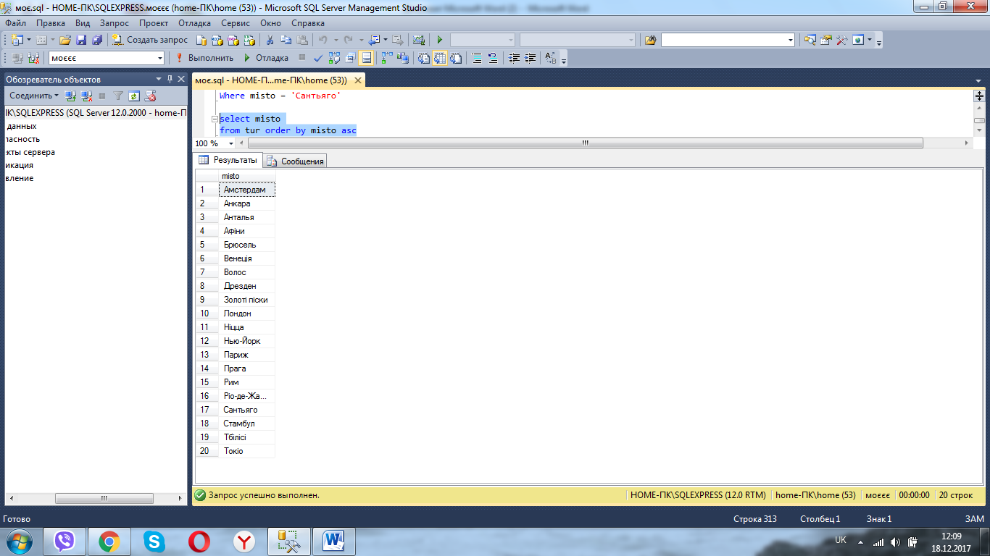

select avg(vartist)

from putivka

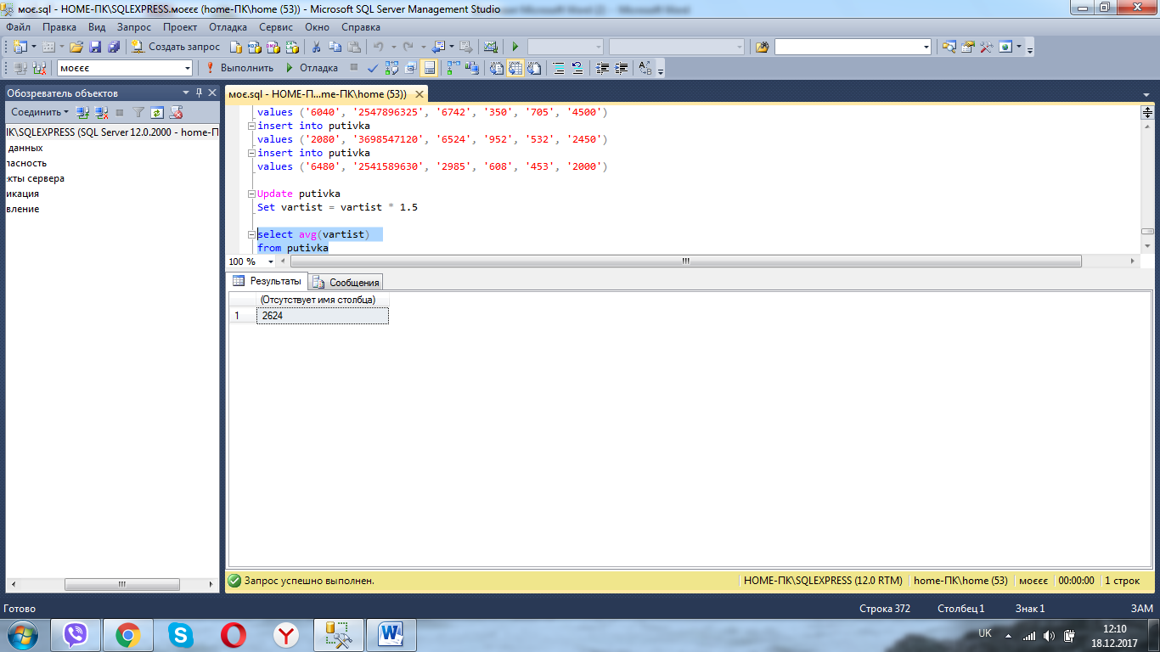

select id

from putivka

where vartist>=2000

