AI QE Lab
Prerequisites & Build Guide
Shopping RAG Assistant • QA Agent • Test Management Lifecycle Agent
Version 1.0 | Purpose: hands-on AI Quality Engineering lab with controlled failures, traceability, evaluation, automation and release-readiness reporting.

1. What we are building
Stream | System | Purpose | Primary testing
1 | Shopping AI Assistant | Natural-language product search and policy Q&A using RAG | RAG, LLM, API, integration, E2E, NFR
2 | QA Agent | Requirements review → risks → tests → failure analysis → defect creation | Agent/tool-use, grounding, coverage, autonomy, HITL
3 | Test Management Lifecycle Agent | Strategy → plan → monitoring → completion → recommendation | Lifecycle agent, governance, document quality, decision quality
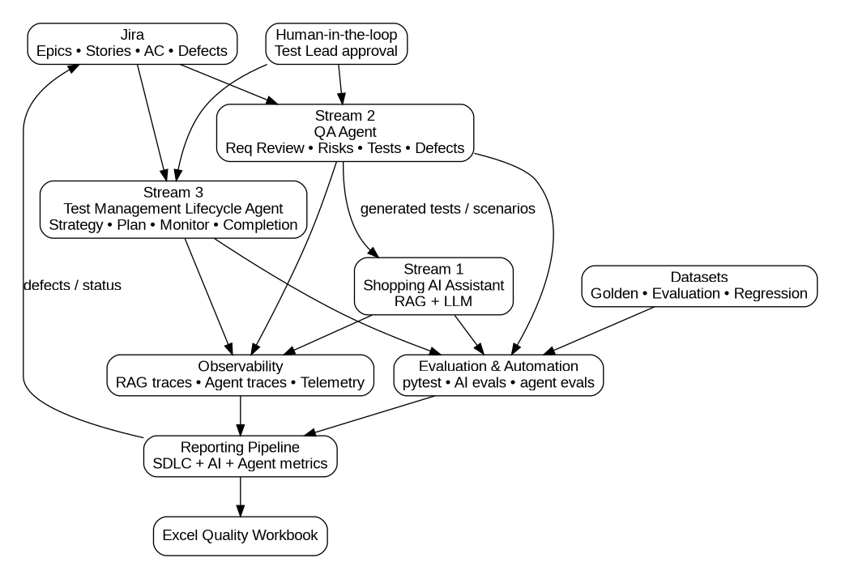

2. Prerequisites checklist
- Local machine with Python 3.11+ and Git.
- IDE/editor: VS Code or equivalent.
- Optional local coding agent: Codex CLI or Claude Code. It is convenience, not a dependency.
- One LLM API account/key (OpenAI or Anthropic initially; abstraction can support both later).
- Dedicated Jira Cloud lab project. Do not point autonomous writes at a real production project.
- Python virtual environment for the lab.
- API spend limit / budget alert configured before bulk evaluation runs.
- Secrets stored in .env; .env excluded from Git.
- Start Jira integrations read-only. Enable writes only after Human-in-the-loop approval flow is tested.
- Open the supplied workbook and review Golden, Evaluation, Regression, Risk Register, Traceability and Metric Catalogue sheets.

3. Build order — do this in sequence
Phase | Build | What | Why
Phase 0 | Local foundation | Repo, venv, secrets, dependencies | Reproducible and safe environment
Phase 1 | Data layer | Load approved products + policies | Known source of truth
Phase 2 | Shopping Assistant | Chat/API + retrieval + generation | First SUT works end-to-end
Phase 3 | Observability | Log retrieval, augmentation, generation, versions, latency | You can inspect R→A→G instead of black-box only
Phase 4 | Evaluation | Run Golden/Evaluation/Regression datasets | Quality becomes measurable
Phase 5 | Jira + QA Agent | Read stories, review, risks, tests, HITL defect creation | Agentic AI testing
Phase 6 | TM Lifecycle Agent | Strategy, plan, monitoring, completion, recommendation | Governance/lifecycle agent testing
Phase 7 | Automation + reporting | pytest + reporting pipeline + Excel/Jira outputs | Repeatable regression and release view

4. Phase 0 — local setup
WHAT: create the project shell. WHY: isolate dependencies/secrets and make every run reproducible. HOW:
- Create folder ai-qe-lab and initialize Git.
- Create Python virtual environment: python -m venv .venv.
- Activate the virtual environment.
- Copy config/.env.example to .env and populate only local secrets.
- Create .gitignore containing .env, .venv/, __pycache__/, logs/, reports/.
- Copy data/, policies/, docs/ and the workbook from this pack into the repository.
- Do not ingest stale/conflicting fixture policies into the approved KB yet.
Expected result: repository exists locally, secrets are not tracked, supplied data can be opened.

5. Phase 1 — data and knowledge base
WHAT: establish the controlled source of truth. WHY: RAG quality cannot be evaluated if expected data is unknown.
Asset | Provided | Use
products.json / products.csv | 160 synthetic products | Product search and recommendation retrieval
Approved policies | Returns, delivery, warranty, payment | Policy RAG
Stale/conflicting fixtures | 2 deliberately problematic files | Controlled failure exercises only
Categories | Retail taxonomy | Filtering and coverage segmentation
HOW: index approved products and approved policy documents. Store source_id, document/version, chunk_id and text/attributes as metadata. Keep fixtures excluded until a specific exercise.

6. Phase 2–3 — RAG assistant and traceability
For every request capture at minimum:
- request_id / timestamp
- user query
- retrieved product/chunk IDs
- retrieval scores and rank
- top_k
- approved source/version
- constructed context or context references
- prompt version
- model/provider/version
- generation parameters
- final answer
- citations/source IDs returned to user
- latency and error status
WHY: a correct final answer can hide broken retrieval. Testing must separate retrieval quality, generation quality and end-to-end quality.

7. Dataset design
Dataset | Purpose | Focus | When run
Golden | Trusted canonical reference | Business-critical facts/behaviour; evaluator calibration | Smoke/baseline; critical checks
Evaluation | Broad quality measurement | Normal + ambiguity + no-match + conflict + adversarial + paraphrase + long-query segments | Scheduled evaluation / quality assessment
Regression | Stable repeatable pack | Critical golden + representative eval + confirmed defects | Every relevant build/prompt/model/RAG/KB change
The workbook contains 35 Golden cases, 80 Evaluation cases and 30 Regression cases. Expected results are intentionally more semantic than exact-string matching where appropriate.
Golden creation logic: manually controlled expected source and facts; emphasize critical business behaviour. Evaluation logic: stratified failure-mode coverage. Regression logic: stable critical subset; add confirmed escaped defects over time.

8. Phase 4 — evaluation
WHAT: evaluation runner sends dataset queries to the application, stores trace/result, applies deterministic and/or model-based evaluators, then aggregates metrics.
Metric | Source | Meaning
Correctness | Expected facts vs answer | Did the answer satisfy the expected business fact/constraint?
Groundedness | Answer claims vs retrieved approved context | Are claims supported by retrieved sources?
Hallucination rate | Unsupported responses/claims | How often unsupported information is produced
Recall@K | Expected relevant item vs top-K retrieval | Did retrieval surface the needed source/item?
Constraint adherence | Query constraints vs recommendation | Were budget/size/colour/etc. respected?
P95 latency | Request telemetry | Operational response time
Thresholds are deliberately left TBD in the workbook. As Test Lead, you agree them with Product/AI stakeholders rather than inheriting arbitrary numbers.

9. Phase 5 — QA Agent
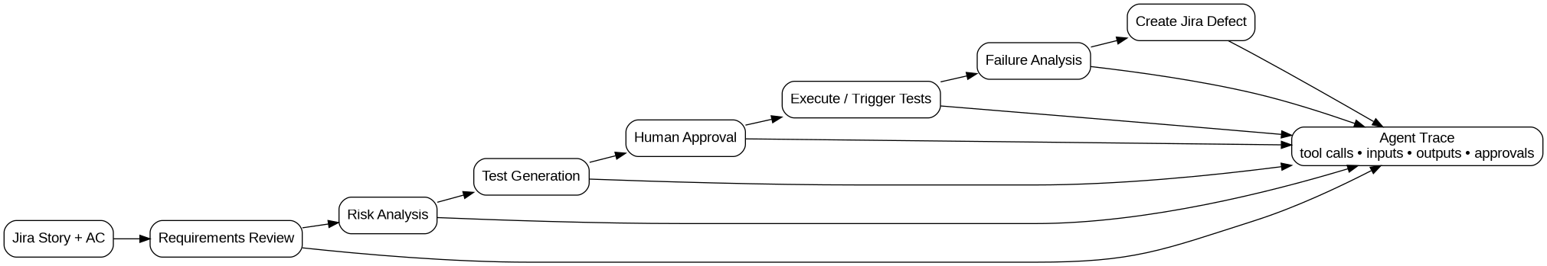
- Input: Jira story, description, AC, architecture/context.
- Requirements Review: identify ambiguity, incompleteness, contradiction and testability gaps.
- Risk Analysis: generate only risks grounded in requirement/architecture evidence.
- Test Generation: positive, negative, edge, integration and AI-specific tests with traceability.
- Execution/analysis: consume test/evaluation results.
- Defect creation: prepare evidence; initially require Human approval before Jira write.
Agent evaluation focus: hallucinated requirements, missed AC, duplicate/irrelevant tests, wrong tool/parameters, unauthorized actions, premature termination, loops, context loss, severity mistakes and excessive tool calls.

10. Phase 6 — Test Management Lifecycle Agent
One programme-level Test Strategy will contain stream-specific approaches. The agent may propose Entry/Exit criteria, but the Test Lead decides/approves them.
- Generate Test Strategy using risk-based/ISTQB-aligned thinking.
- Generate Test Plan using a practical ISO/IEC/IEEE 29119-based structure.
- Maintain plan/status as scope, execution, defects and risks change.
- Read AI, agent and SDLC metrics.
- Produce Test Completion Report.
- Produce GO/NO-GO recommendation with explicit residual risk and evidence.
- Human approval remains mandatory for governance decisions in the lab.

11. ISO/IEC/IEEE 29119 practical use
ISO/IEC/IEEE 29119-2:2021 specifies generic test processes for governing, managing and implementing testing; ISO/IEC/IEEE 29119-3:2021 specifies test documentation templates produced by those processes. This pack provides an original practical mapping, not the copyrighted standard text.
Artifact | Lab structure
Test Strategy | Objectives; scope/streams; test levels/types; risk approach; AI/RAG/agent approach; environments/data; automation/evaluation; governance; metrics; defect/reporting; roles; assumptions/constraints
Test Plan | Context/scope; test basis/items; in/out scope; approach; resources; environment; data; schedule; dependencies; risks; deliverables; monitoring/control; defects; completion criteria; approvals
Status Report | Build/period; coverage/execution; defects; AI/agent metrics; risks/blockers; actions/forecast
Completion Report | Completed scope; deviations; results; unresolved defects; residual risks; criteria assessment; recommendation; follow-ups

12. Risk Register and traceability
Use the workbook Risk Register as the starting register. Do not treat it as exhaustive; add risks discovered during requirements review and exploratory testing.
Target traceability chain:
Business/Product Risk → Requirement/AC → Test → Dataset Case → Execution → Defect → Residual Risk → Release Decision
WHY: AI metrics alone do not prove requirement coverage; conventional execution counts alone do not prove AI output quality.

13. Reporting architecture
The reporting pipeline—not Excel itself—collects data from Jira, pytest/evaluation results and traces. Excel is a human-readable output.
Report area | Data source
SDLC metrics | Jira + traceability + pytest
AI metrics | Evaluation runner + RAG traces
Agent metrics | Agent traces + Jira/tool results
Defects | Jira
Release readiness | Criteria + metrics + residual risk + defects

14. Controlled-failure exercises
Exercise | Change | Expected learning
Bad retrieval | Reduce top_k or alter ranking/index | Retrieval failure vs generation failure
Stale source | Temporarily ingest stale returns fixture | Data freshness/source precedence
Conflict | Ingest conflicting delivery fixture | Conflict handling and source governance
Missing truth | Remove relevant source | Abstention vs hallucination
Prompt change | Modify system prompt | Prompt regression
Model change | Swap provider/model | Back-to-back/model regression
Non-determinism | Repeat same cases | Variance and stable acceptance criteria
Agent autonomy | Remove/alter HITL control in sandbox | Unauthorized-action detection
Bad requirements | Use intentionally incomplete SHOP-005 | Requirements review quality
Bad release logic | Feed failing evidence to TM Agent | Recommendation quality

15. Definition of done for the lab
- Shopping Assistant answers product/policy queries using approved sources and exposes traceable sources.
- RAG traces allow inspection of retrieval, augmentation and generation.
- Golden/Evaluation/Regression datasets execute automatically and persist run metadata.
- QA Agent reviews requirements, identifies risks, generates traceable tests and prepares defects.
- Test Management Agent manages strategy/plan/status/completion lifecycle with HITL.
- Automated conventional, AI and agent evaluations run repeatably.
- Risk Register and requirement-to-defect traceability are maintained.
- Reporting pipeline produces SDLC + AI + Agent metrics and a release-readiness view.
- Controlled failures can be introduced and detected without contaminating the approved baseline.

16. First session — only these actions
- Download/unpack this prerequisites pack.
- Read sections 1–7 of this guide.
- Open the four architecture diagrams.
- Open the workbook and inspect the three dataset sheets.
- Inspect products.json and approved policy files.
- Create the local ai-qe-lab repository and Python virtual environment.
- Copy .env.example to .env; do not add real keys to Git.
- Stop there. Next implementation step is the minimal RAG application with full trace logging.

17. Supplied files
- AI_QE_Lab_Datasets_and_Governance.xlsx
- data/products.json and products.csv
- data/categories.json
- policies/*.md including controlled-failure fixtures
- docs/overall.png, rag.png, qa_agent.png, tm_agent.png (+ SVG/DOT sources)
- docs/requirements_seed.md
- docs/dataset_design.md
- docs/29119_practical_mapping.md
- config/.env.example
- README.md

18. Authoritative standard references
Official ISO pages: ISO/IEC/IEEE 29119-2:2021 (Test processes) and ISO/IEC/IEEE 29119-3:2021 (Test documentation). The standards are copyrighted; this guide summarizes their role and provides an original lab structure rather than reproducing their text.

