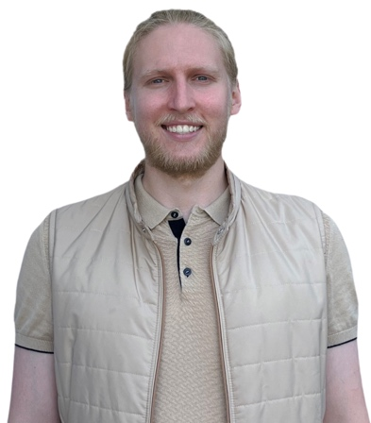

|  |  |
| --- | --- |
| PERSONAL DATA | Oleksandr Sokaliuk  18 August 1997  Raistinger Str. 48  71083 Herrenberg  Germany  +4916093443030  sokaliuk.developer@gmail.com |
| EXPERIENCE | ____________________________________________________ |
| Jul, 2022 - Dec, 2022 | Full-Stack Student-Developer  *Full-Stack Web Development Bootcamp at Wild Code School (Berlin)*  - acquired knowledge: HTML, CSS (styled-components), JavaScript and TypeScript (including Node.js framework), React, APIs (RESTful services), Express.js, WebSocket, Prisma (ORM), Nest.js;  - development of 3 projects based on Agile project management system; |
| Nov, 2021 - March 2022 | Private attorney’s assistant  *Sokaliuka" Law Office, Odesa (Ukraine)*  - drafting documents and participating in legal consultations, which improved my written communication skills and ability to work in a team;  - participated in court hearings and negotiations with clients, which developed persuasion and argumentation skills;  - using legal programs and online resources, which has developed my computer skills and effective information retrieval skills;  - worked on 3 own cases:  1) a сommercial dispute in court on the subject of non-fulfillment of obligations to supply goods:   * performing a thorough analysis of evidence and organizing it, which trained me to structure information and make informed decisions;   2) a criminal trial where we defended a crime victim:   * developed the ability to represent the client's interests and protect their rights, which involves skills of argumentation and persuasion;   3) a civil dispute where we sought damages in court for a neighbor's flooding of a home:   * researching regulations and case law, which involved my ability to seek and analyze information; |
| Dec. 2018 - Aug. 2021 | Senior Associate  *"TCM Group Ukraine LLC, Kiev (Ukraine)*  - intensive practice of communications with client counterparties, which contributed to the development of persuasion and reasoning skills;  - dealt with the automation of work processes in order to design the effective workflow of the team;  - improved organizational skills through managing and organizing a large volume of files and documentation;  - interacting with colleagues and clients to develop team working skills and provide a high level of client service;  - became the youngest senior assistant in the company (more than 40 employees) within the shortest growth period;  - won the competition in the company and got the chance to attend a meeting with the client in Amsterdam. |
| Apr, 2018 - Sep, 2018 | Trainee / Junior Associate  *"Legrant" LLC, Odesa (Ukraine)*  - conducting surveys and drafting legal memoranda in the field of maritime, tax and commercial law;  - assisting lawyers with the drafting of claims, letters of demand and statements of claim;  - participation in the organisation of company events. |
| EDUCATION | ____________________________________________________ |
| Sep, 2018 - Jan, 2020 | Master's degree in law  *National University "Odesa Academy of Law", Odesa (Ukraine)*  - successfully combined learning process with work in the law firm. |
| Sep, 2014 - Jun, 2018 | Bachelor's degree in law  *National University "Odesa Academy of Law", Odesa (Ukraine)*  - member of a debating club at the university;  - attended law lectures and seminars in English from 14 March 2017 to 04 May 2017;  - took 2nd place in the Ukrainian International Criminal Law Debating Tournament;  - participated in the Ukrainian tournament in the civil law. |
| LANGUAGES | ____________________________________________________ |
|  | **Ukrainian** mother language  **Russian** mother language  **English** level – C1  **German** level - B1 |
|  | ____________________________________________________ |