MINISTRY OF EDUCATION AND SCIENCE OF UKRAINE
NATIONAL TECHNICAL UNIVERSITY
“KHARKIV POLYTECHNIC INSTITUTE”
DEPARTMENT OF SOFTWARE ENGINEERING AND MANAGEMENT INFORMATION TECHNOLOGIES

Report of laboratory work № 1
Discipline «Software Engineering»

Executed by: Student of group KN-226e
Budkov O. Yu.
Checked by: Associate professor
Melnyk K. V.

Kharkiv
2026

Theme: Modelling of Domain.
Work objective: Learning Use Case and Activity Diagrams by using Visual Paradigm.
Task: Variant 3. The application has to resolve the following system of formulae:
y = 1/(2x) + Π (i + x), i = 1..n–2, when x < 3
y = Π Σ (i + 1/(4j²)), j = 1..n, i = 1..n+3, when x ≥ 3
The application should also provide the data input from keyboard and file and the output to screen and file.
Progress of work:
1. Get the task and analyze the computational algorithms
The function is piecewise: if x < 3, the program uses the first rule; if x ≥ 3, the second one. The symbol Σ means summation, and Π means multiplication. The letter under the symbol is the loop index; the numbers under and above it are its lower and upper limits.
During the analysis, I found three problems:
1) The upper limit of the product n – 2 must be bigger than the start value 1, so n > 3.
2) The part 1/(2x) has a discontinuity point at x = 0, and this point can be inside the range: x_start = –2, x_end = 2, dx = 1 gives –2, –1, 0, 1, 2. Checking only x_start does not help, so the program checks x inside the loop, prints “not defined” for this point, and continues.
3) The user can type text instead of a number, or a number outside the allowed range. So every value is checked right after it is entered: x_start and x_end must be numbers and x_end ≥ x_start, dx must be a number and dx > 0 (otherwise the loop never ends), n must be an integer and n > 3.
Before drawing the diagrams, I calculated two examples by hand, from the inside to the outside. The accumulator of a sum starts from 0, and the accumulator of a product starts from 1.
Example 1: x = 1, n = 4, i = 1..2
i = 1: product = 1 * (1 + 1) = 2
i = 2: product = 2 * (2 + 1) = 6
y = 1/(2*1) + 6 = 6.5

Example 2: Π Σ (i + j), j = 1..2, i = 1..2
j = 1: sum = (1 + 1) + (2 + 1) = 5
j = 2: sum = (1 + 2) + (2 + 2) = 7
product = 5 * 7 = 35
2. Develop the Activity diagram
The Activity diagram describes the dynamical properties of the system, in our case – the computational algorithm. Its main elements are shown in Table 1.
Table 1 – Main elements of the Activity diagram
Element | Description
Black circle | Initial node. The start of the algorithm.
Rounded rectangle | Action. One step of the algorithm.
Diamond | Decision node. The condition is written near the outgoing arrows.
Arrow | Control flow. It shows the direction.
Circle inside a circle | Activity final node. The end of the algorithm.

The diagram (Figure 1) has four parts.
1) Input. Every value (x_start, x_end, dx, n) is read by a separate action and checked by its own decision node right after it. If the check fails (else), the flow goes back to the input of the same value, so the user sees which value is wrong and does not type the other values again.
2) Discontinuity check. After x = x_start, the program checks x = 0. In this case, it prints “not defined” and goes directly to x = x + dx.
3) Calculation. The node x < 3 chooses the branch. The first branch has one loop: product = product*(i+x) while i <= n–2, then y = 1/(2x) + product. The second branch has two nested loops: Σ inside (counter i, accumulator sum) and Π outside (counter j, accumulator mlt). The action sum = 0 is placed inside the outer loop, so the inner sum starts from zero for every new j.
4) Main loop. The program outputs x and y, increases the argument x = x + dx, and repeats while x <= x_end.
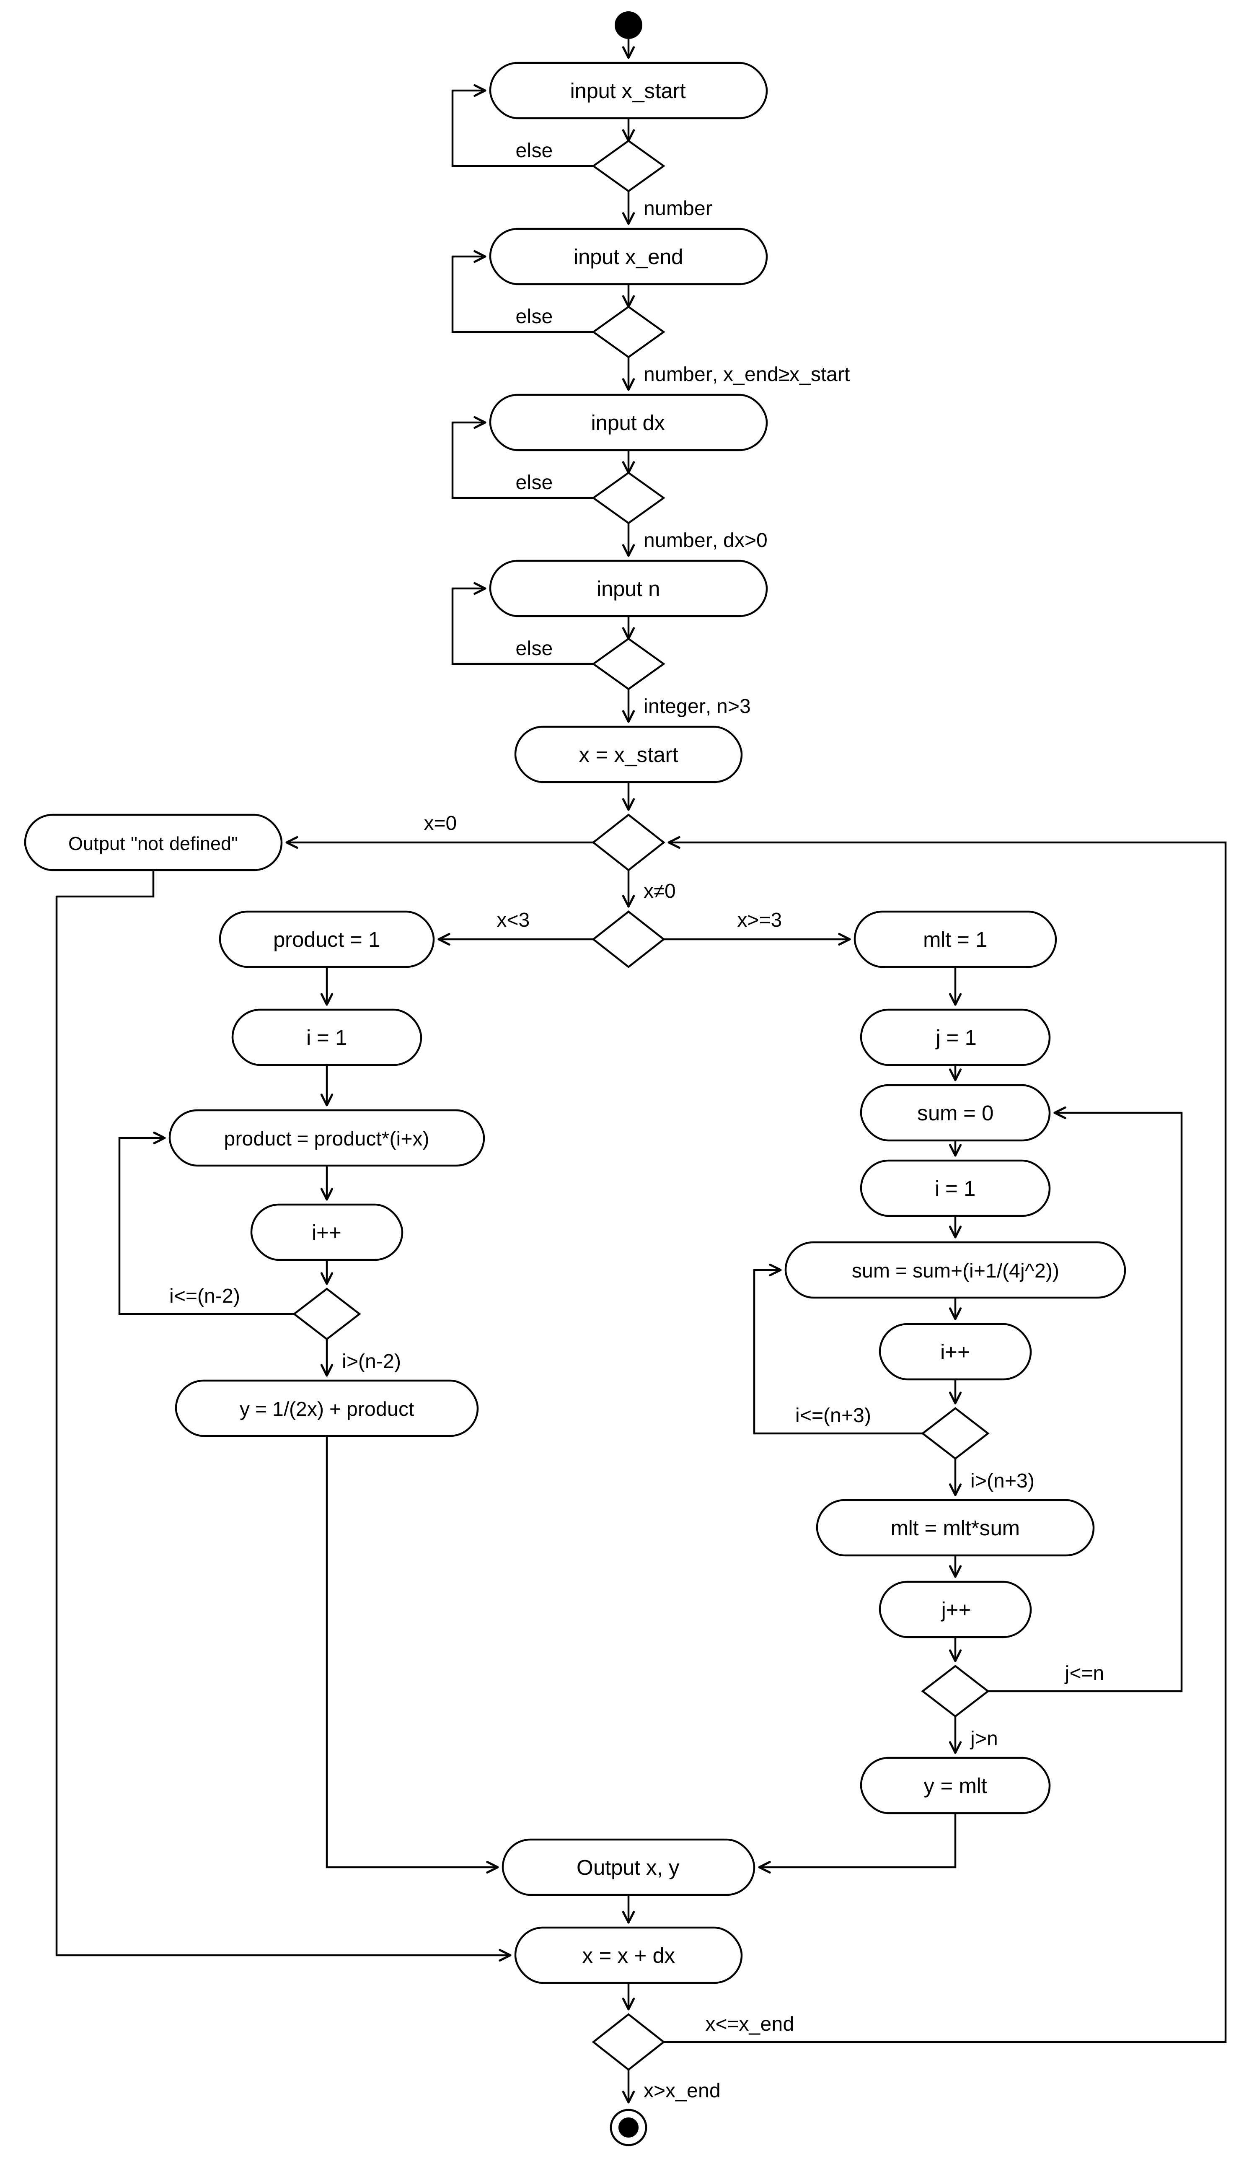
Figure 1 – Activity diagram for the chosen task
3. Develop the Use Case diagram
The Use Case diagram describes the functions (use cases) that the system performs for its external users (actors) and reflects the functional requirements. Its main elements are shown in Table 2.
Table 2 – Main elements of the Use Case diagram
Element | Description
Ellipse | Use case. It describes one functionality of the system.
Stick figure | Actor. A person or an external system that uses our system.
Solid line | Association between an actor and a use case.
Dashed arrow «extend» | The extending use case is optional and supplementary.
Dashed arrow «include» | The included use case is required, not optional.
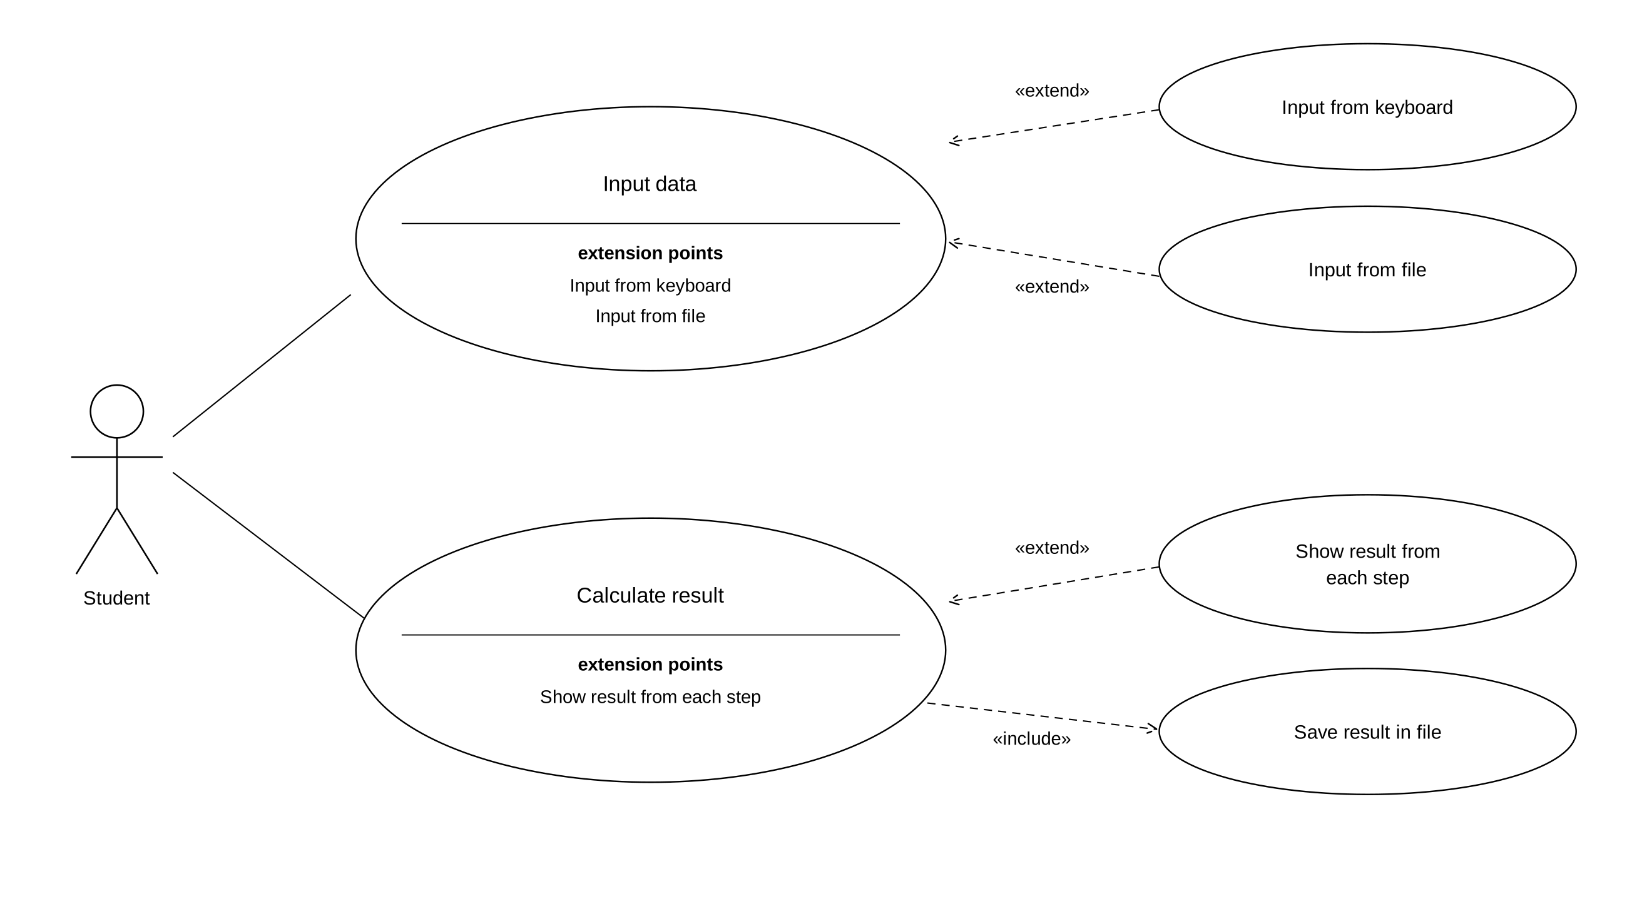
Figure 2 – Use Case diagram for the chosen task
The only actor is the Student. Input data has two extension points: Input from keyboard and Input from file. The user chooses only one way, so both are connected with «extend». The calculation result must always be saved in a file, so Save result in file is connected with «include». Showing the result from each step is optional, so it is connected with «extend». In short, «include» means “always” and «extend» means “sometimes”.
Conclusions
During this laboratory work, I learned to model a domain with UML diagrams. I found the constraint n > 3, the discontinuity point x = 0, and the need to check every input value. The Activity diagram shows the separate check of every input value, the protection from division by zero, and all the loops of the algorithm. The Use Case diagram shows the functional requirements and the difference between «include» and «extend». These two models can be used to write the program in any programming language.

