MINISTRY OF EDUCATION AND SCIENCE OF UKRAINE
NATIONAL TECHNICAL UNIVERSITY
“KHARKIV POLYTECHNIC INSTITUTE”
DEPARTMENT OF SOFTWARE ENGINEERING AND MANAGEMENT INFORMATION TECHNOLOGIES

Report of laboratory work № 2
Discipline «Software Engineering»
Theme: Coding of Domain

Executed by:
Student of group KN-226e
Budkov O. Yu.

Checked by:
Associate professor
Melnyk K. V.

Kharkiv
2026

Goal: learning basic principles of C++.
Task (Variant 3): the program reads the range x_start…x_end, the step dx and the integer n, and calculates y for every x of the range:
y = 1/(2x) + ∏(i + x), i = 1…n−2, if x < 3;
y = ∏ ∑ (i + 1/(4j²)), j = 1…n, i = 1…n+3, if x ≥ 3.
Task 2.1 Program for the Task from the Previous Lab
The program (Figures 1.1–1.6) follows the Activity diagram from Lab 1. It starts with the main menu (Figure 1.7), which explains what the program does, shows the formula and the current data, and offers five options. The data can be typed from the keyboard (Figure 1.8) or loaded from a file. Option 3 prints the table of x and y and can save it to results.txt (Figure 1.9).
Every value is checked right after it is entered, and only the wrong value is asked again. The start value may be any number; the end value cannot be smaller than the start; the step must be greater than 0 and the table cannot have more than 1000 rows; n must be a whole number from 4 to 1000. n is whole because it is the limit of the loops, the step may be fractional because it changes the real argument x. The same check functions are used for the keyboard and for the file, so the rules are the same in both cases. Every error message explains what is wrong and gives an example of a correct value (Figures 1.10–1.11). If the file is missing or wrong, the old data is kept (Figure 1.12).
At x = 0 the function is not defined, so the program prints “not defined” and goes on to the next x. For x ≥ 3 the variable sum is set to 0 inside the j loop, so every j starts a new sum; this branch does not depend on x, so all x ≥ 3 give the same y. The value of x is calculated as x_start + k·dx, so the rounding error from adding dx many times does not build up. If a value is too big for the type double, “too large” is printed. The Help screen (Figure 1.13) explains every value, the rules and the file format.
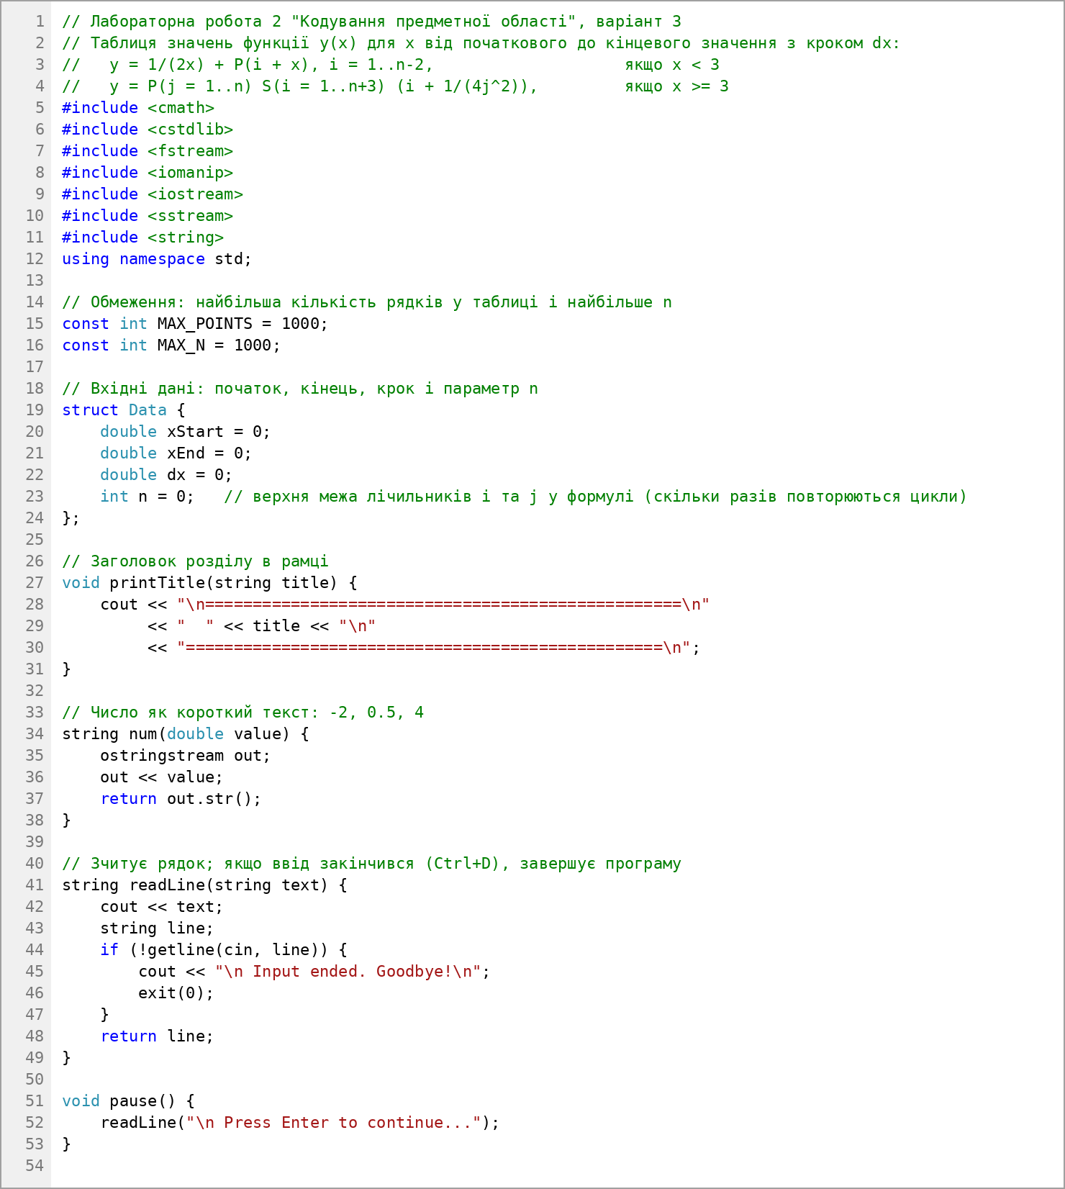
Figure 1.1 – Code of the program (constants, data and input of a line)
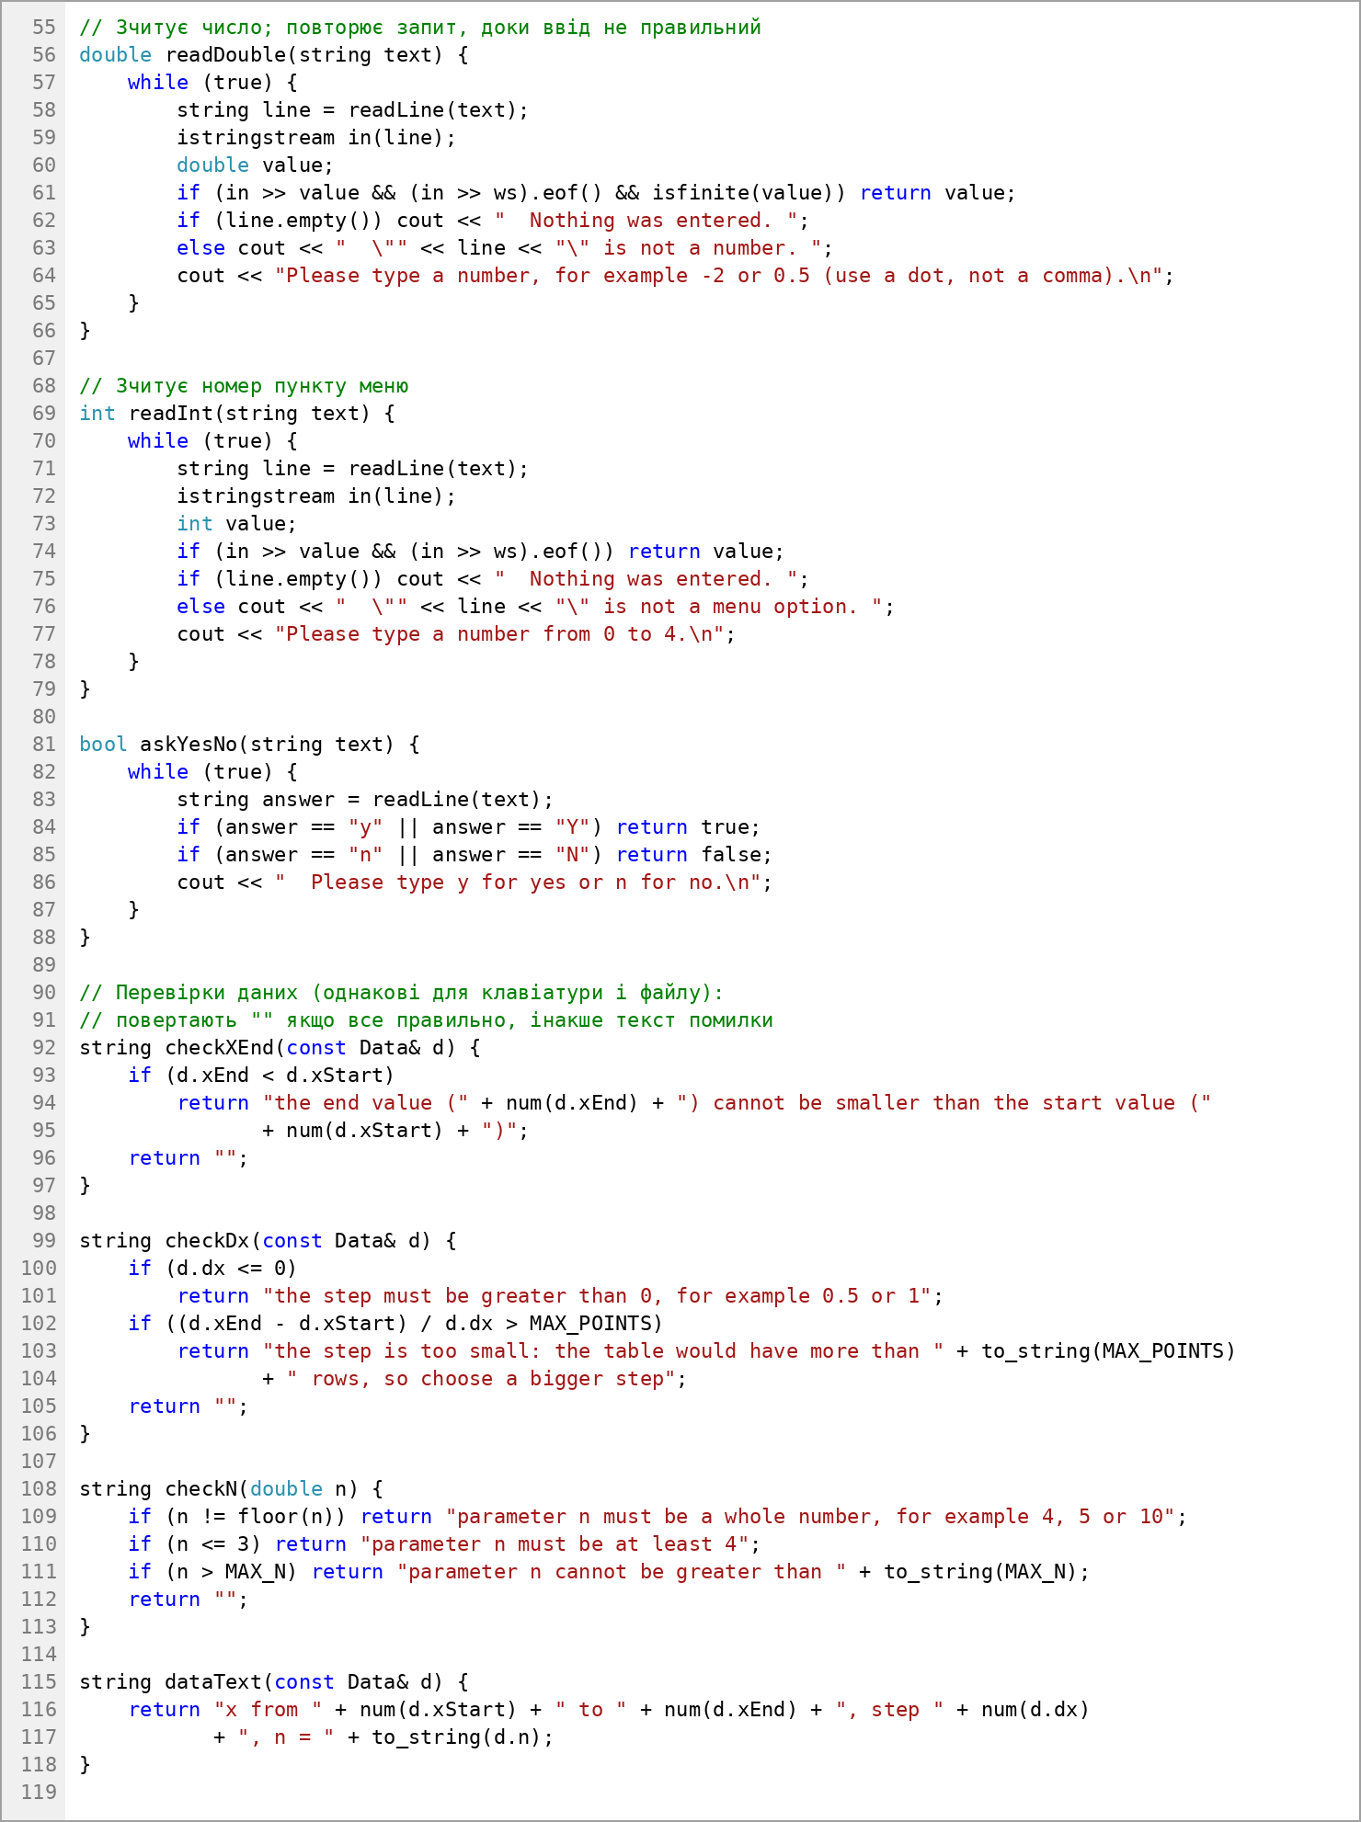
Figure 1.2 – Code of the program (reading numbers and checks of the data)
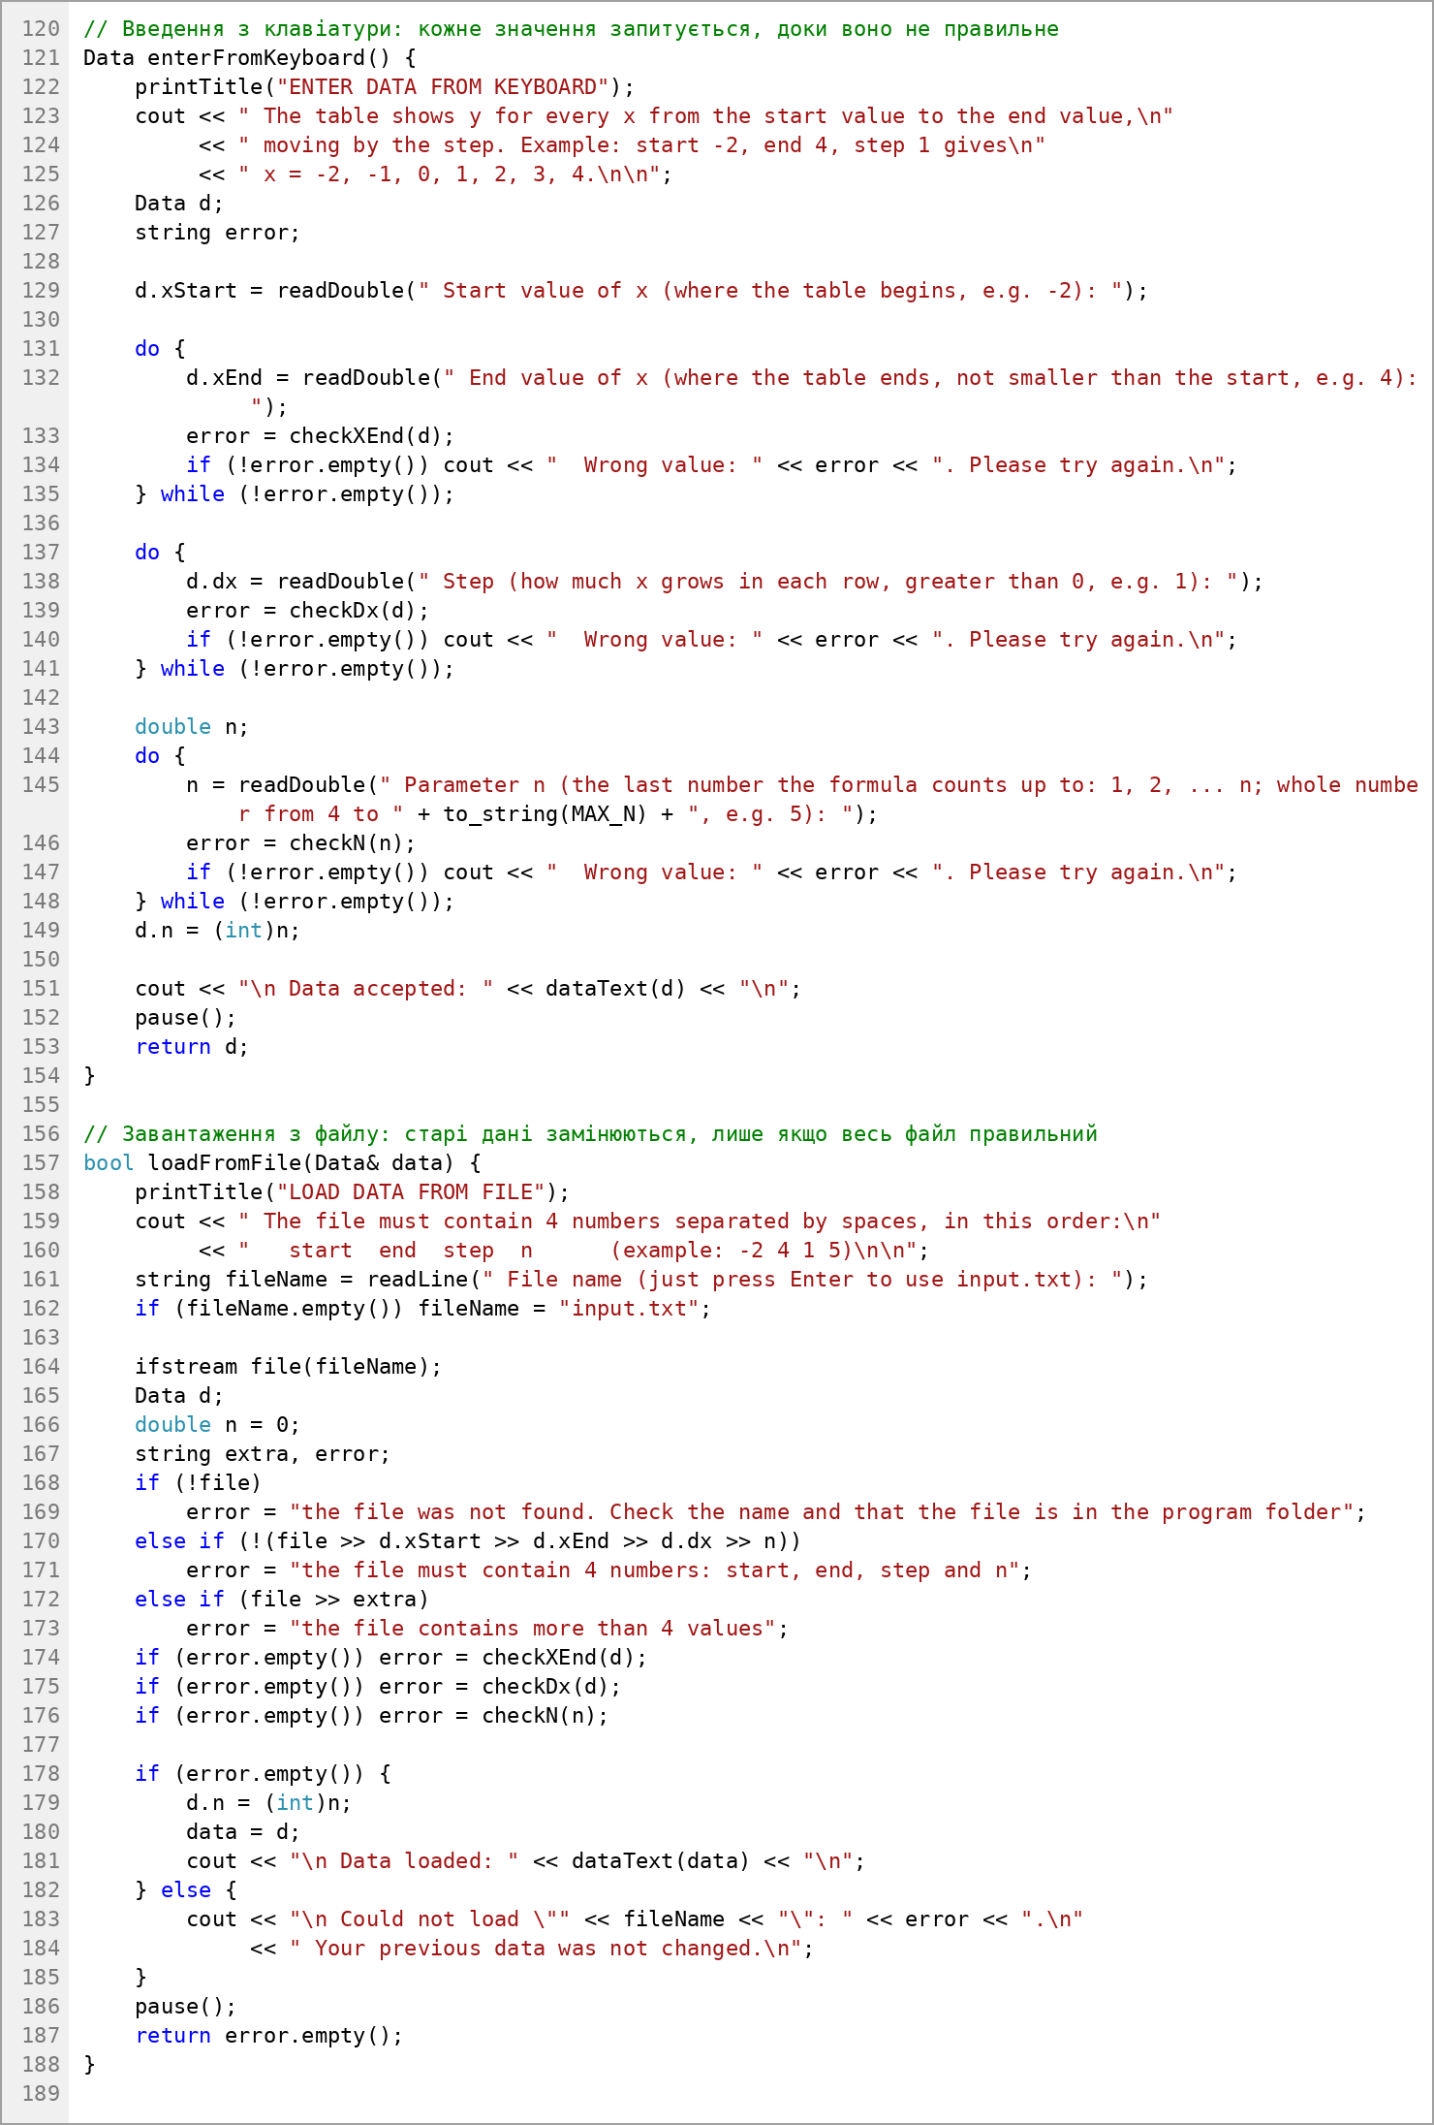
Figure 1.3 – Code of the program (input from keyboard and from file)
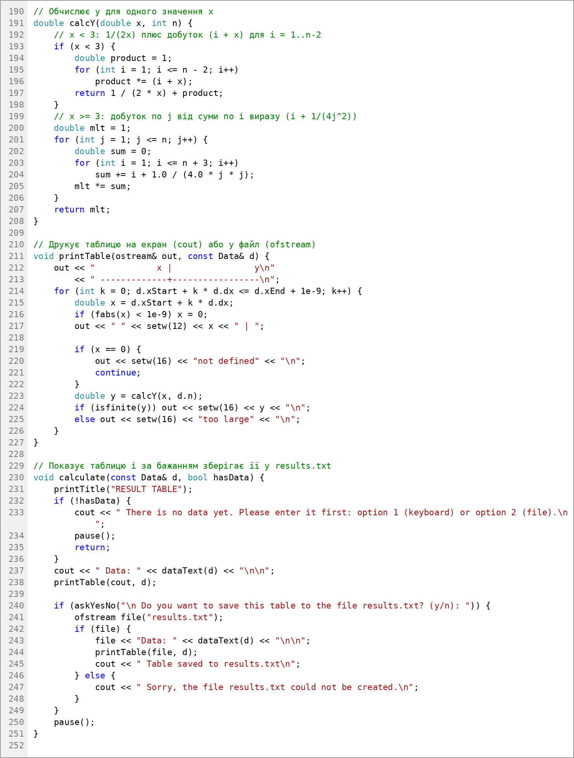
Figure 1.4 – Code of the program (calculation of y, table and saving)
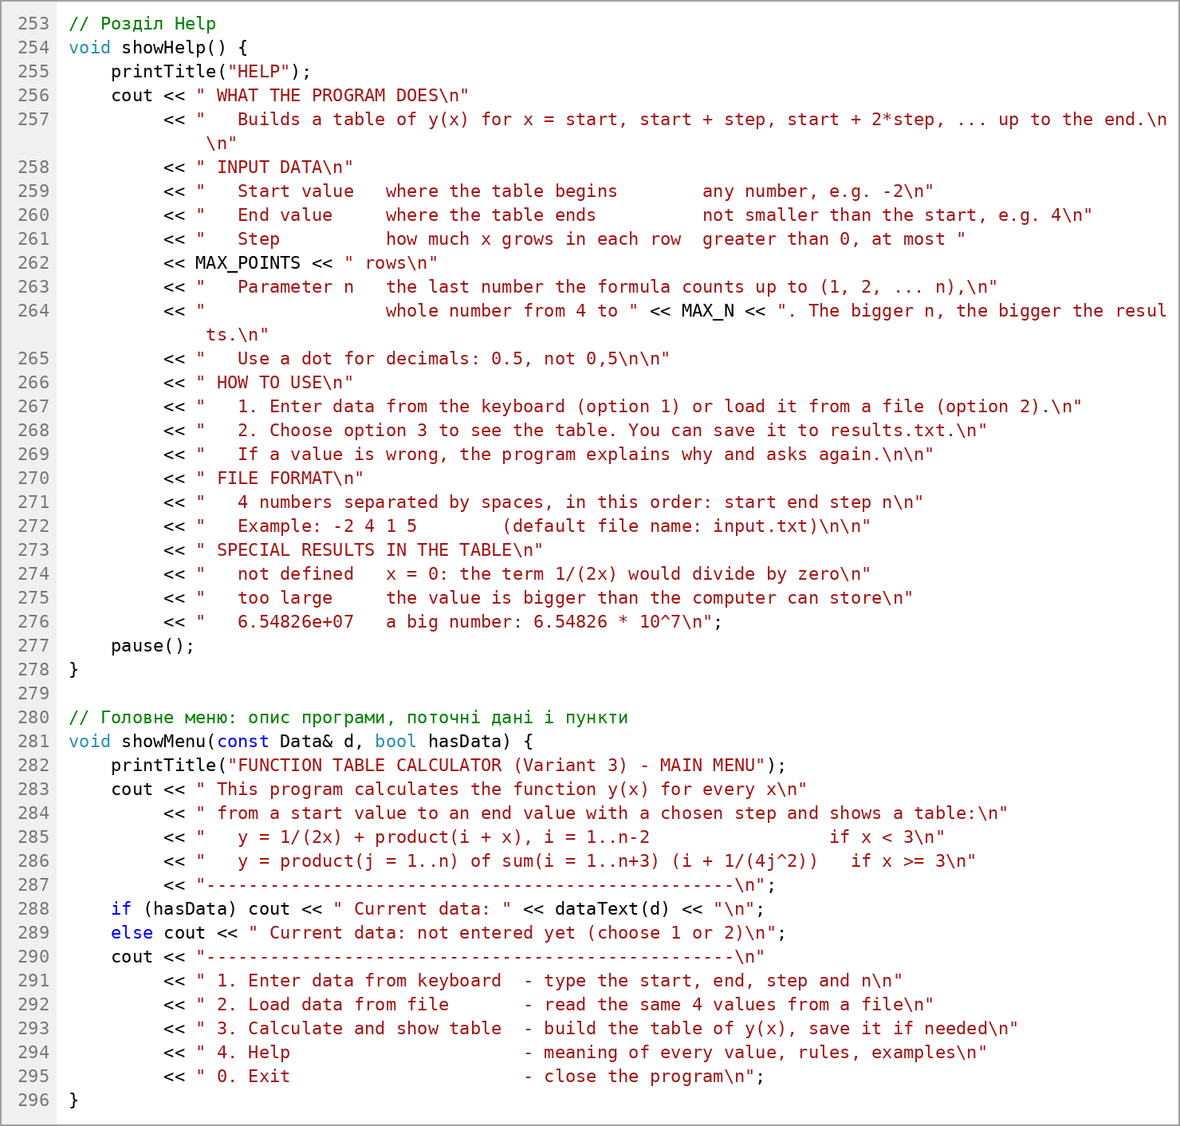
Figure 1.5 – Code of the program (help and main menu)
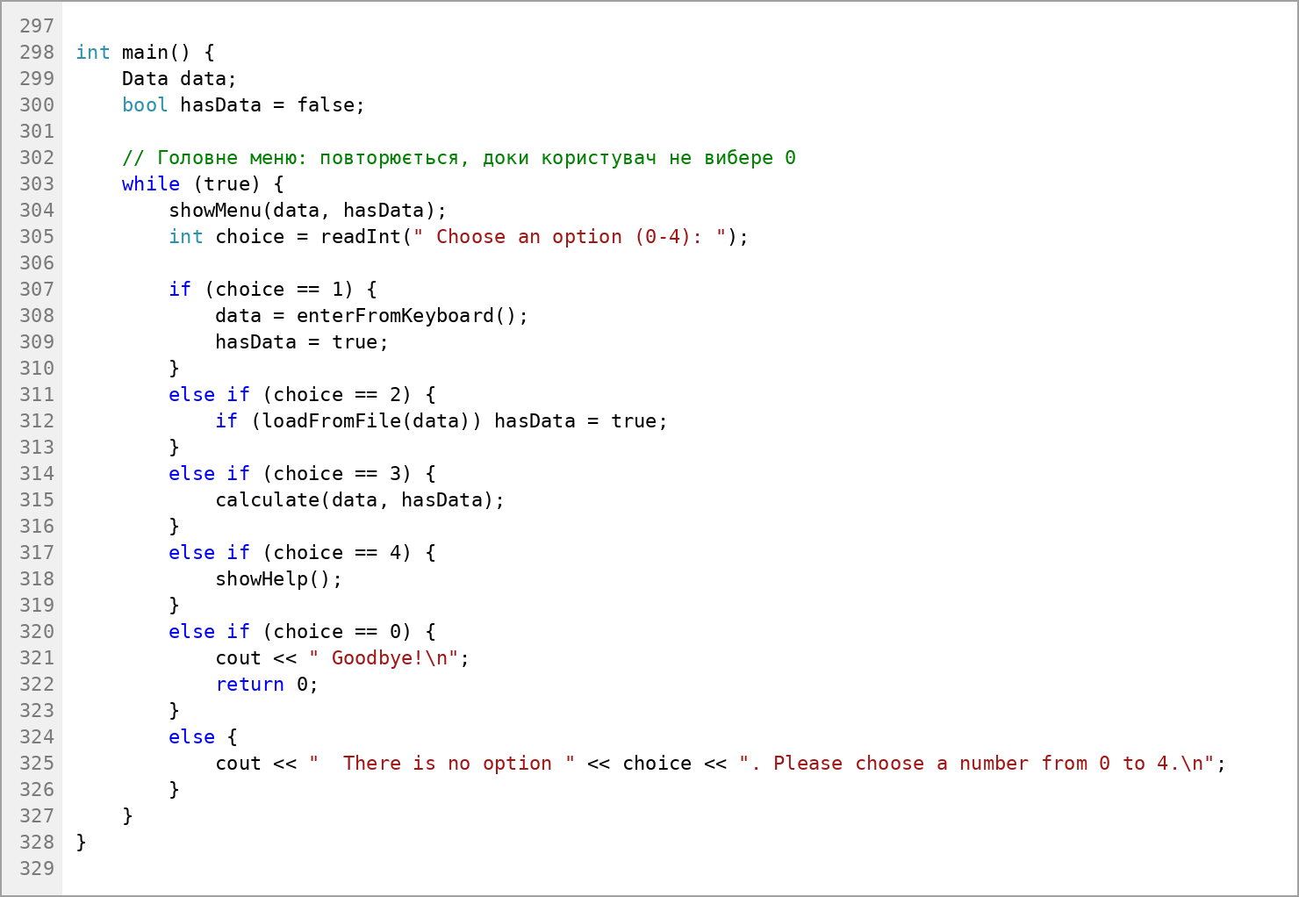
Figure 1.6 – Code of the program (main function)
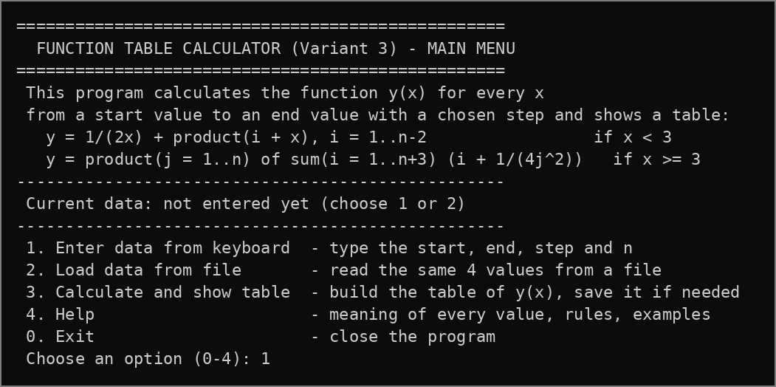
Figure 1.7 – Work of the program: main menu
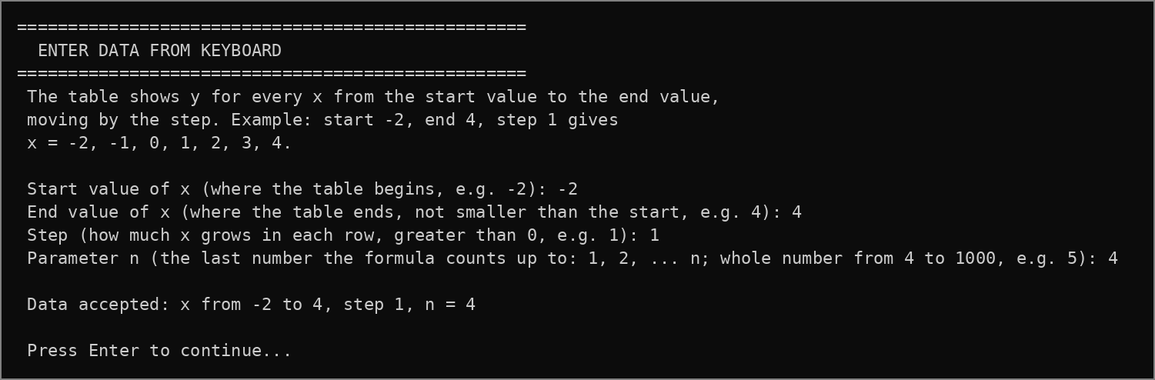
Figure 1.8 – Work of the program: input from keyboard
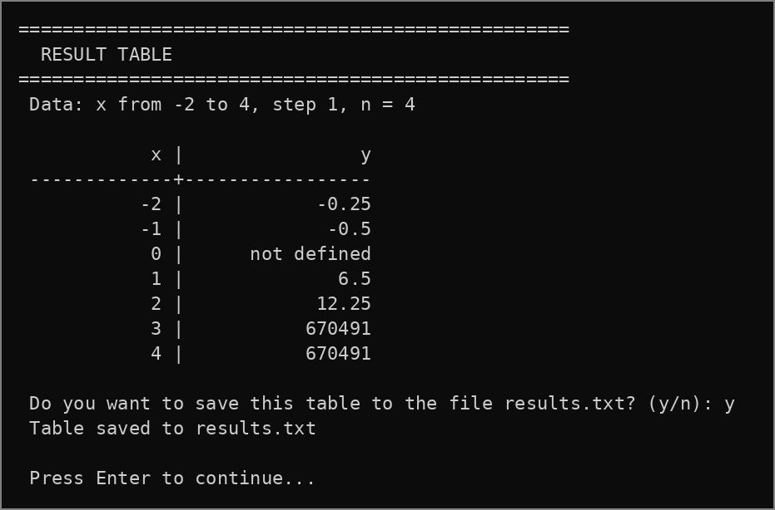
Figure 1.9 – Work of the program: result table and saving to a file
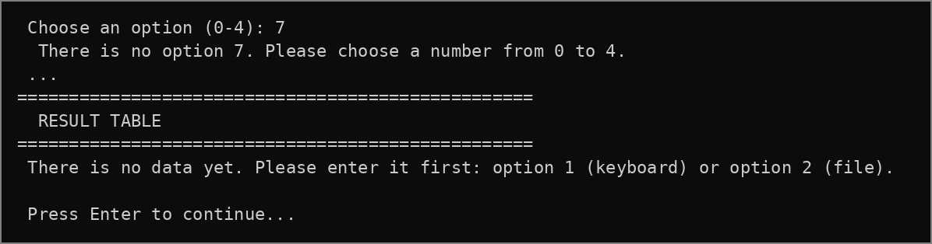
Figure 1.10 – Work of the program: wrong menu option and calculation without data
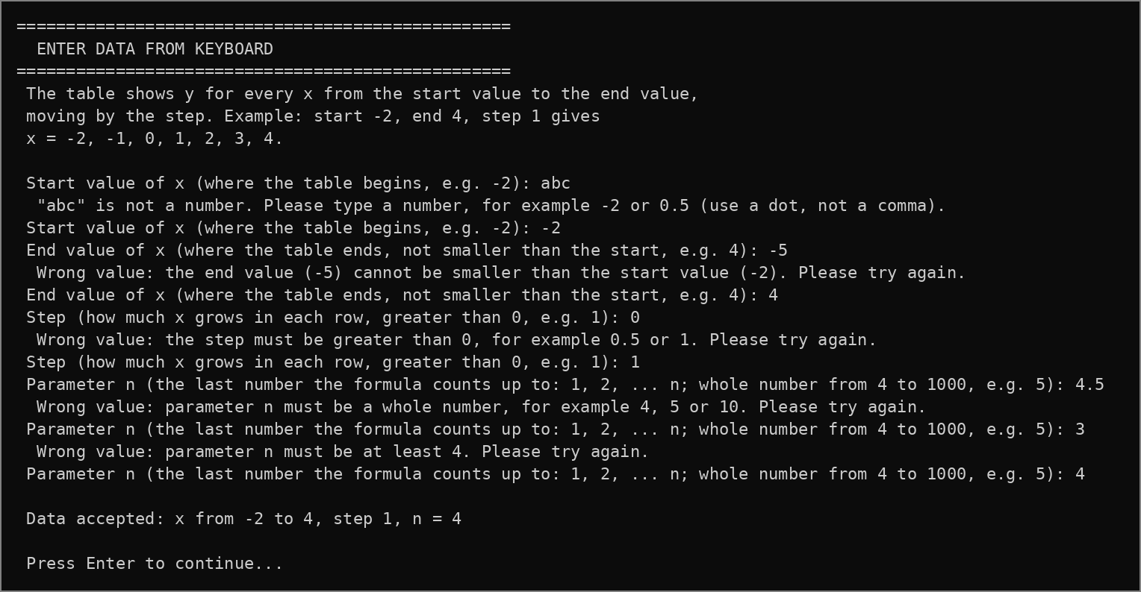
Figure 1.11 – Work of the program: wrong input values
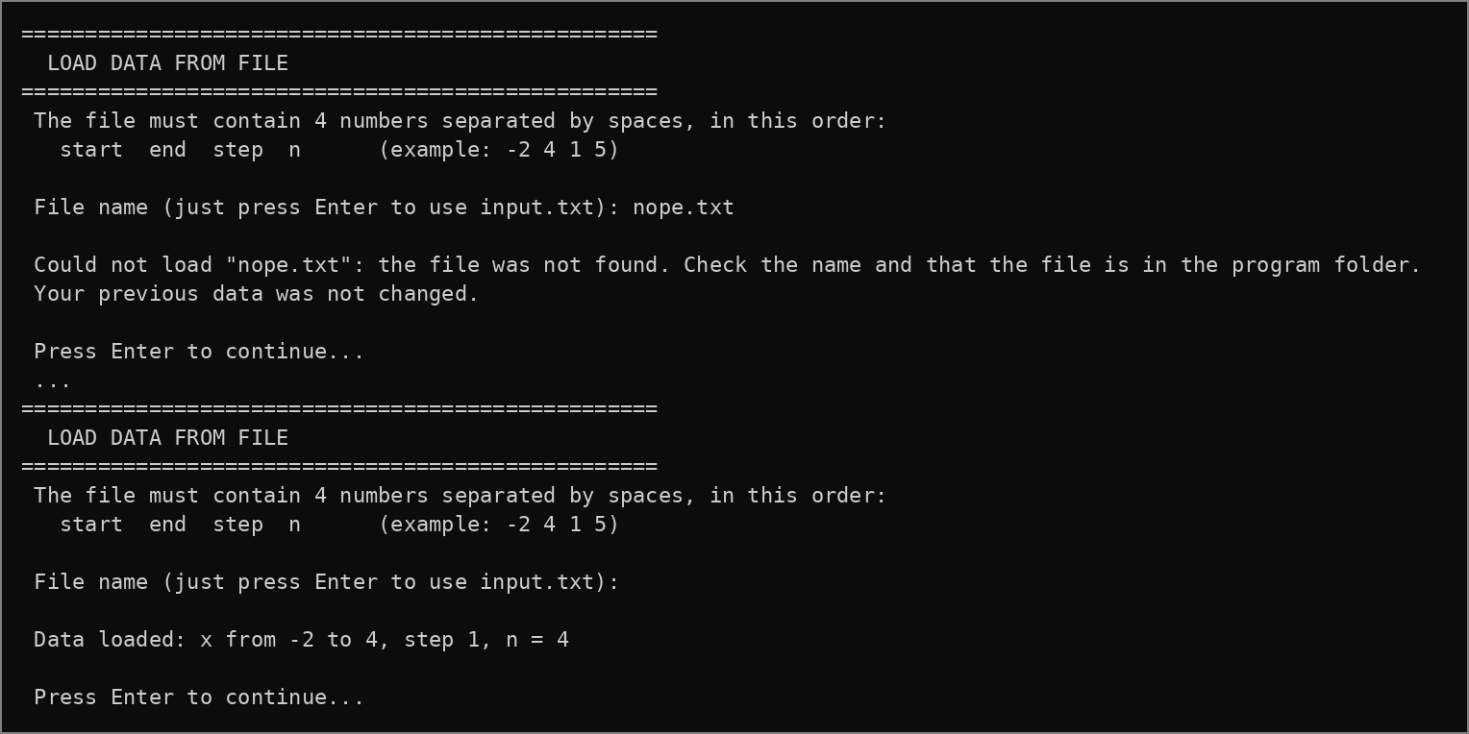
Figure 1.12 – Work of the program: loading data from a file
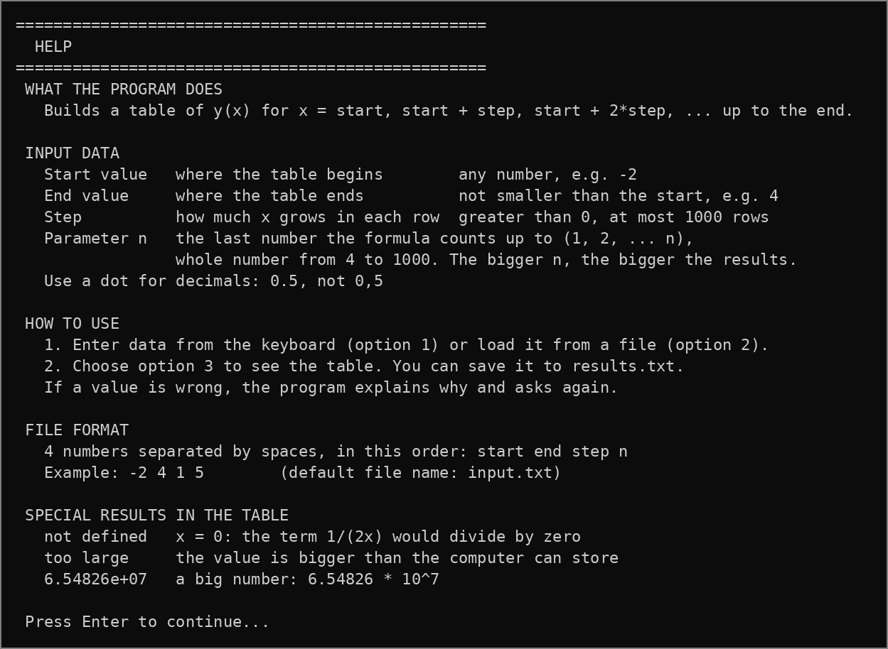
Figure 1.13 – Work of the program: help
Task 2.2 Enhancing Interface and User Experience. Wireframe
To make the console application easier to use, the following UX points were applied:
– clarity of commands: every screen has a title in a frame, and every menu option has a short explanation of what it does;
– help inside the app: the main menu explains the program and shows the formula, every prompt says what the value means and gives an example, and option 4 opens a full Help screen;
– feedback: the menu always shows the current data, and after every action the user sees the result: “Data accepted”, “Data loaded”, the table or “Table saved to results.txt”;
– human-friendly errors: an error explains why the value is wrong and what to type instead, and only this value is asked again;
– consistency and navigation: all screens look the same, “Press Enter to continue” lets the user read the result before the menu appears again, and 0 always means exit.
The wireframe of the screens is shown in Figure 2.1. It shows the structure of every screen without real values: [number] and [user input] mark the places where the user types data, [hint] marks short explanations, and “or” separates the successful result from the error message. The possible transitions between the screens are shown in Figure 2.2.
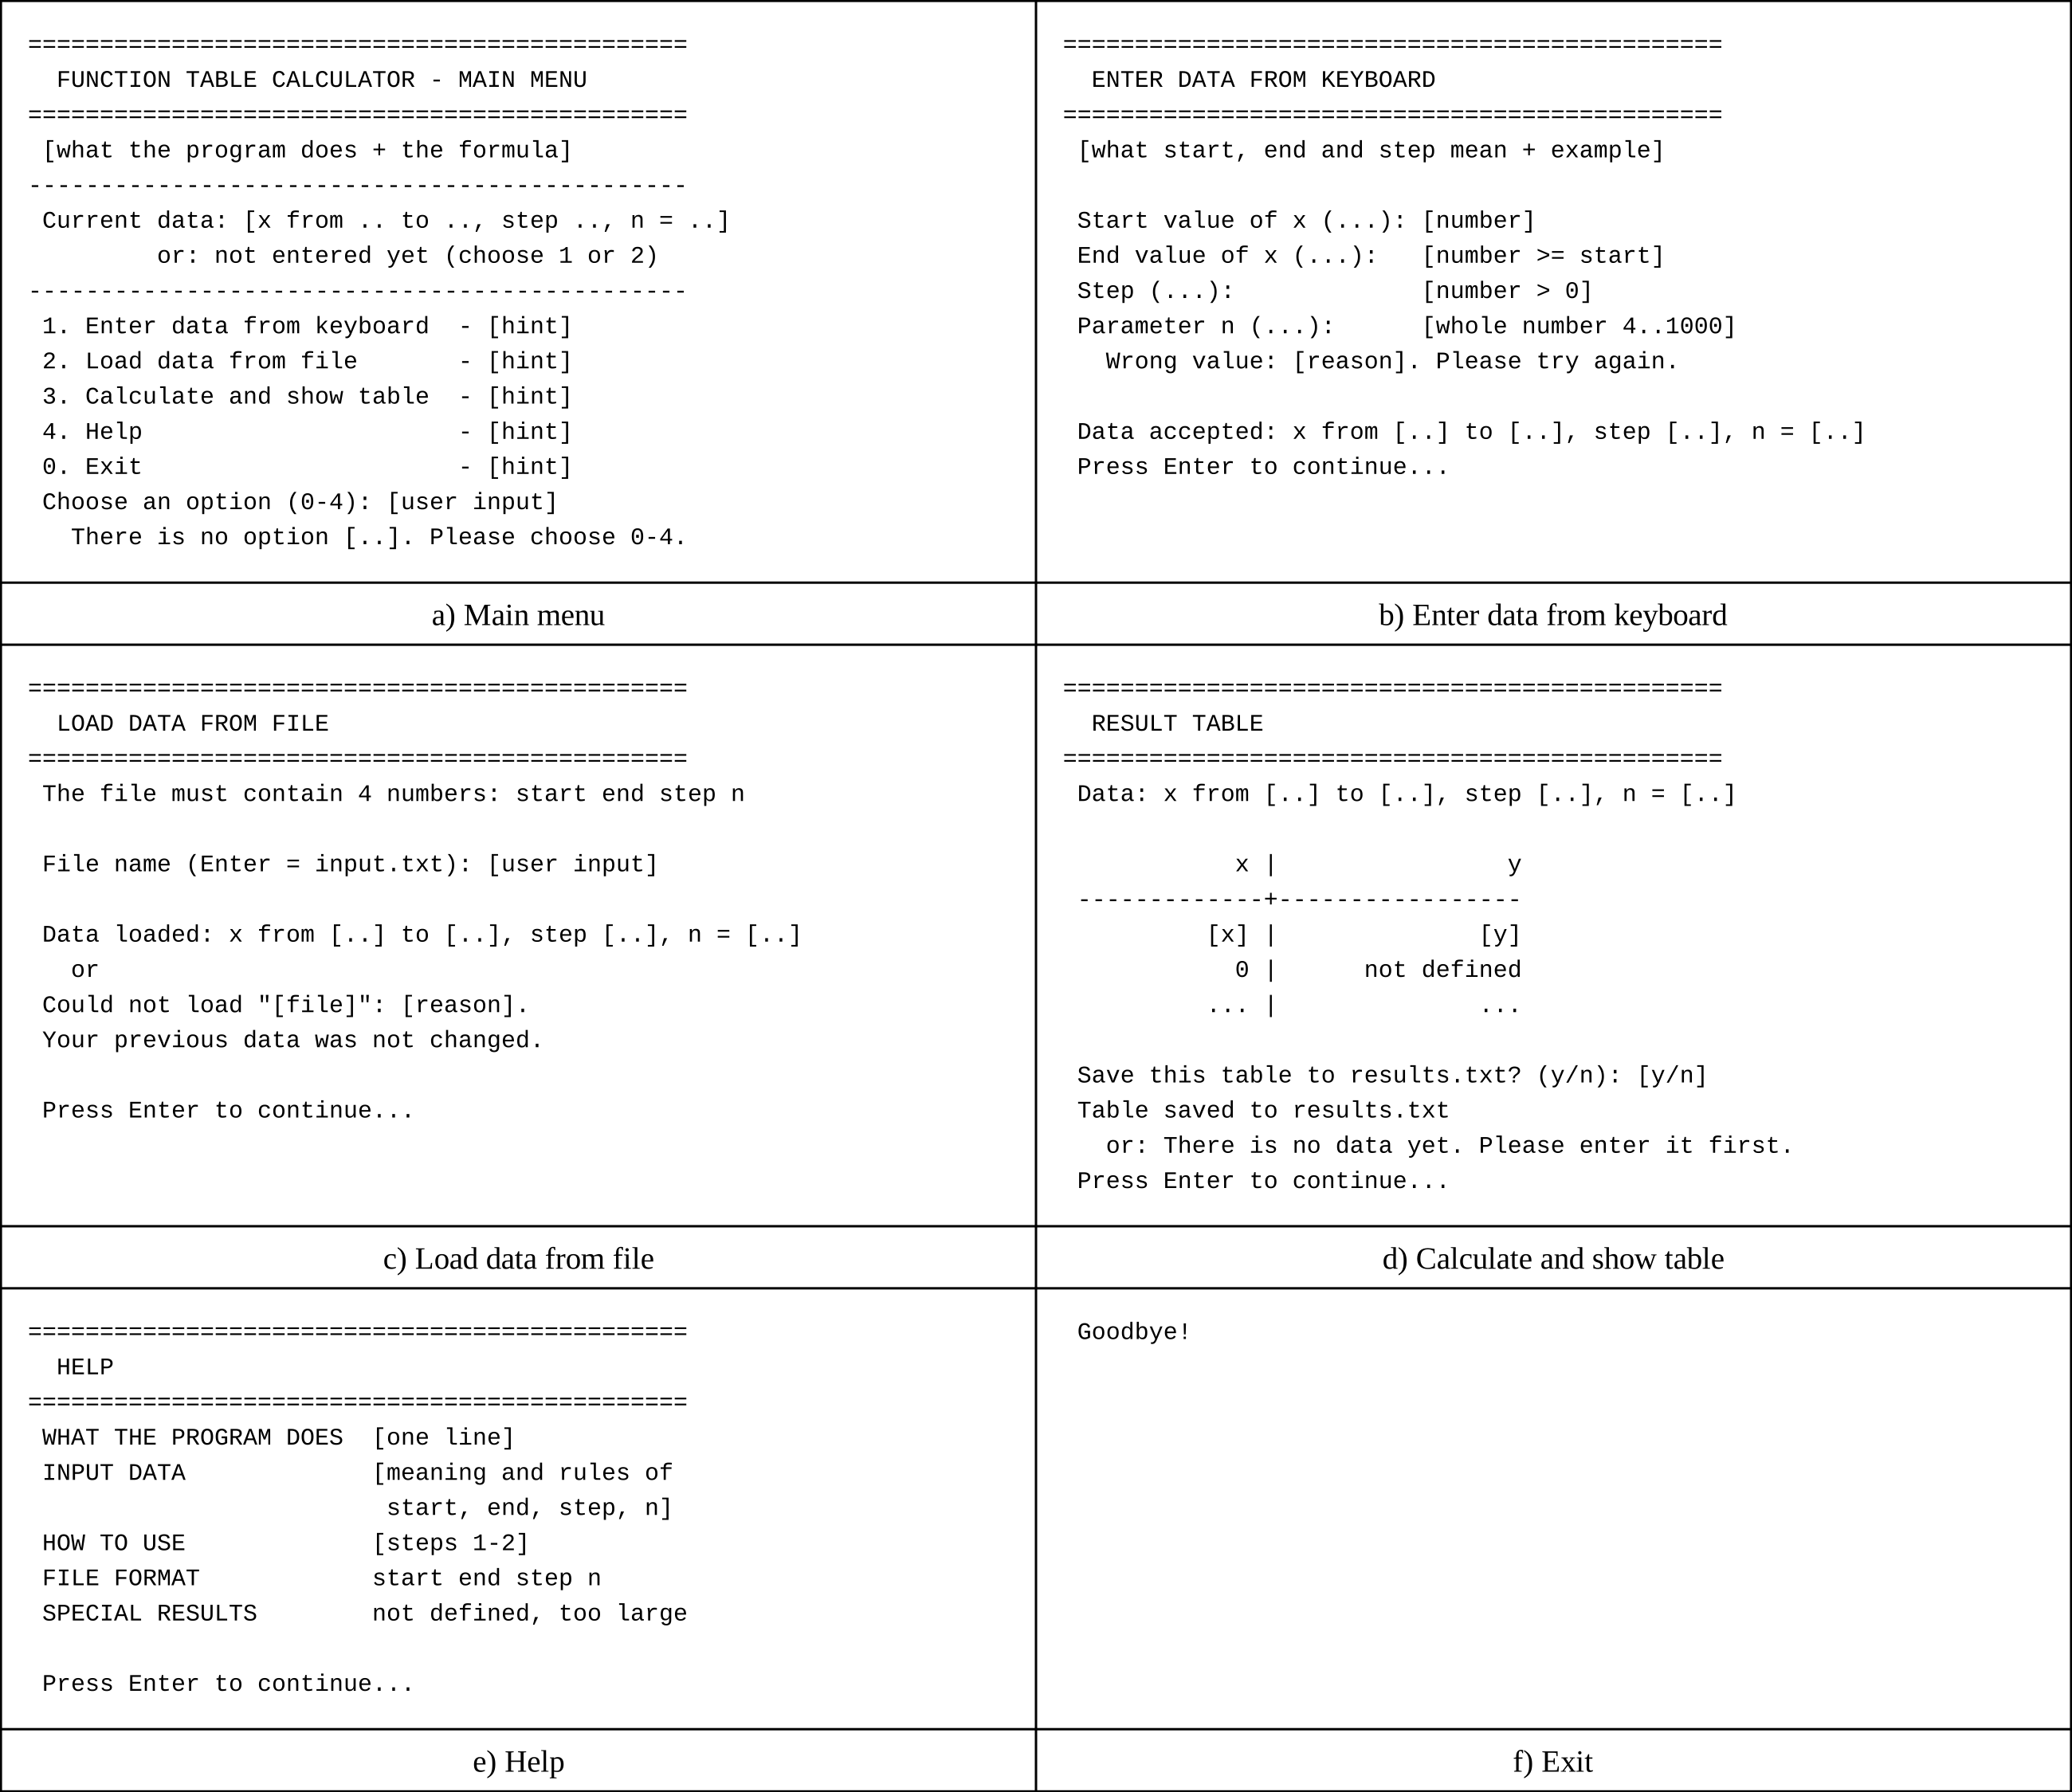
Figure 2.1 – Wireframe: a) main menu, b) enter data from keyboard, c) load data from file, d) calculate and show table, e) help, f) exit
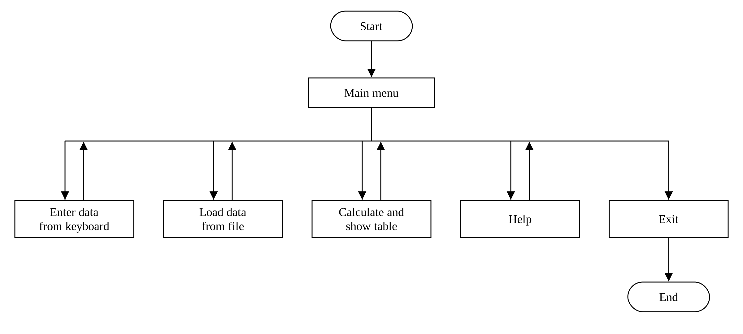
Figure 2.2 – Possible transitions between screens
Use case scenarios:
Use Case 1: Enter data from keyboard. The user chooses 1 and types the start value −2, then the end value −5. The program explains that the end value cannot be smaller than the start value and asks only the end value again. The user types 4, the step 1 and n = 4, and the program prints “Data accepted”.
Use Case 2: Load data from file. The user chooses 2 and presses Enter, so input.txt is used. The program checks the four values by the same rules and prints “Data loaded”. If the file does not exist or is wrong, the program explains the reason and keeps the previous data.
Use Case 3: Calculate and show table. The user chooses 3. The program prints the table of x and y with “not defined” at x = 0 and asks whether to save it; after “y” the table is written to results.txt. If there is no data yet, the program asks to choose option 1 or 2 first.
Use Case 4: Help. The user chooses 4 and reads what every value means, the rules, the file format and the special results in the table.
Use Case 5: Exit. The user chooses 0, the program prints “Goodbye!” and ends.
Conclusions
In this laboratory work we have learned the basic principles of C++ by writing a console program for Variant 3 according to the Activity diagram from Lab 1. The program calculates the function for the whole range with the given step, checks every input value separately with the same rules for the keyboard and the file, shows “not defined” at x = 0 and can save the table to a file. The interface was improved with a described menu, prompts with examples, a Help screen, feedback and errors that explain what is wrong, and it was designed with a wireframe and a diagram of transitions between screens.

