PJM Regional Load: Attention-Head Fault Tolerance of a Transformer Forecaster
Experiment description, results and analysis. Encoder-only Transformer, 4 layers x 8 heads = 32 attention heads.

1. Purpose and scope
This experiment runs the whole protocol independently on eleven regional load series, holding one architecture fixed, and then compares the eleven results.
That comparison answers a question the source study could not: it examined one region only, so it could not tell whether the layer that holds the critical head is a property of the architecture or of the particular series. Eleven series under one fixed architecture separate the two.
AEP is deliberately excluded because it is the region used in the source paper; these eleven series are therefore new evidence rather than a re-run of the published case.

2. Research questions and hypotheses
- RQ1. Does this trained Transformer contain a small number of critical heads alongside many redundant ones?
- RQ2. Is the damage explained by the number of failed heads alone, or also by which heads fail?
- RQ3. How does this result compare with the other datasets, given that the architecture is identical?
Hypotheses tested:
- H1. Attention-head criticality is non-uniform across the network.
- H2. Layer-wise fragility is not monotonic in depth and depends on the task.
- H3. Degradation grows with the number of simultaneously failed heads.
- H4. Criticality-aware fault severity carries information beyond the raw fault count.
- H5. Fault configurations containing critical heads exceed an acceptable degradation threshold more often.

3. Dataset
Property | Value
Corpus | PJM hourly load, every region except AEP
Task | forecast the next hourly value from the previous 20 hours
Regions | PJME, COMED, DAYTON, DOM, DUQ, PJMW, FE, NI, DEOK, EKPC, PJM_Load
Observations | roughly 33 000 to 145 000 hourly values per region
Normalisation | per-region min-max to the unit interval; MAPE reported in the original megawatt scale
Sequence seen by the model | 20 consecutive hours plus a CLS token

4. Model and training configuration
The model is an encoder-only (bidirectional) Transformer with 4 layers of 8 attention heads. Each layer applies multi-head self-attention followed by a position-wise feed-forward network, a two-layer MLP applied to every token independently. Each of the two blocks is wrapped in a residual connection with layer normalisation applied after the residual sum (post-norm). A learned CLS token, placed first in the sequence, carries the prediction, and positional information is a fixed sinusoidal encoding. Self-attention is the only operation that mixes information across positions: there is no recurrent or convolutional layer over the sequence. Within a family only the input adapter, the output head and the activation change between datasets.
Table A. Architecture, as recorded in the result file.
Property | Value
Architecture family | Base Transformer (custom encoder)
Attention | bidirectional (encoder-only)
Layers | 4
Heads per layer | 8
Total attention heads | 32
Embedding dimension d_model | 256
Head width d_k | 32
Feed-forward network | 2-layer MLP: Linear(256 → 1024) → silu → Dropout → Linear(1024 → 256)
Feed-forward activation | silu
Normalisation placement | post-norm
Positional encoding | fixed sinusoidal
Biases | on every linear layer and LayerNorm
Input adapter | scalar projection Linear(1, 256) applied to each hourly load value (no convolution over time)
Sequence length | 20 hourly time steps + 1 CLS token
Readout | CLS token, first position
Output head | Linear(256 → 1), next-hour load
Dropout | 0.05 after the embedding, on the attention-block output, inside the FFN and on the FFN output; none on the attention weights
Fault-injection point | per-head mask on attn·V, before concatenation and W_o
Trainable parameters | 3,160,065

Forward pass:
- Input adapter: scalar projection Linear(1, 256) applied to each hourly load value (no convolution over time) → (batch, 20, 256).
- Add the CLS token at the first position, add the positional encoding, apply Dropout.
- Repeat 4 times: x = LayerNorm(x + Dropout(MHA(x))); x = LayerNorm(x + Dropout(FFN(x))).
- Multi-head attention (MHA) inside each layer: Q, K, V = x·W_q, x·W_k, x·W_v, split into 8 heads of width 32 → softmax(Q·Kᵀ/√32) · V → head mask (fault injection) → concatenate → W_o.
- Take the CLS token and apply the output head: Linear(256 → 1), next-hour load.
Table A2. Layer-by-layer summary. Parameter counts are computed from the configuration and match the recorded trainable-parameter total.
Layer | Type, activation | Output | Params
input | window (20) | (20) | 0
input projection | Dense 256 per time step, linear | (20, 256) | 512
CLS + position | CLS token (first) + sinusoidal positional encoding, Dropout | (21, 256) | 256
L1 | Transformer block: MHA 8x32 + FFN 1024, SiLU (Swish), post-norm | (21, 256) | 789 760
L2 | Transformer block: MHA 8x32 + FFN 1024, SiLU (Swish), post-norm | (21, 256) | 789 760
L3 | Transformer block: MHA 8x32 + FFN 1024, SiLU (Swish), post-norm | (21, 256) | 789 760
L4 | Transformer block: MHA 8x32 + FFN 1024, SiLU (Swish), post-norm | (21, 256) | 789 760
readout | take CLS token | (256) | 0
output | Dense 1, linear | (1) | 257
Total (all trainable) |  |  | 3 160 065

Table A3. Inside one Transformer block (every block is identical).
Layer | Type, activation | Output | Params
MHA | self-attention, 8 heads x 32: W_q, W_k, W_v, W_o | (21, 256) | 263 168
residual | Dropout + add | (21, 256) | 0
LayerNorm 1 | LayerNorm | (21, 256) | 512
FFN 1 | Dense 1024, SiLU (Swish) | (21, 1024) | 263 168
FFN 2 | Dropout, Dense 256, linear | (21, 256) | 262 400
residual | Dropout + add | (21, 256) | 0
LayerNorm 2 | LayerNorm | (21, 256) | 512
Block total |  |  | 789 760

Table B. Training configuration.
Setting | Value
loss | MSELoss
optimizer | AdamW
learning_rate | 0.0001
weight_decay | 0.0001
batch_size | 128
epochs | 50
patience | 8
grad_clip | 1.0
selection_metric | val_mae

5. Fault model and protocol
Definition (attention-head crash). A head is considered crashed when its output tensor is replaced with zeros after the attention weights have been multiplied by the value matrix and before the heads are concatenated and passed through the output projection. The crash removes that head's entire contribution while leaving every trained parameter untouched.
- Faults are injected at inference only. The model is trained on clean data and then frozen, so the measured degradation is the resilience of a fixed model rather than a learned compensation.
- Every fault configuration is evaluated on the same fixed subset, drawn once from data held out of both training and model selection. Clean and faulted results are therefore directly comparable.
- A configuration stays active for exactly one evaluation pass, after which all head masks are restored to one.
Protocol:
- Single-head injection: each of the 32 heads is crashed on its own while every other head stays alive, so each comparison differs in exactly one head. This yields per-head criticality C, redundancy R = 1 - C/max(C) and severity weight W = C/mean(C).
- Random multi-head injection: the number of failed heads is drawn uniformly from 1 to 32, that many heads are chosen without replacement, and all are crashed at once.
- Fault severity against degradation: Pearson, Spearman and Kendall correlations for each severity descriptor, plus the correlation between weighted severity and the raw fault count, which shows how much of the former merely restates the latter.
- Empirical fault-tolerance regions: the widest boundary on the total number of failed heads and the number of failed critical heads within which degradation stays below a threshold with empirical probability at least 0.95.

6. Compute budget
Protocol parameter | Value
Random fault configurations per model | 10,000
Fixed evaluation subset | 1,000
Single-head evaluations per model | 32
Models trained | 11
Seconds per evaluation | -

The run used an NVIDIA GPU; the notebooks select CUDA automatically when it is available and fall back to CPU otherwise. TF32 is disabled so that matmuls stay in full single precision, because the criticality measure resolves damages down to about 1e-6 and reduced-precision accumulation would inject noise directly into the quantity being measured.

7. Results
Table 1. Clean performance on the fixed fault-evaluation subset, before any fault injection.
Model | Primary | Secondary | Tertiary | Parameters
COMED | MAE 0.0087 | RMSE 0.0120 | MAPE 1.244% | 3,160,065
DAYTON | MAE 0.0114 | RMSE 0.0150 | MAPE 1.571% | 3,160,065
DEOK | MAE 0.0100 | RMSE 0.0134 | MAPE 1.476% | 3,160,065
DOM | MAE 0.0083 | RMSE 0.0111 | MAPE 1.582% | 3,160,065
DUQ | MAE 0.0099 | RMSE 0.0135 | MAPE 1.202% | 3,160,065
EKPC | MAE 0.0115 | RMSE 0.0149 | MAPE 2.380% | 3,160,065
FE | MAE 0.0095 | RMSE 0.0128 | MAPE 1.681% | 3,160,065
NI | MAE 0.0080 | RMSE 0.0113 | MAPE 1.157% | 3,160,065
PJM_Load | MAE 0.0113 | RMSE 0.0161 | MAPE 1.399% | 3,160,065
PJME | MAE 0.0071 | RMSE 0.0098 | MAPE 1.033% | 3,160,065
PJMW | MAE 0.0081 | RMSE 0.0106 | MAPE 1.350% | 3,160,065

Table 2. Training. Early stopping on the validation selection metric means the number of epochs run may be below the configured maximum.
Model | Epochs run | Best validation score | Training time, s
COMED | 33 | 0.0083 | 134
DAYTON | 16 | 0.0118 | 65
DEOK | 20 | 0.0105 | 81
DOM | 27 | 0.0082 | 109
DUQ | 50 | 0.0099 | 203
EKPC | 27 | 0.0120 | 99
FE | 16 | 0.0095 | 65
NI | 42 | 0.0079 | 170
PJM_Load | 25 | 0.0112 | 66
PJME | 44 | 0.0071 | 179
PJMW | 33 | 0.0082 | 134

Table 3. Single-head criticality. A small median-to-maximum ratio means importance is concentrated in a few heads.
Model | Most critical head | Max criticality | Median criticality | Median / max | Mean redundancy | Heads above half of max | Heads with no effect
COMED | L3_H7 | 0.021392 | 0.002667 | 0.125 | 0.786 | 3 | 0
DAYTON | L3_H7 | 0.038874 | 0.004125 | 0.106 | 0.847 | 2 | 0
DEOK | L3_H7 | 0.032877 | 0.003599 | 0.109 | 0.831 | 1 | 0
DOM | L3_H7 | 0.024799 | 0.003265 | 0.132 | 0.789 | 4 | 0
DUQ | L0_H2 | 0.031523 | 0.002072 | 0.066 | 0.869 | 1 | 0
EKPC | L3_H7 | 0.020872 | 0.003234 | 0.155 | 0.773 | 3 | 0
FE | L3_H7 | 0.037462 | 0.003301 | 0.088 | 0.860 | 1 | 0
NI | L0_H2 | 0.015920 | 0.002498 | 0.157 | 0.752 | 5 | 0
PJM_Load | L3_H7 | 0.041473 | 0.004243 | 0.102 | 0.847 | 2 | 0
PJME | L0_H2 | 0.019904 | 0.002267 | 0.114 | 0.804 | 3 | 0
PJMW | L3_H7 | 0.021160 | 0.003257 | 0.154 | 0.773 | 4 | 0

Table 4. Where the critical heads sit. The architecture is identical in every row.
Model | Its layer | Most fragile layer by mean | Most fragile layer by strongest head | Critical heads (top 10%)
COMED | 3 | 0 | 3 | L3_H7, L0_H2, L0_H5
DAYTON | 3 | 3 | 3 | L3_H7, L3_H3, L3_H1
DEOK | 3 | 3 | 3 | L3_H7, L3_H3, L0_H2
DOM | 3 | 3 | 3 | L3_H7, L3_H3, L0_H4
DUQ | 0 | 0 | 0 | L0_H2, L3_H7, L0_H5
EKPC | 3 | 3 | 3 | L3_H7, L3_H3, L1_H6
FE | 3 | 3 | 3 | L3_H7, L3_H1, L0_H2
NI | 0 | 0 | 0 | L0_H2, L3_H7, L0_H5
PJM_Load | 3 | 3 | 3 | L3_H7, L3_H3, L3_H6
PJME | 0 | 0 | 0 | L0_H2, L3_H7, L3_H3
PJMW | 3 | 0 | 3 | L3_H7, L0_H2, L3_H3

Table 7. Mean degradation by the number of simultaneously failed heads.
Model | Metric | 1 heads | 2-3 heads | 4-8 heads | 9-16 heads | 17-24 heads | 25+ heads
COMED | delta_mae | 0.003132 | 0.007749 | 0.020371 | 0.042146 | 0.068944 | 0.091539
DAYTON | delta_mae | 0.004169 | 0.008684 | 0.021020 | 0.040790 | 0.066593 | 0.091596
DEOK | delta_mae | 0.003858 | 0.008564 | 0.020353 | 0.039410 | 0.063927 | 0.086319
DOM | delta_mae | 0.004053 | 0.008727 | 0.019799 | 0.038137 | 0.060715 | 0.079455
DUQ | delta_mae | 0.002703 | 0.007291 | 0.020344 | 0.044184 | 0.073568 | 0.099457
EKPC | delta_mae | 0.003088 | 0.007210 | 0.017995 | 0.037245 | 0.061725 | 0.083679
FE | delta_mae | 0.003492 | 0.007410 | 0.017028 | 0.031541 | 0.048610 | 0.062085
NI | delta_mae | 0.002320 | 0.006802 | 0.019944 | 0.043678 | 0.072399 | 0.097530
PJM_Load | delta_mae | 0.004627 | 0.009919 | 0.024266 | 0.047368 | 0.076364 | 0.104270
PJME | delta_mae | 0.002604 | 0.007067 | 0.019332 | 0.042242 | 0.070769 | 0.095625
PJMW | delta_mae | 0.003715 | 0.008139 | 0.018424 | 0.036071 | 0.057850 | 0.076311

Table 9. Rank correlations between each fault-severity descriptor and the degradation. N_fail is the number of failed heads, L_fault the number of affected layers, N_crit_fail the number of failed critical heads, W_fail and W_fail_mean the sum and mean of the criticality weights.
Model | Severity descriptor | Pearson | Spearman | Kendall
COMED | N_fail | 0.943 | 0.944 | 0.802
COMED | L_fault | 0.611 | 0.625 | 0.512
COMED | N_crit_fail | 0.858 | 0.856 | 0.717
COMED | W_fail | 0.974 | 0.974 | 0.861
COMED | W_fail_mean | 0.202 | 0.339 | 0.228
DAYTON | N_fail | 0.884 | 0.886 | 0.718
DAYTON | L_fault | 0.559 | 0.589 | 0.479
DAYTON | N_crit_fail | 0.845 | 0.842 | 0.697
DAYTON | W_fail | 0.944 | 0.944 | 0.795
DAYTON | W_fail_mean | 0.271 | 0.475 | 0.314
DEOK | N_fail | 0.901 | 0.902 | 0.737
DEOK | L_fault | 0.577 | 0.600 | 0.489
DEOK | N_crit_fail | 0.888 | 0.886 | 0.753
DEOK | W_fail | 0.938 | 0.938 | 0.785
DEOK | W_fail_mean | 0.224 | 0.377 | 0.252
DOM | N_fail | 0.894 | 0.894 | 0.721
DOM | L_fault | 0.585 | 0.603 | 0.491
DOM | N_crit_fail | 0.888 | 0.885 | 0.751
DOM | W_fail | 0.948 | 0.947 | 0.800
DOM | W_fail_mean | 0.251 | 0.407 | 0.282
DUQ | N_fail | 0.943 | 0.946 | 0.807
DUQ | L_fault | 0.602 | 0.621 | 0.509
DUQ | N_crit_fail | 0.870 | 0.868 | 0.730
DUQ | W_fail | 0.984 | 0.984 | 0.895
DUQ | W_fail_mean | 0.241 | 0.423 | 0.277
EKPC | N_fail | 0.921 | 0.921 | 0.763
EKPC | L_fault | 0.585 | 0.615 | 0.502
EKPC | N_crit_fail | 0.872 | 0.870 | 0.731
EKPC | W_fail | 0.959 | 0.958 | 0.822
EKPC | W_fail_mean | 0.205 | 0.338 | 0.230
FE | N_fail | 0.829 | 0.831 | 0.656
FE | L_fault | 0.561 | 0.569 | 0.462
FE | N_crit_fail | 0.734 | 0.725 | 0.576
FE | W_fail | 0.868 | 0.866 | 0.686
FE | W_fail_mean | 0.272 | 0.410 | 0.266
NI | N_fail | 0.954 | 0.954 | 0.822
NI | L_fault | 0.613 | 0.631 | 0.518
NI | N_crit_fail | 0.859 | 0.857 | 0.718
NI | W_fail | 0.979 | 0.978 | 0.874
NI | W_fail_mean | 0.188 | 0.312 | 0.211
PJM_Load | N_fail | 0.910 | 0.913 | 0.755
PJM_Load | L_fault | 0.583 | 0.604 | 0.492
PJM_Load | N_crit_fail | 0.890 | 0.888 | 0.755
PJM_Load | W_fail | 0.957 | 0.958 | 0.825
PJM_Load | W_fail_mean | 0.248 | 0.434 | 0.285
PJME | N_fail | 0.951 | 0.952 | 0.818
PJME | L_fault | 0.606 | 0.627 | 0.513
PJME | N_crit_fail | 0.890 | 0.890 | 0.757
PJME | W_fail | 0.980 | 0.980 | 0.879
PJME | W_fail_mean | 0.196 | 0.328 | 0.220
PJMW | N_fail | 0.913 | 0.915 | 0.751
PJMW | L_fault | 0.593 | 0.605 | 0.493
PJMW | N_crit_fail | 0.900 | 0.900 | 0.770
PJMW | W_fail | 0.956 | 0.956 | 0.817
PJMW | W_fail_mean | 0.234 | 0.368 | 0.248

Table 10. Configurations with 4 to 16 failed heads, split into quartiles by the mean criticality of the heads that failed. Holding the fault count roughly constant isolates the effect of head identity. The last column shows how much the weighted severity is a restatement of the fault count.
Model | Least critical quartile | Most critical quartile | Ratio | Configurations | Spearman(W_fail, N_fail)
COMED | 0.018005 | 0.044261 | 2.46 | 4029 | 0.968
DAYTON | 0.014935 | 0.051588 | 3.45 | 4029 | 0.957
DEOK | 0.016143 | 0.044626 | 2.76 | 4029 | 0.961
DOM | 0.014557 | 0.043276 | 2.97 | 4029 | 0.968
DUQ | 0.017498 | 0.053881 | 3.08 | 4029 | 0.943
EKPC | 0.015756 | 0.040702 | 2.58 | 4029 | 0.973
FE | 0.012534 | 0.040827 | 3.26 | 4029 | 0.953
NI | 0.019063 | 0.044392 | 2.33 | 4029 | 0.968
PJM_Load | 0.017468 | 0.055709 | 3.19 | 4029 | 0.954
PJME | 0.018338 | 0.044992 | 2.45 | 4029 | 0.964
PJMW | 0.013722 | 0.039394 | 2.87 | 4029 | 0.965

Table 11. Widest boundary within which degradation stays below the threshold with empirical probability at least 0.95. A boundary is written as a cap on the total number of failed heads together with a cap on the number of failed critical heads.
Model | Threshold | Safe boundary | Highest safe probability | Coverage, %
COMED | 10%_of_clean_mape | none | 0.401 | 0
COMED | 25%_of_clean_mape | none | 0.651 | 0
COMED | 50%_of_clean_mape | none | 0.851 | 0
DAYTON | 10%_of_clean_mape | none | 0.435 | 0
DAYTON | 25%_of_clean_mape | none | 0.550 | 0
DAYTON | 50%_of_clean_mape | none | 0.918 | 0
DEOK | 10%_of_clean_mape | none | 0.438 | 0
DEOK | 25%_of_clean_mape | none | 0.708 | 0
DEOK | 50%_of_clean_mape | none | 0.820 | 0
DOM | 10%_of_clean_mape | none | 0.272 | 0
DOM | 25%_of_clean_mape | none | 0.579 | 0
DOM | 50%_of_clean_mape | none | 0.785 | 0
DUQ | 10%_of_clean_mape | none | 0.621 | 0
DUQ | 25%_of_clean_mape | none | 0.822 | 0
DUQ | 50%_of_clean_mape | none | 0.937 | 0
EKPC | 10%_of_clean_mape | none | 0.551 | 0
EKPC | 25%_of_clean_mape | none | 0.702 | 0
EKPC | 50%_of_clean_mape | none | 0.860 | 0
FE | 10%_of_clean_mape | none | 0.422 | 0
FE | 25%_of_clean_mape | none | 0.678 | 0
FE | 50%_of_clean_mape | none | 0.878 | 0
NI | 10%_of_clean_mape | none | 0.539 | 0
NI | 25%_of_clean_mape | none | 0.788 | 0
NI | 50%_of_clean_mape | none | 0.903 | 0
PJM_Load | 10%_of_clean_mape | none | 0.375 | 0
PJM_Load | 25%_of_clean_mape | none | 0.602 | 0
PJM_Load | 50%_of_clean_mape | none | 0.829 | 0
PJME | 10%_of_clean_mape | none | 0.382 | 0
PJME | 25%_of_clean_mape | none | 0.730 | 0
PJME | 50%_of_clean_mape | none | 0.858 | 0
PJMW | 10%_of_clean_mape | none | 0.404 | 0
PJMW | 25%_of_clean_mape | none | 0.506 | 0
PJMW | 50%_of_clean_mape | none | 0.768 | 0

What criticality is.
The criticality C(l, h) of a head is the average harm the model suffers when that one head is crashed while all other 31 heads keep working. The head in layer l, head index h (written Ll_Hh, both counted from 0) has its output set to zero, the fixed evaluation subset of N = 1,000 samples is run through the model, and each sample's prediction is compared with the fault-free prediction for the same sample. This is repeated for every head, so the 32 values are directly comparable: each differs from the clean model in exactly one head.
For load forecasting the per-sample damage is the increase in absolute error of the next-hour prediction, on the min-max normalised series:
e_i(l, h) = |y_i − ŷ_i, (l,h) crashed| − |y_i − ŷ_i, clean|
C(l, h) = (1/N) · Σ_i max(e_i(l, h), 0)
C is in normalised load units (0 to 1 spans the series' minimum to maximum), so it is not comparable with the classification experiments (recorded as mean_harmful_error_change).
Only harm is counted. A crash occasionally helps a sample (negative damage), and a signed average would let that help cancel the harm, making a disruptive head look safe. The max(·, 0) keeps the measure one-sided.
Two quantities are derived from C. The severity weight W(l, h) = C(l, h) / mean C rescales criticality so that an average head has W = 1, and the critical heads are the 3 heads with the largest C (the top 10% of 32). Figure 1 shows C for every head: rows are layers, columns are head indices, and darker cells are more critical.
The figures below are for COMED, chosen as representative: its most critical head is the one that recurs across the models, and its criticality concentration is the median within that group. The same four figures for every other model are in that model's own figures folder.
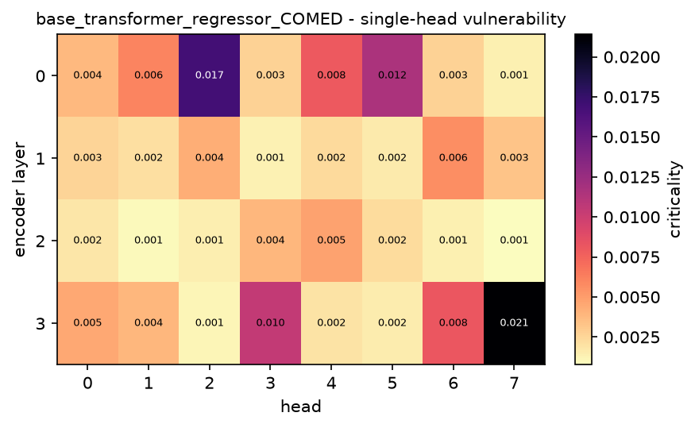
Figure 1. Single-head vulnerability map: the criticality of every head, arranged by layer and head index.
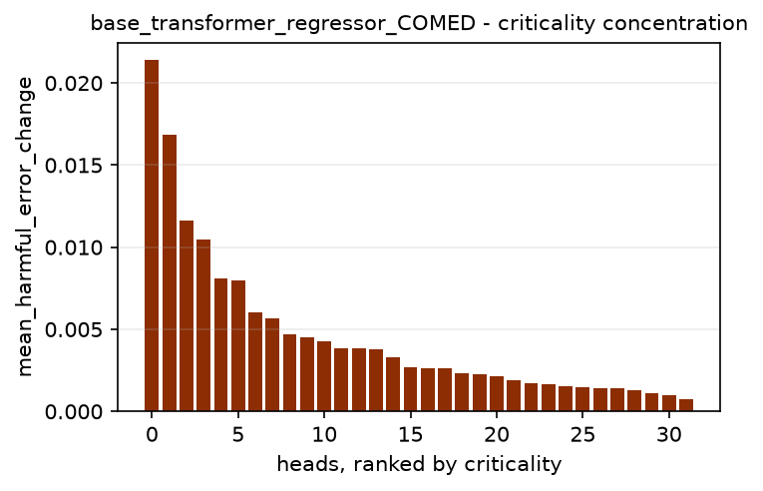
Figure 2. Heads sorted by criticality. A steep drop means importance is concentrated in a few heads.
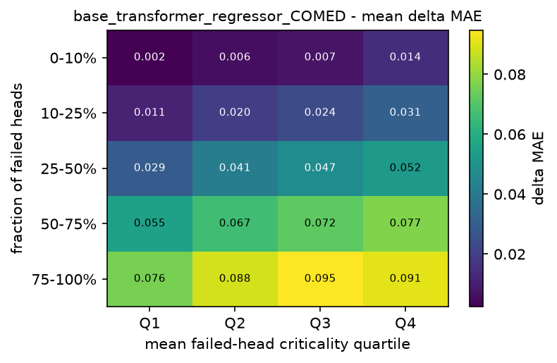
Figure 3. Mean degradation by fault fraction and by the mean criticality of the heads that failed.
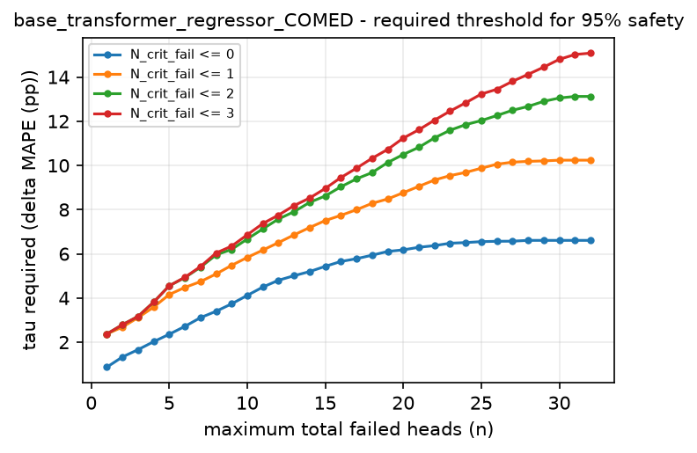
Figure 4. Degradation threshold that must be tolerated for a boundary to be 95% safe.

8. Analysis

H1: is criticality non-uniform?
The ratio of the median head criticality to the largest is 0.066 to 0.157. A value of one would mean every head matters equally, and a value near zero that a single head dominates. Alongside it, 1 to 5 of the 32 heads cause more than half the damage of the worst head, the weakest head still causes 0.01 to 0.05 of what the worst one does, and every head had some measurable effect when crashed alone.
Importance is therefore concentrated in a small minority of heads, and mean redundancy of 0.752 to 0.869 confirms that the typical head can be removed on its own with little effect. The consequence is asymmetric: a randomly chosen head is usually almost free, while the worst head is expensive, so single-head failure cannot be declared safe in general even though the median head very nearly is. H1 is supported.

H2: where the critical heads sit
Counting the layer that holds each model's single most critical head gives layer 0: 3, layer 3: 8. Layer 3 accounts for 8 of the 11 models. More specifically, one and the same head, L3_H7, is the most critical head in 8 of the 11 models.
That recurrence is the result this experiment exists to produce. The architecture, the training recipe and the fault protocol are identical across all 11 models and only the series differs, so a head that comes out most critical 8 times cannot be getting its status from the data. The location of the critical head is therefore a property of the architecture together with the task family, not of the individual series. The 3 exceptions (DUQ, NI, PJME) show that a series can move it, but the default position is fixed.
This resolves the question the source study left open. It observed critical heads in a late layer for forecasting and in early layers for classification, but it varied the model size along with the task and so could not say which caused it. Here the critical head for forecasting sits in layer 3, the last encoder layer, in 8 of 11 independent series under one fixed architecture, while the classification experiments in this repository place it in the first two layers of the very same architecture. Depth position tracks the task family, not the network shape.
H2 is supported: fragility is not monotonic in depth, and the layer that matters is set by the task family rather than by depth or by the individual series.

H3: degradation grows with the number of failures
Mean degradation rises with the fault count in Table 7. Going from a single failed head to more than twenty-four multiplies the degradation by 17.8 (FE) up to 42.0 (NI).
The increase is monotonic across every band in 11 of the 11 models. The fault count is thus the dominant predictor of damage, which the rank correlations of Table 9 independently confirm. H3 is supported.

H4: does head identity matter beyond head count?
The weighted severity W_fail correlates with degradation strongly, but that is not by itself evidence that criticality adds information: W_fail is a sum over the failed heads, so it grows with the fault count almost by construction. Its rank correlation with the plain fault count is 0.943 to 0.973. Any honest test of H4 has to hold the fault count fixed.
W_fail_mean is the cleaner signal, because it is the mean rather than the sum of the criticality weights and so does not grow with the fault count. Its rank correlation with degradation is 0.312 to 0.475, against 0.831 to 0.954 for the raw fault count. That is a substantial correlation for a descriptor that carries no information about how many heads failed, which already points to head identity mattering in its own right.
Table 10 does that, comparing configurations with 4 to 16 failed heads. The most critical quartile degrades the model by a factor of 2.33 to 3.45 relative to the least critical quartile.
The effect is present in every one of the 11 models, so which heads fail matters on top of how many fail and H4 is supported.

H5: critical heads and the safe operating region
No boundary reaches the 0.95 level at any of the thresholds examined. Under a degradation budget this tight, even modest fault configurations cannot be declared safe, so the safe-region analysis constrains rather than reassures.
The engineering consequence is that protection is worth concentrating on the small identified set of critical heads rather than spread evenly over all 32. Redundancy is abundant but not uniform, and the exceptions are identifiable in advance by exactly the single-head sweep used here.

9. Limitations
- Only an encoder-only architecture is evaluated. Decoder-only and encoder-decoder models may behave differently, particularly under causal masking.
- Failure is modelled as a head's output being zeroed. Bit flips in the projection weights, or partial corruption of the attention map, may degrade the model differently.
- Fault configurations are drawn uniformly at random, so correlated hardware failures affecting physically adjacent units are not represented.
- The model is trained from scratch on a limited budget, so its clean accuracy is below what this architecture reaches with longer training. Criticality measured on an under-trained model partly reflects incomplete specialisation of the heads.
- The fault-tolerance regions describe the sampled configurations for this model and these thresholds. They are empirical statements, not universal guarantees.

10. Reproduction
- The experiment is the notebook notebooks/base_transformer/pjm_regions.ipynb. It runs top to bottom and writes its tables, figures and a machine-readable summary to results/base_transformer/pjm_regions/.
- The fault model, the criticality measures, the fault-tolerance regions and the plots all come from the shared library src/faulttol/, so every dataset in this repository is analysed by exactly the same code.
- Protocol parameters are read from environment variables, so a run can be re-budgeted without editing a cell. FT_K_TRIALS and FT_N_FAULT set the fault budget, FT_EPOCHS and FT_PATIENCE the training budget, and FT_DEVICE forces the device. The defaults reproduce the full protocol of the source study.
- This document was generated from the result files by scripts/make_experiment_report.py and can be regenerated at any time without re-running the experiment.

