CIFAR-10: Attention-Head Fault Tolerance of a ViT-Style Encoder (Tiny ViT architecture)
Experiment description, results and analysis. Encoder-only Transformer, 6 layers x 6 heads = 36 attention heads.

1. Purpose and scope
This experiment repeats the protocol on a real image corpus, with the token embedding replaced by a patch projection so the encoder becomes a Vision-Transformer-style classifier. The fault model, the criticality definition and the fault-tolerance analysis are unchanged.
It is the strongest test of whether the layer-position findings are a property of the architecture: a crashed head here removes a channel of attention over spatial image patches rather than over words or over time steps, which is a qualitatively different kind of evidence.
CIFAR-10 is also the corpus used by the Vision Transformer of the Dropout-and-Outliers study, so the two lines of work share a dataset, an image and patch size, and an encoder-only ViT-style design. They are not otherwise the same model: that study uses six blocks of six heads at width 384 with pre-normalisation and learnable absolute positional embeddings, against four blocks of eight heads at width 256 with post-normalisation and fixed sinusoidal encodings here. It also measures a different thing - the magnitude of outlier attention, weight and activation values under Dropout - rather than the effect of crashing a head.
This experiment uses the second of the two architectures in this repository: the Tiny ViT of “Dropout and the Outliers” (Hezbri et al.), which is six blocks of six heads at width 384 with pre-normalisation, learnable absolute positional embeddings, no biases on the query, key and value projections, and GELU. The companion family in notebooks/base_transformer/ runs the identical dataset, training recipe, fault protocol and analysis on four blocks of eight heads at width 256 with post-normalisation and fixed sinusoidal encodings, so the two differ in architecture and in nothing else. Seven architectural choices move together, so any difference between the families localises to this architecture as a bundle rather than to depth, width or normalisation placement individually.

2. Research questions and hypotheses
- RQ1. Does this trained Transformer contain a small number of critical heads alongside many redundant ones?
- RQ2. Is the damage explained by the number of failed heads alone, or also by which heads fail?
- RQ3. How does this result compare with the other datasets, given that the architecture is identical?
Hypotheses tested:
- H1. Attention-head criticality is non-uniform across the network.
- H2. Layer-wise fragility is not monotonic in depth and depends on the task.
- H3. Degradation grows with the number of simultaneously failed heads.
- H4. Criticality-aware fault severity carries information beyond the raw fault count.
- H5. Fault configurations containing critical heads exceed an acceptable degradation threshold more often.

3. Dataset
Property | Value
Corpus | CIFAR-10
Task | image classification, 10 balanced classes
Training images | 50 000 (5 000 held out for validation)
Test images | 10 000, split into a calibration part and a fixed fault-evaluation part
Image size | 32x32 RGB, per-channel standardisation
Sequence seen by the model | 64 patches of 4x4 pixels plus a CLS token
Augmentation | random crop with 4-pixel reflect padding, random horizontal flip

4. Model and training configuration
The model is an encoder-only (bidirectional) Transformer with 6 layers of 6 attention heads. Each layer applies multi-head self-attention followed by a position-wise feed-forward network, a two-layer MLP applied to every token independently. Each of the two blocks is wrapped in a residual connection with layer normalisation applied before the block, plus a final normalisation after the stack (pre-norm). A learned CLS token, placed first in the sequence, carries the prediction, and positional information is a learnable absolute encoding. Self-attention is the only operation that mixes information across positions: there is no recurrent or convolutional layer over the sequence. Within a family only the input adapter, the output head and the activation change between datasets.
Table A. Architecture, as recorded in the result file.
Property | Value
Architecture family | Tiny ViT shape (Hezbri et al., Table 6)
Attention | bidirectional (encoder-only)
Layers | 6
Heads per layer | 6
Total attention heads | 36
Embedding dimension d_model | 384
Head width d_k | 64
Feed-forward network | 2-layer MLP: Linear(384 → 1536) → gelu → Dropout → Linear(1536 → 384)
Feed-forward activation | gelu
Normalisation placement | pre-norm, with a final norm
Positional encoding | learnable absolute
Biases | everywhere except the q, k, v projections
Input adapter | patch embedding Conv2d(3, 384, kernel 4, stride 4): non-overlapping 4x4 patches, i.e. a linear projection of each patch (ViT stem, not a CNN)
Sequence length | 64 image patches + 1 CLS token
Readout | CLS token, first position
Output head | Linear(384 → 10), class logits
Dropout | 0.05 after the embedding, on the attention-block output, inside the FFN and on the FFN output; none on the attention weights
Fault-injection point | per-head mask on attn·V, before concatenation and W_o
Trainable parameters | 10,688,650

Forward pass:
- Input adapter: patch embedding Conv2d(3, 384, kernel 4, stride 4): non-overlapping 4x4 patches, i.e. a linear projection of each patch (ViT stem, not a CNN) → (batch, 64, 384).
- Add the CLS token at the first position, add the positional encoding, apply Dropout.
- Repeat 6 times: x = x + Dropout(MHA(LayerNorm(x))); x = x + Dropout(FFN(LayerNorm(x))).
- Multi-head attention (MHA) inside each layer: Q, K, V = x·W_q, x·W_k, x·W_v, split into 6 heads of width 64 → softmax(Q·Kᵀ/√64) · V → head mask (fault injection) → concatenate → W_o.
- Final LayerNorm after the last layer.
- Take the CLS token and apply the output head: Linear(384 → 10), class logits.
Table A2. Layer-by-layer summary. Parameter counts are computed from the configuration and match the recorded trainable-parameter total.
Layer | Type, activation | Output | Params
input | image (3, 32, 32) | (3, 32, 32) | 0
patch embedding | Conv2d 4x4, stride 4 (linear patch projection) | (64, 384) | 18 816
CLS + position | CLS token (first) + learnable positional encoding, Dropout | (65, 384) | 25 344
L1 | Transformer block: MHA 6x64 + FFN 1536, GELU, pre-norm | (65, 384) | 1 773 312
L2 | Transformer block: MHA 6x64 + FFN 1536, GELU, pre-norm | (65, 384) | 1 773 312
L3 | Transformer block: MHA 6x64 + FFN 1536, GELU, pre-norm | (65, 384) | 1 773 312
L4 | Transformer block: MHA 6x64 + FFN 1536, GELU, pre-norm | (65, 384) | 1 773 312
L5 | Transformer block: MHA 6x64 + FFN 1536, GELU, pre-norm | (65, 384) | 1 773 312
L6 | Transformer block: MHA 6x64 + FFN 1536, GELU, pre-norm | (65, 384) | 1 773 312
final norm | LayerNorm | (65, 384) | 768
readout | take CLS token | (384) | 0
output | Dense 10, softmax logits | (10) | 3 850
Total (all trainable) |  |  | 10 688 650

Table A3. Inside one Transformer block (every block is identical).
Layer | Type, activation | Output | Params
LayerNorm 1 | LayerNorm | (65, 384) | 768
MHA | self-attention, 6 heads x 64: W_q, W_k, W_v, W_o, no q/k/v bias | (65, 384) | 590 208
residual | Dropout + add | (65, 384) | 0
LayerNorm 2 | LayerNorm | (65, 384) | 768
FFN 1 | Dense 1536, GELU | (65, 1536) | 591 360
FFN 2 | Dropout, Dense 384, linear | (65, 384) | 590 208
residual | Dropout + add | (65, 384) | 0
Block total |  |  | 1 773 312

Table B. Training configuration.
Setting | Value
loss | CrossEntropyLoss
optimizer | AdamW
learning_rate | 0.0006
weight_decay | 0.05
batch_size | 128
epochs | 40
patience | 8
grad_clip | 1.0
label_smoothing | 0.1
selection_metric | roc_auc
cosine_schedule | True
augmentation | RandomCrop(32, padding=4) + RandomHorizontalFlip

5. Fault model and protocol
Definition (attention-head crash). A head is considered crashed when its output tensor is replaced with zeros after the attention weights have been multiplied by the value matrix and before the heads are concatenated and passed through the output projection. The crash removes that head's entire contribution while leaving every trained parameter untouched.
- Faults are injected at inference only. The model is trained on clean data and then frozen, so the measured degradation is the resilience of a fixed model rather than a learned compensation.
- Every fault configuration is evaluated on the same fixed subset, drawn once from data held out of both training and model selection. Clean and faulted results are therefore directly comparable.
- A configuration stays active for exactly one evaluation pass, after which all head masks are restored to one.
Protocol:
- Single-head injection: each of the 36 heads is crashed on its own while every other head stays alive, so each comparison differs in exactly one head. This yields per-head criticality C, redundancy R = 1 - C/max(C) and severity weight W = C/mean(C).
- Random multi-head injection: the number of failed heads is drawn uniformly from 1 to 36, that many heads are chosen without replacement, and all are crashed at once.
- Fault severity against degradation: Pearson, Spearman and Kendall correlations for each severity descriptor, plus the correlation between weighted severity and the raw fault count, which shows how much of the former merely restates the latter.
- Empirical fault-tolerance regions: the widest boundary on the total number of failed heads and the number of failed critical heads within which degradation stays below a threshold with empirical probability at least 0.95.

6. Compute budget
Protocol parameter | Value
Random fault configurations per model | 10,000
Fixed evaluation subset | 1,000
Single-head evaluations per model | 36
Models trained | 1
Seconds per evaluation | 0.2692

The run used an NVIDIA GPU; the notebooks select CUDA automatically when it is available and fall back to CPU otherwise. TF32 is disabled so that matmuls stay in full single precision, because the criticality measure resolves damages down to about 1e-6 and reduced-precision accumulation would inject noise directly into the quantity being measured.

7. Results
Table 1. Clean performance on the fixed fault-evaluation subset, before any fault injection.
Model | Primary | Secondary | Tertiary | Parameters
cifar10 | accuracy 0.7350 | macro F1 0.7333 | macro ROC AUC 0.9627 | 10,688,650

Table 2. Training. Early stopping on the validation selection metric means the number of epochs run may be below the configured maximum.
Model | Epochs run | Best validation score | Training time, s
cifar10 | 38 | 0.9605 | 1.447e+03

Table 3. Single-head criticality. A small median-to-maximum ratio means importance is concentrated in a few heads.
Model | Most critical head | Max criticality | Median criticality | Median / max | Mean redundancy | Heads above half of max | Heads with no effect
cifar10 | L0_H2 | 0.199147 | 0.014329 | 0.072 | 0.825 | 4 | 0

Table 4. Where the critical heads sit. The architecture is identical in every row.
Model | Its layer | Most fragile layer by mean | Most fragile layer by strongest head | Critical heads (top 10%)
cifar10 | 0 | 0 | 0 | L0_H2, L0_H4, L0_H1, L0_H0

Table 5. Fragility of each encoder layer.
Layer | Mean criticality | Strongest head | Weakest head | Mean redundancy | Most critical head
0 | 0.141229 | 0.199147 | 0.082433 | 0.291 | L0_H2
1 | 0.016256 | 0.018495 | 0.014214 | 0.918 | L1_H1
2 | 0.014830 | 0.024538 | 0.011543 | 0.926 | L2_H2
3 | 0.013608 | 0.025223 | 0.007731 | 0.932 | L3_H1
4 | 0.013960 | 0.020539 | 0.008859 | 0.930 | L4_H3
5 | 0.008991 | 0.014083 | 0.005388 | 0.955 | L5_H0

Table 6. The five most critical heads followed by the five least critical.
Rank | Head | Criticality | Redundancy | D_pos_mean
1 | L0_H2 | 0.199147 | 5.021e-12 | 0.199147
2 | L0_H4 | 0.194562 | 0.023 | 0.194562
3 | L0_H1 | 0.169893 | 0.147 | 0.169893
4 | L0_H0 | 0.117242 | 0.411 | 0.117242
5 | L0_H3 | 0.084095 | 0.578 | 0.084095
- | L5_H1 | 0.005388 | 0.973 | 0.005388
- | L5_H2 | 0.006833 | 0.966 | 0.006833
- | L3_H3 | 0.007731 | 0.961 | 0.007731
- | L5_H4 | 0.008616 | 0.957 | 0.008616
- | L4_H1 | 0.008859 | 0.956 | 0.008859

Table 7. Mean degradation by the number of simultaneously failed heads.
Model | Metric | 1 heads | 2-3 heads | 4-8 heads | 9-16 heads | 17-24 heads | 25+ heads
cifar10 | D_mean | 0.021002 | 0.052084 | 0.124339 | 0.258918 | 0.394226 | 0.476995

Table 8. Mean degradation by fault fraction (rows) and by quartile of the mean criticality of the failed heads (columns, Q1 least critical).
Fault fraction | Q1 | Q2 | Q3 | Q4
0-10% | 0.007322 | 0.058209 | 0.062997 | 0.132870
10-25% | 0.047087 | 0.126803 | 0.165647 | 0.235874
25-50% | 0.166521 | 0.275875 | 0.325182 | 0.377337
50-75% | 0.333585 | 0.410514 | 0.451163 | 0.472490
75-100% | 0.445089 | 0.486317 | 0.505476 | 0.510138

Table 9. Rank correlations between each fault-severity descriptor and the degradation. N_fail is the number of failed heads, L_fault the number of affected layers, N_crit_fail the number of failed critical heads, W_fail and W_fail_mean the sum and mean of the criticality weights.
Model | Severity descriptor | Pearson | Spearman | Kendall
cifar10 | N_fail | 0.891 | 0.919 | 0.758
cifar10 | L_fault | 0.747 | 0.722 | 0.592
cifar10 | N_crit_fail | 0.923 | 0.944 | 0.833
cifar10 | W_fail | 0.955 | 0.980 | 0.883
cifar10 | W_fail_mean | 0.306 | 0.444 | 0.313

Table 10. Configurations with 4 to 16 failed heads, split into quartiles by the mean criticality of the heads that failed. Holding the fault count roughly constant isolates the effect of head identity. The last column shows how much the weighted severity is a restatement of the fault count.
Model | Least critical quartile | Most critical quartile | Ratio | Configurations | Spearman(W_fail, N_fail)
cifar10 | 0.063959 | 0.307571 | 4.81 | 3593 | 0.945

Table 11. Widest boundary within which degradation stays below the threshold with empirical probability at least 0.95. A boundary is written as a cap on the total number of failed heads together with a cap on the number of failed critical heads.
Model | Threshold | Safe boundary | Highest safe probability | Coverage, %
cifar10 | tau_0.010 | none | 0.273 | 0
cifar10 | tau_0.025 | none | 0.898 | 0
cifar10 | tau_0.050 | N_fail<=1, N_crit_fail<=0 | 0.951 | 2.64

What criticality is.
The criticality C(l, h) of a head is the average harm the model suffers when that one head is crashed while all other 35 heads keep working. The head in layer l, head index h (written Ll_Hh, both counted from 0) has its output set to zero, the fixed evaluation subset of N = 1,000 samples is run through the model, and each sample's prediction is compared with the fault-free prediction for the same sample. This is repeated for every head, so the 36 values are directly comparable: each differs from the clean model in exactly one head.
For classification the per-sample damage is the probability the model loses on the true class y_i:
D_i(l, h) = p_clean(y_i | x_i) − p_(l,h) crashed(y_i | x_i)
C(l, h) = (1/N) · Σ_i max(D_i(l, h), 0)
C is a probability, between 0 and 1. C = 0.01 means that crashing this head costs the correct class one percentage point of probability on an average sample (recorded as D_pos_mean).
Only harm is counted. A crash occasionally helps a sample (negative damage), and a signed average would let that help cancel the harm, making a disruptive head look safe. The max(·, 0) keeps the measure one-sided.
Two quantities are derived from C. The severity weight W(l, h) = C(l, h) / mean C rescales criticality so that an average head has W = 1, and the critical heads are the 4 heads with the largest C (the top 10% of 36). Figure 1 shows C for every head: rows are layers, columns are head indices, and darker cells are more critical.
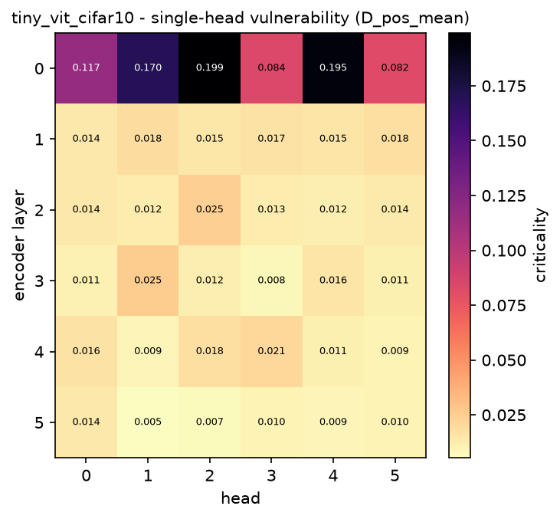
Figure 1. Single-head vulnerability map: the criticality of every head, arranged by layer and head index.
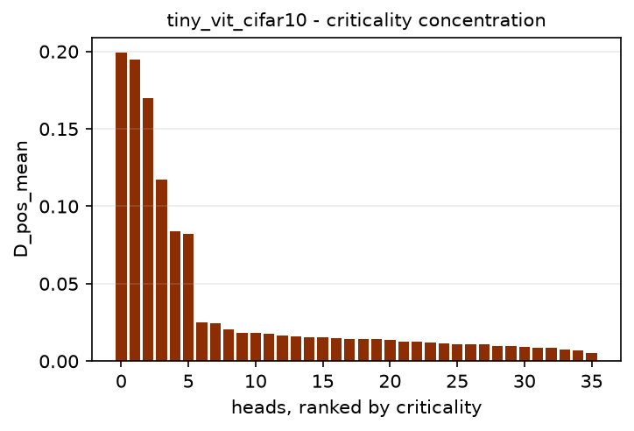
Figure 2. Heads sorted by criticality. A steep drop means importance is concentrated in a few heads.
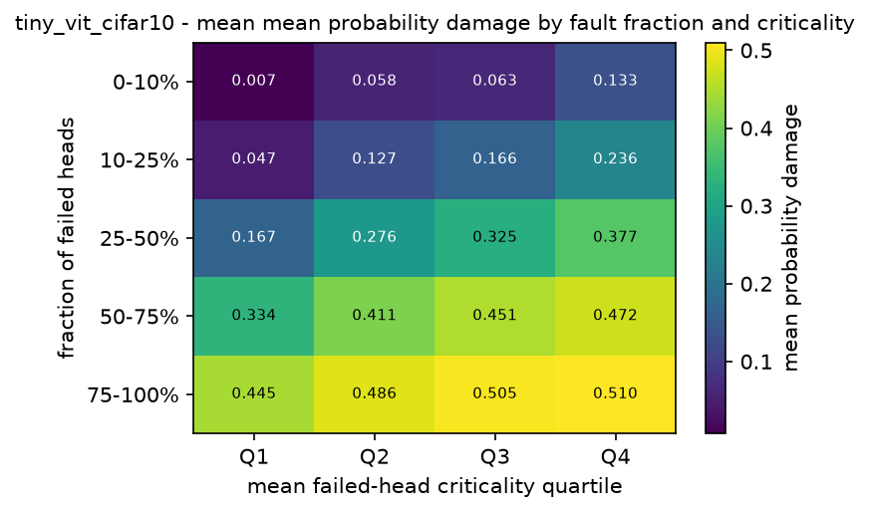
Figure 3. Mean degradation by fault fraction and by the mean criticality of the heads that failed.
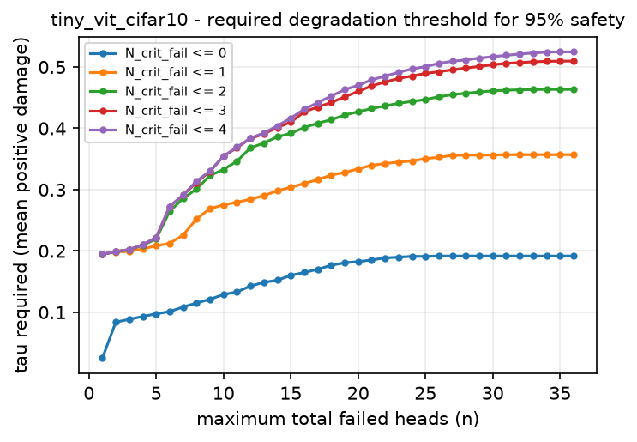
Figure 4. Degradation threshold that must be tolerated for a boundary to be 95% safe.

8. Analysis

H1: is criticality non-uniform?
The ratio of the median head criticality to the largest is 0.072. A value of one would mean every head matters equally, and a value near zero that a single head dominates. Alongside it, 4 of the 36 heads cause more than half the damage of the worst head, the weakest head still causes 0.03 of what the worst one does, and every head had some measurable effect when crashed alone.
Importance is therefore concentrated in a small minority of heads, and mean redundancy of 0.825 confirms that the typical head can be removed on its own with little effect. The consequence is asymmetric: a randomly chosen head is usually almost free, while the worst head is expensive, so single-head failure cannot be declared safe in general even though the median head very nearly is. H1 is supported.

H2: where the critical heads sit
The single most critical head of this model is L0_H2, in layer 0. Both rankings of the layers agree: layer 0 comes first by mean criticality and also by its strongest single head, so that layer is fragile as a whole rather than because of one outlier head.
Fragility is therefore not monotonic in depth: damage neither grows steadily from the input side to the output side nor the reverse, which is what H2 predicts.
Which layers matter is decided by where this model concentrated the computation its prediction depends on. Since the architecture is shared with the other experiments in this family, any difference in the critical layer between them is attributable to the task and the data, not to depth or width. Comparisons against a different family in this repository do not have that property, because there the architecture changes too.
H2 is supported: the layer that matters is set by the task, not by depth.

H3: degradation grows with the number of failures
Mean degradation rises with the fault count in Table 7. Going from a single failed head to more than twenty-four multiplies the degradation by 22.7.
The increase is monotonic across every band in this model. The fault count is thus the dominant predictor of damage, which the rank correlations of Table 9 independently confirm. H3 is supported.

H4: does head identity matter beyond head count?
The weighted severity W_fail correlates with degradation strongly, but that is not by itself evidence that criticality adds information: W_fail is a sum over the failed heads, so it grows with the fault count almost by construction. Its rank correlation with the plain fault count is 0.945. Any honest test of H4 has to hold the fault count fixed.
W_fail_mean is the cleaner signal, because it is the mean rather than the sum of the criticality weights and so does not grow with the fault count. Its rank correlation with degradation is 0.444, against 0.919 for the raw fault count. That is a substantial correlation for a descriptor that carries no information about how many heads failed, which already points to head identity mattering in its own right.
Table 10 does that, comparing configurations with 4 to 16 failed heads. The most critical quartile degrades the model by a factor of 4.81 relative to the least critical quartile.
The effect is present, so which heads fail matters on top of how many fail and H4 is supported.

H5: critical heads and the safe operating region
A 95%-safe boundary exists in 1 of the 3 threshold cases examined.
In that boundary the cap on failed critical heads is binding, that is, strictly below the 4 critical heads the model has. Widening such a boundary to admit one more critical failure raises the degradation that must be tolerated, which is the content of H5, and to that extent it is supported.
The widest safe boundary is N_fail<=1, N_crit_fail<=0 (cifar10), covering 2.6% of the sampled configurations at threshold tau_0.050.
The engineering consequence is that protection is worth concentrating on the small identified set of critical heads rather than spread evenly over all 36. Redundancy is abundant but not uniform, and the exceptions are identifiable in advance by exactly the single-head sweep used here.

9. Limitations
- Only an encoder-only architecture is evaluated. Decoder-only and encoder-decoder models may behave differently, particularly under causal masking.
- Failure is modelled as a head's output being zeroed. Bit flips in the projection weights, or partial corruption of the attention map, may degrade the model differently.
- Fault configurations are drawn uniformly at random, so correlated hardware failures affecting physically adjacent units are not represented.
- The model is trained from scratch on a limited budget, so its clean accuracy is below what this architecture reaches with longer training. Criticality measured on an under-trained model partly reflects incomplete specialisation of the heads.
- The fault-tolerance regions describe the sampled configurations for this model and these thresholds. They are empirical statements, not universal guarantees.

10. Reproduction
- The experiment is the notebook notebooks/tiny_vit/cifar10.ipynb. It runs top to bottom and writes its tables, figures and a machine-readable summary to results/tiny_vit/cifar10/.
- The fault model, the criticality measures, the fault-tolerance regions and the plots all come from the shared library src/faulttol/, so every dataset in this repository is analysed by exactly the same code.
- Protocol parameters are read from environment variables, so a run can be re-budgeted without editing a cell. FT_K_TRIALS and FT_N_FAULT set the fault budget, FT_EPOCHS and FT_PATIENCE the training budget, and FT_DEVICE forces the device. The defaults reproduce the full protocol of the source study.
- This document was generated from the result files by scripts/make_experiment_report.py and can be regenerated at any time without re-running the experiment.

