PJM Regional Load: Attention-Head Fault Tolerance of a Transformer Forecaster (Tiny ViT architecture)
Experiment description, results and analysis. Encoder-only Transformer, 6 layers x 6 heads = 36 attention heads.

1. Purpose and scope
This experiment runs the whole protocol independently on eleven regional load series, holding one architecture fixed, and then compares the eleven results.
That comparison answers a question the source study could not: it examined one region only, so it could not tell whether the layer that holds the critical head is a property of the architecture or of the particular series. Eleven series under one fixed architecture separate the two.
AEP is deliberately excluded because it is the region used in the source paper; these eleven series are therefore new evidence rather than a re-run of the published case.
This experiment uses the second of the two architectures in this repository: the Tiny ViT of “Dropout and the Outliers” (Hezbri et al.), which is six blocks of six heads at width 384 with pre-normalisation, learnable absolute positional embeddings, no biases on the query, key and value projections, and GELU. The companion family in notebooks/base_transformer/ runs the identical dataset, training recipe, fault protocol and analysis on four blocks of eight heads at width 256 with post-normalisation and fixed sinusoidal encodings, so the two differ in architecture and in nothing else. Seven architectural choices move together, so any difference between the families localises to this architecture as a bundle rather than to depth, width or normalisation placement individually.

2. Research questions and hypotheses
- RQ1. Does this trained Transformer contain a small number of critical heads alongside many redundant ones?
- RQ2. Is the damage explained by the number of failed heads alone, or also by which heads fail?
- RQ3. How does this result compare with the other datasets, given that the architecture is identical?
Hypotheses tested:
- H1. Attention-head criticality is non-uniform across the network.
- H2. Layer-wise fragility is not monotonic in depth and depends on the task.
- H3. Degradation grows with the number of simultaneously failed heads.
- H4. Criticality-aware fault severity carries information beyond the raw fault count.
- H5. Fault configurations containing critical heads exceed an acceptable degradation threshold more often.

3. Dataset
Property | Value
Corpus | PJM hourly load, every region except AEP
Task | forecast the next hourly value from the previous 20 hours
Regions | PJME, COMED, DAYTON, DOM, DUQ, PJMW, FE, NI, DEOK, EKPC, PJM_Load
Observations | roughly 33 000 to 145 000 hourly values per region
Normalisation | per-region min-max to the unit interval; MAPE reported in the original megawatt scale
Sequence seen by the model | 20 consecutive hours plus a CLS token

4. Model and training configuration
The model is an encoder-only (bidirectional) Transformer with 6 layers of 6 attention heads. Each layer applies multi-head self-attention followed by a position-wise feed-forward network, a two-layer MLP applied to every token independently. Each of the two blocks is wrapped in a residual connection with layer normalisation applied before the block, plus a final normalisation after the stack (pre-norm). A learned CLS token, placed first in the sequence, carries the prediction, and positional information is a learnable absolute encoding. Self-attention is the only operation that mixes information across positions: there is no recurrent or convolutional layer over the sequence. Within a family only the input adapter, the output head and the activation change between datasets.
Table A. Architecture, as recorded in the result file.
Property | Value
Architecture family | Tiny ViT shape (Hezbri et al., Table 6)
Attention | bidirectional (encoder-only)
Layers | 6
Heads per layer | 6
Total attention heads | 36
Embedding dimension d_model | 384
Head width d_k | 64
Feed-forward network | 2-layer MLP: Linear(384 → 1536) → gelu → Dropout → Linear(1536 → 384)
Feed-forward activation | gelu
Normalisation placement | pre-norm, with a final norm
Positional encoding | learnable absolute
Biases | everywhere except the q, k, v projections
Input adapter | scalar projection Linear(1, 384) applied to each hourly load value (no convolution over time)
Sequence length | 20 hourly time steps + 1 CLS token
Readout | CLS token, first position
Output head | Linear(384 → 1), next-hour load
Dropout | 0.05 after the embedding, on the attention-block output, inside the FFN and on the FFN output; none on the attention weights
Fault-injection point | per-head mask on attn·V, before concatenation and W_o
Trainable parameters | 10,650,241

Forward pass:
- Input adapter: scalar projection Linear(1, 384) applied to each hourly load value (no convolution over time) → (batch, 20, 384).
- Add the CLS token at the first position, add the positional encoding, apply Dropout.
- Repeat 6 times: x = x + Dropout(MHA(LayerNorm(x))); x = x + Dropout(FFN(LayerNorm(x))).
- Multi-head attention (MHA) inside each layer: Q, K, V = x·W_q, x·W_k, x·W_v, split into 6 heads of width 64 → softmax(Q·Kᵀ/√64) · V → head mask (fault injection) → concatenate → W_o.
- Final LayerNorm after the last layer.
- Take the CLS token and apply the output head: Linear(384 → 1), next-hour load.
Table A2. Layer-by-layer summary. Parameter counts are computed from the configuration and match the recorded trainable-parameter total.
Layer | Type, activation | Output | Params
input | window (20) | (20) | 0
input projection | Dense 384 per time step, linear | (20, 384) | 768
CLS + position | CLS token (first) + learnable positional encoding, Dropout | (21, 384) | 8 448
L1 | Transformer block: MHA 6x64 + FFN 1536, GELU, pre-norm | (21, 384) | 1 773 312
L2 | Transformer block: MHA 6x64 + FFN 1536, GELU, pre-norm | (21, 384) | 1 773 312
L3 | Transformer block: MHA 6x64 + FFN 1536, GELU, pre-norm | (21, 384) | 1 773 312
L4 | Transformer block: MHA 6x64 + FFN 1536, GELU, pre-norm | (21, 384) | 1 773 312
L5 | Transformer block: MHA 6x64 + FFN 1536, GELU, pre-norm | (21, 384) | 1 773 312
L6 | Transformer block: MHA 6x64 + FFN 1536, GELU, pre-norm | (21, 384) | 1 773 312
final norm | LayerNorm | (21, 384) | 768
readout | take CLS token | (384) | 0
output | Dense 1, linear | (1) | 385
Total (all trainable) |  |  | 10 650 241

Table A3. Inside one Transformer block (every block is identical).
Layer | Type, activation | Output | Params
LayerNorm 1 | LayerNorm | (21, 384) | 768
MHA | self-attention, 6 heads x 64: W_q, W_k, W_v, W_o, no q/k/v bias | (21, 384) | 590 208
residual | Dropout + add | (21, 384) | 0
LayerNorm 2 | LayerNorm | (21, 384) | 768
FFN 1 | Dense 1536, GELU | (21, 1536) | 591 360
FFN 2 | Dropout, Dense 384, linear | (21, 384) | 590 208
residual | Dropout + add | (21, 384) | 0
Block total |  |  | 1 773 312

Table B. Training configuration.
Setting | Value
loss | MSELoss
optimizer | AdamW
learning_rate | 0.0001
weight_decay | 0.0001
batch_size | 128
epochs | 50
patience | 8
grad_clip | 1.0
selection_metric | val_mae

5. Fault model and protocol
Definition (attention-head crash). A head is considered crashed when its output tensor is replaced with zeros after the attention weights have been multiplied by the value matrix and before the heads are concatenated and passed through the output projection. The crash removes that head's entire contribution while leaving every trained parameter untouched.
- Faults are injected at inference only. The model is trained on clean data and then frozen, so the measured degradation is the resilience of a fixed model rather than a learned compensation.
- Every fault configuration is evaluated on the same fixed subset, drawn once from data held out of both training and model selection. Clean and faulted results are therefore directly comparable.
- A configuration stays active for exactly one evaluation pass, after which all head masks are restored to one.
Protocol:
- Single-head injection: each of the 36 heads is crashed on its own while every other head stays alive, so each comparison differs in exactly one head. This yields per-head criticality C, redundancy R = 1 - C/max(C) and severity weight W = C/mean(C).
- Random multi-head injection: the number of failed heads is drawn uniformly from 1 to 36, that many heads are chosen without replacement, and all are crashed at once.
- Fault severity against degradation: Pearson, Spearman and Kendall correlations for each severity descriptor, plus the correlation between weighted severity and the raw fault count, which shows how much of the former merely restates the latter.
- Empirical fault-tolerance regions: the widest boundary on the total number of failed heads and the number of failed critical heads within which degradation stays below a threshold with empirical probability at least 0.95.

6. Compute budget
Protocol parameter | Value
Random fault configurations per model | 10,000
Fixed evaluation subset | 1,000
Single-head evaluations per model | 36
Models trained | 11
Seconds per evaluation | -

The run used an NVIDIA GPU; the notebooks select CUDA automatically when it is available and fall back to CPU otherwise. TF32 is disabled so that matmuls stay in full single precision, because the criticality measure resolves damages down to about 1e-6 and reduced-precision accumulation would inject noise directly into the quantity being measured.

7. Results
Table 1. Clean performance on the fixed fault-evaluation subset, before any fault injection.
Model | Primary | Secondary | Tertiary | Parameters
COMED | MAE 0.0098 | RMSE 0.0128 | MAPE 1.440% | 10,650,241
DAYTON | MAE 0.0077 | RMSE 0.0109 | MAPE 1.056% | 10,650,241
DEOK | MAE 0.0103 | RMSE 0.0138 | MAPE 1.530% | 10,650,241
DOM | MAE 0.0087 | RMSE 0.0116 | MAPE 1.671% | 10,650,241
DUQ | MAE 0.0108 | RMSE 0.0146 | MAPE 1.320% | 10,650,241
EKPC | MAE 0.0116 | RMSE 0.0155 | MAPE 2.420% | 10,650,241
FE | MAE 0.0075 | RMSE 0.0101 | MAPE 1.340% | 10,650,241
NI | MAE 0.0098 | RMSE 0.0137 | MAPE 1.389% | 10,650,241
PJM_Load | MAE 0.0126 | RMSE 0.0175 | MAPE 1.544% | 10,650,241
PJME | MAE 0.0097 | RMSE 0.0128 | MAPE 1.442% | 10,650,241
PJMW | MAE 0.0076 | RMSE 0.0100 | MAPE 1.257% | 10,650,241

Table 2. Training. Early stopping on the validation selection metric means the number of epochs run may be below the configured maximum.
Model | Epochs run | Best validation score | Training time, s
COMED | 28 | 0.0091 | 304
DAYTON | 50 | 0.0079 | 545
DEOK | 17 | 0.0108 | 181
DOM | 23 | 0.0092 | 250
DUQ | 42 | 0.0107 | 458
EKPC | 32 | 0.0122 | 309
FE | 27 | 0.0074 | 290
NI | 23 | 0.0095 | 245
PJM_Load | 24 | 0.0123 | 168
PJME | 22 | 0.0097 | 238
PJMW | 43 | 0.0076 | 461

Table 3. Single-head criticality. A small median-to-maximum ratio means importance is concentrated in a few heads.
Model | Most critical head | Max criticality | Median criticality | Median / max | Mean redundancy | Heads above half of max | Heads with no effect
COMED | L1_H3 | 0.020726 | 0.003190 | 0.154 | 0.738 | 6 | 0
DAYTON | L0_H3 | 0.043193 | 0.002214 | 0.051 | 0.894 | 1 | 0
DEOK | L1_H0 | 0.033456 | 0.002880 | 0.086 | 0.826 | 2 | 0
DOM | L0_H4 | 0.032494 | 0.003192 | 0.098 | 0.828 | 2 | 0
DUQ | L1_H5 | 0.033884 | 0.002061 | 0.061 | 0.872 | 2 | 0
EKPC | L0_H4 | 0.033450 | 0.002136 | 0.064 | 0.894 | 2 | 0
FE | L0_H4 | 0.049163 | 0.002080 | 0.042 | 0.911 | 1 | 0
NI | L0_H4 | 0.041776 | 0.003297 | 0.079 | 0.857 | 2 | 0
PJM_Load | L0_H4 | 0.074464 | 0.003496 | 0.047 | 0.872 | 3 | 0
PJME | L0_H5 | 0.040658 | 0.003206 | 0.079 | 0.835 | 4 | 0
PJMW | L0_H4 | 0.051755 | 0.001676 | 0.032 | 0.924 | 1 | 0

Table 4. Where the critical heads sit. The architecture is identical in every row.
Model | Its layer | Most fragile layer by mean | Most fragile layer by strongest head | Critical heads (top 10%)
COMED | 1 | 1 | 1 | L1_H3, L0_H4, L1_H0, L0_H2
DAYTON | 0 | 0 | 0 | L0_H3, L0_H1, L1_H0, L0_H4
DEOK | 1 | 1 | 1 | L1_H0, L1_H1, L0_H4, L0_H1
DOM | 0 | 0 | 0 | L0_H4, L1_H1, L0_H2, L0_H1
DUQ | 1 | 1 | 1 | L1_H5, L1_H4, L1_H0, L0_H4
EKPC | 0 | 0 | 0 | L0_H4, L0_H3, L5_H1, L0_H5
FE | 0 | 0 | 0 | L0_H4, L1_H4, L1_H1, L1_H5
NI | 0 | 0 | 0 | L0_H4, L1_H2, L1_H5, L0_H1
PJM_Load | 0 | 0 | 0 | L0_H4, L1_H2, L0_H5, L0_H1
PJME | 0 | 0 | 0 | L0_H5, L1_H5, L1_H4, L0_H4
PJMW | 0 | 0 | 0 | L0_H4, L0_H3, L1_H4, L0_H2

Table 7. Mean degradation by the number of simultaneously failed heads.
Model | Metric | 1 heads | 2-3 heads | 4-8 heads | 9-16 heads | 17-24 heads | 25+ heads
COMED | delta_mae | 0.003855 | 0.008540 | 0.018101 | 0.033145 | 0.052671 | 0.074857
DAYTON | delta_mae | 0.003709 | 0.008203 | 0.019032 | 0.037867 | 0.061016 | 0.084243
DEOK | delta_mae | 0.004209 | 0.008749 | 0.019805 | 0.036018 | 0.057153 | 0.080348
DOM | delta_mae | 0.004370 | 0.009163 | 0.018744 | 0.034354 | 0.051911 | 0.070495
DUQ | delta_mae | 0.002641 | 0.006222 | 0.016454 | 0.033709 | 0.056342 | 0.083965
EKPC | delta_mae | 0.002373 | 0.005019 | 0.011725 | 0.026932 | 0.047941 | 0.071615
FE | delta_mae | 0.003538 | 0.007237 | 0.015538 | 0.029873 | 0.044032 | 0.057350
NI | delta_mae | 0.004656 | 0.009465 | 0.020516 | 0.037264 | 0.056338 | 0.077617
PJM_Load | delta_mae | 0.007606 | 0.016493 | 0.035256 | 0.059650 | 0.080670 | 0.098521
PJME | delta_mae | 0.004604 | 0.010480 | 0.023526 | 0.039675 | 0.056614 | 0.077796
PJMW | delta_mae | 0.003273 | 0.006845 | 0.014871 | 0.031476 | 0.050524 | 0.068221

Table 9. Rank correlations between each fault-severity descriptor and the degradation. N_fail is the number of failed heads, L_fault the number of affected layers, N_crit_fail the number of failed critical heads, W_fail and W_fail_mean the sum and mean of the criticality weights.
Model | Severity descriptor | Pearson | Spearman | Kendall
COMED | N_fail | 0.882 | 0.883 | 0.708
COMED | L_fault | 0.623 | 0.691 | 0.561
COMED | N_crit_fail | 0.897 | 0.900 | 0.766
COMED | W_fail | 0.930 | 0.932 | 0.772
COMED | W_fail_mean | 0.234 | 0.367 | 0.255
DAYTON | N_fail | 0.837 | 0.845 | 0.667
DAYTON | L_fault | 0.607 | 0.666 | 0.541
DAYTON | N_crit_fail | 0.926 | 0.926 | 0.805
DAYTON | W_fail | 0.960 | 0.962 | 0.832
DAYTON | W_fail_mean | 0.332 | 0.592 | 0.408
DEOK | N_fail | 0.857 | 0.861 | 0.685
DEOK | L_fault | 0.612 | 0.667 | 0.539
DEOK | N_crit_fail | 0.883 | 0.884 | 0.745
DEOK | W_fail | 0.928 | 0.930 | 0.773
DEOK | W_fail_mean | 0.277 | 0.452 | 0.310
DOM | N_fail | 0.879 | 0.880 | 0.708
DOM | L_fault | 0.647 | 0.685 | 0.554
DOM | N_crit_fail | 0.875 | 0.875 | 0.734
DOM | W_fail | 0.937 | 0.937 | 0.786
DOM | W_fail_mean | 0.275 | 0.436 | 0.298
DUQ | N_fail | 0.855 | 0.863 | 0.687
DUQ | L_fault | 0.588 | 0.673 | 0.544
DUQ | N_crit_fail | 0.952 | 0.954 | 0.849
DUQ | W_fail | 0.965 | 0.970 | 0.847
DUQ | W_fail_mean | 0.326 | 0.556 | 0.386
EKPC | N_fail | 0.840 | 0.856 | 0.679
EKPC | L_fault | 0.573 | 0.666 | 0.537
EKPC | N_crit_fail | 0.899 | 0.903 | 0.767
EKPC | W_fail | 0.956 | 0.962 | 0.828
EKPC | W_fail_mean | 0.305 | 0.596 | 0.394
FE | N_fail | 0.842 | 0.854 | 0.685
FE | L_fault | 0.649 | 0.657 | 0.533
FE | N_crit_fail | 0.875 | 0.884 | 0.746
FE | W_fail | 0.948 | 0.954 | 0.820
FE | W_fail_mean | 0.377 | 0.598 | 0.395
NI | N_fail | 0.879 | 0.880 | 0.707
NI | L_fault | 0.642 | 0.681 | 0.552
NI | N_crit_fail | 0.920 | 0.920 | 0.794
NI | W_fail | 0.942 | 0.943 | 0.794
NI | W_fail_mean | 0.277 | 0.453 | 0.304
PJM_Load | N_fail | 0.773 | 0.793 | 0.613
PJM_Load | L_fault | 0.644 | 0.627 | 0.505
PJM_Load | N_crit_fail | 0.832 | 0.827 | 0.680
PJM_Load | W_fail | 0.882 | 0.889 | 0.720
PJM_Load | W_fail_mean | 0.408 | 0.535 | 0.370
PJME | N_fail | 0.818 | 0.825 | 0.646
PJME | L_fault | 0.604 | 0.642 | 0.518
PJME | N_crit_fail | 0.922 | 0.922 | 0.799
PJME | W_fail | 0.910 | 0.914 | 0.751
PJME | W_fail_mean | 0.341 | 0.494 | 0.339
PJMW | N_fail | 0.799 | 0.826 | 0.648
PJMW | L_fault | 0.591 | 0.655 | 0.530
PJMW | N_crit_fail | 0.879 | 0.893 | 0.758
PJMW | W_fail | 0.970 | 0.967 | 0.842
PJMW | W_fail_mean | 0.397 | 0.675 | 0.456

Table 10. Configurations with 4 to 16 failed heads, split into quartiles by the mean criticality of the heads that failed. Holding the fault count roughly constant isolates the effect of head identity. The last column shows how much the weighted severity is a restatement of the fault count.
Model | Least critical quartile | Most critical quartile | Ratio | Configurations | Spearman(W_fail, N_fail)
COMED | 0.013448 | 0.039762 | 2.96 | 3593 | 0.975
DAYTON | 0.006549 | 0.056784 | 8.67 | 3593 | 0.926
DEOK | 0.012954 | 0.048216 | 3.72 | 3593 | 0.964
DOM | 0.011596 | 0.042554 | 3.67 | 3593 | 0.959
DUQ | 0.006935 | 0.051261 | 7.39 | 3593 | 0.946
EKPC | 0.004193 | 0.044179 | 10.54 | 3593 | 0.932
FE | 0.007988 | 0.047533 | 5.95 | 3593 | 0.923
NI | 0.012040 | 0.047468 | 3.94 | 3593 | 0.954
PJM_Load | 0.013807 | 0.079915 | 5.79 | 3593 | 0.929
PJME | 0.012857 | 0.052272 | 4.07 | 3593 | 0.951
PJMW | 0.005806 | 0.059094 | 10.18 | 3593 | 0.904

Table 11. Widest boundary within which degradation stays below the threshold with empirical probability at least 0.95. A boundary is written as a cap on the total number of failed heads together with a cap on the number of failed critical heads.
Model | Threshold | Safe boundary | Highest safe probability | Coverage, %
COMED | 10%_of_clean_mape | none | 0.412 | 0
COMED | 25%_of_clean_mape | none | 0.685 | 0
COMED | 50%_of_clean_mape | none | 0.772 | 0
DAYTON | 10%_of_clean_mape | none | 0.426 | 0
DAYTON | 25%_of_clean_mape | none | 0.871 | 0
DAYTON | 50%_of_clean_mape | N_fail<=1, N_crit_fail<=0 | 0.966 | 2.63
DEOK | 10%_of_clean_mape | none | 0.567 | 0
DEOK | 25%_of_clean_mape | none | 0.654 | 0
DEOK | 50%_of_clean_mape | none | 0.894 | 0
DOM | 10%_of_clean_mape | none | 0.374 | 0
DOM | 25%_of_clean_mape | none | 0.709 | 0
DOM | 50%_of_clean_mape | none | 0.781 | 0
DUQ | 10%_of_clean_mape | none | 0.715 | 0
DUQ | 25%_of_clean_mape | none | 0.820 | 0
DUQ | 50%_of_clean_mape | N_fail<=2, N_crit_fail<=0 | 0.951 | 5.08
EKPC | 10%_of_clean_mape | none | 0.769 | 0
EKPC | 25%_of_clean_mape | N_fail<=1, N_crit_fail<=0 | 0.970 | 2.64
EKPC | 50%_of_clean_mape | N_fail<=5, N_crit_fail<=0 | 0.955 | 10.34
FE | 10%_of_clean_mape | none | 0.504 | 0
FE | 25%_of_clean_mape | none | 0.772 | 0
FE | 50%_of_clean_mape | none | 0.884 | 0
NI | 10%_of_clean_mape | none | 0.457 | 0
NI | 25%_of_clean_mape | none | 0.801 | 0
NI | 50%_of_clean_mape | none | 0.850 | 0
PJM_Load | 10%_of_clean_mape | none | 0.556 | 0
PJM_Load | 25%_of_clean_mape | none | 0.831 | 0
PJM_Load | 50%_of_clean_mape | none | 0.906 | 0
PJME | 10%_of_clean_mape | none | 0.446 | 0
PJME | 25%_of_clean_mape | none | 0.734 | 0
PJME | 50%_of_clean_mape | none | 0.863 | 0
PJMW | 10%_of_clean_mape | none | 0.657 | 0
PJMW | 25%_of_clean_mape | none | 0.860 | 0
PJMW | 50%_of_clean_mape | N_fail<=1, N_crit_fail<=0 | 0.985 | 2.65

What criticality is.
The criticality C(l, h) of a head is the average harm the model suffers when that one head is crashed while all other 35 heads keep working. The head in layer l, head index h (written Ll_Hh, both counted from 0) has its output set to zero, the fixed evaluation subset of N = 1,000 samples is run through the model, and each sample's prediction is compared with the fault-free prediction for the same sample. This is repeated for every head, so the 36 values are directly comparable: each differs from the clean model in exactly one head.
For load forecasting the per-sample damage is the increase in absolute error of the next-hour prediction, on the min-max normalised series:
e_i(l, h) = |y_i − ŷ_i, (l,h) crashed| − |y_i − ŷ_i, clean|
C(l, h) = (1/N) · Σ_i max(e_i(l, h), 0)
C is in normalised load units (0 to 1 spans the series' minimum to maximum), so it is not comparable with the classification experiments (recorded as mean_harmful_error_change).
Only harm is counted. A crash occasionally helps a sample (negative damage), and a signed average would let that help cancel the harm, making a disruptive head look safe. The max(·, 0) keeps the measure one-sided.
Two quantities are derived from C. The severity weight W(l, h) = C(l, h) / mean C rescales criticality so that an average head has W = 1, and the critical heads are the 4 heads with the largest C (the top 10% of 36). Figure 1 shows C for every head: rows are layers, columns are head indices, and darker cells are more critical.
The figures below are for EKPC, chosen as representative: its most critical head is the one that recurs across the models, and its criticality concentration is the median within that group. The same four figures for every other model are in that model's own figures folder.
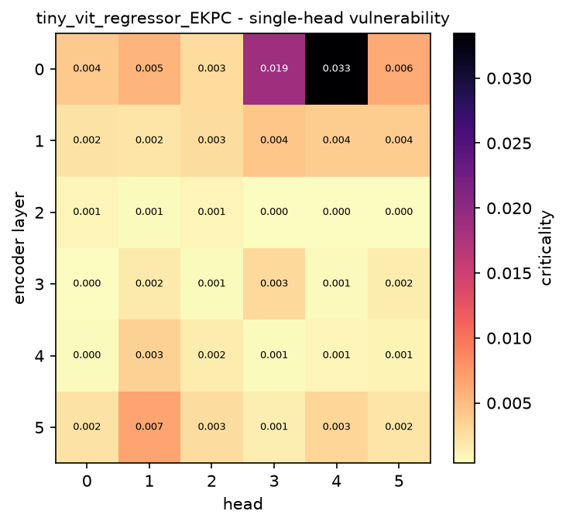
Figure 1. Single-head vulnerability map: the criticality of every head, arranged by layer and head index.
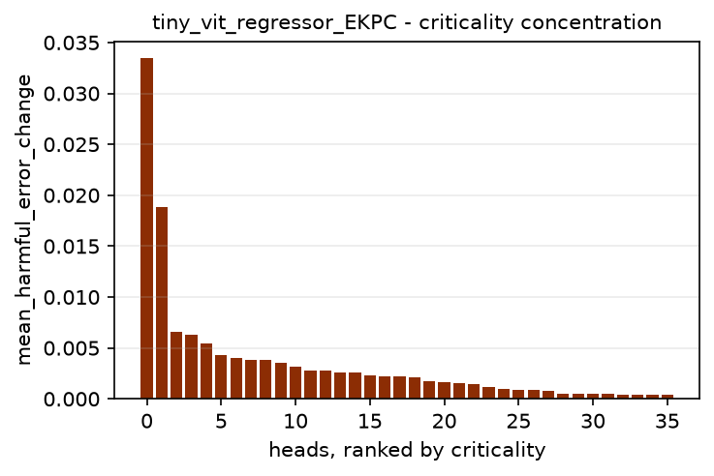
Figure 2. Heads sorted by criticality. A steep drop means importance is concentrated in a few heads.
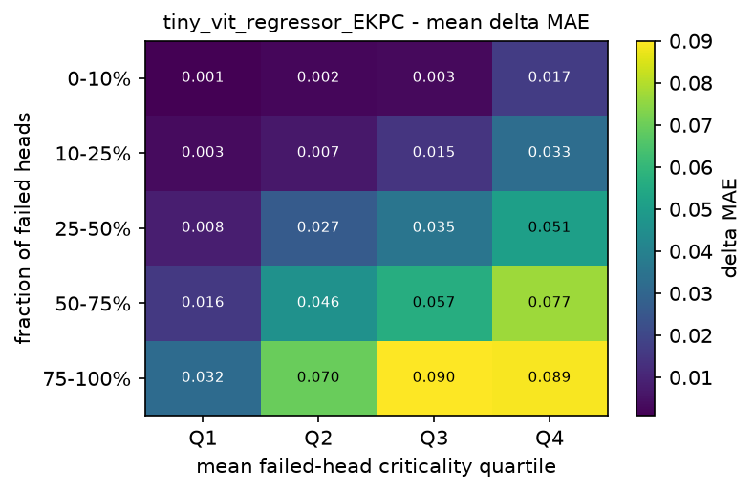
Figure 3. Mean degradation by fault fraction and by the mean criticality of the heads that failed.
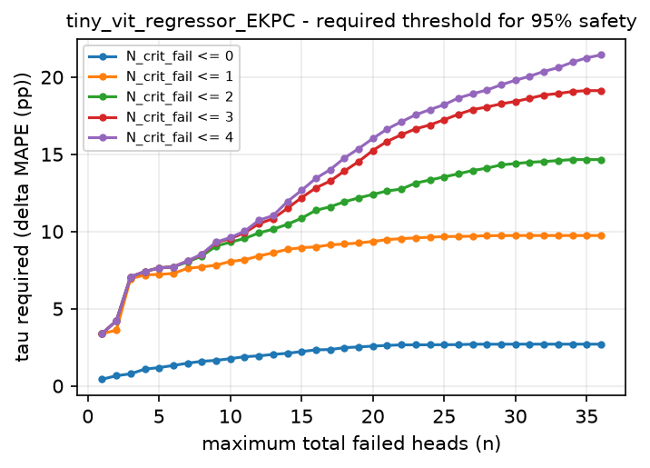
Figure 4. Degradation threshold that must be tolerated for a boundary to be 95% safe.

8. Analysis

H1: is criticality non-uniform?
The ratio of the median head criticality to the largest is 0.032 to 0.154. A value of one would mean every head matters equally, and a value near zero that a single head dominates. Alongside it, 1 to 6 of the 36 heads cause more than half the damage of the worst head, the weakest head still causes 0.00 to 0.02 of what the worst one does, and every head had some measurable effect when crashed alone.
Importance is therefore concentrated in a small minority of heads, and mean redundancy of 0.738 to 0.924 confirms that the typical head can be removed on its own with little effect. The consequence is asymmetric: a randomly chosen head is usually almost free, while the worst head is expensive, so single-head failure cannot be declared safe in general even though the median head very nearly is. H1 is supported.

H2: where the critical heads sit
Counting the layer that holds each model's single most critical head gives layer 0: 8, layer 1: 3. Layer 0 accounts for 8 of the 11 models. More specifically, one and the same head, L0_H4, is the most critical head in 6 of the 11 models.
The critical location is not stable across series: no single head or layer accounts for most of the 11 models. Because the architecture, the training recipe and the fault protocol are identical and only the series differs, that spread is a property of the data rather than of the network. This is exactly the comparison the source study could not make from a single region.
H2 is supported: the layer that matters is set by the series, not by depth.

H3: degradation grows with the number of failures
Mean degradation rises with the fault count in Table 7. Going from a single failed head to more than twenty-four multiplies the degradation by 13.0 (PJM_Load) up to 31.8 (DUQ).
The increase is monotonic across every band in 11 of the 11 models. The fault count is thus the dominant predictor of damage, which the rank correlations of Table 9 independently confirm. H3 is supported.

H4: does head identity matter beyond head count?
The weighted severity W_fail correlates with degradation strongly, but that is not by itself evidence that criticality adds information: W_fail is a sum over the failed heads, so it grows with the fault count almost by construction. Its rank correlation with the plain fault count is 0.904 to 0.975. Any honest test of H4 has to hold the fault count fixed.
W_fail_mean is the cleaner signal, because it is the mean rather than the sum of the criticality weights and so does not grow with the fault count. Its rank correlation with degradation is 0.367 to 0.675, against 0.793 to 0.883 for the raw fault count. That is a substantial correlation for a descriptor that carries no information about how many heads failed, which already points to head identity mattering in its own right.
Table 10 does that, comparing configurations with 4 to 16 failed heads. The most critical quartile degrades the model by a factor of 2.96 to 10.54 relative to the least critical quartile.
The effect is present in every one of the 11 models, so which heads fail matters on top of how many fail and H4 is supported.

H5: critical heads and the safe operating region
A 95%-safe boundary exists in 5 of the 33 threshold cases examined.
In every one of those boundaries the cap on failed critical heads is binding, that is, strictly below the 4 critical heads the model has. Widening such a boundary to admit one more critical failure raises the degradation that must be tolerated, which is the content of H5, and to that extent it is supported.
The widest safe boundary is N_fail<=5, N_crit_fail<=0 (EKPC), covering 10.3% of the sampled configurations at threshold 50%_of_clean_mape.
The engineering consequence is that protection is worth concentrating on the small identified set of critical heads rather than spread evenly over all 36. Redundancy is abundant but not uniform, and the exceptions are identifiable in advance by exactly the single-head sweep used here.

9. Limitations
- Only an encoder-only architecture is evaluated. Decoder-only and encoder-decoder models may behave differently, particularly under causal masking.
- Failure is modelled as a head's output being zeroed. Bit flips in the projection weights, or partial corruption of the attention map, may degrade the model differently.
- Fault configurations are drawn uniformly at random, so correlated hardware failures affecting physically adjacent units are not represented.
- The model is trained from scratch on a limited budget, so its clean accuracy is below what this architecture reaches with longer training. Criticality measured on an under-trained model partly reflects incomplete specialisation of the heads.
- The fault-tolerance regions describe the sampled configurations for this model and these thresholds. They are empirical statements, not universal guarantees.

10. Reproduction
- The experiment is the notebook notebooks/tiny_vit/pjm_regions.ipynb. It runs top to bottom and writes its tables, figures and a machine-readable summary to results/tiny_vit/pjm_regions/.
- The fault model, the criticality measures, the fault-tolerance regions and the plots all come from the shared library src/faulttol/, so every dataset in this repository is analysed by exactly the same code.
- Protocol parameters are read from environment variables, so a run can be re-budgeted without editing a cell. FT_K_TRIALS and FT_N_FAULT set the fault budget, FT_EPOCHS and FT_PATIENCE the training budget, and FT_DEVICE forces the device. The defaults reproduce the full protocol of the source study.
- This document was generated from the result files by scripts/make_experiment_report.py and can be regenerated at any time without re-running the experiment.

