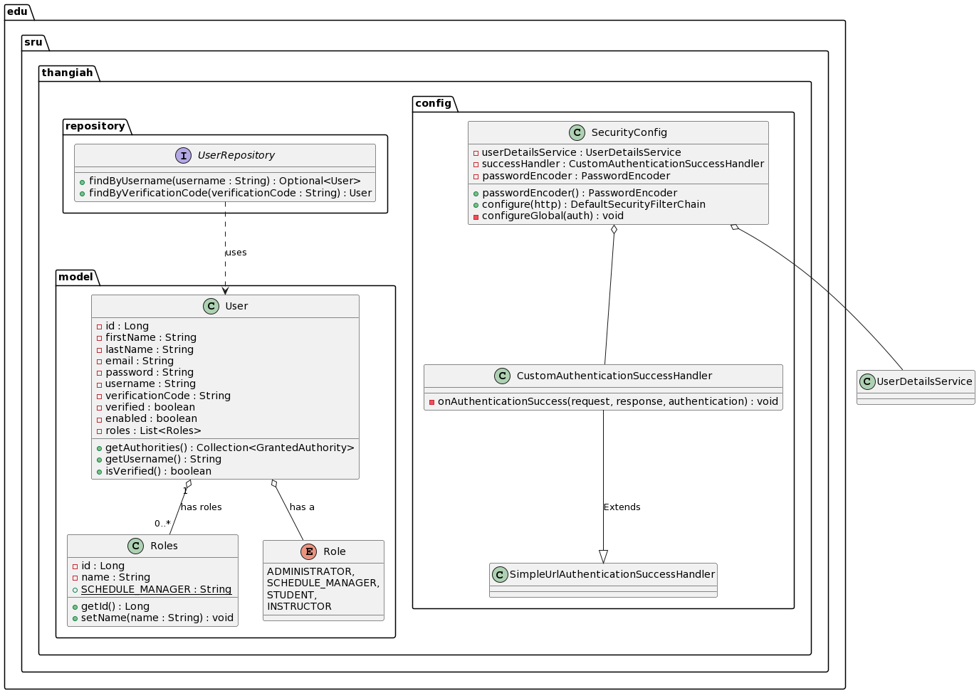

@startuml

package edu.sru.thangiah.config {

class CustomAuthenticationSuccessHandler {

- onAuthenticationSuccess(request, response, authentication) : void

}

CustomAuthenticationSuccessHandler --|> SimpleUrlAuthenticationSuccessHandler : Extends

class SecurityConfig {

- userDetailsService : UserDetailsService

- successHandler : CustomAuthenticationSuccessHandler

- passwordEncoder : PasswordEncoder

+ passwordEncoder() : PasswordEncoder

+ configure(http) : DefaultSecurityFilterChain

- configureGlobal(auth) : void

}

}

SecurityConfig o-- UserDetailsService

SecurityConfig o-- CustomAuthenticationSuccessHandler

package edu.sru.thangiah.model {

class Roles {

- id : Long

- name : String

+ SCHEDULE_MANAGER : String {static}

+ getId() : Long

+ setName(name : String) : void

}

class User {

- id : Long

- firstName : String

- lastName : String

- email : String

- password : String

- username : String

- verificationCode : String

- verified : boolean

- enabled : boolean

- roles : List<Roles>

+ getAuthorities() : Collection<GrantedAuthority>

+ getUsername() : String

+ isVerified() : boolean

}

enum Role {

ADMINISTRATOR,

SCHEDULE_MANAGER,

STUDENT,

INSTRUCTOR

}

}

User "1" o-- "0..*" Roles : has roles

User o-- Role : has a

package edu.sru.thangiah.repository {

interface UserRepository {

+ findByUsername(username : String) : Optional<User>

+ findByVerificationCode(verificationCode : String) : User

}

}

UserRepository ..> User : uses

@enduml