***Login***

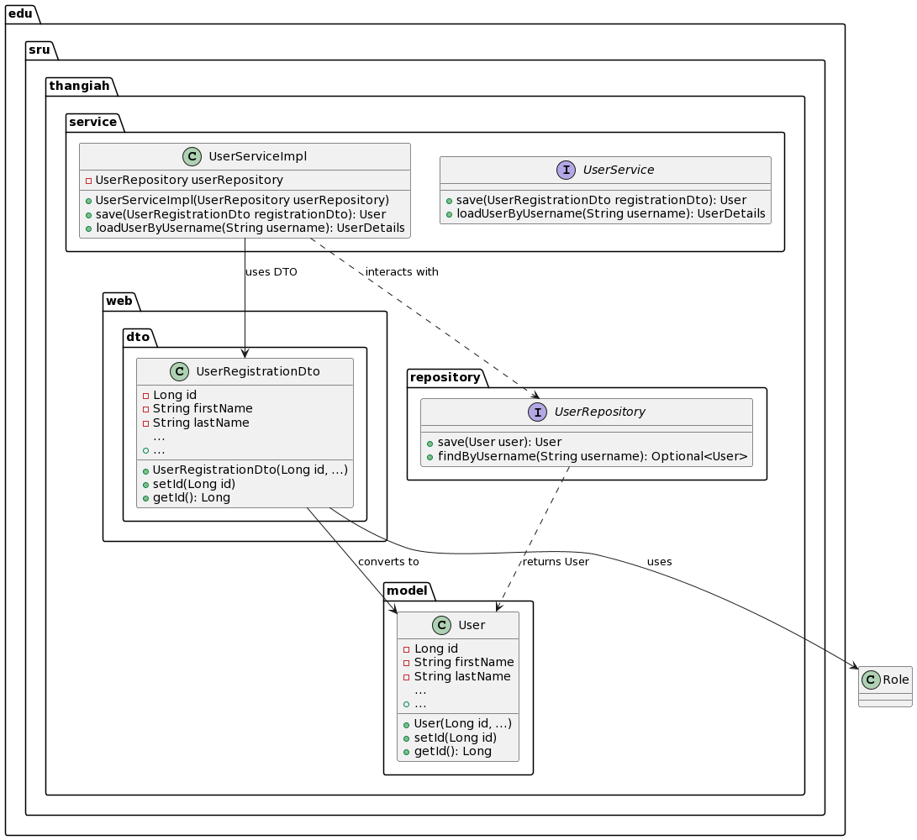

@startuml

package "edu.sru.thangiah.web.dto" {

class UserRegistrationDto {

- Long id

- String firstName

- String lastName

...

+ UserRegistrationDto(Long id, ...)

+ setId(Long id)

+ getId(): Long

+ ...

}

}

package "edu.sru.thangiah.service" {

interface UserService {

+ save(UserRegistrationDto registrationDto): User

+ loadUserByUsername(String username): UserDetails

}

class UserServiceImpl {

- UserRepository userRepository

+ UserServiceImpl(UserRepository userRepository)

+ save(UserRegistrationDto registrationDto): User

+ loadUserByUsername(String username): UserDetails

}

}

package "edu.sru.thangiah.repository" {

interface UserRepository {

+ save(User user): User

+ findByUsername(String username): Optional<User>

}

}

package "edu.sru.thangiah.model" {

class User {

- Long id

- String firstName

- String lastName

...

+ User(Long id, ...)

+ setId(Long id)

+ getId(): Long

+ ...

}

}

UserRegistrationDto --> User : converts to

UserServiceImpl --> UserRegistrationDto : uses DTO

UserServiceImpl ..> UserRepository : interacts with

UserRepository ..> User : returns User

UserRegistrationDto --> Role : uses

@enduml