CHAPTER 2: REGIME-CONDITIONAL CONTROL ASSESSMENT

Synthesis Screening Under Device Proliferation — Control-Point Robustness and Policy Durability
Draft — corrected July 2026
Scope: Synthesis-level control mechanisms under R0 (status quo) and R1 (projected mandatory / on-device) regimes. Methodology: Substitution tests, sensitivity analysis, scenario modeling, control-architecture assessment.

EXECUTIVE SUMMARY
This chapter assesses the durability of synthesis-screening and governance mechanisms across two regimes:
- R0 (status quo, October 2026): voluntary screening; no enforced federal mandate; weak enforcement.
- R1 (projected, late 2026+): a composite projection — the OSTP framework’s technical screening spec (mandatory 50-nt window, functional SOC definitions, on-device/manufacturer expectations) given legal force by S. 3741 (Commerce regulation) and/or federal funding conditions. Under R1 the control question shifts: with commercial providers and benchtop manufacturers inside the screening perimeter, the residual exposure is DIY / in-house synthesis reached by neither a provider nor a device mandate — the control gap this chapter tracks.
Key finding. R0 control architecture is fragile across all levers (supply-chain, provider-level, voluntary screening). If implemented, R1 is substantially more robust at device-level screening and mandatory provider compliance, but retains residual vulnerabilities — chiefly reagent/solvent substitutability, ambiguous status of DIY systems, legacy devices, and extra-jurisdictional providers.
Policy implication. S. 3741 and the (paused) OSTP framework revision together would create more durable control than supply-chain restriction can achieve — but supply-chain restriction should not be a primary lever, because key inputs are substitutable or commodity.

1. REGIME R0 CONTROL ARCHITECTURE (OCTOBER 2026 STATUS QUO)

1.1 R0 Policy Baseline
The OSTP Framework for Nucleic Acid Synthesis Screening (April 2024) was issued under EO 14110 (§4.4(b)(i), Oct 30, 2023). Its funding requirement took effect for federally funded purchases on or after April 26, 2025 (NIH NOT-OD-25-012). EO 14292 (Improving the Safety and Security of Biological Research, May 5, 2025) then directed federal agencies to revise or replace the framework within 90 days (deadline Aug 3, 2025); as of July 2026 no revised framework has been published, leaving the framework’s enforcement status uncertain. The IGSC Harmonized Screening Protocol v3.0 (September 2024) operates voluntarily. No mandatory on-device screening requirement is in force for benchtop manufacturers, and no bulk-reagent monitoring exists.
Governing documents (R0): - OSTP Framework for Nucleic Acid Synthesis Screening (April 2024) — funding requirement effective April 26, 2025; paused/under revision per EO 14292. - IGSC Harmonized Screening Protocol v3.0 (September 2024) — voluntary. - HHS Screening Framework Guidance for Providers and Users of Synthetic Nucleic Acids (October 2023) — recommendations. - NIH NOT-OD-25-012 — procurement condition (federally funded purchasers only).

1.2 R0 Control Levers (4)
Lever 1: Provider-level screening (IGSC members). IGSC v3.0 has members screen orders against a Regulated Pathogen Database (RPD; managed in a public GitHub repository). The historical minimum was a 200-nucleotide window; IGSC v3.0 requires members to transition to a 50-bp threshold by October 24, 2026 to conform to the OSTP framework. Members (e.g., Twist Bioscience, IDT, GenScript, Eurofins, DNA Script, Ansa) adopt this voluntarily. R0 durability: LOW. Non-members are unbound; implementation varies across members (a provider survey found only some members using 200 nt as their floor, others screening everything or at 20–60 nt); orders can be routed to providers outside IGSC entirely. No federal mechanism compels participation.
Lever 2: Printhead sourcing (supply-chain chokepoint). Industrial inkjet printheads (multiple suppliers, several countries) are standard components with many non-synthesis uses (textile, ceramic, 3D printing). R0 durability: VERY LOW. No geographic or legal chokepoint; commodity cost; no export-control or licensing regime; non-synthesis demand precludes synthesis-specific monitoring.
Lever 3: Phosphoramidite supply (reagent chokepoint). Standard phosphoramidites are commodity research chemicals from multiple independent suppliers globally (Glen Research, ChemGenes, LGC Biosearch, Sigma/Millipore). R0 durability: VERY LOW. No single chokepoint; competitive unregulated market; alternative chemistries (enzymatic, electrochemical) reduce dependence.
Lever 4: Solvent supply (acetonitrile → propylene carbonate). Kim et al. (2024) demonstrate OpenIDS operating with propylene carbonate — a GRAS food additive — as a substitute for acetonitrile. R0 durability: VERY LOW. Propylene carbonate is an unregulated global commodity; other aprotic-solvent substitutes exist.

1.3 R0 Residual Vulnerabilities (by approach — analytical)
Stated as the governance-relevant vulnerability, not as procedures.
- OpenIDS (inkjet): physically visible but subject to no R0 registration or monitoring; IGSC screening reaches only orders placed with participating providers, so a DIY device outside that channel falls outside every R0 lever. Detectability (R0): Low.
- MAS 2.0 (photolithographic): an open-source maskless array synthesizer; a visible bench build but outside any R0 registration, and self-run library-grade output is not synthesis-screened. Same DIY blind spot as OpenIDS. Detectability (R0): Low.
- Electrochemical: at TRL 3 and resembling generic electrochemistry apparatus, presents no distinctive equipment/procurement signature. Detectability (R0): Very Low — but this is a conditional-future concern (immature; no independent builds).
- Enzymatic (service): constrained at the provider. Major providers (Ansa, DNA Script) screen voluntarily; no significant unscreened enzymatic-service market identified as of July 2026. Residual: extra-jurisdictional providers. Detectability (R0): Low–Medium.
- Enzymatic (benchtop): unmonitored after purchase under R0 (no on-device mandate); private synthesis leaves no external trace. Detectability (R0): Very Low.
- DropSynth: an assembly method (vortex emulsion; no microfluidic fabrication, no cleanroom) that stitches a commercial microarray oligo pool into genes — so it inherits the screening perimeter through its provider-supplied inputs. Barrier is molecular-biology expertise, not equipment. Detectability (R0): Low–Medium (inputs are provider-screenable; assembly itself is untracked).
- Commercial benchtop: manufacturer/reseller customer vetting is voluntary and uneven under R0; no on-device detection. Detectability (R0): Low–Medium.

1.4 R0 Summary: fragile across all levers
Control lever | Mechanism | Enforcer | Durability | Why it fails
Provider screening | IGSC v3.0 (voluntary) | Self-regulatory | LOW | Non-members / other providers outside protocol
Printhead sourcing | Availability monitoring | None | VERY LOW | Many suppliers; non-synthesis uses; no oversight
Phosphoramidite supply | Reagent restriction | None | VERY LOW | Multiple global suppliers; no chokepoint
Solvent (acetonitrile) | Solvent restriction | EPA (hazmat only) | VERY LOW | GRAS substitute (propylene carbonate) available
Conclusion. No single R0 lever is durable; restricting one input allows substitution of another. Supply-chain restriction is not a durable control mechanism under R0.

2. REGIME R1 CONTROL ARCHITECTURE (LATE 2026+, PROJECTED)

2.1 R1 Policy Baseline
R1 is a projected regime assembled from two distinct instruments that must be kept separate (their conflation was an error in earlier drafts):
(A) The OSTP Framework revision — the technical screening specification. The framework is where the screening mechanics live. Its scheduled tightening — a 200 → 50-nucleotide window and an expanded, functional SOC definition (sequences that contribute to pathogenicity/toxicity, including those from unregulated agents) — is dated October 13, 2026 (three years after the October 2023 HHS Guidance), with IGSC members required to align by October 24, 2026 (IGSC v3.0). The framework’s enforcement is via funding/procurement conditions: federal funding agencies require federally funded purchasers to buy only from providers/manufacturers adhering to the framework (NIH NOT-OD-25-012; parallel DOE Financial Assistance Letter). EO 14292 (May 5, 2025) paused the framework and directed revision within 90 days (deadline Aug 3, 2025); as of July 2026 no revised framework is published, so the October 2026 milestone is documented but its on-schedule effect is uncertain.
(B) S. 3741, the Biosecurity Modernization and Innovation Act of 2026 — the legislative vehicle. Introduced January 29, 2026 (Cotton, Klobuchar; referred to Senate Commerce). What it actually does: directs the Secretary of Commerce to promulgate regulations requiring gene-synthesis providers to screen orders and customers; establishes a biotechnology governance sandbox at NIST; requires a 90-day White House assessment of federal biosecurity oversight. Its enforcement vehicle is Commerce regulation — not funding/procurement conditions and not FDA device regulation — and the bill does not itself specify the 50-nt window, functional-SOC definitions, or an on-device manufacturer mandate. Those are OSTP-framework specifics.
Enforcement mechanisms — three distinct pathways (corrected): 1. Funding/procurement conditions (the OSTP framework’s mechanism): reaches federally funded purchasers only, via award terms (NIH NOT-OD-25-012; HHS/ASPR; DOE FAL). Covers providers and benchtop manufacturers, but not non-federally-funded actors. 2. Commerce regulation (S. 3741’s mechanism, if enacted): would make provider order/customer screening mandatory more broadly than funding conditions reach. 3. FDA device classification is not the mechanism and remains unresolved — whether DIY/benchtop synthesizers acquire a formal device classification, and under whose authority, is an open question, not an established mandate.
Composite R1, stated honestly. The “mandatory + on-device” R1 this chapter models = the OSTP framework’s technical spec (50-nt, functional SOC, manufacturer/on-device expectations) + a screening mandate given force by S. 3741 (Commerce) and/or the framework’s funding conditions. As of July 2026, the framework is paused and S. 3741 is a referred bill. Every R1 claim is conditional on the framework revision being issued substantially as scheduled and on S. 3741 (or equivalent) being enacted.

2.2 R1 Control Levers (5)
Lever 1: Mandatory provider screening (50-nt threshold). Under R1, provider order/customer screening becomes mandatory — via Commerce regulation (S. 3741) and/or funding/procurement conditions — at a 50-nucleotide window (vs. R0’s voluntary 200-nt), against the regulated-pathogen database plus functional SOC definitions. Screening compares each ordered sequence — in nucleotide space and across six-frame protein translations — against regulated-agent sequences; a best match within a defined window (each 16 amino acid and/or 50 nucleotide window) flags the order for customer-legitimacy review. R1 durability: MEDIUM–HIGH. Mandatory compliance for covered providers; functional definitions improve detection of AI-designed variants. Residual gap: providers outside U.S. jurisdiction. Benchmarking: Laird et al. (Applied Biosafety, 2025) found tested screening tools cleared >95% sensitivity and >97% accuracy on a blinded NIST dataset, with most already screening to 50 nt and several implementing functional checks.
Lever 2: On-device screening (manufacturers). The OSTP framework directs manufacturers of benchtop equipment to screen SOC-containing runs and retain flagged-order records; under R1 this is enforced through funding/procurement conditions on federally funded purchasers of benchtop equipment (NOT-OD-25-012). A broader statutory on-device mandate would require the framework revision or new legislation — S. 3741 as introduced does not add one. R1 durability: MEDIUM–HIGH. Hard to circumvent on compliant commercial devices; applies to newly manufactured units. Residual gaps: legacy/used devices without screening; the unresolved status of DIY/open-source systems (see §2.1). Cost context: IFP (2024) treats screening integration as a modest fraction of instrument cost.
Lever 3: Functional SOC detection (AI-resistant). Shifts detection from pure sequence homology toward function-aware definitions (six-frame translation + functional annotation, structural/regulatory features, detection of AI-designed variants). R1 durability: MEDIUM–HIGH. Harder to evade than synonymous-codon changes. Motivation: Wittmann et al. (2025) showed AI-designed proteins can evade similarity-based screening (one tool pre-patch flagged only 23% of variants); the response — patches raising detection to ~72% average and 97% of the most-likely-functional variants — drove improved (functional) detection, not screening obsolescence.
Lever 4: Mandatory record retention (forensic trail). Providers retain customer/order/screening/disposition records (≥3 years; longer where feasible). R1 durability: MEDIUM. Enables post-hoc attribution and deters repeat activity, but is post-incident (does not prevent initial synthesis); extra-jurisdictional providers are unbound.
Lever 5: International coordination. The IBBIS Common Mechanism provides a free, global baseline screening tool; IGSC (40+ members) applies the Harmonized Screening Protocol and maintains the RPD in a public GitHub repository; ISO 20688-2:2024 carries biosecurity provisions; the Australia Group coordinates export controls across ~43 countries; and the BWC Ninth Review Conference (2022) established a follow-on working group on measures including nucleic-acid synthesis. UK DSIT (Oct 2024) and EU guidance overlap but are not identical to U.S. guidance. R1 durability: LOW–MEDIUM. Coordination is incomplete; non-participating jurisdictions remain outside the regime, though major global providers tend to comply with the strictest applicable regime. (A U.S.-only mandate would shift orders to unscreened foreign providers — the chokepoint fails without international agreement.)

2.3 R1 Residual Vulnerabilities (by approach — analytical)
- OpenIDS: if DIY open-source tools fall under a device mandate, on-device screening applies (though open firmware is a weaker barrier than proprietary firmware — §3.1); if exempted, only provider-level screening reaches it. Classification unresolved. Detectability (R1): Low–Medium.
- MAS 2.0: shares OpenIDS’s unresolved DIY classification — on-device screening applies only if open-source array synthesizers are brought under a device mandate; otherwise only provider-level screening of any purchased reagents/oligos reaches it. Detectability (R1): Low–Medium.
- Electrochemical: likely outside any on-device mandate (not a commercial device) and hard to detect; a policy gap in the projected framework. Detectability (R1): Low.
- Enzymatic (service): strengthened — mandatory provider screening, enforcement, tighter window, retention. Residual: extra-jurisdictional providers. Detectability (R1): High domestically; Low internationally.
- Enzymatic (benchtop): constrained by manufacturer on-device expectations + retention. Residual: legacy devices. Detectability (R1): Medium–High.
- DropSynth: provider screening reaches its commercial oligo-pool inputs (the assembly inherits the perimeter); an expertise barrier, not an equipment one; a device mandate would apply only if it were ever commercialized as an instrument. Detectability (R1): Medium.
- Commercial benchtop: most constrained — on-device screening + mandatory provider screening + retention + funding/procurement enforcement. Residual: secondary market for legacy devices. Detectability (R1): High (new); Medium (legacy).

3. CONTROL-ROBUSTNESS ANALYSIS

3.1 Substitution test: if one lever fails, do others hold?
- Provider screening circumvented (order routed to a non-participating or extra-jurisdictional provider). R0: control fails. R1: on-device screening backstops compliant devices → holds; DIY/unregulated-service routes → fails. Finding: on-device screening is the effective backstop, but only where it applies.
- On-device screening on DIY vs. commercial devices. Open-source firmware is inherently modifiable, so on-device screening is not tamper-proof for DIY systems; proprietary commercial firmware is a substantially higher barrier. Record retention gives a partial post-hoc backstop in both cases. Finding: on-device screening is durable for regulated commercial devices, weak for open DIY systems — an argument for pairing it with provider-level and attribution controls, not a circumvention recipe.
- Phosphoramidite restriction. Fails under both regimes: multiple suppliers, propylene-carbonate substitution commodity-trivial. Finding: reagent restriction is not durable.
- Printhead restriction. Fails: many suppliers, non-synthesis cover demand, non-printhead methods sidestep it. Finding: component restriction is not durable.

3.2 Sensitivity analysis
- Reagent price −50%. Rank order roughly unchanged: commercial remains cheapest per base; OpenIDS remains accessible at ~$1–2/seq; service pricing sticky. No material shift.
- On-device screening cost +$5–10K/device. <10% of instrument price for commercial/enzymatic benchtop; minimal adoption impact; DIY unaffected. No material shift.
- Electrochemical TRL 3→5 by 2028 (conditional). If it occurred, electrochemical could become the cheapest DIY option (~$8–10K), displacing OpenIDS as sole low-cost DIY route. But advancement is conditional-future and not guaranteed.
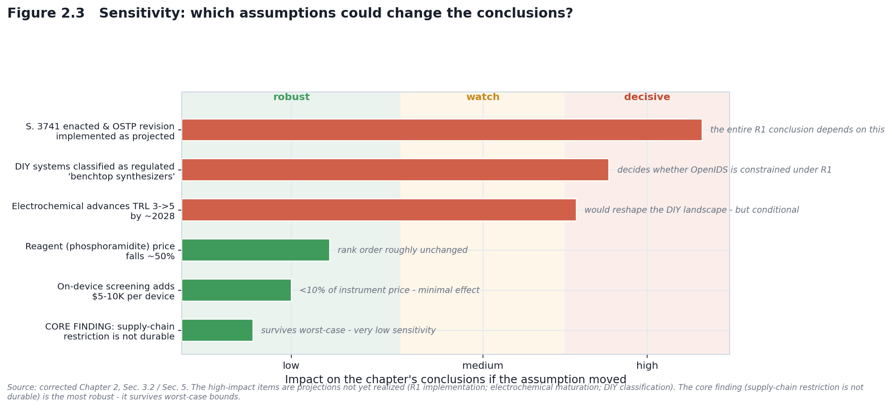
Figure 2.3

3.3 Scenario test: full R1 mandate implemented
Assuming S. 3741 is enacted and the OSTP revision implements on-device + mandatory provider screening with functional SOC detection and retention:
Approach | Provider screening | On-device | Functional detection | Retention | Overall R1 detectability
OpenIDS | bypassable via non-participating provider | applies iff classified (open firmware weak) | active | provider-side | Medium (if classified) / Low (if exempt)
MAS 2.0 | bypassable (self-run) | applies iff classified | active | provider-side | Medium (if classified) / Low (if exempt)
Electrochemical | bypassable | does not apply (not commercial device) | active | partial | Low (policy gap)
Enzymatic (service) | mandatory (strengthened) | n/a | strengthened | mandatory | Medium–High (intl gap)
Enzymatic (benchtop) | mandatory | manufacturer-integrated | active | device + provider | Medium–High (legacy gap)
Commercial benchtop | mandatory | manufacturer-integrated | active | device + provider | High (new) / Medium (legacy)
DropSynth | applies to oligo-pool inputs | iff commercialized | active | provider-side | Medium (inherits perimeter via inputs)
Scenario summary. Heavily constrained: commercial benchtop, enzymatic benchtop, enzymatic service (domestic). Moderately constrained: OpenIDS and MAS 2.0 (if classified), DropSynth (inputs screened). Weakly constrained: electrochemical, OpenIDS/MAS 2.0 (if exempt), extra-jurisdictional service.
Residual vulnerabilities (R1): (1) legacy/used devices without on-device screening; (2) unresolved DIY classification; (3) extra-jurisdictional providers; (4) reagent/solvent substitutability.

4. CONTROL SURVIVAL MATRIX (worst-case)
Control lever | R0 survives worst case? | R1 survives worst case? | Note
Provider screening | ✗ | ✗ (gap: extra-jurisdictional) | Mandatory helps domestically; international gap remains
Phosphoramidite supply | ✗ | ✗ | Multiple suppliers; no chokepoint
Acetonitrile solvent | ✗ | ✗ | GRAS substitute (propylene carbonate)
Printhead sourcing | ✗ | ✗ | Cover demand; alternative methods exist
On-device screening | N/A | ◑ partial (new devices; weak for DIY/legacy) | Effective for regulated commercial devices
Functional SOC detection | ✗ (R0 = homology only) | ✓ (harder, not impossible) | Motivated by Wittmann et al. 2025
Record retention | N/A | ✓ (post-hoc only) | Attribution, not prevention
International coordination | ✗ | ◑ partial | Non-signatories remain outside

4.1 Robustness ranking
Mechanism | R0 | R1 | Durability tier
Provider screening (domestic) | LOW | MED–HIGH | Tier 1 (enforcement-dependent)
On-device screening (new devices) | N/A | MED–HIGH | Tier 1 (weak for DIY/legacy)
Functional SOC detection | N/A | MEDIUM | Tier 1
Record retention | N/A | MEDIUM | Tier 2 (post-hoc)
International coordination | N/A | LOW–MED | Tier 3
Supply-chain restriction | VERY LOW | VERY LOW | Tier 4 (not durable)
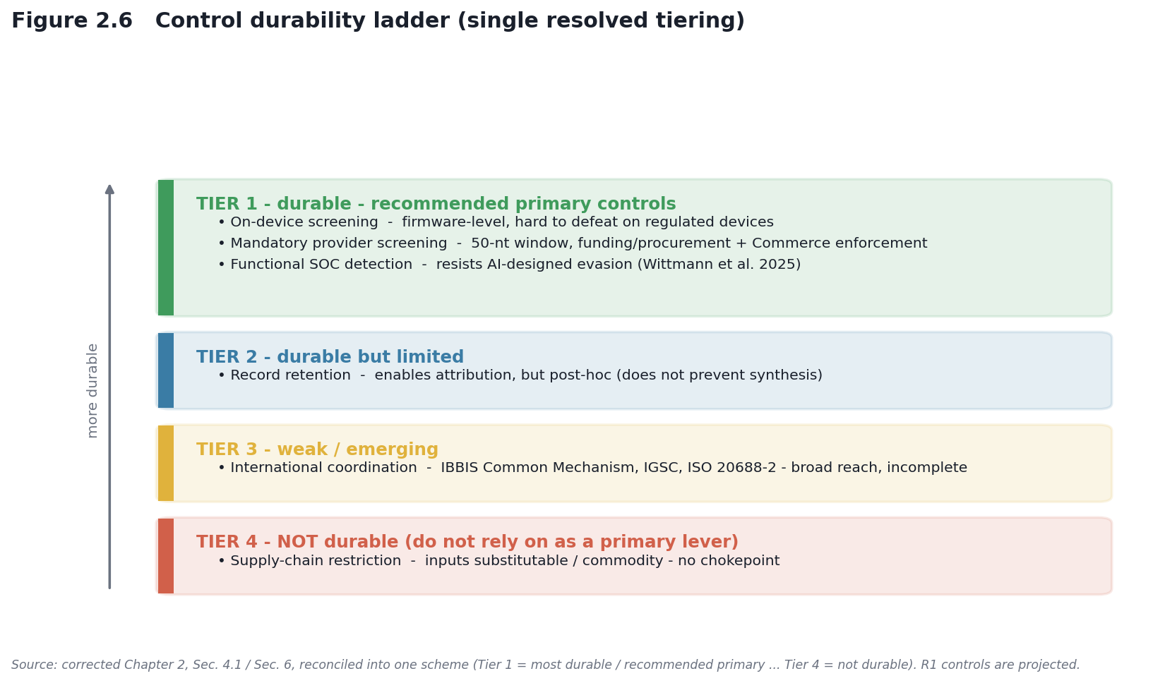
Figure 2.6

5. KEY FINDINGS & POLICY IMPLICATIONS
- R0 is fragile across all levers. Voluntary governance + fragmented supply-chain monitoring is insufficient; supply-chain restriction offers negligible resistance. → Do not rely on supply-chain restriction as a primary lever.
- R1 on-device screening is more durable than supply-chain restriction — if implemented — but retains gaps for DIY systems, legacy devices, and extra-jurisdictional providers. → Pair device-level control with provider-level screening and attribution.
- Substitution resistance persists at the reagent/solvent level under both regimes. → Control belongs at the device and provider, not the input.
- Electrochemical synthesis is underspecified in the projected framework (portable, low-signature, unclear device status). → The framework revision should address classification and oversight explicitly.
- Enzymatic service becomes more controllable under R1 (mandatory provider screening, enforcement, centralized auditability). → Shifting demand toward regulated providers strengthens governance.

6. RECOMMENDED CONTROL ARCHITECTURE (R1 + post-2026)
Tier 1 (high durability): mandatory on-device screening for benchtop devices; mandatory provider screening (50-nt, functional SOC) enforced via Commerce regulation and/or funding/procurement; functional SOC detection integrated with structural/functional resources. Tier 2 (medium durability): mandatory record retention (attribution). Tier 3 (emerging): international coordination (IBBIS Common Mechanism; IGSC; ISO 20688-2; UK/EU alignment). Not recommended as a primary control (Tier 4, low durability): supply-chain restriction on phosphoramidites, solvents, or printheads — substitutable/commodity, with non-synthesis cover demand.

7. CRITICAL POLICY GAPS
- DIY-systems classification (OpenIDS, electrochemical). Unresolved whether open-source/DIY tools fall under a device mandate. → Define scope explicitly or establish an alternative oversight pathway.
- Electrochemical underspecified. → Address emerging low-signature platforms in the framework.
- Legacy/secondary-market devices. Pre-mandate instruments lack on-device screening. → Consider registration/retrofit.
- Incomplete international coordination. → Pursue bilateral/multilateral alignment with major supply-chain jurisdictions.

8. CONCLUSION
R0 voluntary provider screening plus fragmented supply-chain monitoring is not a durable control architecture: every lever can be circumvented through substitution or routing around participating providers, and supply-chain restriction lacks durability.
R1, if implemented as projected and paired with the complementary measures above, would be substantially more durable — mandatory on-device + provider screening + functional detection + retention create multiple layers hard to defeat simultaneously for regulated devices. But R1 remains incomplete without resolving four gaps: DIY classification, electrochemical oversight, legacy devices, and international coordination.
Honest bottom line, split by confidence: - HIGH confidence: supply-chain restriction is not a durable control (structural; survives worst-case). - Conditional/MEDIUM confidence: R1 device-level control will prove effective — this depends on the OSTP framework revision being issued and S. 3741 (or equivalent) being enacted and implemented, and on resolving the DIY-classification question. The chapter does not claim R1 works; it claims R1 is aimed at the right levers.

REFERENCES
Policy documents - Executive Order 14292 (2025). Improving the Safety and Security of Biological Research. Federal Register, 90 FR 19611 (May 8, 2025). - Executive Order 14110 (2023). Safe, Secure, and Trustworthy Development and Use of Artificial Intelligence (§4.4(b)). October 30, 2023 (rescinded Jan 25, 2025). - OSTP (2024). Framework for Nucleic Acid Synthesis Screening. ASPR S3. https://aspr.hhs.gov/S3/Documents/OSTP-Nucleic-Acid-Synthesis-Screening-Framework-508.pdf - U.S. Congress (2026). S. 3741, Biosecurity Modernization and Innovation Act of 2026, 119th Congress (Cotton, Klobuchar). https://www.congress.gov/bill/119th-congress/senate-bill/3741 - HHS/ASPR (2023). Screening Framework Guidance for Providers and Users of Synthetic Nucleic Acids. October 2023. - NIH NOT-OD-25-012 (2024). Notification of NIH Requirements Regarding Procurement of Synthetic Nucleic Acids and Benchtop Nucleic Acid Synthesis Equipment (effective April 26, 2025). - IGSC (2024). Harmonized Screening Protocol v3.0. https://genesynthesisconsortium.org/ (50-bp transition by October 24, 2026). - UK Government, DSIT (2024). Guidance on screening synthetic nucleic acids. - ISO 20688-2:2024, Biotechnology — Nucleic acid synthesis (biosecurity provisions).
Scientific literature - Kim, J., Kim, H., & Bang, D. (2024). An open-source, 3D printed inkjet DNA synthesizer. Scientific Reports, 14, 3773. https://doi.org/10.1038/s41598-024-53944-x - Wittmann, B. J., Alexanian, T., Bartling, C., et al. (2025). Strengthening nucleic acid biosecurity screening against generative protein design tools. Science, 390(6768), 82–87. https://doi.org/10.1126/science.adu8578 - Laird, T. S., et al. (2025). Inter-tool Analysis of a NIST Dataset for Assessing Baseline Nucleic Acid Sequence Screening. Applied Biosafety. https://doi.org/10.1177/15356760251401228
Grey literature - Institute for Progress (2024). Securing Benchtop DNA Synthesizers. https://ifp.org/securing-benchtop-dna-synthesizers/ - Nuclear Threat Initiative (NTI | bio). Reports on benchtop DNA synthesis governance. https://www.nti.org/

