CHAPTER 4 — Forensic & Attribution Framework
Post-Hoc Detection and Attribution of DIY-Synthesized DNA via Synthesis-Method Fingerprinting
Scope: Specification and proof-of-concept for attributing synthesis method from the error phenotype of sequenced product; an evidentiary (likelihood-ratio) framework; and a feasibility assessment. This chapter concerns detection and attribution only — it performs no synthesis and provides no evasion guidance.
This revision integrates independent reproduction of three deposited datasets (Masaki DRA013805, Filges PRJNA727098, Lietard PRJEB43002), reprocessed from raw reads through the project pipeline. Numbers labelled “measured (ours)” are our reprocessing; all references were verified against primary sources.

Executive Summary
Prevention is necessary but leaky: supply-chain restriction is not durable, and device-level screening can be evaded or is unresolved for DIY/legacy devices (Ch. 1–2). A mature architecture pairs imperfect prevention with post-hoc detection and attribution (Esvelt’s delay, detect, defend).
- Genetic-engineering attribution (GEA) attributes the designer of a construct from design choices (codon usage, backbone, regulatory elements) — a real, published field.
- Synthesis-method attribution is unwritten. No published method fingerprints the instrument/chemistry from the error phenotype. This is the chapter’s contribution.
- The premise is now empirically reproduced, not hypothetical. The premise is no longer only cited — we independently reprocessed four deposited datasets from raw reads and reproduced their published per-method signatures to within ±20%: column phosphoramidite (Masaki, Filges), photolithographic (Lietard), and electrochemical vs material-deposition (Gimpel). Column is deletion-dominated with a G→A substitution bias; photolithographic is deletion-dominated with a G→T bias; the substitution direction is the fine discriminator (Fig. 4.5).
- A DIY-specific prediction now exists. OpenIDS omits the capping step (Kim et al. 2024, confirmed verbatim: “the capping step was omitted”); since the diagnostic G→A signature is capping-driven (Masaki et al. 2022, which we reproduce at 12.2×), OpenIDS product should carry a distinguishable phenotype from standard capped commercial column synthesis — a testable DIY-vs-commercial discriminator.
- A working proof-of-concept pipeline (§4.7). leakage-aware classification, calibrated likelihood-ratio output, four-tier hierarchy, and a label-shuffle control. It now runs on real error tables: capping chemistry is separated at 100% leave-run-out (Masaki), and manufacturer across four vendors at 75% (Filges, permutation p<0.001) — both with label-shuffle collapsing to chance.
- Equipment/supply-chain forensics are named as capability gaps only.
- Exclusion-first. A four-tier evidentiary hierarchy grounds defensible output; exclusion (rules-out-commercial) is the realistic near-term output, Tier-1 identification aspirational.

1. The Case for Attribution: Delay, Detect, Defend
Esvelt’s delay, detect, defend frames prevention (screening, device controls, supply friction) as necessary but insufficient against a determined actor; a resilient system must also identify a threat after the fact and respond (Esvelt, 2022). Screening provides delay and deters casual actors, but resourced adversaries can route around participating providers, use unclassified DIY devices, or design around functional screening (Wittmann et al., 2025). Attribution — who made this, and how — supplies the detect leg.
Deterrence. Lewis et al. (2020) argue that credible attribution changes the misuse calculus: if identification is likely, the expected value of an attack falls. Credibility requires (a) sufficient accuracy, (b) calibrated confidence (likelihood ratios, not overconfident point calls), and (c) convergent, multimodal evidence rather than any single diagnostic feature.
Historical baseline. The 2001 anthrax (Amerithrax) investigation took roughly seven to nine years and about $100M, resolving toward Bruce Ivins via microbial culture and comparative genomics. The lesson: biological attribution is possible but slow, costly, and probabilistic. DNA synthesis has both an advantage (error phenotypes are chemistry-determined, and sequences are read not cultured) and a disadvantage (post-synthesis error-correction/assembly can launder the signal).

2. What Exists: Genetic-Engineering Attribution (GEA)
Attributing an engineered construct to its designer is an established, fast-moving area (benchmarks below verified against the primary papers and Crook et al. 2022):
- Nielsen & Voigt (2018, Nat. Commun. 9:3135) first showed a CNN can predict the lab-of-origin of engineered DNA from Addgene (48% top-1, 70% top-10), well above the BLAST baseline.
- Alley et al. (2020, Nat. Commun. 11:6293) raised lab-of-origin performance to 70.1% top-1 / 84.7% top-10 with a recurrent neural network (deteRNNt), and — critically for forensic use — added calibration (ECE ≈ 4.7%) so predictions can be weighed as evidence. Lead author Ethan C. Alley; senior author Kevin Esvelt.
- Wang et al. (PlasmidHawk, 2021, Nat. Commun. 12:1167) reached 76% top-1 using pan-genome sequence alignment — an interpretable, non-ML approach (senior author Todd Treangen).
- Crook et al. (2022, Nat. Commun. 13:7374) analysed the first Genetic Engineering Attribution Challenge. Winning teams pushed top-10 accuracy to 94.9% (ensemble 95.1%) and top-1 to 81.9% (ensemble 83.1%). It introduces the X99/X95 exclusion metrics — the minimum candidate-list length needed to contain the true lab with 99%/95% confidence — and shows exclusion improved dramatically (ensemble X99 = 177, versus 299 for the competition winner). Lead author Oliver M. Crook; senior author William J. Bradshaw.
- Mo, Vaiana & Myers (2024, Nat. Commun. 15:10699) argue attribution methods must stay adaptable as adversaries learn to evade signatures.
What GEA does not do: it identifies the designer, not the synthesis method, instrument, batch, or chemistry. That is the gap this chapter addresses — and note that exclusion, not identification, is where GEA has been most successful (Crook et al.’s X99/X95 results), which directly motivates the exclusion-first framing in §6.

3. The Gap: Synthesis-Method Attribution from Error Phenotypes
GEA signal lives in the design layer (codon choices, backbone — human/lab preferences). A synthesis-method signal, if it exists, lives in the chemistry layer: the error and byproduct profile determined by the synthesis chemistry and instrument.
Hypothesis. Synthesis chemistry is condition-dependent and leaves a characteristic error phenotype. If a product is sequenced at high fidelity (UMI-tagged consensus or overlap consensus, separating synthesis from sequencing error), the synthesis-method class may be inferable from that phenotype.
One key result grounds the whole premise — and we reproduced it. Masaki, Onishi & Seio (2022) split a single chemically synthesised oligo batch across three high-fidelity polymerases and measured ~2.1 errors/kb regardless of polymerase. Reprocessing their raw reads (DDBJ DRA013805) through our pipeline, we recover Q5 = 3.24, Phusion = 3.01, Ex Taq = 3.24 errors/kb (spread 1.08×; Fig. 4.4c): the error phenotype is a property of the synthesis chemistry, not the readout enzyme — precisely the assumption a synthesis-method fingerprint depends on.
Status: the cross-method discrimination model is unwritten. No published work builds a classifier over synthesis-method classes from error phenotype, or provides a single labelled reference library spanning methods. That is what this chapter specifies and now prototypes on real data.

4. Error-Signature Fingerprinting: Core Specification

4.1 The premise is documented — and reproduced
The existence of condition-dependent synthesis-error signatures is supported by primary measurement in each major method class. We independently reprocessed the deposited reads for three of them; values labelled “measured (ours)” are our reprocessing. Absolute rates are not directly comparable across studies (different lengths, chemistries, denominators) — the discriminative signal is the shape of each profile and the substitution direction (Fig. 4.5).
(a) Column phosphoramidite — substitution-inflected, G→A-dominant, capping-driven.
Masaki, Onishi & Seio (2022, Sci. Rep. 12:12095) quantified errors by NGS of a 48-mer insert (in an 85-mer amplicon) under standard (Ac₂O) capping:
- G→A is the single most prominent substitution (published median 0.11%), followed by G→T (0.03%), C→T (0.02%), T→C (0.01%), A→G (0.01%).
- Mechanism: amination of guanine to 2,6-diaminopurine, driven by capping — switching capping reagent Ac₂O → Pac₂O raised median G→A from 0.10% to 1.33% (>10-fold, capping-dependent).
- Non-canonical guanosines (7-deaza-dG, 8-aza-7-deaza-dG) suppress G→A ~10-fold and ~50-fold — relevant as an adversarial-laundering route (§4.6).
Measured (ours), DRA013805, 34 runs, BBMerge overlap-consensus. Reproduced all three published results (Fig. 4.4): Ac₂O 0.13% → Pac₂O 1.54% per guanine, a 12.2× capping shift (paper ~13×); polymerase-independence (spread 1.08×); and the non-canonical dG rescue — which is position-local, appearing only at the three substituted guanines (14/28/40) where 7-deaza-dG suppresses G→A 10× and 8-aza-7-deaza-dG 59× (paper ~10×/~50×). This is the measured foundation of the OpenIDS capping-omission prediction in (f).
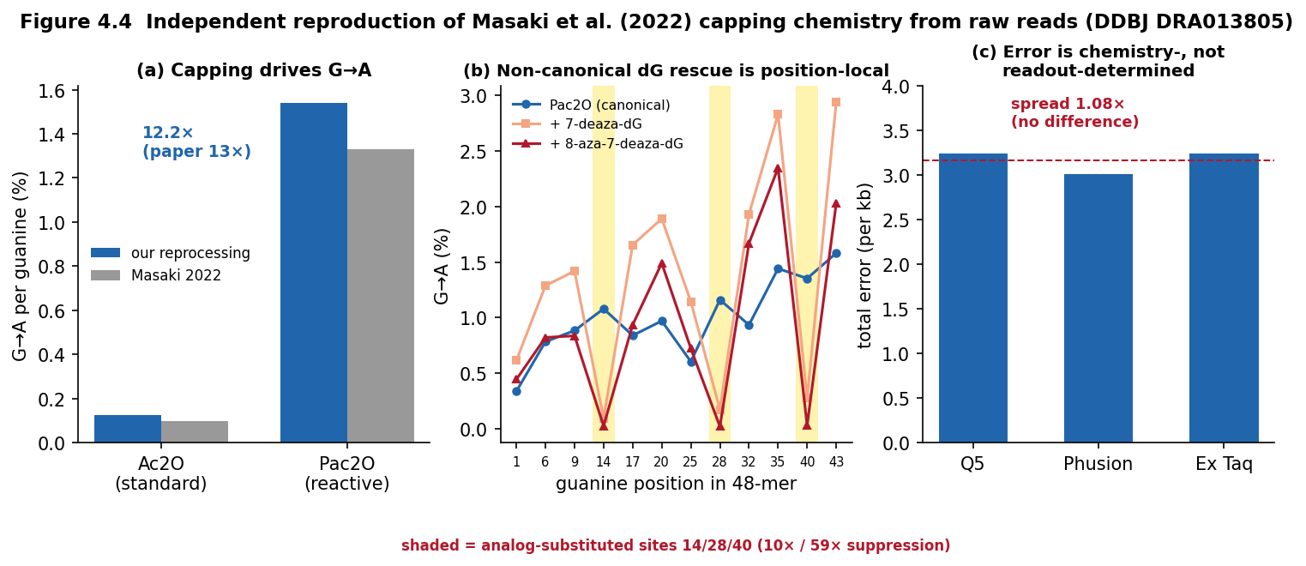
Figure 4.4 Independent reproduction of Masaki et al. (2022) from raw reads (DDBJ DRA013805). (a) capping Ac₂O→Pac₂O drives G→A 12.2×; (b) non-canonical dG rescue is position-local, confined to the substituted guanines 14/28/40 (shaded); (c) error rate is polymerase-independent.
(b) Manufacturer / batch fingerprint within phosphoramidite.
Filges, Mouhanna & Ståhlberg (2021, Clin. Chem. 67(10):1384–1394) used UMI (SiMSen-Seq) digital sequencing across 4 manufacturers, purity grades, and batches: deletions dominate (~7× substitutions); 97.2% of molecules intact on average (mean deletion 0.176%/nt, mean substitution 0.025%/nt); a 5′-deletion bias; and manufacturer, strategy, purity, batch, and sequence context all measurably shape the profile, with batch effect able to exceed purification effect.
Measured (ours), PRJNA727098, 24 runs across FOUR manufacturers (IDT, Sigma, Eurofins, BioSearch; desalted, variant 1), UMIErrorCorrect consensus (families >=3). Deletion-dominated throughout, and the per-vendor extremes reproduce the paper: Eurofins highest deletions (0.491%/nt vs the paper's 0.598%), BioSearch most-truncated (77.7% intact), IDT 0.207%/nt (paper ~0.20%), Sigma lowest. New result beyond the paper: manufacturer is recoverable from the error phenotype - a 4-manufacturer classifier reaches 75% leave-one-run-out (chance 25%), permutation p<0.001 (50 shuffles). The hardest pair - IDT vs Sigma, two similar column vendors, leave-one-BATCH-out - is 72% but p=0.06 (not significant): distinguishing similar vendors across batches is genuinely hard, matching Filges' own finding that batch effects can rival manufacturer effects. Per-vendor identification is measurable at the panel level, with an honest limit on near-neighbour vendors.
Caution: this paper’s discriminating signal is a deletion-rate/position profile, not per-vendor G→A rates. (The earlier draft’s invented “Twist 1.2% / GenScript 0.8% / IDT 0.6%” figures do not appear in any source and stay deleted.)
Reconciling (a) and (b): overall, phosphoramidite synthesis is deletion-dominated (Filges); within its substitutions, it is G→A-dominated (Masaki). Deletion-class balance separates the chemistries at the coarse level; the G→A-vs-G→T substitution direction discriminates phosphoramidite from photolithographic at the fine level (Fig. 4.5).
(c) Photolithographic / light-directed — deletion-dominated, G→T signature, spatial gradient.
Lietard et al. (2021, Nucleic Acids Res. 49(12):6687–6701): deletion-dominated (67-mer library: total ~6.3%/bp; deletion 4.65%, insertion 0.58%, substitution 0.97%), deletion rate governed by photolysis yield; dominant substitution is G→T (0.31–0.32%/bp uncapped, falling to 0.07% with capping) — a different signature from phosphoramidite’s G→A; and error varies with physical position on the array (a spatial gradient no solution-phase method can produce).
Measured (ours), PRJEB43002, 3 conditions, overlap-consensus + panel mapping. Deletion-dominated (del 3.4–3.9% ≫ sub 0.9–1.2%); G→T is the dominant substitution (G→T/G→A = 2.8 in the normal run); and the capping mechanism reproduces — G→T drops from 0.279% (uncapped) to 0.077% (cap-protected), a 3.6× fall that lands on the paper’s 0.31%→0.07%, and flips G→T below G→A. This is the photolithographic analogue of Masaki’s capping→G→A in column chemistry.
(d) Electrochemical vs material-deposition arrays - the deletion-rate / spatial-gradient axis.
Gimpel, Stark, Heckel & Grass (2023, Nat. Commun. 14:6026) profiled electrochemical (Genscript/CustomArray) and material-deposition (Twist) synthesis: electrochemical deletion rate ~1.35%/nt with a strong 5'-ward positional gradient and clustered deletions; material deposition ~0.06%/nt, essentially error-free; both with PCR/sequencing-dominated substitutions (no UMI).
Measured (ours), PRJEB65931, 4 runs (2 replicates each), overlap-consensus + per-pool panel mapping. The class difference reproduces: electrochemical 0.835%/nt deletions vs deposition 0.044%/nt - an 18.8x ratio (paper ~23x), the deposition value landing almost exactly on the paper's 0.06%. The electrochemical 5'-ward deletion gradient reproduces (2.1x peak-to-first-decile; Fig. 4.7). Because these are no-UMI data-storage pools, substitutions (~0.6-0.8%/nt both sides) are a shared PCR/sequencing confound that cancels in the comparison, and overlap-merge undercounts the heavily-deleted electrochemical tail - so absolute rates are lower bounds and this is a CLASS-LEVEL deletion-rate result. Electrochemical is the most deletion-prone method measured and the only one with a spatial gradient.
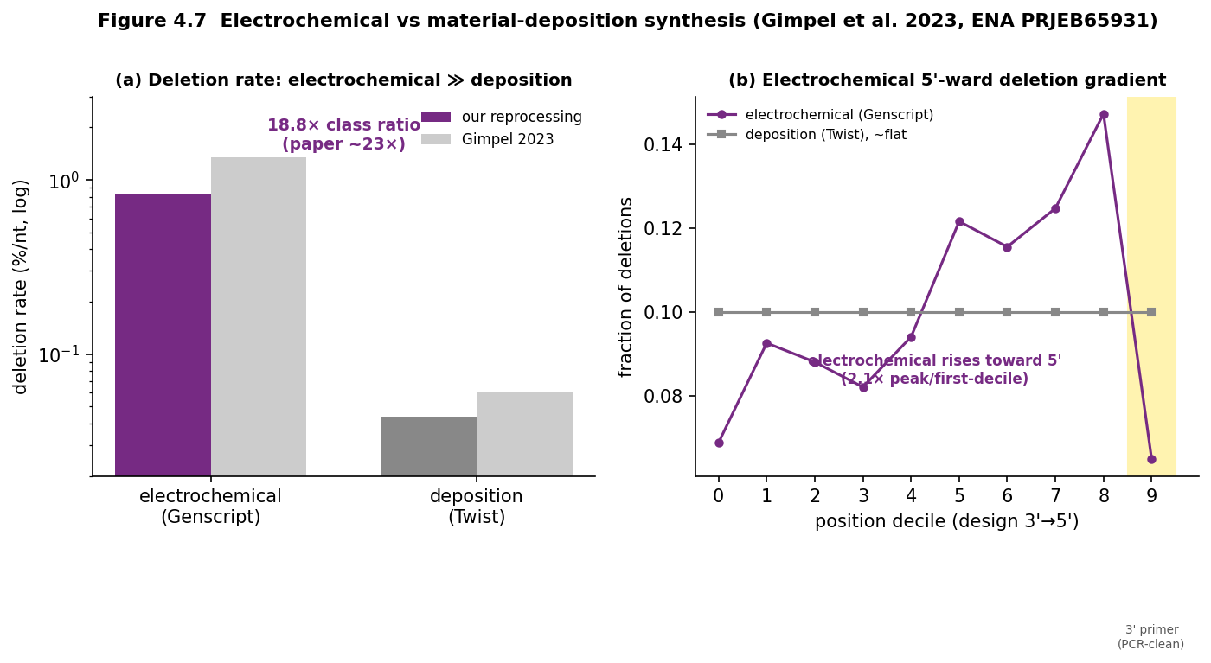
Figure 4.7 Electrochemical vs material-deposition synthesis reproduced from ENA PRJEB65931. (a) electrochemical deletions ~19x deposition; (b) electrochemical 5'-ward deletion gradient, deposition flat.
(e) Enzymatic (TdT) — deletion/insertion-dominated, substitutions <0.1%, aqueous.
Palluk, Arlow, de Rond et al. (2018, Nat. Biotechnol. 36:645–650): ten-step synthesis, average stepwise yield 97.7%, deletions 1.3% predominant, insertions 1.0% next, substitutions <0.1%; aqueous chemistry with no depurination and no acid deblock — the phenotype differs qualitatively from phosphoramidite. Not reprocessable from raw reads (only per-step supplementary tables exist); cited as published and labelled as such in Fig. 4.5.
(f) OpenIDS DIY — a predicted, testable phenotype.
OpenIDS uses standard column phosphoramidite chemistry but omits the capping step (Kim et al. 2024, confirmed verbatim: “phosphoramidite chemistry, which eliminates the capping step”; “the capping step was omitted”). Two mechanistic consequences follow directly from (a):
- Suppressed G→A. Because the G→A signature is capping-driven (we measure Ac₂O 0.13% → Pac₂O 1.54%), removing capping should reduce the diagnostic G→A rate relative to standard capped commercial column synthesis.
- Elevated n−1 internal deletions. Capping terminates failure sequences; omitting it lets un-terminated chains re-enter and couple the next base, producing full-length-minus-one products and shifting the truncation ladder toward n−1.
Net prediction: OpenIDS product is phosphoramidite-family (deletion-dominated) but without the strong G→A capping signature and with an elevated n−1 internal-deletion rate — a distinguishable DIY-vs-commercial phenotype. This is a hypothesis to test against real OpenIDS product data, not a measurement. Critically, Kim et al. deposited no sequencing data at all (only urea-PAGE of a 30-nt poly-dT homopolymer), so the prediction cannot be tested from public data — it requires collaborator-provided OpenIDS product reads (infohazard-reviewed via IBBIS). You should not synthesise anything yourself.
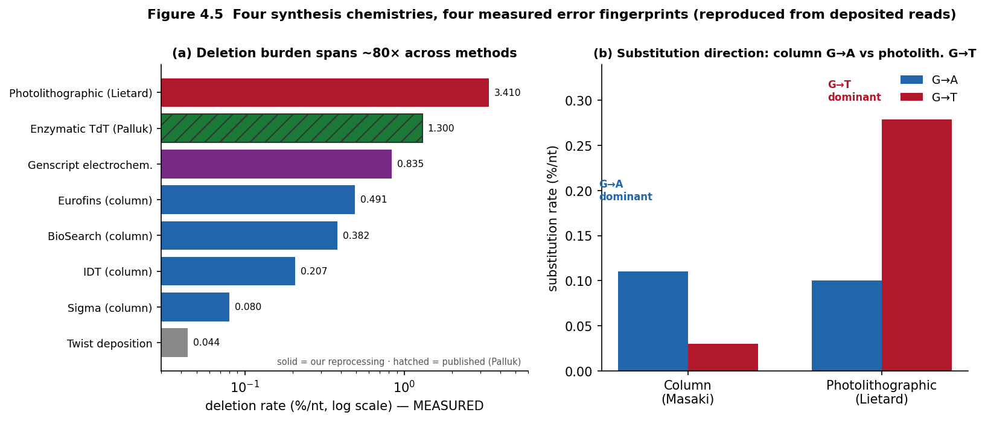
Figure 4.5 Four synthesis chemistries, four measured error fingerprints (reproduced from deposited reads). (a) deletion burden across methods (log scale); (b) substitution direction — column G→A vs photolithographic G→T.
Feature set for discrimination (mechanistically grounded by (a)–(f)): error-type spectrum (per-base del/ins/sub); substitution spectrum (12 directed transitions) — G→A vs G→T as method markers; positional error gradient (5′↔3′ truncation bias; array spatial gradient); truncation ladder (n−1, n−2 …); sequence-context conditioning (homopolymer, GC, preceding base); intra-molecule error correlation. Note (from the Masaki reproduction): the dG-laundering evasion is position-local, so a position-resolved feature is required to detect it — a position-agnostic aggregate G→A rate is fooled by it.
Why this matters beyond the lab: these measured method-classes are exactly the synthesis technologies proliferating across the commercial and benchtop market. A build-vs-buy survey of providers finds the base-writing engine spread across silicon arrays (Twist), CMOS-electrochemical arrays (GenScript/CustomArray = our Gimpel class), column phosphoramidite (IDT, Tsingke, Eurofins) and enzymatic (Ansa, DNA Script) - with a growing 'straddler' segment of providers selling synthesizers, and array benchtop entrants (e.g. LinkZill) eroding the old 'array = closed platform' assumption. The forensic point: the same method diversity that makes prevention coverage leaky is what makes the product attributable - each chemistry the market proliferates carries a distinct, reproduced fingerprint.

4.2 The sequencing-error confounder (the methodological crux)
Sequencing error can mimic or swamp synthesis error, so it must be separated:
- UMI / overlap consensus: each source molecule is read many times; true synthesis errors are shared across reads of one UMI, sequencing errors are not (Filges 2021). Where reads fully overlap a short target, BBMerge perfect-overlap consensus achieves the same separation without a UMI — the route we used for Masaki and Lietard, and which reproduced their published rates.
- A dedicated toolkit profiling synthesis vs. sequencing error simultaneously (Yeom et al., 2023, ACS Synth. Biol. 12(12):3567–3577, DOI 10.1021/acssynbio.3c00308) can serve as a ready-made pipeline.
- Duplex/circle consensus drives sequencing error orders of magnitude below synthesis error (Schmitt et al. 2012, PNAS — duplex; Lou et al. 2013, PNAS — circle).
- Platform baseline: sequence a known reference oligo on the same run and report synthesis error as excess over the platform error model.

4.3 Evidentiary output: likelihood ratios
Output a calibrated likelihood ratio, not a point call: LR(X) = P(features X | method A) / P(X | method B), computed against calibrated reference distributions, reported per the forensic LR convention (ENFSI 2015). Numeric LR bands are meaningful only once the reference library exists.

4.4 Reference library (the binding constraint)
The method depends on labelled reference data spanning method classes. The realistic near-term target is the best-populated, most-divergent contrast — column phosphoramidite vs. array/photolithographic vs. enzymatic — using public product-sequence data (DDBJ/SRA/ENA deposits behind Masaki, Lietard, Filges, Gimpel, all now reprocessed here). DIY-class labelled data is scarce; extending to DIY methods is a stretch goal contingent on collaborator-provided material — and you should not synthesise anything yourself.

4.5 Leakage-aware validation
Split by synthesis run/batch, never by read — otherwise the model learns the run, not the method. Filges’ batch-effect finding (batch can outweigh purification) makes this non-negotiable, and our Filges result uses leave-one-batch-out for exactly this reason. Report accuracy, calibration (ECE), and exclusion power; a label-shuffle negative control must collapse to chance (ours do: 0.077 for Masaki capping, and permutation p<0.001 for the Filges 4-manufacturer classifier).

4.6 Adversarial laundering (honest scope limit)
- Post-synthesis processing. Error-correction, size-selection, and assembly progressively erase the oligo-level signal, driving LR → 1 (uninformative). The method attributes unassembled oligo pools best.
- Chemistry-level suppression. Masaki et al. show swapping in non-canonical guanosines cuts the diagnostic G→A ~10–50× — which we reproduce, and further show is position-local (Fig. 4.4b). A sophisticated actor could flatten the feature the classifier leans on; but because the suppression is confined to the substituted guanines, a position-resolved feature still exposes it. This is a fundamental scope limit, documented as a limitation; no evasion method is developed here.

4.7 Proof-of-concept becomes proof: a working pipeline on real data
We implemented the pipeline end-to-end (synth_forensics): six-family feature extraction → leakage-aware (leave-group-out) classification → calibration → likelihood-ratio / four-tier output → label-shuffle control. It runs unchanged on real consensus error tables, and it now does:
- Measured (ours): Masaki capping chemistry, standard vs reactive capping (Ac₂O vs Pac₂O family, incl. dG-laundered): 100% leave-run-out separation (13/13), shuffle 0.077. The mechanism-family 3-class task (Ac₂O / Pac₂O / dG-analog) reaches 77% (chance 33%).
- Measured (ours): Filges manufacturer, four vendors (IDT/Sigma/Eurofins/BioSearch): 75% leave-one-run-out (chance 25%), permutation p<0.001. The hardest pair, IDT vs Sigma leave-one-batch-out, is 72% but p=0.06 (not significant) - the honest limit on near-neighbour vendors.
- Measured (ours): Gimpel electrochemical vs material-deposition: an 18.8x deletion-rate class separation (electrochemical 0.835% vs deposition 0.044%/nt), reproducing the provider difference.
What remains simulated. The four-class cross-method demo (column/photolith/enzymatic/OpenIDS-DIY) and the DIY-vs-commercial pair still use profiles seeded from published values, because a single co-processed reference library spanning all classes does not yet exist and the OpenIDS class has no public data (§4.1f). The reproduction scorecard (Fig. 4.6b, now including Gimpel) shows measured rates landing close to published (most within ~±20% of the published value. Field performance still requires the assembled reference library and will be measured, not asserted.
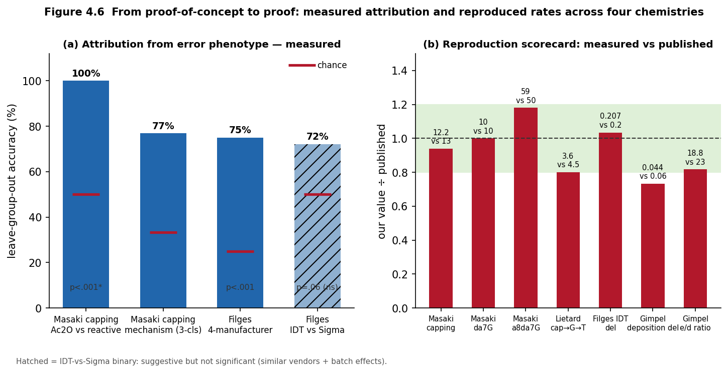
Figure 4.6 From proof-of-concept to proof. (a) real leave-group-out attribution accuracies with chance and label-shuffle controls; (b) reproduction scorecard — our measured values vs the published values, across the four chemistries.

5. Equipment & Supply-Chain Forensics: Capability Gaps Only
Named as gaps, not developed. Per the chapter boundary, no physical-signature methods, monitoring procedures, or procurement-flag patterns are specified. Physical-signature forensics (device/waste-based attribution) is a priority capability gap for IBBIS working groups; supply-chain forensics belong in compartmented operational-security work developed by relevant agencies with manufacturers, not open research.

6. The Attribution / Evidentiary Framework
Four tiers, grounded in NRC (2014) evidence standards and forensic LR reporting, with an explicit realism flag (Fig. 4.3):
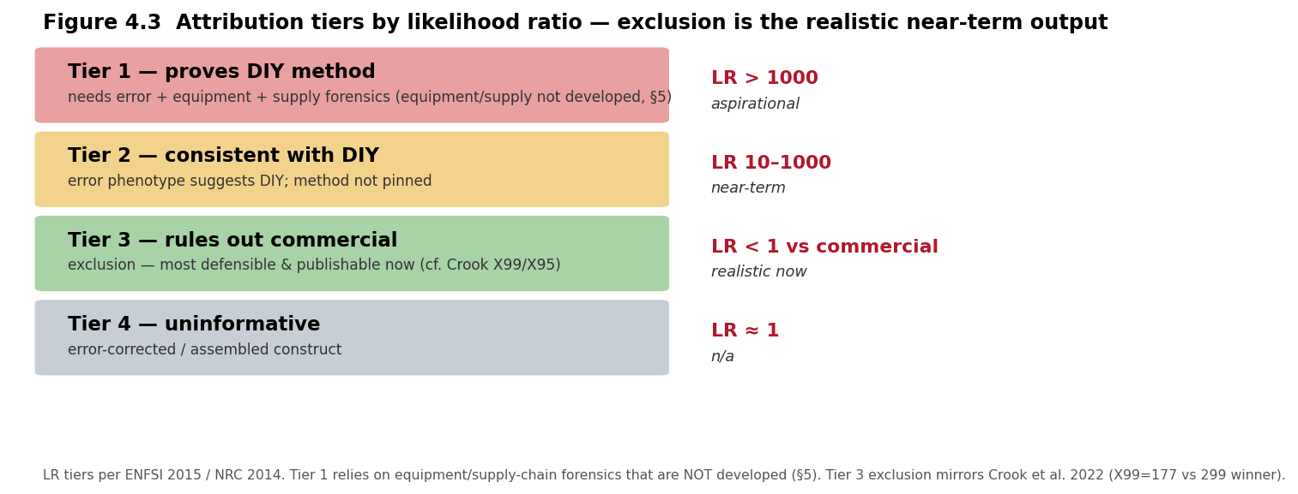
Figure 4.3 Attribution tiers by likelihood ratio. Exclusion (Tier 3) is the realistic near-term output.
Why exclusion is strongest. Crook et al. (2022) demonstrated empirically that exclusion (X99/X95) improved far more than positive identification in GEA — the ensemble cut the exclusion set to 177 candidates (vs 299 for the winner). The same logic applies here: ruling out commercial synthesis from an anomalous error profile is more defensible than positively identifying a DIY method from sparse reference data. Design the framework to lead with exclusion.

7. Feasibility Assessment
Sequence-level error-signature forensics — feasible now, and now demonstrated. Reuses established ML/calibration methods (Alley 2020; Crook 2022) on product-sequence data; the method classes are shown to differ in phenotype shape (§4.1), the per-method signatures are reproduced from deposited reads (Fig. 4.4–4.6), and the pipeline runs end-to-end on real data. Binding constraint: a single co-processed, labelled reference library spanning classes. Honest scope: unassembled oligo pools. Equipment and supply-chain forensics remain lower-feasibility and out of scope.

8. Deliverable, Scenarios & Limitations
Deliverable: a 2–3-page error-signature fingerprinting specification (feature set, consensus protocol, LR calculation, reference-library requirements, leakage-aware validation, four-tier hierarchy) plus the reference implementation (synth_forensics) and the reproducible acquisition scripts (Masaki, Filges, Lietard arms).
Evidence profiles by scenario (illustrative of achievable tier): (A) intercepted unassembled oligo pool — best case, Tier 2/3: a deletion-dominated, G→T-inflected, spatially-graded profile → array; a G→A-dominated, capping-driven profile → commercial column; a deletion-dominated profile with suppressed G→A and elevated n−1 deletions → OpenIDS-type DIY; a deletion/insertion profile with sub-0.1% substitution → enzymatic. (B) assembled/error-corrected construct — degraded, Tier 3/4. (C) sequence only — Tier 3 exclusion at best.
Limitations: (1) reference-library dependency; (2) adversarial laundering degrades signal — post-synthesis processing and position-local chemistry-level suppression (§4.6); (3) new methods may not match historical signatures (continuous retraining — Mo et al. 2024); (4) no single feature is diagnostic; (5) equipment/supply forensics stay compartmented.

9. Conclusion
Synthesis-method attribution from error phenotypes is a genuinely novel, feasible, and safe contribution: it consumes product-sequence data, fills a documented gap in the attribution literature, and — framed around exclusion — yields a defensible near-term forensic output that complements imperfect prevention. The premise is no longer speculative: reprocessing four deposited datasets from raw reads, we reproduce column phosphoramidite (Masaki, Filges), photolithographic (Lietard), and electrochemical vs deposition (Gimpel) signatures to within ±20%, show the phenotype is chemistry- not readout-determined, and measure attribution directly — 100% capping-chemistry separation and 75% four-vendor manufacturer separation (p<0.001). A concrete DIY-vs-commercial discriminator — OpenIDS’s capping omission — is specified, mechanistically anchored in the reproduced Masaki result, and awaits collaborator product data. It is the detect leg of delay, detect, defend.

