В нашому мобільному застосунку користувачу після онбордингу пропонують купити тижневу підписку вартістю $4.99, що надає доступ до преміум-функцій. Зараз підписку на цьому екрані купують 17% з користувачів, що отримали пропозицію.

Ми вирішили протестувати альтернативний дизайн екрана з підпискою, на якому ми також пропонуємо підписку вартістю $4.99, але кажемо користувачеві, що це зі знижкою 50%.

Кожного дня застосунок встановлюють близько 2 тис користувачів, до екрану з підпискою при цьому доходять 34% користувачів.

Завдання:

* Сформулюй гіпотезу, яку ми перевірятимемо в цьому тесті.
* Опиши, яких користувачів ми маємо включити в цей тест.
* Обери цільову та допоміжні метрики, обґрунтуй свій вибір.
* Розрахуй розмір вибірки, який потрібний нам для перевірки гіпотези, та кількість днів, протягом яких тест має бути запущений.
* Опиши, за якої умови ми вважатимемо тест успішним та як діятимемо залежно від результату. Запропонуй альтернативний варіант для тестування, якщо цей не виявиться успішним.

*****

**Notes and Assumptions**

1. Daily Users for the test are those, who reached the screen with a proposition. Not those, who installed the app. Because all those who haven’t seen the screen could not decide on it, doesn’t matter what it looks like and what is written on it. Our test will not consider them.
   1. Here is the variant from installation to payment
2. We don’t know the period from installation to accepting the proposition/ But that is required to calculate the number of daily visitors to the page. Assume that CR 17% is for the same day as the installation.
3. We don’t have numbers on the Churn rate and the number of users at the beginning and of the experiment. Therefore we can’t calculate the Retention rate, which is the metric impacted by conversion.

*******

# The variant of HT with CR from the Subscription screen

## Test hypothesis

We need to increase the conversion rate to a weekly subscription after onboarding in the mobile app. The current conversion from installation to the end of the onboarding is 34% (680 users), and conversion from onboarding to subscription is 17% out of 680. We would like to increase the latter number. We expect it is possible to increase the conversion rate by min 30% (to reach CR 22%)

The hypothesis is that the users who reach the subscription proposition screen are ready to buy, but need a trigger. We suppose that they will buy more willingly

* if they compare the price with a bigger one, or
* if they realize that their interest in the application is rewarded with a discount.

## Metrics

Primary Metrics

* CR from prop screen to weekly subscription is possible to improve from 17% to 22%
* (Monthly) Recurring Revenue may increase from $577 to $747 per day, as the current event directly impacts Revenue

Secondary Metrics

* Retention and Churn Rates should be controlled to evaluate the effectiveness of improved RC for the Revenue.
* CR from installation to proposition screen should be tracked to ensure the input data for the test are sufficient and consistent

|  |  | **Metric** | **Current** | **Desirable** |
| --- | --- | --- | --- | --- |
| From installation to prop screen | 100% | CR | 34% |  |
| 2000 |  | **680.0** |  |
|  |  |  |  |  |
| **From prop screen to weekly subscription** | 100% | **CR** | **17%** | **22%** |
| **680.0** |  | 115.6 | 149.6 |
|  |  |  |  |  |
|  |  | APPRU per week | $ 4.99 | $ 4.99 |
|  |  | **New daily RR** | **$ 576.84** | **$ 746.50** |
|  |  | **Retention Rate** |  |  |

## 

## 

## Test description (Experiment)

We’ll run two versions of the subscription proposition screen. The price will remain the same, but one of the screens will have a discount label, showing that the proposed subscription cost is 50% of the regular price.

The predefined Confidence level is 95 and Statistical power is 80%.

### Audience

Considering not large number of daily visitors, we’ll run the test for the entire population of visitors who reach the screen during the test period.

All the visitors should be split 50:50, randomly, into control and test groups.

* To the **control group**, the original version of the screen will be shown.
* To the **test group**, the version mentioning that the price is a 50% discount.

### Sample Size and Duration

The calculators say that we need a sample size of 750 - 930 users per variant, considering 680 visitors per day (4760 per week).

To get these numbers with the current number of visitors to the screen we need 3 days, but we’ll run the test during a minimum of 2 weeks. That is exactly 2 business cycles, that gives us a chance to track the Retention rate metric for weekly subscriptions.

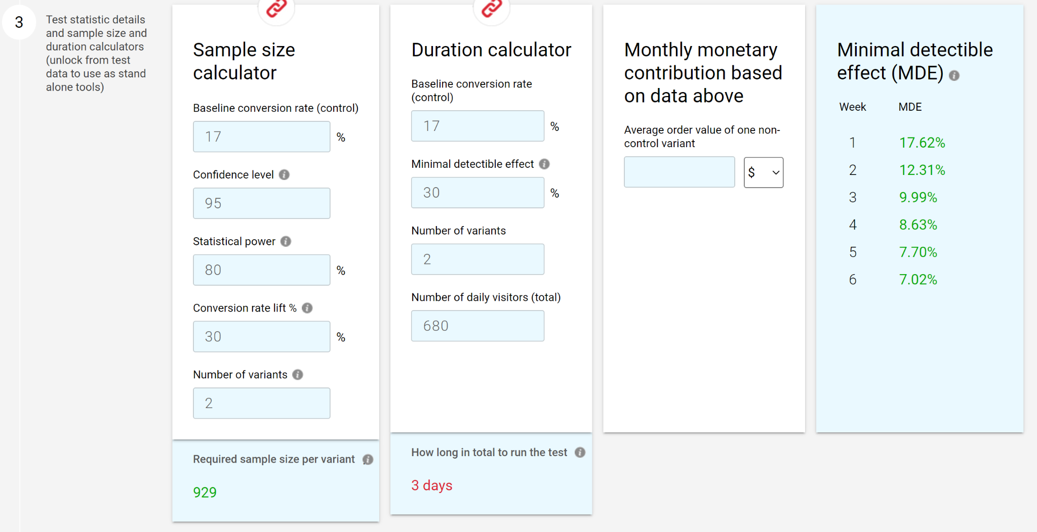

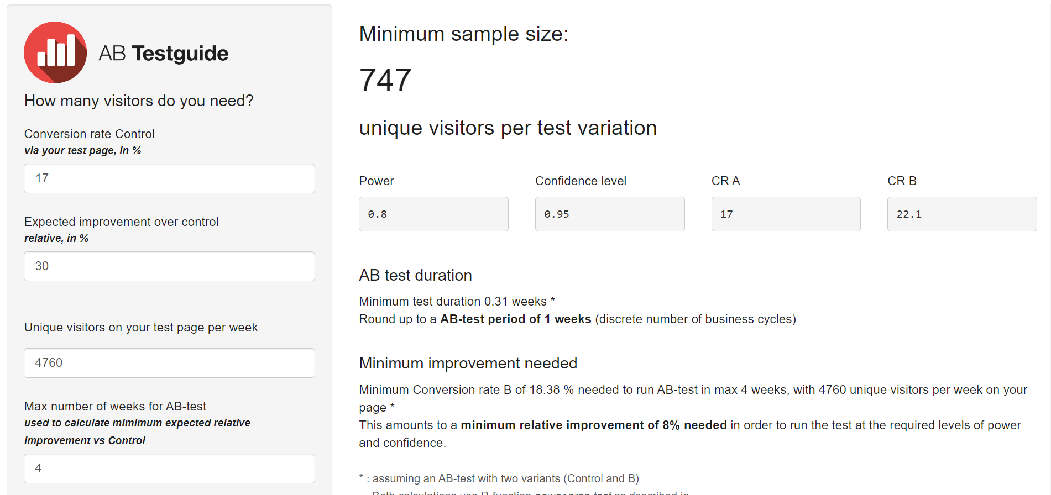

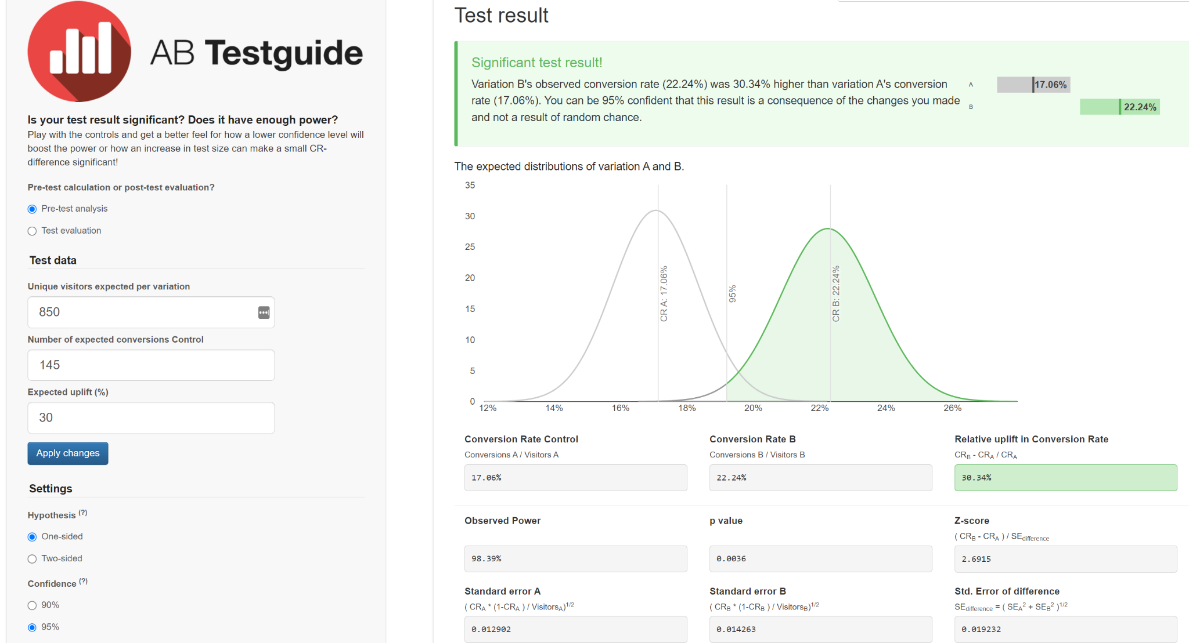

https://abtestguide.com/calc/?ua=850&ub=850&ca=145&cb=189&pre=1&up=30

## Potential outcomes

In case the CR metric in the test group will show from 20 to 30% increase during a week and the Retention Rate won’t decrease more than in previous periods, the test should be considered successful and the original screen should be changed to the new one.

In case the CR metric and retention rate won’t show the expected results, another test may be run.

**Alternative1**: The Lift may be decreased to cover a bigger audience with the same test

**Alternative 2**: for the test group show the screen with the subscription proposition earlier on the onboarding path.

Additionally, I would pay attention to the quality of engagement and onboarding processes. With concurrent analysis of Retention and Churn rates.

**********************************

# 

# The variant of HT with CR from Installation

## Test hypothesis

We need to increase the conversion rate to a weekly subscription after onboarding in the mobile app. The current conversion from installation to the end of the onboarding is 34, and conversion from onboarding to subscription is 17% out of 680. We would like to increase the latter number. We expect it is possible to increase the conversion rate **from installation to payment** by min 10%.

*** Note: I consider this test incorrect ***

The hypothesis is that the users who reach the subscription proposition screen are ready to buy, but need a trigger. We suppose that they will buy more willingly

* if they compare the price with a bigger one, or
* if they realize that their interest in the application is rewarded with a discount.

## Metrics

Primary Metrics

* CR from prop screen to weekly subscription is possible to improve from 5.8% to 6.4%
* (Monthly) Recurring Revenue may increase from $577 to $635 per day, as the current event directly impacts Revenue

Secondary Metrics

* Retention and Churn Rates should be controlled to evaluate the effectiveness of improved RC for the Revenue.
* CR from proposition screen to payment should be tracked

|  |  | **Metric** | **Current** | **Desirable** |
| --- | --- | --- | --- | --- |
| From installation to prop screen | 100% | CR | 34.0% |  |
| 2000 |  | 680.0 |  |
|  |  |  |  |  |
| From prop screen to weekly subscription | 100% | CR | 17.0% |  |
| **680.0** |  | 115.6 |  |
|  |  |  |  |  |
| From installation to weekly subscription | 100% | **CR** | **5.8%** | 6.4% |
| 2000 |  | 115.6 | 127.16 |
|  |  |  |  |  |
|  |  | APPRU per week | $ 4.99 | $ 4.99 |
|  |  | **New WRR** | **$ 576.84** | **$ 634.53** |
|  |  | **Retention Rate** |  |  |

## Test description (Experiment)

We’ll run two versions of the subscription proposition screen. The price will remain the same, but one of the screens will have a discount label, showing that the proposed subscription cost is 50% of the regular price.

The predefined Confidence level is 95 and Statistical power is 80%.

### Audience

Considering not large number of daily visitors, we’ll run the test for the entire population of visitors for the test period.

All the visitors should be split 50:50, randomly, into control and test groups.

* To the **control group**, the original version of the screen will be shown.
* To the **test group**, the version mentioning that the price is a 50% discount.

### Sample Size and Duration

The calculators say that we need a sample size of 21639 users per variant, considering 2000 visitors per day (14000 per week).

To get these numbers with the current number of visitors to the screen we need 3 weeks.

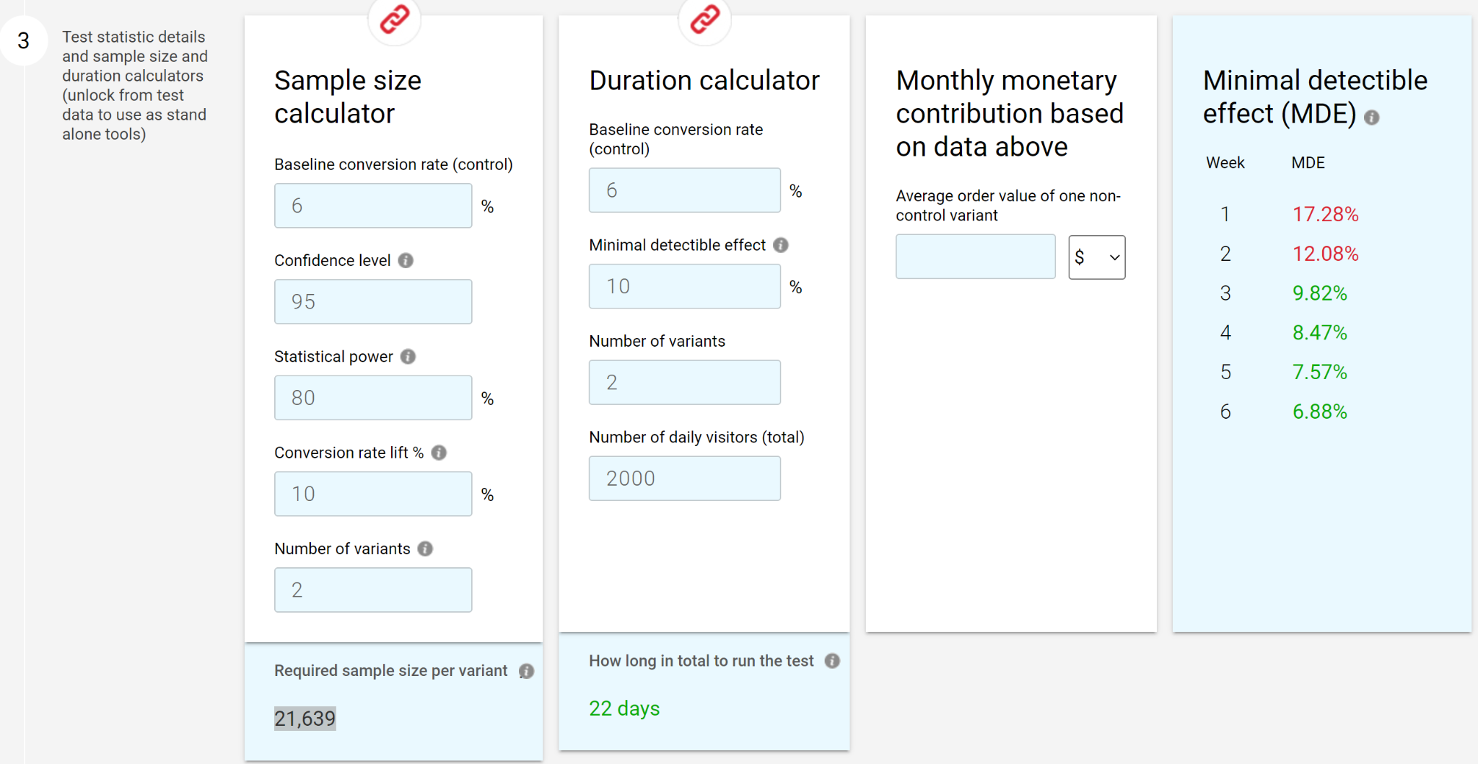

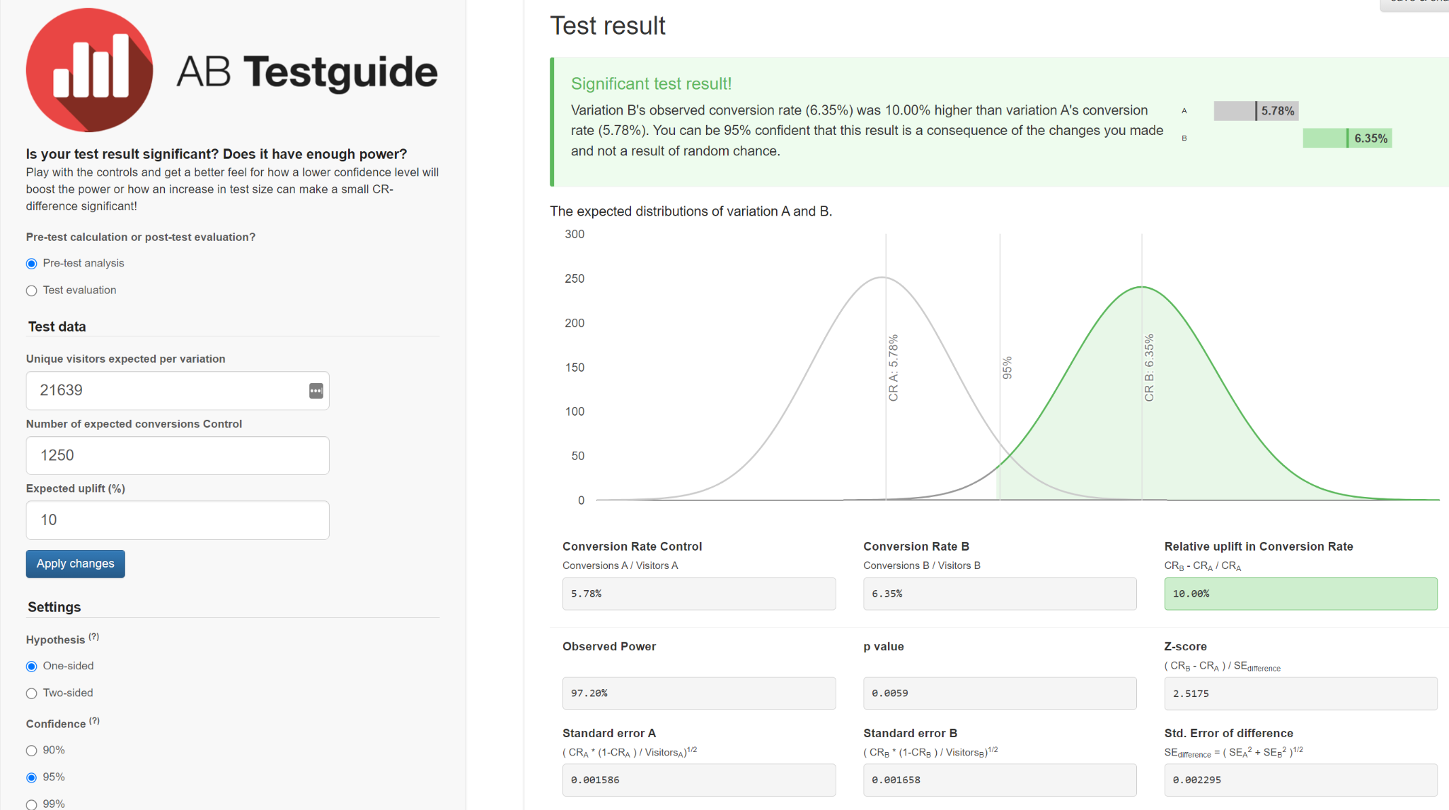

## Potential outcomes

In case the CR metric in the test group shows from 6.4% increase during a week and the Retention Rate won’t decrease more than in previous periods, the test should be considered successful and the original screen should be changed to the new one.

In case the CR metric and retention rate won’t show the expected results, another test may be run.

**Alternative 1**: The Lift may be decreased to cover a bigger audience with the same test

**Alternative 2**: for the test group show the screen with the subscription proposition earlier on the onboarding path.

Additionally, I would pay attention to the quality of engagement and onboarding processes. With concurrent analysis of Retention and Churn rates.