**Wireframe for the HOME page**

Welcome to my site!

My name is Olena Slobodeniuk.

I am professional accountant with the over 19 years of experience.

I am detail oriented, organized, independent worker with strong time-management and problem-solving skills. I am able to learn quickly, adapt well to new technologies and work under pressure and within tight deadlines.

Let's get acquainted!

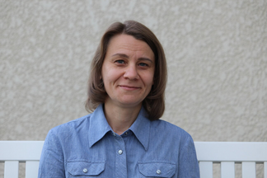

Olena Slobodeniuk - 2023

Contact me

What I do

Home

Home

Contact me

What I do

Logo

**Wireframe for the WHAT I DO page**

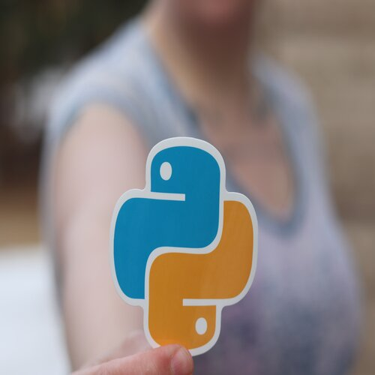 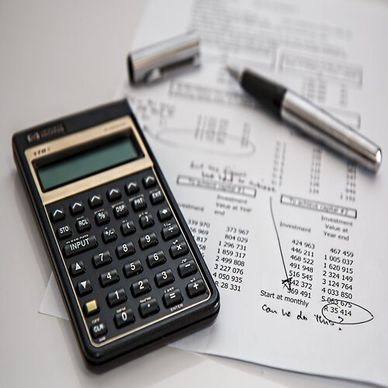

**Experience**

Chief accountant (June 2018 — March 2022'): Manufacturing Enterprise Limited Liability Company "Akvaton" (Enameled wire production, wholesale, foreign economic activity; number of subordinates - 3 pers., workforce - 85 people). • Kept accurate bookkeeping which gives good results of inspection by regulatory authorities; • Created team –work between different departments of the company, which increased client’s service quality for 13%; • Improved ineffective policies in accounting, which fastened the provision of information to higher management;

Chief accountant (July 2015 – May 2018): Private Enterprise “Rivne-Flex” (Printing and manufacturing of packaging. Workforce - 50 people, number of subordinates - 2 pers.) • Implemented new accounting software for better supplying of information for managers; • Developed skills and knowledge of the accountants, we could replace each other in case of absence and provide information for higher management; • Improved the procedure of salary calculating, which helped employees to be more informed about their payment.

**Education**

Bachelor’s degree in Accounting and Auditing (completed in June 2003), National University of water and Environmental Engineering, Ukraine

Pathway Connect Certificate (completed in December 2022) BUY-Pathway Worldwide, USA: - a year-long program teaching life skills, English, algebra and personal finance - introductory course “Programing building blocks”

BYU-Idaho, USA, “WEB & Computer Programing” (started in January 2023, currently studying)

**Skills**

• Attention to details • Proficient PC user (MS Word, MS Excel) • Upper-intermediate level of English • Fluent Ukrainian and Russian • Beginner level of French • Teamwork and collaboration • Tax monitoring and control • Accurate bookkeeping • Good organization skills • High analytical skills

Olena Slobodeniuk - 2023

Contact me

What I do

Home

Home

Contact me

What I do

Logo

**Wireframe for the CONTACT ME page**

You can always reach me by:

phone +1(587) 433 55 93

or

email [lena2805sl@gmail.com](mailto:lena2805sl@gmail.com)

Don't hesitate contacting me!



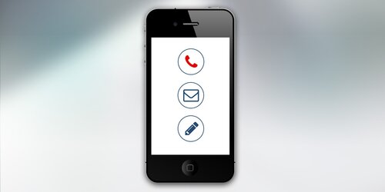

Olena Slobodeniuk - 2023

Contact me

What I do

Home

Home

Contact me

What I do

Logo