**Surveys**

Mean and standard deviation

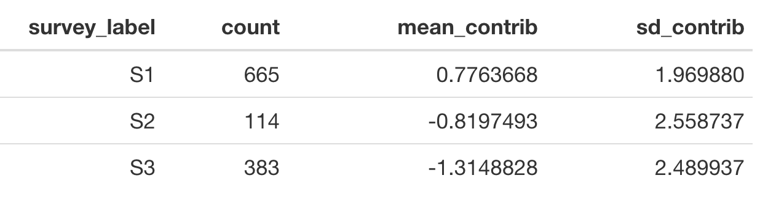

ANOVA

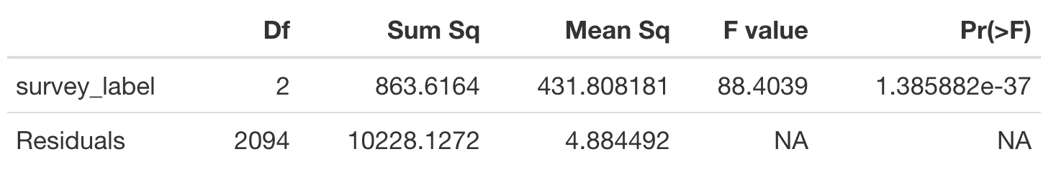

Boxplot

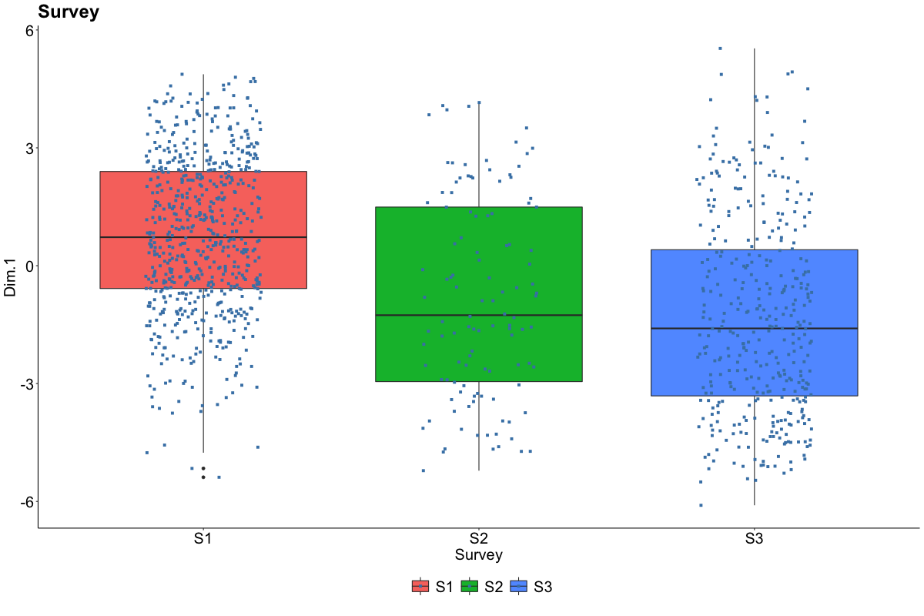

**Work Sector**

Mean and standard deviation

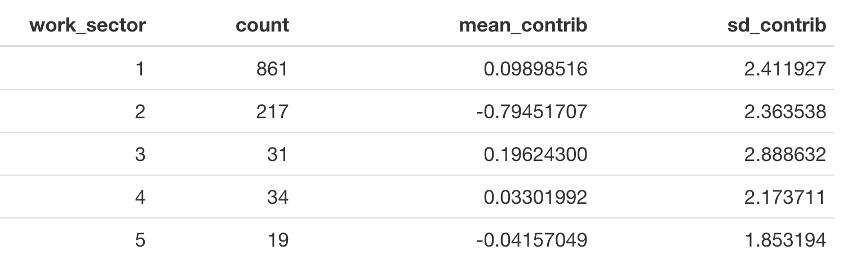

ANOVA

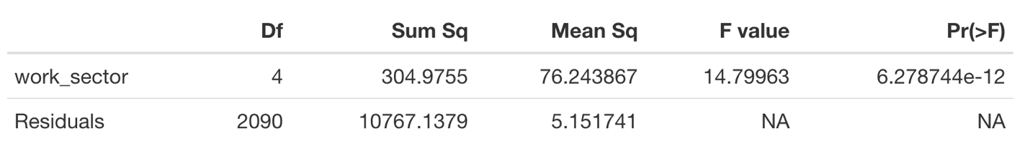

Boxplot

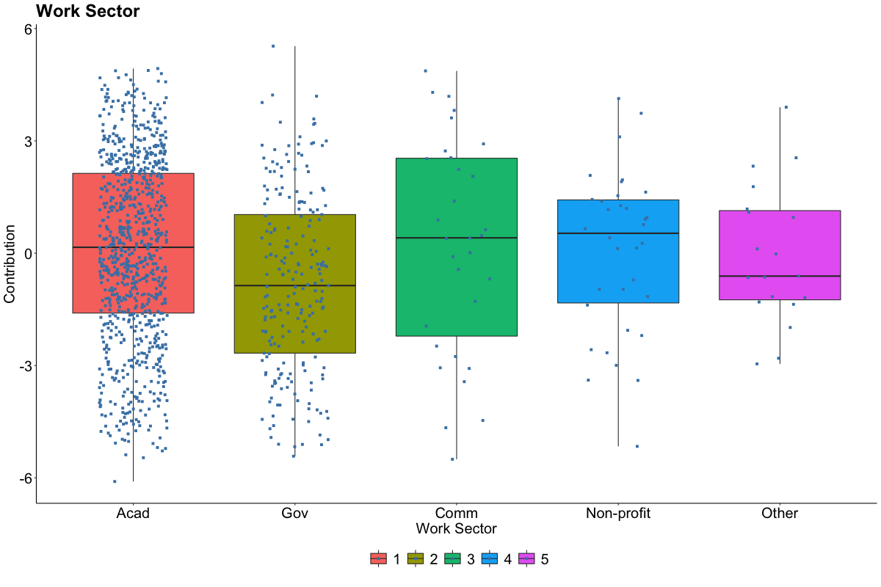

**Domain**

Mean and standard deviation

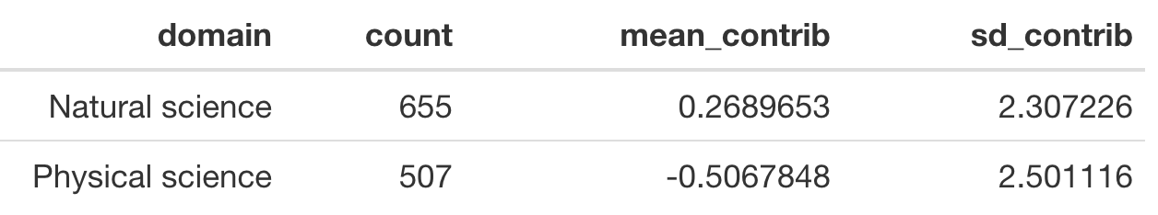

ANOVA

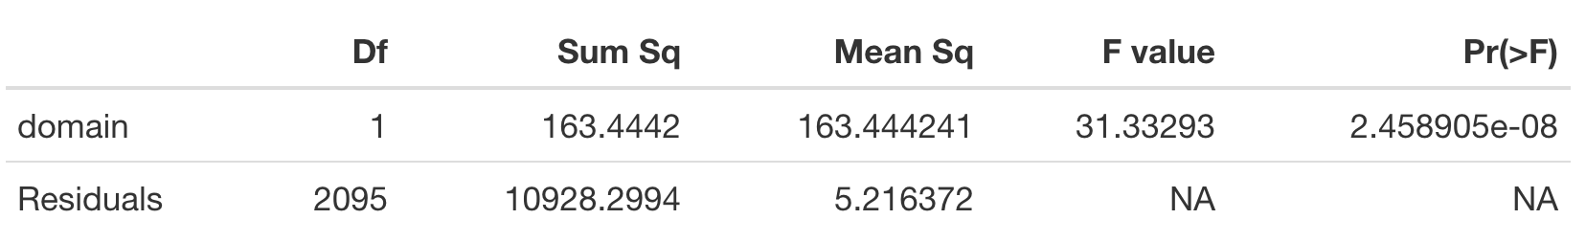

Boxplot

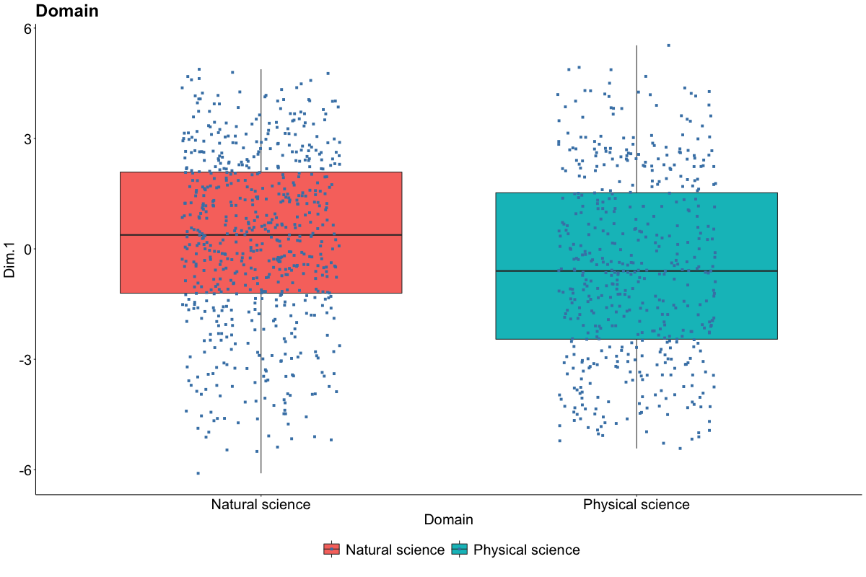

**Funding agency**

Mean and standard deviation

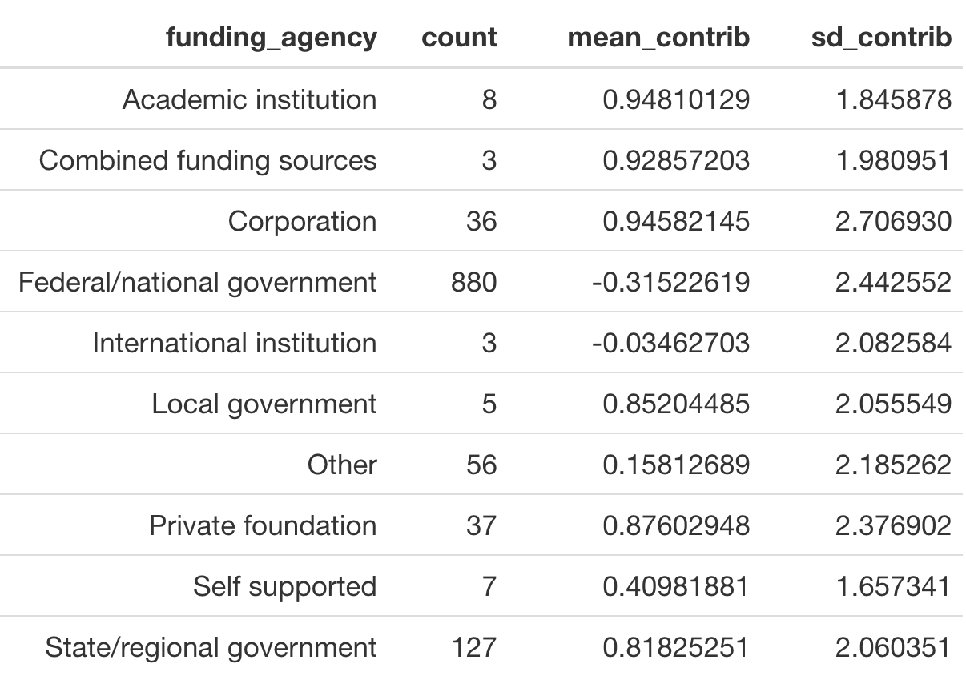

ANOVA

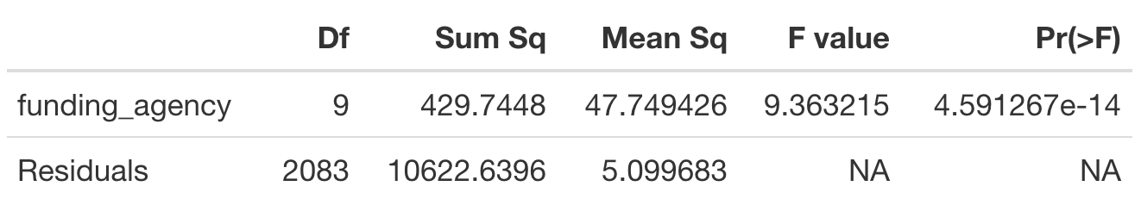

Boxplot

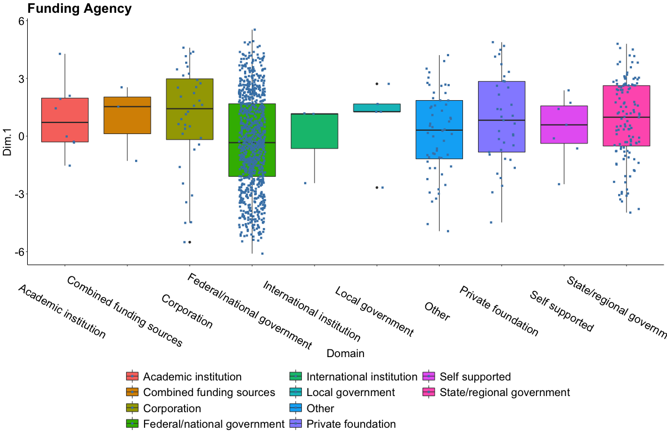

**Region**

Mean and standard deviation

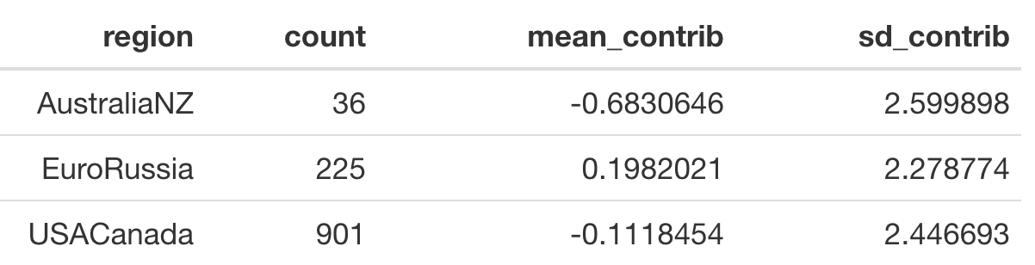

ANOVA

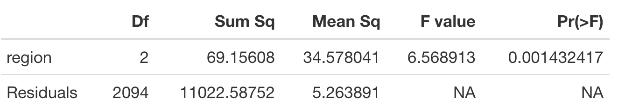

Boxplot

