**МІНІСТЕРСТВО ОСВІТИ І НАУКИ УКРАЇНИ**

**НАЦІОНАЛЬНОМУ УНІВЕРСИТЕТІ “ЛЬВІВСЬКА ПОЛІТЕХНІКА”**

**Кафедра Системи штучного інтелекту**

**Лабораторна робота №2**

з дисципліни

«Організація баз даних та знань»

**Виконала:**

студентка групи КН-208

Пона Олена

**Викладач:**

Мельникова Н.І.

**Львів – 2019 р.**

DROP DATABASE EmploymentCenter;

CREATE DATABASE IF NOT EXISTS EmploymentCenter;

CREATE TABLE EmploymentCenter.employer(

employer_id INTEGER UNSIGNED NOT NULL AUTO_INCREMENT,

employer_name TEXT NOT NULL,

mobile_number CHAR(99) NOT NULL,

email CHAR(99) NOT NULL,

PRIMARY KEY (employer_id)

);

CREATE TABLE EmploymentCenter.vacancies(

vacancies_id INTEGER UNSIGNED NOT NULL AUTO_INCREMENT,

employer_id INTEGER UNSIGNED NOT NULL,

name_of_vacancy TEXT NOT NULL,

properties CHAR(99),

PRIMARY KEY (vacancies_id),

CONSTRAINT employer_role FOREIGN KEY (employer_id) REFERENCES employer (employer_id) ON DELETE NO ACTION ON UPDATE NO ACTION

);

CREATE TABLE EmploymentCenter.employee(

employee_id INTEGER UNSIGNED NOT NULL AUTO_INCREMENT,

person_name CHAR(99) NOT NULL,

mobile_number CHAR(10) NOT NULL,

secretary_id INTEGER UNSIGNED NOT NULL,

email CHAR(100) NOT NULL,

time_for_work TIME NOT NULL,

PRIMARY KEY (employee_id)

);

CREATE TABLE EmploymentCenter.document (

cv_id INTEGER UNSIGNED NOT NULL AUTO_INCREMENT,

employee_id INTEGER UNSIGNED NOT NULL,

PRIMARY KEY(cv_id),

CONSTRAINT employee_role FOREIGN KEY (employee_id) REFERENCES employee(employee_id) ON DELETE NO ACTION ON UPDATE NO ACTION

);

CREATE TABLE EmploymentCenter.information(

information_id INTEGER UNSIGNED NOT NULL AUTO_INCREMENT,

name_of_institution CHAR(100) NOT NULL,

time_of_starting_work TIME NOT NULL,

time_of_finishing_work TIME NOT NULL,

cv_id INTEGER UNSIGNED NOT NULL,

PRIMARY KEY (information_id),

CONSTRAINT cv_information FOREIGN KEY (cv_id) REFERENCES document(cv_id) ON DELETE NO ACTION ON UPDATE NO ACTION

);

CREATE TABLE EmploymentCenter.files (

files_id INTEGER UNSIGNED NOT NULL,

link_on_files TEXT NOT NULL,

document_id INTEGER UNSIGNED NOT NULL,

cv_id INTEGER NOT NULL,

date_of_loading DATE NOT NULL,

CONSTRAINT cv_files FOREIGN KEY (document_id) REFERENCES information(information_id) ON DELETE NO ACTION ON UPDATE NO ACTION

);

CREATE TABLE EmploymentCenter.secretary(

secretary_id INTEGER UNSIGNED NOT NULL AUTO_INCREMENT,

start_time TIME NOT NULL,

finish_time TIME NOT NULL,

employee_id INTEGER UNSIGNED NOT NULL,

vacancies_id INTEGER UNSIGNED NOT NULL,

result TEXT NOT NULL,

description_of_result TEXT NOT NULL,

PRIMARY KEY (secretary_id),

CONSTRAINT employee_information FOREIGN KEY (employee_id) REFERENCES employee (employee_id) ON DELETE NO ACTION ON UPDATE NO ACTION,

CONSTRAINT vacancies_information FOREIGN KEY(vacancies_id) REFERENCES vacancies (vacancies_id) ON DELETE NO ACTION ON UPDATE NO ACTION

);

CREATE TABLE EmploymentCenter.TypeOfDocument(

passport_copy BOOLEAN DEFAULT 0,

medical_book BOOLEAN DEFAULT 0,

type_id INTEGER UNSIGNED NOT NULL,

cv_id INTEGER UNSIGNED NOT NULL,

CONSTRAINT cv_documents FOREIGN KEY (cv_id) REFERENCES document(cv_id) ON DELETE NO ACTION ON UPDATE NO ACTION

);

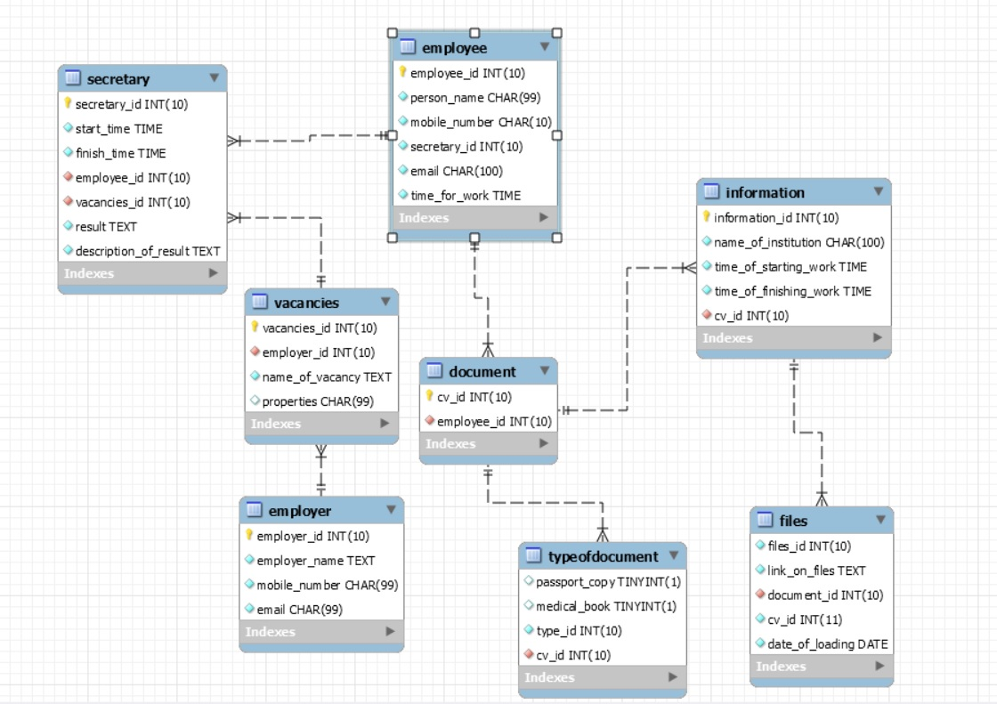

**Висновок:** на цій лабораторній роботі було завершено моделювання і засобами SQL створено базу даних, що складається з семи таблиць.