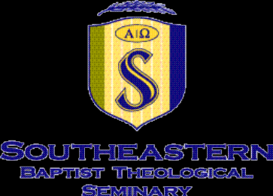
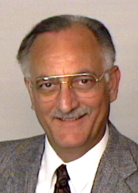 Wayne McDill

Wake Forest, NC 27587
(919) 863-8474

Summary:
More than forty years experience in church and denominational service in the Southern Baptist Convention.
Experience:
Senior Professor of Preaching, Southeastern Baptist Theological Seminary, Wake Forest, North Carolina, August 1989 to present.
Adjunct Professor, Golden Gate North, a satellite campus of Golden Gate Baptist Theological Seminary, Mill Valley, California.
Pastor, Metropolitan Baptist Church of Portland, Oregon, August 1979 to August 1989. This assignment arose out of a family commitment to Northwest missions.
Staff Associate in the Evangelism Division of the Baptist General Convention of Texas, July 1973 to August 1979.
Pastor, Central Baptist Church of Hillsboro, Texas from October 1967 to April 1973.
Education:
Th.D., Southwestern Baptist Theological Seminary, Fort Worth, Texas (1976). Primary concentration in Christian Ethics; secondary studies in Preaching and Philosophy.
M.Div., Southwestern Baptist Theological Seminary (1967).
B.A., East Texas Baptist College (1963). Major in Speech Education, minor in Music Education.
Publications:
Preparing Bible Messages. Wake Forest: Southeastern Seminary, 2003. Published in digital format for use by missionaries untrained workers on mission fields.
The Moment of Truth: A Practical Guide to Effective Sermon Delivery. Nashville: Broadman & Holman, 1999.
The Message in Your Emotions. Nashville: Broadman & Holman, 1996.
The Twelve Essential Skills for Great Preaching. Nashville, TN: Broadman & Holman, 1994.
Making Friends for Christ. Nashville, TN: Broadman, 1979.
The Power to Become. Old Tappan, NJ: Fleming Revell, 1979.
Evangelism in a Tangled World. Nashville, TN: Broadman, 1976.
Personal Data:
Born April 23, 1941, in Beaumont, Texas
Wife: Sharon Kay Kennon of Longview, Texas
Four children, sixteen grandchildren
Hobbies: Writing, gardening, family camping.

