7. FINANCE PLAN
Capital required. Olera is requesting approximately $4 million in CRP funding over three years to finance the later-stage R&D, real-world validation, and commercialization work required to cross the Valley of Death described in Section 1. CRP capital will complete and validate the CareNavigator execution and outcomes infrastructure, establish Caregiver Staffing as a repeatable provider-revenue pathway, generate the evidence needed for institutional commercialization, and develop the operating playbooks required for subsequent expansion. The award is designed to move Olera from pre-scale commercialization to an investable commercial inflection point. It does not assume that revenue from the limited CRP markets immediately replaces the full federal operating budget.
From CRP capital to commercial sustainability. Olera's financing strategy combines capital sources that enter at different stages (Figure 9). During the CRP, federal capital finances the R&D and evidence generation that private investors are not yet positioned to underwrite. Caregiver Staffing begins generating commercial revenue, demonstrating willingness to pay, retention, unit economics, and market replicability while contributing operating cash. As these results mature alongside CareNavigator's real-world evidence, Olera will pursue independent third-party capital to finance post-CRP commercialization while provider and institutional revenue grow.
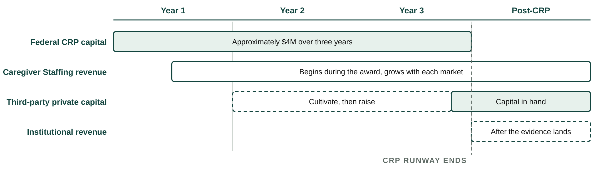
Figure 9. Financing transition. CRP evidence unlocks private capital before provider and institutional revenue mature.
Fundraising Plan. Olera will begin financing its next stage before CRP funding ends. The aims are deliberately sequenced so that sufficient technical, real-world, and early commercial evidence should be available by approximately the end of Year 2 to begin structured investor cultivation, while Year 3 strengthens the financing case and supports a formal raise. The objective is to enter post-CRP commercialization with financing secured or actively closing rather than encounter a new funding gap.
CRP period | Evidence available | Fundraising activity
Year 1. Prepare | Technical and commercial milestones begin accumulating | Quarterly investor-readiness reviews; define financing milestones and reporting; maintain investor relationships
Year 2. Cultivate | Real-world deployment; paying Staffing customers and preliminary economics; accumulating outcomes | Begin structured investor cultivation and updates; targeted introductions; build data room and financing materials
Year 3. Raise | Mature Staffing economics; care-establishment evidence; institutional evidence package; replicated operating model | Formal financing process, diligence, term-sheet negotiation, and targeted close before CRP runway ends
Table 5. Fundraising plan for uninterrupted post-CRP commercialization.
Investor engagement and financing readiness. Commercialization advisor David Qu will advise Olera quarterly throughout the CRP, helping management define investment-readiness milestones, pressure-test the financing strategy and materials, and prepare for institutional fundraising. As milestones mature, he will support introductions and continued engagement with relevant senior-care and healthcare investors in his network, including Ziegler, Equitage Ventures, 7Wire Ventures, and Alumni Ventures, among others. His Letter of Support describes this role and commitment to helping Olera prepare for and pursue independent third-party financing as CRP milestones are achieved.
Post-CRP financing requirement. Olera expects independent third-party capital to finance post-CRP commercialization. The raise will be sized from the five-year operating and revenue model to support expansion of Caregiver Staffing and CareNavigator, institutional contracting, and sufficient operating runway as recurring revenue matures. Detailed revenue assumptions and staffing requirements are presented in the Revenue Stream section.
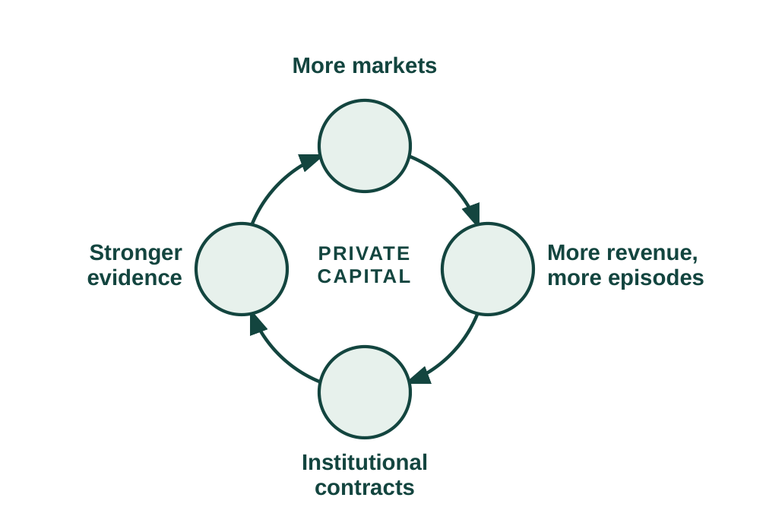
Figure 10. Post-CRP growth flywheel.
Use of post-CRP capital. Third-party capital will accelerate both commercialization pathways. Expanding Caregiver Staffing into additional markets creates workforce capacity and provider revenue; expanding CareNavigator creates more established-care episodes and a larger longitudinal evidence base for institutional contracting. These pathways reinforce one another: broader deployment generates more revenue and evidence, stronger evidence supports institutional contracts, and the resulting revenue can be reinvested in additional markets. Private capital is therefore the bridge from a CRP-validated model to commercial scale (Figure 10).
Financing continuity. Caregiver Staffing revenue provides commercial validation, operating cash, and incremental runway during the transition, but Olera's planned strategy is to secure independent third-party capital before the CRP ends. If financing takes longer than expected, management can moderate expansion while commercial revenue extends runway.
The sections that follow describe how Olera will deploy this capital to produce, market, and sell its products and how provider and institutional revenue scale over time.

