11. PROJECT MANAGEMENT PLAN
Team and governance. The PI, TJ Falohun, has led the project as PD/PI since Phase I and retains final go/no-go authority at major decision points. Co-investigator Logan DuBose, MD, MBA, the company's Chief Research Officer and a practicing primary-care clinician, oversees clinical relevance, research operations, commercialization coordination, and the milestone calendar. Clemson University leads the academic human-subjects effort with co-investigator Qiping Fan, PhD, supported by biostatistical expertise for study design and analysis. Olera's execution team includes internal engineering and product leadership, growth and marketing support, experienced call-center personnel, and research staff. Independent statistical review and external CPA validation of the commercial unit-economics model provide additional checks on the research and commercialization conclusions.
How research and commercialization stay synchronized. Day-to-day execution is managed through named workstream owners, maintained task boards, regular operating meetings, and milestone dashboards tied to the Research Strategy and Commercialization Plan. Leadership reviews operating progress continuously and commercialization evidence at defined stage gates, including transitions from engineering to free real-world validation, from validation to paid commercialization, and from CRP-supported experimentation to post-CRP expansion. A milestone that misses its predefined threshold triggers the corresponding alternative strategy rather than automatic continuation. Progress is reported to the NIH Program Officer through required reporting, while the PI retains final authority over major go/no-go decisions.
Commercialization timeline and gates. The first three years deliberately progress from build, to validate free, to monetize. Post-CRP commercialization then shifts to expand and scale, using the evidence, operating playbooks, commercial revenue, and third-party capital developed during the award. The detailed experimental timeline and thresholds are provided in the Research Strategy; the management timeline below shows how those activities produce successive commercialization decisions.
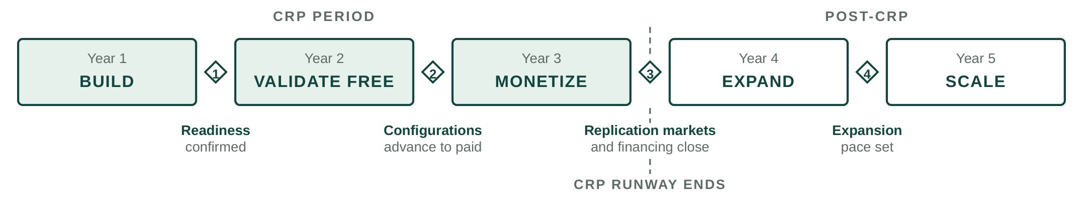
Figure 13. Five commercialization stages and the four decisions between them. Gate 3 is where the CRP runway ends and post-CRP financing is targeted to close.
Period | Research and product execution | Commercialization milestone | Decision or financing gate
Year 1 (CRP)Build | Complete and instrument CareNavigator execution infrastructure; engineer and automate Caregiver Staffing workflows; establish acquisition, outcomes, and county-market measurement systems. | Technical and measurement infrastructure operational; Staffing workflow ready for real-world deployment; commercialization hypotheses and investor-readiness framework established. | Confirm readiness for real-world market validation; correct components missing predefined readiness thresholds before scaled deployment.
Year 2 (CRP)Validate free | Deploy across selected CRP county markets; test CareNavigator acquisition and execution; provide Staffing free of charge to isolate operational performance from willingness to pay; measure applicant acquisition, qualification, provider interviews, successful hires, retention, care establishment, and longitudinal outcomes. | Quantify acquisition costs, successful hires per county per month, provider demand and repeat use, geographic replicability, and care-establishment performance; assemble evidence for structured investor cultivation. | Determine which market and channel configurations advance to paid testing; begin structured investor cultivation and institutional-buyer evidence discussions.
Year 3 (CRP)Monetize | Introduce real Staffing pricing and billing; test pricing and packaging; measure willingness to pay, repeat purchase, retention, and contribution economics; independently validate unit economics; complete CareNavigator outcomes and economic evidence package. | Base planning case: about $120K recognized Staffing revenue and about $240K annualized exit run rate; county-level commercial economics characterized; validated market-entry playbook and institutional evidence package completed. | Select markets for post-CRP replication; determine institutional contracting readiness; conduct formal third-party financing process and target financing availability before CRP runway ends.
Year 4 (post-CRP)Expand | Replicate validated Staffing playbook into additional counties; pursue initial institutional CareNavigator relationships; deploy post-CRP capital; expand market operations and institutional business development. | Base planning case reaches about $600K combined commercial revenue, with Staffing expansion and initial institutional revenue establishing two complementary commercial pathways. | Set expansion pace based on measured county economics, institutional traction, available capital, and operating runway.
Year 5 (post-CRP)Scale | Continue county replication; mature early institutional relationships; expand workforce, provider-success, and institutional commercial capacity; reinvest revenue alongside growth capital. | Base planning case reaches about $1.5M combined commercial revenue, approximately 25 Staffing counties, and approximately three institutional relationships, with a validated pathway to broader national replication. | Scale according to measured economics and capital efficiency as recurring revenue progressively finances a greater share of continued commercialization.
Table 8. Five-year research-to-commercialization management timeline. Years 1 to 3 comprise the CRP period; Years 4 and 5 show the immediate post-CRP commercialization handoff. Revenue values are planning projections rather than CRP success criteria and will be replaced by economics measured during the award.
Together, these gates ensure that commercialization advances in response to measured technical, market, workforce, economic, and outcomes evidence rather than a predetermined expansion schedule.

