SIGNIFICANCE
The unmet need. If we are fortunate, each of us will grow old, and reach the point where we, or someone we love, needs help with bathing, dressing, meals, medications, and moving safely through the home. Most families meet that moment at its worst, after a fall or a hospitalization, and are expected to become experts in eldercare overnight.
A recognized need becomes established care only if a family clears three gates (Figure 1). They must find the right care across four systems with separate eligibility rules and nobody accountable for whether care begins. They must afford it: full-time home care runs $80,080 a year,¹ Medicare does not cover custodial home care, Medicaid pays only after spend-down, and an estimated $58 billion in assistance goes unclaimed each year because families cannot navigate the programs.² And someone must be available to deliver it: 63.3 percent of home-care providers declined cases in 2023 they could not staff.³
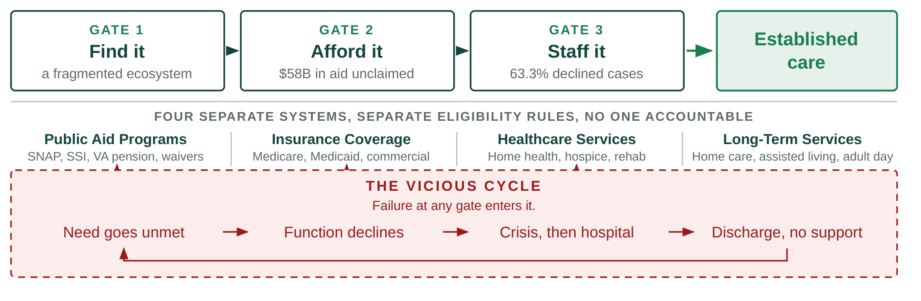
Figure 1. The three gates a family must clear, and the cycle that follows failure at any one of them.
Failure at any one gate leaves a vulnerable older adult in the vicious cycle. Nearly a third of older adults with difficulty in daily activities go without bathing, meals, or medications in a given month,⁴ and unmet needs of this kind independently predict emergency department use, readmission, nursing home placement, and mortality.^{5,6,7}
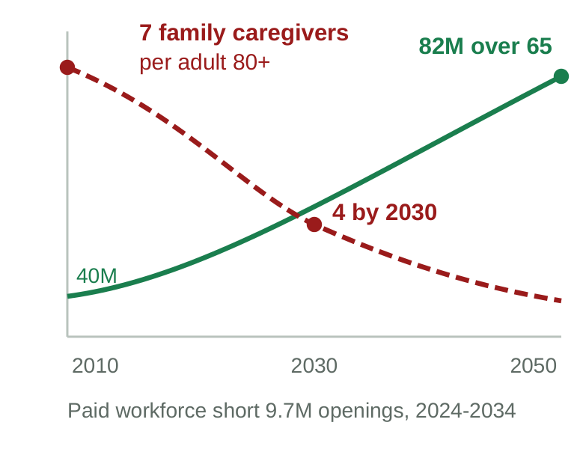
Figure 2. Demand rising while both sources of supply contract.
Where the money already goes. Demand is rising while both sources of supply contract (Figure 2): the population over 65 reaches 82 million by 2050⁸ while family caregivers per adult over 80 fall from more than seven to four,⁹ and the paid workforce that would have to absorb the difference faces 9.7 million direct-care job openings between 2024 and 2034.¹⁰
The cost of that shortfall is already being paid, just not where anyone planned. Family caregiving costs working Americans $107 billion a year in earnings they do not make, and their employers roughly $26 billion more in lost productivity.¹¹ Families then spend down what they saved, so a lifetime of retirement savings, and often the inheritance behind it, goes into a few years of long-term care. Medicaid picks the bill up only once that money is gone, by which point the family has lost its assets, the employer the work, and the public system has inherited a more expensive person to care for.¹² CAPABLE showed how avoidable that is: roughly $3,000 in program cost against more than $20,000 in reduced Medicaid spending per participant.^{13,14} The money largely exists today; too much of it is spent later, on worse outcomes and more expensive care. Every dollar of that consequence sits on an identifiable balance sheet: a health plan's, a state Medicaid budget's, a health system's, an employer's, or a family's. That is what makes this an addressable market and not only a public health problem.
Why information is not the bottleneck. Knowing what exists is not the hard part. A family has to work out which aid program applies, which insurance benefit applies, and which service or provider is needed, then complete the same sequence for each: applications, documentation, intake, scheduling, waiting, follow-up requests, provider availability, approval, and confirmation that care began. Families are lost to follow-up somewhere in that sequence, and existing help stops earlier: a discharge planner hands over a printed list and the case closes at the hospital door, information services return directories, referral marketplaces introduce a provider and are paid on placement. None is accountable for whether care was established, and even where navigation succeeds there may be no local caregiver capacity to deliver it.
Two things are therefore required at once: navigation that runs through to established care meeting the family's needs, and an available caregiver or provider to deliver it. Neither is sufficient alone, and that is the structural claim of this application. A product that helps families find and afford care still fails if the local system lacks the caregivers to deliver it, which is a faster path back into the vicious cycle.
The product and the north star. Olera exists to increase the effective capacity of America's aging-care system: to unlock financial resources that already exist, to bring new caregivers into a workforce short of them, and to use AI to turn both into care that actually begins.
CareNavigator is an eldercare AI navigation system built over an expert-curated national database of aid programs and providers, developed across NIA SBIR Phases I through IIB. It screens a household's needs and means and returns a care and funding plan with the steps each resource requires (Figure 3). What this award adds is execution: task-scoped agents that carry those steps out against a validated schema, follow up on a cadence, escalate to a person when a counterparty answers off-script, and confirm the date care began. Alongside it, Olera recruits and verifies new caregivers and places them with licensed providers, who employ, train, insure, and supervise them. Together they turn a recognized need into established care, which is how the cycle in Figure 1 is interrupted.
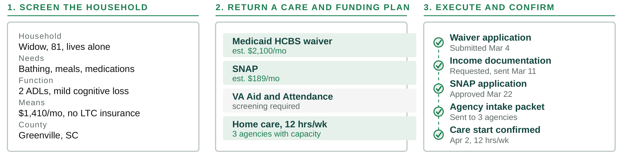
Figure 3. What CareNavigator produces for one household, and what the system then executes and confirms.
CareNavigator is free to families, and no provider pays to be listed or to receive a family connection. Nothing about a family's access depends on who has paid, which removes the gating on who can be helped, keeps the network from tilting toward whoever bought placement, leaves no incentive to steer anyone, and lets federally reimbursed providers participate, which pay-per-referral models cannot accommodate. Caregiver Staffing is the product sold and priced during this award.
Market segments and customers. The beachhead customer for our staffing product is healthcare and long-term services and supports providers, roughly 165,000 of which operate in the United States.^{15,16} The published median cost of acquiring a caregiver is $520 per hire, and that figure is for word of mouth, the cheapest channel an agency has.¹⁷ Providers fill roughly 970,000 direct-care positions a year;¹⁰ at the 16 percent of annual pay published work puts on replacing an hourly worker,¹⁸ against a direct-care median just under $26,000, that is about $4 billion a year spent replacing people who left. Table 1 sets our pilot pricing against what providers pay to acquire caregivers today.
Agency size | Hires per year at  75% turnover | Current cost at the  $520 median | Olera at $275/mo,  unlimited hiring | Effective cost  per hire | Annual saving
15 caregivers | 11 | $5,850 | $3,300 | $293 | $2,550
30 caregivers | 23 | $11,700 | $3,300 | $147 | $8,400
50 caregivers | 38 | $19,500 | $3,300 | $88 | $16,200
100 caregivers | 75 | $39,000 | $3,300 | $44 | $35,700
Table 1. What a provider pays today to hire a caregiver, and what Olera charges instead.
A second customer class is emerging, and this award generates the evidence needed to develop products for it. The organizations named above bear the cost when care does not get established, in avoidable emergency visits, readmissions, premature institutionalization, and caregiver breakdown, and Medicare now pays directly for care navigation through the GUIDE model.¹⁹ Evidence that care was established, paired with defensible estimates of the utilization it avoids, is what makes that proposition real. The Commercialization Plan models both; at modeled steady state a single market carries about 50 paying provider accounts and $165,000 in annual recurring revenue against roughly $30,000 to enter it, with lifetime value above four times acquisition cost.
Competitive environment and our advantage. Table 2 places our two products against every category of alternative across the path a family travels. Each solves only part of it, and families can still fall through before care is established.
Category of alternative | Find it | Afford it | Staff it | Establish care | Open to any family
Olera  CareNavigator and Caregiver Staffing | ✓ | ✓ | ✓ | ✓ | ✓
Public information services  Eldercare Locator, BenefitsCheckUp | ✓ | ✓ | ✗ | ✗ | ✓
General AI assistants  ChatGPT, Claude, Gemini | ✓ | ✓ | ✗ | ✗ | ✓
Human navigators  social workers, case managers, discharge planners, private care managers | ✓ | ✓ | ✗ | ✓ | ✗
Employer and health-plan navigation platforms  Wellthy, Grayce, Cariloop, Homethrive, ianacare | ✓ | ✓ | ✗ | ✓ | ✗
Referral marketplaces  A Place for Mom, Caring.com | ✓ | ✗ | ✗ | ✗ | ✓
Staffing agencies, job boards, gig platforms  local and franchise agencies, Indeed, shift marketplaces | ✗ | ✗ | ✓ | ✗ | ✓
Table 2. Coverage of the path to care, by category of alternative.
Coverage is by design across the full pathway. Olera clears the first three stages at production scale today and the last at pilot scale; Aim 1 builds the execution layer that closes it. The staffing channels in the last row supply workers already in direct care and none of them enlarges the workforce.
Human navigators are the strongest competitors: social workers, hospital case managers, discharge planners, and private geriatric care managers do this work well and cover more of the path than any product does. They are also scarce, and the constraint cannot be solved by hiring: healthcare social workers are projected to grow six percent by 2034, about 13,600 positions, against a population over 65 growing far faster.²⁰ The closest commercial analogues are the navigation platforms sold to employers and health plans, where access depends on who employs or insures a family,²¹ and referral marketplaces charge placement fees, which determines who appears and has drawn sustained criticism.²² Olera builds the pathways that bring new people into caregiving, the subject of Key Innovation 1.
Related development efforts in academia and industry. What the science has settled is that hands-on navigation works. Unmet daily-activity needs predict downstream utilization and placement,^{4,5} which is why we measure care established rather than clinical endpoints, and home-based support trials, principally CAPABLE, show that function-focused support reduces disability with savings well above program cost. Studies of digital caregiver navigation tools, four of them our own, establish that such platforms can be built and measured as usable and accepted.^{23,24,25,26} What remains unresolved is how to deliver that support at open access, at scale, through to a confirmed start, and on economics that sustain themselves without a grant. That is a commercialization problem rather than a scientific one.
The causes of the caregiver shortage are equally well documented and economic: median annual earnings for direct-care workers are just under $26,000,¹⁰ the work is demanding, career ladders are short, and median turnover in home care runs near 75 percent a year.¹⁷ Both the literature and the industry response concentrate on retaining and competing for workers already in the field. Comparatively little has addressed enlarging the pool itself, which is the gap Key Innovation 1 addresses.
Hurdles to adoption. Three groups have to adopt this, and each has a distinct reason not to. Families must trust an AI system with decisions about someone they love, and acceptance research finds willingness that is real but conditional: among 199 family caregivers surveyed, 62 percent intended to use AI-enabled care technology, with trust and perceived cost among the significant predictors.²⁷ We answer trust with verification rather than assurance. The Phase IIB evaluation now underway measures acceptance in 200 diverse family caregivers and reports before this award begins; Aim 1 then audits execution outputs against a blinded panel and tests the execution experience with families. We answer cost by charging families nothing.
Providers are wary of platforms that promise volume and deliver overhead, so Aim 2 removes the purchase decision by giving them the product free, leaving only the question of whether the workflow produces hires; Aim 3 then asks a different set of providers to pay, once that is answered on operating data rather than a pitch. New caregivers must be safely integrated into the workforce and well received by the providers who take them on, which is why Aim 2 measures the pathway end to end. All three have to happen in one market at once, at a cost that market's revenue supports. The aims are built around these hurdles, with prespecified alternative strategies if any gate fails.
INNOVATION
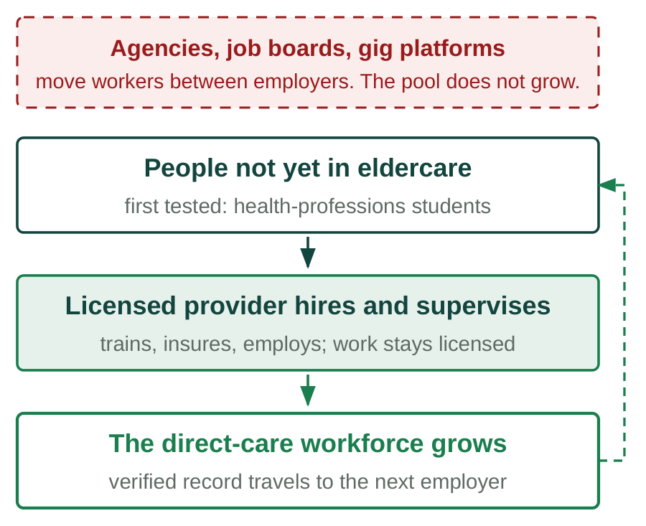
Figure 4. Existing channels move workers between employers. This pathway adds them, and the verified record follows the worker.
Key Innovation 1: infrastructure that adds caregivers to the field. Every staffing channel serving this industry, whether an agency, a job board, or a gig platform, competes for workers already inside the direct-care labor market. One provider's hire is another's vacancy, and the national shortage does not shrink by a single worker. Olera builds the infrastructure to bring in people who were not in the field (Figure 4).
That infrastructure is the innovation, not the recruiting. It is a technical pathway carrying a person with no eldercare experience through online training, screening, identity and credential verification, placement with a licensed employer, and supervised work, and issuing a verified, longitudinal record of their caregiving experience: hours, employers, training, competencies, populations served including dementia care, supervisor evaluations, reliability, background checks, and references. That record travels with the worker. Nothing like it exists today, so a caregiver who changes employers starts over and is re-screened on work already verified. The record is what makes any new worker pool viable, and it improves with every shift worked. [TJ: confirm the name and scope of the verified worker record.]
The first population is health-professions students, chosen because admission to their programs requires documented patient-care hours, which makes recruitment structurally inexpensive rather than a matter of wage competition. Health professions confer 263,800 undergraduate degrees a year,²⁸ entry into nursing, medicine, and physician assistant training turns on documented direct patient care,²⁹ and our own pilot drew more than 900 applicants. Nothing in the pathway is specific to students, though: it is population-agnostic by design, and Aim 2 measures it in one market with a health-professions campus nearby and one without, so the dependency is tested rather than assumed. Every step a worker takes also writes to the record described in Key Innovation 3.
Key Innovation 2: execution, not information. The prevailing paradigm is that tools inform and families execute. Every step after the information is handed over is left to the family, and those are precisely the steps at which families are lost.
CareNavigator's agents perform that work and the family decides. The system operates across the whole ecosystem in Figure 1 rather than across benefit programs alone: public aid, insurance coverage, healthcare services, and long-term services and supports differ in what they pay for and are alike in what they require, and it is that shared administrative sequence the agents execute. A case runs from a detected need through eligibility and funding, a plan, the administrative work it requires, a provider with capacity, a caregiver to fill it, confirmed care, and what happened after. The unit of success changes from information delivered to care established. Agents that complete multi-step administrative work are being built across many industries; the general capability is not ours, the substrate they act on is. No competing effort holds a county-level record of what a given agency actually decided, so a general-purpose agent can draft an application and cannot tell a family whether this county's waiting list is open. That makes the outcome measurable, and saleable to an organization bearing the cost of unmet need.
Key Innovation 3: a county-level record of what actually happens. Eldercare information exists in three layers, and almost everyone works from the first. The open web holds public directories and program rules, often neither accurate nor current, and equally available to any general-purpose AI system, which is why a chatbot can describe a benefit and cannot tell a family whether their county's waiting list is open.
Beneath that sit local program realities and provider truths that were never published: which office actually processes an application, what a program requires in practice rather than on its form, and which providers take which payment sources and have capacity. We assembled that layer through field work, expert curation, and direct outreach, into more than 72,000 records across all fifty states.
Beneath that sits a third layer that can only be learned by operating. For a specific household in a specific county: what looked appropriate, what was submitted, what the agency then asked for, where the process stalled, whether it was approved, how long it took, whether provider capacity existed, and what care was established. No public dataset holds it. NHATS is a survey; claims data record what was billed, not what was needed and refused. Neither observes the interval between recognizing a need and care beginning, which is the interval in which the system fails them.
Execution produces that layer, and it compounds: more families produce more executed cases, which produce more observed rules, capacity, and outcomes, which produce better navigation for more families. What this project builds is the first longitudinal, county-level administrative record of what older adults need, what they qualify for, where the system fails them, and whether care was established. A competitor who copies every feature begins with an empty database, and the measurement exists nowhere else for researchers or the state agencies that plan around it. We commit to publishing from it.
APPROACH
Overall research design. Olera developed two products across Phases I through IIB: CareNavigator and Caregiver Staffing. Everything that could be established without customers has been (Table 7). What this award asks is whether the two work together in a local market and whether that market can pay for itself. The award answers that question in three stages (Figure 5).
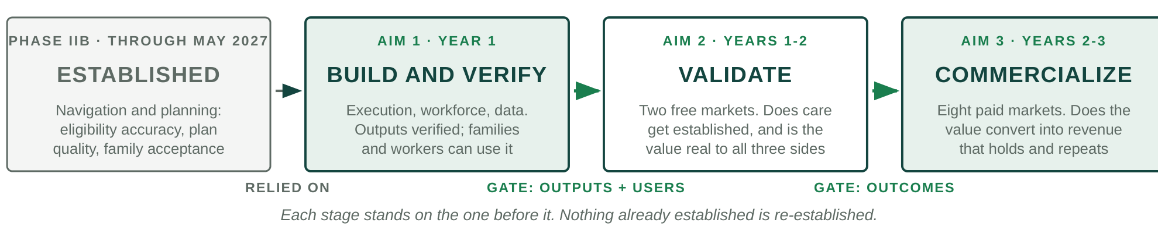
Figure 5. What each stage establishes, and what the next one therefore does not repeat.
Each stage carries a gate, and failure triggers a prespecified alternative strategy before the next stage begins: if Aim 1 misses verification, no market activates until the alternative engineering plan succeeds; if Aim 2 misses establishment, the alternative implementation plan runs before anything is sold. Primary endpoints are operational or economic and come from platform, billing, payroll, and employment records. Human subjects research sits inside the aims as Tasks 1.5 and 2.4, under Clemson University IRB approval with Dr. Fan as protocol lead; consent, privacy, data security, and risk assessment are in the PHS Human Subjects and Clinical Trials Information form. Phase IIB is the first stage in Figure 5: where this award relies on a Phase IIB result, the contingency is stated.
Regulatory plan. No federal premarket pathway applies. CareNavigator is navigational and administrative software that does not diagnose, treat, or make clinical decisions, so it is not a medical device and nothing in this award waits on federal approval. Four regimes govern operations: family data under HIPAA-aligned safeguards; referral practice, where charging no fee means no steering incentive exists; employment, training, insurance, and supervision of placed workers, which rest with the licensed provider rather than with Olera; and any joining of an external record to ours, which requires a data-use agreement and an IRB determination.
Specific Aim 1: Engineer and verify the technology and infrastructure both products require. (Year 1)
Aim 1 builds the AI agents that execute administrative work on a family's behalf, the infrastructure that carries a new caregiver into the workforce, and the data layer underneath both, then verifies that what CareNavigator produces is good enough to put in front of families and providers in Aim 2.
Engineering approach. The platform runs today as a TypeScript and React web application over managed Postgres, with agent and data services in Python, under trunk-based development; staging runs on a synthetic household corpus, so no real family record is used in testing. Agents are task-scoped rather than conversational. One assembles a packet, one submits it, one follows up, one confirms the start date, each with a bounded set of tools and a single unit of work. An orchestration service holds case state in the database rather than a model's context window, so a case survives restarts and can be replayed exactly. Tools are exposed through the Model Context Protocol, so the same definitions run against either the Anthropic or OpenAI agent runtimes and neither model nor vendor becomes a structural dependency. Model selection is by task: a reasoning model for planning and adjudication, a smaller one for extraction and classification. Every model output entering a workflow is validated against a strict schema, so a care and funding plan is a checked data object rather than prose to be parsed. [TJ: confirm runtime and model choices.]
Task 1.1: Execution and follow-up. CareNavigator screens a household and identifies the aid and services it qualifies for; that much runs nationally today. This task builds what happens next. Families are lost at the same two points whether the resource is a public benefit, an insurance entitlement, or a home care agency: assembling what is required, and waiting for an answer. The execution loop builds the required package from the household record and the resource's requirements, submits it through whichever channel that resource accepts, and records what was sent. The follow-up loop schedules the next contact, answers requests for further documentation, escalates to a human navigator when a counterparty responds outside the expected pattern or model confidence falls below a set threshold, and closes the case only on a confirmed start date. Intake requirements are modeled per resource type rather than hard-coded per program, which is what lets aid and services share one sequence. Every action is idempotent and logged, and nothing leaves the system without the family's approval.
Task 1.2: The aid, provider, and outcomes database. The curated record of more than 72,000 aid programs and providers is expanded and re-verified on a rolling schedule, so accuracy does not decay as program rules change, and new instrumentation captures what each completed case decided: what was applied for, what was approved or denied, how long it took, and what care started. Retrieval is hybrid over program rules, forms, and the county-level operational record, and every assertion an agent makes carries a pointer to the record it came from, which is what makes the Task 1.4 audit possible at all.
Task 1.3: Caregiver workforce infrastructure. This task builds recruitment and screening workflows, training and credential tracking, and the provider-facing placement interface, replacing the manual delivery that capped the pilot. The verified experience record accumulates hours, competencies, populations served, supervisor evaluations, and credential status, and is issued to the worker as a portable credential. Identity, background check, and credential verification run through third-party services behind one internal interface, and provider-side integration is by scheduled export and a documented API rather than per-agency custom work, which is what makes the eight-market entry in Aim 3 affordable.
Task 1.4: Verify the execution outputs against blinded expert review. Phase IIB already measures how accurately CareNavigator identifies what a household qualifies for, at a greater than 90 percent target against a manually determined standard. This task does not re-measure that; it measures whether the packages the execution agents assemble are correct enough to send to an agency on a family's behalf. A case is one household scenario; the output under review is the application package the system generates and the executable task list that carries the case to a confirmed start. A three-person panel of licensed clinical social workers, independent of the engineering team and holding no equity in Olera, prepares the same packages by hand, blinded to the platform's output. The two are compared field by field and the plans rated against a rubric for appropriateness, accuracy, and completeness. A stratified random sample of 60 cases in each of the two quarters before the gate, 120 in all, sizes cumulative agreement to a 95 percent half-width of about 6 points, and the audit repeats annually. Agreement is reported with a confidence interval and as Cohen's kappa, inter-rater reliability is established before any output is adjudicated, every material error is confirmed by a second reader, and audited households are held out of tuning data. The bar is 90 percent field-level agreement, the standard Phase IIB set for identification, applied to the harder task of assembling a filing. Nick [SURNAME TBD], LCSW, leads the panel; his Letter of Support is included. This is internal product verification, not human subjects research, and a determination will be obtained.
Task 1.5: Test the technology with the people who will use it. (Human subjects research; Clemson University IRB.) Verified output is not usable output. Before any market opens, the two populations who interact directly with what Aim 1 builds evaluate it. Families use the execution capability, which is new: they review a care and funding plan, approve a filing, respond to a documentation request, and locate the status of a submission. This is not a repeat of the Phase IIB evaluation, which measures acceptance of navigation and planning. What is untested is whether a family understands and trusts an agent acting on their behalf and catches an error when one appears. Workers move through the entry pathway end to end: training, screening, credential verification, and the issuing of the verified record. Twenty to twenty-five families and fifteen to twenty prospective workers complete role-specific tasks against criteria set in advance, thinking aloud while a moderator outside the engineering team records task success, time, errors, and assists, followed by an interview on comprehension and trust. Recruitment runs in batches until two consecutive rounds raise no new high-priority issue. Post-use measures are the System Usability Scale and the 12-item trust-in-automation scale, and safety is the rate at which a participant would have submitted something incorrect without noticing. Findings convert into an engineering backlog that must clear before the gate.
Potential problems, alternative strategies, and the gate to Aim 2. Program rules change during a three-year award and would degrade accuracy through no fault of the system; the re-verification schedule in Task 1.2 addresses this. If expert agreement falls short we narrow scope rather than widen it: automated execution is restricted to the resource categories where accuracy is highest, the remainder routed to human-assisted execution, and the boundary reported. Aim 1 relies on the Phase IIB evaluation for family acceptance of navigation and planning. That study completes before this award begins; if it misses its predefined milestones, the corresponding validation is added to Task 1.5 and no market activates until it clears. The gate to Aim 2 is two-part: the criteria in Table 4 must be met, and the people who have to use the product must be able to.
Metrics for Success and Quantitative Criteria (Aim 1):
Measure | Criterion | Source of the measurement
Field-level agreement with the blinded expert panel | ≥ 90% | 120 audited packages, Task 1.4
Material errors against the expert standard | ≤ 10% | Same audit
Inter-rater reliability among panelists | κ ≥ 0.70 | Established before adjudication
Execution loops complete end to end, aid and services | Both paths | Task 1.1 release testing
Curated records re-verified on schedule | ≥ 95% | Task 1.2 re-verification log
Workers completing the pathway to a verified record | ≥ 90% | Task 1.3 workforce system
Usability with families and workers | SUS ≥ 72 | Task 1.5, IRB
Unnoticed incorrect submissions in testing | 0 | Task 1.5 safety measure
Table 4. Aim 1 quantitative success criteria.
Gate at month 12, both parts: the first two criteria are met, and the Task 1.5 backlog clears.
Specific Aim 2: Validate both products in two markets, at no charge. (Years 1 to 2)
With real households, providers, and caregivers concentrated in one place, does care get established, does the staffing pathway complete, and do all three sides accept it? Nothing is charged, so adoption is not confounded with price, and Aim 2 also measures what it costs to acquire and serve the participants a working market requires.
Task 2.1: Activate the two pilot markets. Markets are ranked on organic family traffic, provider density, what a household can secure under that state's aid rules, and proximity to a health-professions campus. Two are selected, one with a campus nearby and one without, so the dependency is tested while it is still free to learn. The fair question is how enough families and providers reach one local market at all. Table 3 lists the channels and what each has already produced. Providers get both products free for the life of the award, every activation is tagged by source, market, and cohort, and any channel that misses its cost ceiling is closed rather than carried.
Side | Channels already producing for us | Channels added in Aim 2
Families | Organic search and published guidance: about 15,500 visits a month, from nearly every county, at near-zero acquisition cost | Area agencies on aging, faith and community organizations, hospital discharge teams and clinical referral
Providers | Claimed listings on the free tools, more than 700 to date and about 150 more each month; direct outreach, more than 300 I-Corps discovery conversations | Provider associations and franchise networks
Caregivers | Campus advisors and pre-health student organizations: the student pilot drew more than 900 applicants and placed more than 20 | Community colleges and workforce development boards, the primary non-student pool; career changers; referrals from placed workers
Table 3. Acquisition channels activated in each pilot market, and what each has produced to date.
Every channel runs under a budget, an attribution window, and a cost ceiling set in advance; channels that miss the ceiling are closed rather than carried.
Task 2.2: Recruit, place, and retain caregivers. Table 3 also lists the workforce channels. Prior direct-care employment is ascertained at intake, so the share new to the field is measured rather than inferred, and each placement is timestamped from application to first confirmed shift, giving time to hire and fill rate. Retention is reported by cohort at 90 days, separately for workers who stay with the placing provider and those who move to another licensed employer carrying their record, because a worker who changes employers still represents capacity added. The month 21 gate requires half of the Aim 2 placements still in direct care at 90 days.
Task 2.3: Measure care establishment. Each household is followed from screening to a confirmed start date, recording the step at which any household stops. Enrollment is 400 households across the two markets, sizing the establishment proportion to a 95 percent half-width of five points or better. Reported outcomes are the share reaching established aid or care, time to established care, aid dollars secured, drop-off by step, and eligibility accuracy against the accumulating volume of executed cases, which tests whether the record sharpens with use. What counts is fixed before measurement begins, and an outcome counts once. No published benchmark exists for how often a family reaches established care, because no one measures it. Aim 2 therefore reports establishment as an estimate with stated precision rather than against a threshold we would have to invent, and gates instead on the loops completing for both aid and services.
Task 2.4: Measure the value the integrated product created, with everyone who experienced it. (Human subjects research; Clemson University IRB.) Aim 1 asked whether the technology works for its users. This asks what can only be asked afterward: under real market conditions, did the integrated product create the value each side needed? Platform data shows whether care was established and whether workers stayed. It cannot show whether a provider considers the workflow worth keeping, whether a worker felt supported enough to remain in the field, or whether a family would have reached care without us.
Participants and measures. Adults 18 or older in three roles, all of whom used the products: about 40 family caregivers who reached a decision point, 30 provider accounts across owner, recruiter, and scheduler roles, and 40 placed workers. Sampling is purposive across outcome strata, so households and accounts that did not succeed are represented alongside those that did. The older adults receiving care are beneficiaries and are not enrolled. Recruitment targets at least the racial and ethnic composition of the two markets, and enrollment targets by sex, race, ethnicity, and age appear in the PHS Inclusion Enrollment Report. A semi-structured interview across all three groups examines what was expected, what was received, what nearly failed, and what would have to be true to continue. Providers also complete the Acceptability, Appropriateness, and Feasibility of Intervention Measures and a willingness-to-pay item feeding the Aim 3 price range; workers complete items on supervision, integration, and intent to remain in direct care; families report whether they would have reached care unaided. Closed-ended outcomes are analyzed with generalized estimating equations using a logit link and an exchangeable working correlation, clustered at the provider organization with small-sample corrections, market a reporting stratum rather than a model term, reported with 95 percent confidence intervals as implementation estimates rather than between-group tests. Interviews are analyzed thematically against a shared codebook by two independent coders with inter-coder agreement reported, guided by the Consolidated Framework for Implementation Research and checked against COREQ. Research participation is separated from employment decisions and commercial conversation, and worker responses are not shared with employers. Findings are integrated in a joint display and reviewed before the month 21 gate.
Task 2.5: Measure what it costs, and what it is worth. Acquisition cost is measured per family and per provider by channel and market, each running under a budget, attribution window, cost ceiling, and decision rule set in advance. Cost to serve is measured per established case and per placed worker by time-driven activity-based costing over agent compute, messages, navigator time, and support. These figures are the denominators of every economic claim in Aim 3. The same task asks free-pilot providers what the product was worth: shifts filled, workers hired, business they could accept that they would otherwise have declined, and what they consider a fair price. That runs apart from any sales conversation and seeds the price range Aim 3 tests.
Potential problems, alternative strategies, and the gate to Aim 3. Worker retention is the most consequential risk in this application. If people new to the field leave within 90 days, providers will not pay twice and Aim 3 weakens no matter how well navigation performs. Retention is therefore reported both with the placing provider and in direct care with any licensed employer, because only the second speaks to capacity added; if the first is poor while the second holds, the emphasis shifts from placement to the verified record, which providers value as reduced screening burden. If the campus-free market produces no caregivers, that is a finding rather than a loss: the family side continues there and Aim 3's market selection is revised toward the conditions that worked. If family volume is too low for providers to experience value, family acquisition is reallocated before any provider-side conclusion is drawn. The criteria in Table 5 must be met before any market is opened for sale.
Metrics for Success and Quantitative Criteria (Aim 2):
Measure | Criterion | Source of the measurement
Households reaching established aid or care | Estimated, ±5 pts | n = 400, confirmed start date, Task 2.3
Task completion, with drop-off per step, two cycles running | ≥ 90% / ≤ 10% | Task 2.3 funnel instrumentation
Placed workers with no prior direct-care employment | Reported | Ascertained at intake, Task 2.2
Placed workers still in direct care at 90 days | ≥ 50% | Employment and verified-record data
Provider acceptability, appropriateness, feasibility | ≥ 4.0 of 5 | Task 2.4, IRB
Providers stating the product is worth paying for | Reported with range | Task 2.4 willingness to pay
Workers intending to remain in direct care | Reported | Task 2.4, IRB
Cost to acquire and cost to serve | Measured, both sides | Task 2.5, activity-based costing
Table 5. Aim 2 quantitative success criteria.
Gate at month 21, before wave one opens: the execution loops complete for both aid and services, and worker retention meets its bar.
Specific Aim 3: Commercialize the products in eight new paid markets. (Years 2 to 3)
Aims 1 and 2 establish that the products work. Aim 3 asks whether the model generates enough revenue in new paid markets to cover what those markets cost to run, and whether the market-entry playbook works in the hands of people who did not write it.
Task 3.1: Set the price range and pre-register the experiment. What providers will actually pay is not something we know yet, which is why it is measured rather than assumed. The starting range comes from three sources: prices providers have already paid us, about $275 per month and $150 per placement; what the Aim 2 providers said the product was worth once they had used it, from Tasks 2.4 and 2.5; and a Van Westendorp price-sensitivity survey of about 120 provider decision-makers screened for purchase authority across both market types, whose cumulative response curves define the acceptable range. That survey runs under IRB approval, apart from any sales conversation. Four candidate prices, the packages, the assignment rule, the primary contrast, the follow-up horizon, and the decision rule are all pre-registered before a single market opens.
Task 3.2: Open eight markets under assigned prices and measure conversion. The eight are selected on the Task 2.1 criteria applied nationally, and open in two waves of four: wave one at month 21, wave two at month 30. Wave one tells us what the playbook gets wrong in a market we did not design in, and those corrections go into it before wave two, which is then run by staff who did not write it, with every deviation logged. That is the test of whether market entry transfers to people rather than living in the founders' heads. Each market runs the Aim 2 acquisition playbooks, and the waves are compared on time to first provider, cost per activation, and the self-service share of activations. Entering a market costs roughly $30,000, so all ten are about $300,000, under eight percent of the funds requested.
Each of the four prices is assigned to two of the eight markets, by market rather than by account because providers in the same market compare quotes. Two prices would show only whether demand rises or falls; four show where it turns. Within each pair, one market has a health-professions campus nearby and one does not, so price is crossed with workforce source rather than confounded with it. The primary outcome is paid conversion within 60 days of offer, and every market here is new, so conversion carries no prior-gift confound. The primary comparison uses randomization inference: the observed difference between arms is referred to the distribution of differences the other possible price assignments would have produced, which is valid with eight units of assignment. That comparison resolves a market-level difference of roughly 20 percentage points or more; smaller differences are reported as ordered but not separated, and the decision rule is built for that resolution rather than assuming a finer one. Account-level generalized estimating equations with market as the cluster are pre-specified as secondary: about 40 accounts per market reach a priced offer, 320 in all and 80 per arm, sizing account-level conversion to a 95 percent half-width near 10 points, confirmed by a biostatistician against the rate measured in Aim 2. Markets are paired non-adjacently and a contamination monitor runs in the offer workflow. A pre-registered interim analysis at month 30 drops a dominated arm and reallocates to wave two. The decision rule selects the price maximizing expected 12-month revenue per account rather than conversion alone, because a price that converts and then churns is worse than one that does neither.
Task 3.3: Measure the economics, and have them independently validated. Every figure comes from live billing, payroll, and cost records. Acquisition cost includes spending on accounts that never converted, and monthly margin is revenue less the cost to serve from Task 2.5. Retention is estimated at 3, 6, 9, and 12 months using discrete-time survival models on account-month records, treating cancellation, uncured payment failure, and downgrade as separate ways of leaving; expected lifetime times monthly margin gives lifetime value with a confidence interval rather than a point estimate. Profitability is reported market by market, flagged as descriptive below 20 paying accounts. ADC, a strategic accounting and CPA firm, then independently validates those numbers, working from the raw records and the pre-specified analysis plan without access to our operating model. ADC confirms revenue, acquisition cost, operating cost, retention, customer economics, and market-level profitability and produces the financial package an investor requires; discrepancies are reported rather than quietly reconciled. Their Letter of Support is included.
Task 3.4: Assemble the evidence package for institutional buyers. The second customer class buys on avoided cost, and this task builds what that conversation requires without overclaiming what the award can prove. It assembles three things: the Aim 2 and Aim 3 records of what care began, for whom, and when; utilization-linked operational data wherever a partner can share it and a data-use agreement and IRB determination permit; and a model built with external actuarial consultation, estimating the hospitalization and premature institutionalization established care would be expected to avoid, from published effect sizes and our measured establishment rates. That is modeled and estimated avoided cost, not causal proof, and is labeled that way in every artifact. What it delivers is a defensible starting number and a specification of what a post-award proof-of-concept with a payer would have to measure.
Potential problems and alternative strategies. Contamination across neighboring markets is the standard objection to market-level assignment; account-level assignment is specified in advance as a sensitivity analysis alongside the mitigations above. If conversion is too low at every price for the arms to be distinguishable, the interim analysis reallocates and the result is reported as a finding. If price sits below cost to serve, the pre-registered alternatives run in order: improve the product where the Aim 2 value study locates the gap, reduce acquisition and serving cost, repackage, re-test in wave two. Revenue pathways beyond staffing, including the institutional customer class Task 3.4 makes available, are developed in the Commercialization Plan. There is also a point at which we would stop. If, at the month 30 interim analysis, fewer than 40 percent of the workers placed in the wave-one paid markets remain in direct care at 90 days and paid conversion is below 20 percent at every offered price, we hold wave two and redirect the remaining effort to completing and publishing the analysis. A commercialization program should fund projects willing to find out they are wrong.
What exists at the end of three years. A commercially tested CareNavigator and workforce system, verified against expert review and used by the people it was built for; market economics measured on live billing and independently validated; a market-entry playbook executed by staff who did not write it, in eight markets we did not design in; and an evidence package specifying what a payer proof-of-concept would have to measure. That is the de-risked asset, and it is what follow-on investment underwrites. The ten-market footprint is deliberately small: the markets are an instrument, not the deliverable, and the same dollars spent on a larger one would buy more revenue and less evidence.
Metrics for Success and Quantitative Criteria (Aim 3):
Measure | Criterion | Source of the measurement
Paid conversion within 60 days, by price arm | ±10 pts per arm | Task 3.2, 320 offers, randomization inference
Lifetime value against acquisition cost, 12 months | ≥ 3 : 1 | Task 3.3, restricted mean survival time
Payback period on acquisition cost | < 12 months | Task 3.3
Per-market profitability after the cost of serving families | Positive | Task 3.3
Retention at 3, 6, 9, and 12 months | Reported by wave | Discrete-time survival, competing events
Independent validation delivered | Delivered | Task 3.3, ADC
Institutional-buyer evidence package assembled | Delivered | Task 3.4
Table 6. Aim 3 quantitative success criteria.
Technical assistance and project oversight. Three external providers carry defined deliverables. Clemson University, through Dr. Fan as Co-Investigator at 25 percent effort, designs and executes the human subjects studies in Tasks 1.5 and 2.4 and holds the protocols, with Dr. Marcia Ory of Texas A&M supervising as she has on Phase IIB, integrated through quarterly protocol review and the subaward's data-management procedures. ADC performs the independent financial validation in Task 3.3, and pricing, biostatistical, and actuarial consultation supports the arm sizing in Task 3.1 and the modeling in Task 3.4. The Principal Investigator holds integration authority and every gate decision, against a quarterly milestone review of Tables 4 through 6. Consultant scopes and commercialization milestones are in the Project Management Plan.
Timetable. Figure 6 gives the quarter-by-quarter schedule and the four decision points, each of which holds the next stage until its gate is met.
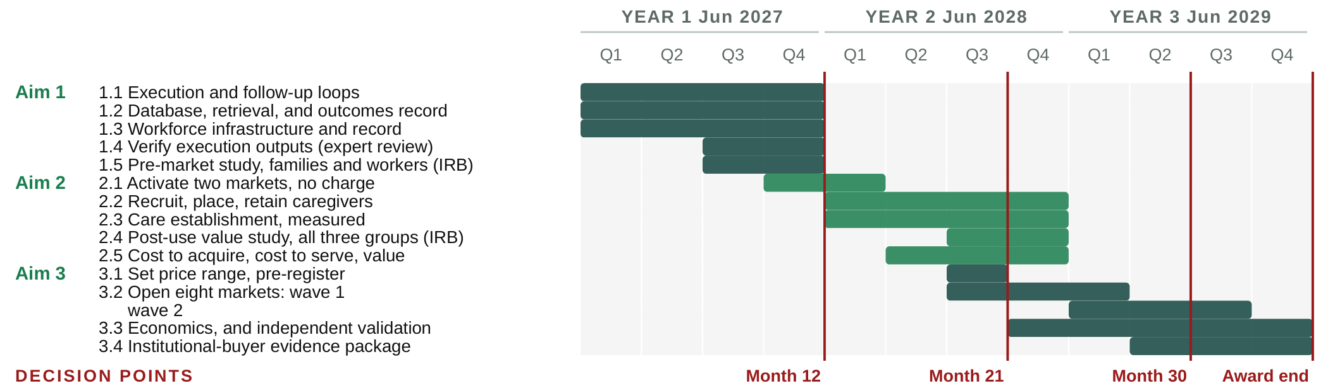
Figure 6. Three-year timetable, showing the sequencing among the aims, staged market entry, and the four decision points.
CRP PROGRESS REPORT
Development status of the technology. CareNavigator runs in production today, doing the screening and matching described in Significance. The multi-agent navigation layer, developed under Phase IIB using retrieval-augmented generation, parameter-efficient fine-tuning, and reinforcement learning from expert feedback, is in production integration during the remaining Phase IIB year. Execution and follow-up, which Aim 1 builds, do not exist in the product today and are not in scope for the existing award, so no budget line here re-funds Phase IIB work.
What prior funding established. The technology was developed across NIA SBIR Phase I/II Fast-Track and Phase IIB awards (1R44AG074116), scored at 20 and 25, and the Phase IIB review assessed the platform's commercial potential as extremely high. Table 7 records what each activity established and which funding produced it; two of the five were funded outside the Phase II scope, using I-Corps support and company capital.
Risk | Retired by | Evidence
Technical  Could the data be assembled? | NIA Phase I to IIB | An expert-curated national database of more than 72,000 aid programs and providers across all fifty states, and a multi-agent eldercare AI entering production.
User  Would families accept it? | NIA Phase I to IIB | Four peer-reviewed evaluations with family caregivers: usability 4.57 of 5; acceptance 5.83 of 7 after four weeks (n = 65); multi-agent version 5.73 of 7 (n = 31).
Demand  Would families come, and at what cost? | Beyond Phase II scope; company funds | Organic traffic grew from roughly 50 visits a day in 2023 to more than 500 today, from nearly every county, at near-zero cost.
Supply  Would providers participate? | I-Corps and company funds | More than 300 customer-discovery conversations with owners and operators through NIH and NSF I-Corps; more than 700 providers have since claimed a listing at no charge.
Workforce and willingness to pay  Could we recruit caregivers, and would anyone pay? | Beyond Phase II scope; company funds | A student caregiver pilot drew more than 900 applicants and placed more than 20 into provider jobs. Four providers trialed the staffing product and three paid, at roughly $50 to $275 per placement and $275 per month, across multiple semesters. Delivery was deliberately manual, to learn what the workflow had to do before building infrastructure for it.
The risk that remains  Can one local market pay for itself, and can we repeat it? | Not yet retired | Measurable only with real customers paying real prices, over long enough to observe churn. This is the uncertainty the three aims remove.
Table 7. Commercialization risks retired to date, the funding that retired each, and the risk that remains.
The Phase IIB evaluation now underway is the largest of them. Two hundred family caregivers of people living with dementia, from diverse backgrounds and at least half reporting a documented social need, are evaluating the integrated CareNavigator before and after use on technology acceptance, usability, self-efficacy, and caregiving appraisals. It reports before this award begins. Among providers with a claimed account, platform activity runs about fifteen times higher on the day a family lead arrives. The provider tools launched nationwide in July 2026 with no paywall, so there is no pricing history to read and Aim 3 sets the first one.
Who set these endpoints, and who executes them. Olera has been evaluated by Ziegler, the leading underwriter of financing for nonprofit senior living providers, and by Equitage Ventures, an early-stage fund dedicated to the aging economy, and the aims were additionally reviewed by David Qu [TITLE, AFFILIATION] as an independent reviewer. That diligence set the commercial endpoints in Tables 4 through 6, so the milestones here are the ones our prospective investors said they would need. Dr. Falohun was PI on both prior NIA awards and delivered against their milestones. Dr. Fan is Co-Investigator and holds every human subjects protocol, with Dr. Marcia Ory of the Center for Population Health and Aging at Texas A&M University supervising, as she has on Phase IIB. Market operations are led by [TEAM: who leads market operations] at [TEAM: staff per market at steady state], the staffing level the ten-market schedule in Figure 6 was built on. Nine years of investment answered everything that could be answered without customers; whether a local market pays for itself, and whether that repeats, has to be measured with real money changing hands. That is what the three aims do.

BIBLIOGRAPHY AND REFERENCES CITED
1. Genworth Cost of Care Survey, most recent edition. [CONFIRM EDITION AND YEAR]
2. National Council on Aging. Benefits access and unclaimed assistance for older adults. 2025.
3. Activated Insights (formerly Home Care Pulse). 2024 Home Care Benchmarking Report, reporting 2023 operating data.
4. Freedman VA, Spillman BC. Disability and care needs among older Americans. Milbank Q. 2014.
5. Systematic review of unmet activity-of-daily-living needs and downstream utilization, hospitalization, nursing home placement, and mortality. 2024.
6. Hass Z, et al. Unmet need for help with activities of daily living and subsequent emergency department admission. 2017.
7. DePalma G, et al. Hospital readmission among older adults who return home with unmet need for activities of daily living. Gerontologist. 2013.
8. U.S. Census Bureau. 2023 National Population Projections.
9. Redfoot D, Feinberg L, Houser A. The aging of the baby boom and the growing care gap. AARP Public Policy Institute. 2013.
10. PHI. Direct Care Workers in the United States: Key Facts. September 2025.
11. Mudrazija S, Aranda MP. Current and future replacement and opportunity costs of family caregiving for older Americans with and without dementia. Innov Aging. 2025;9(6):igaf049.
12. KFF analysis of CMS National Health Expenditure and Medicaid long-term services and supports data, 2022. Of $415 billion in national LTSS spending, Medicaid paid 61 percent.
13. Szanton SL, et al. Medicaid cost savings of a preventive home visit program for disabled older adults. J Am Geriatr Soc. 2018.
14. Szanton SL, et al. Effect of a biobehavioral environmental approach on disability among low-income older adults: a randomized clinical trial. 2021.
15. Centers for Medicare and Medicaid Services. National Health Expenditure Accounts, 2023.
16. National Center for Health Statistics. National Post-acute and Long-term Care Study, 2020.
17. Activated Insights. 2025 Home Care Benchmarking Report: median caregiver acquisition cost $520 through word of mouth; median professional caregiver turnover 75 percent.
18. Boushey H, Glynn SJ. There are significant business costs to replacing employees. Center for American Progress. 2012. Replacement cost for hourly workers estimated at 16 percent of annual pay.
19. Centers for Medicare and Medicaid Services. Guiding an Improved Dementia Experience (GUIDE) Model. Launched July 1, 2024.
20. U.S. Bureau of Labor Statistics. Occupational Outlook Handbook: social workers. Healthcare social workers projected to grow 6 percent, 2024 to 2034.
21. Published company materials for employer- and health-plan-sponsored caregiver navigation platforms, including Wellthy, Grayce, Cariloop, Homethrive, and ianacare. Accessed 2026.
22. Reporting on placement-fee incentives in senior living referral marketplaces. 2024.
23. Fan Q, et al. Olera platform development and caregiver needs assessment. 2023.
24. Fan Q, et al. Usability evaluation of the Olera caregiving platform: Mobile Application Rating Scale 4.57 of 5 (n = 30). JMIR. 2024.
25. DuBose L, et al. Digital caregiving assistance for older adults and their families. 2024.
26. Hoang MN, Kim L, Fisher L, DuBose L, Ory MG, Lee S, Falohun T, Fan Q. Exploring informal caregivers' perception of the Olera digital caregiving assistance platform for dementia care: mixed methods evaluation study. JMIR Form Res. 2026;10:e92967.
27. Yee A, Yaffe MJ, Schuster T, Lambert S, Abbasgholizadeh-Rahimi S. Family caregivers' acceptance of artificial intelligence-enabled technologies for providing care to older adults. BMC Geriatr. 2025;26:150.
28. National Center for Education Statistics. Undergraduate degree fields: health professions and related programs conferred 263,800 degrees, 2021-22.
29. Physician Assistant Education Association. By the Numbers: Student Report, 2024-25; documented direct patient-care hour requirements.

