2. VALUE OF THE CRP PROJECT, EXPECTED OUTCOMES, AND IMPACT
The product to be commercialized. CareNavigator is Olera's family-facing eldercare navigation platform. It combines a national, expert-curated resource database with AI-supported execution workflows and longitudinal outcomes tracking to help families move from recognized need to established care. Families use CareNavigator at no cost. The platform assesses needs, identifies appropriate care and financial aid, helps execute the administrative and follow-up work required to obtain them, confirms whether care was established, and records where the pathway succeeds or fails (Figure 4).
Caregiver Staffing is a complementary provider-facing product and capacity mechanism. When an otherwise appropriate care plan cannot be delivered because a provider lacks workers, Olera recruits new caregivers into the workforce and connects them with licensed providers, which retain responsibility for interviewing, hiring, training, credentialing, supervision, and care delivery. This architecture allows Olera to commercialize provider-facing staffing while preserving broad, free access to CareNavigator and building the evidence needed for future institutional contracting.
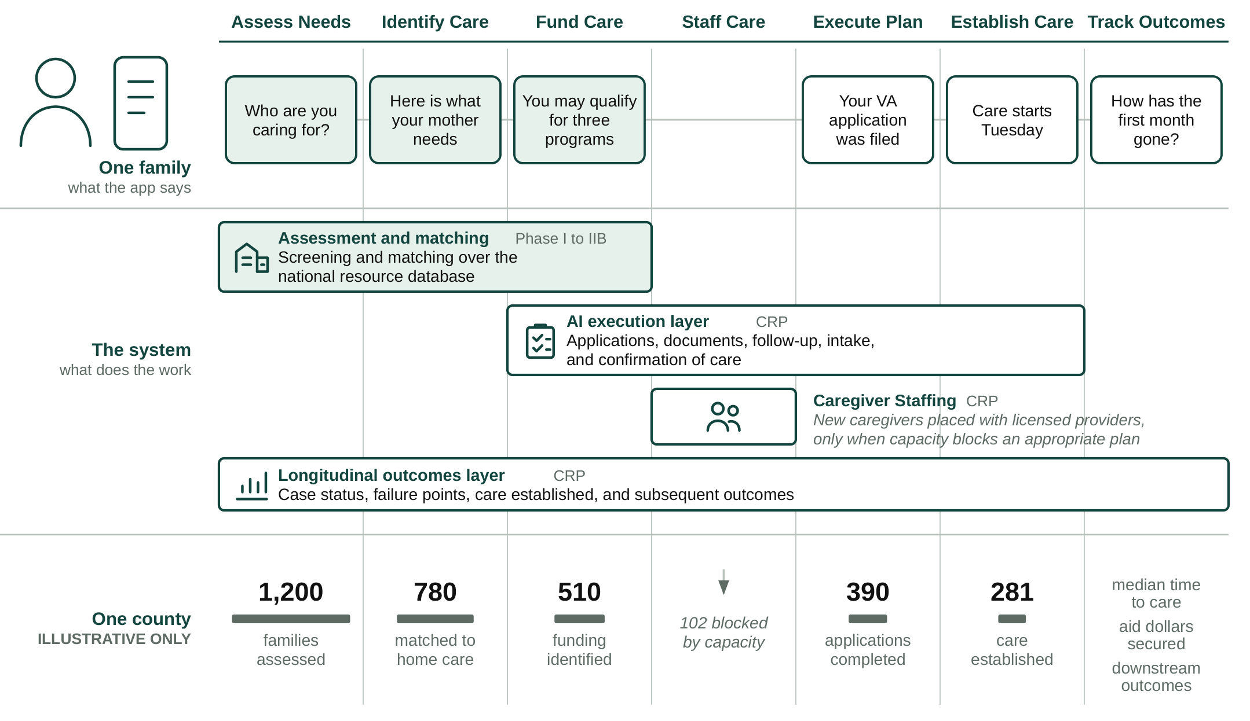
Figure 4. What a family sees, what the system does, and what accumulates across a county. Shaded elements exist today; the county register is illustrative only.
Foundation from prior SBIR R&D. Olera's NIA Phase I and Phase IIB awards (Impact Scores 20 and 25) established the foundation for this commercialization effort: a nationally deployed first-generation CareNavigator; an expert-curated database containing more than 72,000 eldercare provider and aid-program records; peer-reviewed evidence of usability and technology acceptance; and extensive customer discovery defining the needs of families and providers. More than 200 NIH/NSF I-Corps customer-discovery interviews also identified caregiver availability as a recurrent constraint. In an early staffing pilot, Olera received approximately 900 student applications, accepted 100 candidates, and placed 25 with local providers, with participating students and providers returning in a subsequent semester. These results support the CRP's next step: integrate, execute, measure, and commercialize the complete pathway.
Weaknesses in current approaches. Families do not lack individual resources; they lack a system accountable for carrying them across the full pathway to established care. Existing approaches are useful but fragmented. Table 1 organizes the gap around the same care-establishment pathway used throughout this application.
Pathway step | What exists today | Where families still fall off | Olera's CRP approach
Assess Needs | Screeners, clinicians, AAAs, care managers | Assessment may end as information or referral rather than an executable case | Persistent case begins with structured needs assessment
Identify Care | Directories, referral platforms, social workers, care managers | Fragmented inventories, limited networks, and handoffs leave families to reconcile options | Curated national resource infrastructure identifies appropriate services and providers
Fund Care | Benefits tools, agencies, program websites | Eligibility information does not ensure applications, documentation, follow-up, or approval | Aid identification is linked to execution and case tracking
Staff Care | Provider recruiting, job boards, staffing channels | Providers may have an appropriate opening but lack workers to serve the family | Caregiver Staffing creates an additional workforce channel when capacity blocks care
Execute Plan | Families, care managers, patient navigators, social workers | Administrative tasks cross organizations; risk of "lost to follow up" | AI-supported workflows execute applications, documents, follow-up, intake, and escalation
Establish Care | Provider intake and admission | Referral or eligibility is often treated as success even when service never starts | Closed-loop confirmation records whether appropriate care actually begins
Track Outcomes | Organization-specific records and claims | No longitudinal record connects need, pathway failure, care establishment, and subsequent outcomes | Case-level outcomes infrastructure records the pathway and supports institutional evidence generation
Table 1. Current approaches address portions of the care-establishment pathway; the CRP integrates them into a closed-loop system oriented to confirmed care.
Commercial applications and innovation. The commercial opportunity is not another directory, referral marketplace, or staffing channel in isolation. It is an integrated infrastructure that carries a family across the care-establishment pathway and creates evidence about what happened at every step. The Research Strategy describes the underlying technical innovations in detail; commercially, three features matter most. First, CareNavigator links assessment, resource identification, funding, execution, staffing when needed, and confirmation of care rather than optimizing a single handoff. Second, AI-supported execution moves the product from recommending what a family should do toward completing and tracking the work required to establish care. Third, every executed case can produce a structured longitudinal record of the family's needs, resources pursued, administrative barriers, local capacity, care establishment, and subsequent outcomes.
At scale, this longitudinal record could become a distinctive commercial and scientific asset: a county-level empirical map of where eldercare pathways succeed, where they fail, and what resolves those failures. The resulting analytics could inform payers and accountable care organizations seeking to reduce avoidable utilization; health systems seeking reliable transitions from referral to care; providers planning service and workforce capacity; public agencies allocating aging resources; researchers studying access and implementation; and communities identifying local gaps. The CRP tests and builds the infrastructure required to create this asset; it does not assume its value in advance (Figure 4, lower register).
Expected outcomes. Successful completion of the CRP will leave Olera with: (1) a verified CareNavigator capable of executing and tracking the pathway from care plan to established care; (2) real-world evidence on care establishment, failure points, operating cost, and longitudinal outcomes; (3) a repeatable Caregiver Staffing model that can both generate provider revenue and relieve workforce constraints to enable care establishment; (4) geographically resolved longitudinal data describing how families move through the eldercare system; and (5) an institutional-buyer evidence package and operating model positioned for subsequent contracting and private investment.
Commercial and non-commercial impact. Olera's commercial and public-health objectives reinforce one another: growth means more families can receive support before unmet needs progress to higher-cost crises, while each completed case improves the evidence available to make the system more effective. The CRP therefore has societal, educational, scientific, and public-health value beyond company revenue.
Impact potential | Measured by | National priority served
Societal. Families establish appropriate care; available aid is converted into support; caregiving capacity is added where supply is short | Aid dollars secured; care established; time to care; staffed caregiver hours added | 2022 National Strategy to Support Family Caregivers
Educational. Future health professionals gain supervised, real-world geriatric care experience while contributing to the direct-care workforce | Students recruited and placed; documented patient-care hours; retention | National direct-care workforce need
Scientific and public health. New visibility into where the care-establishment pathway fails, what resolves failure, and how patterns differ across communities | Case-level pathway records; failure points; county-level capacity and outcomes; longitudinal follow-up | Healthy aging, integrated care, long-term care access, and implementation research
Table 2. Commercial growth produces measurable societal, educational, scientific, and public-health value.
Integration with Olera's business plan. These CRP outputs integrate directly with Olera's commercialization strategy. Caregiver Staffing provides a nearer-term provider-revenue pathway while serving as a capacity mechanism to enable care establishment where staff is short. CareNavigator's execution and outcomes infrastructure builds the evidence required for larger institutional contracts with organizations that benefit when members establish appropriate care earlier. Together, these pathways are designed to sustain a free-to-families CareNavigator while creating the commercial proof needed for subsequent private investment. Olera's history, capabilities, financing, management, and post-CRP growth strategy are described in the Company section that follows.

