3. COMPANY
Origins and objectives. Olera, Inc. grew from a multidisciplinary effort at Texas A&M University to solve a problem families repeatedly described: eldercare was difficult to navigate, difficult to afford, and difficult to convert from information into actual support. In 2019, PI Tokunbo (TJ) Falohun helped launch the Texas A&M chapter of Sling Health, bringing engineering, medicine, and business trainees together around healthcare problems. There he began working with Logan DuBose, MD, MBA, now Olera's Chief Research Officer and co-investigator. Their initial work focused on dementia caregiving; continued discovery revealed a broader need across eldercare and led to Olera's formation in 2020.
Olera's corporate objective is to make establishing eldercare navigable and broadly accessible for American families while building the commercial infrastructure that can sustain that access. The commercialization strategy has evolved as evidence accumulated; the mission has not. Core CareNavigator access remains free to families, recommendations remain neutral, and commercialization is concentrated where Olera creates incremental value for providers and institutional buyers.
Olera, Inc. | At a glance
Founded and structure | 2020 · independent U.S. small business concern · C-corporation · founder-led Board
Commercial stage | Pre-scale commercial company · nationally deployed CareNavigator · early Caregiver Staffing validation · no current product generates significant annual sales
Leadership | TJ Falohun, PhD, CEO and PI · Logan DuBose, MD, MBA, Chief Research Officer and co-investigator
Technical and product | Founder-led product and engineering · additional software engineering capacity, including a full-time engineer with Olera about 2 years
Operations and growth | Two full-time family and provider call-center personnel (more than 3 years) · part-time marketing support (about 1.5 years)
Research | Two part-time research assistants (about 5 years and about 1.5 years) · longstanding Clemson University evaluation collaboration
Federal R&D | Approximately $5.7M NIA SBIR, 2021–2027 · Phase I/II Fast-Track and Phase IIB (1R44AG074116)
Commercialization development | NSF I-Corps customer discovery (200+ interviews) · Blackstone Techstars · Texas A&M startup support
Senior advisors | Marcia Ory, PhD (more than 6 years advising Olera) · David Qu, MBA · Qiping Fan, MD, MS, Clemson University
Finance and professional infrastructure | Founder-led finance and federal administration supported by ADC accounting/CPA and specialized legal and compliance counsel
Regulatory and compliance | HIPAA-aligned data practices · federal research, IRB, and data stewardship experience · referral-compliance review informing the revenue architecture
Table 3. Olera at a glance: present size, operating continuity, funding history, commercialization development, and professional infrastructure.
Core competencies and operating continuity. Olera's capabilities now extend beyond the founders and reflect several years of accumulated operating experience. The company combines software and applied AI engineering, an expert-curated eldercare data infrastructure, human-centered aging research, digital distribution, family and provider operations, and commercialization research. Its national platform and resource infrastructure were built through successive SBIR awards; five peer-reviewed studies established usability and technology acceptance; more than 200 NIH/NSF I-Corps interviews informed product and customer discovery; and direct family and provider operations continue to expose the team to the practical barriers between a recommendation and established care.
Key research, operations, engineering, marketing, and scientific-advisory relationships extend from approximately 1.5 years to more than six years. That continuity preserves institutional knowledge while allowing a small team to operate across research, product development, commercialization, and national family and provider support.
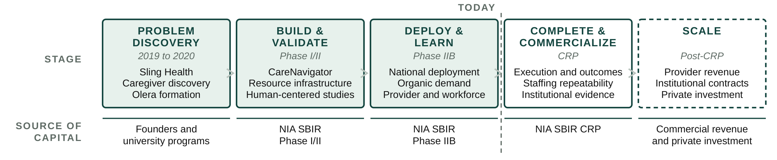
Figure 5. Olera's progression from problem discovery through federal R&D to commercial scale. Each stage produces what is required to reach the next source of capital.
This progression is the company's commercialization history as well as its financing logic. Early discovery defined the problem; Phase I/II built and evaluated the first-generation platform and national resource infrastructure; Phase IIB supported national deployment and deeper provider and workforce learning; and the CRP is designed to complete execution and outcomes capabilities, establish repeatable Caregiver Staffing economics, and build the evidence required for institutional commercialization. Successful CRP completion therefore changes the appropriate source of capital: subsequent scale is intended to be financed by commercial revenue and private investment rather than continued dependence on federal R&D support.
Vision, sustainability, and management evolution. Olera scales management capacity using the same evidence-driven discipline it applies to product development: build, measure, learn, and expand what works. Today, the founders retain overlapping responsibility for strategy, product, engineering, research, finance, and administration, supported by established engineering, operations, marketing, and research personnel. DuBose leads research and internal finance and federal administration with professional accounting support from ADC; Falohun leads company, product, and technical strategy. This structure has allowed Olera to remain capital-efficient while building and operating a national platform.
The lean internal team is complemented by senior expertise accumulated over years rather than assembled for a single application. Marcia Ory, PhD, has advised Olera for more than six years and brings decades of aging, caregiving, implementation, dissemination, and sustainability expertise, including 20 years at NIA. Qiping Fan, MD, MS, and Clemson University provide longstanding capabilities in epidemiology, mixed-methods evaluation, health-services research, and independent study execution. David Qu, MBA, brings approximately 30 years of healthcare-technology commercialization and executive experience, including scaling and exiting digital-health companies, together with relationships across healthcare and senior-care investment networks. ADC and specialized legal and compliance counsel provide professional infrastructure in functions that do not yet require full-time executive leadership.
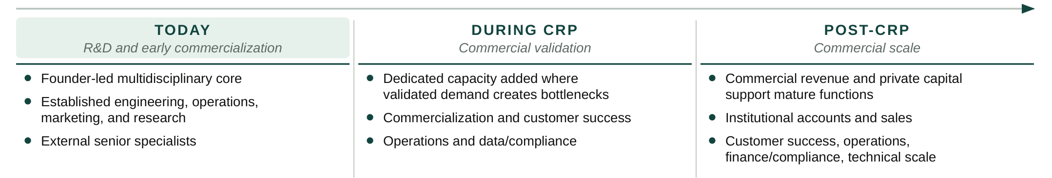
Figure 6. Management capacity scales against validated commercial need rather than ahead of it.
As CRP milestones demonstrate repeatable provider sales, operating demand, and institutional engagement, Olera will internalize dedicated commercial, customer-success, operations, data and compliance, and finance capabilities when their workload and strategic importance justify full-time leadership. Post-CRP, commercial revenue and private capital are expected to support the mature organization required for national scale. The objective is not simply a larger R&D organization, but a commercially financed eldercare technology company capable of sustaining a free-to-families CareNavigator while scaling provider and institutional revenue.
The markets and customers that can support that transition, the advantages Olera brings to them, the competitive landscape, and the strategy for gaining market acceptance are described next.

