4. MARKET, CUSTOMER, AND COMPETITION
Market segments and potential customers. Olera commercializes through two buyer classes created by the same care-establishment pathway. The near-term beachhead is care-delivery providers that lose revenue when caregiver vacancies prevent them from accepting or staffing new cases. The emerging institutional market is healthcare organizations that bear financial risk when unmet needs contribute to avoidable utilization, failed care transitions, or earlier institutional care. Families remain users rather than customers: CareNavigator stays free to them.
Caregiver Staffing addresses an unusually persistent provider problem. The United States employed approximately 4.68 million home health and personal care aides in 2025, and the Bureau of Labor Statistics projects 18% employment growth through 2035 alongside roughly 760,500 openings each year from 2025 to 2035; home-care benchmarking separately reported 75% median professional-caregiver turnover in 2024.^{26,27} The problem directly constrains growth: 63.3% of surveyed home-care providers reported turning down cases because of staffing shortages in 2023.²⁸ Non-medical home care is therefore Olera's initial provider beachhead, with expansion potential across home health, assisted living, hospice, skilled nursing, and other organizations that employ direct-care workers.
The institutional market is larger but evidence-gated. Prospective customers include Medicare Advantage plans, accountable care organizations (ACOs), health systems, Medicaid managed-care and managed long-term-services-and-supports organizations, and other entities exposed to the downstream cost of unmet need. In 2026, 35.2 million people are enrolled in Medicare Advantage and 14.3 million Medicare beneficiaries receive care coordinated through accountable-care arrangements.^{29,30} CMS's active GUIDE Model further validates the purchasing logic: Medicare is already testing and paying for dementia care navigation, community-resource connection, and caregiver support with explicit goals of reducing hospitalization, delaying nursing-home placement, and reducing Medicare and Medicaid expenditures.³¹ Olera does not assume these populations are immediately serviceable revenue; rather, they establish the scale of risk-bearing organizations for which CRP-generated care-establishment and longitudinal outcomes evidence could create a contracting pathway.
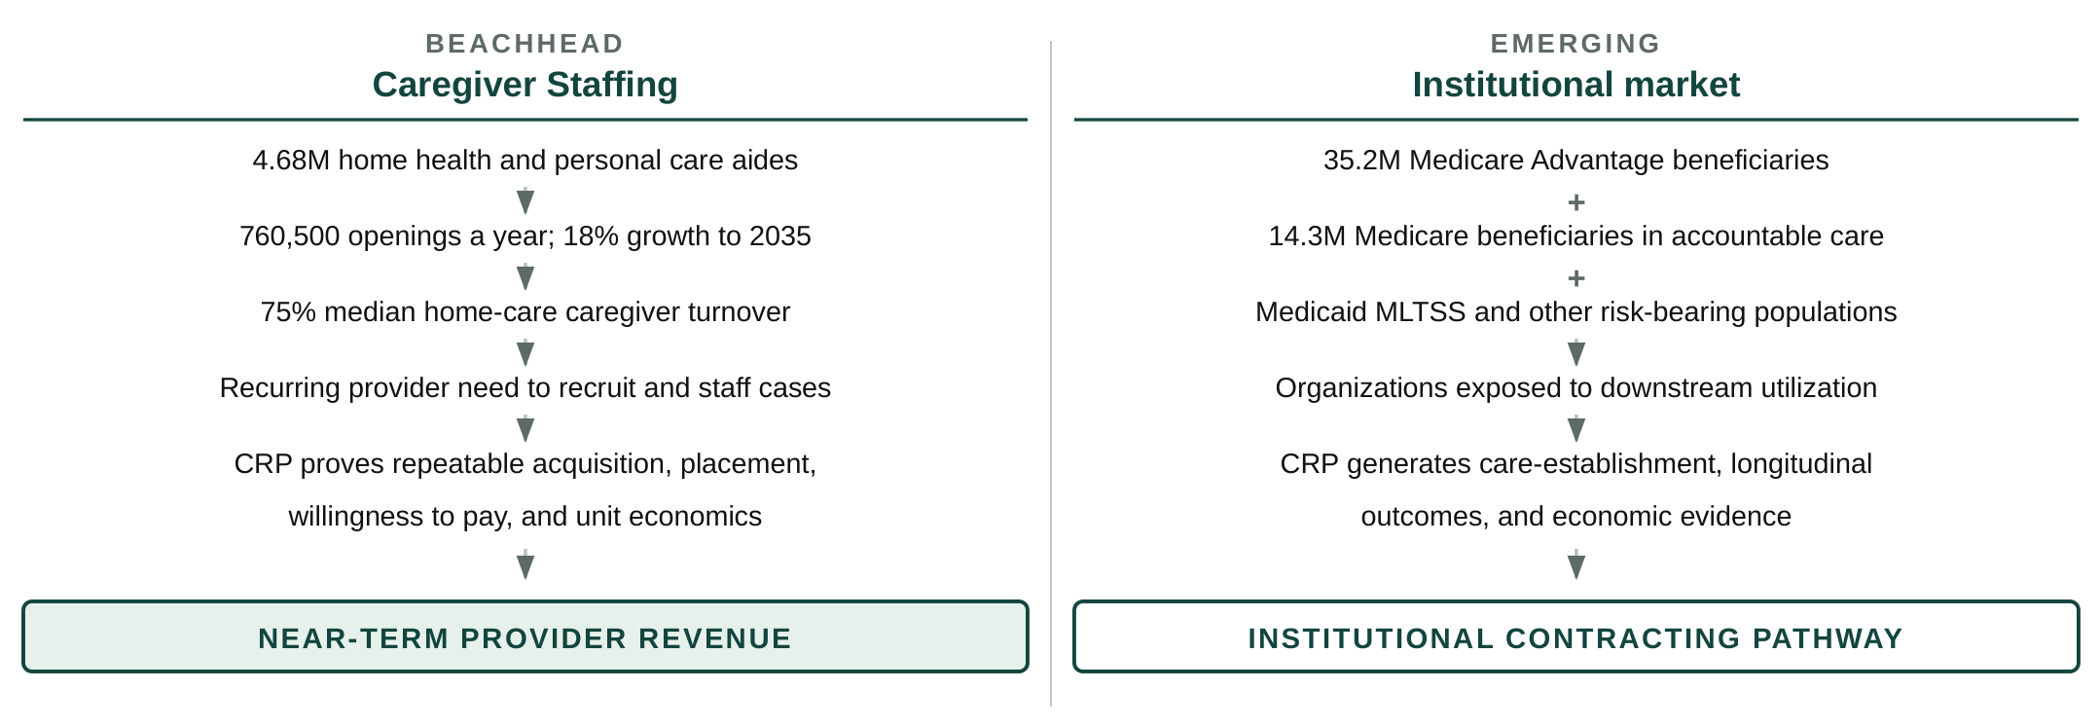
Figure 7. Olera's provider beachhead addresses a recurring staffing expenditure today; the larger CareNavigator opportunity opens as CRP evidence establishes value for organizations bearing downstream healthcare risk.
Market opportunity and path to meaningful scale. The two markets should not be reduced to a single speculative TAM. Caregiver Staffing enters an existing, recurring recruitment market in which providers already spend to fill vacancies; the CRP determines Olera's repeatable pricing, conversion, retention, and unit economics. CareNavigator enters a larger institutional market only as evidence matures; the CRP determines whether established care and longitudinal outcomes create sufficient economic value for institutional contracting. Because both markets contain large numbers of providers or covered lives, Olera does not require dominant market share for commercial sustainability. Section 10 models post-CRP economics using observed CRP conversion, pricing, and operating data rather than assuming a final price in advance.
Significant advantages and competitive position. Sections 1 and 2 established why existing navigation approaches fail to carry families reliably through the full care-establishment pathway. The remaining relevant competitive question is not whether alternatives exist, but why Olera can create differentiated value as those alternatives evolve. Four advantages matter.
1. End-to-end executionCareNavigator integrates assessment, care identification, funding, AI-agent execution, staffing when needed, and longitudinal outcomes rather than optimizing a single step. | 2. New workforce supplyCaregiver Staffing is designed to create an easier pathway into direct care, not merely redistribute workers already circulating among providers.
3. Distribution and local dataOrganic family demand, a national provider and benefits infrastructure, and county-level care-establishment and outcomes data compound as the platform is used. | 4. AI interoperabilityOlera can expose domain data and execution capabilities to search and general-purpose AI interfaces, allowing them to become entry points to CareNavigator rather than substitutes for its execution layer.
Caregiver Staffing's initial workforce wedge is deliberately narrow. Olera initially targets health-profession applicants and students for whom paid caregiving can also provide meaningful patient-care experience. The opportunity is nationally distributed and continuously replenished: in the most recent cycles, U.S. MD programs reported 54,699 applicants and NursingCAS reported 75,078 applicants across 282 participating nursing schools.^{32,33} These figures do not represent the full addressable workforce; they demonstrate the scale of only two readily measured pipelines before PA, PT, OT, pharmacy, allied-health, other nursing pathways, and students preparing to apply are considered. Olera's pilot experience also indicates interest from undergraduates outside pre-health pathways. Over time, the same university infrastructure can reach other students seeking flexible, meaningful paid work through career centers and related campus channels, and the workforce-entry system is designed to extend to career changers and other new entrants to the field.
This wedge is differentiated from conventional job boards. Traditional recruiting channels primarily compete for workers already searching for caregiver jobs. Recent recruitment benchmarking found Indeed generated 68% of applications to participating home-care agencies in Q1 2026, illustrating how concentrated conventional caregiver acquisition remains.³⁴ Olera instead builds relationships with universities and applicant communities to introduce caregiving as a paid entry pathway into healthcare, while the licensed provider remains the employer responsible for interviewing, hiring, training, credentialing, supervision, and employment standards. The wedge is attractive because the work can provide patient-care experience and income, can fit evenings, weekends, summers, and gap years, and is geographically replicable through colleges and universities nationwide.
Current and emerging competition. For Caregiver Staffing, Olera competes across categories rather than against a single end-to-end incumbent. Provider staffing alternatives include large job boards like Indeed, staffing agencies, caregiver-specific recruiting platforms, and emerging student-caregiver models such as CareYaya. For CareNavigator, alternatives include government and nonprofit resource directories, patient navigators, social workers and care managers, eldercare referral platforms like A Place for Mom or Caring.com, and increasingly general-purpose AI and search where families ask eldercare-related questions. Incumbents may add AI, execution, or staffing capabilities over the next several years, and general-purpose AI systems will become more capable at answering eldercare questions. Olera's response is to compete where domain-specific infrastructure matters most: verified local provider and benefits data, execution of real administrative workflows, workforce-capacity creation, confirmation of care establishment, and longitudinal outcome records. Where general-purpose AI or search becomes the family's preferred interface, Olera's strategy is interoperability that allows those interfaces to call CareNavigator's data and execution capabilities rather than requiring Olera to own every point of discovery.
Market and customer acceptance hurdles. The CRP is structured to measure the remaining commercial uncertainties rather than assume adoption.
Commercial hurdle | How the CRP retires it
Will providers pay? | Measure willingness to pay, conversion, retention, and unit economics for Caregiver Staffing across markets.
Can new workforce supply replicate? | Measure applicant acquisition, provider hiring, placement, retention, and market-to-market reproducibility.
Will institutions value the evidence? | Generate longitudinal care-establishment and outcomes data, economic analyses, and contracting-ready evidence for prospective institutional buyers.
Can AI execution be trusted? | Independently verify workflows, characterize error behavior, ground actions in curated data, and maintain auditable longitudinal records.
Can the model scale geographically? | Deploy across multiple counties and measure where performance, cost, workforce capacity, and care-establishment rates vary.
Table 4. Principal market-acceptance uncertainties and the CRP activity designed to retire each.
Strategic alliances, partnerships, and route to market. Olera enters the CRP with relationships on both sides of its beachhead: university relationships that support workforce recruitment and working relationships with local and franchise-affiliated eldercare providers that can serve as early customers and implementation sites. Its existing national provider database and organic family traffic provide additional distribution infrastructure, while academic and commercialization advisors connect the company to senior-care operators, payers, investors, and strategic partners. These relationships reduce the distance between local validation and larger regional or enterprise opportunities. No FDA approval is required for the products proposed here, and Olera does not depend on a licensing agreement to commercialize them.
Marketing and sales strategy. Provider sales begin where Olera can demonstrate an immediate staffing constraint and measurable hiring value; institutional development begins with organizations whose populations and economics align with the outcomes the CRP is designed to measure. The CRP converts successful local deployments into evidence, case studies, and repeatable commercial playbooks that can support larger provider and institutional relationships. The detailed acquisition channels, sales process, production infrastructure, and post-CRP scaling plan are presented in the Production and Marketing Plan (Section 9).
Taken together, Olera is entering two commercially substantial markets from a differentiated position: a provider market with an immediate, recurring staffing problem that, if solved, addresses a key step in the care-establishment pathway; and an institutional market in which payment becomes possible as CareNavigator proves that earlier care establishment creates outcomes and economic value. The remaining risks are measurable, the CRP is designed to address them, and Olera already has distribution and partnership footholds from which to scale.

