5. INTELLECTUAL PROPERTY PROTECTION
Protection strategy. Olera will protect each component of its commercial advantage with the form of intellectual-property protection best suited to that asset, while continuing to build cumulative data, distribution, workflow, and relationship advantages that create practical barriers to replication. The principal proprietary assets generated and extended through the CRP include CareNavigator's non-public workflow orchestration and execution logic; the structure, normalization, quality-control methods, and derived variables that organize Olera's provider and financial-aid data; the longitudinal care-establishment and outcomes architecture and resulting proprietary datasets; and the methods that connect local workforce capacity to care execution. Olera will maintain appropriate non-public methods, configurations, derived data, and operating processes as trade secrets through role-based technical access, confidentiality obligations, and employee, contractor, and partner agreements governing confidentiality, intellectual-property ownership, and permitted data use. Original source code, interfaces, documentation, and content are protected by copyright, while Olera and product branding will be protected through trademark rights and registration where commercially appropriate. For CRP-generated inventions with sufficient novelty and commercial value, Olera will evaluate patent protection with IP counsel before public disclosure; where disclosure would weaken the asset's defensive value, trade-secret protection may provide the stronger strategy.
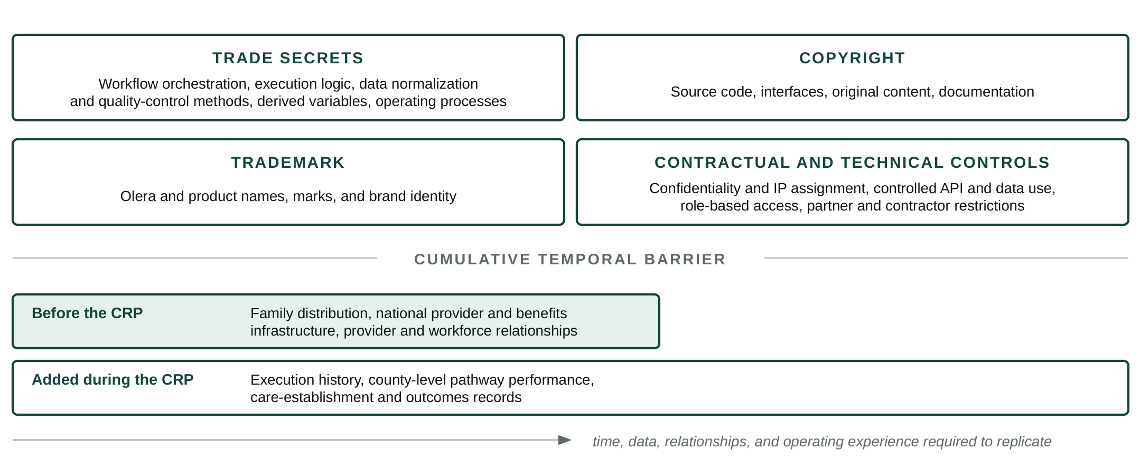
Figure 8. Formal protections secure specific Olera assets, while cumulative distribution, data, relationships, and operating evidence create a growing temporal barrier to replication.
Temporal barriers to replication. Individual interface features can be reproduced; the integrated commercial asset is substantially harder to recreate. A new entrant would need to rebuild Olera's family distribution, national provider and benefits infrastructure, execution workflows, provider and workforce relationships, and the longitudinal evidence showing where care is established, where it fails, and what follows. These barriers compound during the CRP: every deployment both advances commercialization and adds execution history, local-market intelligence, care-establishment records, and longitudinal outcomes that a new entrant cannot obtain retrospectively. Olera will selectively expose capabilities through controlled interfaces where interoperability expands distribution while retaining the proprietary data, workflow logic, and outcome infrastructure behind those interfaces. The result is a layered protection strategy in which formal IP rights protect discrete assets and accumulated data, distribution, relationships, and operating experience increase the time and capital required to reproduce the system.
Working legal basis for drafting. USPTO guidance distinguishes patents, trademarks, copyrights, and trade secrets; identifies software code as copyrightable subject matter; and notes that trade-secret protection depends on reasonable measures to preserve secrecy, including access controls and confidentiality agreements. Patent eligibility and filing strategy for any CRP-generated invention should be evaluated with qualified IP counsel before public disclosure.

