9. REVENUE STREAM - How does CRP validation become scalable revenue?
Two revenue engines, sequenced by evidence.
Olera's revenue model has two independent but reinforcing engines. CareNavigator remains free to families and basic family-provider connections remain free to providers. The near-term engine is Caregiver Staffing: providers pay when Olera helps them successfully hire workers, whether the staffing need arises from turnover, existing clients, externally generated referrals, growth, or a capacity constraint identified through CareNavigator. The emerging engine is institutional CareNavigator contracting with organizations responsible for populations of older adults, including Medicare Advantage plans, accountable care organizations, Medicaid organizations, and health systems. Staffing monetizes successful workforce recruitment; institutional contracts monetize the navigation, execution, and outcomes infrastructure as CRP evidence establishes its value.
Caregiver Staffing: revenue follows successful hires.
The Staffing model is intentionally simple: successful hires × realized revenue per successful hire × active county markets. CRP Year 1 is an engineering year and generates no Staffing revenue. In Year 2, Olera deploys Staffing free to providers so the project can establish applicant acquisition, provider hiring, placement, retention, and market-to-market reproducibility before price is introduced. Paid testing begins in Year 3. The working base-case price is $250 per successful hire, with $150 and $350 as sensitivity bounds. This is an Aim 3 pricing hypothesis, not an asserted market price. It is economically plausible relative to the burden providers already bear: home-care benchmarking reports approximately 75% professional-caregiver turnover, while industry estimates place recruiting and training cost at up to approximately $2,700 per replacement.¹-³
Revenue equations and assumptions.
Model input | Base projection | Range / benchmark | Basis
Staffing equation | counties × hires/mo × paid months × $/hire | — | Derived arithmetic
Successful hires/county/month | 10 | Expected mature range 10-30 | Conservative Olera/CRP hypothesis
Price/successful hire | $250 | $150-$350 sensitivity | Aim 3 pricing hypothesis
Home-care turnover | — | ~75% | Published benchmark¹,³
Recruiting/training burden | — | up to ~$2,700/replacement | Published benchmark²
Institutional equation | active contracts × annual contract value | — | Derived arithmetic
First institutional revenue | Post-CRP Y4 | — | Planning assumption
Institutional relationships | ~3 by Y5 | — | Planning assumption
Annual value/relationship | ~$250K | Negotiated after evidence | Planning hypothesis, not benchmark
Institutional payment precedent | — | CMS GUIDE; Medicare ACO market | Published buyer/economic precedent⁴-⁶
Table 9. The projection separates published benchmarks from Olera planning assumptions and CRP hypotheses.
For the financial projection, Olera holds every paid market at only 10 successful hires per month. At $250 per hire, that equals $30,000 annualized Staffing revenue per county. Olera expects mature markets may support approximately 10-30 successful hires per month, but the model does not require that maturation. Across eight CRP markets, the conservative case produces a $240,000 annualized Staffing run rate; the same markets would produce $480,000 at 20 hires per month and $720,000 at 30. Within-market maturation is therefore upside that the CRP measures rather than revenue the forecast presumes.
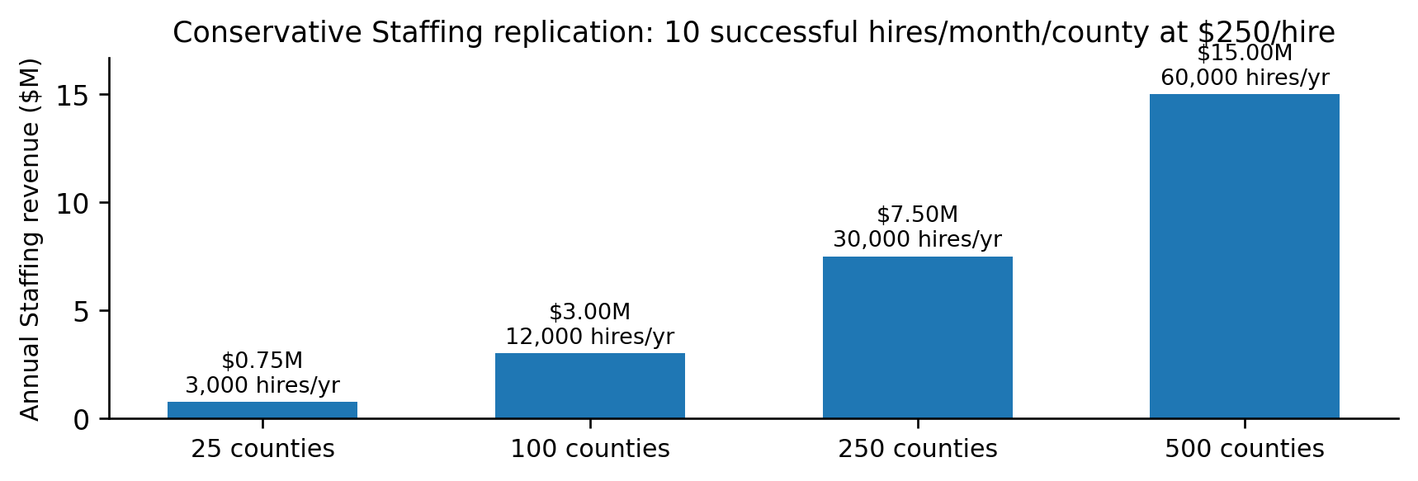
Figure 10. Replication economics at the deliberately conservative 10-hire/month projection. Mature-market throughput above 10 hires/month and all institutional CareNavigator revenue are excluded.
The five-year model is an early commercialization case, not the scale ceiling. At the same conservative assumptions, 100 active counties produce approximately 12,000 successful hires and $3.0 million in annual Staffing revenue; 250 counties, 30,000 hires and $7.5 million; and 500 counties, 60,000 hires and $15 million. At 500 counties, 60,000 successful provider hires are equivalent in scale to approximately 8% of the roughly 766,000 annual U.S. home health and personal care aide openings projected by BLS.⁷ Successful hires are not assumed to equal unique new workforce entrants: the CRP will separately measure unique workers recruited, prior workforce status, repeat placements, retention, and resulting provider capacity. Health-profession applicants are the initial recruitment wedge; the workforce-entry infrastructure is designed to expand to broader labor populations as the model scales.
Institutional CareNavigator: contracts follow outcomes evidence.
The institutional engine is modeled separately and more conservatively. Olera assumes no institutional revenue during the CRP. Years 1-3 instead test the intermediate outcome on which the institutional value proposition depends: whether recognized needs progress through navigation, funding, execution, and ultimately established care; why pathways fail when they do not; and what happens longitudinally after care is or is not established. This matters economically because unmet home- and community-based service needs have been associated with substantially greater acute-care utilization: an AHRQ evidence map summarizes a 13-state Medicaid HCBS study in which participants reporting unmet needs had greater ED use (52% vs. 34%) and hospital/rehabilitation stays (36% vs. 24%).⁸ The CRP does not assume that CareNavigator prevents these downstream events; it generates the care-establishment and longitudinal evidence needed to determine whether that value proposition is real.
Recognized unmet need → CareNavigator execution → care established → longitudinal outcomes/economic evidence → institutional contract.
There is already precedent for organizations responsible for health outcomes to pay for care-management and coordination infrastructure: CMS's GUIDE Model uses per-patient-per-month dementia care-management payments for coordination and caregiver support, and in 2026 the Medicare Shared Savings Program includes 511 ACOs serving 12.6 million Traditional Medicare beneficiaries.⁴-⁶ These sources establish the buyer class and purchasing logic; they do not establish Olera's future price. Accordingly, the five-year model treats institutional revenue as evidence-gated contracts rather than multiplying an unvalidated PMPM across a hypothetical health plan. The base case assumes the first paid relationship in post-CRP Year 4 and approximately three active relationships in Year 5. A working $250,000 annual value per mature relationship is used only as a planning hypothesis and will be replaced by negotiated pricing.
Five-year conservative revenue model.
 | CRP Y1 | CRP Y2 | CRP Y3 | Post-CRP Y4 | Post-CRP Y5
Commercial stage | Build | Validate free | Monetize | Expand | Scale
Staffing markets | 0 | ~8 free | ~8 paid | ~15 | ~25
Staffing revenue | $0 | $0 | ~$120K* | ~$450K | ~$750K
Institutional relationships | 0 | 0 | 0 | ~1 | ~3
Institutional revenue | $0 | $0 | $0 | ~$150K | ~$750K
Total commercial revenue | $0 | $0 | ~$120K | ~$600K | ~$1.50M
Table 10. Illustrative base case. *Y3 assumes approximately six paid-month equivalents across the eight CRP markets; the resulting exit Staffing run rate is approximately $240K/year at the same conservative throughput.
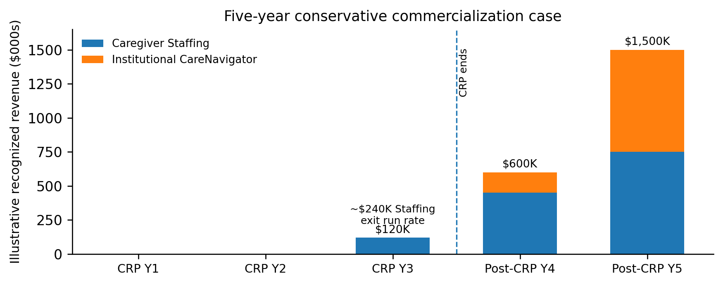
Figure 11. Revenue is intentionally back-loaded: Year 1 builds the system, Year 2 validates Staffing free, Year 3 introduces real billing, and post-CRP expansion adds both Staffing markets and institutional contracts.
How the projection should be read.
These projections are not top-down estimates of market share. They are bottom-up scenarios derived from the number of successful caregiver hires Olera can produce in each county and the number of evidence-gated institutional contracts the company can secure. The base case deliberately holds Staffing throughput at 10 hires per month per county even as markets mature, so it excludes the expected 10-30-hire mature range. Institutional revenue begins only after CRP evidence exists. The principal assumptions—Staffing throughput, price, repeat purchasing, contribution margin, and institutional contracting value—are therefore the same variables the CRP and subsequent buyer negotiations are designed to replace with measured commercial data.
Commercial hiring, workforce expansion, and family care establishment are tracked as related but distinct outcomes. Staffing revenue is earned on successful provider hires; workforce impact is measured through unique entrants, retention, and provider capacity; and CareNavigator-linked family impact is measured by whether cases encountering a documented workforce barrier subsequently establish care. Downstream utilization remains a longitudinal hypothesis until supported by evidence.
Staffing and capital as revenue grows.
During the CRP, engineering, research, and market-validation personnel remain central. As paid Staffing expands, Olera adds centralized market operations, worker acquisition, provider success, and sales capacity rather than recreating a full team in every county. As institutional contracts emerge, business development, implementation, analytics, and account-management capacity grow in parallel. Engineering grows more slowly because the platform, portals, and workflows are designed for self-service and automation. Under the illustrative base case, commercial revenue reaches approximately $120,000 in CRP Year 3, $600,000 in post-CRP Year 4, and $1.5 million in Year 5. This revenue meaningfully reduces—but is not assumed immediately to eliminate—the post-CRP financing requirement. The Finance Plan therefore sizes post-CRP capital against the remaining operating gap and the additional capital required to replicate validated Staffing markets and develop institutional contracts, rather than assuming that revenue from the limited CRP markets immediately replaces federal support.
References supporting quantitative benchmarks
1. Home Care Association of America. Activated Insights Benchmarking Report Now Available - Member Discount Included. 2025. Reports median professional-caregiver turnover of approximately 75% in 2024.
2. Activated Insights. Caregiver Retention Software for Home-Based Care. Reports recruiting/training costs of up to approximately $2,700 per replacement caregiver.
3. Activated Insights. 2025 Benchmarking Report for Home-Based Care. Home-care workforce recruitment and retention benchmarking.
4. Centers for Medicare & Medicaid Services. GUIDE Model Frequently Asked Questions. Describes per-patient-per-month dementia care-management payments for coordination and caregiver education/support.
5. Centers for Medicare & Medicaid Services. GUIDE (Guiding an Improved Dementia Experience) Model. Describes care coordination, caregiver support, and alternative payment methodology.
6. Centers for Medicare & Medicaid Services. 2026 Medicare Accountable Care Organization Initiatives Participation Highlights. Reports 511 Medicare Shared Savings Program ACOs serving 12.6 million Traditional Medicare beneficiaries in 2026.
7. U.S. Bureau of Labor Statistics. Home Health and Personal Care Aides, Occupational Outlook Handbook / 2024-2034 employment projections. Approximately 765,800 projected openings annually.
8. Agency for Healthcare Research and Quality. Evidence Map on Home- and Community-Based Services and Person-Centered Care for Older Adults. Technical Brief No. 49. Summarizes a 13-state Medicaid HCBS study reporting ED use of 52% vs. 34% and hospital/rehabilitation stays of 36% vs. 24% among participants with versus without unmet HCBS needs.
Modeling note. Olera-specific throughput, pricing, market counts, timing, and institutional contract values are planning assumptions or CRP hypotheses and are not represented as published benchmarks. Successful hires are commercial events; unique workforce entrants, net capacity added, and care establishment are measured separately.

