OpenOCD install
Contents
- 1 Overview
- 2 Documentation
- 3 Windows
  - 3.1 Rename
  - 3.2 Drivers
- 4 OS X
- 5 GNU/Linux
  - 5.1 UDEV
- 6 Testing
- 7 Next

Overview
OpenOCD is an open source project hosted on SourceForge, and usually is distributed as source code, but there are good chances that up-to-date binaries are already available for your platform.
Warning: OpenOCD is a very complex project, capable of working with many JTAG probes, but support for them must be explicitly included at build time, so be sure that support for your JTAG probe was included in the binaries you plan to use.

Documentation
The OpenOCD documentation is available in the Files section of the SourceForge project. For version 0.7.0, the manual is openocd.pdf.

Windows
As recommended in the OpenOCD web page, for Windows, pre-compiled packages can be downloaded from Freddie Chopin site, the OpenOCD section.
The latest version is openocd-0.8.0.7z. For hard to understand reasons (saving half a megabyte?), the format used for the archive is .7z; use the un-archiver of your choice to extract the content.
Create a folder where to store all OpenOCD versions, for example:
C:\Program Files\OpenOCD
and copy the openocd-0.8.0 folder there.
As you might have noticed, the distribution contains, in separate folders, both 32 and 64-bit executables, together with their required libraries and the configuration scripts.
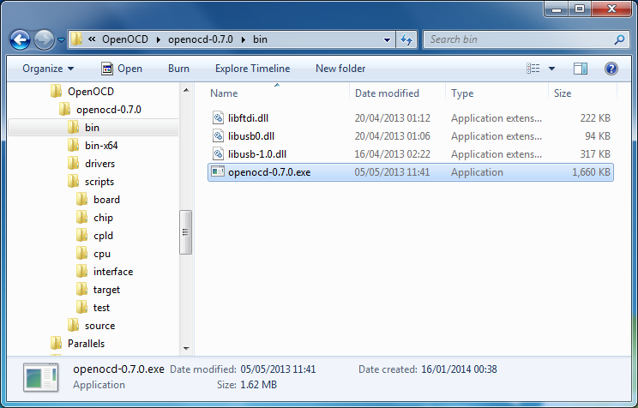
OpenOCD 0.7.0 Windows distribution.

Rename
For unknown reasons, the program name was changed to include the version name. To later make the debug configurations portable, it is recommended to copy the executable with the short name:
copy openocd-0.8.0.exe openocd.exe
To check if OpenOCD starts, use the following command:
C:\Users\Liviu Ionescu>"C:\Program Files\OpenOCD\openocd-0.8.0\bin\openocd" --version
Open On-Chip Debugger 0.7.0 (2014-04-28-08:39)

Drivers
As usual on Windows, mastering drivers is a challenge and OpenOCD is no exceptions, so don’t be surprised to encounter many incompatible drivers for various JTAG probes. The OpenOCD distribution includes some libusb drivers, and recommends to run the zadig.exe tool to activate them. Although this manoeuvre will make OpenOCD happy, it will most probably ruin other USB drivers you might have installed. Our strong recommendation is NOT to do this, and instead use the manufacturer drivers, when compatible with OpenOCD.
One example of compatible drivers are the ST-LINK/V2 USB drivers, from ST, available as part number STSW-LINK003 or STSW-LINK006 for Windows 8. Download the s-link_v2_usbdriver.zip archive and run the st-link_v2_usbdriver.exe with administrative privileges. By default, the package will install the drivers to:
C:\Program Files\STMicroelectronics\st_toolset
As for most Windows drivers, to complete the installation, a restart will help.
Connect the ST-LINK/v2 or the DISCOVERY board and check in Control Panel → System → Device Manager if the JTAG is operational.
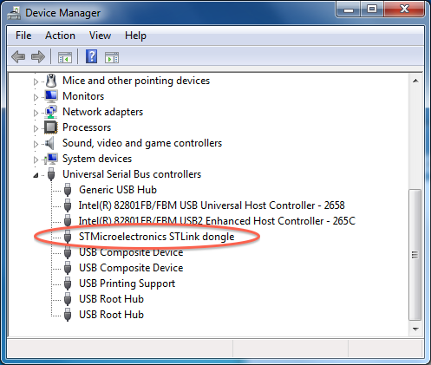
ST-LINK Windows device.
For other probes follow the manufacturer instructions.
Note 1: All Windows tests were performed on Windows 7. If, for any reasons, you still use the venerable Windows XP, some differences may be observed in the USB subsystem; to stay on the safe side, try to always use original manufacturer drivers.
Note 2: OpenOCD v0.7.0 does not work with the current J-Link drivers, so on Windows it is not possible to use OpenOCD with J-Link; use the SEGGER supplied software instead.

OS X
For OS X, the recommended method to install additional packages is via MacPorts. If you do not have MacPorts installed, download the .pkg appropriate for your OS X version (for example MacPorts-2.2.1-10.9-Mavericks.pkg) and install it as usual. The result is a folder /opt/local where everything is stored.
To instal OpenOCD, you must tell MacPorts which variants you want included, where variants correspond to different JTAG interface families. For a list of available variants, use:
$ port variants openocd
openocd has the variants:
...
jlink: Enable building support for the Segger J-Link JTAG Programmer
...
stlink: Enable building support for the STM ST-link
...
For example, to include support for the ST-LINK, J-Link and FTDI based probes, use:
$ sudo port install openocd +jlink +stlink +ft2232
The installation result is stored in /opt/local; the executable is in /opt/local/bin/openocd and the configuration scripts are in /opt/local/share/openocd/scripts. No other files are stored in the OS X system folders.
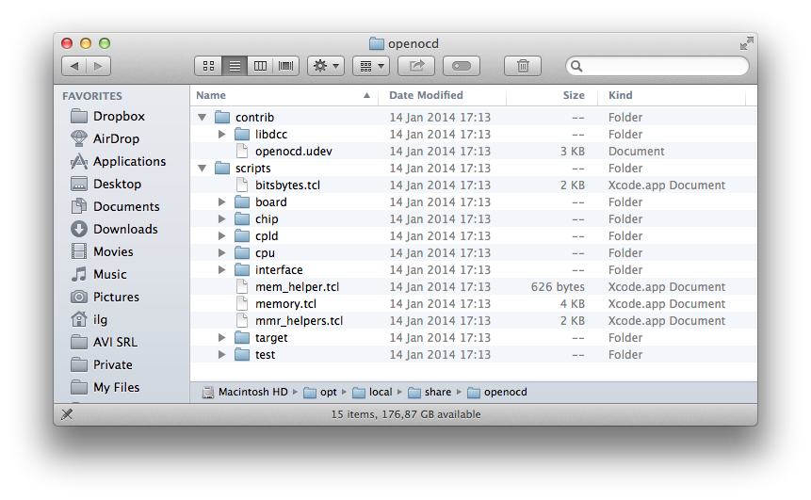
OpenOCD OS X distribution.
To check if OpenOCD starts, use:
$ /opt/local/bin/openocd --version
Open On-Chip Debugger 0.7.0 (2014-01-14-17:13)
For the above variants, no other drivers and no further configurations are necessary for the USB devices on OS X.
To letter upgrade to newer versions, it is recommended to first update MacPorts:
$ sudo port -v selfupdate
$ sudo port upgrade openocd +jlink +stlink +ft2232

GNU/Linux
Most GNU/Linux distributions already pack OpenOCD, so it must be available as a binary package.
For example, for Ubuntu 13.10 you can install it with:
$ sudo apt-get install openocd
The executable is installed in /usr/bin/openocd and the configuration scripts are in /usr/share/openocd/scripts.
To check if OpenOCD starts and is recent, use:
$ /usr/bin/openocd --version
Open On-Chip Debugger 0.7.0 (2013-05-15-17:28)
If you are using another distribution, or an Ubuntu older than 13.10, you’ll probably see a previous version of OpenOCD. For example on Ubuntu 12LTS you’ll find version 0.5.x, which is way too old. In this case you have two options:
- either upgrade your whole system
- or build OpenOCD from sources
The preferred option is to upgrade, but there are cases when this is not realistic, and the only solution is to build the package from sources, which, at least for a normal usage, is not as complicated as it seems.
The examples below were tested on a fresh Ubuntu 12LTS x64, but, with some adjustments, the procedure can be used for other distributions too.
The prerequisites are the libusb-1.0 and libftdi libraries, which can be installed with:
sudo apt-get install libftdi-dev libusb-1.0-0-dev
Then change to a folder of your choice, get the archive, configure and build it:
cd Work
wget http://sourceforge.net/projects/openocd/files/openocd/0.7.0/\
openocd-0.7.0.tar.gz
tar xvf openocd-0.7.0.tar.gz
cd openocd-0.7.0
./configure --enable-stlink --enable-jlink --enable-ftdi \
--enable-ft2232_libftdi
make
If the build completes without errors, install the result:
sudo make install
The executable is installed in /usr/bin/openocd and the configuration scripts are in /usr/share/openocd/scripts.
As it can be seen, the executable is build with support for ST-LINK, J-Link and FTDI based probes (using the open source libftdi library). If you need support for other probes, or want to use the proprietary FTDI drivers, just follow the explanations in the README and INSTALL files.

UDEV
For the JTAG probes implemented as USB devices (actually most of them), the last installation step on GNU/Linux is to configure the UDEV subsystem. OpenOCD provides an UDEV rules file defining all the supported IDs; to install it, just copy the file to /etc/udev/rules.d and eventually notify the daemon:
sudo cp /usr/local/share/openocd/contrib/openocd.udev \
/etc/udev/rules.d/98-openocd.rules
sudo udevadm control --reload-rules
Note: If you previously installed the J-Link binaries, the USB IDs were already added to UDEV. The above OpenOCD rules file also defines the J-Link ID. Apparently UDEV does not complain; if you encounter problems, just comment out the definition in the OpenOCD file.

Testing
To test if OpenOCD is able to connect to a specific board, you generally need to select the interface and the processor. As a shortcut, for some well known boards, there are ready made configuration files to set both the interface and the processor. For example, on OS X, to test a connection to the STM32F4DISCOVERY evaluation board, you can use the sample below:
$ /opt/local/bin/openocd -f board/stm32f4discovery.cfg
Open On-Chip Debugger 0.7.0 (2014-01-14-17:13)
Licensed under GNU GPL v2
For bug reports, read

http://openocd.sourceforge.net/doc/doxygen/bugs.html

srst_only separate srst_nogate srst_open_drain connect_deassert_srst
Info : This adapter doesn't support configurable speed
Info : STLINK v2 JTAG v14 API v2 SWIM v0 VID 0x0483 PID 0x3748
Info : Target voltage: 2.908789
Info : stm32f4x.cpu: hardware has 6 breakpoints, 4 watchpoints
^C
Or Ubuntu the command is similar, just change the program path to /usr/bin/openocd.
A similar session on Windows 7; be sure you use back-slashes in the executable path; for the scripts paths you can use either forward or back slashes:
C:\Users\Liviu Ionescu>"C:\Program Files\OpenOCD\openocd-0.7.0\bin\openocd-0.7.0.exe" -f board/stm32f4discovery.cfg
Open On-Chip Debugger 0.7.0 (2013-05-05-10:41)
Licensed under GNU GPL v2
For bug reports, read

http://openocd.sourceforge.net/doc/doxygen/bugs.html

srst_only separate srst_nogate srst_open_drain connect_deassert_srst
Info : This adapter doesn't support configurable speed
Info : STLINK v2 JTAG v14 API v2 SWIM v0 VID 0x0483 PID 0x3748
Info : Target voltage: 2.911943
Info : stm32f4x.cpu: hardware has 6 breakpoints, 4 watchpoints
On OS X, to test a connection via J-Link to the Olimex STM32-H103 board, you can use the sample below:
$ /opt/local/bin/openocd -f interface/jlink.cfg -f board/olimex_stm32_h103.cfg
Open On-Chip Debugger 0.7.0 (2014-01-14-17:13)
Licensed under GNU GPL v2
For bug reports, read

http://openocd.sourceforge.net/doc/doxygen/bugs.html

Info : only one transport option; autoselect 'jtag'
adapter speed: 1000 kHz
adapter_nsrst_delay: 100
jtag_ntrst_delay: 100
cortex_m3 reset_config sysresetreq
Info : J-Link initialization started / target CPU reset initiated
Info : J-Link ARM V8 compiled Nov 25 2013 19:20:08
Info : J-Link caps 0xb9ff7bbf
Info : J-Link hw version 80000
Info : J-Link hw type J-Link
Info : J-Link max mem block 9296
Info : J-Link configuration
Info : USB-Address: 0x0
Info : Kickstart power on JTAG-pin 19: 0xffffffff
Info : Vref = 3.287 TCK = 1 TDI = 0 TDO = 1 TMS = 0 SRST = 0 TRST = 0
Info : J-Link JTAG Interface ready
Info : clock speed 1000 kHz
Info : JTAG tap: stm32f1x.cpu tap/device found: 0x3ba00477 (mfg: 0x23b, part: 0xba00, ver: 0x3)
Info : JTAG tap: stm32f1x.bs tap/device found: 0x16410041 (mfg: 0x020, part: 0x6410, ver: 0x1)
Info : stm32f1x.cpu: hardware has 6 breakpoints, 4 watchpoints
^C
On Ubuntu the command is similar, just change the program path to /usr/bin/openocd.

