Cloud Native Data Engineering — Assignment 2
Design & Deploy: Relational Modeling, SQL & Cloud Database Implementation
Campus Energy Monitoring Platform
Obaro Erigha
Autumn 2026 · Amazon RDS for MySQL 8.4 · us-east-2

Contents
Overview — How Assignment 2 Evolves Assignment 1 3
Part 1 — Dataset Acquisition & Profiling 4
1.1 Acquisition option: Option B (public real-world data) 4
1.2 Construction 4
1.3 Profile 4
Part 2 — Normalization (1NF → 2NF → 3NF) 6
2.1 Insertion anomaly 6
2.2 Deletion anomaly 6
2.3 Update anomaly 6
2.4 Functional dependencies (verified against all 28,336 rows) 6
2.5 Decomposition and business assumptions 7
Part 3 — Conceptual and Logical Data Model 8
3a. Conceptual ER diagram 8
3b. Logical ER diagram 10
3c. Structural requirements 11
Part 4 — Deploy to AWS RDS 12
4a. Provisioning 12
4b. Schema creation and data loading 12
4c. Verification evidence 13
Part 5 — Business Queries 14
Q1. INNER JOIN x6, GROUP BY, HAVING 14
Q2. LEFT OUTER JOIN, GROUP BY, HAVING 15
Q3. CTE + window function LAG 15
Q4. CTE + window function ROW_NUMBER, multi-table INNER JOIN 16
Q5. Recursive hierarchy (self-join on space_usage), GROUP BY WITH ROLLUP 17
Q6. INNER JOIN incl. weather, CASE banding, GROUP BY, HAVING 18
Q7. CTE + window functions AVG/STDDEV OVER (PARTITION BY) 19
Q8. RIGHT OUTER JOIN + LEFT OUTER JOIN, GROUP BY 20
Part 6 — Optimization, With Proof 22
6a. Execution plans — two most join-heavy queries 22
6b. Index hypothesis and before/after 22
6c. Empirical analysis 23
Part 7 — Cost, Teardown & Cloud Hygiene 24
7a. Billing 24
7b. Teardown 24
7c. Production 24/7 cost estimate 25
Appendix A — Full EXPLAIN ANALYZE Output (RDS MySQL 8.4.11) 26
Appendix B — Notes, Reproducibility and Deliverables 29

Overview — How Assignment 2 Evolves Assignment 1
Assignment 1 designed a Campus Energy Monitoring Platform for a university facilities team running 124 buildings and 308 hourly meters at the BDG2 "Bull" site (Austin, TX), combining building metadata, meter readings, weather and EIA electricity prices. Assignment 2 implements that platform's relational serving layer: the same buildings, meters, weather and price sources are normalized to 3NF, deployed to Amazon RDS, and queried for the A1 success criteria (cost attribution per building, data completeness ≥ 95%, anomaly detection, peak demand).
Decision | Assignment 1 | Assignment 2 | Why
Relational engine | RDS PostgreSQL | RDS MySQL 8.4.11 | A2 spec requires RDS MySQL; 8.4 chosen over 8.0 because 8.0 entered paid RDS Extended Support on 2026-08-01 (verified via AWS API).
Data grain | Hourly readings | Daily per meter (Jul–Sep 2017) | 28,336 rows fits the 5k–50k free-tier guidance and covers Austin's summer cooling peak.
Data source | BDG2 + EIA | BDG2 + EIA-861M (real data only) | Same sources; EIA-861M gives real Texas commercial monthly prices.
Scope | Full lake + warehouse | Relational model on RDS | A2 focuses on the OLTP/serving tier; the lake tiers remain A1 design.

Part 1 — Dataset Acquisition & Profiling

1.1 Acquisition option: Option B (public real-world data)
No synthetic records were generated. Two public sources were reshaped by a documented, reproducible script (scripts/build_flat_table.py) into one flat, denormalized table.
Source | Provider | URL | License | Downloaded
Building Data Genome Project 2 (commit 9b97ccbe) | BUDS Lab, NUS (Miller et al., 2020) | github.com/buds-lab/building-data-genome-project-2 | CC BY-SA 4.0 | 2026-10-31
EIA-861M Monthly Sales & Revenue (sales_revenue.xlsx) | U.S. Energy Information Administration | eia.gov/electricity/data/eia861m/xls/sales_revenue.xlsx | U.S. Gov. public domain | 2026-11-01 (sha256 c7963ad7…)
Citation: Miller, C. et al. The Building Data Genome Project 2, energy meter data from the ASHRAE Great Energy Predictor III competition. Sci Data 7, 368 (2020). doi:10.1038/s41597-020-00712-x. Per the BDG2 paper (Tables 4–5), all energy meters are reported in kWh (chilled water converted from tons × 3.51685).

1.2 Construction
- Filtered BDG2 metadata to site "Bull": 124 buildings.
- Read cleaned hourly meters for electricity (123), chilled water (95) and steam (90) = 308 meters; restricted to 2017-07-01 00:00 – 2017-09-30 23:00; unpivoted wide → long; aggregated per meter per day (sum, max hour, hour of max, hours reported).
- Aggregated Bull hourly weather to daily values; joined the EIA-861M Texas commercial average retail price for Jul/Aug/Sep 2017 (8.24 / 8.17 / 8.16 ¢/kWh, status Final).
- Applied unit rates: electricity = EIA price; chilled water = EIA price ÷ chiller COP 4.0 (assumption); steam = $0.034/kWh (gas boiler assumption).

1.3 Profile
Rows: 28,336 (308 meters × 92 days; 0 duplicate meter-days) · Columns: 29 · Rows by utility: electricity 11,316, chilled water 8,740, steam 8,280.
Column(s) | Type | Nulls | Business concept
reading_id, reading_date | int, date | 0 | Reading
meter_code ("building|utility") | text | 0 | Meter (non-atomic composite)
utility_type, unit | text | 0 | Utility
building_name, building_kaggle_id, gross_sqm, gross_sqft | text, int, decimal | 0 | Building
primary_space_usage, sub_space_usage | text | 0 | Space-usage category (parent / child)
site_name, timezone, lat, lng | text, decimal | 0 | Site
daily_consumption_kwh, peak_hour_kwh, peak_hour | decimal, int | 237 each | Reading measures
hours_reported | int 0–24 | 0 | Data quality
avg/max_air_temp_c, avg_dew_temp_c, total_precip_mm, weather_hours | decimal, int | 0 | Weather (site-day)
tx_comm_price_cents_kwh, eia_data_status, unit_rate_usd, rate_source | decimal, text | 0 | Tariff (utility × month)
est_daily_cost_usd | decimal | 237 | Derived cost

Five-row preview (selected columns)
reading_id | reading_date | meter_code | primary / sub usage | gross_sqm | daily kWh | peak kWh @hr | hrs | rate $ | cost $
1 | 2017-07-01 | Bull_assembly_Amalia|chilledwater | Entertainment / Sports Stadium | 52,377.0 | 98,524.7 | 4,450.8 @15 | 24 | 0.0206 | 2,029.61
2 | 2017-07-01 | Bull_assembly_Amalia|electricity | Entertainment / Sports Stadium | 52,377.0 | 9,366.0 | 415.0 @22 | 24 | 0.0824 | 771.76
3 | 2017-07-01 | Bull_assembly_Amalia|steam | Entertainment / Sports Stadium | 52,377.0 | 1,916.3 | 100.5 @7 | 24 | 0.0340 | 65.15
4 | 2017-07-01 | Bull_assembly_Beau|chilledwater | Entertainment / Conference Center | 46,789.1 | 72,685.3 | 3,421.2 @1 | 24 | 0.0206 | 1,497.32
5 | 2017-07-01 | Bull_assembly_Beau|electricity | Entertainment / Conference Center | 46,789.1 | 9,774.0 | 523.0 @0 | 24 | 0.0824 | 805.38

Real anomalies present (input to Part 2)
- Repeated entity data: building name, usage and area repeat on every meter-day (e.g., Bull_lodging_Caren on 276 rows); site/timezone/lat/lng on all 28,336 rows. These play the role of the spec's "repeated customer names and addresses".
- Inconsistent casing: sub-usage 'Office' (16 buildings) vs 'office' (1), and lower-case 'garage' (5).
- Nulls: 237 meter-days with no readings (Bull_office_Mai electricity is null for all 92 days); 698 partial days.
- Non-atomic value: meter_code packs building and utility into one string.

Part 2 — Normalization (1NF → 2NF → 3NF)
The step-by-step decomposition is in the workbook normalization_workbook.xlsx (tabs 1NF, 2NF, 3NF). All rows below are actual rows from the flat table.

2.1 Insertion anomaly
Bull_office_Mai's electricity meter reported nothing in the window, yet the only way to record that the meter exists is as reading rows — so it occupies 92 rows whose measures are all NULL. Conversely, a new building, a new usage category, or the October-2017 EIA price cannot be recorded until some meter reports a reading.
reading_id | reading_date | meter_code | sub_space_usage | gross_sqm | daily_consumption_kwh | hours_reported
280 | 2017-07-01 | Bull_office_Mai|electricity | office | 792.0 | NULL | 0

2.2 Deletion anomaly
Bull_assembly_Maren is the only Swimming Pool building. Purging its 276 readings (e.g., meters decommissioned) would also erase its floor area (11,345.5 m²) and the fact that 'Swimming Pool' is a sub-category of 'Entertainment/public assembly'.
reading_id | reading_date | meter_code | primary_space_usage | sub_space_usage | gross_sqm | kWh
34 | 2017-07-01 | Bull_assembly_Maren|chilledwater | Entertainment/public assembly | Swimming Pool | 11345.5 | 35450.5750
35 | 2017-07-01 | Bull_assembly_Maren|electricity | Entertainment/public assembly | Swimming Pool | 11345.5 | 7721.0000
36 | 2017-07-01 | Bull_assembly_Maren|steam | Entertainment/public assembly | Swimming Pool | 11345.5 | 302.3312

2.3 Update anomaly
Bull_office_Mai is stored as 'office' while 16 other buildings use 'Office'. Correcting it requires updating all 276 of its rows; missing any leaves one building with two usages and splits GROUP BY results. The same applies to any gross_sqm correction (276 rows) or an EIA price revision (August price repeated on 9,548 rows).
reading_id | reading_date | meter_code | primary_space_usage | sub_space_usage
279 | 2017-07-01 | Bull_office_Mai|chilledwater | Office | office
280 | 2017-07-01 | Bull_office_Mai|electricity | Office | office
281 | 2017-07-01 | Bull_office_Mai|steam | Office | office
587 | 2017-07-02 | Bull_office_Mai|chilledwater | Office | office

2.4 Functional dependencies (verified against all 28,336 rows)
FD | Dependency | Type
FD1 | {building_name, utility_type, reading_date} → consumption, peak_hour_kwh, peak_hour, hours_reported | full (1NF key)
FD2 | building_name → building_kaggle_id, site_name, primary/sub usage, gross_sqm, gross_sqft | partial
FD3 | building_kaggle_id → building_name | alternate key
FD4 | utility_type → unit | partial
FD5 | site_name → timezone, lat, lng | transitive
FD6 | sub_space_usage → primary_space_usage | transitive
FD7 | gross_sqm → gross_sqft (× 10.7639) | derived
FD8 | {site_name, reading_date} → weather measures | partial
FD9 | reading_date → reading_month → TX price, EIA status | partial + transitive
FD10 | {utility_type, reading_month} → unit_rate_usd, rate_source | partial
FD11 | {consumption, unit_rate_usd} → est_daily_cost_usd | derived

2.5 Decomposition and business assumptions
- 1NF: split non-atomic meter_code; drop the row-number surrogate; key {building_name, utility_type, reading_date}.
- 2NF: remove partial dependencies (FD2, FD4, FD8, FD9, FD10) → R_building (124), R_utility (3), R_day_weather (92), R_utility_day_rate (276), R_reading (28,336).
- 3NF: remove transitive/derived dependencies (FD5, FD6, FD7, FD9, FD11) → 9 tables, 28,897 rows. A lossless-join check re-joins them to all 28,336 flat rows with identical values.
Business assumptions:
- A building has at most one meter per utility, so (building, utility) identifies a meter (308 pairs = 308 meters).
- Each sub-usage belongs to exactly one primary usage (0 violations).
- Weather is observed per site per day, not per building.
- Tariffs are set per utility per calendar month; the stored unit rate is a business (contract) decision.
- Sub-usage casing is standardized on load ('office' → 'Office', 'garage' → 'Garage'); the raw anomaly remains visible in the 1NF/2NF tabs.
- Derived values (gross_sqft, cost) are not stored; they are computed in SQL.

Part 3 — Conceptual and Logical Data Model

3a. Conceptual ER diagram
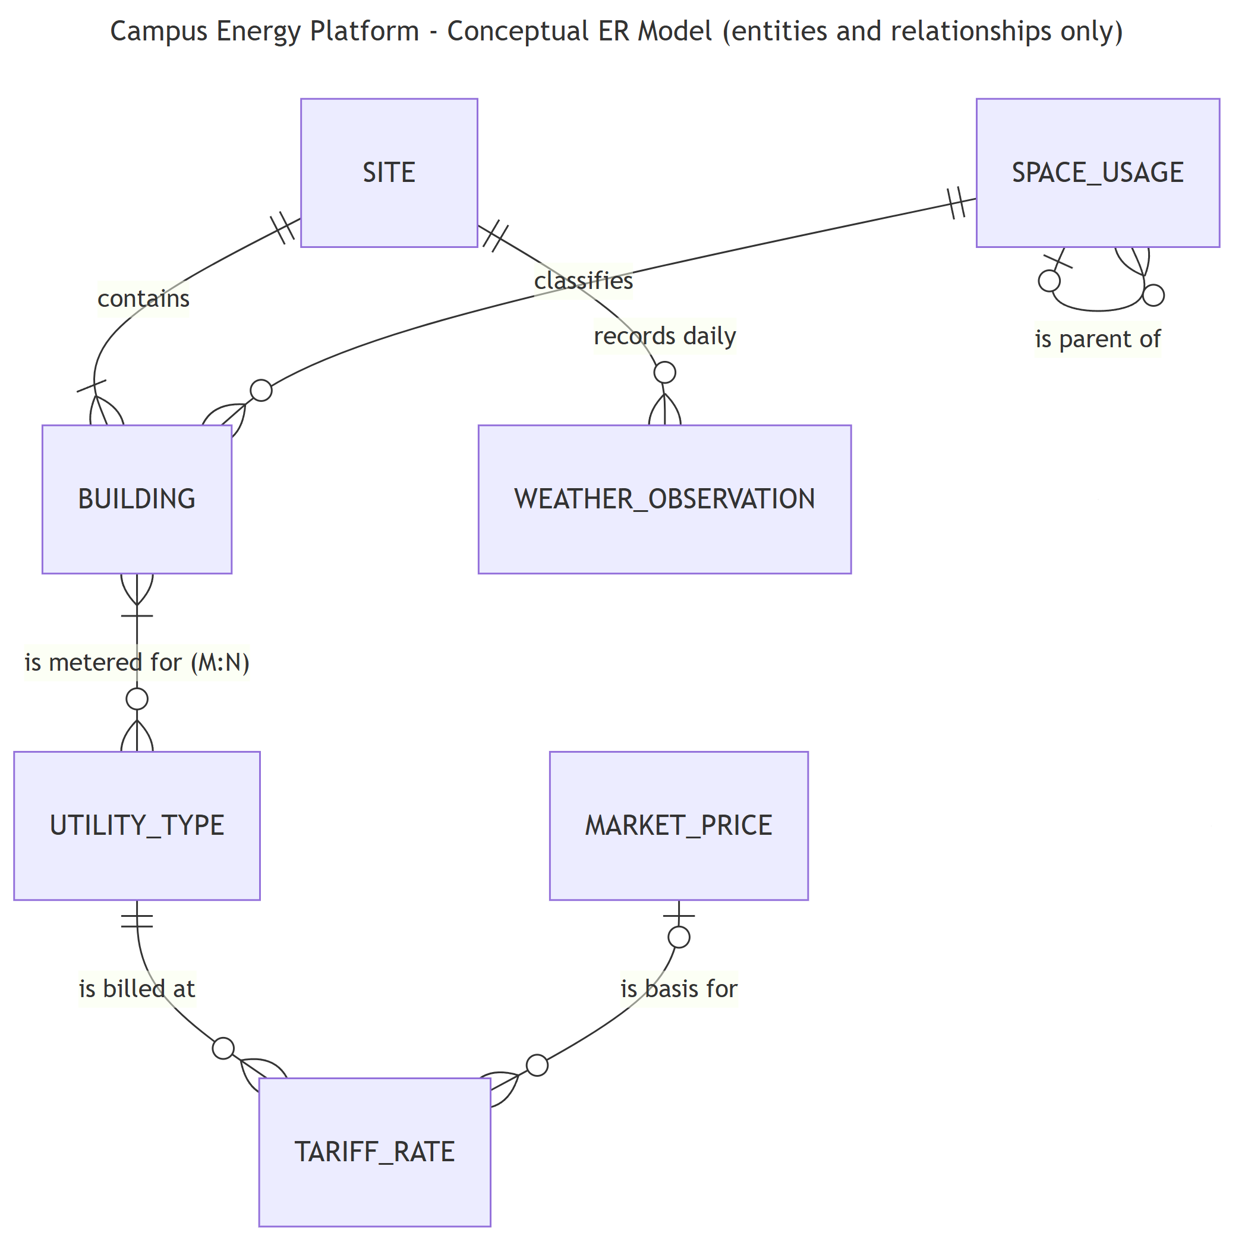
Figure 3.1 — Conceptual model (entities and relationships only); BUILDING–UTILITY_TYPE shown as M:N.
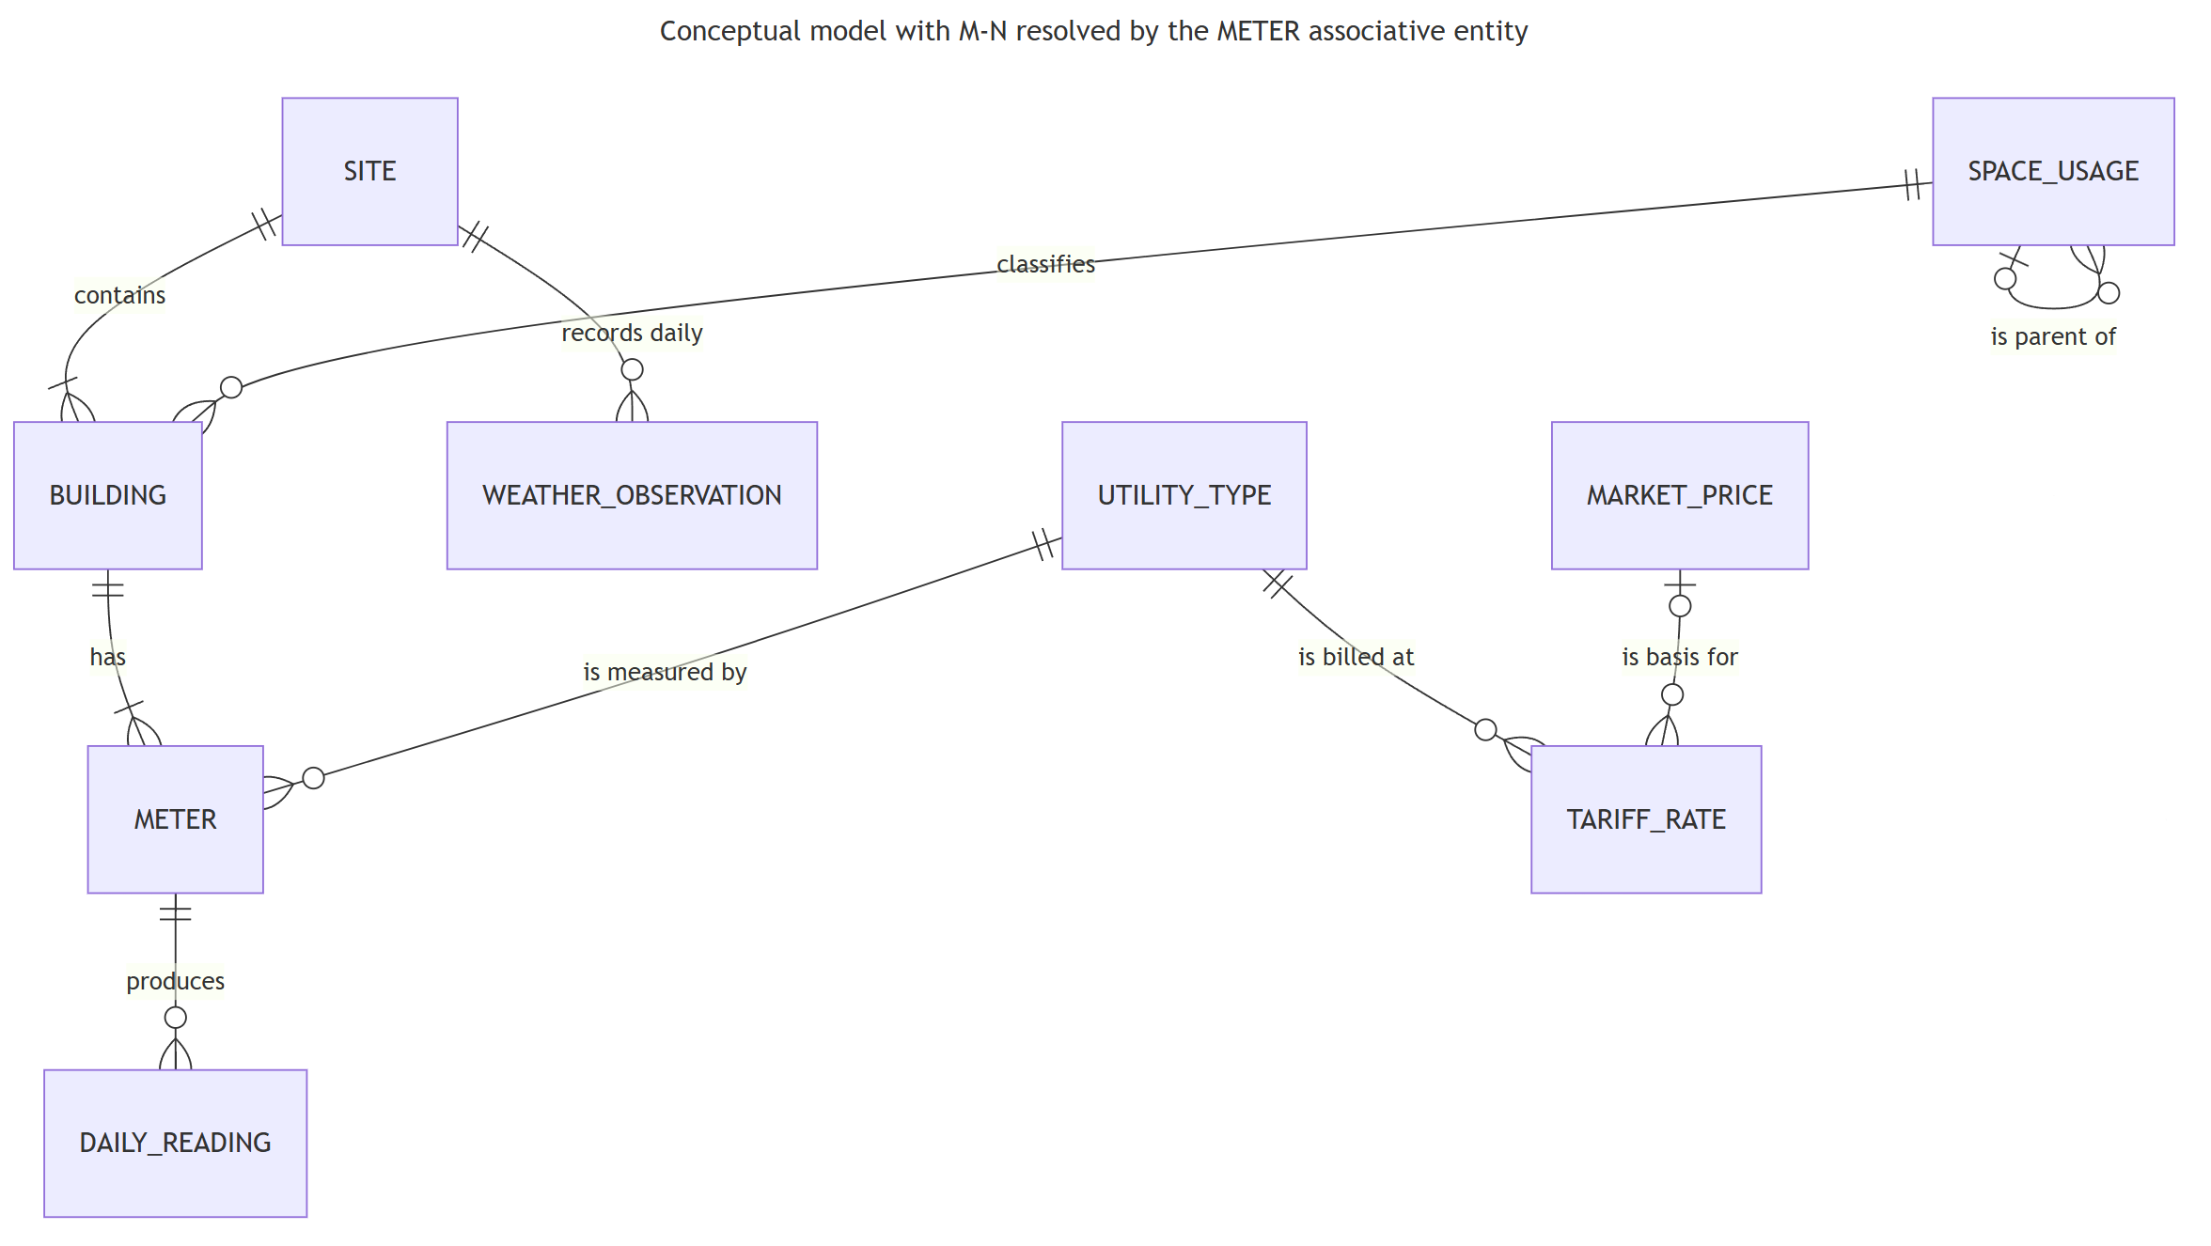
Figure 3.2 — Conceptual model with the M:N resolved by the METER associative entity.

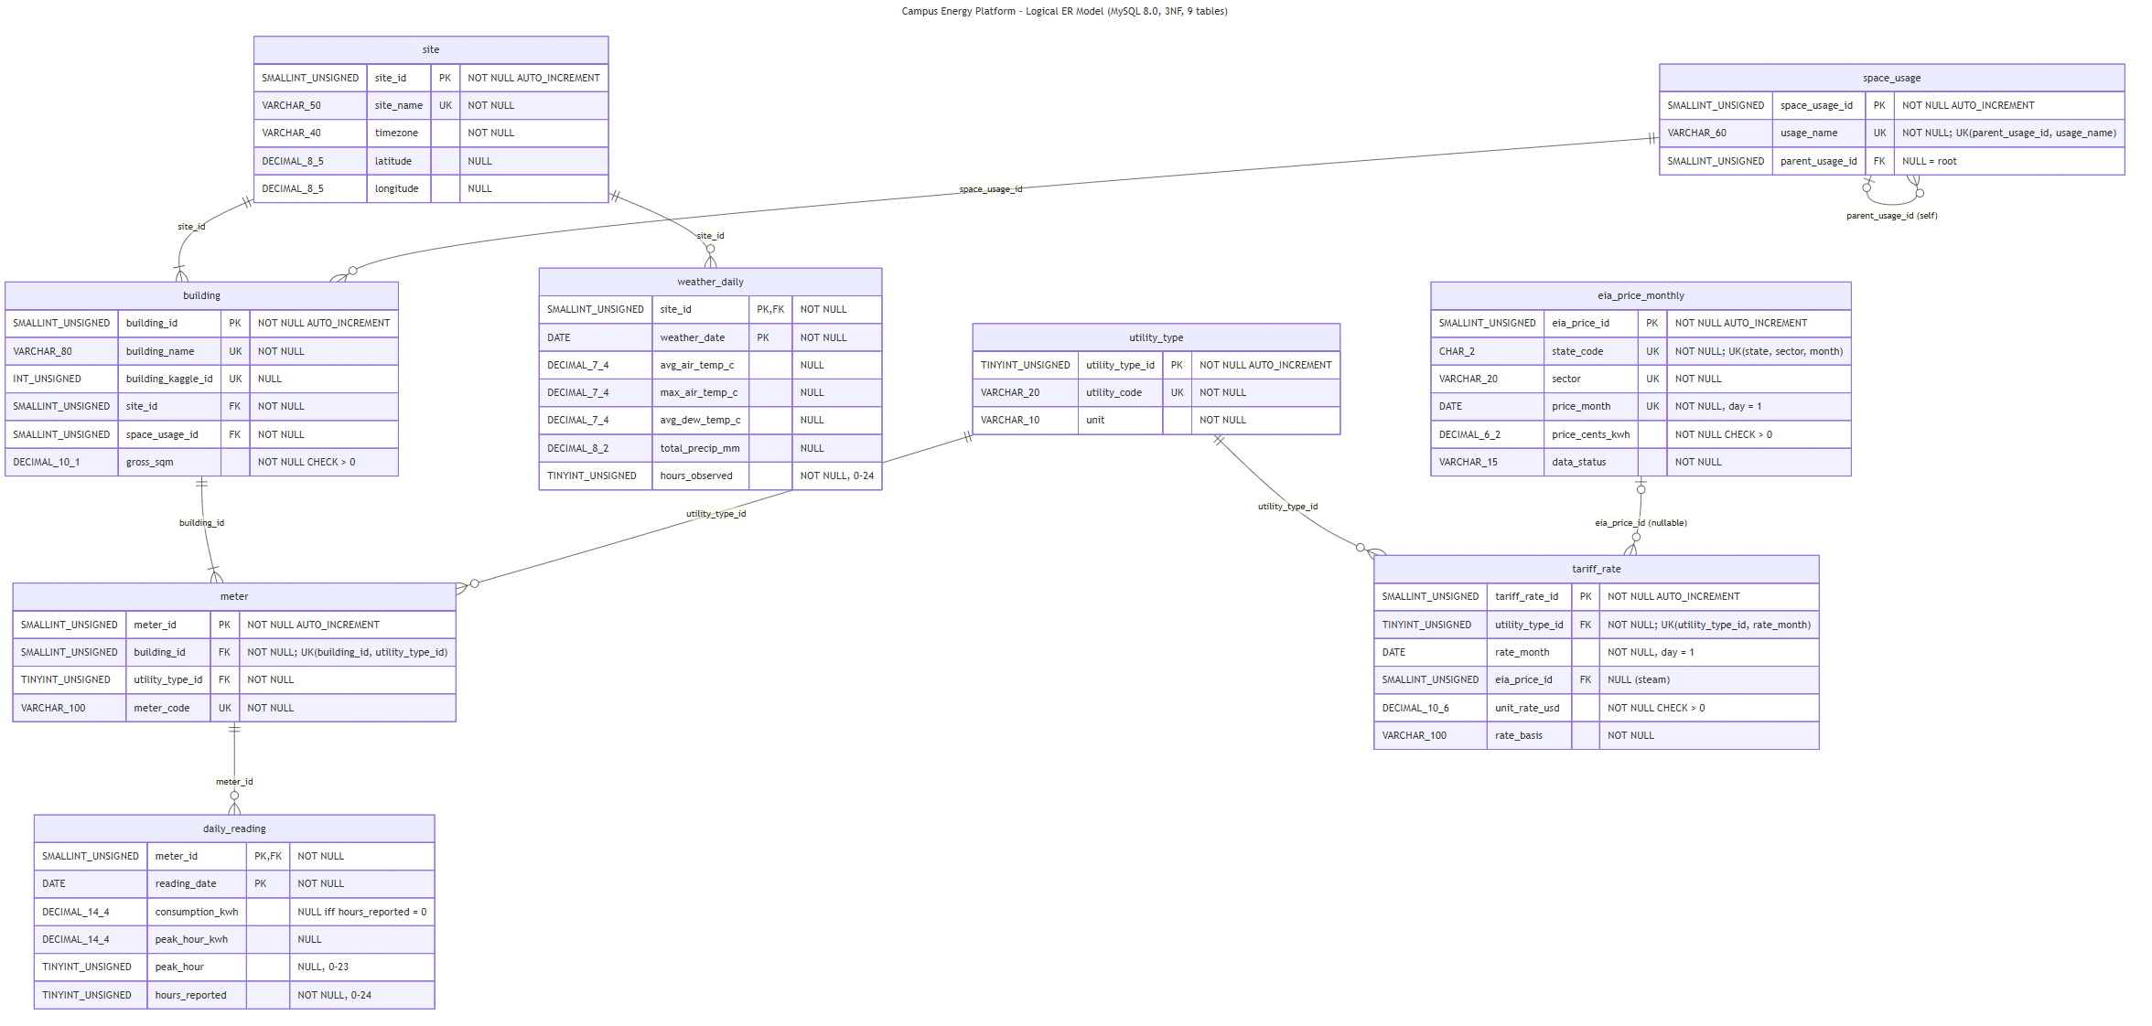
3b. Logical ER diagram

Figure 3.3 — Logical model: 9 tables, MySQL types (DECIMAL_10_1 = DECIMAL(10,1)), PK/FK/UK, NULL rules, cardinalities.

3c. Structural requirements
Requirement | Met by | Evidence
≥ 6 entities | 9 tables: site, space_usage, building, utility_type, meter, daily_reading, weather_daily, eia_price_monthly, tariff_rate | SHOW TABLES on RDS (Screenshot 4.2)
M:N via junction | building ↔ utility_type resolved by meter (UNIQUE building_id, utility_type_id) | 308 meters; buildings with 3/2/1 utilities: 88/8/28
Recursive hierarchy | space_usage.parent_usage_id → space_usage (e.g., Education → College Laboratory) | WITH RECURSIVE walk; Q5 rollup

Design choices (vs. the rejected alternative)
- Meter as associative entity rather than a bare building_utility bridge: the physical meter is the real asset that produces readings.
- Self-referencing hierarchy rather than separate primary/sub tables: depth can grow (e.g., Laboratory → Wet Lab) without a schema change.
- Composite PK (meter_id, reading_date) enforces one reading per meter per day and clusters each meter's time series.
- ON DELETE RESTRICT removes the Part 2 deletion anomaly (a used category cannot vanish); tariff → EIA price uses SET NULL.
- DECIMAL for energy and money: the SQL cost total ($14,832,619.22) matches an exact Decimal recomputation to the cent.

Part 4 — Deploy to AWS RDS

4a. Provisioning
Setting | Value
Identifier / engine | a2-campus-energy · MySQL 8.4.11 (Extended Support explicitly disabled)
Class / storage | db.t3.micro (2 vCPU, 1 GiB) · 20 GiB gp2 · storage autoscaling OFF
Availability / backups | Single-AZ (us-east-2a) · automated backup retention 0
Monitoring | Performance Insights off · Enhanced Monitoring off
Security | Encrypted at rest (aws/rds KMS key) · TLS client connections verified against the RDS CA bundle · publicly accessible but security group allows TCP 3306 from one /32 (the author's IP) only
Credentials | Master password entered in a hidden prompt; never written to disk or shared
Commands (region passed explicitly; IDs abbreviated):
aws ec2 create-security-group --group-name a2-rds-mysql-sg --vpc-id <default-vpc> --region us-east-2 ...
aws ec2 authorize-security-group-ingress --group-id <sg> --protocol tcp --port 3306 --cidr <my-ip>/32 --region us-east-2
aws rds create-db-instance --db-instance-identifier a2-campus-energy --engine mysql --engine-version 8.4.11 \
--engine-lifecycle-support open-source-rds-extended-support-disabled --db-instance-class db.t3.micro \
--allocated-storage 20 --storage-type gp2 --no-multi-az --publicly-accessible --vpc-security-group-ids <sg> \
--master-username a2admin --master-user-password <hidden> --backup-retention-period 0 \
--no-enable-performance-insights --monitoring-interval 0 --storage-encrypted --region us-east-2

4b. Schema creation and data loading
schema.sql (9 tables, 9 foreign keys, 12 CHECK constraints) was executed on RDS over TLS, then scripts/load_3nf.py (pymysql) loaded the 9 normalized CSVs in foreign-key order. The schema and loader were first validated on a local MySQL instance (re-runnable DDL; constraint violations correctly rejected).
Table | Rows on RDS
site | 1
space_usage | 21
building | 124
utility_type | 3
meter | 308
daily_reading | 28,336
weather_daily | 92
eia_price_monthly | 3
tariff_rate | 9
TOTAL | 28,897

4c. Verification evidence
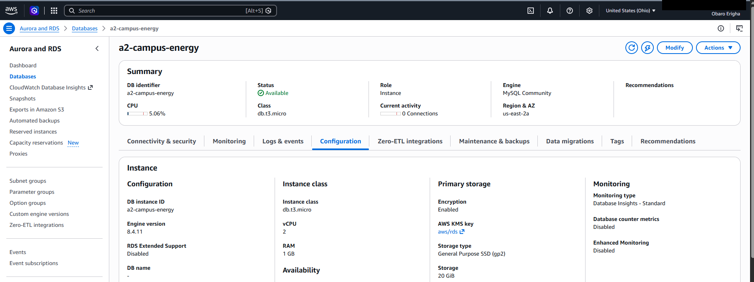
Screenshot 4.1 — RDS console: DB identifier a2-campus-energy, MySQL Community 8.4.11, status Available (account ID redacted).
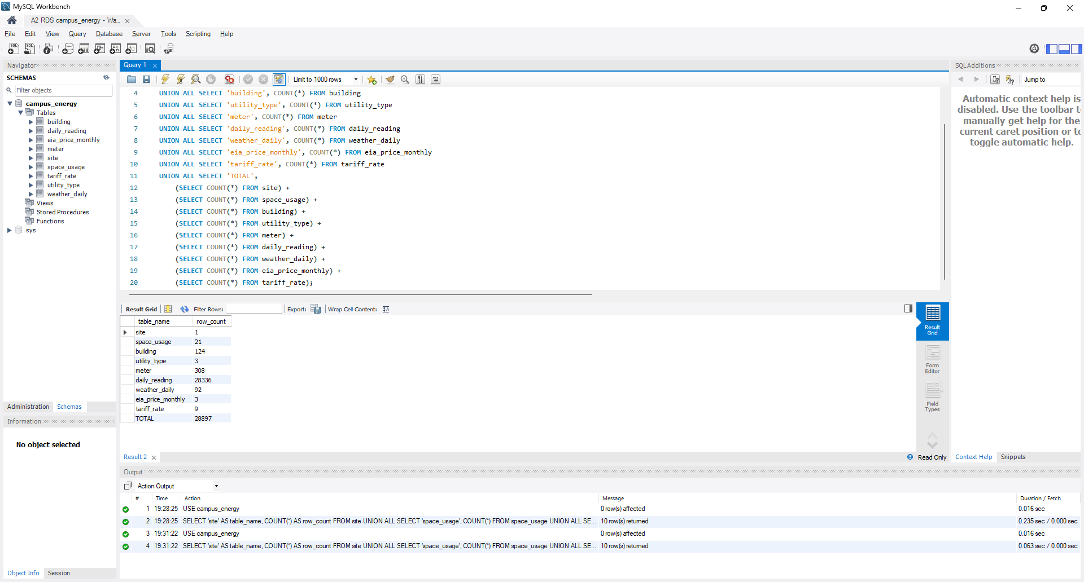
Screenshot 4.2 — MySQL Workbench connected to the live RDS endpoint (hidden): 9 tables and SELECT COUNT(*) per table, total 28,897.

Part 5 — Business Queries
All 8 queries were executed on the live RDS instance. Coverage: multi-table INNER JOINs (Q1, Q3–Q6), LEFT OUTER (Q2, Q8), RIGHT OUTER (Q8), GROUP BY/HAVING (Q1, Q2, Q6), CTEs (Q3, Q4, Q7), window functions LAG (Q3), ROW_NUMBER + DENSE_RANK (Q4), AVG/STDDEV OVER (Q7), and a hierarchy self-join WITH ROLLUP (Q5).

Q1. INNER JOIN x6, GROUP BY, HAVING
Business question: In August 2017 (Austin's peak cooling month), which 10 buildings had the highest total energy cost per square metre across all utilities, so that facilities can prioritise energy audits?
SELECT b.building_name,
parent.usage_name AS primary_usage,
su.usage_name AS sub_usage,
b.gross_sqm,
COUNT(DISTINCT m.meter_id) AS meters,
ROUND(SUM(dr.consumption_kwh), 0) AS total_kwh,
ROUND(SUM(dr.consumption_kwh * tr.unit_rate_usd), 2) AS total_cost_usd,
ROUND(SUM(dr.consumption_kwh * tr.unit_rate_usd) / b.gross_sqm, 2) AS cost_per_sqm_usd
FROM daily_reading dr
JOIN meter m ON m.meter_id = dr.meter_id
JOIN utility_type ut ON ut.utility_type_id = m.utility_type_id
JOIN tariff_rate tr ON tr.utility_type_id = m.utility_type_id
AND tr.rate_month = '2017-08-01'
JOIN building b ON b.building_id = m.building_id
JOIN space_usage su ON su.space_usage_id = b.space_usage_id
JOIN space_usage parent ON parent.space_usage_id = su.parent_usage_id
WHERE dr.reading_date >= '2017-08-01' AND dr.reading_date < '2017-09-01'
GROUP BY b.building_id, b.building_name, parent.usage_name, su.usage_name, b.gross_sqm
HAVING SUM(dr.consumption_kwh) > 0
ORDER BY cost_per_sqm_usd DESC
LIMIT 10;

Result: All top-10 buildings are Education laboratories/classrooms; Bull_education_Jeffery leads at $12.90/m² for August — the audit shortlist.
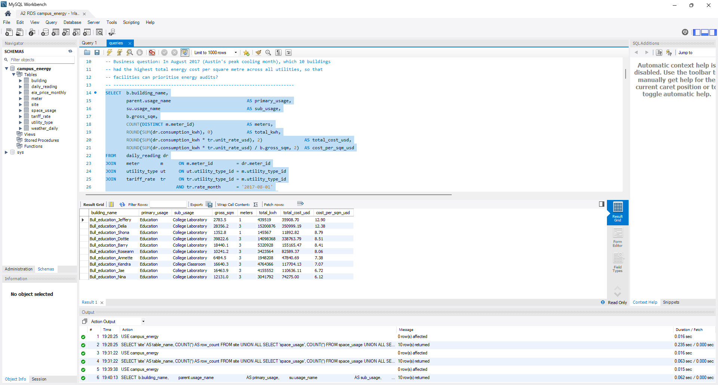
Screenshot 5.1 — Q1 executed on RDS with its result set.

Q2. LEFT OUTER JOIN, GROUP BY, HAVING
Business question: Which meters miss the A1 target of 95% data completeness (hours reported / hours expected) for the quarter, so the metering team can fix them? LEFT JOIN keeps a meter even if it has no reading rows at all.
SELECT m.meter_code,
b.building_name,
ut.utility_code,
COUNT(dr.reading_date) AS days_present,
COALESCE(SUM(dr.hours_reported), 0) AS hours_reported,
92 * 24 AS hours_expected,
ROUND(100 * COALESCE(SUM(dr.hours_reported), 0) / (92 * 24), 1) AS completeness_pct,
SUM(CASE WHEN dr.hours_reported = 0 THEN 1 ELSE 0 END) AS fully_missing_days
FROM meter m
JOIN building b ON b.building_id = m.building_id
JOIN utility_type ut ON ut.utility_type_id = m.utility_type_id
LEFT JOIN daily_reading dr ON dr.meter_id = m.meter_id
GROUP BY m.meter_id, m.meter_code, b.building_name, ut.utility_code
HAVING completeness_pct < 95
ORDER BY completeness_pct ASC;

Result: 10 meters miss the 95% target; Bull_office_Mai electricity reported 0 of 2,208 hours and three dormitory electricity meters are near 56–61%.
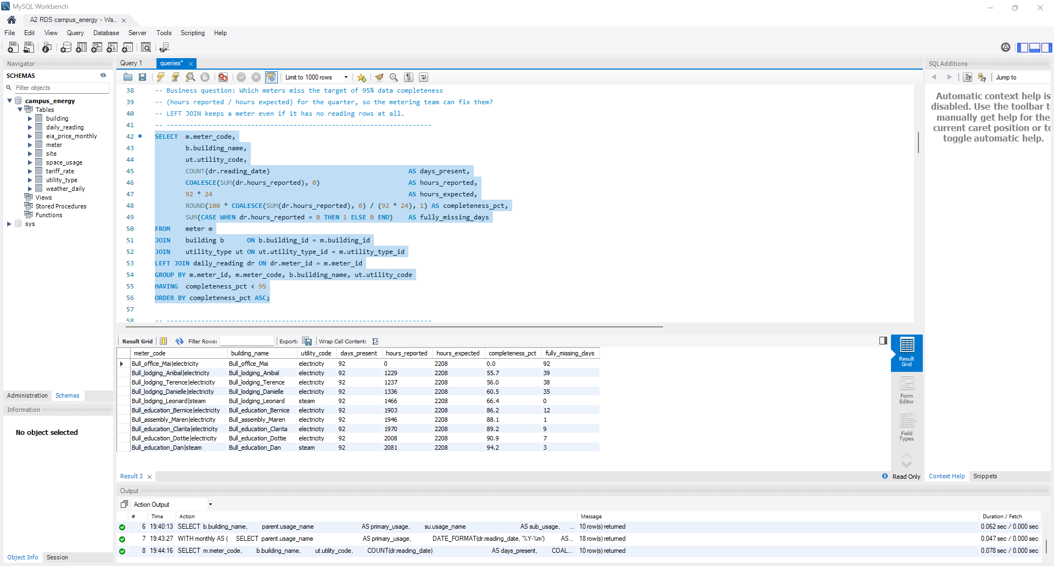
Screenshot 5.2 — Q2 executed on RDS with its result set.

Q3. CTE + window function LAG
Business question: How did electricity consumption change month over month for each primary space-usage category (e.g., did dormitories drop in August as students left)?
WITH monthly AS (
SELECT parent.usage_name AS primary_usage,
DATE_FORMAT(dr.reading_date, '%Y-%m') AS month,
SUM(dr.consumption_kwh) AS kwh
FROM daily_reading dr
JOIN meter m ON m.meter_id = dr.meter_id
JOIN utility_type ut ON ut.utility_type_id = m.utility_type_id
JOIN building b ON b.building_id = m.building_id
JOIN space_usage su ON su.space_usage_id = b.space_usage_id
JOIN space_usage parent ON parent.space_usage_id = su.parent_usage_id
WHERE ut.utility_code = 'electricity'
GROUP BY parent.usage_name, DATE_FORMAT(dr.reading_date, '%Y-%m')
)
SELECT primary_usage,
month,
ROUND(kwh, 0) AS kwh,
ROUND(LAG(kwh) OVER (PARTITION BY primary_usage ORDER BY month), 0) AS prev_month_kwh,
ROUND(100 * (kwh - LAG(kwh) OVER (PARTITION BY primary_usage ORDER BY month))
/ LAG(kwh) OVER (PARTITION BY primary_usage ORDER BY month), 1) AS mom_change_pct
FROM monthly
ORDER BY primary_usage, month;

Result: Dormitory electricity rose 6.9% in August and 18.7% in September (students returning), while Education fell slightly.
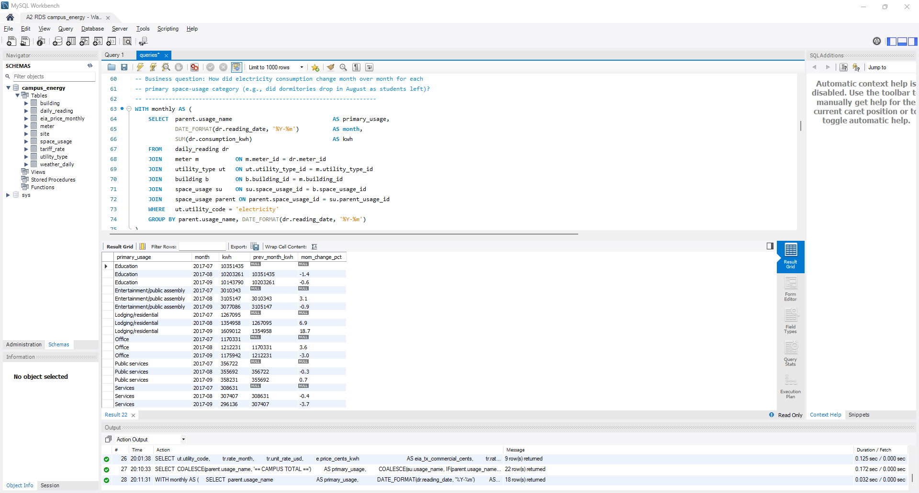
Screenshot 5.3 — Q3 executed on RDS with its result set.

Q4. CTE + window function ROW_NUMBER, multi-table INNER JOIN
Business question: For each utility, which 3 buildings set the highest single-hour peak demand this quarter, and on what date and hour? (Peak demand drives demand charges.)
WITH peaks AS (
SELECT ut.utility_code,
b.building_name,
dr.reading_date,
dr.peak_hour,
dr.peak_hour_kwh,
ROW_NUMBER() OVER (PARTITION BY ut.utility_code, b.building_id
ORDER BY dr.peak_hour_kwh DESC, dr.reading_date) AS rn_in_building
FROM daily_reading dr
JOIN meter m ON m.meter_id = dr.meter_id
JOIN utility_type ut ON ut.utility_type_id = m.utility_type_id
JOIN building b ON b.building_id = m.building_id
WHERE dr.peak_hour_kwh IS NOT NULL
), building_peak AS (
SELECT utility_code, building_name, reading_date, peak_hour, peak_hour_kwh,
DENSE_RANK() OVER (PARTITION BY utility_code ORDER BY peak_hour_kwh DESC) AS peak_rank
FROM peaks
WHERE rn_in_building = 1
)
SELECT utility_code, peak_rank, building_name, reading_date, peak_hour,
ROUND(peak_hour_kwh, 1) AS peak_hour_kwh
FROM building_peak
WHERE peak_rank <= 3
ORDER BY utility_code, peak_rank;

Result: Bull_education_Dottie's 221,228 kWh single-hour electricity peak (next highest 11,845) is almost certainly a meter fault; real chilled-water peaks cluster on 2017-08-08.
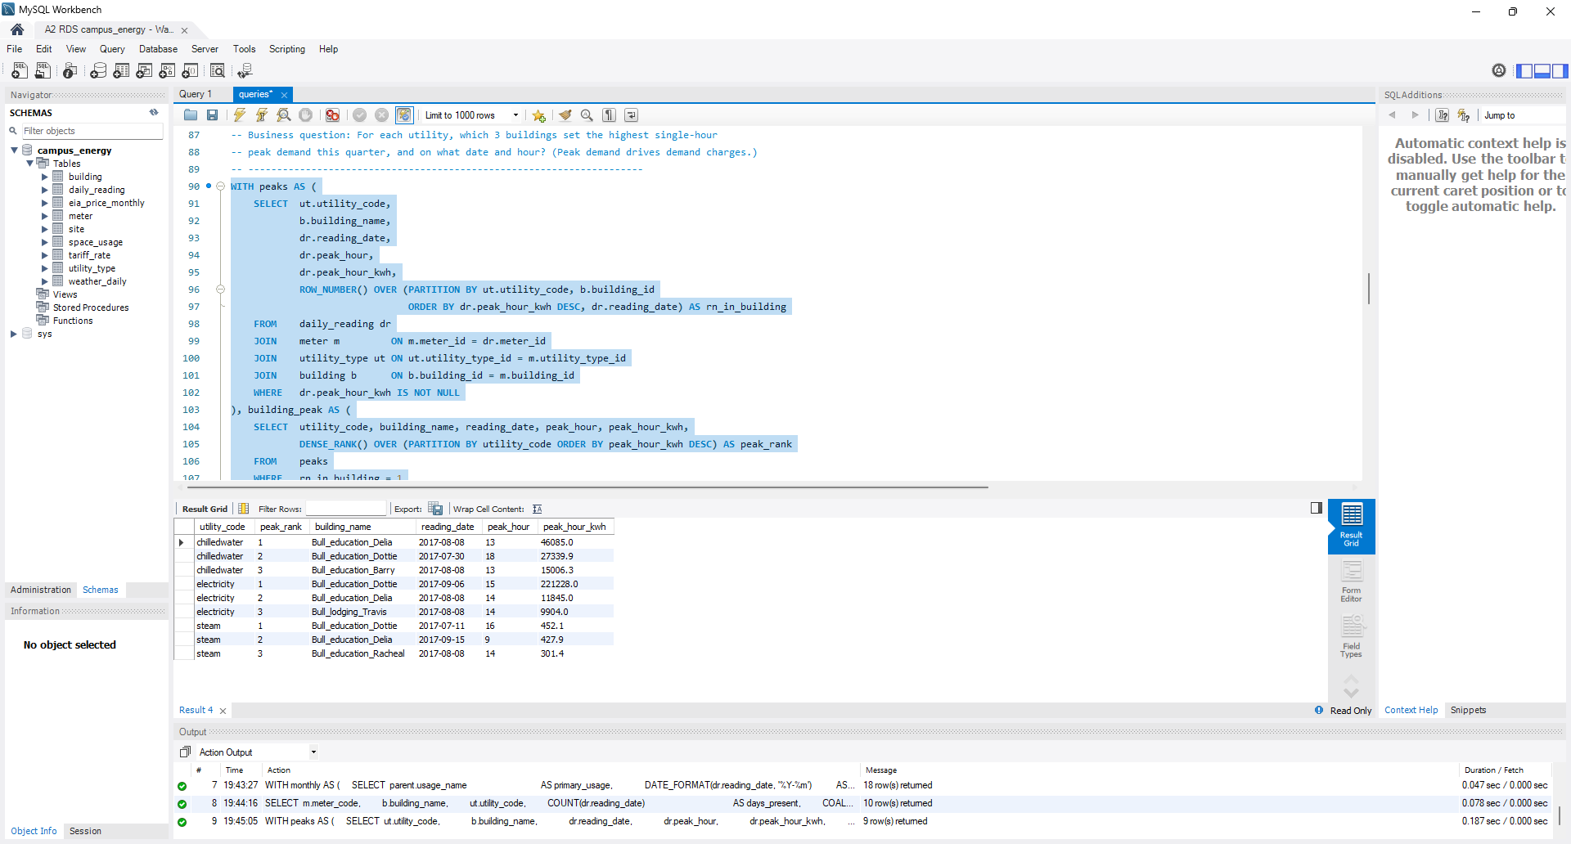
Screenshot 5.4 — Q4 executed on RDS with its result set.

Q5. Recursive hierarchy (self-join on space_usage), GROUP BY WITH ROLLUP
Business question: What is the quarter's total energy cost by space-usage category, rolled up from sub-usage to primary usage to campus total, so Finance can allocate 100% of cost (A1 success criterion)?
SELECT COALESCE(parent.usage_name, '== CAMPUS TOTAL ==') AS primary_usage,
COALESCE(su.usage_name, IF(parent.usage_name IS NULL, '', '-- subtotal --')) AS sub_usage,
COUNT(DISTINCT b.building_id) AS buildings,
ROUND(SUM(dr.consumption_kwh * tr.unit_rate_usd), 2) AS cost_usd
FROM daily_reading dr
JOIN meter m ON m.meter_id = dr.meter_id
JOIN tariff_rate tr ON tr.utility_type_id = m.utility_type_id
AND tr.rate_month = DATE_FORMAT(dr.reading_date, '%Y-%m-01')
JOIN building b ON b.building_id = m.building_id
JOIN space_usage su ON su.space_usage_id = b.space_usage_id
JOIN space_usage parent ON parent.space_usage_id = su.parent_usage_id
GROUP BY parent.usage_name, su.usage_name WITH ROLLUP;

Result: Rolls 100% of the quarter's cost from sub-usage to campus total: $14,832,619.22; Education accounts for $9.73M.
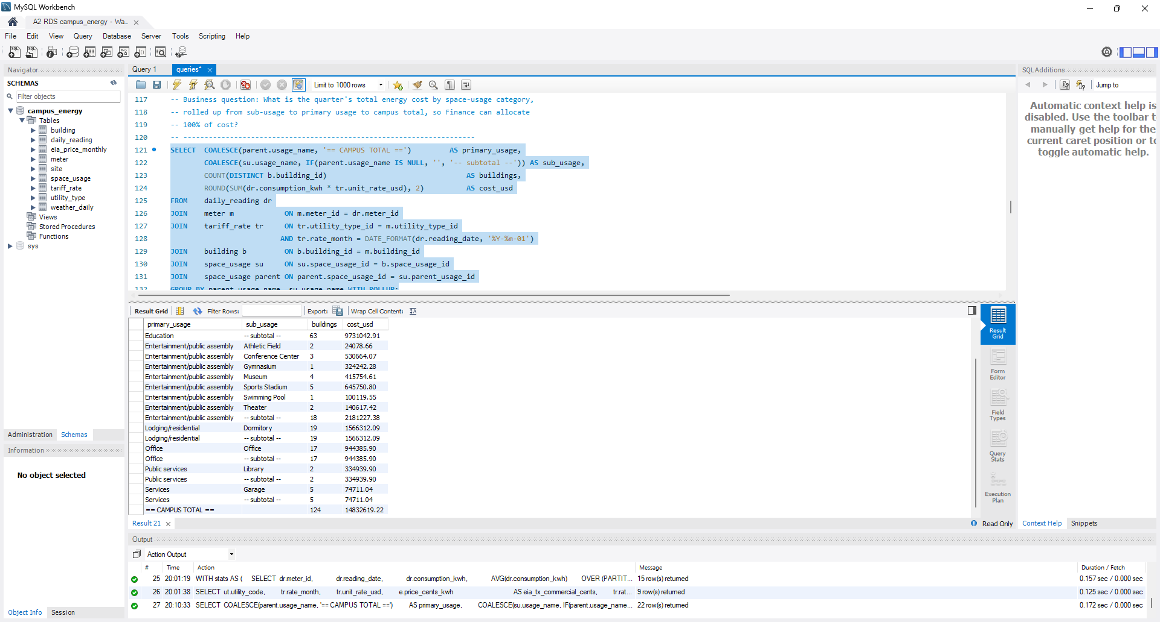
Screenshot 5.5 — Q5 executed on RDS with its result set.

Q6. INNER JOIN incl. weather, CASE banding, GROUP BY, HAVING
Business question: How much more chilled water does the average building use per day on very hot days (max >= 38 C) than on milder days, to size cooling-plant capacity?
SELECT CASE WHEN w.max_air_temp_c >= 38 THEN '1: >= 38 C'
WHEN w.max_air_temp_c >= 35 THEN '2: 35-37.9 C'
ELSE '3: < 35 C' END AS temp_band,
COUNT(DISTINCT w.weather_date) AS days,
ROUND(AVG(w.max_air_temp_c), 1) AS avg_max_temp_c,
ROUND(AVG(dr.consumption_kwh), 0) AS avg_chw_kwh_per_meter_day,
ROUND(SUM(dr.consumption_kwh) / COUNT(DISTINCT w.weather_date), 0) AS campus_chw_kwh_per_day
FROM daily_reading dr
JOIN meter m ON m.meter_id = dr.meter_id
JOIN utility_type ut ON ut.utility_type_id = m.utility_type_id
JOIN building b ON b.building_id = m.building_id
JOIN weather_daily w ON w.site_id = b.site_id AND w.weather_date = dr.reading_date
WHERE ut.utility_code = 'chilledwater'
AND dr.hours_reported = 24
GROUP BY temp_band
HAVING COUNT(DISTINCT w.weather_date) >= 3
ORDER BY temp_band;

Result: Campus chilled water averaged 6.13M kWh/day on ≥ 38 °C days vs 4.84M on < 35 °C days (+27%).
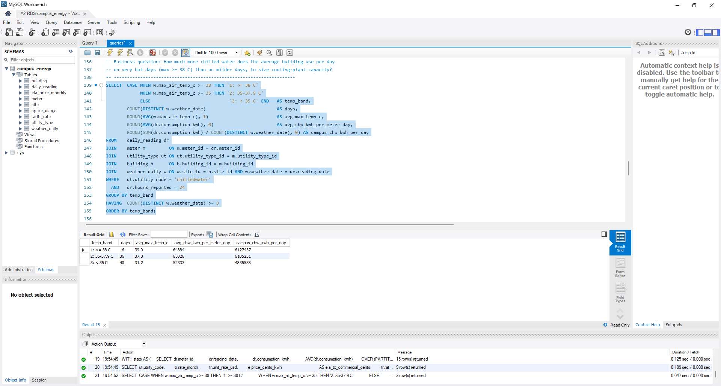
Screenshot 5.6 — Q6 executed on RDS with its result set.

Q7. CTE + window functions AVG/STDDEV OVER (PARTITION BY)
Business question: Which meter-days were abnormal (consumption more than 3 standard deviations from that meter's own quarterly mean), so operators can investigate within 24 hours (A1 success criterion)?
WITH stats AS (
SELECT dr.meter_id,
dr.reading_date,
dr.consumption_kwh,
AVG(dr.consumption_kwh) OVER (PARTITION BY dr.meter_id) AS mean_kwh,
STDDEV_SAMP(dr.consumption_kwh) OVER (PARTITION BY dr.meter_id) AS sd_kwh
FROM daily_reading dr
WHERE dr.consumption_kwh IS NOT NULL
AND dr.hours_reported = 24
)
SELECT m.meter_code,
s.reading_date,
ROUND(s.consumption_kwh, 0) AS kwh,
ROUND(s.mean_kwh, 0) AS meter_mean_kwh,
ROUND((s.consumption_kwh - s.mean_kwh) / s.sd_kwh, 2) AS z_score,
CASE WHEN s.consumption_kwh > s.mean_kwh THEN 'SPIKE' ELSE 'DROP' END AS anomaly_type
FROM stats s
JOIN meter m ON m.meter_id = s.meter_id
WHERE s.sd_kwh > 0
AND ABS(s.consumption_kwh - s.mean_kwh) > 3 * s.sd_kwh
ORDER BY ABS((s.consumption_kwh - s.mean_kwh) / s.sd_kwh) DESC
LIMIT 15;

Result: 15 meter-days exceed 3σ from their meter's mean (e.g., Bull_lodging_Anibal steam z = 8.37) — candidates for the 24-hour anomaly review.
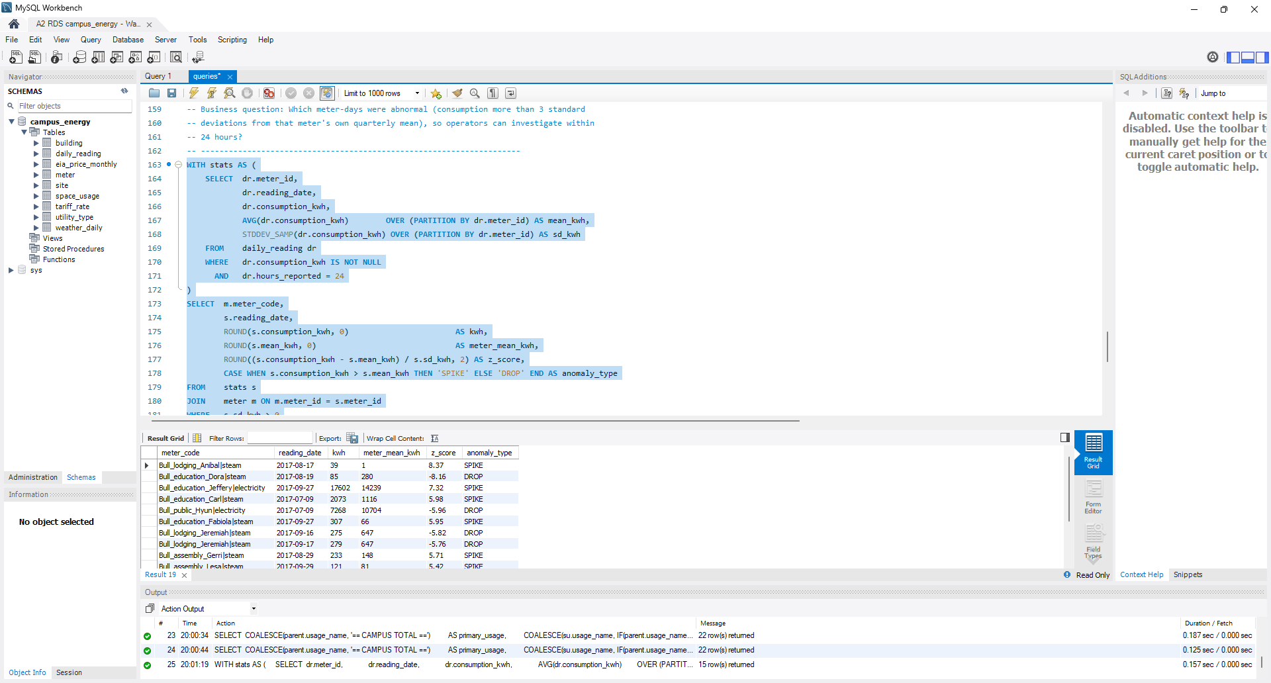
Screenshot 5.7 — Q7 executed on RDS with its result set.

Q8. RIGHT OUTER JOIN + LEFT OUTER JOIN, GROUP BY
Business question: For every tariff (utility x month) on file, what was the metered consumption and cost, and what market price was it based on? Tariffs with no readings must still appear (RIGHT JOIN), and steam has no EIA basis (LEFT JOIN -> NULL).
SELECT ut.utility_code,
tr.rate_month,
tr.unit_rate_usd,
e.price_cents_kwh AS eia_tx_commercial_cents,
tr.rate_basis,
COUNT(dr.reading_date) AS meter_days,
ROUND(COALESCE(SUM(dr.consumption_kwh), 0), 0) AS kwh,
ROUND(COALESCE(SUM(dr.consumption_kwh), 0) * tr.unit_rate_usd, 2) AS cost_usd
FROM daily_reading dr
JOIN meter m ON m.meter_id = dr.meter_id
RIGHT JOIN tariff_rate tr
ON tr.utility_type_id = m.utility_type_id
AND tr.rate_month = DATE_FORMAT(dr.reading_date, '%Y-%m-01')
JOIN utility_type ut ON ut.utility_type_id = tr.utility_type_id
LEFT JOIN eia_price_monthly e ON e.eia_price_id = tr.eia_price_id
GROUP BY ut.utility_code, tr.tariff_rate_id, tr.rate_month, tr.unit_rate_usd,
e.price_cents_kwh, tr.rate_basis
ORDER BY tr.rate_month, ut.utility_code;

Result: Every tariff on file has readings; steam shows a NULL EIA basis (assumed rate) via the LEFT JOIN.
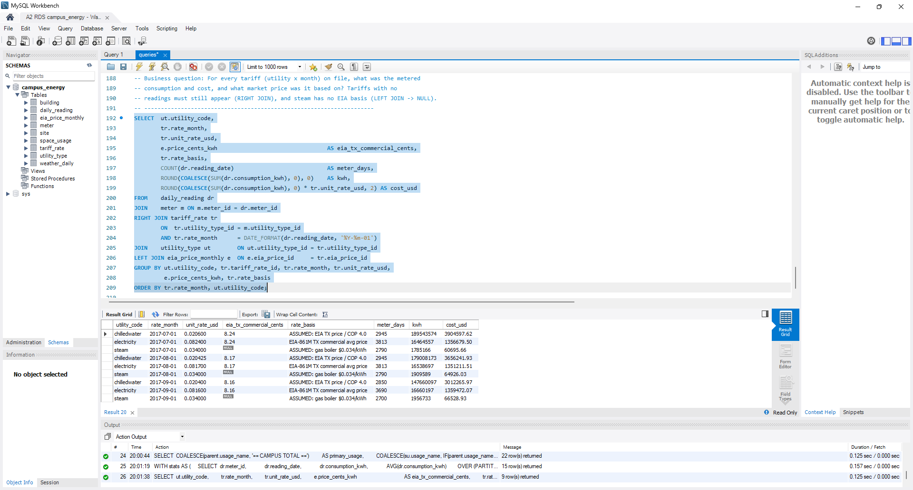
Screenshot 5.8 — Q8 executed on RDS with its result set.

Part 6 — Optimization, With Proof
Evidence: evidence/phase6_experiment.txt, captured on RDS MySQL 8.4.11 by an order-safe script (baseline, then three index hypotheses, each plan run 3 times; medians reported). A first before/after attempt was discarded because the index already existed when the baseline was taken.

6a. Execution plans — two most join-heavy queries
Q1 (7 tables) and Q5 (6 tables). Baseline plans (full text in Appendix A):
- Q1: daily_reading read via 'Index lookup on dr using PRIMARY (meter_id=m.meter_id)', rows=92 × loops=308 = 28,336 examined, 9,548 kept after the date filter; median 44.3 ms.
- Q5: tariff_rate joined before daily_reading through the non-sargable DATE_FORMAT condition, so rows=92 × loops=924 = 85,008 examined to produce 28,336; median 124 ms.

6b. Index hypothesis and before/after
Hypothesis H1: CREATE INDEX idx_dr_meter_date_kwh ON daily_reading (meter_id, reading_date, consumption_kwh); — a covering index on Q1's per-meter lookup path. Two alternatives were also tested.
Run set (RDS 8.4.11) | Access on daily_reading | Rows examined → kept | Q1 ms (3 runs) | Median
Baseline (PK only) | PRIMARY index lookup | 28,336 → 9,548 | 44.3 / 41.5 / 53.6 | 44.3
H1 (meter_id, reading_date, consumption_kwh) | unchanged — PRIMARY | 28,336 → 9,548 | 42.3 / 42.4 / 52.0 | 42.4
H2 (reading_date, meter_id, consumption_kwh) | unchanged — PRIMARY | 28,336 → 9,548 | 43.5 / 41.7 / 41.4 | 41.7
H3 tariff_rate (rate_month, utility_type_id, unit_rate_usd) | unchanged; join reordered (tr scan 9 rows → single-row lookup) | 28,336 → 9,548 | 41.8 / 42.0 / 42.9 | 42.0

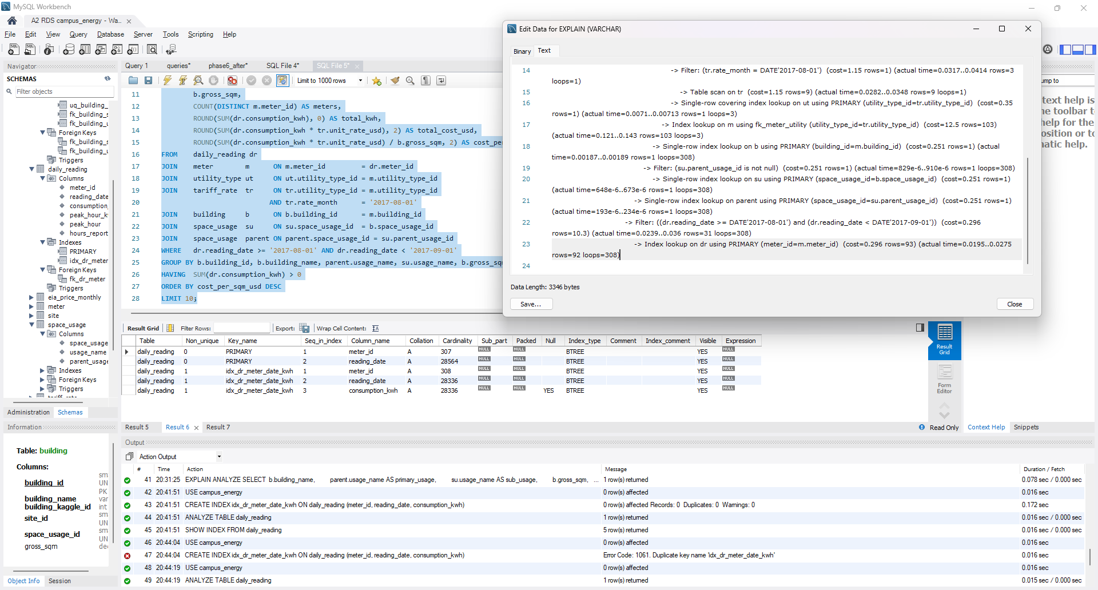
Screenshot 6.1 — After: idx_dr_meter_date_kwh exists (SHOW INDEX) but EXPLAIN ANALYZE still shows 'Index lookup on dr using PRIMARY … rows=92 loops=308'.

6c. Empirical analysis
On RDS MySQL 8.4.11, Q1's baseline plan reads daily_reading through the clustered primary key ('Index lookup on dr using PRIMARY (meter_id=m.meter_id)'), examining 92 rows × 308 loops = 28,336 rows and keeping only 31 per loop (9,548) after the date filter, for a median of 44.3 ms. The hypothesized covering index idx_dr_meter_date_kwh did not improve performance: the optimizer kept the PRIMARY lookup with the same 28,336 rows examined, and the 42.4 ms median sits inside the baseline's 41.5–53.6 ms run-to-run spread, because InnoDB's clustered key (meter_id, reading_date) already holds every column Q1 needs (secondary path costed 0.296 vs 0.297 per lookup) and a ref lookup can only use the equality prefix meter_id, so the August range is still applied as a filter. A date-leading index (H2, 41.7 ms) and a tariff_rate index (H3, 42.0 ms, which only reordered the 9-row tariff scan) left the daily_reading access unchanged as well. The plans show where the time actually goes — the join completes at 12.8 ms while sorting and grouping 9,548 rows runs from 30.2 to 41.3 ms — so the remaining cost is post-join work that no index on these tables removes; Q5's 85,008-row over-read is a query/schema issue (non-sargable DATE_FORMAT join), and no index was retained in production.

Part 7 — Cost, Teardown & Cloud Hygiene

7a. Billing
The instance ran from 18:56 to 21:15 CST on 2026-11-01 (≈2.3 hours; 2026-11-02 00:56–03:13 UTC). Estimated actual cost: db.t3.micro $0.017/h × 2.3 h ≈ $0.04, plus 20 GiB gp2 and public IPv4 ≈ $0.02, ≈ $0.06 total, covered by free-plan credits. A $1 monthly budget alarm was in place before any resource was created.
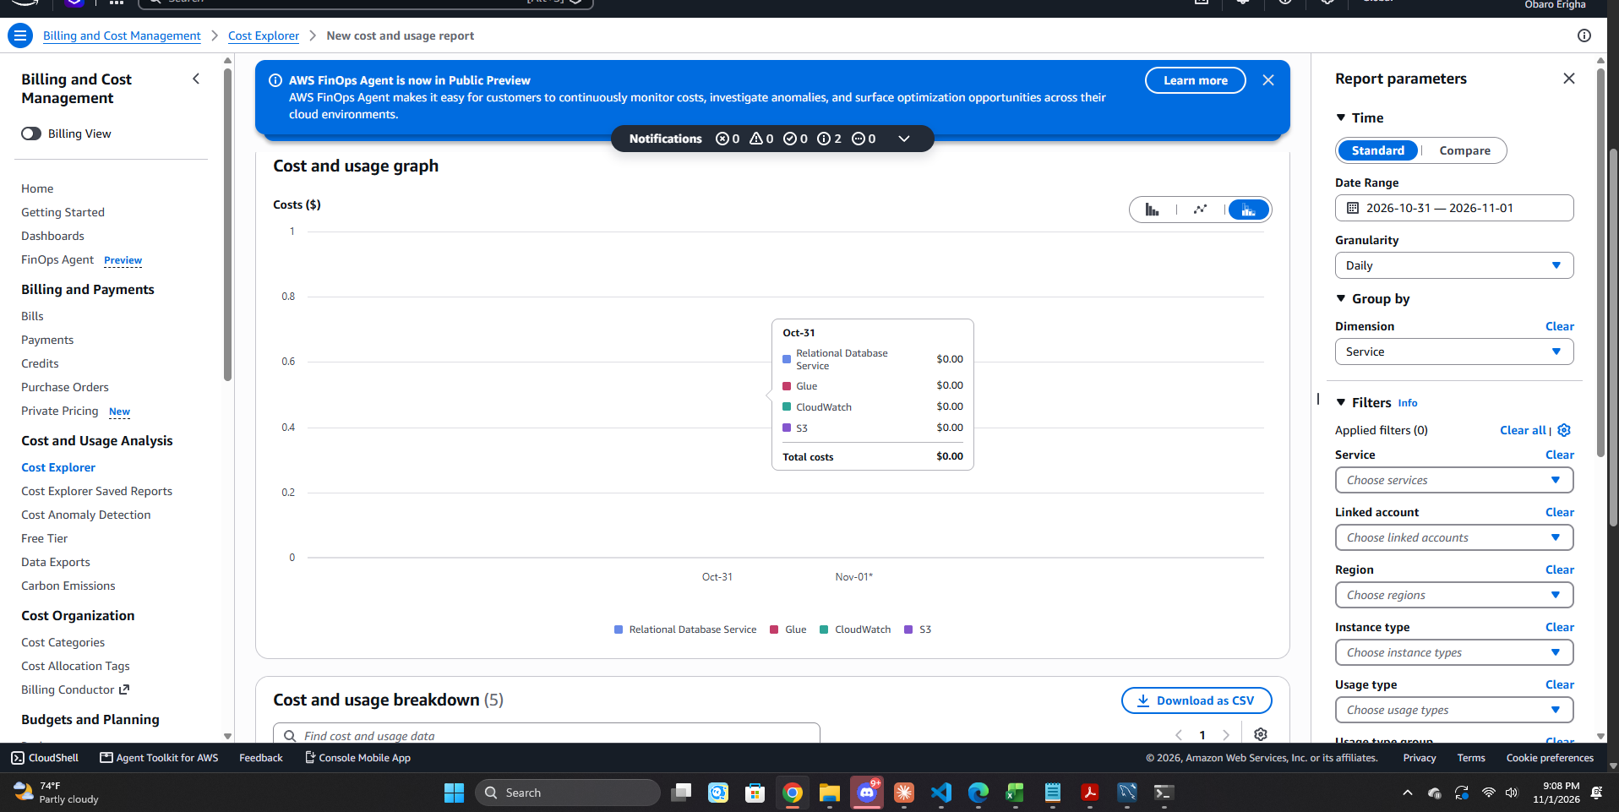
Screenshot 7.1 — Cost Explorer (daily, grouped by Service) listing Relational Database Service.
Note: AWS Cost Explorer data lags actual usage by up to 24 hours, and this account's usage is offset by free-plan credits; the screenshot was captured shortly before teardown, so the RDS line shows $0.00 rather than the ≈$0.06 incurred (which accrues to 2026-11-02 UTC).

7b. Teardown
aws rds delete-db-instance --db-instance-identifier a2-campus-energy --skip-final-snapshot --delete-automated-backups --region us-east-2
aws rds wait db-instance-deleted --db-instance-identifier a2-campus-energy --region us-east-2 # returned 21:15:12 CST
aws ec2 delete-security-group --group-id <sg> --region us-east-2 # returned True 21:15:22 CST

Post-teardown sweep: 0 RDS instances, 0 automated backups, 0 Elastic IPs; only the default security group remains.
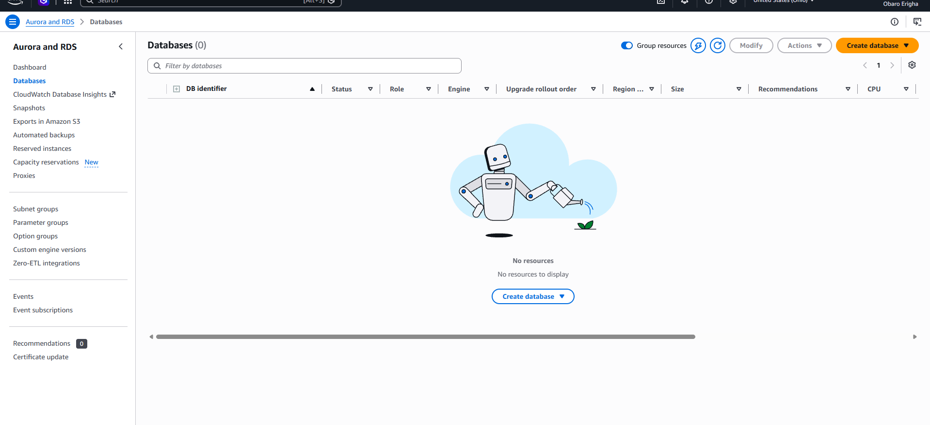
Screenshot 7.2 — RDS console, US East (Ohio): Databases (0) — instance deleted.

7c. Production 24/7 cost estimate
Component (us-east-2, MySQL) | Rate (AWS Pricing API) | Math | $/month
db.t3.micro Multi-AZ instance | $0.034/h | 0.034 × 730 h | $24.82
20 GiB gp3 storage, Multi-AZ | $0.23/GB-mo | 0.23 × 20 | $4.60
7-day automated backups | $0.095/GB-mo beyond free | ≤ 20 GB free (= provisioned storage) | $0.00
Public IPv4 | $0.005/h | 0 (private subnet in production) | $0.00
Total |  |  | ≈ $29.42 (≈ $353/yr)

Operating this database 24/7 in production as a Multi-AZ db.t3.micro with 20 GiB gp3 storage and 7-day backups would cost about $29.42 per month — $24.82 for the instance (0.034 × 730 h) plus $4.60 for storage (0.23 × 20 GB), with backups inside the free allowance — or roughly $353 per year in us-east-2. Because the platform's load is steady and always-on, purchasing a 1-year No-Upfront Reserved Instance ($0.0239/h) lowers the instance charge to $17.45 per month (−30%), bringing the total to about $22 per month with no upfront payment, while keeping the instance private and on MySQL 8.4 avoids the public-IPv4 and 8.0 Extended Support surcharges.

Appendix A — Full EXPLAIN ANALYZE Output (RDS MySQL 8.4.11)

Q1 — baseline (run 2 of 3)
-> Limit: 10 row(s) (actual time=41.5..41.5 rows=10 loops=1)
-> Sort: cost_per_sqm_usd DESC (actual time=41.5..41.5 rows=10 loops=1)
-> Filter: (`sum(daily_reading.consumption_kwh)` > 0) (actual time=30.4..41.4 rows=124 loops=1)
-> Stream results (actual time=30.4..41.4 rows=124 loops=1)
-> Group aggregate: sum(daily_reading.consumption_kwh), sum(tmp_field), sum(tmp_field), sum(daily_reading.consumption_kwh), count(distinct meter.meter_id) (actual time=30.4..41.3 rows=124 loops=1)
-> Sort: b.building_id, b.building_name, parent.usage_name, su.usage_name, b.gross_sqm (actual time=30.2..31.5 rows=9548 loops=1)
-> Stream results (cost=1122 rows=1078) (actual time=0.208..20.7 rows=9548 loops=1)
-> Nested loop inner join (cost=1122 rows=1078) (actual time=0.202..12.8 rows=9548 loops=1)
-> Nested loop inner join (cost=122 rows=103) (actual time=0.172..1.38 rows=308 loops=1)
-> Nested loop inner join (cost=85.9 rows=103) (actual time=0.17..1.27 rows=308 loops=1)
-> Nested loop inner join (cost=49.9 rows=103) (actual time=0.165..0.986 rows=308 loops=1)
-> Nested loop inner join (cost=14 rows=103) (actual time=0.16..0.499 rows=308 loops=1)
-> Nested loop inner join (cost=1.5 rows=1) (actual time=0.0362..0.0536 rows=3 loops=1)
-> Filter: (tr.rate_month = DATE'2017-08-01') (cost=1.15 rows=1) (actual time=0.0266..0.0347 rows=3 loops=1)
-> Table scan on tr (cost=1.15 rows=9) (actual time=0.0237..0.0294 rows=9 loops=1)
-> Single-row covering index lookup on ut using PRIMARY (utility_type_id=tr.utility_type_id) (cost=0.35 rows=1) (actual time=0.00562..0.00576 rows=1 loops=3)
-> Index lookup on m using fk_meter_utility (utility_type_id=tr.utility_type_id) (cost=12.5 rows=103) (actual time=0.12..0.141 rows=103 loops=3)
-> Single-row index lookup on b using PRIMARY (building_id=m.building_id) (cost=0.251 rows=1) (actual time=0.00141..0.00143 rows=1 loops=308)
-> Filter: (su.parent_usage_id is not null) (cost=0.251 rows=1) (actual time=674e-6..751e-6 rows=1 loops=308)
-> Single-row index lookup on su using PRIMARY (space_usage_id=b.space_usage_id) (cost=0.251 rows=1) (actual time=545e-6..570e-6 rows=1 loops=308)
-> Single-row index lookup on parent using PRIMARY (space_usage_id=su.parent_usage_id) (cost=0.251 rows=1) (actual time=180e-6..205e-6 rows=1 loops=308)
-> Filter: ((dr.reading_date >= DATE'2017-08-01') and (dr.reading_date < DATE'2017-09-01')) (cost=0.297 rows=10.5) (actual time=0.0233..0.0351 rows=31 loops=308)
-> Index lookup on dr using PRIMARY (meter_id=m.meter_id) (cost=0.297 rows=94.6) (actual time=0.0191..0.0268 rows=92 loops=308)

Q1 — after index H1 idx_dr_meter_date_kwh (run 2 of 3)
-> Limit: 10 row(s) (actual time=42.4..42.4 rows=10 loops=1)
-> Sort: cost_per_sqm_usd DESC (actual time=42.4..42.4 rows=10 loops=1)
-> Filter: (`sum(daily_reading.consumption_kwh)` > 0) (actual time=31..42.3 rows=124 loops=1)
-> Stream results (actual time=31..42.3 rows=124 loops=1)
-> Group aggregate: sum(daily_reading.consumption_kwh), sum(tmp_field), sum(tmp_field), sum(daily_reading.consumption_kwh), count(distinct meter.meter_id) (actual time=31..42.2 rows=124 loops=1)
-> Sort: b.building_id, b.building_name, parent.usage_name, su.usage_name, b.gross_sqm (actual time=30.8..32.2 rows=9548 loops=1)
-> Stream results (cost=1104 rows=1059) (actual time=0.202..20.8 rows=9548 loops=1)
-> Nested loop inner join (cost=1104 rows=1059) (actual time=0.196..12.8 rows=9548 loops=1)
-> Nested loop inner join (cost=122 rows=103) (actual time=0.165..1.42 rows=308 loops=1)
-> Nested loop inner join (cost=85.9 rows=103) (actual time=0.163..1.31 rows=308 loops=1)
-> Nested loop inner join (cost=49.9 rows=103) (actual time=0.159..1.02 rows=308 loops=1)
-> Nested loop inner join (cost=14 rows=103) (actual time=0.153..0.494 rows=308 loops=1)
-> Nested loop inner join (cost=1.5 rows=1) (actual time=0.0323..0.05 rows=3 loops=1)
-> Filter: (tr.rate_month = DATE'2017-08-01') (cost=1.15 rows=1) (actual time=0.0238..0.0318 rows=3 loops=1)
-> Table scan on tr (cost=1.15 rows=9) (actual time=0.0209..0.0263 rows=9 loops=1)
-> Single-row covering index lookup on ut using PRIMARY (utility_type_id=tr.utility_type_id) (cost=0.35 rows=1) (actual time=0.0054..0.00544 rows=1 loops=3)
-> Index lookup on m using fk_meter_utility (utility_type_id=tr.utility_type_id) (cost=12.5 rows=103) (actual time=0.12..0.14 rows=103 loops=3)
-> Single-row index lookup on b using PRIMARY (building_id=m.building_id) (cost=0.251 rows=1) (actual time=0.00155..0.00157 rows=1 loops=308)
-> Filter: (su.parent_usage_id is not null) (cost=0.251 rows=1) (actual time=678e-6..755e-6 rows=1 loops=308)
-> Single-row index lookup on su using PRIMARY (space_usage_id=b.space_usage_id) (cost=0.251 rows=1) (actual time=551e-6..576e-6 rows=1 loops=308)
-> Single-row index lookup on parent using PRIMARY (space_usage_id=su.parent_usage_id) (cost=0.251 rows=1) (actual time=190e-6..216e-6 rows=1 loops=308)
-> Filter: ((dr.reading_date >= DATE'2017-08-01') and (dr.reading_date < DATE'2017-09-01')) (cost=0.296 rows=10.3) (actual time=0.0235..0.0351 rows=31 loops=308)
-> Index lookup on dr using PRIMARY (meter_id=m.meter_id) (cost=0.296 rows=92.8) (actual time=0.0193..0.027 rows=92 loops=308)

Q5 — baseline (run 2 of 3)
-> Table scan on <temporary> (cost=2.5..2.5 rows=0) (actual time=124..124 rows=22 loops=1)
-> Temporary table (cost=0..0 rows=0) (actual time=124..124 rows=22 loops=1)
-> Group aggregate with rollup: sum(tmp_field), count(distinct building.building_id) (actual time=94.5..124 rows=22 loops=1)
-> Sort: usage_name, usage_name (actual time=94.4..97.2 rows=28336 loops=1)
-> Stream results (cost=9409 rows=87365) (actual time=0.0865..71.3 rows=28336 loops=1)
-> Nested loop inner join (cost=9409 rows=87365) (actual time=0.08..52.5 rows=28336 loops=1)
-> Nested loop inner join (cost=408 rows=924) (actual time=0.0488..1.92 rows=924 loops=1)
-> Nested loop inner join (cost=161 rows=308) (actual time=0.0389..0.547 rows=308 loops=1)
-> Nested loop inner join (cost=99.5 rows=124) (actual time=0.0335..0.246 rows=124 loops=1)
-> Nested loop inner join (cost=56 rows=124) (actual time=0.0307..0.19 rows=124 loops=1)
-> Covering index scan on b using fk_building_usage (cost=12.7 rows=124) (actual time=0.0199..0.0678 rows=124 loops=1)
-> Filter: (su.parent_usage_id is not null) (cost=0.251 rows=1) (actual time=707e-6..804e-6 rows=1 loops=124)
-> Single-row index lookup on su using PRIMARY (space_usage_id=b.space_usage_id) (cost=0.251 rows=1) (actual time=548e-6..573e-6 rows=1 loops=124)
-> Single-row index lookup on parent using PRIMARY (space_usage_id=su.parent_usage_id) (cost=0.251 rows=1) (actual time=230e-6..271e-6 rows=1 loops=124)
-> Covering index lookup on m using uq_meter_building_utility (building_id=b.building_id) (cost=0.252 rows=2.48) (actual time=0.00159..0.00219 rows=2.48 loops=124)
-> Index lookup on tr using uq_tariff_utility_month (utility_type_id=m.utility_type_id) (cost=0.501 rows=3) (actual time=0.00358..0.0042 rows=3 loops=308)
-> Filter: (tr.rate_month = cast(date_format(dr.reading_date,'%Y-%m-01') as date)) (cost=0.297 rows=94.6) (actual time=0.0297..0.053 rows=30.7 loops=924)
-> Index lookup on dr using PRIMARY (meter_id=m.meter_id) (cost=0.297 rows=94.6) (actual time=0.0185..0.0262 rows=92 loops=924)

Q5 — with index H1 (run 1)
-> Table scan on <temporary> (cost=2.5..2.5 rows=0) (actual time=123..123 rows=22 loops=1)
-> Temporary table (cost=0..0 rows=0) (actual time=123..123 rows=22 loops=1)
-> Group aggregate with rollup: sum(tmp_field), count(distinct building.building_id) (actual time=95.2..123 rows=22 loops=1)
-> Sort: usage_name, usage_name (actual time=95..97.7 rows=28336 loops=1)
-> Stream results (cost=9250 rows=85779) (actual time=0.112..71.4 rows=28336 loops=1)
-> Nested loop inner join (cost=9250 rows=85779) (actual time=0.105..52.5 rows=28336 loops=1)
-> Nested loop inner join (cost=408 rows=924) (actual time=0.0707..1.96 rows=924 loops=1)
-> Nested loop inner join (cost=161 rows=308) (actual time=0.0558..0.571 rows=308 loops=1)
-> Nested loop inner join (cost=99.5 rows=124) (actual time=0.0482..0.272 rows=124 loops=1)
-> Nested loop inner join (cost=56 rows=124) (actual time=0.0442..0.212 rows=124 loops=1)
-> Covering index scan on b using fk_building_usage (cost=12.7 rows=124) (actual time=0.0275..0.0826 rows=124 loops=1)
-> Filter: (su.parent_usage_id is not null) (cost=0.251 rows=1) (actual time=760e-6..859e-6 rows=1 loops=124)
-> Single-row index lookup on su using PRIMARY (space_usage_id=b.space_usage_id) (cost=0.251 rows=1) (actual time=602e-6..629e-6 rows=1 loops=124)
-> Single-row index lookup on parent using PRIMARY (space_usage_id=su.parent_usage_id) (cost=0.251 rows=1) (actual time=249e-6..298e-6 rows=1 loops=124)
-> Covering index lookup on m using uq_meter_building_utility (building_id=b.building_id) (cost=0.252 rows=2.48) (actual time=0.00155..0.00215 rows=2.48 loops=124)
-> Index lookup on tr using uq_tariff_utility_month (utility_type_id=m.utility_type_id) (cost=0.501 rows=3) (actual time=0.00363..0.00424 rows=3 loops=308)
-> Filter: (tr.rate_month = cast(date_format(dr.reading_date,'%Y-%m-01') as date)) (cost=0.296 rows=92.8) (actual time=0.0299..0.053 rows=30.7 loops=924)
-> Index lookup on dr using PRIMARY (meter_id=m.meter_id) (cost=0.296 rows=92.8) (actual time=0.0185..0.0261 rows=92 loops=924)

Appendix B — Notes, Reproducibility and Deliverables

Footnote: cost scale vs. Assignment 1
Assignment 1 valued campus electricity at about $5.4M per year. With real BDG2 consumption and real EIA prices, electricity alone totals $4,067,363 for the July–September 2017 quarter (Q8), and the full quarter across all utilities is $14,832,619.22 (chilled water dominates at ≈ 516 GWh-thermal priced at an assumed chiller COP of 4.0). Summer is Austin's peak season, so an annual figure would be lower than 4× the quarter, but the A1 estimate was clearly conservative; A1 is submitted and unchanged, and A2's figures supersede it.

Assumptions behind the cost figures
- Chilled water rate = TX commercial electricity price ÷ COP 4.0; steam = $0.034/kWh (≈ $8/MMBtu gas ÷ 0.8 boiler efficiency). Both are assumptions, flagged in the data (rate_basis column).

Deliverables
File | Purpose
A2_campus_energy.sql | DDL, load verification, 8 commented queries, Part 6 EXPLAIN + index commands
normalization_workbook.xlsx | Tabs 1NF / 2NF / 3NF with keys, FDs, real sample rows
scripts/build_flat_table.py | Option B: reproducible construction of the flat table from BDG2 + EIA
scripts/normalize.py, scripts/load_3nf.py | 3NF decomposition (lossless check) and RDS loader
design/*.mmd, *.png | Editable ER diagram sources and renders
evidence/phase6_experiment.txt | Raw RDS execution plans

Peer review (optional bonus)
[Add peer review here if submitting for the +5 bonus.]

