Assignment 1: An analysis of the relationship between age and self-reported health level

Oles Matiushenko

2025-01-26

## Introduction

In this report, I investigate the relationship between age and self-reported level of health. Anecdotal evidence suggests that physical health declines as we get older. I indend to verify if this is indeed the case using the National Health and Nutrition Examination Study data.

## The Set-up

I will be using two variables from the NHANES dataset for the analysis: *Age*, which is a continuous numeric variable, and *HealthGen*, which is a categorical variable. The relationship between the chosen variables can be best illustrated with a box plot. Box plots show the distribution of the continuous variable and allow for easy comparison across categories.

## Results

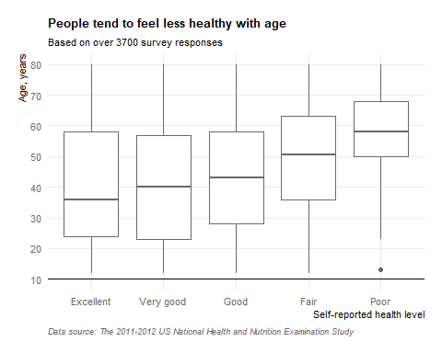

The graph clearly demonstrates that younger people tend to feel healthier than older people. An increase in the median age from left to right is consistent with the declining health; the median age of respondents increases from 36.0 (IQR 34.0) years in the “Excellent” health category to 58.0 (IQR 18.0) years in the “Poor” health category.

The median (and, especially, the mean) age of the subjects who consider themselves to be in “Excellent”, “Very good”, or “Good” health condition is relatively similar (Table 1). A pronounced increase in the median age occurs between “Good” and “Fair” health condition categories and, again, between “Fair” and “Poor” health condition categories.

Age of the subjects in the “Poor” health category is noticeably less spread out than in other categories. Apart from a single very young outlier, most data points sit closely around the median.

