WT

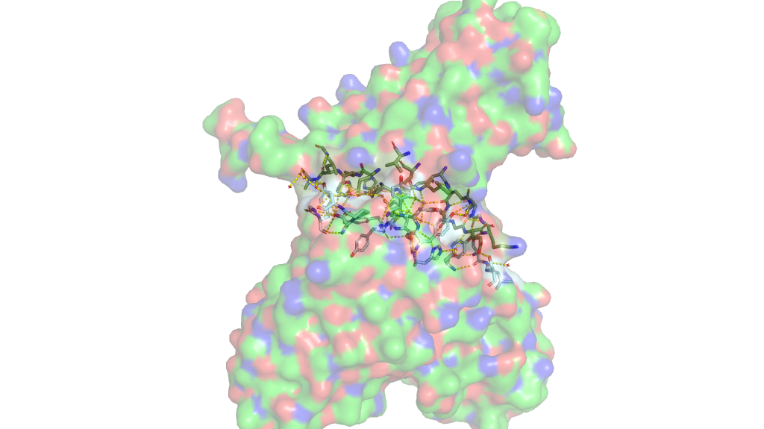

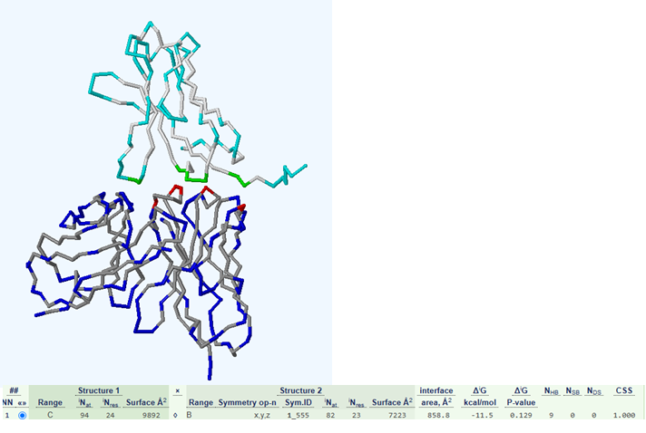
Figure 1ePISA

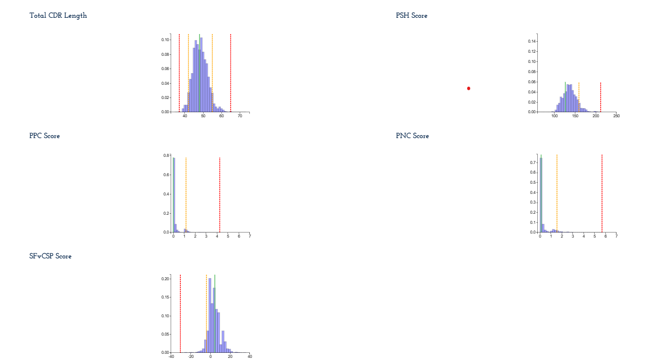

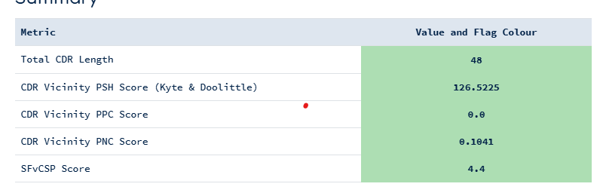
Figure 2SabPred
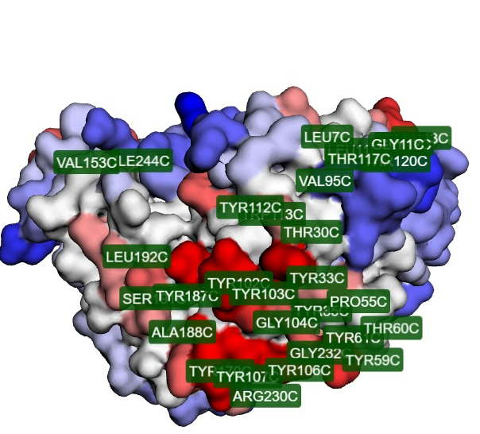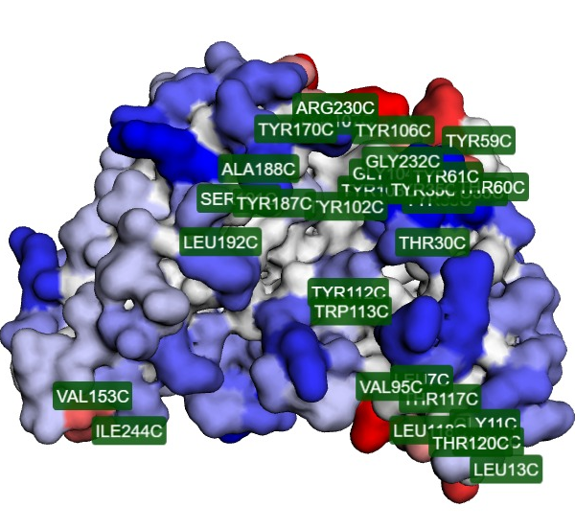

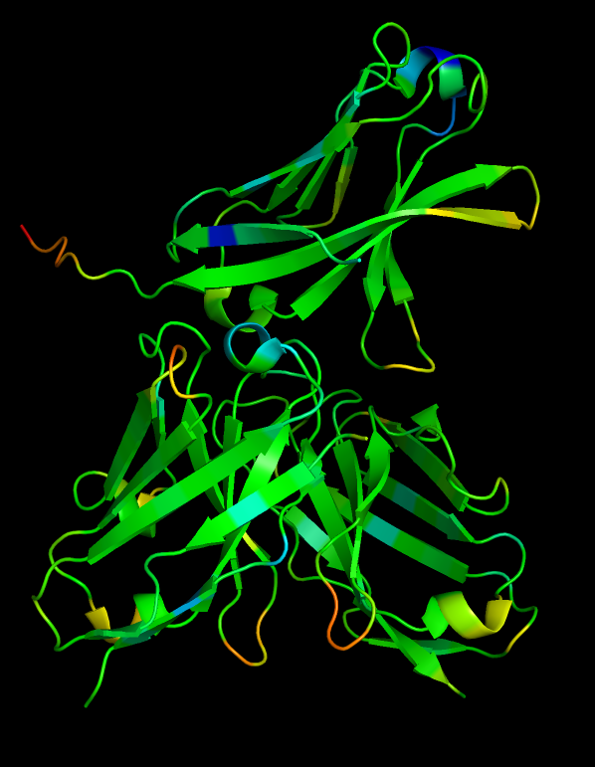

Figure 3. Solubility by CamSole Structure corrected, left (red -low, blue-high). Solubility by CamSole, right (red -low, blue-high)

Design 1 (d0 n0)

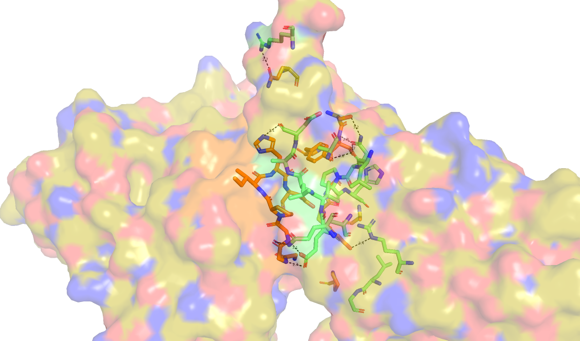

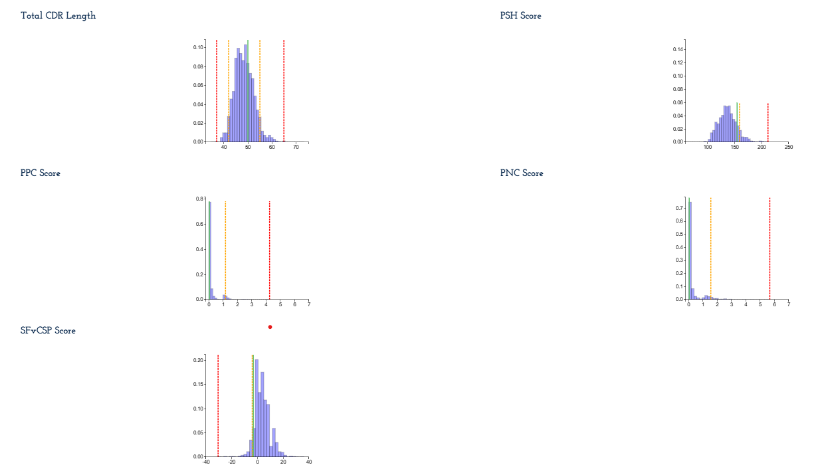

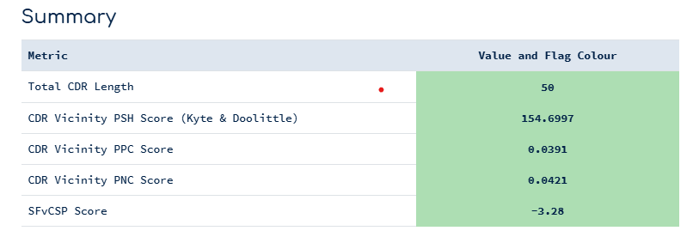

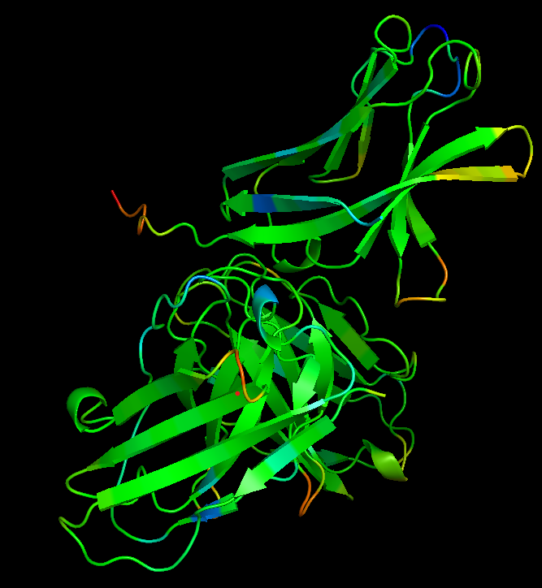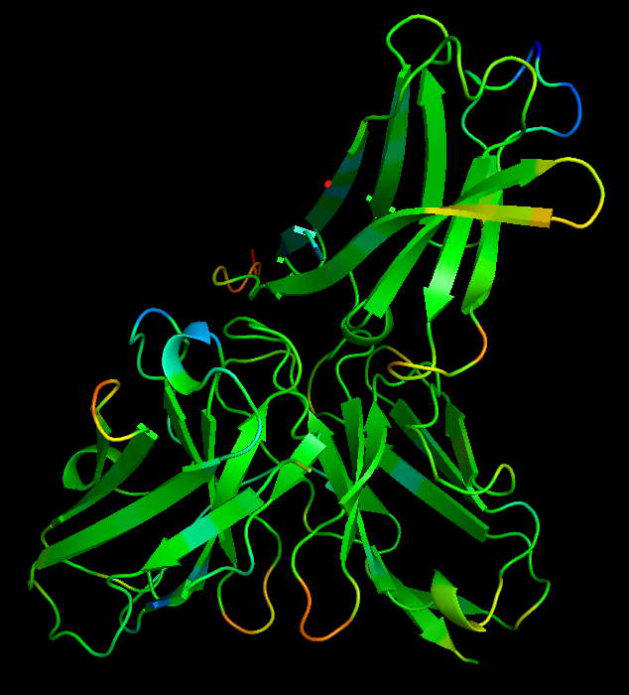

Overall : this design does not look more convincing than the structure. The least incoluble region appear to be removed from CDRs (to look at Ab only structure pay attention to structure not corrected version)
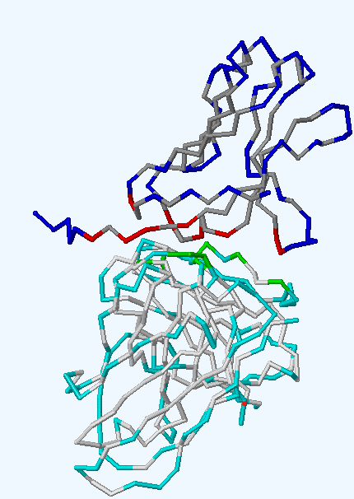

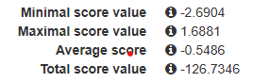
poo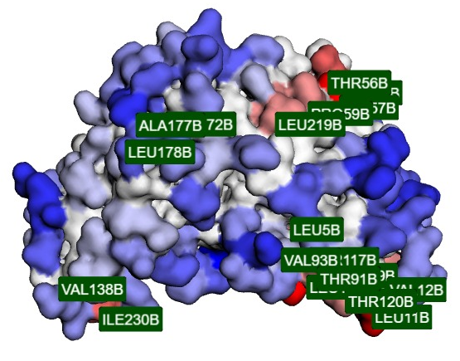 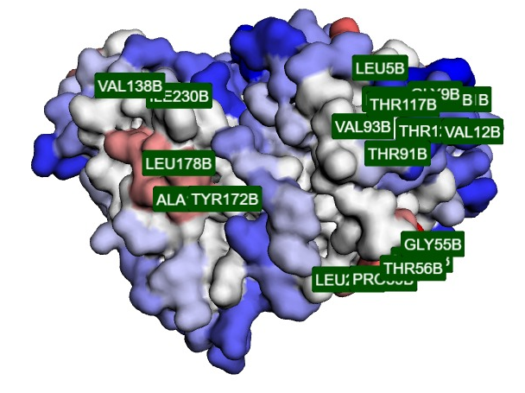
Figure 4. Developability: https://biocomp.chem.uw.edu.pl/A3D2/job/da6039c74cd3094/best loction to stay in buenos aires

