Supplementary Information

Figures
S1. Calibration curves
S2. Modeled erosion perennial streams
S3. Modeled erosion ephemeral streams

Tables
S1. Model inputs and sources
S2. CPT
S3. Calibration
S4. Breakpoint bin ranges
S5. Subwatershed characteristics

Figures

Model code:
The model code can be found here:
https://bitbucket.org/integratedmodelling/org.aries.oc/src/master/ and is embedded in the ARIES (Artificial Intelligence for Ecosystem Services system). To run it requires k.LAB version 0.9.11.

Calibration Figures

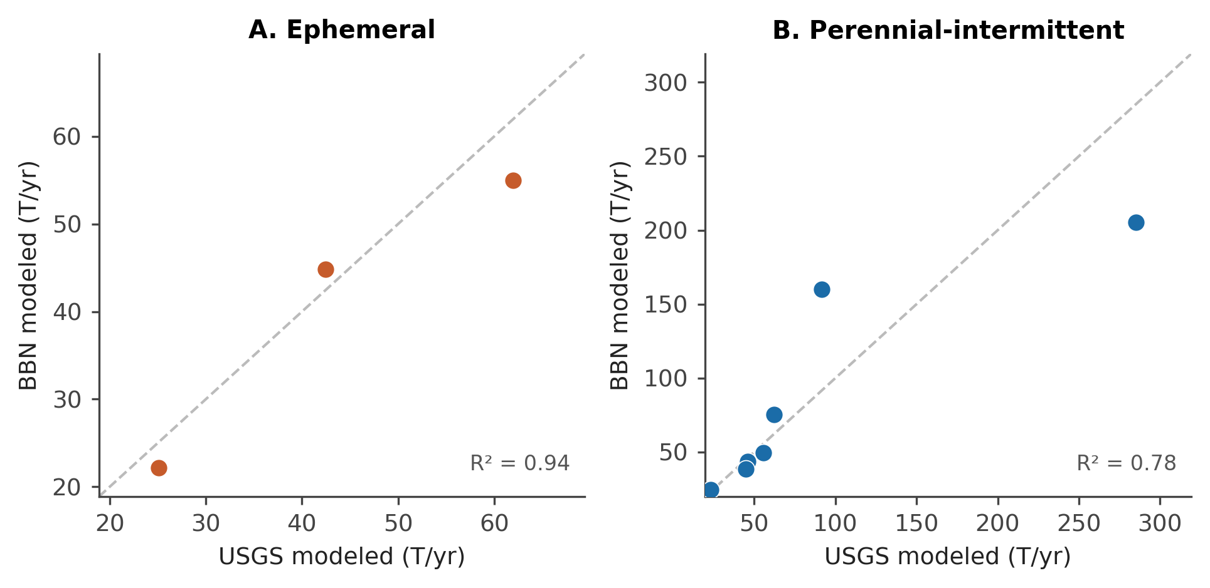
Figure S1. Calibration curves for bank erosion in (A) ephemeral (R² = 0.94) and (B) perennial-intermittent (R² = 0.78) subwatersheds in West Maui measured in metric tonnes per annum (T/yr). Given the limited number of watersheds (particularly ephemeral ones), R² is inevitably high, so would benefit from further experimental work elsewhere to better determine the strength and transferability of these relationships.
A.

B.

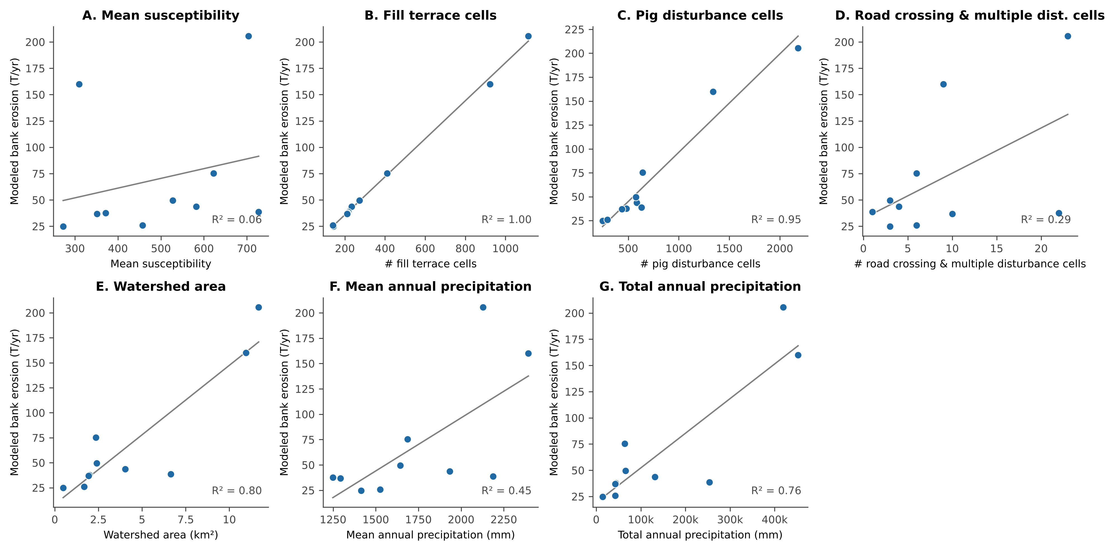
Figure S2. Modeled bank erosion vs. watershed characteristics for perennial-intermittent watersheds. Watershed characteristics: A. mean susceptibility; B. # fill terrace cells; C. # pig disturbance only cells; D # road crossing & multiple disturbance cells; E. watershed area (km2); F. mean annual precipitation (mm); G. total annual precipitation (mm).
A.

B.

C.

D.

E.

F.

G.

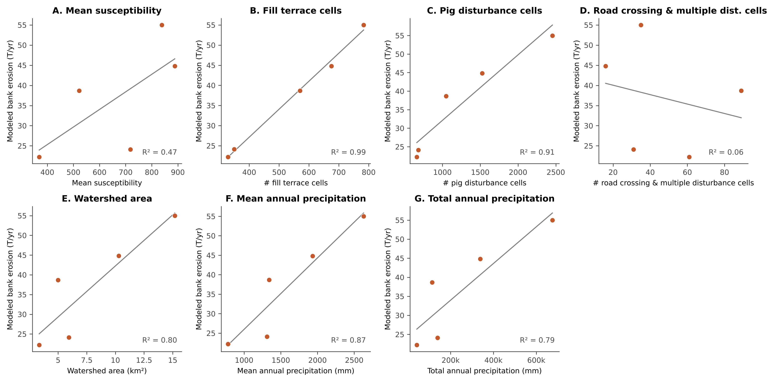
Figure S3. Modeled bank erosion vs. watershed characteristics ephemeral watersheds A. vs. mean susceptibility, B. vs. # fill terrace cells, C. vs. # pig disturbance only cells. D # road crossing & multiple disturbance cells, E. vs. watershed area (km2), F. vs. mean annual precipitation (mm), G. vs. vs. total annual precipitation (mm).

A.

B.

C.

D.

E.

F.

G.

Tables

Table S1. Model inputs and sources
Data input (spatial resolution) | Source | Model component
Fill terrace presence/absence (2.4 m) | U.S. Geological Survey (USGS) https://www.sciencebase.gov/catalog/item/58213484e4b08f3b91767f13 | Bayesian belief network (BBN)
Susceptibility map (10 m) | USGS https://www.sciencebase.gov/catalog/item/58213484e4b08f3b91767f13 | BBN
Streams | Derived from USGS National Elevation Dataset (NED) using ArcHydro 3000 https://www.sciencebase.gov/catalog/item/58213484e4b08f3b91767f13 | BBN
Watersheds (2.4 m) | Hawaiʻi Department of Aquatic Resources (DAR) | BBN
Agricultural roads | Falinski 2016. Derived from WorldView2. | Disturbance layer input
Pig exposure | Hawaiʻi Department of Fish and Wildlife (DOFAW) | Disturbance layer input
Agricultural Zone | Derived from State Land Use Designation Maps http://luc.hawaii.gov/maps/land-use-district-boundary-maps/state-of-hawaii-land-use-district-boundaries-map/ | Disturbance layer input
Road crossings | Intersection of Agricultural roads and Streams, within Agricultural Zone, as defined in this table | Disturbance layer input
Disturbance | Interaction of Pig exposure and Road crossings | BBN
Bank exposure function | Expert elicited function based on empirical estimates | Deterministic function
Management measures | Map of where measures are placed on the landscape | post-BBN

Table S2. Conditional probability table of expected bank erosion under each combination of input variables. Probabilities of each combination of input variables are read horizontally and sum to 1. Probabilities derived from expert elicitation and logical consistency check.
Fill Terraces | Susceptibility | Disturbance | Bank Erosion
 |  |  | Very High | High | Moderate | Low | Very Low
Present | High | FeralPigs | 0.65 | 0.35 | 0 | 0 | 0
Present | High | RoadCrossing | 0.8 | 0.2 | 0 | 0 | 0
Present | High | MultipleDisturbance | 0.85 | 0.15 | 0 | 0 | 0
Present | High | Undisturbed | 0.6 | 0.4 | 0 | 0 | 0
Present | Moderate | FeralPigs | 0.55 | 0.4 | 0.05 | 0 | 0
Present | Moderate | RoadCrossing | 0.7 | 0.3 | 0 | 0 | 0
Present | Moderate | MultipleDisturbance | 0.75 | 0.25 | 0 | 0 | 0
Present | Moderate | Undisturbed | 0.5 | 0.4 | 0.1 | 0 | 0
Present | Low | FeralPigs | 0.45 | 0.4 | 0.15 | 0 | 0
Present | Low | RoadCrossing | 0.6 | 0.4 | 0 | 0 | 0
Present | Low | MultipleDisturbance | 0.65 | 0.35 | 0 | 0 | 0
Present | Low | Undisturbed | 0.4 | 0.4 | 0.2 | 0 | 0
Absent | High | FeralPigs | 0 | 0 | 0 | 0.3 | 0.7
Absent | High | RoadCrossing | 0 | 0 | 0 | 0.45 | 0.55
Absent | High | MultipleDisturbance | 0 | 0 | 0 | 0.5 | 0.5
Absent | High | Undisturbed | 0 | 0 | 0 | 0 | 1
Absent | Moderate | FeralPigs | 0 | 0 | 0 | 0.2 | 0.8
Absent | Moderate | RoadCrossing | 0 | 0 | 0 | 0.35 | 0.65
Absent | Moderate | MultipleDisturbance | 0 | 0 | 0 | 0.4 | 0.6
Absent | Moderate | Undisturbed | 0 | 0 | 0 | 0 | 1
Absent | Low | FeralPigs | 0 | 0 | 0 | 0.1 | 0.9
Absent | Low | RoadCrossing | 0 | 0 | 0 | 0.25 | 0.75
Absent | Low | MultipleDisturbance | 0 | 0 | 0 | 0.3 | 0.7
Absent | Low | Undisturbed | 0 | 0 | 0 | 0 | 1

Table S3. Model calibration for bank erosion across the 15 West Maui subwatersheds. Subwatersheds are listed from north to south. Estimated annual bank erosion taken in metric tons per annum (tons/yr) from (Stock and Cerovski-Darriau, 2021).
ID | Subwatershed Name | Estimated annual bank erosion, tons/yr | Modeled, calibrated bank erosion, tons/yr | % difference, modeled vs. reconnaissance sediment budget
1 | Honolua Streamª | 91 | 159.9 | 75.0%
2 | Mokule'ia Bayª | 23 | 24.7 | 6.4%
3 | Kanauiki^{b} | 27 | 25.9 | -4.0%
4 | Mokupe'a Gulchª | 46 | 43.7 | -4.7%
5 | Honokahua Streamª | 45 | 38.7 | -13.9%
6 | Napili 2-3^{b} | 44 | 37.7 | -13.7%
7 | Napili 4-5ª | 56 | 49.6 | -11.0%
8 | Honokeana^{b} | 43 | 36.9 | -13.4%
9 | Ka'Opala Gulchª | 62 | 75.3 | 21.4%
10 | Kahana Streamª | 285 | 205.5 | -27.9%
11 | Mahinahina^{d} | 45 | 38.7 | -13.8%
12 | Honokowai Stream^{c} | 62 | 55.0 | -11.3%
13 | Hanakaoo^{d} | 26 | 24.1 | -6.8%
14 | Ka'anapali-Kahua^{c} | 25 | 22.2 | -11.6%
15 | Wahikuli Gulch^{c} | 42 | 44.8 | 5.6%
 | Total | 922 | 882.7 | -4.3%
ªPerennial-intermittent validation subwatershed
^{b}Perennial-intermittent calibration subwatershed
^{c}Ephemeral validation subwatershed
^{d}Ephemeral calibration subwatershed

Table S4. Model break point bin ranges (lower and upper bound, mean of bin) for northern and southern watersheds in metric tons per hectare per annum (tons/ha/yr) and associated stream bank lowering rates (mm/yr). Informed by average lowering rate estimates of 5 mm/yr (southern watersheds) and 14 mm/yr (northern watersheds) (Stock and Cerovski-Darriau, 2021). VL = very low; L = low; M = moderate; H = high; VH = very high.

 |  | Southern |  |  | Northern
Erosion bins | Level | Lower bound | Upper bound | Ave | Lower bound | Upper bound | Ave
T/ha/yr | VL | 0 | 0 | 0 | 0 | 0 | 0
 | L | 0 | 1 | 0.5 | 0 | 2.6 | 1.3
 | M | 1 | 3.8 | 2.4 | 2.6 | 10.2 | 6.4
 | H | 3.8 | 7.6 | 5.7 | 10.2 | 20.8 | 15.5
 | VH | 7.6 | 9.4 | 8.5 | 20.8 | 25.7 | 23.25
Lowering rates
mm/yr | VL | 0.0 | 0.0 | 0.0 | 0.0 | 0.0 | 0.0
 | L | 0.0 | 0.8 | 0.4 | 0.0 | 2.0 | 1.0
 | M | 0.8 | 2.9 | 1.8 | 2.0 | 7.8 | 4.9
 | H | 2.9 | 5.8 | 4.4 | 7.8 | 16.0 | 11.9
 | VH | 5.8 | 7.2 | 6.5 | 16.0 | 19.8 | 17.9

Table S5. Subwatershed characteristics. Subwatersheds are listed from north to south. Erosion is measured in metric tonnes per annum (tons/yr). Empirical model estimates (Empirical column) taken from (Stock and Cerovski-Darriau, 2021), who extrapolated from four cross-sections.
 | Erosion (tons/yr)
 | Empirical | Modeled | Summed susceptibility | Mean susceptibility | # fill terrace cells | # pig disturbance cells | # road crossing & multiple disturbance cells | Watershed area (km2) | Mean annual precipitation (mm) | Total annual precipitation (mm)
Honolua Streamª | 91 | 159.9 | 1,711,589 | 309.8 | 923 | 1,340 | 9 | 10.96 | 2,394 | 452,453
Mokuleʻia Bayª | 23 | 24.7 | 78,771 | 272.6 | 143 | 246 | 3 | 0.48 | 1,415 | 14,147
Kanauiki^{b} | 27 | 25.9 | 129,334 | 457.0 | 140 | 295 | 6 | 1.68 | 1,526 | 42,726
Mokupeʻa Gulchª | 46 | 43.7 | 337,702 | 582.2 | 234 | 585 | 4 | 4.03 | 1,934 | 131,512
Honokahua Streamª | 45 | 38.7 | 821,215 | 727.4 | 217 | 631 | 1 | 6.65 | 2,188 | 253,792
Napili 2-3^{b} | 44 | 37.7 | 207,829 | 371.8 | 213 | 482 | 22 | 1.98 | 1,249 | 43,707
Napili 4-5ª | 56 | 49.6 | 312,854 | 527.6 | 273 | 575 | 3 | 2.41 | 1,644 | 65,744
Honokeana^{b} | 43 | 36.9 | 159,793 | 351.2 | 211 | 438 | 10 | 1.94 | 1,294 | 42,691
Kaʻopala Gulchª | 62 | 75.3 | 429,051 | 622.7 | 410 | 642 | 6 | 2.36 | 1,686 | 64,076
Kahana Streamª | 285 | 205.5 | 2,262,148 | 703.4 | 1,114 | 2,180 | 23 | 11.68 | 2,128 | 419,288
Mahinahina^{d} | 45 | 38.7 | 744,514 | 522.1 | 570 | 1,048 | 89 | 5.00 | 1,341 | 113,993
Honokowai Stream^{c} | 62 | 55.0 | 3,314,048 | 838.6 | 783 | 2,455 | 35 | 15.18 | 2,628 | 675,403
Hanakaoo^{d} | 26 | 24.1 | 872,329 | 718.0 | 350 | 682 | 31 | 5.94 | 1,311 | 138,921
Kaʻanapali-Kahua^{c} | 25 | 22.2 | 331,261 | 368.9 | 329 | 661 | 61 | 3.35 | 781 | 42,156
Wahikuli Gulch^{c} | 42 | 44.8 | 2,256,235 | 888.3 | 675 | 1,526 | 16 | 10.29 | 1,932 | 338,058
Totals | 922 | 882.7 |  |  | 6,585 | 13,786 | 319 | 83.93
ªPerennial-intermittent validation subwatershed
^{b}Perennial-intermittent calibration subwatershed
^{c}Ephemeral validation subwatershed
^{d}Ephemeral calibration subwatershed

Data Processing
1. Fill Terraces
We coded the presence or absence of fill terraces using their spatial distribution determined by (Stock and Cerovski-Darriau, 2021) from walking the stream channel in three subwatersheds spanning the wet to dry side (Cerovski-Darriau and Stock, 2021). USGS mapping found fill terraces were only present adjacent to or downstream of agricultural fields, and within that zone, spanned 40% of the stream length regardless of rainfall or stream flow frequency type (i.e., ephemeral, intermittent, or perennial). Therefore, in the remaining 12 subwatersheds we probabilistically distributed fill terraces within 40% of the anthropogenically modified zones based on the mapping data. When fill terraces are absent, we assume that erosion does not produce sediment during small annual events (Stock and Cerovski-Darriau, 2021).

2. Susceptibility
We estimated the susceptibility of banks to erosion by using water stresses from stream flow as a proxy (Supplementary Information, Stream Flow Force). We estimated this force using a steady uniform flow approximation of reach averaged shear stress (τ_{b}), calculated for a given location based on approximations for hydraulic radius using upslope drainage area, and channel slope using the 10-m digital elevation model (Table S1) (Stock and Cerovski-Darriau, 2021).

3. Disturbances
We considered road crossings and feral pig disturbance within the BBN disturbance node (Figure 3). We described disturbance using four categories: (1) No disturbance, (2) Only pig disturbance, (3) Only road crossings, and (4) Multiple disturbances from pigs and road crossings. We defined road crossings as the intersection of agricultural roads and streams. Road crossings co-located with fill terraces in the modified agricultural zone exacerbate erosion potential while those where fill terraces are absent produce a lower sediment yield.

We obtained boundaries of fenced areas for feral pig management from the Division of Land and Natural Resources (DLNR) (Table S1) and used them to estimate pig presence. In areas outside fences, we assumed that pigs were present in high abundance, consistent with empirical evidence and managers’ observations (Nogueira-Filho et al., 2009). Within fenced areas, we classified pig occurrence as low to absent. These assumptions were confirmed through stakeholder discussions.

Stream Flow Force
We derived stream network, flow direction, and flow accumulation datasets using a 10 m digital elevation model (DEM, Table S1). For each stream cell throughout the network, we calculated the shear stress (Leopold et al., 1964):

τ_{b} = ρgDS (1)

where τ_{b} =bed shear stress [N/m²]; ρ=density of water; g=gravity; D=bankfull depth; S=water surface slope (approximated as channel slope).

We used the 10 m DEM to generate a slope map in ArcGIS, which we used to assign a slope, S, for each cell. We used the empirical relationship between drainage area, A, and bankfull depth, D, (Equation 2) from four channel cross-sections measured in the field (Stock and Cerovski-Darriau) for each cell.

D=0.42A^{0.38} (2)

We used the flow accumulation raster generated in ArcGIS from the 10 m DEM (as A in Equation 2) to calculate D for each stream cell. We used the resulting τ_{b} values to estimate the relative amount of bank sediment likely to be transported by stream flow.

Since the critical shear stress needed for the stream to erode sediment is unknown, we divided the values into quantiles to represent locations where shear stress is likely to be low (two lowest quartiles), moderate, or high. We assumed the relative force on the channel bed, τ_{b}, correlates with the relative force on the bank. Thus τ_{b} can be used as a proxy for erosive potential, where higher τ_{b} means higher susceptibility to erosion. This approximation should not be used for high-resolution prioritization of intervention sites since at fine scales, vegetation, microflows, boulder positioning and other local elements will also affect flow forces. However, it is appropriate to estimate variation between subwatersheds.

