**Deep Learning Lab Course 2017**

**Assignment 3.**

**Olesya Tsapenko**

I have Implemented auto-encoder as it was described at the assignment.

After that I played with learning rate. Results you can see below (I have used logarithm of training loss for ease of understanding which learning rate is the best; 500 epochs)

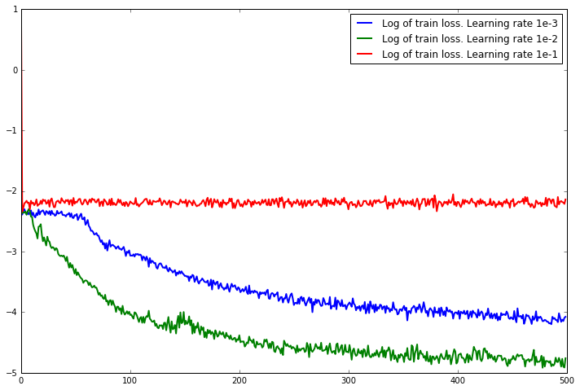

Conclusions from this graphics:

* learning rate 0.1 is too big that we do not have any convergence at all;
* learning rate 0.001 is still too small however we have convergence, but it may take long time (particularly, at the first 50 epochs we do not see converges at all);
* learning rate 0.01 is the best.

Based on this graph, I had decided to do all subsequent calculations with learning rate 0.01.

Some examples of auto-encoder:

|  |  |
| --- | --- |
| **Imput images** | **Auto-encoded images** |
|  |  |
|  |  |

After that I had added small random Gaussian noise to several images and look at the auto-encoded outputs (auto-encoder was trained only with “pure” images without any noise). Results can be seen below:

|  |  |
| --- | --- |
| **Imput noisy images** | **Auto-encoded images** |
|  |  |
|  |  |

Conclusions from this assignment :

* auto-encoder works pretty fast (25 seconds for 500 epochs on the same computer which I used for the second assignment);
* even these 25 seconds are enough for having quite good results;
* auto-encoder for noisy images returns not-noisy results because it was trained with “pure” images and uses weight-matrices which correspond features of “pure” pictures. When we unwrapped our image back from weight-matrices we do not have information about noise . It still works good enough even with really noisy images.