**Deep Learning Lab Course 2017**

**Assignment 4.**

**Olesya Tsapenko**

I have Implemented U-net as it was described at the assignment. I calculated accuracy for training and test data each 500 iterations for speed-up the whole process.

As an accuracy I have used a slightly changed formula from the assignment:

The results after 40000 iterations you can see at the graphics below:

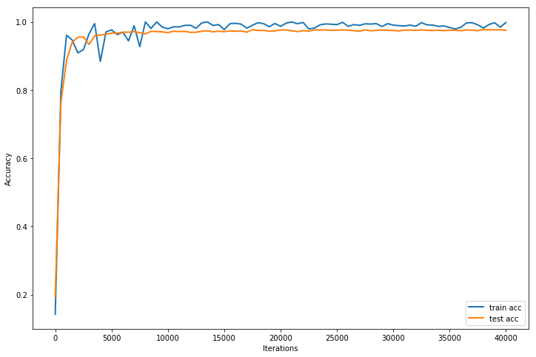

Conclusions from this graphics:

* according the graphics it should be not so necessary to continue training after ~5000 iterations;
* despite the previous fact, I plotted the results for the test data each 500 iterations and I still could see significant improvements between iterations with almost the same accuracy at the same time (I suppose it has happened because our accuracy function is still not perfect for this problem);
* the training accuracy fluctuates a bit because we use a mini-batch with a size is equal to 1 for training but 27 images for testing, which gives us the smother result for the test graphic;
* the whole process is time-consuming (Duration: 25952.3s).

Some examples of the segmentation:

|  |  |
| --- | --- |
| **Ground-trueth labels** | **Results of segmentation** |
|  |  |
|  |  |
|  |  |
|  |  |

Conclusions from this assignment :

* despite the good accuracy we can still see pretty wrong borders for predicted images (we should not rely only at the accuracy function during the training process);
* more complicated borders (like several cells in a row) are more difficult to estimate and vice versa.