**Deep Learning Lab Course 2017**

**Assignment 5.**

**Olesya Tsapenko**

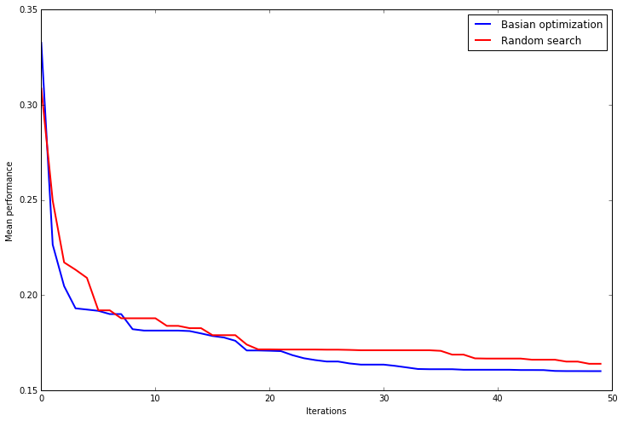 As a part of the current assignment, I used Basian optimization and Random Search to find a good hyperparameter setting for a surrogate function. For a more significant estimate of its performance, all computations were made 10 times (with 50 iterations each). The trajectory of the mean performance of the incumbents can be seen at the graphics below:

Conclusions from this graphics:

* after approximately 22 iterations, Basian optimisation outperforms Random Search;
* Basian optimisation is not better at the beginning because at this technique we try to estimate a function but with a really small number of samples which leads to a big uncertainty regions;

As a second step of the assignment, I have computed the runtime of each technique. At the graphics below, you can see the cumulative runtime after each iteration:

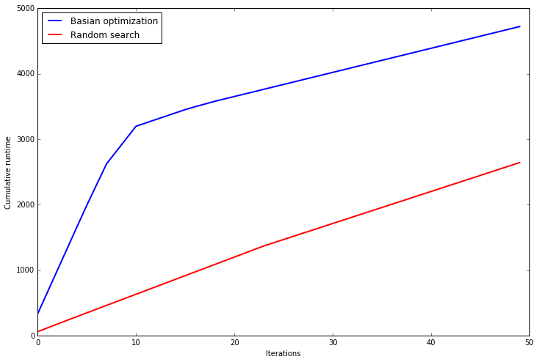

Conclusions from this graphics:

* despite the fact that Basian optimization gives us a better result than Rundom Search, the first technique is much more time consuming;
* at the first 10 iterations, computations for Basian optimization are more expensive;
* computations for Random Search are almost the same for each iteration;
* in my opinion, if I would have evaluated the true objective function, computations would have been much more expensive but the overall look of the graph would not change.

Conclusions from this assignment :

* in our case, finding a next hyperparameter configurations for Basian optimization is more expensive then just evaluate the function for a random configurations. It allows to conclude that we can randomly find a good solution with more iterations just because it is still cheaper but it is not always the case;
* the choice of a hyperparameter optimization technique still depends on the task.