**Deep Learning Lab Course 2017**

**Assignment 6.**

**Olesya Tsapenko**

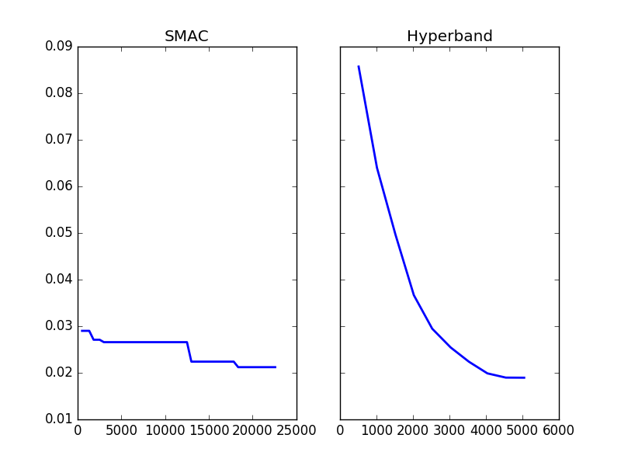 As a part of the current assignment, I have implemented the configuration space from Task 1. After that I used SMAC and Hyberband for finding a good parameter configuration. The incumbent trajectory of losses on the y- axis and the estimated wall-clock time on the x-axis of the both methods can be seen at the graphics below:

Conclusions from these graphics:

* the Hyberband method is almost **twice** **faster** than SMAC;
* the Hyberband method is smother than SMAC;
* however, the started SMAC loss is much more smaller than Hyberband one.

The speed of Hyberband is determined by the the nature of this method (using early stopping of learning curves). On the graphics of learning curves below you can easily see it:

