Compte rendu TP image 3D-2
Traitement de l’image

Tristan Cossin
Master IMAGINA

MAI 2017

Engine (seuil = 200):
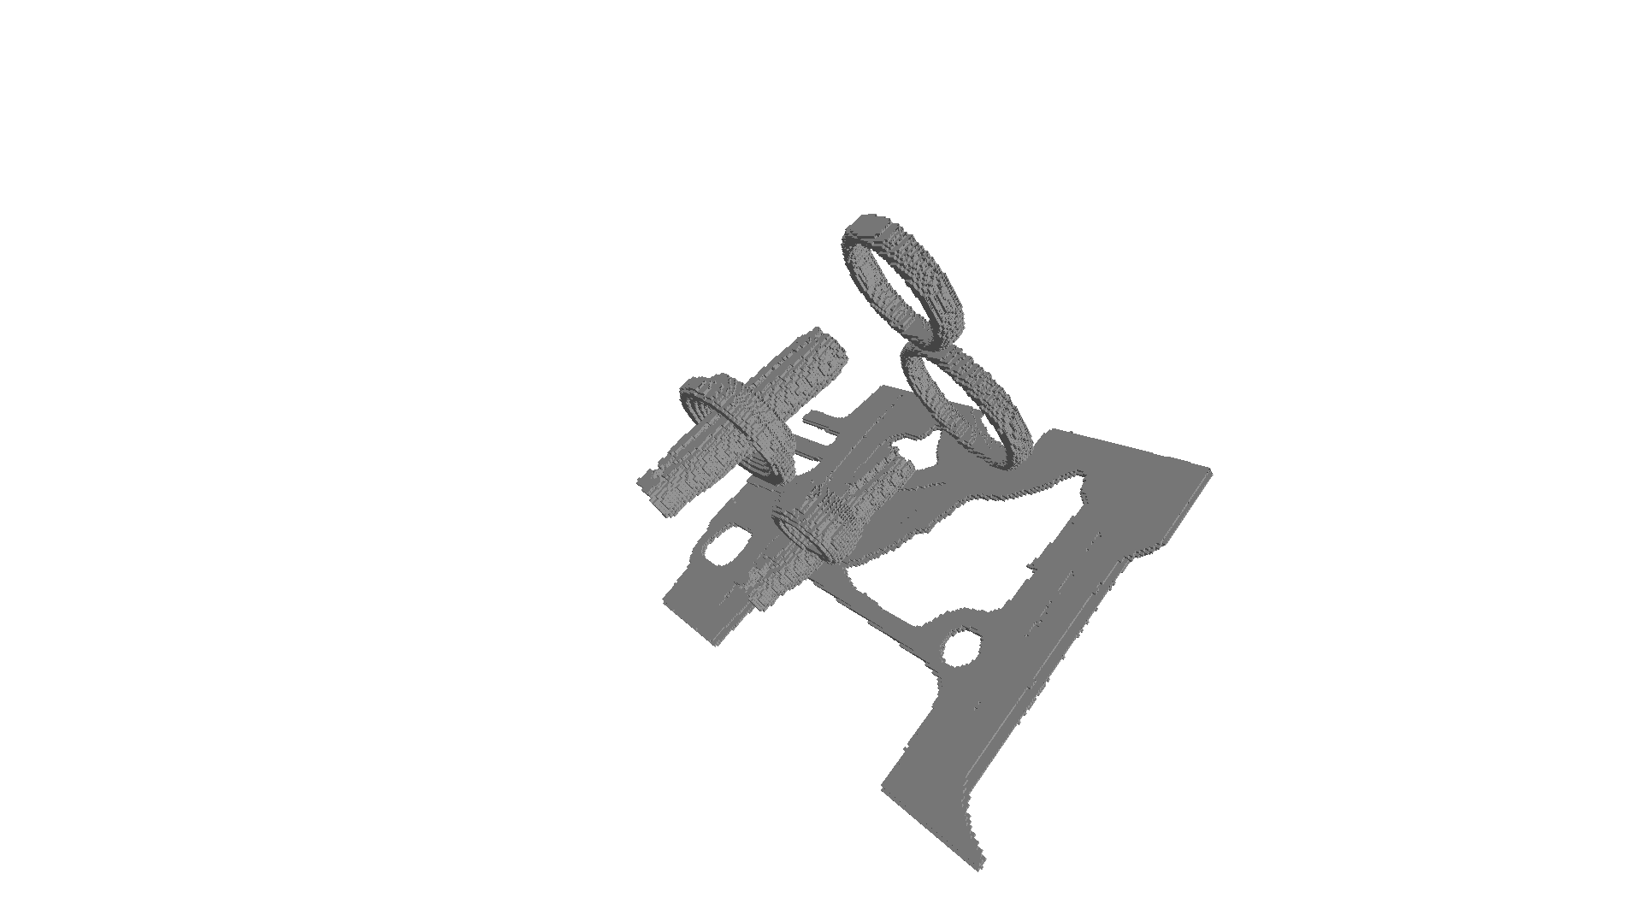

Engine (seuil = 100):

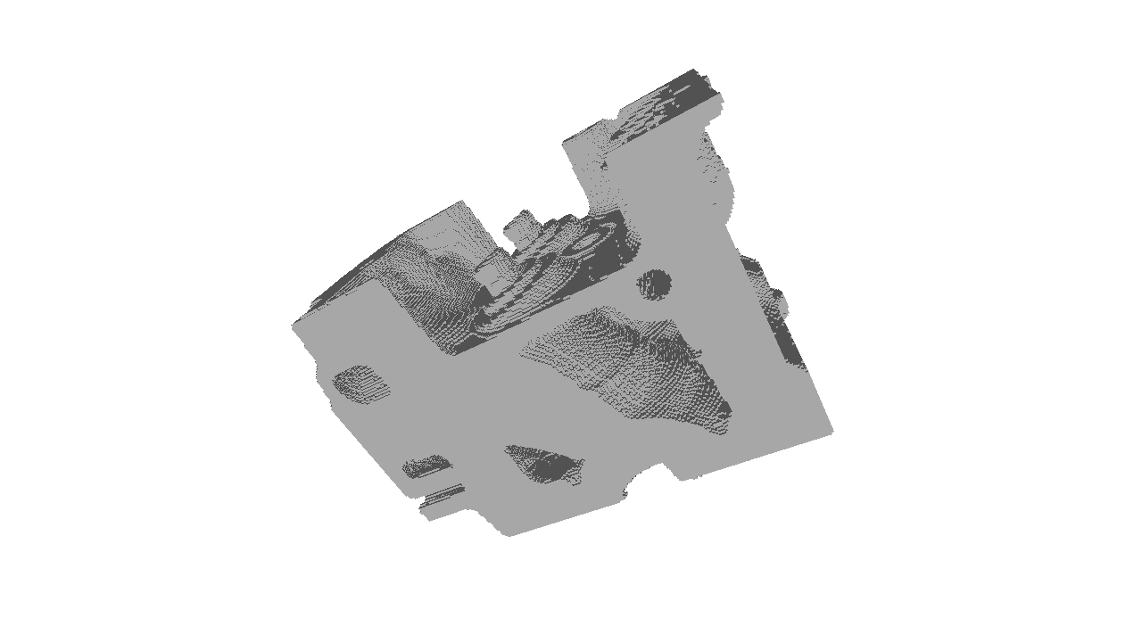
Whatisit (seuil = 100):
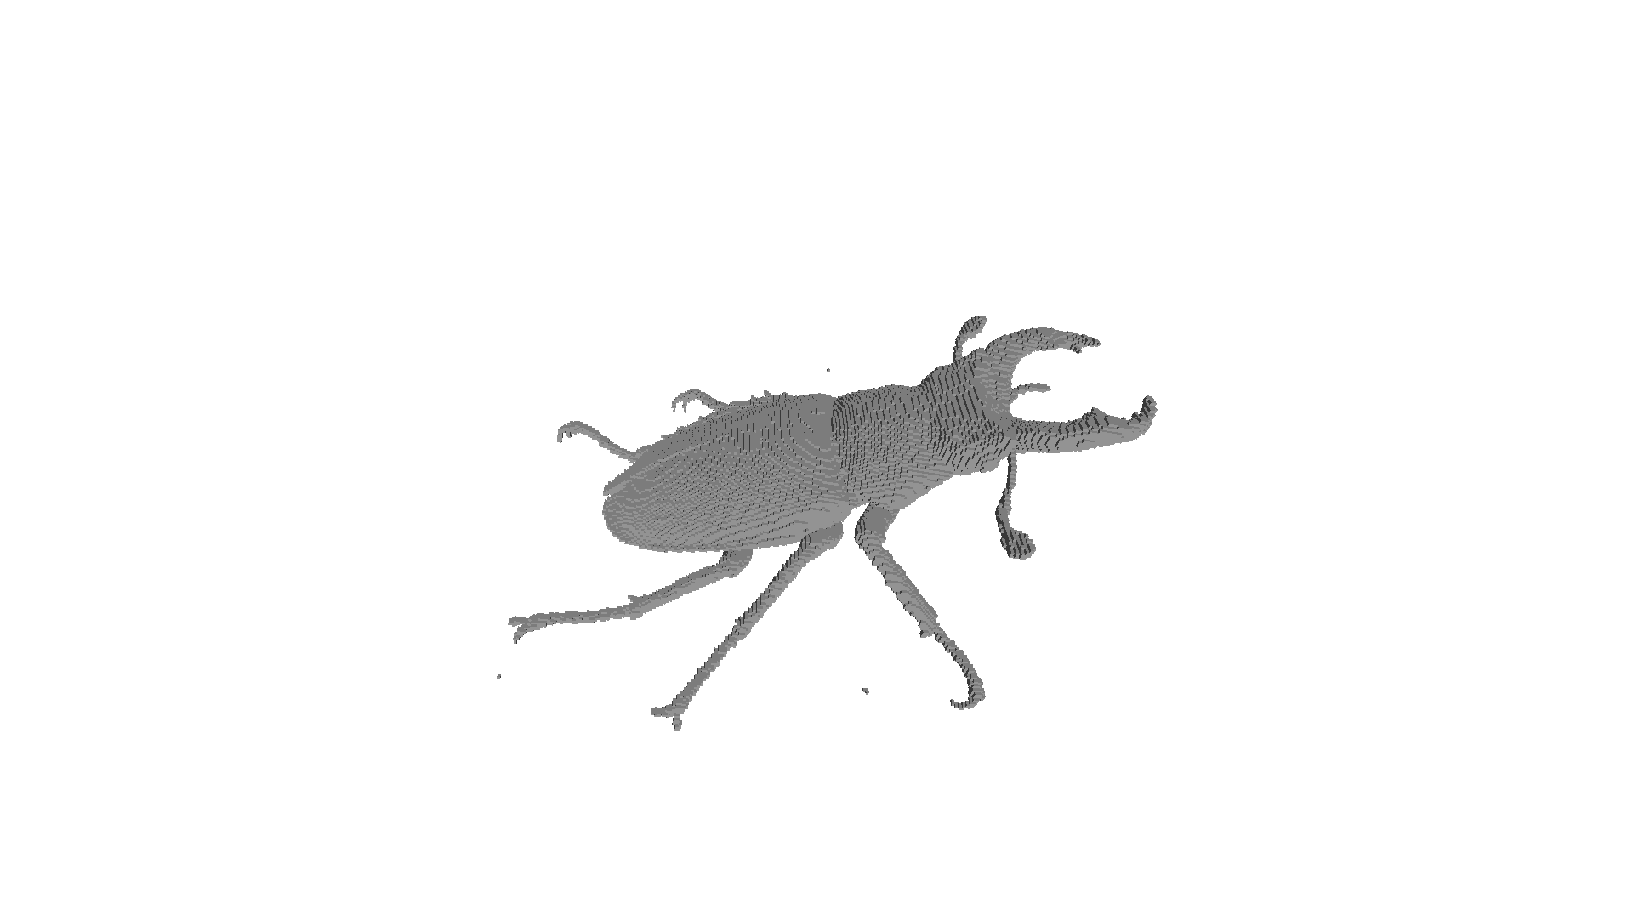
StatueLeg (seuil = 50):

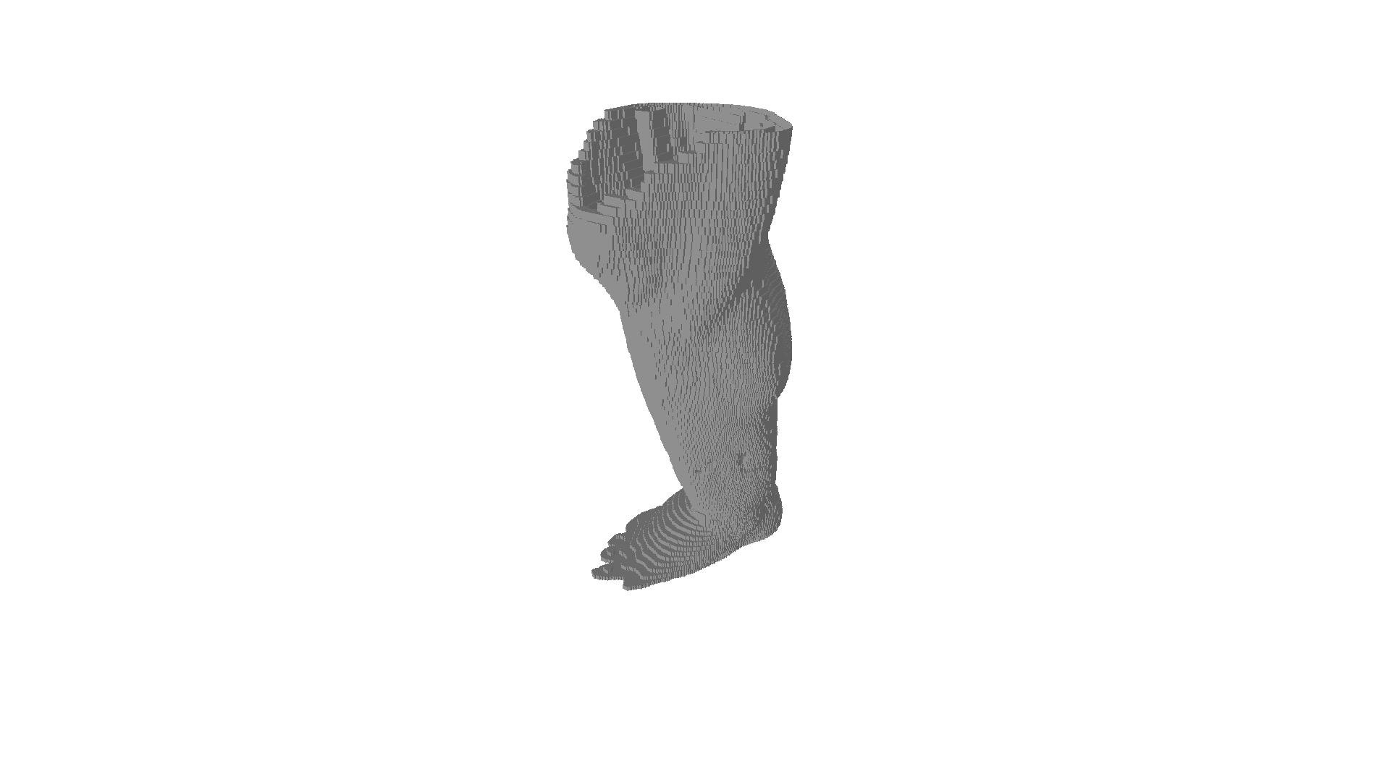

Manix (seuil = 900):
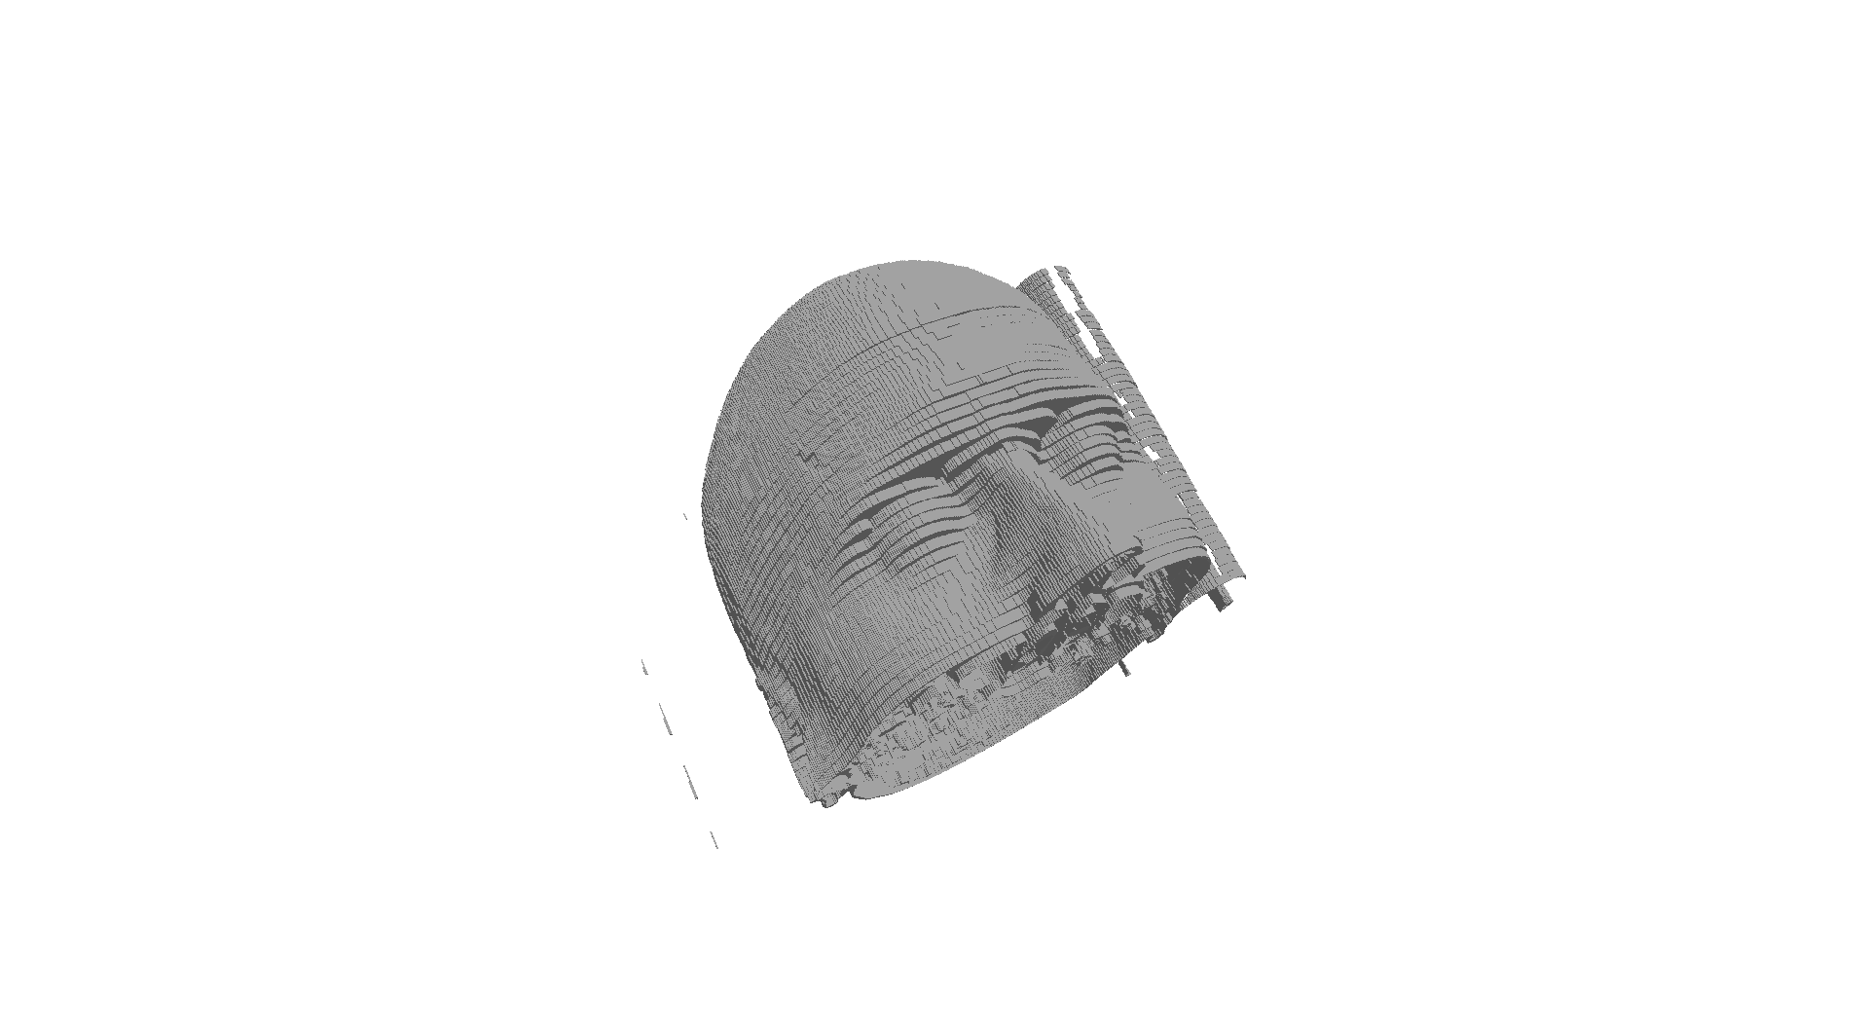

Manix (seuil = 1100):

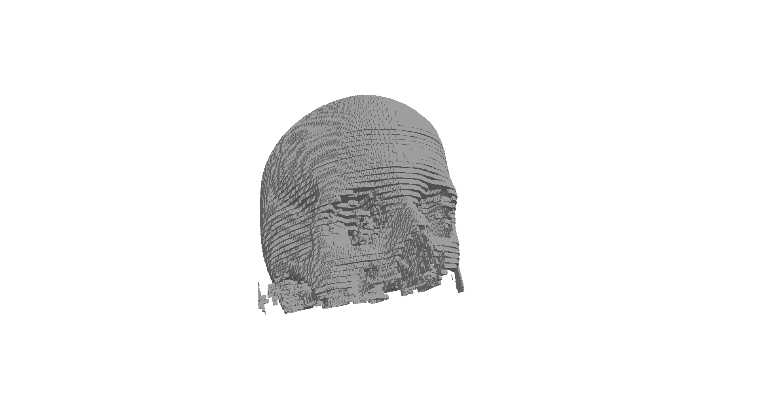
Méthode d’enregistrement des faces:

void ToString(ofstream &file, face &t)
{
file << "facet normal 0 0 0" << endl;
file << "outer loop"<< endl;
file << "vertex " << t.v1.x << " " << t.v1.y << " " << t.v1.z << endl;
file << "vertex " << t.v2.x << " " << t.v2.y << " " << t.v2.z << endl;
file << "vertex " << t.v3.x << " " << t.v3.y << " " << t.v3.z << endl;
file << "endloop " << endl;
file << "endfacet " << endl;
}

Méthode getValue:

unsigned short getValue(unsigned short *buffer, int x, int y, int z)
{
return inverserOctet(buffer[(z * tailleX * tailleY) + ((tailleY - y - 1) * tailleX) + x ]);
}

Méthode MarchingCube:

void MarchingCube(unsigned short *buffer, int threashold)
{
std::ofstream file;
file.open("out.stl");

file << "solid test" << endl;

//pour tous les voxels
for(int i = 1; i < tailleX - 1; i++)
{
for(int j = 1; j < tailleY - 1; j++)
{
for(int k = 1; k < tailleZ - 1; k++)
{
//si le voxel est supérieur ou égal au seuil
if(getValue(buffer, i, j, k) >= threashold)
{
//tableau des sommets du voxel
vector<point> vertices;

point v1;
v1.x = (i - 0.5) * sizeX;
v1.y = (j - 0.5) * sizeY;
v1.z = (k - 0.5) * sizeZ;
vertices.push_back(v1);

point v2;
v2.x = (i + 0.5) * sizeX;
v2.y = (j - 0.5) * sizeY;
v2.z = (k - 0.5) * sizeZ;
vertices.push_back(v2);

point v3;
v3.x = (i + 0.5) * sizeX;
v3.y = (j + 0.5) * sizeY;
v3.z = (k - 0.5) * sizeZ;
vertices.push_back(v3);

point v4;
v4.x = (i - 0.5) * sizeX;
v4.y = (j + 0.5) * sizeY;
v4.z = (k - 0.5) * sizeZ;
vertices.push_back(v4);

point v5;
v5.x = (i - 0.5) * sizeX;
v5.y = (j - 0.5) * sizeY;
v5.z = (k + 0.5) * sizeZ;
vertices.push_back(v5);

point v6;
v6.x = (i + 0.5) * sizeX;
v6.y = (j - 0.5) * sizeY;
v6.z = (k + 0.5) * sizeZ;
vertices.push_back(v6);

point v7;
v7.x = (i + 0.5) * sizeX;
v7.y = (j + 0.5) * sizeY;
v7.z = (k + 0.5) * sizeZ;
vertices.push_back(v7);

point v8;
v8.x = (i - 0.5) * sizeX;
v8.y = (j + 0.5) * sizeY;
v8.z = (k + 0.5) * sizeZ;
vertices.push_back(v8);

//on check les 6 voxels adjacent
if(getValue(buffer, i - 1, j, k) < threashold)
{
face t1;
t1.v1 = vertices[0];
t1.v2 = vertices[3];
t1.v3 = vertices[7];

face t2;
t2.v1 = vertices[7];
t2.v2 = vertices[4];
t2.v3 = vertices[0];

ToString(file, t1);
ToString(file, t2);
}

if(getValue(buffer, i + 1, j, k) < threashold)
{
face t1;
t1.v1 = vertices[2];
t1.v2 = vertices[6];
t1.v3 = vertices[5];

face t2;
t2.v1 = vertices[5];
t2.v2 = vertices[1];
t2.v3 = vertices[2];

ToString(file, t1);
ToString(file, t2);
}

if(getValue(buffer, i, j - 1, k) < threashold)
{
face t1;
t1.v1 = vertices[0];
t1.v2 = vertices[1];
t1.v3 = vertices[5];

face t2;
t2.v1 = vertices[5];
t2.v2 = vertices[4];
t2.v3 = vertices[0];

ToString(file, t1);
ToString(file, t2);
}

if(getValue(buffer, i, j + 1, k) < threashold)
{
face t1;
t1.v1 = vertices[7];
t1.v2 = vertices[6];
t1.v3 = vertices[2];

face t2;
t2.v1 = vertices[2];
t2.v2 = vertices[3];
t2.v3 = vertices[0];

ToString(file, t1);
ToString(file, t2);
}

if(getValue(buffer, i, j, k - 1) < threashold)
{
face t1;
t1.v1 = vertices[0];
t1.v2 = vertices[1];
t1.v3 = vertices[2];

face t2;
t2.v1 = vertices[2];
t2.v2 = vertices[3];
t2.v3 = vertices[0];

ToString(file, t1);
ToString(file, t2);
}

if(getValue(buffer, i, j, k + 1) < threashold)
{
face t1;
t1.v1 = vertices[4];
t1.v2 = vertices[5];
t1.v3 = vertices[6];

face t2;
t2.v1 = vertices[6];
t2.v2 = vertices[7];
t2.v3 = vertices[4];

ToString(file, t1);
ToString(file, t2);
}
}
}
}
}

file << "endsolid test";

file.close();
}

