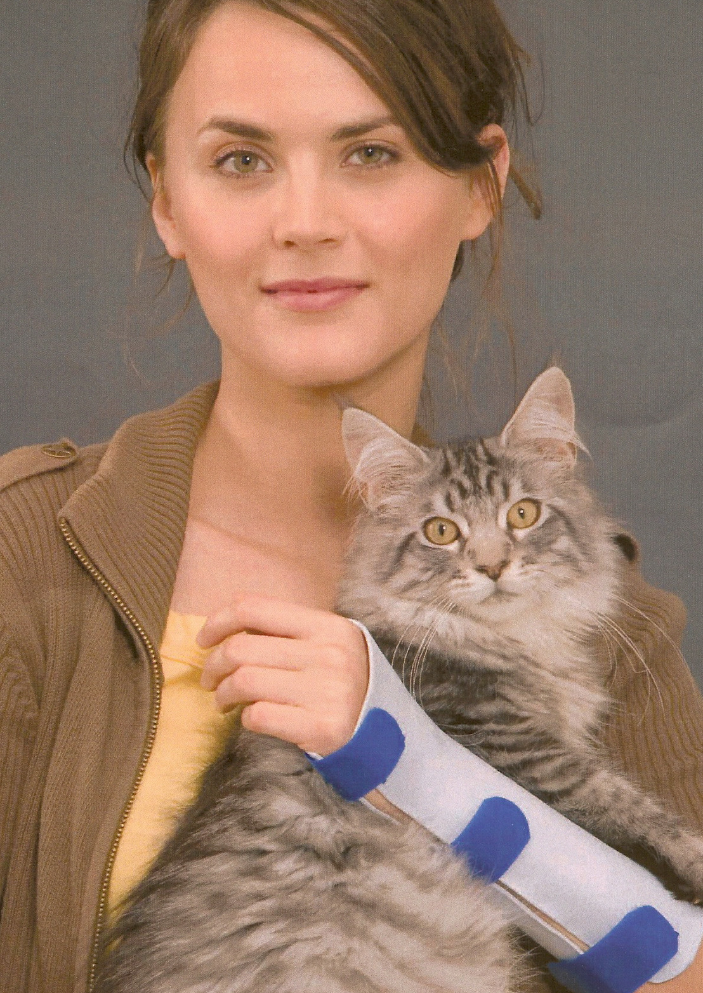
ORFIT Industries America

350 Jericho Turnpike
Suite 101
Jericho, NY 11753
Phone: 1888-ORFIT US
Fax: 516-935-8505

For more information on Orfit splinting workshops contact:
Debby Schwartz
Product and Educational Specialist
Physical Rehabilitation

Debby.schwartz@orfit.com
Cell 856-701-8014
Fax 856-685-7214

The assignment of AOTA CEUs does not imply endorsement of specific course content, products, or clinical procedures by AOTA."

For more information on the Jacksonville course, please contact:
Jennifer Dodson
904-803-4480
3kingsuespecialist@gmail.com
Or visit www.3KingsUEspecialists.com

Check out www.orfit.com

Best Western Hotel JTB/ Southpoint
4660 Salisbury Road
Jacksonville, Florida 32256
January 24, 2009
8:00 am -5:00pm
Sign up now to reserve your spot (Space is limited to 24 participants)!
Get more details and register online at www.3kingsUEspecialists.com

is pleased to present

A Splinting Guide:
Immobilization Splinting
With Orfit Industries America

Registration Form:
Name______________________________________
Address____________________________________
City________________________________________
State __________ Zip Code_______________
Tel.#_______________________________________
Profession and License #_______________________
Email address:___________________________________
Payment by Check: $185 if postmarked by December 24,2008, after this date cost is $205.
Checks payable to: 3 Kings Upper Extremity Specialists
Course is based on minimum of 15 participants
Maximum number of participants is 24.
Please mail completed form and check to:
3 Kings Upper Extremity Specialists
104 Oak View Circle
Ponte Vedra Beach, FL 32082
Cancellation policy: 3 Kings Upper Extremity Specialists and Orfit Industries America reserve the right to cancel course with fewer than 15 participants and will return all payments.
3 Kings Upper Extremity Specialists and OIA reserve the right to cancel a workshop. In the event of cancellation, 3 Kings Upper Extremity Specialists and OIA will offer a full course refund. 3 Kings Upper Extremity Specialists and OIA are not responsible for reimbursement for any travel related expenses. Participants must also notify 3 Kings Upper Extremity Specialists and OIA regarding cancellation of registration no less than 14 days prior to the workshops for a full refund less $50.00 administrative fees.


Workshop Course Outline Full Day
7:30 Registration
8:00 Immobilization Splinting- Power Point
9:00 Introduction to Orfit Products -Power Point
9:30 Demonstration of Resting Hand Splint
10:00 Splint Lab
11:30 Demonstration of Circumferential Wrist Splint
12:00 Splint Lab
1:00 Lunch
2:00 Demonstration of Elbow Splint
2:30 Splint Lab
3:00 Short Break – Snack Provided
3:30 Demonstration of Anti Spasticity Splint
4:00 Splint Lab
4:30 Thumb Splint/ Conclusion and questions

Learning Objectives- Splinting Course

Upon completion of this course, participants will be able to:
1. Recognize indications, precautions and contraindications for immobilization splinting of the upper extremity
2. Analyze mechanical properties required to fabricate low temperature thermoplastic immobilization splints for the upper extremity.
3. Identify important anatomical structures and landmarks of the upper extremity.
4. Analyze key characteristics of splinting materials for fabrication of specific splints.
5. Learn to critique and assess different splinting materials

Instructor
Debby Schwartz, OTR/L, CHT
Product and Educational Specialist, Physical Rehabilitation
Debby Schwartz, OTR/L, CHT is a hand therapist with over 22 years of experience as a practicing clinician. She has joined Orfit Industries America to promote product awareness and splinting education. Debby is an active member of ASHT and has participated in IFSHT meetings as well. She has presented on a variety of hand therapy topics both at national and international conferences. Debby has also written a number of articles for the Journal of Hand Therapy, the British Journal of Hand Therapy, ADVANCE for OT, www.exploringhandtherapy.com and other hand therapy publications.
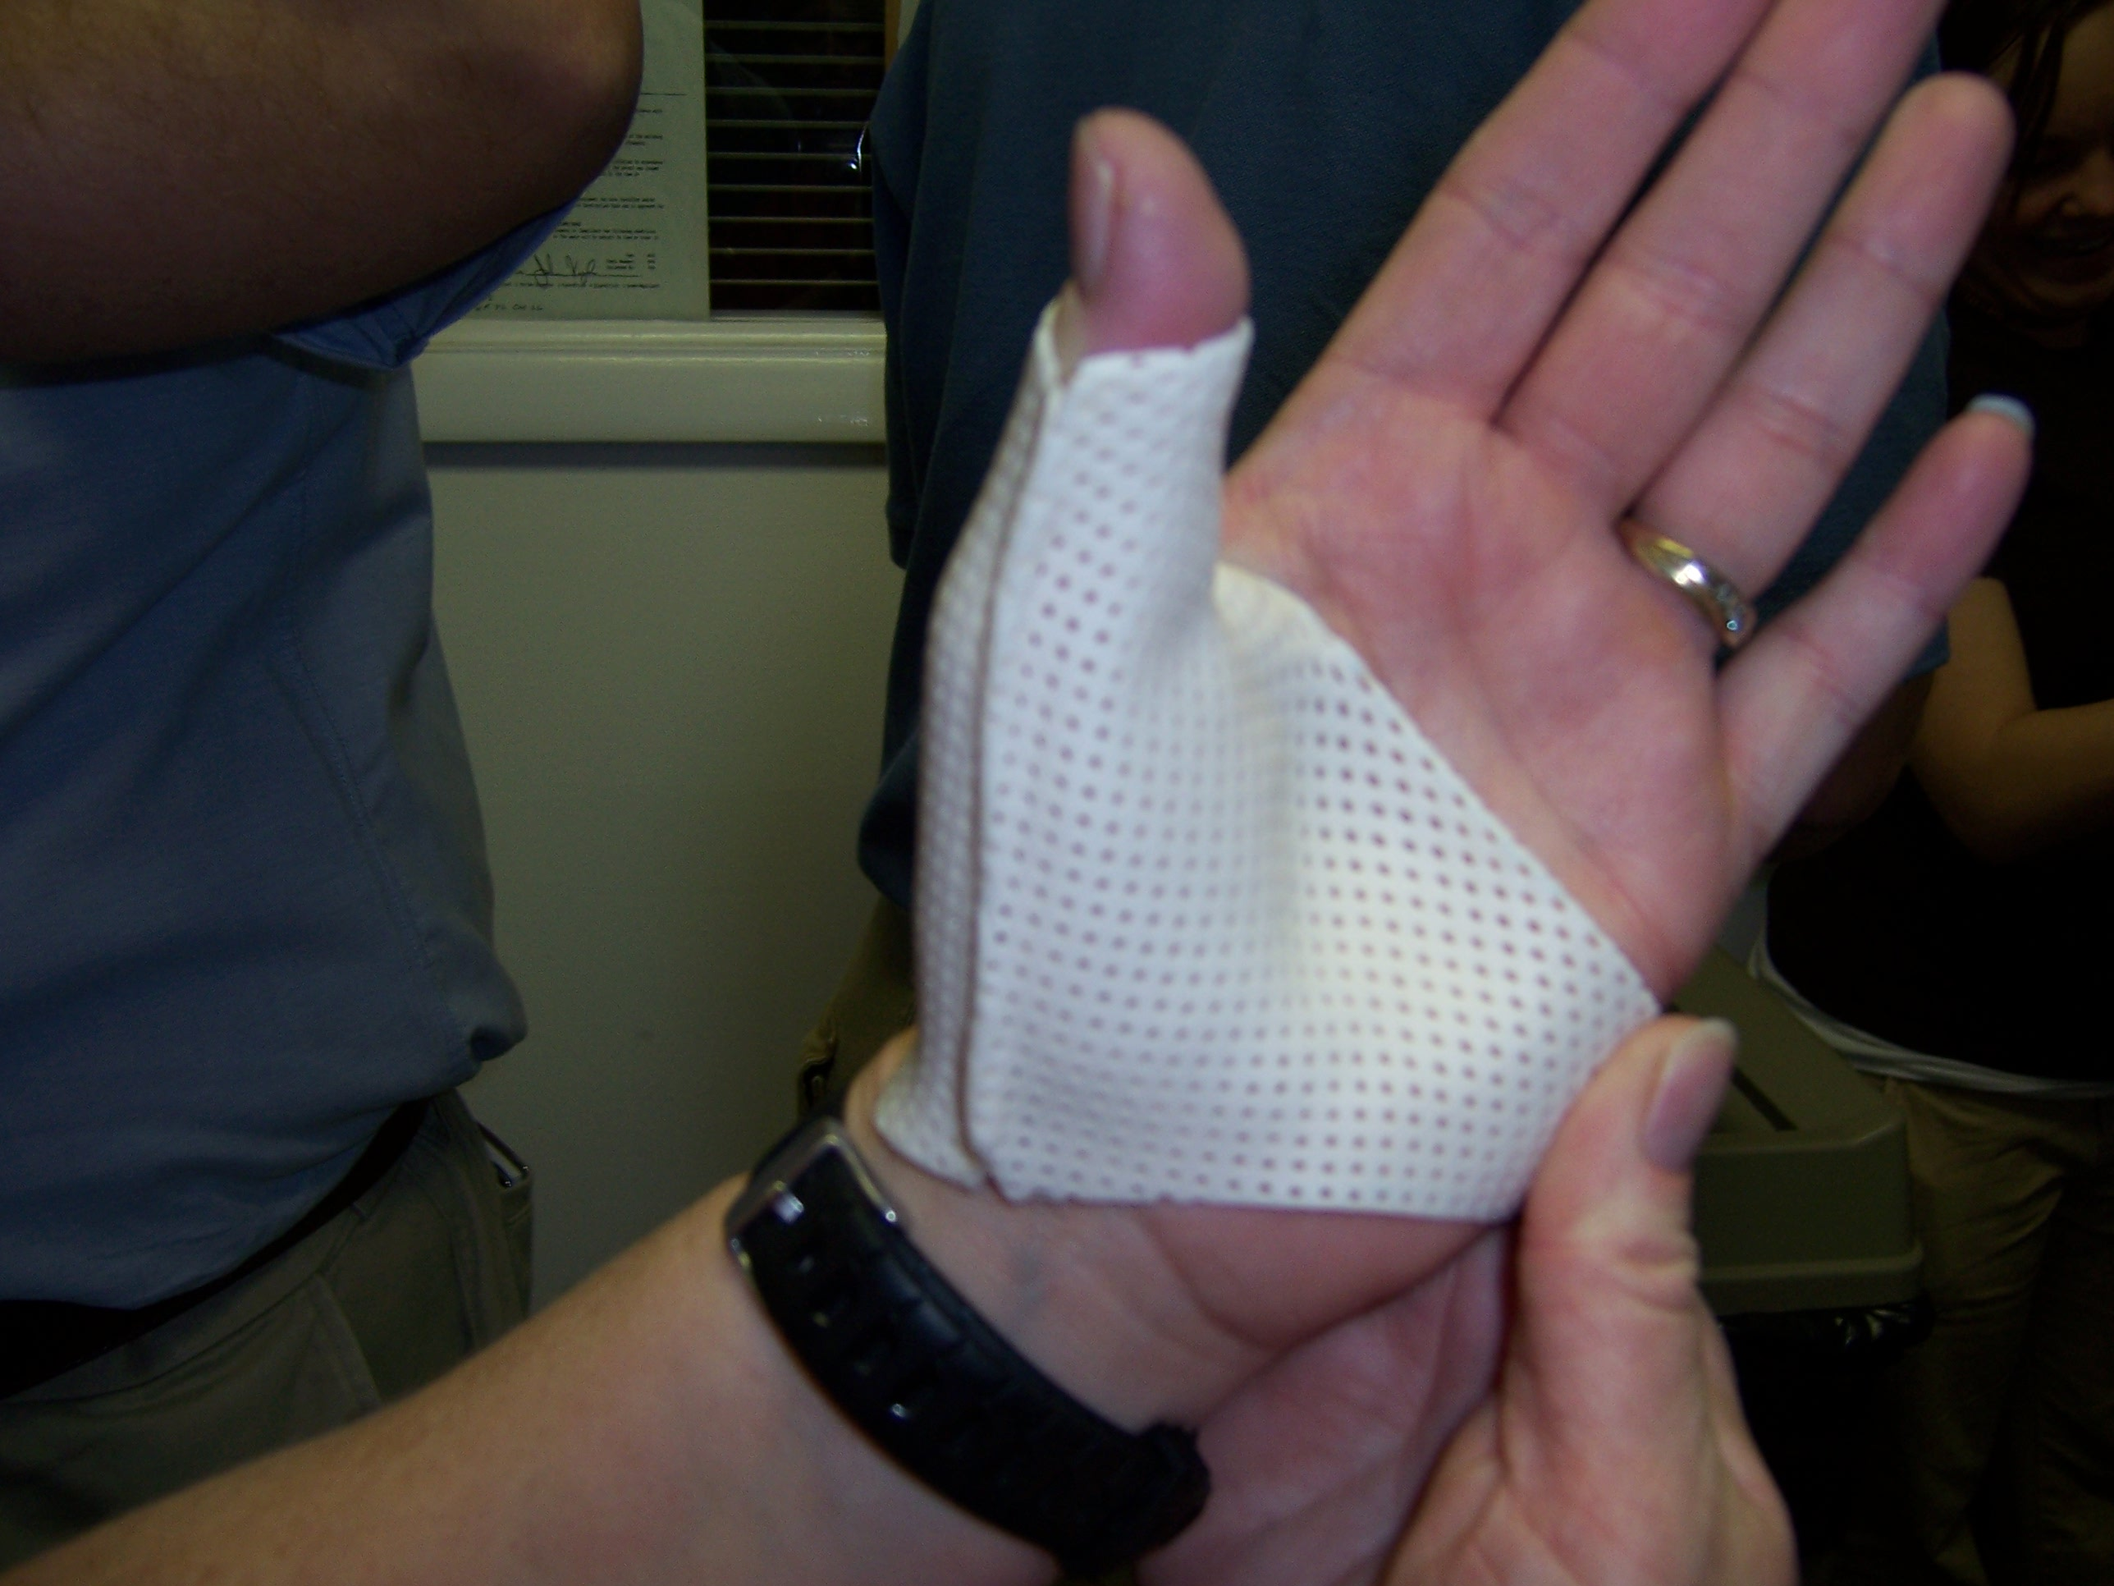
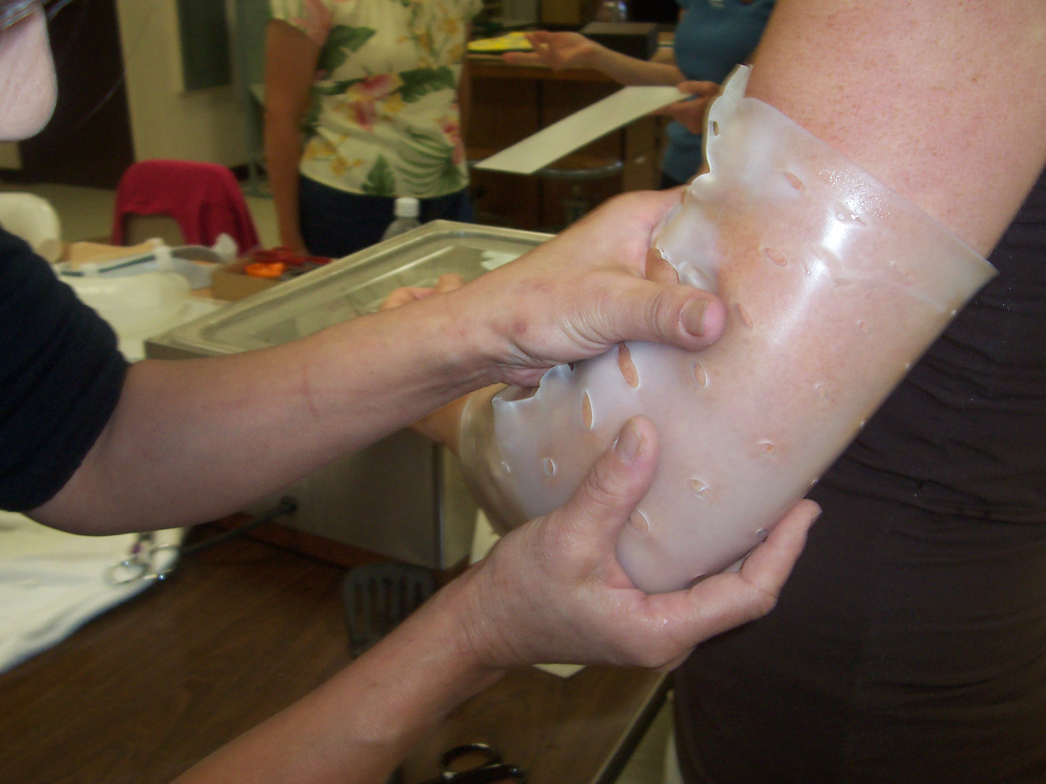
A Certificate of attendance will be issued to all participants completing the CEU requirements. One day equals 8.0 contact hours (.8 CEU’s). This splinting workshop meets criteria “A” for hand therapy certification and is accepted by NBCOT and most state OT boards. 3Kings UE Specialists will be providing CEUs for FL OTs. CE Broker # 50-9345.
Content Focus: Domain of OT: Performance Skills, Client Factors, Context
Occupational Therapy Process: Intervention
Workshop Format: Power point presentation, splinting demonstration, lecture and hands on fabrication of splints will guarantee achievement of learning objectives.
Satisfactory workshop completion requirements include sign-in, active participation in splinting lab, attendance at presentations, and completion of a course evaluation.
This splinting course is appropriate for OT’s, OTA’s, PT’s and PTA’s with beginner to intermediate splinting skills

