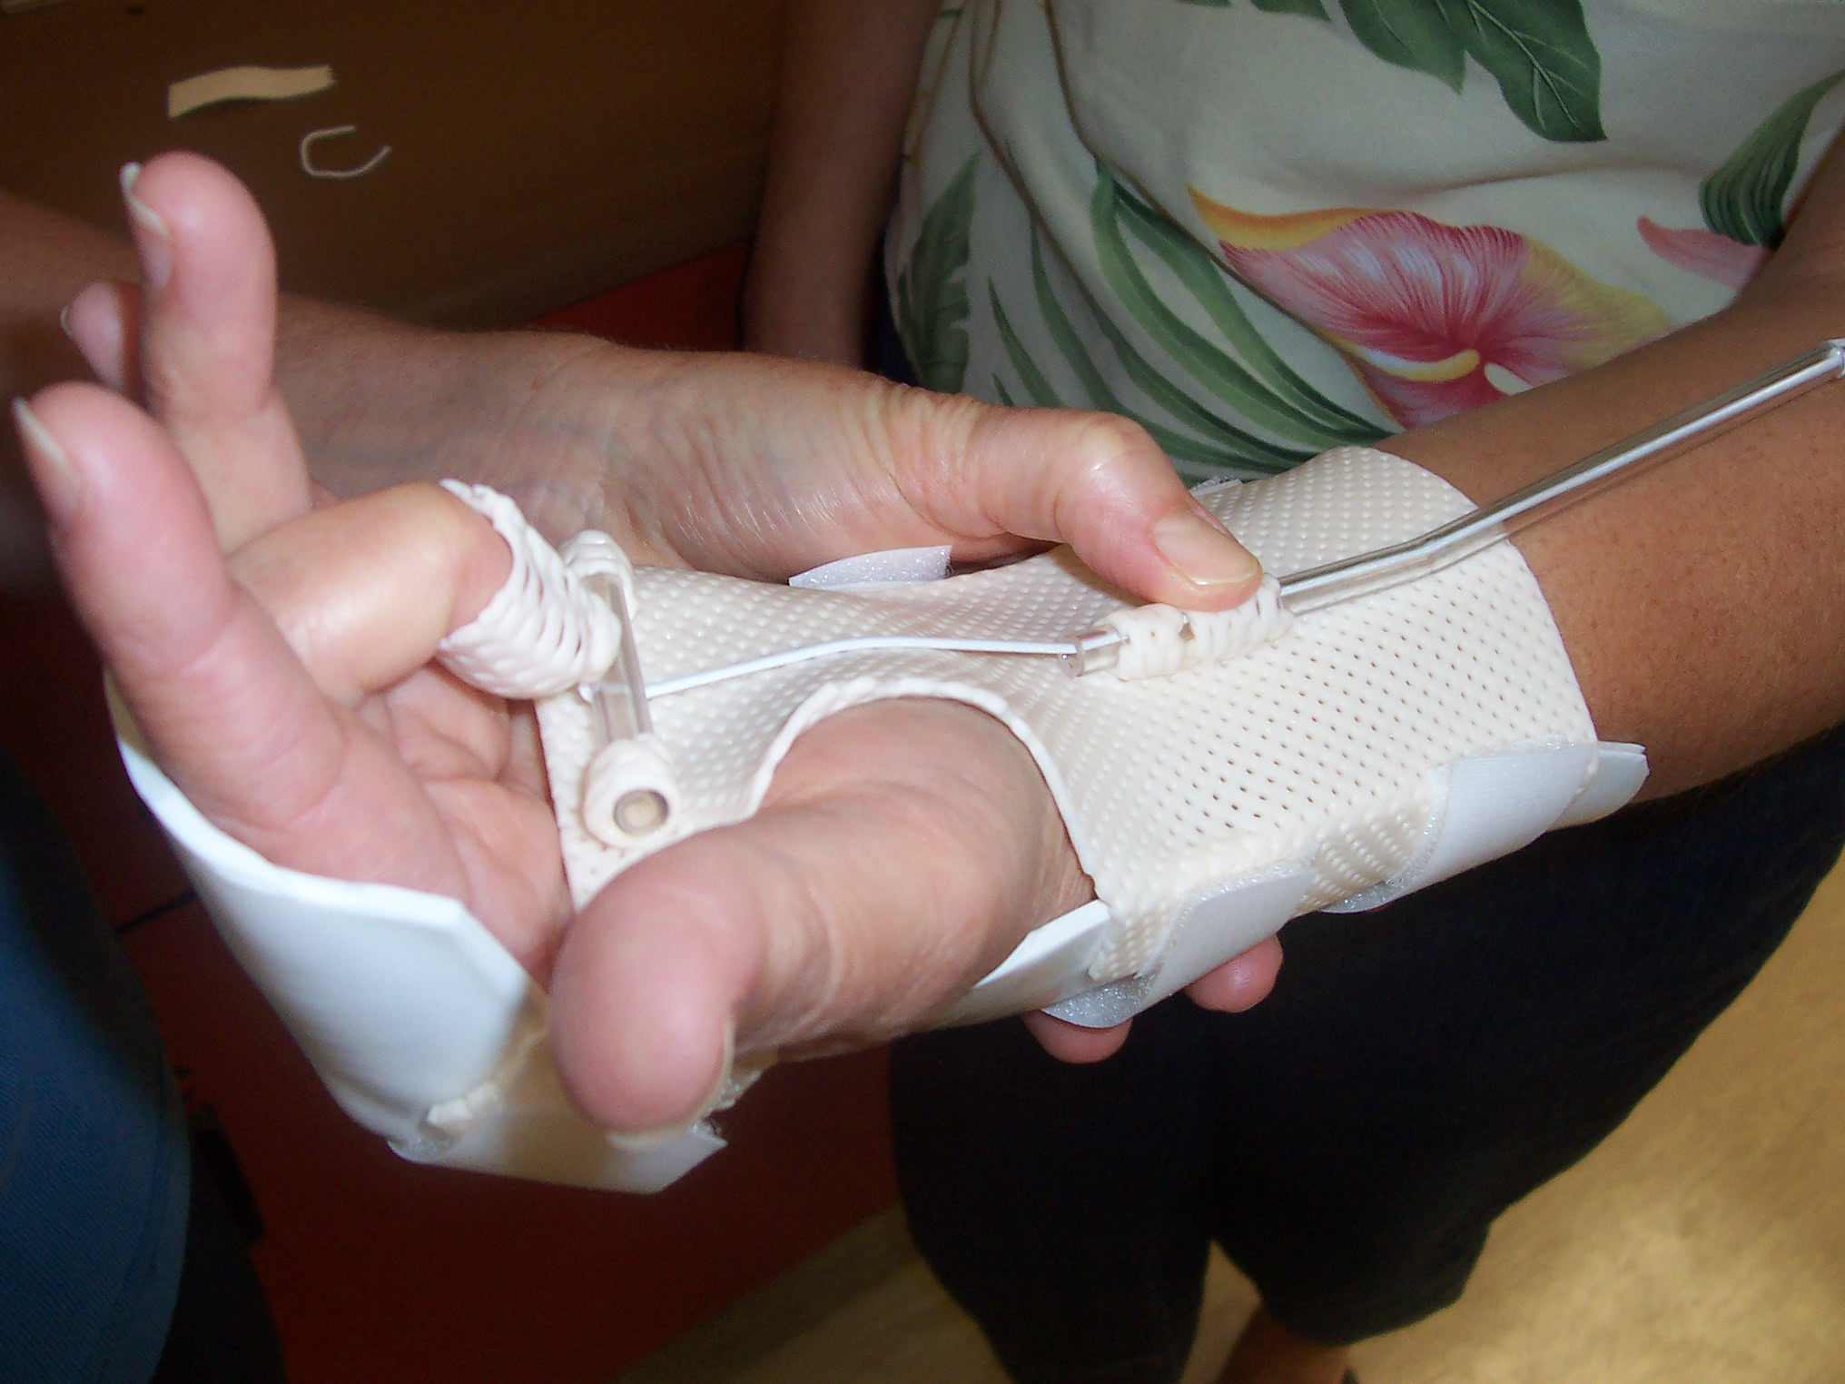
ORFIT Industries America
350 Jericho Turnpike
Suite 101
Jericho, NY 11753
Phone: 1888-ORFIT US
Fax: 516-935-8505

For more workshop information contact :
Debby Schwartz
Product and Educational Specialist,
Physical Rehabilitation

Debby.schwartz@orfit.com
Cell 856-701-8014
Fax 856-685-7214

For more info on the Jacksonville course, please contact Jennifer Dodson, OTR/L,CHT at 904-803-4480 or 3KingsUEspecialist@gmail.com

Check out www.orfit.com

Presents
A Splinting Guide:
An Orfit Industries Sponsored Mobilization Splinting Course

October 10, 2009
8:00 am -5:00 pm
Baptist Medical Center – Downtown
Wolfson Tower, 8th Floor
(Function Room “C”)
800 Prudential Drive
Jacksonville, FL 32207
Registration due by October 1, 2009
Space is limited to the first 20 registrants
To register online and find more info. Visit www.3KingsUEspecialists.com or call 904-803-4480

The assignment of AOTA CEUs does not imply endorsement of specific course content, products, or clinical procedures by AOTA."

Registration Form:
Name_______________________________
Address_____________________________
City________________________________
State ______ Zip Code_____________
Tel#_______________________________
Email address________________________
Early Bird Price:$235.00 postmarked before 9/10/09
Regular Registration: $255 after 9/10.
Course Cost is based on minimum of 15 participants
Maximum number of participants is 20
Please mail completed form and check to:
3 Kings Upper Extremity Specialists
104 Oak View Circle
Ponte Vedra Beach, FL 32082
Cancellation policy: 3 Kings Upper Extremity Specialists and Orfit Industries America reserve the right to cancel course with fewer than 15 participants and will return all payments.3 Kings Upper Extremity Specialists and OIA reserve the right to cancel a workshop. In the event of cancellation, 3 Kings Upper Extremity Specialists and OIA will offer a full course refund 3 Kings Upper Extremity Specialists and OIA are not responsible for reimbursement for any travel related expenses. Participants must also notify 3 Kings Upper Extremity Specialists and OIA regarding cancellation of registration by Sept 10 for a full refund less $75.00 administrative fees. If a participants cancels between Sept 10-24, they will be refunded $100. Cancellations after Sept. 24 are nonrefundable.

ORFIT Industries America

This splinting workshop is appropriate for OT’s, COTA’s, PT’s, PTA’s and CHT’s working with an upper extremity patient caseload and possessing intermediate splinting skills.
Content Focus: Domain of OT: Performance Skills, Client Factors, Context
Occupational Therapy Process: Intervention

Course Outline
8:00 Mobilization Splinting- Power Point Presentation
9:00 Introduction to Orfit Products-
9:30 Demonstration of Dorsal Blocking Splint with Kleinert Attachment
10:00 Splint Lab
11:00 Demonstration of Circumferential Wrist Splint with Orfitube Outrigger
11:30 Splint Lab
12:30 Lunch (Provided)
1:30 Demonstration of Functional Ulnar Nerve/ Median Nerve Splint
2:00 Splint Lab
3:00 Demonstration of Wrist Extension Assist with Coils
3:30 Splint Lab
4:30 Conclusion and questions

Learning Objectives- Splinting Course
Upon completion of this course, participants will be able to:
1. Recognize indications, precautions and contraindications for mobilization splinting of the upper extremity
2. Analyze mechanical properties required to fabricate low temperature thermoplastic mobilization splints for the upper extremity.
3. Compare and contrast outrigger/ and or coil designs of mobilization splints.
4. Identify important anatomical structures and landmarks of the upper extremity.
5. Analyze key characteristics of splinting materials for fabrication of specific splints.
6. Learn to critique and assess different splinting materials.

Instructor
Debby Schwartz, OTR/L, CHT
Product and Educational Specialist, Physical Rehabilitation
Debby Schwartz, OTR/L, CHT is a hand therapist with over 20 years of experience as a practicing clinician. She has joined Orfit Industries America to promote product awareness and splinting education. Debby is an active member of ASHT and has participated in IFSHT meetings as well. She has presented on a variety of hand therapy topics both at national and international conferences and has written a number of articles for hand therapy publications.

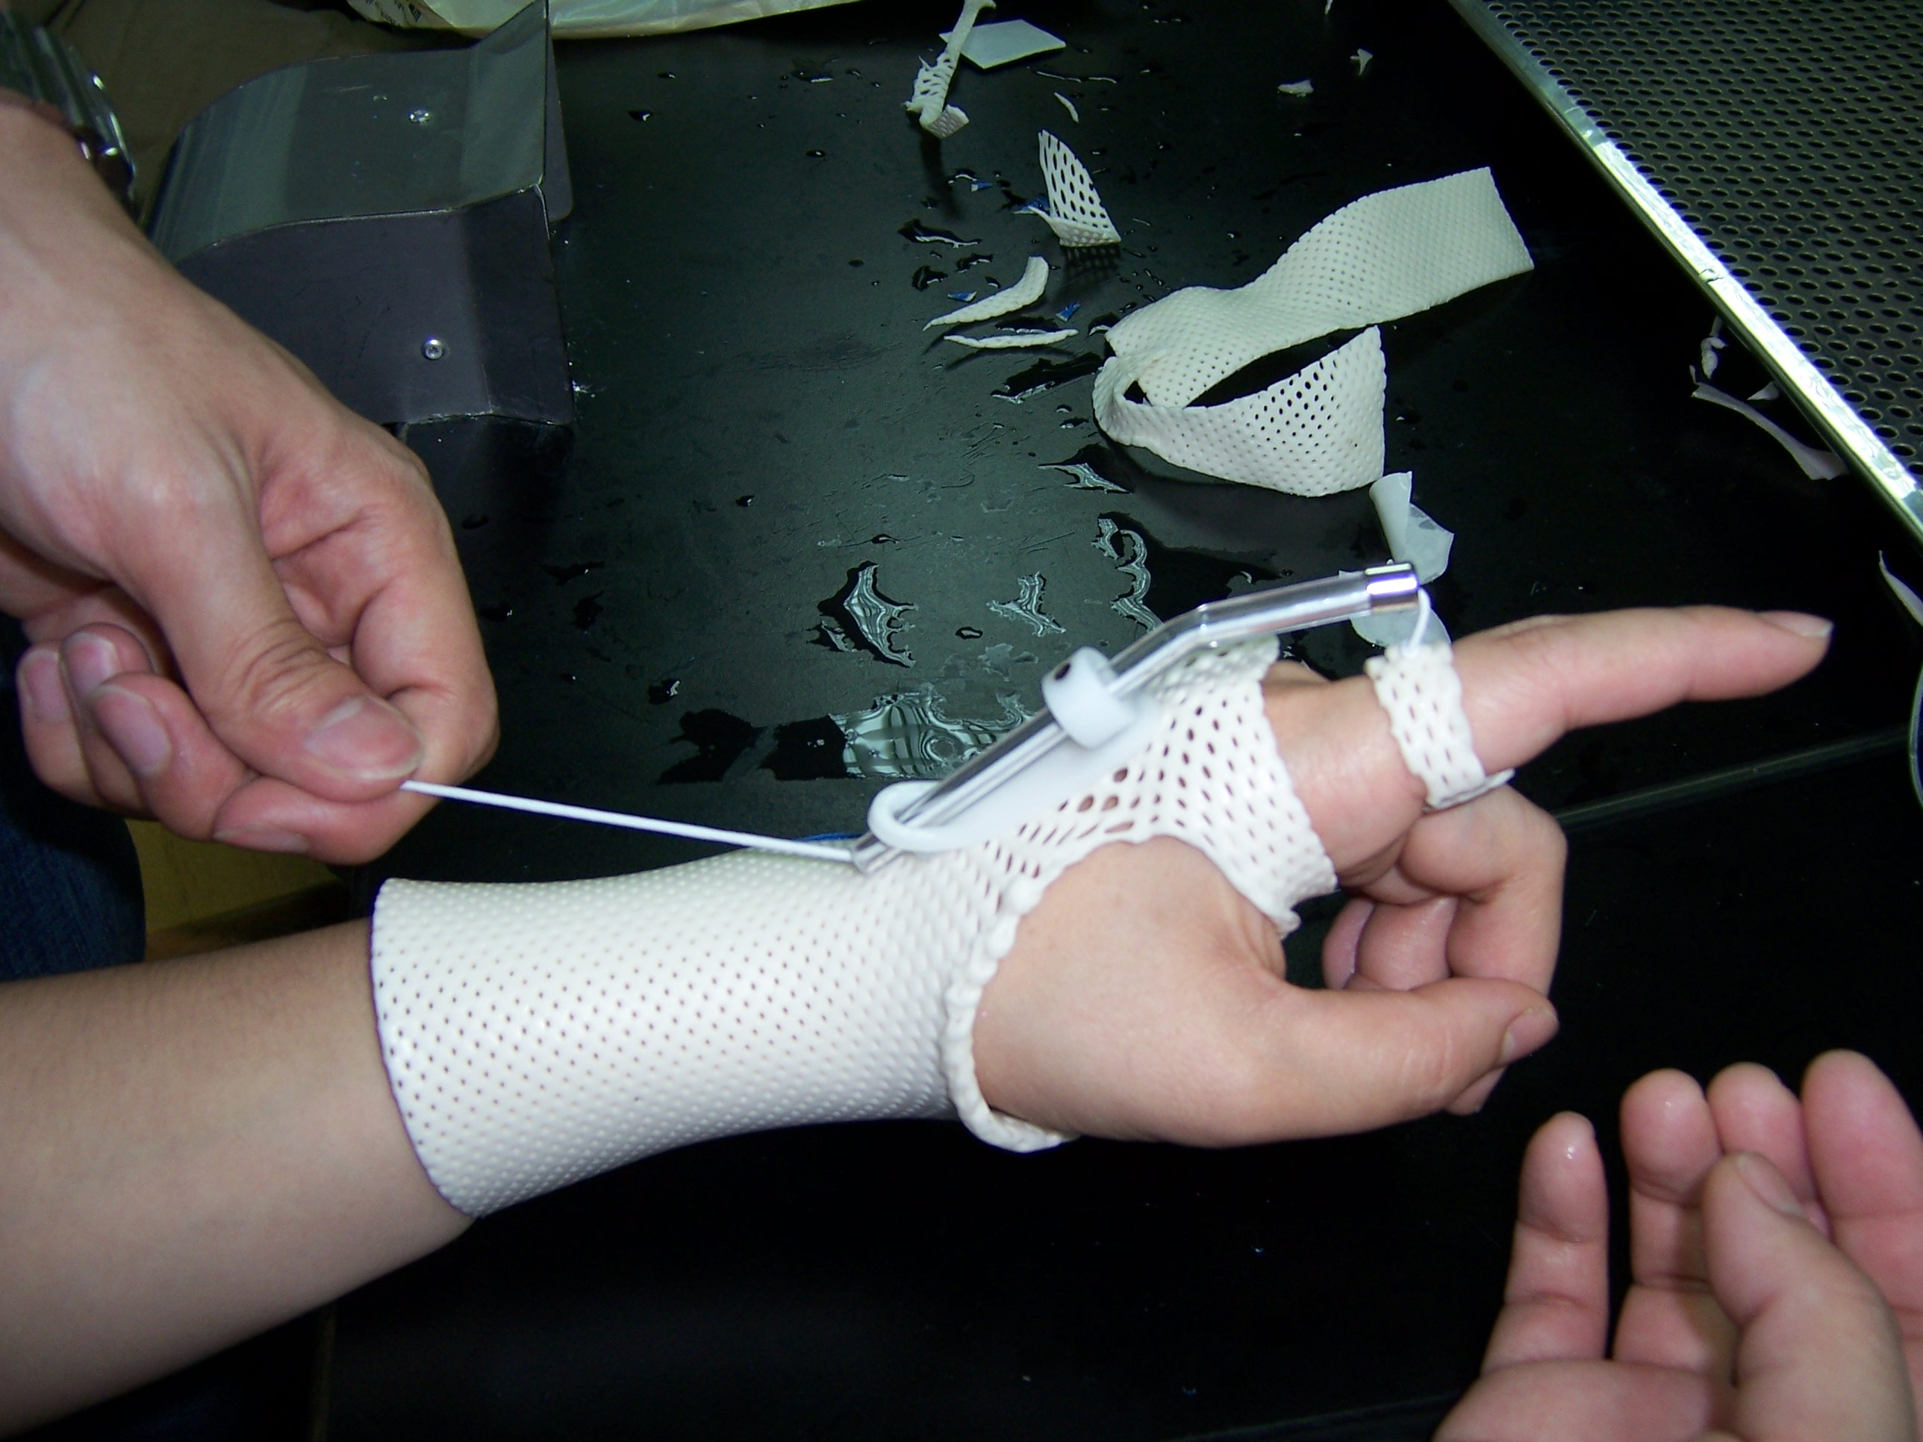
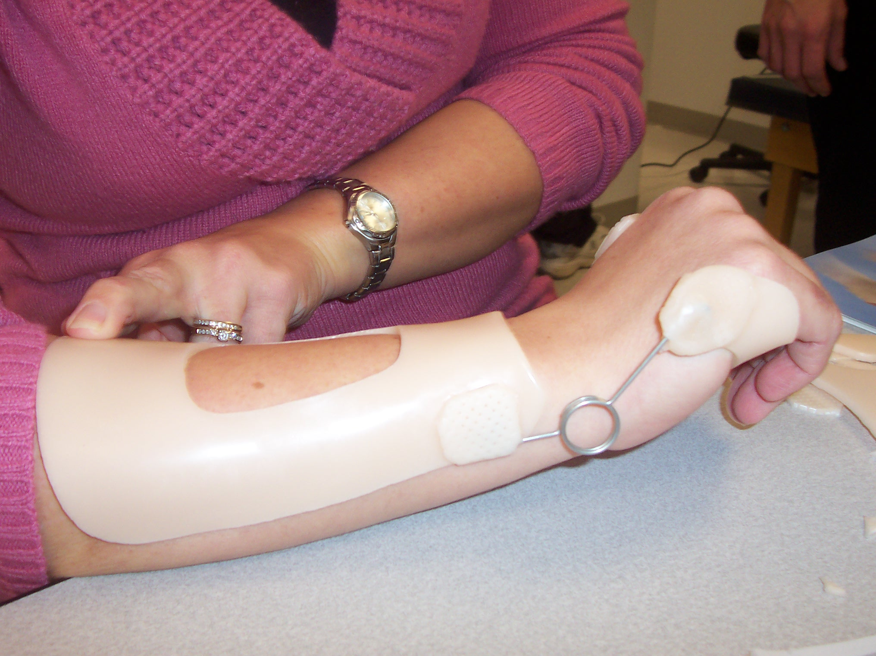
A Certificate of attendance will be issued to all participants completing the CEU requirements. One day equals 8.0 contact hours (.8 CEU’s). This splinting workshop meets criteria “A” for hand therapy certification and is accepted by NBCOT and most state OT boards.
Workshop Format: Power point presentation, splinting demonstration, lecture and hands on fabrication of splints will guarantee achievement of learning objectives.

