SELECT
a.sum_salary, a.count_emp, d.*
FROM
departments d,
(SELECT
SUM(s.salary) AS sum_salary,
COUNT(s.emp_no) AS count_emp,
de.dept_no
FROM
dept_emp de
JOIN salaries s ON de.emp_no = s.emp_no
WHERE
s.to_date = '9999-01-01'
AND de.to_date = '9999-01-01'
GROUP BY de.dept_no) a
WHERE
d.dept_no = a.dept_no;
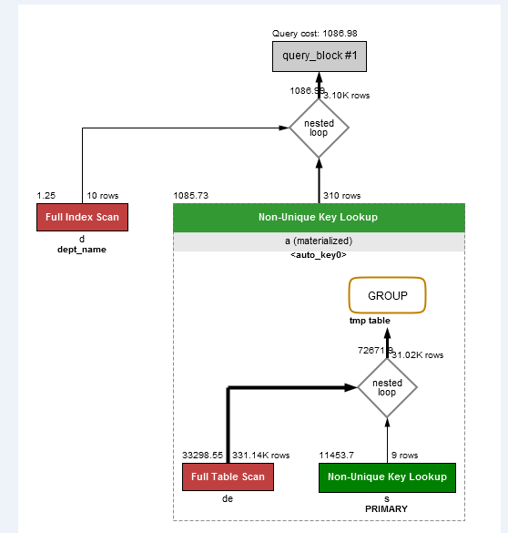

После добавления индекса в таблице dept_emp по «to_date»
