PROJECT DOCUMENTATION
Networking Issues in Mobile Systems. Part 1: Conceptual Design
Project topic: Mobile Currency Exchange System

1. General Information
Project Name | Currency Exchange
Project Authors | Oleh Smolinskyi
Field of Study | Computer Science
Year / Semester | 4 / 7
Supervisor | Krzysztof Rychlicki-Kicior
Submission Date | 01.11.2026
Repository | https://github.com/olezhakashz/currency-exchange, tag part1

2. Project Description

2.1. Project Objective
The goal of the project is a mobile app for virtual currency exchange. The user can see current exchange rates from the National Bank of Poland (NBP), convert amounts, and buy or sell currency from a virtual wallet that starts with 1000 PLN. No real money is used.
The main point of the project is not the number of features but how the app behaves when the wireless connection is bad: rates are cached and labelled with their date, orders are blocked when the phone is offline, and if the reply to an order is lost the app can still find out what really happened.

2.2. Project Scope
The system has four parts:
- Mobile app: shows rates, converts amounts, shows the wallet, sends buy and sell orders. It keeps a local cache of the last rates and wallet, and a list of orders that are still waiting for an answer.
- Web service: a REST API over HTTPS. It logs users in, gets rates from NBP, checks and executes orders, and answers status questions about orders.
- Database: users, balances, orders and a dated copy of the NBP rates.
- NBP API: external system. It owns the exchange rates. My server only keeps a copy.
I kept the scope small on purpose. I left out rate history, topping up the wallet and a transaction history screen because they are only extra reads and don’t add anything new on the network side (see section 8).
Technology: Flutter for the app, Python with FastAPI for the web service, SQLite for the database, Git and GitHub for version control.

3. System Requirements

3.1. Functional Requirements
ID | Function Name | Description | Priority
F1 | Register / log in | The user can create an account with email and password and log in. The server returns a token. | High
F2 | View current rates | The app shows NBP table A mid rates, each with its effective date. | High
F3 | Convert amount | The user can convert between PLN and a chosen currency with the displayed rate. Done on the phone. | Medium
F4 | View wallet | The user can see balances. A new user starts with 1000.00 PLN. | High
F5 | Buy currency | The user can buy a currency with PLN at the current server rate. | High
F6 | Sell currency | The user can sell a currency for PLN at the current server rate. | High
F7 | Reject low balance | The server rejects a buy or sell if there is not enough money. | High
F8 | Request ID | Every order gets a unique request ID on the phone before it is sent. | High
F9 | Order status | The app can ask the server for the status of an order by its request ID. | High
F10 | Reject changed rate | The server rejects an order if the rate the user saw is no longer the current rate, and sends the new rate. | Medium

3.2. Non-Functional Requirements
ID | Name | Description | Category
N1 | Timeout | Every request from the app has a 10 s timeout. | Performance
N2 | Cached label | Cached data is shown with its date and a “cached” label. | Usability
N3 | Stale rates | Rates older than the latest NBP publication day are marked “stale”. | Data correctness
N4 | Offline blocking | When offline, buy and sell are disabled within 1 s, with a message. | Reliability
N5 | At most once | The server runs an order at most once per request ID. | Reliability
N6 | Retries | Reads are retried up to 3 times (1 s, 2 s, 4 s). Orders are never resent automatically; the app checks the status instead. | Reliability
N7 | Reconnection | After reconnecting, the app refreshes rates and wallet within 5 s and resolves orders with unknown result. | Reliability
N8 | Atomic balances | Balance changes are done in one database transaction; a balance can never go below zero. | Data correctness
N9 | NBP calls | The server calls NBP at most once per hour and serves its saved copy otherwise. | Performance
N10 | Security | All traffic uses HTTPS; wallet and order endpoints need a valid token. | Security

3.3. Network-Failure Scenarios
Offline policy: reads can be shown from the cache, actions (buy, sell) are blocked while offline, because only the server can confirm an order at the current rate and balance.
ID | Scenario | What the user sees | Server state | Expected result (test)
S1 | Offline before sending | Buy button disabled, “You’re offline” | Nothing received | No request sent, no order in DB (N4)
S2 | Reply lost after the order ran | “Checking order…” | Order saved as CONFIRMED | After reconnect the app asks for status and shows “Confirmed”; exactly 1 order (F9, N7)
S3 | Request lost before the server | “Checking order…” | Nothing saved | Status is NOT_FOUND; app shows “Not executed, try again”
S4 | Timeout | After 10 s: cached data for reads, “Checking order…” for orders | Unknown until checked | The app never shows success without server confirmation (N1)
S5 | Slow reply (8 s) | Spinner, then the result | Normal | Result shown once, no second request
S6 | Read fails twice | Spinner, then rates | Unchanged | Third try works; max 3 tries (N6)
S7 | Same order sent twice | One “Confirmed” | One order | Server returns the saved result for the repeat (F8, N5)
S8 | App opened offline | Cached rates with date, wallet “last known”, buttons disabled | Unchanged | Labels visible, no action possible (N2, N4)
S9 | Stale rates | Rates marked “stale” | Old rate copy | Order with an old rate is rejected with the new rate (N3, F10)
S10 | Reconnection | Labels disappear, fresh data | Unchanged | Within 5 s the app matches the server (N7)
S11 | Two devices sell all EUR at once | One “Confirmed”, one “Not enough money” | One sell saved | Exactly one succeeds, balance never negative (N8, F7)
S12 | Rate changes before submit | “Rate changed to X. Confirm?” | No order | Nothing runs until the user confirms (F10)
S13 | Double tap on Buy | One “Checking…”, then “Confirmed” | One order | Button disabled after first tap (F8)
S14 | NBP is down | Rates marked “stale” | Last saved rates | App keeps working with labelled rates

4. UML Diagrams
The diagrams are made in PlantUML. The editable source files (.puml) are in the repository in docs/diagrams/.

4.1. Use Case Diagram
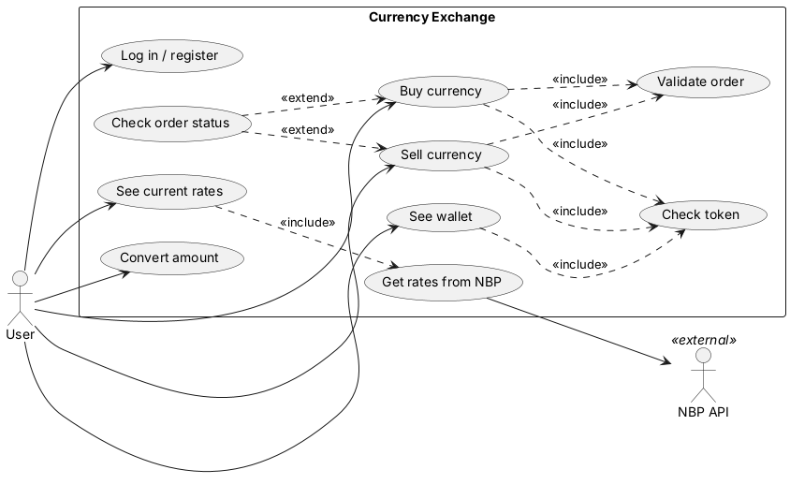
Use-case diagram
There are two actors: the user, and the NBP API as an external system. Every use case that touches the wallet includes checking the token. Buy and sell also include server-side validation. “Check order status” extends buy and sell: it only happens when the answer to an order didn’t arrive.

4.2. Class Diagram
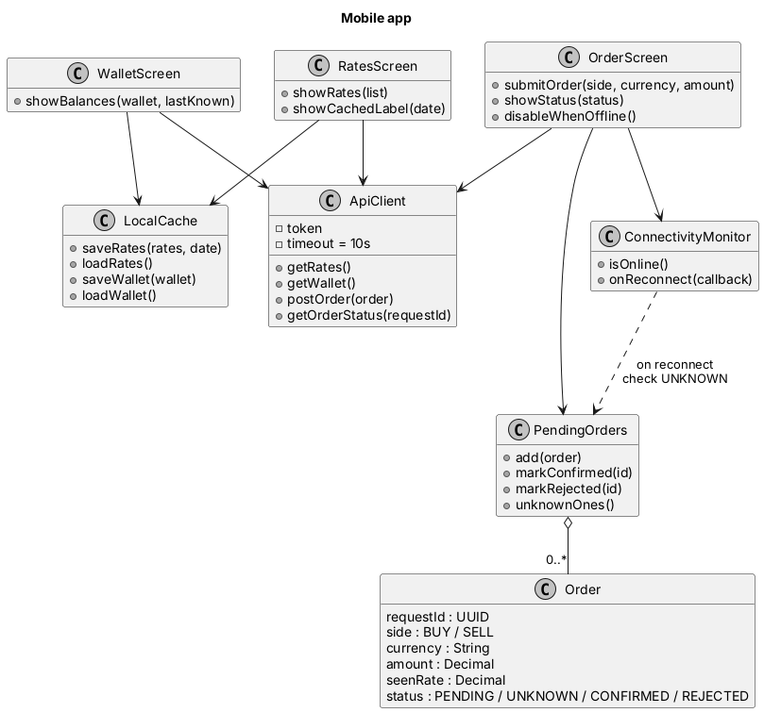
Mobile app classes
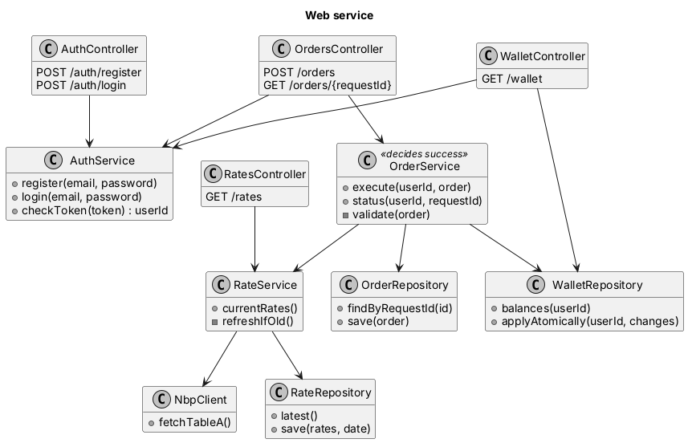
Web service classes
Responsibilities. On the phone, the screens use ApiClient (with the 10 s timeout) to talk to the server, LocalCache to show data offline, ConnectivityMonitor to block buttons when offline, and PendingOrders to remember orders that have no answer yet. On the server, AuthService checks tokens, RateService serves rates and calls NBP through NbpClient only when the saved copy is old, and OrderService validates and executes orders.
OrderService is the only component that decides whether an order succeeded. Its decision is the row in the orders table. The phone only shows what the server confirmed.

5. Database Design
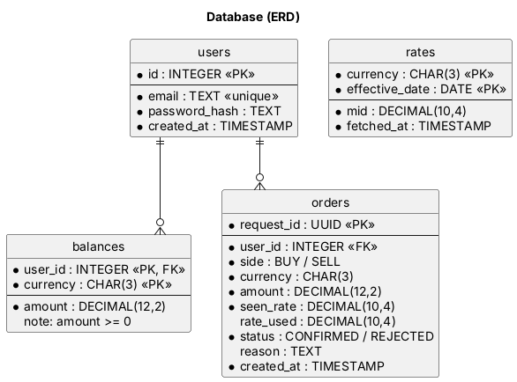
ERD
Table | Primary key | Foreign keys | What it stores
users | id (INTEGER) | none | email (unique), password hash, created at
balances | user_id + currency | user_id → users.id | amount (DECIMAL(12,2), must be ≥ 0) per currency
orders | request_id (UUID) | user_id → users.id | side (BUY/SELL), currency, amount, rate the user saw, rate used, status, reason, time
rates | currency + effective_date | none | NBP mid rate (DECIMAL(10,4)) and when it was fetched
One user has many balances (one per currency) and many orders. request_id is the primary key of orders, so the database itself stops the same order from being saved twice. The rates table has no link to users because rates are the same for everyone and belong to NBP.

6. System Architecture
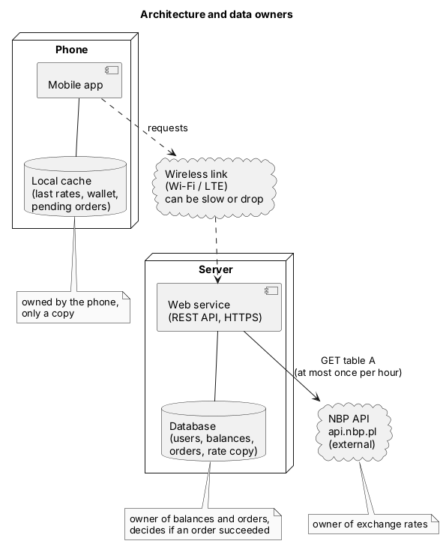
Architecture
The phone talks only to my web service, over the wireless link, which can be slow or drop. The web service talks to the database and, at most once per hour, to NBP.
Data owners: NBP owns the exchange rates. The web service and its database own users, balances and orders. The phone only has copies (cache) and a list of its own pending orders.

6.1. API Outline
Method | Path | Token | Type | Purpose
POST | /auth/register | no | action | create a user with 1000 PLN
POST | /auth/login | no | action | get a token
GET | /rates | no | read | current rates, date, stale flag
GET | /wallet | yes | read | balances
POST | /orders | yes | action | buy or sell, at most once per requestId
GET | /orders/{requestId} | yes | read | CONFIRMED, REJECTED or NOT_FOUND
Full request and response examples are in docs/api.md in the repository.

6.2. Data Flow
Normal read (see rates).
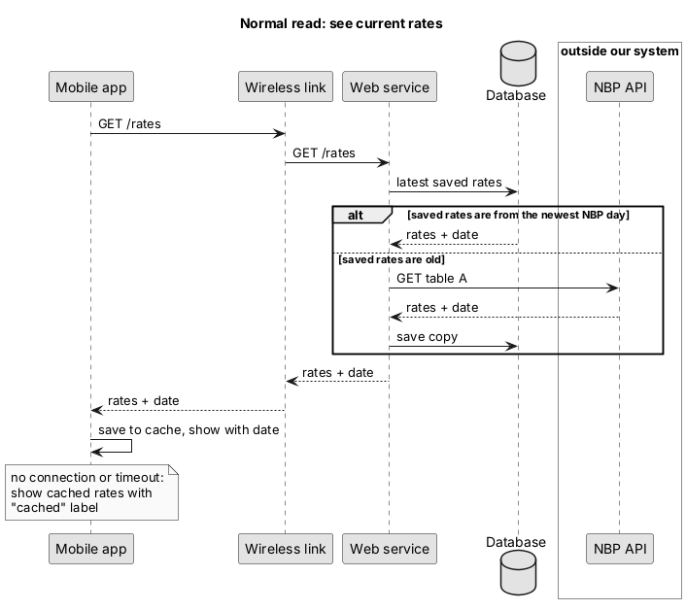
Read flow
Data-changing action (buy 100 EUR).
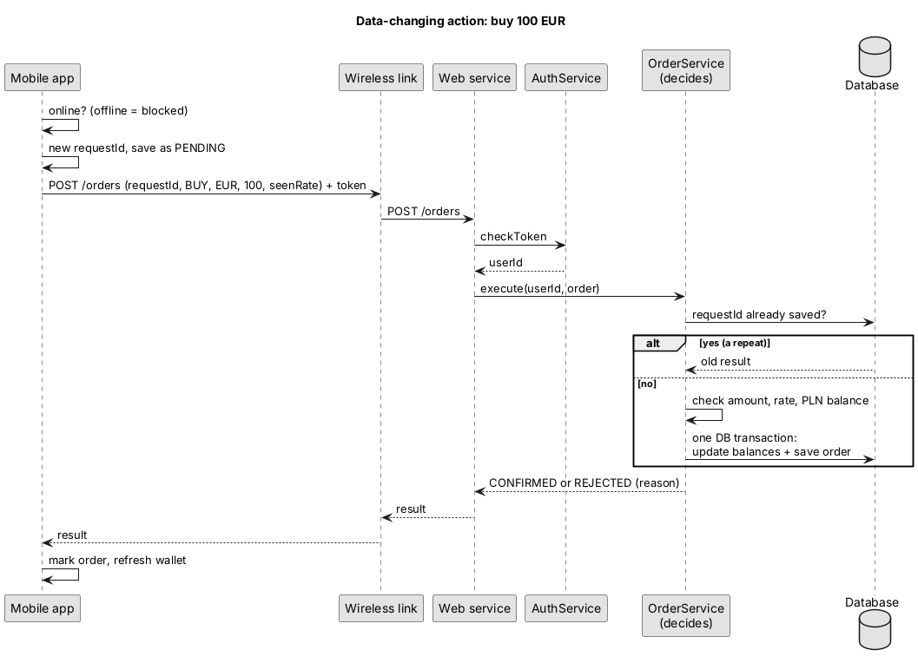
Buy flow
When I press Buy, the app first checks that I’m online. Then it gives the order a random request ID and saves it on the phone as PENDING. The order is sent with the rate I saw and my token. The server checks the token, then checks whether this request ID already exists. If it does, it just returns the old answer. If not, it checks the amount, the rate and my PLN balance, and then changes both balances and saves the order in one database transaction. The server answers CONFIRMED or REJECTED and the phone shows that.
Lost reply (finding the real result after reconnecting).
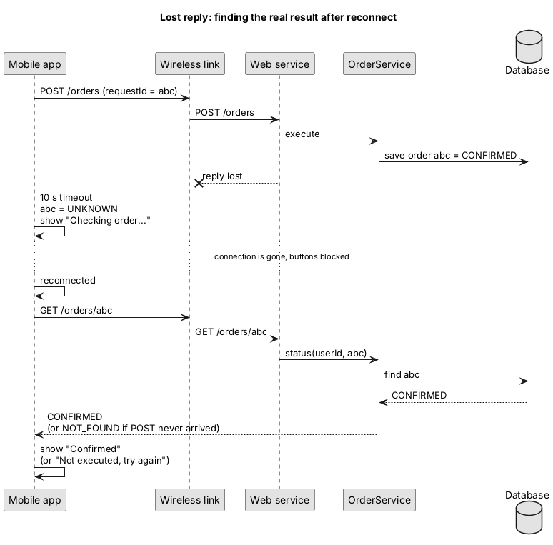
Recovery flow

7. Project Implementation Plan
Stage | Description | Deadline | Responsible Person
1 | Requirements analysis and network scenarios | Done (Lab 02) | Oleh
2 | UML diagrams and data flow | Done (Lab 03) | Oleh
3 | Part 1 design report, ERD, API outline | Lab 04 | Oleh
4 | Web service: rates endpoint and NBP client with caching | [date] | Oleh
5 | Login, wallet, database | [date] | Oleh
6 | Orders: buy, sell, request ID, status endpoint | [date] | Oleh
7 | Mobile app screens and local cache | [date] | Oleh
8 | Offline blocking, retries, reconnection handling | [date] | Oleh
9 | Testing the network scenarios S1 to S14 | [date] | Oleh
10 | Part 2 report and demo | [date] | Oleh

8. Conclusions and Possible Extensions
The design puts all decisions about money on the server and treats the phone’s data as copies. That makes the bad-network cases manageable: the phone can always show something (with a label), and it can always find out the real result of an order by asking with its request ID.
Possible extensions after the main project is done:
- rate history chart for one currency (NBP has an endpoint for it)
- transaction history screen
- topping up the wallet
- push notification when a rate reaches a value the user chose
- queueing orders while offline, with the user confirming again when the phone is back online
- more currencies (NBP table B) and buy/sell rates (table C)

9. Sources
- National Bank of Poland, Web API documentation: https://api.nbp.pl/en.html
- FastAPI documentation: https://fastapi.tiangolo.com
- Flutter documentation: https://docs.flutter.dev
- SQLite documentation: https://www.sqlite.org/docs.html
- PlantUML language reference: https://plantuml.com
- RFC 9110, HTTP Semantics (idempotent methods), IETF, 2022: https://www.rfc-editor.org/rfc/rfc9110
- Lecture materials, Networking Issues in Mobile Systems

