Hello all.

For the visual thinkers of our group, here is an attempt a simple diagram flow diagram to illustrate what is flowing form where. I’ll start with the simplest version and then add to it a bit.

(This image was taken initially from <https://github.com/JacORB/JacORB/blob/master/README.md>)

**Creating a pull request on GitHub**

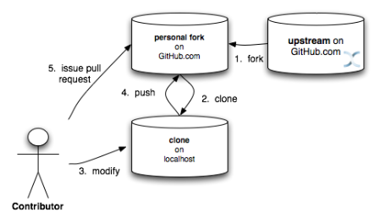

**Creating a pull request on GitHub (Revision one – We’ll work on branches)**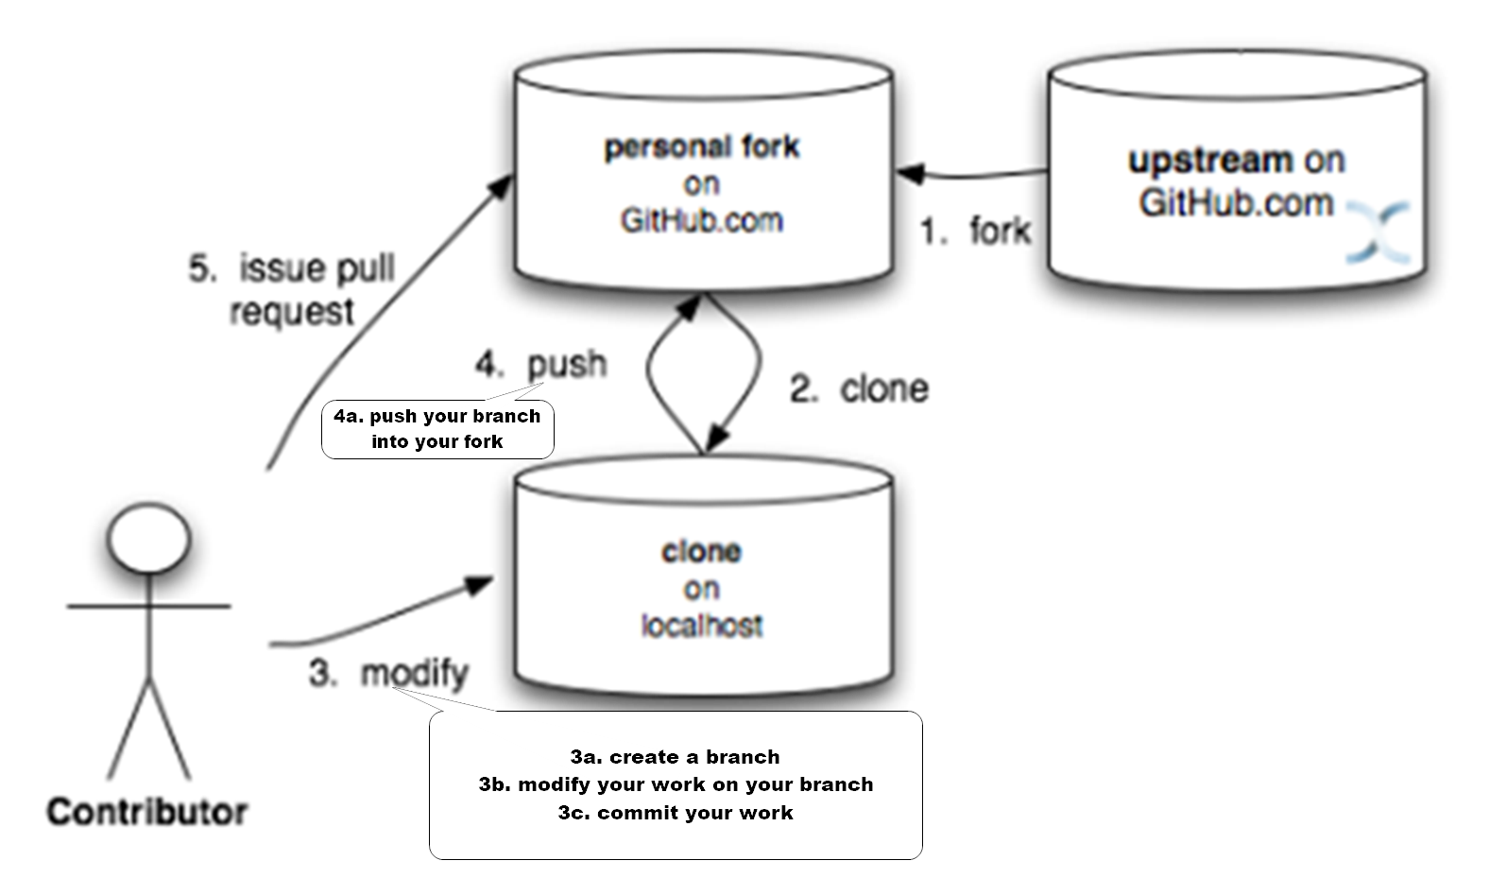

**Creating a pull request on GitHub (Revision two – Fetch and merge as needed)**

**3.5 Fetch as needed**

**3.75 Merge as needed**

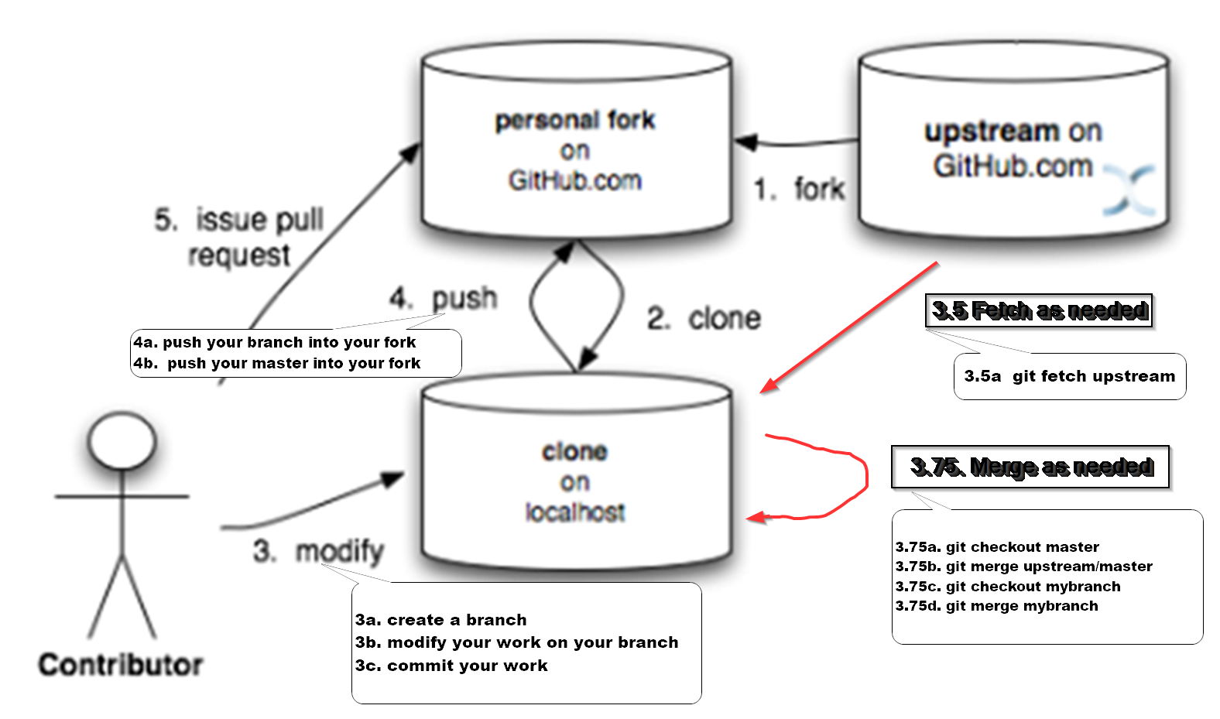

Here are a few other images and links that might help:

Another workfow diagram. Mostly correct, again think of "upstream" as BradyMetals, and note we don't utilize an upstream dev branch (2nd horizontal row).

Diagram assumes changes are made quickly so it doesn't show "every morning or as needed" activity: git fetch upstream (BradyMetals); git checkout master; git merge upstream/master; etc...

<https://camo.githubusercontent.com/ba055eab9cd7f0c24ea14ff0b704371afd611f4e/687474703a2f2f7777772e646176696467772e636f6d2f636f6e74656e742f696d616765732f323031342f4175672f4749742d576f726b666c6f772d4469616772616d2d2d352d2e706e67>

Interactive cheat sheet: Illustrates which commands work between which tiers. Click on one...

<http://ndpsoftware.com/git-cheatsheet.html>

A Visual Git Reference, focuses on what's going on within your local repository

<http://marklodato.github.io/visual-git-guide/index-en.html>

Why we fetch and merge don't just pull

<http://longair.net/blog/2009/04/16/git-fetch-and-merge/>