Ministry of Education and Research of the Republic of Moldova
Technical University of Moldova
Faculty of Computers, Informatics and Microelectronics
Department of Software Engineering and Automatics
REPORT
on laboratory work no. 1
Course: Operating Systems
Topic: The OS as a Resource Manager (Track A, Linux)
Done by: st. gr. FAF-242, Olga Saban
Checked by: assist. univ. Patricia Reițman

Chișinău, 2026

1. Purpose of the work
The purpose of this lab is to see the operating system as a manager of resources. A program never works with the hardware directly: the OS gives it files, processes, memory and devices, and controls how they are used. In this lab I looked at each of these four resources with ordinary Linux commands and wrote down what the commands show.
I worked on Ubuntu Linux in a virtual machine (user vboxuser, host name VMForLab, kernel Linux 7.0.0-34-generic, 64-bit ARM). For every part I ran the commands from the task, saved screenshots of the terminal, and answered the “Observe” questions using my own output.

2. The work done

Setup
I created the working folder ~/os-lab1 and checked who I am and what system I use.
mkdir -p ~/os-lab1 && cd ~/os-lab1
whoami
uname -a
uptime
pwd

I am the ordinary user vboxuser. The kernel is Linux 7.0.0 (an Ubuntu build for 64-bit ARM). The machine had been up for 32 minutes and was almost idle: the load average was about 0.02 (Figure 0.1). The same figure shows ls -la /, the root of the file tree.
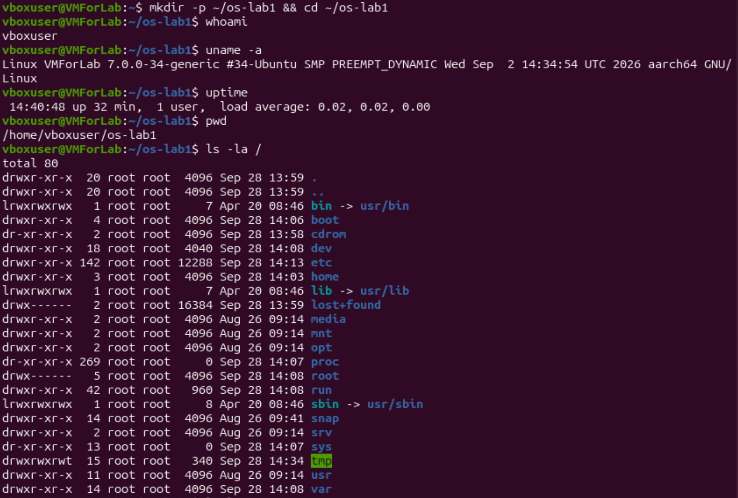
Figure 0.1 – Setup commands and ls -la /

Part 1. Files and directories
First I looked at the top of the tree with ls -la /, at my home directory with ls -la ~, and at the first lines of /etc (Figure 1.1). Then I made a small experiment in a new folder demo: I created a file, copied it, renamed the copy, deleted it and changed the permissions of the original.
cd /etc && ls | head
cd ~/os-lab1
mkdir demo && cd demo
echo "Hello operating systems" > note.txt
cp note.txt copy.txt
mv copy.txt renamed.txt
ls -l
rm renamed.txt
ls -l note.txt
chmod 600 note.txt
ls -l note.txt

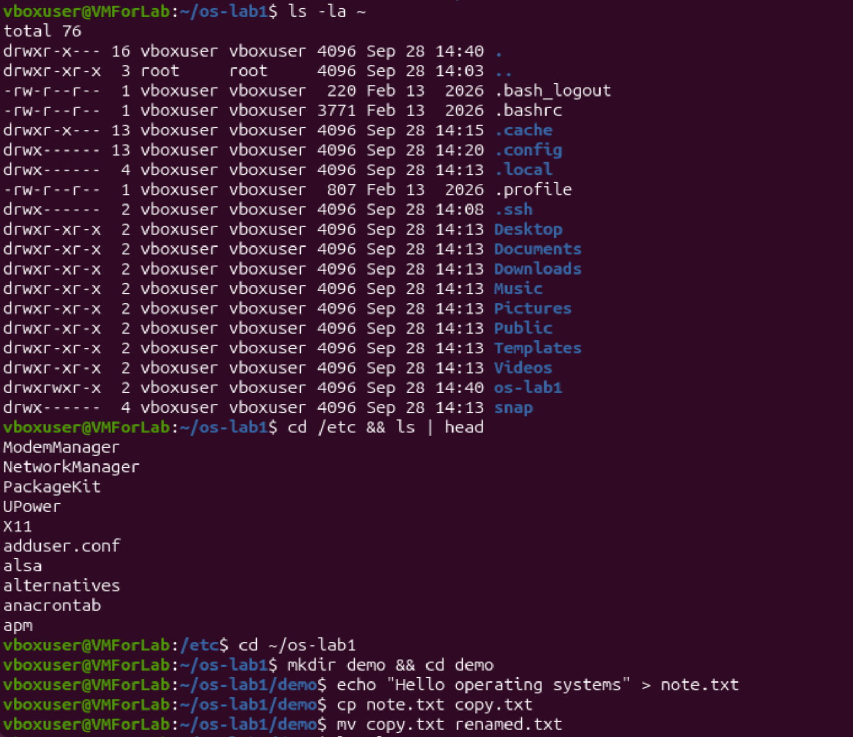
Figure 1.1 – ls -la ~, the beginning of /etc and the demo folder
The listings before and after the permission change are in Figure 1.2. While typing I made a mistake: I wrote chmod 644note.txt without a space and got chmod: missing operand. I corrected it to chmod 644 note.txt.
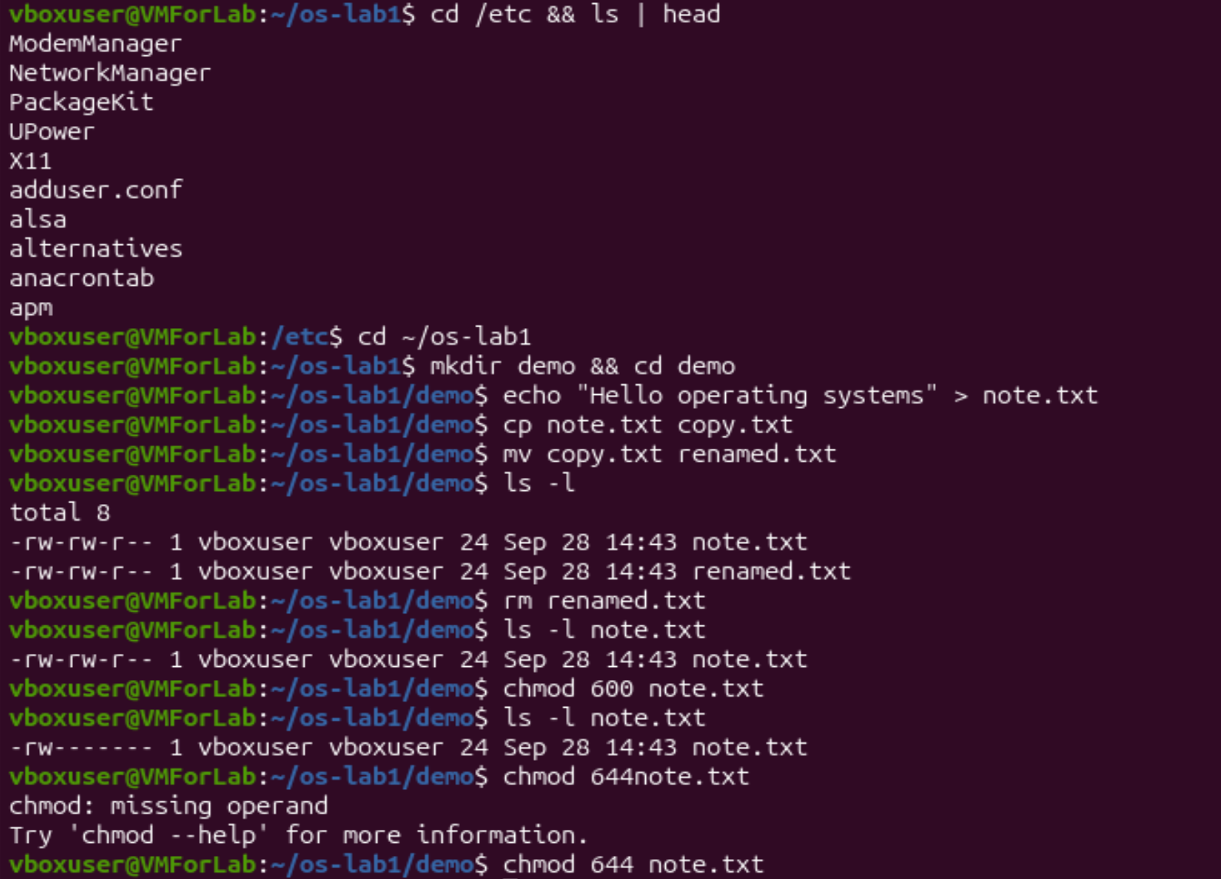
Figure 1.2 – ls -l, rm, chmod 600 and the chmod typo

Observe, Part 1
1. Owner and group. The files note.txt and renamed.txt belong to user vboxuser and group vboxuser. Ubuntu gives every user a private group with the same name, and the OS marks each new file with the identity of the process that created it.
2. The ten characters after chmod 600: -rw-------.
Characters | Value | Meaning
1 | - | a regular file (a directory would show d, a symlink l)
2–4 | rw- | the owner may read and write, but not execute
5–7 | --- | the group has no rights
8–10 | --- | all other users have no rights

So only I can read or change the file. Before the change it was -rw-rw-r-- (mode 664): the group could also write, and other users could read.
3. Two directories under /. /etc holds the system-wide configuration files (network, users, services). /home holds the personal directories of ordinary users; mine is /home/vboxuser. I also noticed that /tmp is writable for everybody and has the sticky bit (drwxrwxrwt), and that /bin is only a symbolic link to /usr/bin.
Interesting output. The size of note.txt is 24 bytes: 23 characters of “Hello operating systems” plus one newline added by echo. My typo chmod 644note.txt also showed that the shell splits a command into words at spaces: 644note.txt became one argument (the mode) and there was no file name, so chmod refused to run.

Part 2. Processes
I listed the processes with ps aux, counted them, and watched the live view in top (Figures 2.1 and 2.2).
ps aux | head
ps aux | wc -l
top

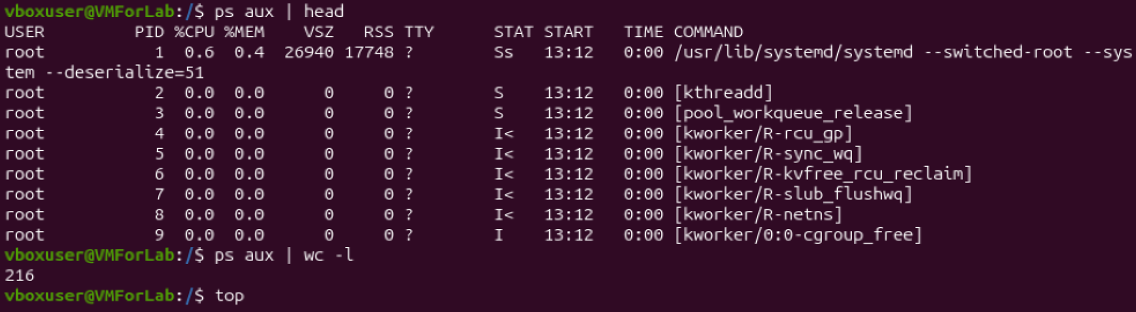
Figure 2.1 – ps aux | head and ps aux | wc -l
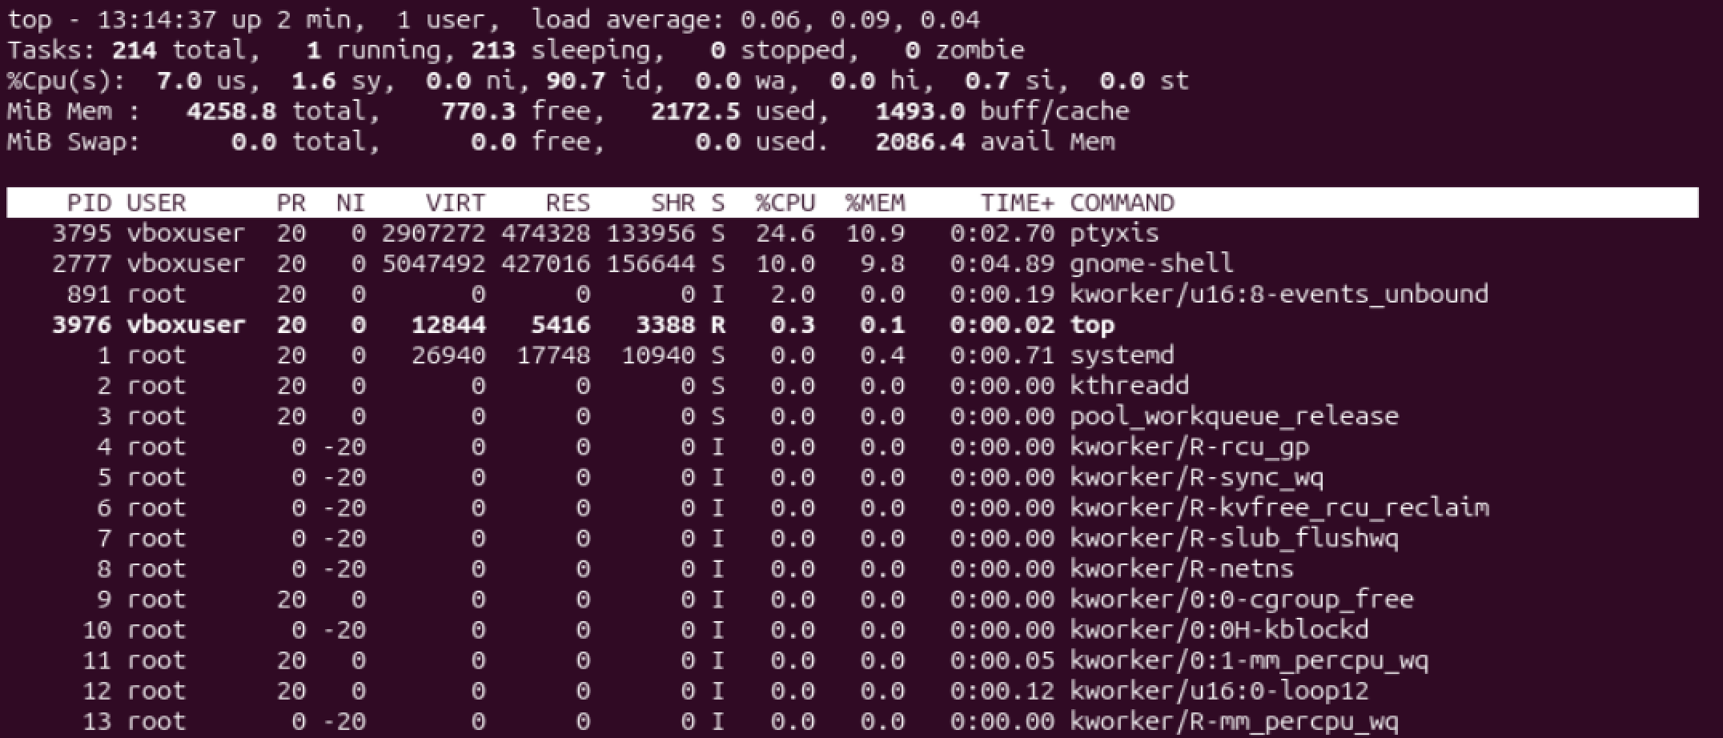
Figure 2.2 – The top command
Then I started background processes with sleep 300 &, looked at them with jobs and ps -ef | grep sleep, and stopped one with kill (Figure 2.3). Finally I looked at how the kernel describes a process in /proc/<PID> (Figure 2.4).
sleep 300 &
jobs
ps -ef | grep sleep
kill 4098

sleep 300 &
PID=$!
ls /proc/$PID/
cat /proc/$PID/status | head -20
kill $PID

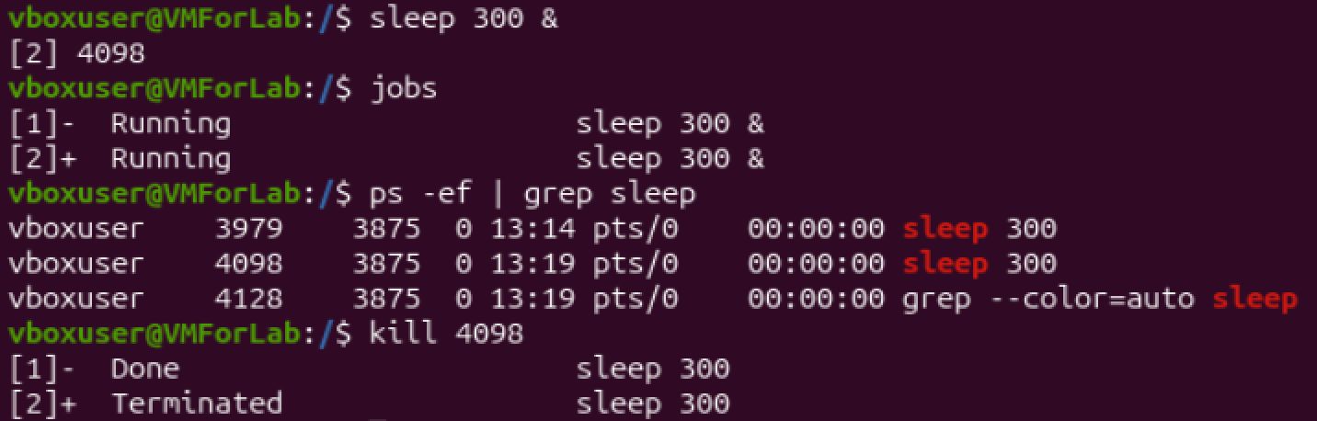
Figure 2.3 – sleep, jobs, ps -ef and kill
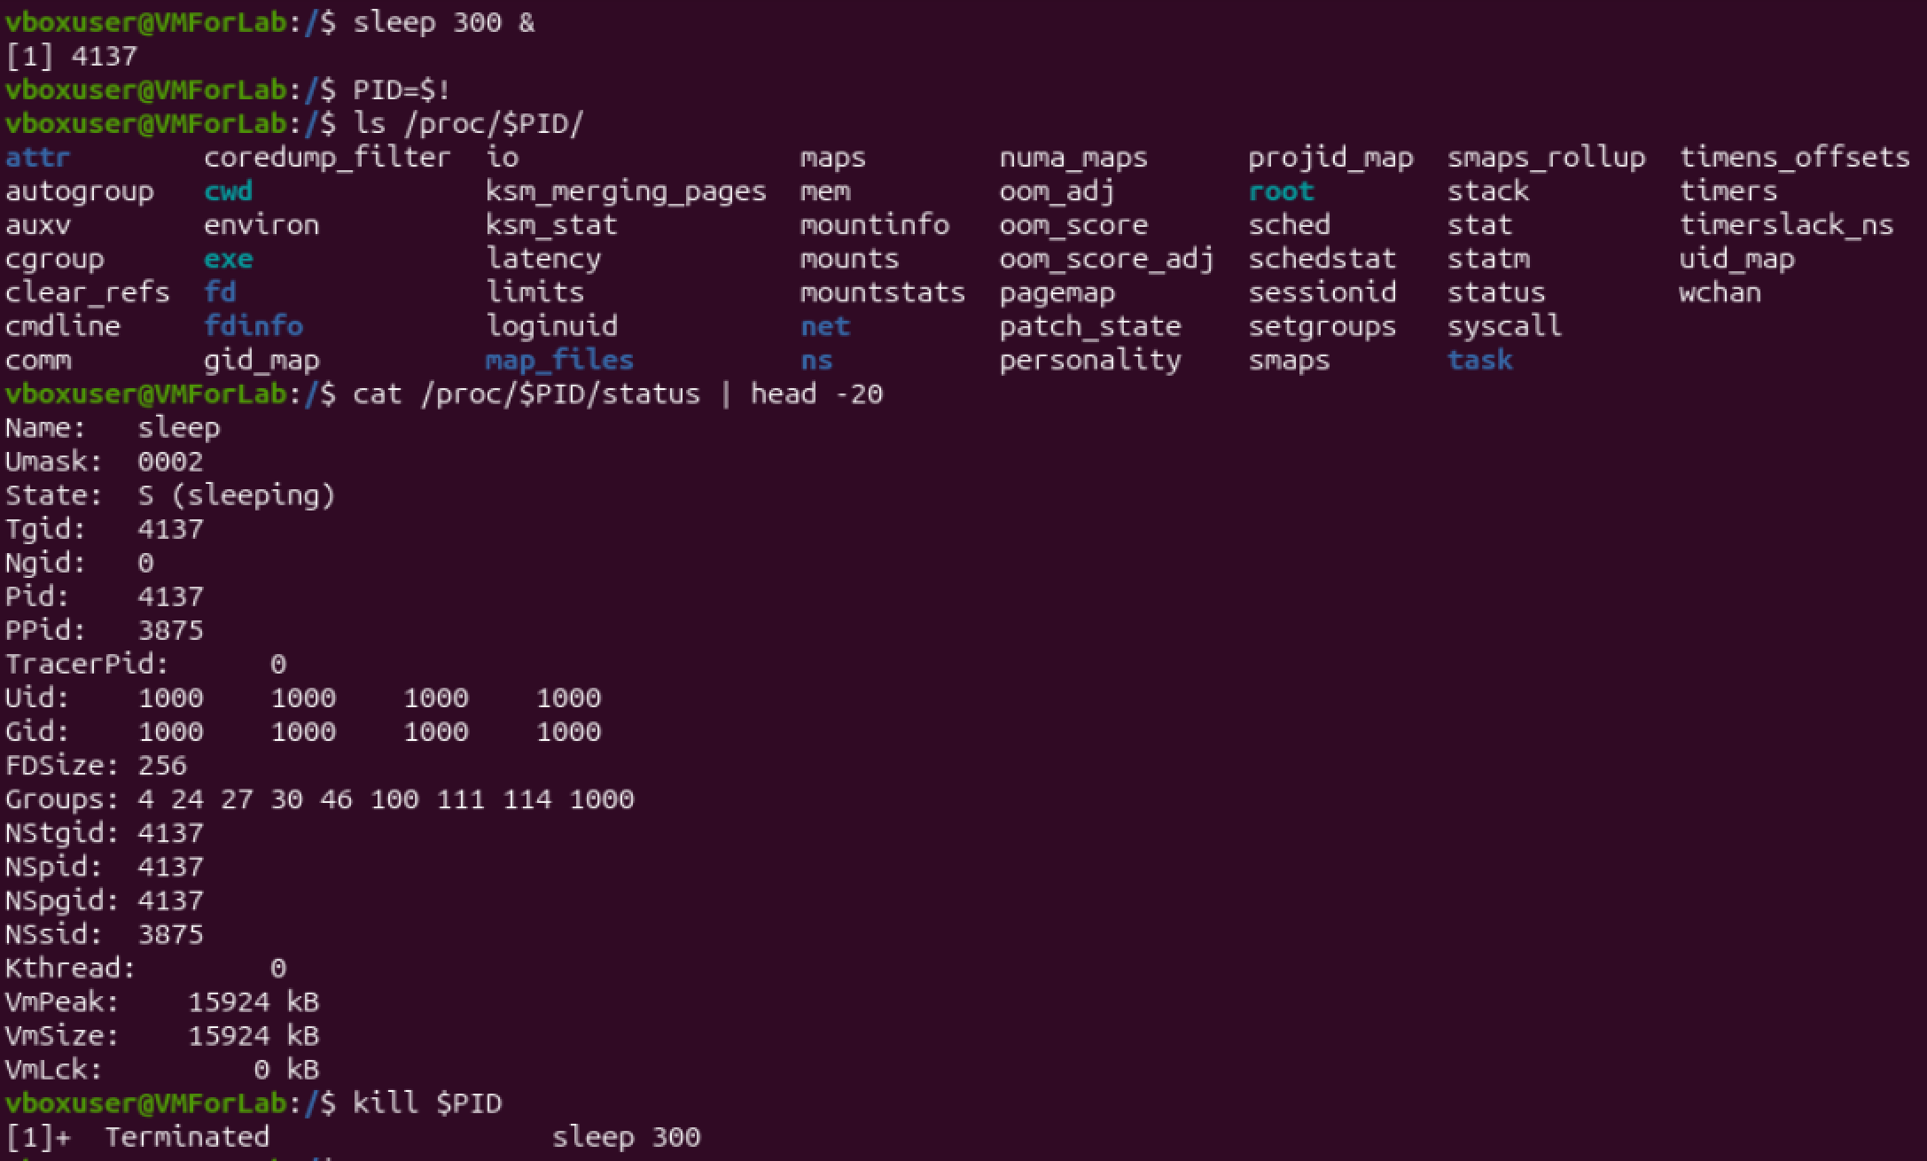
Figure 2.4 – The /proc/PID listing and status

Observe, Part 2
1. PID 1 is systemd (/usr/lib/systemd/systemd --switched-root --system ...), owned by root. It is the first user-space process started by the kernel at boot. It starts and supervises the other services, and every other process descends from it. The names in square brackets with low PIDs (kthreadd, kworker/...) are not programs but threads of the kernel itself.
2. Number of processes. About 215. ps aux | wc -l printed 216 lines, and one of them is the header. top counted 214 tasks: 1 running, 213 sleeping, 0 stopped and 0 zombie. The CPU was 90.7% idle, so the OS was managing more than 200 processes while almost none of them was actually running.
3. State: of the sleeping process is S (sleeping). The process is alive but waits for a timer (sleep 300), so it uses no CPU and the scheduler skips it until the time is up. Its parent is PPid: 3875, my shell, and it runs with my user ID 1000.
Interesting output. After the second sleep 300 &, jobs and ps -ef showed two sleep processes with the same parent (3875, my bash) but different PIDs (3979 and 4098). After kill 4098 the shell reported job [2] as Terminated (stopped by my signal) and job [1] as Done (its 300 seconds had simply ended: 13:14 + 5 minutes = 13:19). So the OS creates a process, remembers its parent and its state, and tells the parent how it ended. Also, ls /proc/<PID>/ shows that the kernel presents the data of a running process (status, cmdline, maps, fd, ...) as files, although none of it is stored on the disk.

Part 3. Memory
I checked the memory of the whole machine with free -h and /proc/meminfo, and the memory of one small process with VmRSS (Figure 3.1).
free -h
cat /proc/meminfo | head -6
sleep 300 & PID=$!
grep VmRSS /proc/$PID/status
kill $PID

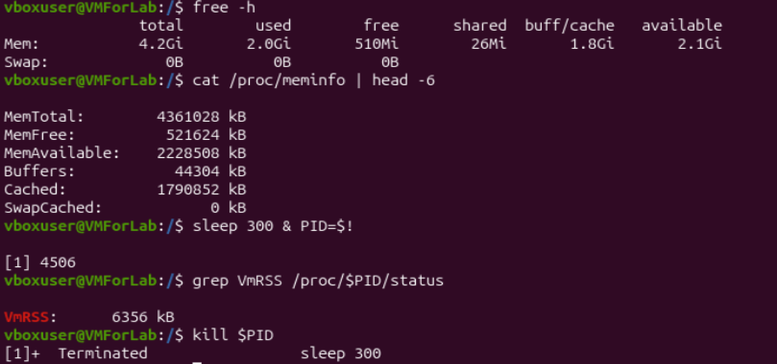
Figure 3.1 – free -h, /proc/meminfo and VmRSS

Observe, Part 3
1. RAM. The VM has 4.2 GiB of RAM in total (MemTotal = 4 361 028 kB). Only about 510 MiB is strictly free, but 1.8 GiB is used by the page cache and buffers, which the OS gives back when programs need memory. So about 2.1 GiB is actually available.
2. Swap is disk space that the OS uses as an overflow for RAM: pages that are not needed right now can be moved there when RAM runs short. On my VM it is 0 B, so no swap is configured.
3. VmRSS of a bare sleep is 6356 kB, about 6 MB. This surprised me, because sleep does nothing. The figure includes the pages of the program and of the shared C library that are loaded in memory, and most of them are shared with other processes, so the real extra cost of one more sleep is smaller.
Interesting output. MemFree is only 521 MB of 4.3 GB, but MemAvailable is 2.2 GB. The difference is mostly the Cached value (1.79 GB). Linux uses “unused” RAM as a disk cache, so a low “free” value does not mean that the machine is short of memory.

Part 4. Devices and storage
I looked at the disks and mounted file systems with df -h, lsblk and mount, measured my lab folder with du, and listed the device files in /dev (Figures 4.1 and 4.2).
df -h
lsblk
du -sh ~/os-lab1
ls -l /dev | head
mount | head

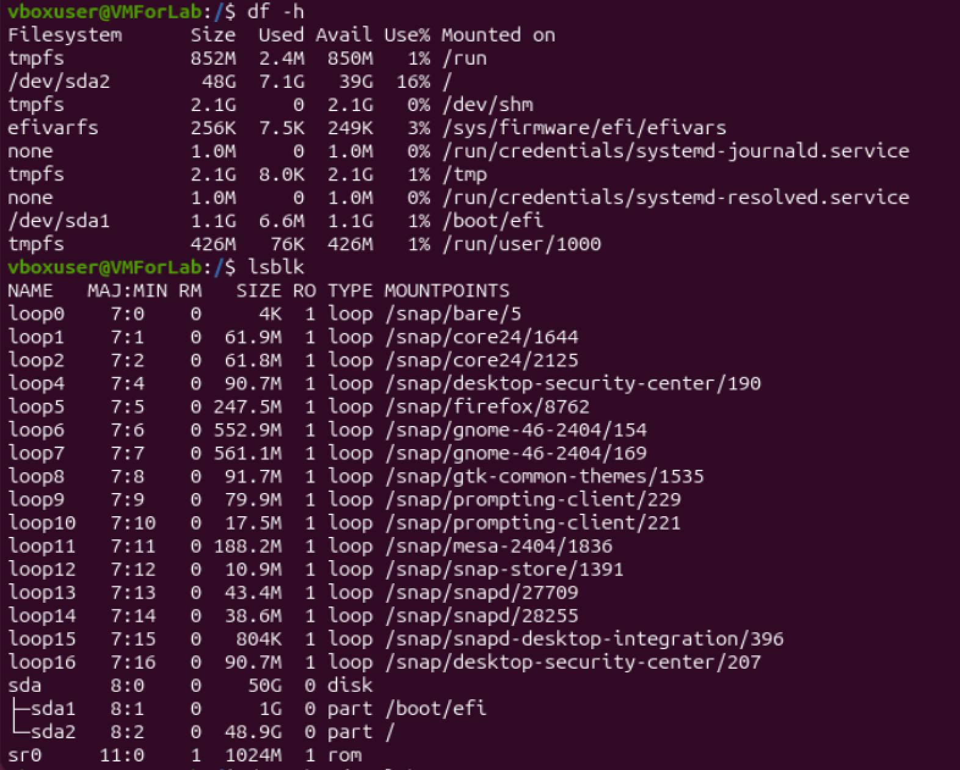
Figure 4.1 – df -h and lsblk
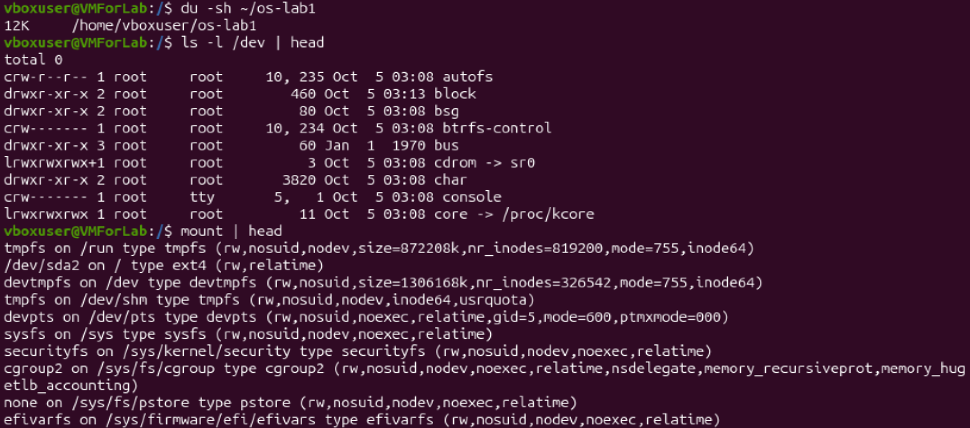
Figure 4.2 – du, ls -l /dev and mount

Observe, Part 4
1. Root file system. / is mounted from /dev/sda2 (type ext4, 48 GB, 16% used). It is the second partition of the 50 GB virtual disk sda. The first partition, /dev/sda1 (1 GB), is mounted on /boot/efi.
2. A /dev entry. /dev/console is a character device (the line starts with c). It stands for the system console, the terminal to which the kernel itself writes its messages. Another example from the same listing is /dev/cdrom -> sr0, a symbolic link to the virtual optical drive.
3. “Everything is a file.” The OS shows disks, terminals and other devices (and even kernel data such as /proc/kcore) as entries in the same directory tree, and ls -l lists them all in the same way. A program can use the same file operations on all of them instead of needing a special interface for each device.
Interesting output. In ls -l /dev the first character shows the type of the entry: c for character devices such as console, d for directories and l for symbolic links. For devices, two numbers (major, minor, for example 5, 1) are printed in place of the file size. They tell the kernel which driver handles the device.

3. Conclusions
In this lab I looked at four resources that the operating system manages. My main findings are:
- Files. The OS keeps one directory tree and stores an owner, a group and permission bits for every file. ls -l shows them and chmod changes them: mode 600 left only the owner with access to note.txt.
- Processes. The OS runs more than 200 processes on an almost idle machine. All of them descend from systemd (PID 1), and the kernel keeps for each one a parent, a state and a user ID, visible in ps, top and /proc/<PID>/status.
- Memory. free -h shows that a low “free” value is normal in Linux, because unused RAM works as a disk cache. The memory that is really available (2.1 GiB) is much larger. My VM has no swap.
- Devices and storage. The 50 GB disk sda is divided into two partitions, and /dev/sda2 holds the root file system. Devices are presented as files in /dev, so the same tools work for files and for hardware.
Together, these results show that the OS stands between my programs and the hardware and gives each program a controlled and uniform view of it. I also learned that the kernel shows its own internal data (/proc, /dev) in the same form as ordinary files, which makes it easy to study with simple commands.

