Ministry of Education and Research of the Republic of Moldova
Technical University of Moldova
Faculty of Computers, Informatics and Microelectronics
Department of Software Engineering and Automatics
REPORT
on laboratory work no. 2
Course: Operating Systems
Topic: Meet the OS You Will Build (xv6 on RISC-V)
Done by: st. gr. FAF-242, Olga Saban
Checked by: assist. univ. Patricia Reițman
Chișinău, 2026

1. Purpose of the work
The purpose of this lab is to get to know xv6, the small teaching operating system that we will modify in the next labs. xv6 is a re-implementation of Unix Version 6 for the RISC-V processor. In this lab I built it from source, booted it in the QEMU emulator, used it as a normal Unix system, read a part of its source code, and wrote my first program for it.
I worked on an Ubuntu virtual machine over SSH (user ubuntu), starting from a fresh clone of the upstream repository mit-pdos/xv6-riscv. The figures below are screenshots of my own terminal session, in the order in which I ran the commands.

2. The work done

Part 1. Build it and boot it
On the VM I cloned the repository, listed its contents (LICENSE, Makefile, README, kernel, mkfs, test-xv6.py, user) and started the build with make qemu (Figure 1.1).
git clone https://github.com/mit-pdos/xv6-riscv ~/xv6-riscv
cd ~/xv6-riscv/
ls
make qemu

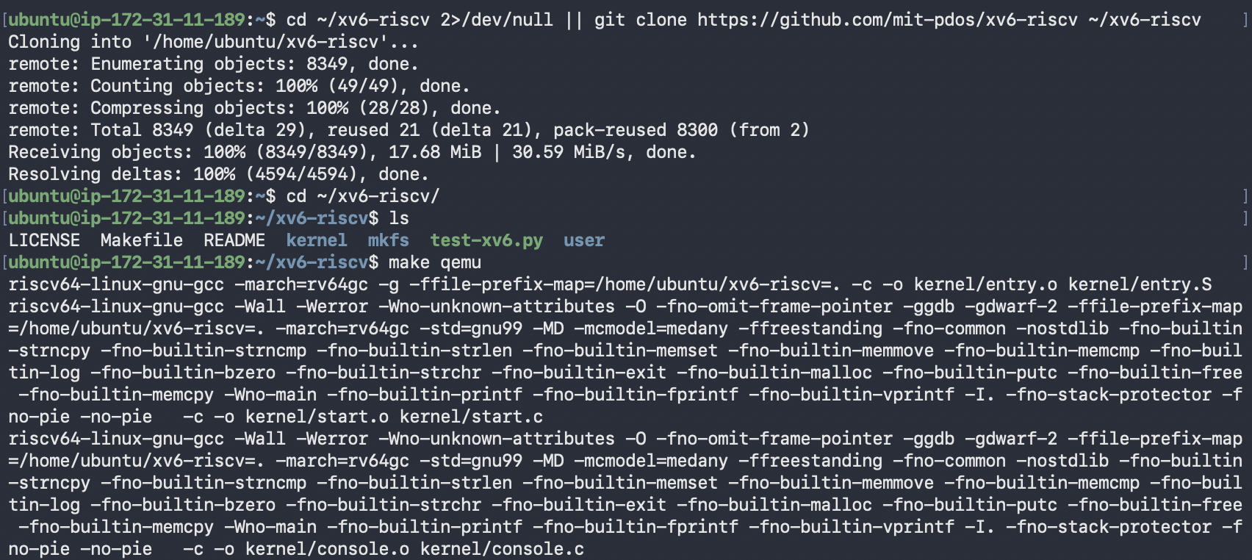
Figure 1.1 – Cloning xv6-riscv and starting the build with make qemu
Every file is compiled with riscv64-linux-gnu-gcc -march=rv64gc. This is a cross-compiler: it runs on my VM but produces machine code for a RISC-V CPU. QEMU then emulates a RISC-V machine and boots the kernel that was just built (Figure 1.2).
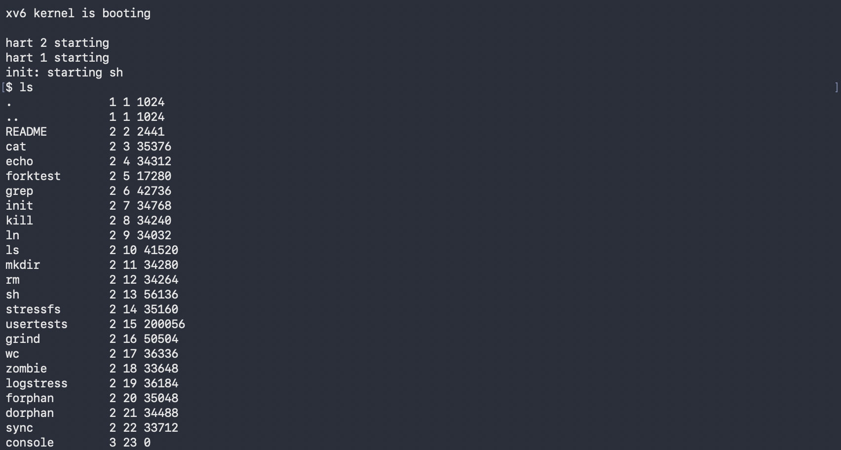
Figure 1.2 – xv6 boots, starts the shell, and ls lists the root directory
The lines hart 2 starting and hart 1 starting are the extra CPU cores coming online. “Hart” is the RISC-V term for a hardware thread, and QEMU is started with -smp 3, so there are three of them. After that init launches the shell and the $ prompt appears.

Part 2. Use xv6 as the Unix it is
Inside xv6 I tried a few basic commands: cat README (Figure 2.1), echo, the pipe ls | grep c, wc README and usertests -q (Figures 2.2 and 2.3).
Figure 2.1 – Start of cat README (the rest of the file is cut)
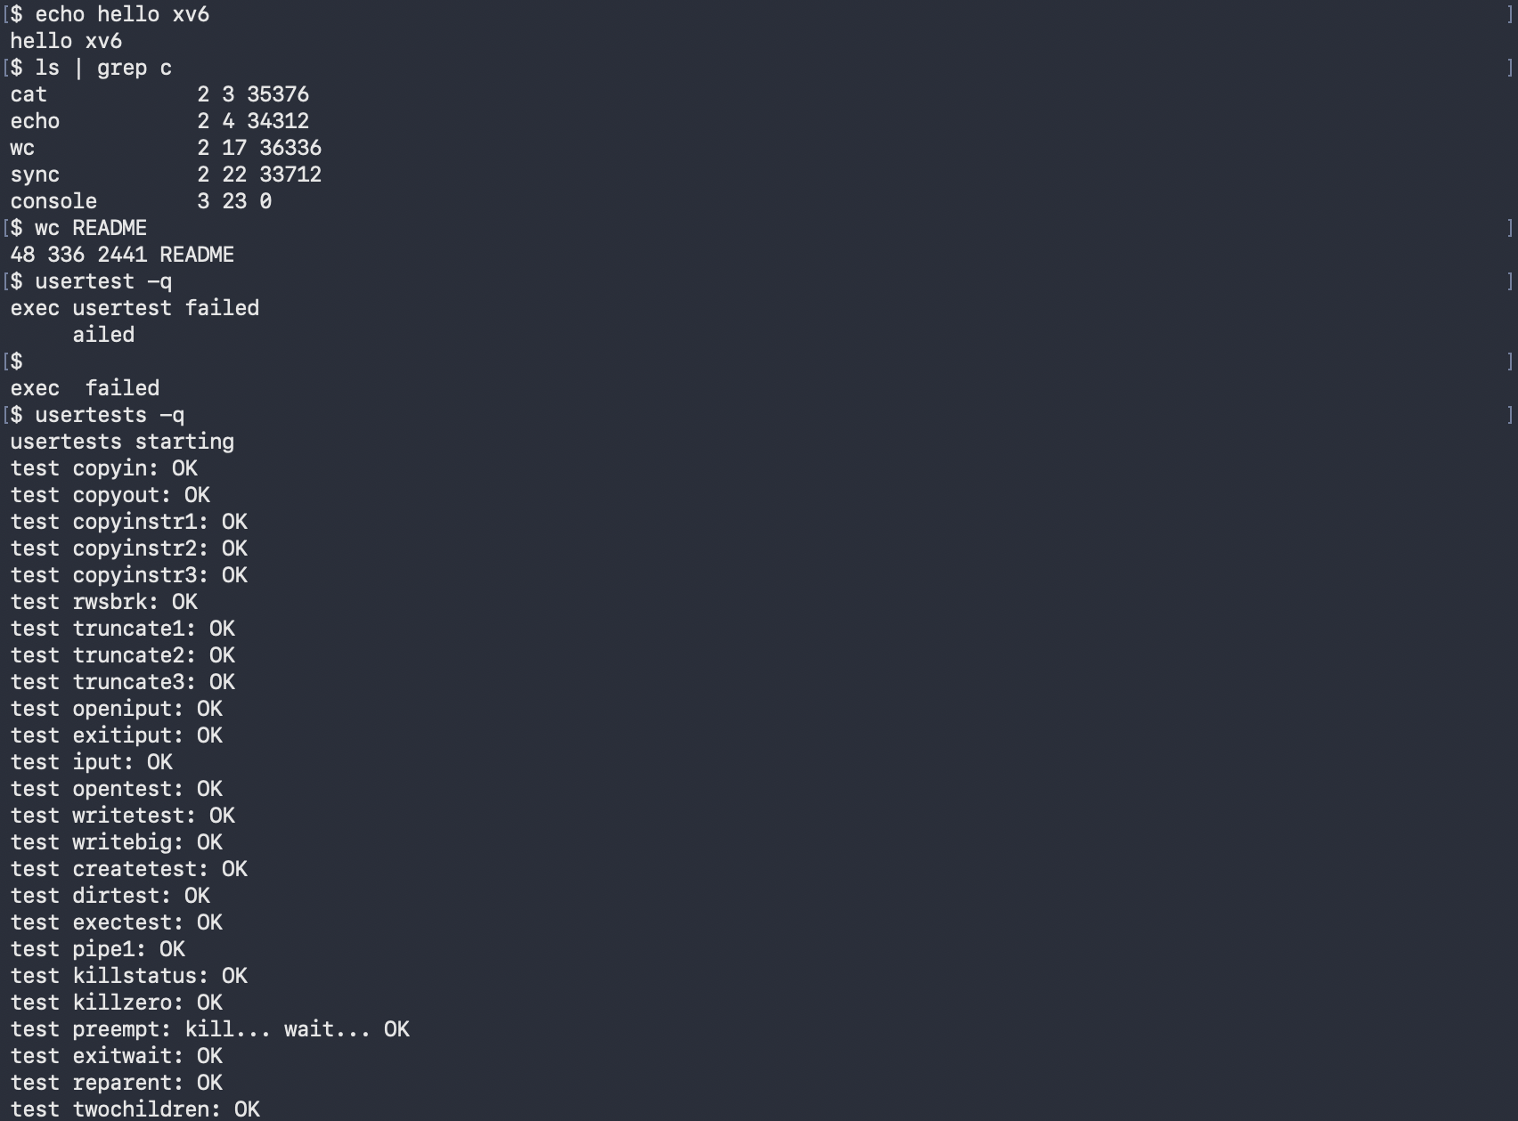
Figure 2.2 – echo, the pipe ls | grep c, wc README, a mistyped usertest, then usertests -q
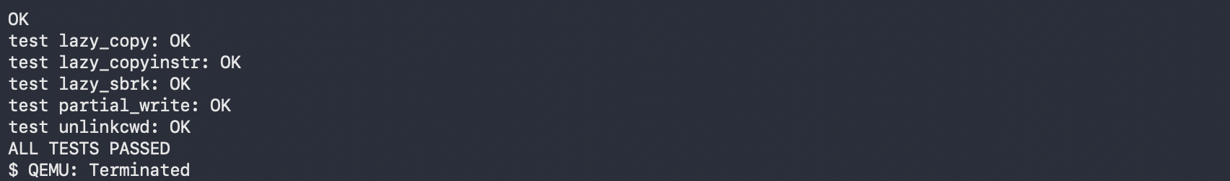
Figure 2.3 – End of usertests -q with ALL TESTS PASSED, then QEMU closed with Ctrl-A, X

Observe, Part 2
1. Three programs xv6 ships with: ls, cat and grep. It also includes echo, wc, mkdir, rm, kill, sh and test programs such as usertests (see the listing in Figure 1.2).
2. Two OS features that must exist for a pipe to work:
- Processes. The shell uses fork() to create two processes and exec() to load ls and grep into them, so both run at the same time.
- Inter-process communication. pipe() gives a kernel buffer with a read end and a write end (two file descriptors). The shell attaches the output of ls to the write end and the input of grep to the read end, so the data passes from one process to the other through the kernel.
3. xv6 shell and the Linux shell from Lab 1. The core is the same: running programs, pipes, < and > redirection, & and ;. Everything else is missing: there is no history, no tab completion, no variables and no wildcards. Error messages are minimal too. My typo usertest produced only exec usertest failed (Figure 2.2), where Linux would say “command not found” and often suggest the right name.
Interesting output. xv6’s ls prints the name, type, inode number and size of each entry. Type 1 is a directory, 2 a regular file and 3 a device, so console 3 23 0 is the terminal exposed as a file, the same idea as /dev/console in Lab 1. wc README returned 48 336 2441 (lines, words, bytes), and 2441 is exactly the size that ls shows for README. usertests -q ended with ALL TESTS PASSED, which confirms that the kernel I built works.

Part 3. Read the source
After quitting QEMU I read some of the source code on the VM.
sed -n "1,40p" user/ls.c
sed -n "1,30p" user/cat.c
cat user/user.h
grep -n "sys_read\|sys_write" kernel/sysfile.c | head

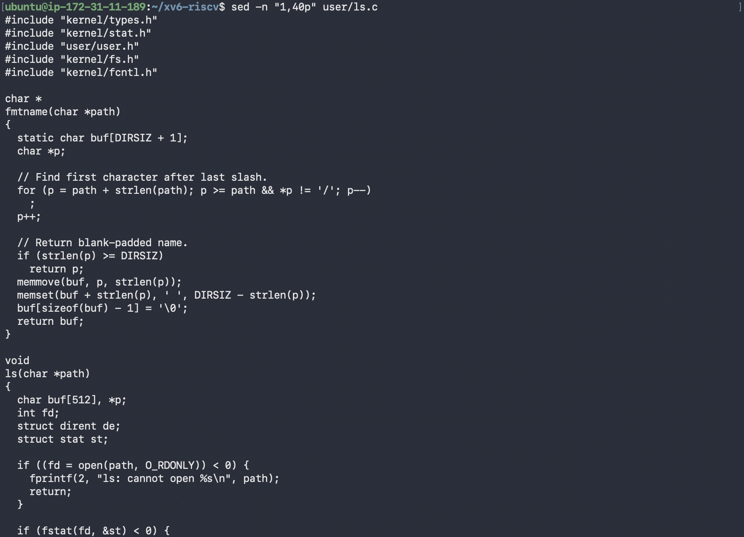
Figure 3.1 – First 40 lines of user/ls.c
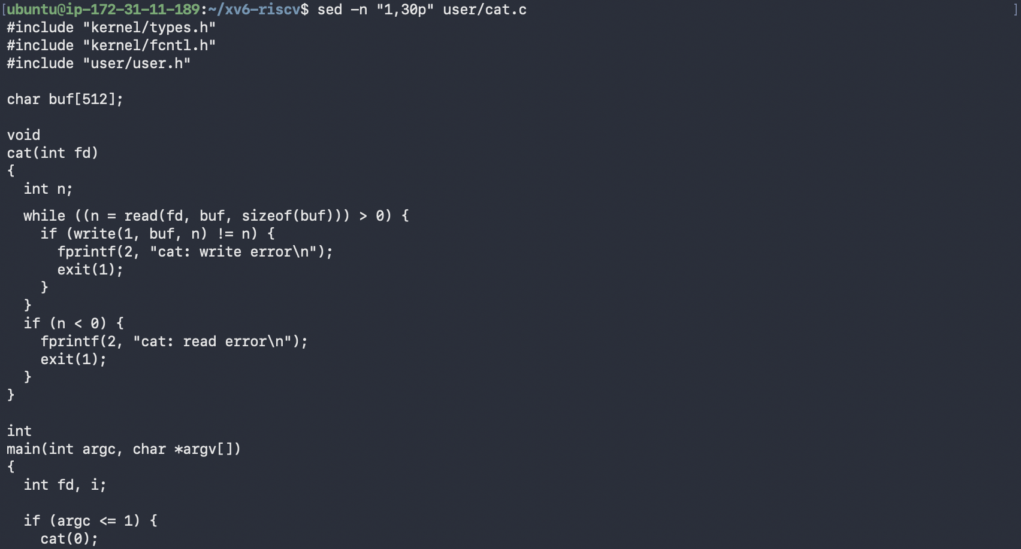
Figure 3.2 – First 30 lines of user/cat.c
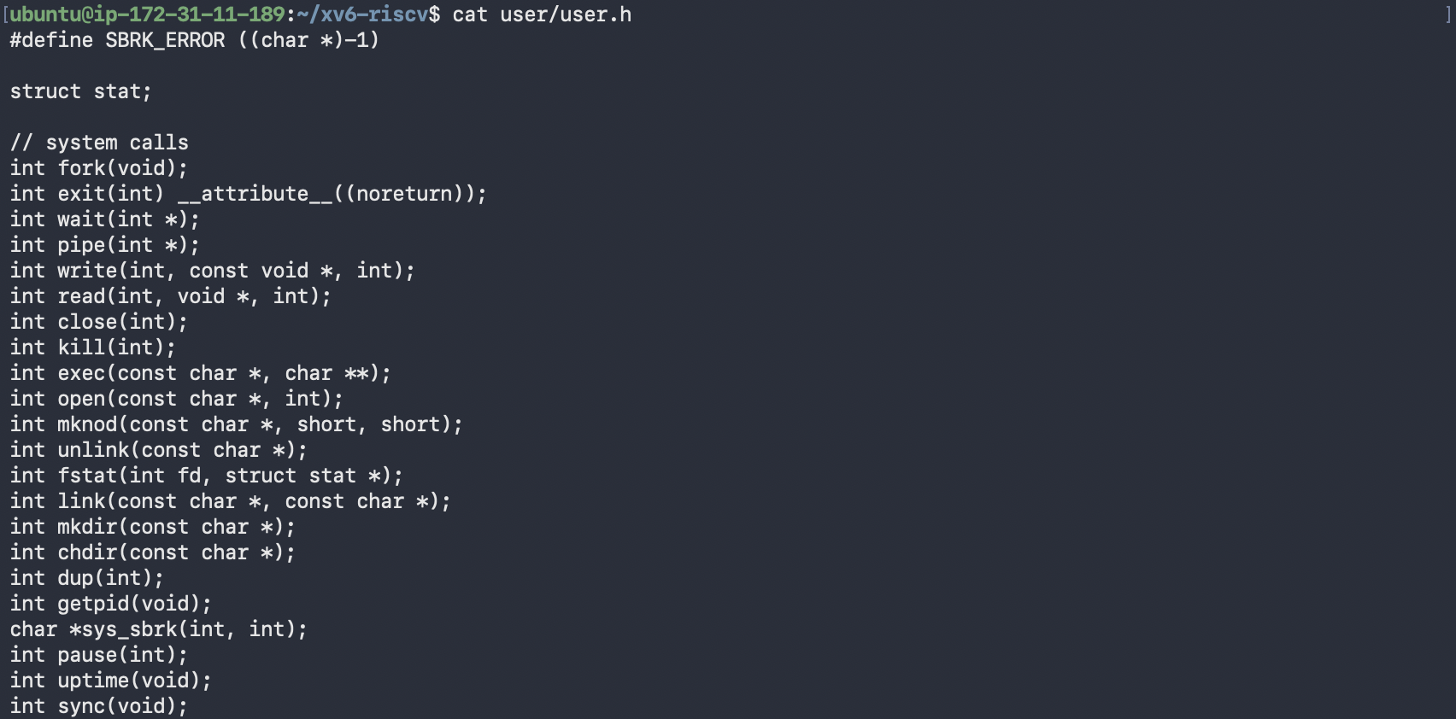
Figure 3.3 – System call declarations in user/user.h
Figure 3.4 – Locating sys_read and sys_write in kernel/sysfile.c

Observe, Part 3
1. System calls used by user/cat.c (Figure 3.2):
- read(fd, buf, sizeof(buf)) asks the kernel to copy up to 512 bytes from an open file into buf. It returns the number of bytes read, or 0 at the end of the file.
- write(1, buf, n) asks the kernel to send n bytes to file descriptor 1, the standard output (the console).
- exit(1) asks the kernel to terminate the process and pass the status to its parent.
- open() and close() appear further down in main, to open each file given on the command line and to release it afterwards.
fprintf(2, ...) is not a system call. It is a library function from printf.c that finally calls write() on file descriptor 2 (the standard error).
2. Where sys_read is implemented: in kernel/sysfile.c at line 69, with sys_write at line 83 (Figure 3.4).
3. Difference between kernel/ and user/. kernel/ is the operating system itself. It runs in privileged (supervisor) mode with full access to memory and devices. user/ contains ordinary programs that run in unprivileged user mode, and the only way they can do anything outside their own memory is to ask the kernel through the system calls declared in user/user.h.
Interesting output. Figure 3.3 shows that the whole interface between programs and the kernel is 22 system calls, while Linux has several hundred. It also shows that this version has no sleep() declaration, only pause(int), which turned out to matter in Part 4.

Part 4. My first xv6 program
My first attempts to create user/sleep.c with a one-line echo failed, because bash treated <ticks> inside the string as a redirection. I switched to a heredoc (cat > user/sleep.c << 'EOF') with the code from the lab sheet (Figure 4.1).
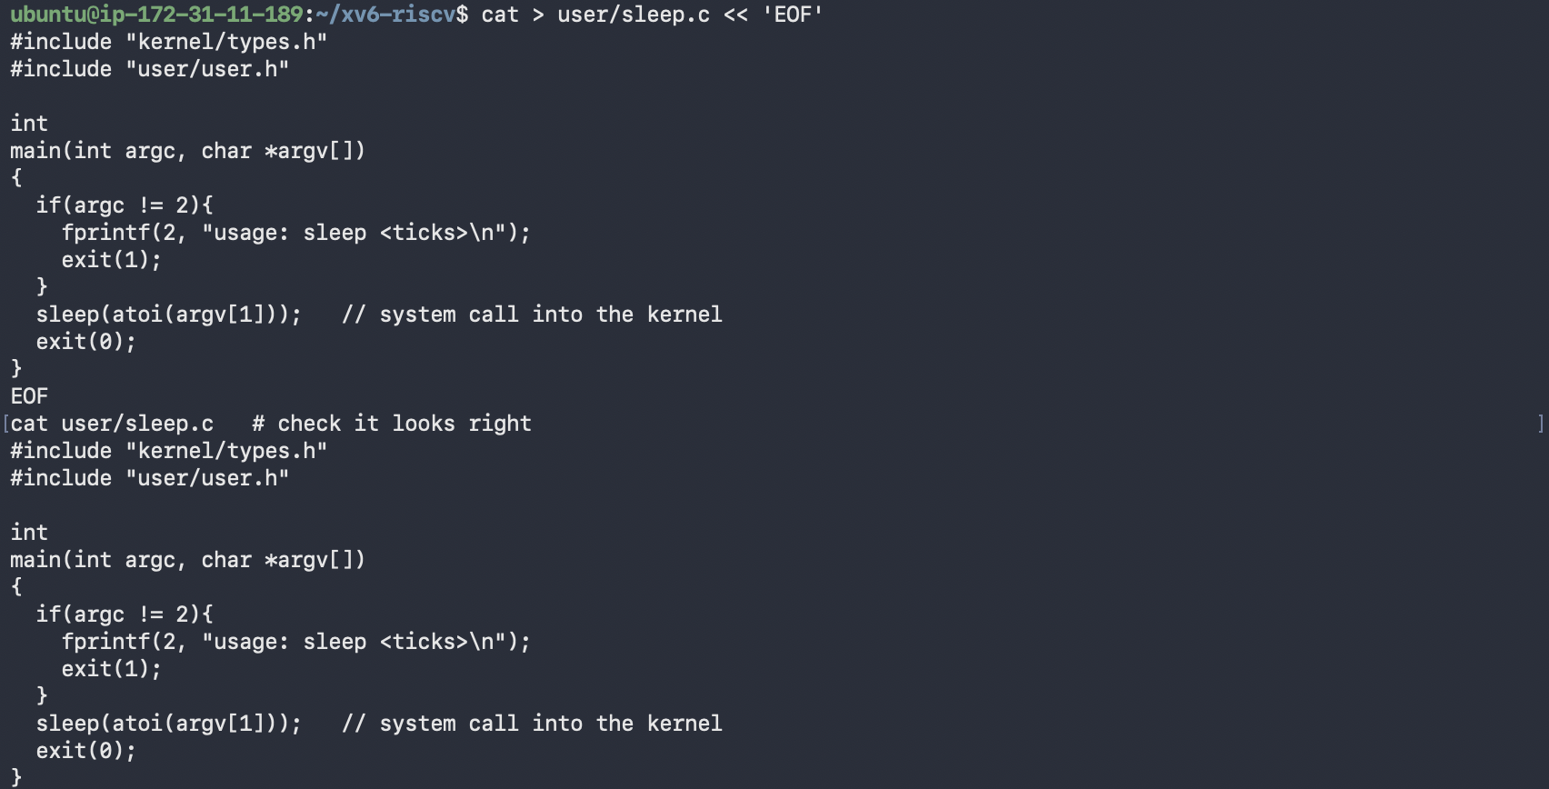
Figure 4.1 – Writing user/sleep.c with a heredoc and printing it back
Next I opened the Makefile in vim and added one line to UPROGS, indented with a tab like the other entries:
UPROGS=\
$U/_cat\
$U/_echo\
$U/_sleep\
$U/_forktest\
...

The first build failed with implicit declaration of function 'sleep' (Figure 4.2). In current upstream xv6 the sleep system call has been renamed to pause() (declared in user/user.h line 25, implemented as sys_pause in kernel/sysproc.c). It does what the lab describes, waiting for a number of clock ticks, so I replaced the call with sed and checked the result with grep. The program is still called sleep.
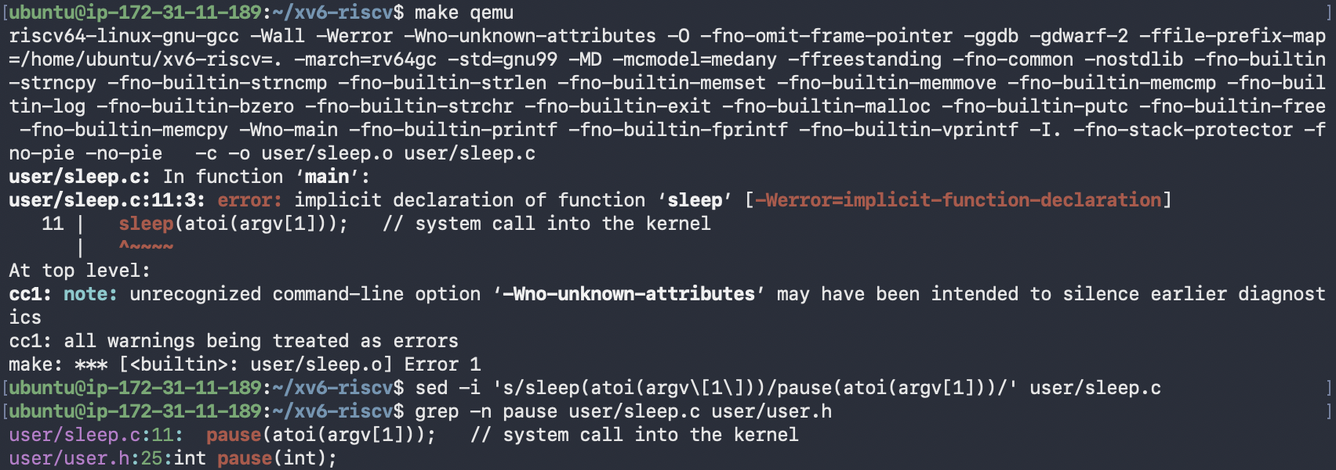
Figure 4.2 – Build error for sleep() and the switch to pause()
The final user/sleep.c:
#include "kernel/types.h"
#include "user/user.h"

int
main(int argc, char *argv[])
{
if(argc != 2){
fprintf(2, "usage: sleep <ticks>\n");
exit(1);
}
pause(atoi(argv[1])); // system call into the kernel
exit(0);
}

Then I rebuilt and tested the program inside xv6 (Figure 4.3).
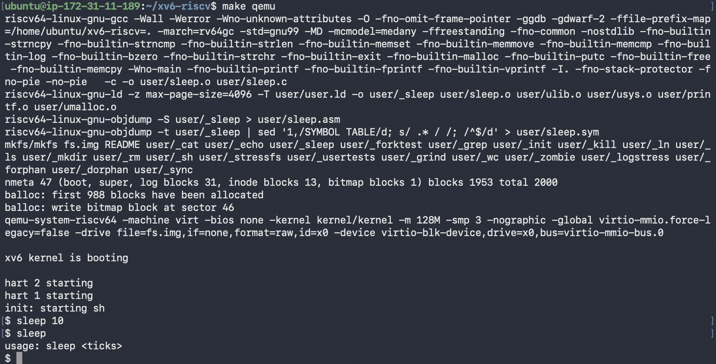
Figure 4.3 – Successful rebuild, then sleep 10 and sleep with no argument inside xv6

Observe, Part 4
The mkfs line now includes user/_sleep, so the program was packed into the xv6 disk image. Inside xv6, sleep 10 paused before returning to the prompt. One tick is roughly 0.1 s in QEMU, so that is about one second. Running sleep without an argument printed usage: sleep <ticks>, so the argument check works as well.
Interesting output. The error in Figure 4.2 shows how a program is tied to the kernel interface: sleep() is not declared in user/user.h, so the compiler refuses the call, and only the declared system call pause() works. Because the compiler flag -Werror turns every warning into an error, even an implicit declaration stops the build.

3. Conclusions
In this lab I built and used xv6, the operating system that I will extend in the next labs. My main findings are:
- Build. xv6 is compiled with a cross-compiler for RISC-V and started in QEMU with three harts. After init starts the shell, the system behaves like a small Unix.
- Unix ideas. Files, directories, devices (console), processes and pipes exist in xv6 in the same form as in Linux, but without the comfort of a modern shell. A pipe needs processes (fork, exec) and a kernel buffer for communication (pipe). usertests -q passed all tests.
- Source code. The code is split into kernel/ (privileged) and user/ (unprivileged). Programs such as cat use only a few system calls (read, write, open, close, exit), and the full list is only 22 calls, declared in user/user.h.
- My own program. I added sleep to UPROGS in the Makefile and wrote it with the system call pause(), because this version of xv6 has no sleep(). It waits for the given number of ticks and prints a usage message when the argument is missing.
The most useful mistakes were the redirection problem with <ticks> in the shell and the missing sleep() declaration. Both showed me where the boundary between the shell, the user programs and the kernel is.

